Project Title: Housemate Bulletin

# Project Description:

Most people have lived with house mates at some part in their lives. We want to make a tool that makes the experience engaging, but plugging into this small “social network” of house mates.

If you look back at the house mate experience, the center of house mates’ communication experience is the bulletin board in the kitchen. You can leave notes to each house mate, give reminders to each other, organize the social activities by leaving a house Todo list.

When I look at such a blackboard/magnet board, I recall these following attributes:

1. The board is public within the house, in the sense that it doesn’t need a lock and key to read and write to the board.
2. The board is one look summary of house’s priority. The main house focus is displayed front and center for all roommates. All housemates should be able to edit the main priority.
3. The board directs all house mates to a common purpose. To organize a weekend BBQ, one can sign up to get meat, another one will get beer, and another will buy propane. The Todo list is collaborative, associated to action of each person (accountable), and openly viewable.
4. The board allows house mates who don’t see each other to leave messages to each other. Housemates don’t see each other all the time, in a bulletin board, house mates will leave messages to each other via Post It notes. We want to simulate the experience of leaving notes to each other; via a simple messaging interface.

# Goals and Mockups

We want to build a digital replacement of the housemate bulletin board. Here’s a visual mockup of the bulletin board:

## Bulletin Board

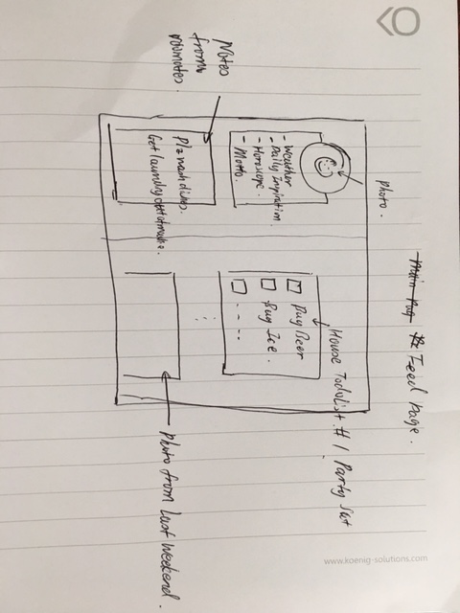

This page has 3 major elements:

* Upper Left: Housemate Photo, Local Weather, Horoscope, and Motto
* Lower Left: Direct messages from other roommates.
* Right: House Feed Section. House TODO lists and photos shared within the house. In the mockup, we have 2 examples:
  + Imagine if you have a BBQ this weekend. We need Beer, Ice, Propane and Chips. The TODO list allows me to sign up for an item; and when it’s done, allows me cross it off. This TODO list is updated in real time.
  + Photo from last weekend: posted photo from last weekend’s social activity. Photos posted to the RoommateBulletin will be displayed to all roommates.
  + For sake of this project, we will put in posts from a news API service into this Feed section.

## Login Page:

In this page, people will sign in and establish who they are. We are not implementing a strong authentication. We will just let me tell us who they are, and establish their identity that way.

Visual Mockup:

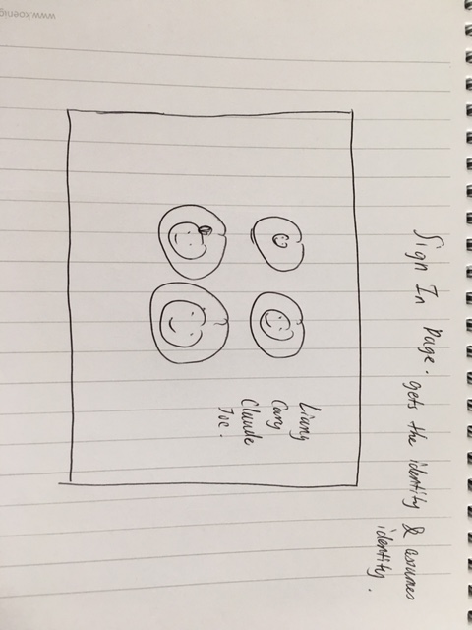

A straight-forward sign-in page with 4 circular icons with roommates’ profile photos. Clicking on your profile photo will establish an identity and leads to the bulletin page.

TODO List

Visual Mockup

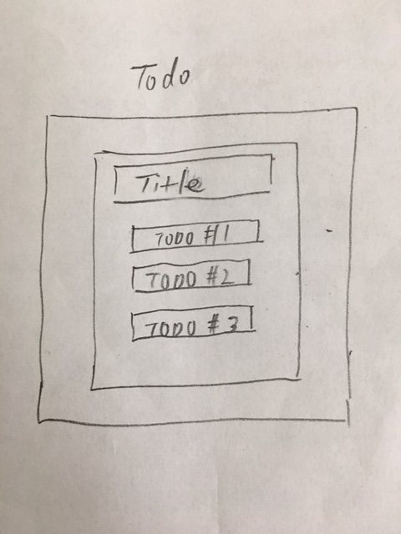

A page to create a new TODO list for roommates.

This page creates a TODO list, and finished list will be inserted into all roommates’ feed.

# Future State:

The ultimate goal is to create a digital bulletin board that makes personalization transparent. In the current design, a roommate needs to manually identity himself/herself to the web app to see their board. We foresee the roommate identification experience to be frictionless by integrating facial recognition into the work flow.

Our future state workflow will be ->

Roommate Stand In front of a Monitor -> Monitor identify the roommate -> Monitor automatically display the Roommate Bulletin customized to the roommate.