CURRICULUM VITAE
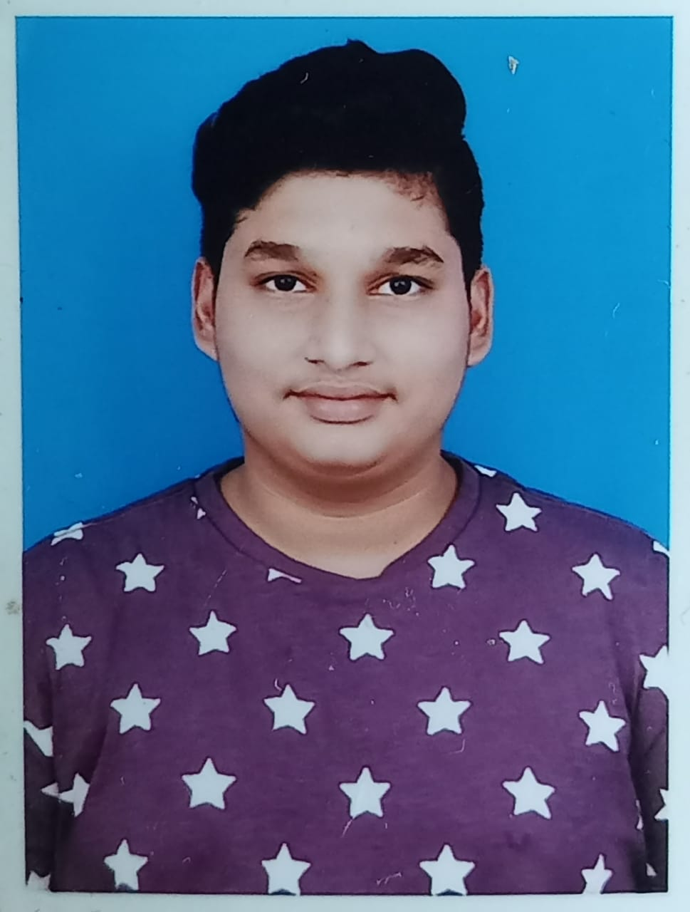

L Chetan H. No.37-340, Narigapalli, Chittoor, Andhra Pradesh
Pin code: 517002
Email: lchetan2002@gmail.com
Phone No: +91-6302807019

CAREER OBJECTIVE

To Secure a responsible career opportunity to fully utilize my training and skills, while making a significant contribution to the success of the company.

EDUCATIONAL QUALIFICATIONS

Degree / Institution/ Year CGPA / Percentage
Certificate Board

B-Tech CSE Lovely Professional University Pursuing 8.56
Intermediate Narayana Junior College 2020 93.2
10th Bharatiya Vidya Bhavan 2018 75

TECHNICAL SKILLS

Software : SQL Server
Languages : C, C++, Python, PHP, JavaScript
DBMS : Oracle
Others : HTML, CSS, React, Bootstrap

PROJECTS UNDERTAKEN

Project: Snake Game

Objective: To make the best version of user-friendly snake game using python.

Description:
As a first experience, I wanted to make my project as much as possible by approaching every different step of the Graphical User Interface and trying to understand them deeply. Being extremely interested in everything having a relation with the GUI, the project was a great occasion to give us the time to learn and confirm our interest for this field. So, I decided to make snake game with the use of GUI so that the users have better experiences.

Project: Covid Precautions Website

Objective: To create awareness and provide efficient methods to stay safe and protect themselves.

Description:

I have created a user-friendly website which contains all the aspects to be taken care off, for the prevention of covid-19 and included few remedies for the covid effected patients. All the things mentioned in the webpage were added only after a huge research and talks with the respective doctors.

WORKSHOPS / SEMINARS

Node.js from Geekle.us, October 2021
React Global Online Summit from Geekle.us, November 2021
UI Designer and UI Developer from Sandeep Saroha (UI Architect), June 2021

Awards/Achievements/Participation

Awarded certification of appreciation by google.
Participated in Web designing contest.
LinkedIn awarded Skill Assessment badges for clearing JavaScript, Html, CSS and python tests.
Certificate of completion for accomplishing the web development course in Udemy.

LANGUAGES KNOWN:

English, Hindi, Telugu, Tamil

HOBBIES:

Listening to Music, Photography, Travelling, Cooking

PERSONAL DETAILS

Mother’s Name : L Anjali
Father’s Name : L D R Murthy
Date of Birth : 21 – 10 – 2002
Gender : Male

REFERENCES:

References will be provided on request

