CAPSTONE PROJECT FINAL REPORT

COHORT-6 BATCH-4

Meeting Intelligence & Action Tracking System

Final Report Submission
Submitted by: Cohort-6 Batch-4 Project Team
Mentor / Guide: Aarnav Singh

Table of Contents
Abstract 4
1. Introduction 4
1.1 Problem Statement 4
1.2 Objectives 4
1.3 Scope 5
1.4 Organization of the Report 5
2. Background 6
2.1 Domain Information 6
2.2 Problem Description and Gap Analysis 6
2.3 Possible Applications 6
3. Motivation 7
4. Dataset and Input Data 7
4.1 Runtime Input 7
5. System Architecture and Methodology 7
5.1 Architecture Overview 7
5.2 Processing Pipeline 9
5.3 Tools and Packages 9
5.4 Algorithms and Techniques 10
6. Implementation 10
6.1 Stage 1 – Meeting Processing 10
6.2 Stage 2 – Meeting Intelligence 10
6.3 Stage 3 – Action Tracking and Automation 11
7. Evaluation and Results 11
7.1 Evaluation Methodology 11
7.2 Evaluation Metrics 12
7.3 Sample Output 13
8. Deployment 13
9. Project Demonstration 13
10. Challenges and Limitations 14
11. Conclusion and Future Work 14
11.1 Conclusion 14
11.2 Future Work 14
12. Project Execution Timeline 15
13. Team Members 15
Appendix A: LLM-as-a-Judge Prompt 16
A.1 System Prompt 16
A.2 User Prompt 17
Appendix B: Sample Outputs 18
B.1 Extracted Meeting Intelligence 18
B.2 Workflow Screenshots 19

Abstract
Meetings generate decisions, commitments, and deadlines, but converting these outcomes into tracked work is typically a manual and error-prone task. This project developed the Meeting Intelligence & Action Tracking System, an end-to-end workflow that accepts a meeting recording and automatically produces a transcript, a structured meeting summary, and downstream actions.
The system is orchestrated in n8n. A meeting audio file, or an existing transcript in JSON format, is submitted through an n8n form together with the meeting title and participant email addresses. Audio is transcribed by AssemblyAI with speaker labels, producing a diarized transcript, which is then sent to OpenAI GPT-5 to extract a structured summary, key topics, decisions, action items (with assignees, deadlines, priorities, status, and progress notes), risks, and follow-up requirements.
A Super Agent then coordinates three specialist agents: a Jira agent that creates or updates tickets, a Calendar agent that schedules deadline reminders and follow-up meetings, and a Gmail & Docs agent that emails participants and archives the notes in Google Docs. If orchestration fails, an administrator is notified by email so that no meeting output is lost.
Extraction quality was evaluated on test meeting recordings using a rubric-based LLM-as-a-Judge evaluation with a Claude model, covering faithfulness, completeness, field accuracy, and summary quality.

1. Introduction

1.1 Problem Statement
Meeting recordings contain important information such as discussion topics, decisions, responsibilities, deadlines, risks, and follow-up requirements. Manually listening to recordings, preparing meeting notes, identifying action items, and distributing the resulting information is time-consuming and can lead to missed or inconsistently recorded tasks.
This project automated that process. A user uploads a meeting recording, or an existing JSON transcript, and enters the meeting title and participant email addresses through an n8n form.
The workflow transcribes audio with speaker labels using AssemblyAI, extracts structured meeting intelligence (summary, decisions, action items, risks, and follow-up requirements) using OpenAI GPT-5, and passes the result to a Super Agent that coordinates specialist agents to create or update Jira tasks, schedule deadline reminders and follow-up meetings in Google Calendar, email participants, and save the meeting notes in Google Docs.

1.2 Objectives
- Build an n8n form-based meeting intake interface that accepts a meeting title, participant email addresses, and either an audio recording or a JSON transcript.
- Produce an accurate, speaker-labelled transcript of each meeting using AssemblyAI.
- Extract structured meeting intelligence, with explicit controls against invented assignees or deadlines.
- Automate downstream actions through a multi-agent design: task creation and updates, deadline reminders, follow-up scheduling, meeting notes, and participant emails.
- Evaluate extraction quality using an LLM-as-a-Judge mechanism (Claude).

1.3 Scope
The project covered recorded meetings submitted through the intake form, from upload through to automated outputs. The scope is summarized below.
In scope:
- Intake of MP3, WAV, and MP4 recordings, or a JSON transcript, along with the meeting title and participant email addresses, through the n8n form.
- Transcription of audio with speaker diarization using AssemblyAI.
- Extraction of a structured summary, key topics, decisions, action items, risks, and follow-up requirements using OpenAI GPT-5.
- Orchestration of downstream actions by a Super Agent that coordinates Jira, Calendar, and Gmail & Docs agents, with an email alert to an administrator if orchestration fails.
- Creation and update of Jira tasks for action items, Google Calendar deadline reminders and follow-up meetings, summary emails to participants through Gmail, meeting notes in Google Docs, and a weekly digest of overdue Jira actions in Slack.
- Reflection of task updates in Jira: if a task’s status, assignee, deadline, or priority changes in a follow-up meeting, the corresponding Jira ticket is updated.
Out of scope:
- Live, in-meeting capture.
- Direct integration with Zoom, Microsoft Teams, and Google Meet, mapping of speaker labels to participant names, and multilingual support, which are listed as future work in Section 11.2.
- Evaluation beyond the meeting recordings used for testing.

1.4 Organization of the Report
The report is organized as follows:
- Section 2 – Background: domain information, problem description and gap analysis, and possible applications.
- Sections 3 and 4 – Motivation and input data: the rationale for the project and the runtime input.
- Sections 5 and 6 – Architecture and implementation: the system architecture, methodology, and the three implementation stages.
- Section 7 – Evaluation: evaluation methodology, metrics, and sample output.
- Sections 8 and 9 – Deployment and demonstration: how the system is deployed and the project demonstration.
- Sections 10 and 11 – Limitations and conclusions: challenges and limitations, conclusion, and future work.
- Sections 12 and 13 and Appendices A and B – Execution timeline, team members, the LLM-as-a-Judge prompt, and sample outputs.

2. Background

2.1 Domain Information
The project combines Generative AI, Natural Language Processing, speech-to-text processing, structured information extraction, multi-agent orchestration, LLM-as-a-Judge evaluation, and workflow automation. The implementation uses n8n as the orchestration layer, AssemblyAI for speech-to-text with speaker diarization, OpenAI GPT-5 for meeting-intelligence extraction, tool-calling agents built on gpt-5-mini for downstream actions, and a Claude model as the judge for evaluating extraction quality.

2.2 Problem Description and Gap Analysis
Meeting platforms such as Zoom, Microsoft Teams, and Google Meet offer transcription, AI summaries, and action-item extraction with tentative owners. Their value chain ends there: the output is a static document, and converting it into tracked work, scheduled follow-ups, archived records, and verified completion is left to the participants. This “last mile” is where most meeting outcomes are lost.
This project treated extracted action items as the starting point rather than the final deliverable. Where existing platforms stop, the system continues with downstream integrations:
- Task creation: Action items become Jira tickets with assignee, start date, due date, priority, and status, and existing tickets are updated when progress is discussed.
- Follow-up scheduling: Deadline reminders and follow-up meetings are created in Google Calendar for the relevant participants.
- Documentation: Meeting notes are created in Google Docs and a summary is emailed to participants.
- Overdue monitoring: A weekly digest of overdue Jira actions, grouped by assignee, is posted to the team’s Slack channel so that missed commitments are followed up.

2.3 Possible Applications
- Corporate and project team meetings
- Client and stakeholder meetings
- Academic and research meetings
- Project review and planning meetings
- Software development team meetings
- Team discussions and follow-up meetings

3. Motivation
This project was selected because it addresses a gap that is both widespread and well understood: current meeting platforms stop at summaries and action items, leaving execution and follow-through to manual effort. In delivery organizations, where a program manager or software engineer may attend several meetings a day, this gap translates directly into missed commitments, duplicated tracking effort, and decisions that lose traceability within weeks.
The problem is also a natural fit for the GenAI patterns covered in the programme — speech-to-text, structured extraction with hallucination controls, and tool-calling agents that act on external systems — making it a realistic test of end-to-end LLM engineering rather than a standalone model exercise.

4. Dataset and Input Data

4.1 Runtime Input
The system is designed around user-provided meeting inputs rather than a fixed dataset. The n8n Meeting Intake Form requires a meeting title, participant email addresses (comma separated), and one file: either an audio recording in MP3, WAV, or MP4 format, or a transcript in JSON format. A JSON transcript bypasses transcription; the workflow locates the transcript text however the file stores it and converts it to plain text.

5. System Architecture and Methodology

5.1 Architecture Overview
The system is implemented as an n8n workflow with three functional stages: meeting processing, meeting intelligence, and action tracking and automation. The third stage follows a multi-agent pattern in which a Super Agent delegates work to three specialist agents. Figure 1 shows the workflow.
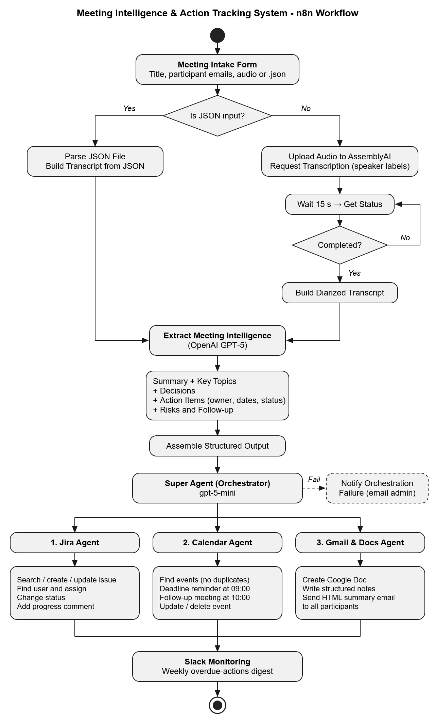
Figure 1: n8n workflow of the Meeting Intelligence & Action Tracking System
Jira acts as the system of record for meeting outcomes. Tasks decided in a meeting are created in Jira by the Jira agent, together with their assignee, start date, due date, priority, and status. Before creating a ticket, the agent searches for an existing ticket with the same title; when a follow-up meeting discusses a known task, for example a revised deadline, a new assignee, or a change in status, the existing ticket is updated and the progress note is added as a comment.

5.2 Processing Pipeline
Table 1: End-to-end processing steps
Step | Component | Description
1 | Meeting Intake | Collect the meeting title, participant email addresses, and one audio recording or JSON transcript through the n8n form.
2 | Input Routing | Check the file type; route JSON transcripts to parsing and audio files to transcription.
3 | Transcription | Upload the audio to AssemblyAI and request transcription with speaker labels enabled.
4 | Transcript Retrieval | Poll the job status every 15 seconds until complete, then format the result as a diarized transcript (“Speaker A: …”). For JSON input, extract the transcript text as plain text.
5 | Intelligence Extraction | Use OpenAI GPT-5 to produce structured JSON: summary, key topics, decisions, action items, risks, and follow-up information.
6 | Output Assembly | Normalize action items, write Jira titles and descriptions, and build the HTML summary email.
7 | Orchestration | The Super Agent (gpt-5-mini) calls the Jira, Calendar, and Gmail & Docs agents in turn, retrying a failed agent once.
8 | Action Tracking | The Jira agent creates or updates tickets, sets assignee, dates, priority, and status, and adds progress comments.
9 | Scheduling | The Calendar agent creates deadline reminders and the follow-up meeting, avoiding duplicates and past dates.
10 | Documentation & Communication | The Gmail & Docs agent saves the notes in Google Docs and emails the summary to participants.
11 | Failure Handling | Email the error and the original summary to an administrator if orchestration fails.
12 | Overdue Monitoring | Query Jira for open tickets past their due date and post a weekly digest, grouped by assignee, to the team’s Slack channel.

5.3 Tools and Packages
Table 2: Tools and their roles
Tool | Role
n8n | Workflow orchestration and API integration
AssemblyAI | Speech-to-text transcription with speaker diarization
OpenAI GPT-5 | Extraction of the summary, decisions, action items, risks, and follow-up as structured JSON
OpenAI gpt-5-mini | Models for the Super Agent and specialist agents
Anthropic Claude | LLM-as-a-Judge evaluation of the extracted output
Jira | Task tracking: ticket creation, assignment, status updates, and comments
Gmail | Participant summary distribution
Google Docs | Meeting-note storage
Google Calendar | Deadline reminders and follow-up meeting scheduling
Slack | Weekly digest of overdue Jira actions posted to the team channel

5.4 Algorithms and Techniques
- Speech-to-text transcription with speaker diarization using AssemblyAI
- LLM-as-a-Judge evaluation of extraction quality using a Claude model
- LLM-based summarization
- Prompt-based structured information extraction with JSON output
- Extraction of action items, decisions, risks, and follow-up requirements
- Rule-based normalization and default handling for missing assignees and deadlines
- Workflow branching, status polling, and multi-agent orchestration with tool-calling agents and retries

6. Implementation

6.1 Stage 1 – Meeting Processing
The n8n intake form captures the meeting title, participant email addresses, and one file. An “Is JSON Input?” check routes the file: a JSON transcript is parsed and converted to plain text, while an audio file is uploaded to AssemblyAI and a transcription job is requested with speaker labels enabled. The workflow waits 15 seconds, checks the job status, and repeats until transcription is complete. The result is formatted as a diarized transcript with lines such as “Speaker A: …”.

6.2 Stage 2 – Meeting Intelligence
The transcript is passed to OpenAI GPT-5 with a prompt that requests structured JSON output (Table 3). To limit hallucination, the model is explicitly instructed to use “Unassigned” or “No deadline” rather than invent assignees or dates. An assembly step then normalizes the action items, writes the Jira ticket titles and descriptions, and builds the summary email as HTML.
Table 3: Structured output fields
Field | Description
Summary | Concise overview of the meeting
Key topics | Main discussion topics
Decisions taken | Decisions agreed during the meeting
Action items | Title, assignee, deadline, priority, details, status, and progress note
Risks and issues | Risks and issues raised that may affect delivery
Follow-up | Whether a follow-up is required, with proposed date and participants

6.3 Stage 3 – Action Tracking and Automation
Downstream actions are handled by a Super Agent (Orchestrator) that delegates to three specialist agents. It calls the Jira agent first, then the Calendar agent, and finally the Gmail & Docs agent, so that the summary email can report the tickets and events created.
A failed agent is retried once, and the Super Agent node itself retries once on failure. The Super Agent runs on gpt-5-mini. If orchestration still fails, the error and the original summary are emailed to an administrator so that no meeting output is lost.
Jira agent: For each action item, the agent searches for an existing ticket with the same title and either creates a Task in the Cross-Team Projects space or updates the existing ticket. It sets the due date from the deadline, the start date from the date work was said to begin (or the meeting date if none was stated), and a High, Medium, or Low priority from the transcript. It looks up the assignee by name in Jira, assigns the ticket, moves it to In Progress or Done where appropriate, and adds the progress note as a comment, or records the intended assignee when no match is found.
Calendar agent: Working in India Standard Time, the agent checks for existing events to avoid duplicates and never creates events in the past. It adds a 30-minute deadline reminder at 09:00 on each deadline date and books a follow-up meeting at 10:00 with all participants invited, defaulting to seven days ahead when no timeframe was suggested. Reminders for completed items are removed.
Gmail & Docs agent: The agent creates a Google Doc named after the meeting title and date, writes the structured notes into it (summary, topics, action items, decisions, risks, follow-up, and tracking), and sends the HTML summary to all participants with a section listing the Jira tickets and calendar events.
Slack monitoring: At the end of the workflow, a monitoring step queries Jira for open tickets that are past their due date and posts a weekly overdue-actions digest to the team’s Slack channel through the Meeting-Intelligence-Monitoring app. The digest groups items by assignee and lists each ticket’s priority, title, due date, days overdue, and Jira key, so that missed commitments are followed up without manual checking.
Jira was adopted as the primary task-management platform to avoid duplicate tracking.

7. Evaluation and Results

7.1 Evaluation Methodology
Extraction quality was assessed using an LLM-as-a-Judge mechanism, in which a Claude model scored the output generated by OpenAI GPT-5 against the meeting transcript using a fixed rubric. Each meeting was rated from 1 to 5 on four criteria: faithfulness (no invented action items, decisions, assignees, or deadlines), completeness (no agreed action item or decision missed), field accuracy (correct assignee, deadline, and priority), and summary quality. Scores were averaged across all test meetings.

7.2 Evaluation Metrics
Table 4: Evaluation metrics
Metric | Measures | Method
LLM-as-a-Judge: Faithfulness | No invented action items, decisions, assignees, or deadlines | Claude scores the extracted output against the transcript (1–5)
LLM-as-a-Judge: Completeness | Coverage of all action items and decisions agreed in the meeting | Claude scores the extracted output against the transcript (1–5)
LLM-as-a-Judge: Field accuracy | Correctness of assignee, deadline, and priority for each action item | Claude scores the extracted output against the transcript (1–5)
LLM-as-a-Judge: Summary quality | Accuracy and conciseness of the meeting summary, risks and issues, and blockers | Claude scores the extracted output against the transcript (1–5)

Table 5 defines the scoring rubric applied by the Claude judge for each criterion in Table 4. Intermediate scores of 4 and 2 are used where the output falls between the anchors shown.
Table 5: LLM-as-a-Judge scoring rubric
Criterion | Score 5 | Score 3 | Score 1
Faithfulness | Every action item, decision, assignee, deadline, risk, and blocker is supported by the transcript | One unsupported item, or several minor unsupported details | Output is largely fabricated or unrelated to the transcript
Completeness | No agreed action item or decision is missing | One significant item, or two to three minor items, missing | Most action items or decisions missing
Field accuracy | Assignee, deadline, and priority correct for every action item | Two to three fields incorrect | Fields mostly wrong or missing
Summary quality | Accurate, concise, and covers the main outcomes | Generally accurate but misses a key outcome or is noticeably verbose | Inaccurate or unusable
An output passes when every criterion scores 4 or above. A score of 3 on any criterion flags the output for review, and a score of 2 or below fails it. The judge runs at temperature 0 and returns its scores, verdict, and justification as structured JSON. The full judge prompt is given in Appendix A.

7.3 Sample Output
The workflow was run end to end on the three scenario meetings described in Section 9. For each meeting, GPT-5 produced structured JSON containing the summary, action items with assignees, deadlines and priorities, decisions, risks, and blockers; the Jira agent created or updated the corresponding tickets, and the Slack digest listed overdue actions by assignee. A sample of the extracted JSON is given in Appendix B.1, and screenshots of the intake form, meeting summary, Jira tickets across the meetings, and the Slack digest are given in Appendix B.2.

8. Deployment
The system is deployed on n8n Cloud as a published workflow triggered through its Meeting Intake Form, integrating external APIs and productivity platforms. The form is live at https://cnprabhu5.app.n8n.cloud/form/meeting-intake. For the final demonstration, the complete workflow was run from file upload to generated meeting outputs.

9. Project Demonstration
The demonstration followed a three-meeting scenario that takes the same set of action items through their full lifecycle in Jira. Speakers referred to each task by the same name and stated owners by name in every meeting, so that the Jira agent could match tasks to existing tickets and resolve assignees.
In the initial meeting, the team discusses the work and assigns tasks to the meeting invitees; the workflow creates a Jira ticket for each action item with its assignee, start date, due date, and priority, adds deadline reminders, and books the follow-up meeting.
In the follow-up meeting, the team reports progress: most tasks move to In Progress, one task receives a revised deadline, another is reassigned, and one is reported as complete. The workflow updates the existing tickets rather than creating duplicates, adds each progress update as a comment, moves the completed task to Done, and removes its deadline reminder.
In the closing meeting, the team confirms that all remaining action items are complete; the workflow moves every ticket to Done, removes the remaining deadline reminders, and emails a final summary to participants.
For each meeting, the recording was submitted through the n8n form and the following steps were shown:
- Upload the meeting recording (or a JSON transcript) through the n8n form and enter the meeting details and participant emails.
- Show transcription through AssemblyAI with speaker labels.
- Show the generated diarized transcript.
- Run the GPT-5 meeting-intelligence extraction.
- Display the summary, decisions, action items, risks, and follow-up information.
- Show the Super Agent delegating work to the Jira, Calendar, and Gmail & Docs agents.
- Show the Jira tickets created or updated for the extracted action items.
- Show the generated Google Docs meeting notes and the email sent to participants.
- Show the deadline reminders and the follow-up meeting in Google Calendar.
- Show the weekly digest of overdue Jira actions posted to Slack.
n8n link: https://cnprabhu5.app.n8n.cloud/form/meeting-intake

10. Challenges and Limitations
The main challenges and limitations are as follows:
- Dependence on third-party APIs, including their availability, latency, and usage costs.
- Transcription accuracy with overlapping speech, accents, or poor audio quality; speaker diarization labels speakers generically (e.g. “Speaker A”) rather than by name.
- Assignees can only be resolved when names are stated in the meeting, and matching names to Jira users can be wrong. Stricter name matching is needed. Existing tickets are matched by title, so a task described differently in a follow-up meeting may create a duplicate ticket.
- Relative deadlines (e.g. “next Friday”) require normalization to calendar dates.
- Transcription is asynchronous: the workflow polls AssemblyAI every 15 seconds, so long recordings increase end-to-end processing time.
- When the meeting does not state when work starts, the start date defaults to the day the form was submitted, which may differ from the actual meeting date.

11. Conclusion and Future Work

11.1 Conclusion
The project delivered an end-to-end Meeting Intelligence & Action Tracking prototype that converts a meeting recording or transcript into a speaker-labelled transcript, structured meeting intelligence extracted by GPT-5, and automated follow-through coordinated by a Super Agent across Jira, Google Calendar, Gmail, and Google Docs, with overdue actions reported to the team in Slack. Extraction quality was evaluated using a Claude LLM judge.

11.2 Future Work
- Direct integration with Zoom, Microsoft Teams, and Google Meet to capture recordings automatically.
- Mapping of speaker labels to participant names.
- Stricter assignee matching against Jira users, for example using email addresses or asking for confirmation when a match is ambiguous.
- Use of the actual meeting date, rather than the form submission date, as the default start date.
- Multilingual transcription and extraction.
- Running the Claude LLM-as-a-Judge inside the workflow as a quality gate before downstream actions.

12. Project Execution Timeline
Table 6: Planned versus actual execution
Week | Stage | Planned Goal | Status / Remarks
Week 1 | Stage 1 | Finalize architecture, n8n meeting intake form, audio upload and AssemblyAI transcription with speaker labels. | Completed
Week 2 | Stage 1 → Stage 2 | Complete transcript processing and integrate structured LLM meeting-intelligence extraction. | Completed
Week 3 | Stage 2 | Refine summaries, decisions, action items and risks; implement LLM-as-a-Judge evaluation with Claude; | Completed
Week 4 | Stage 3 | Build the Super Agent and the Jira, Calendar, and Gmail & Docs agents; perform end-to-end testing. | Completed
Week 5 | Stage 3 | Final testing, evaluation, deployment preparation and demonstration. | In Progress

13. Team Members
Table 7: Team members
S.No | Team Member | TalentSprint ID | Email
1 | Mohan Reddy | 2616382 | cmohanr@gmail.com
2 | Chethan L | 2616808 | l.chethan880@gmail.com
3 | Pullaiahgari Manideep Reddy | 2616388 | manideep8491@gmail.com
4 | Swetha Raut | 2616306 | shwetamraut91@gmail.com
5 | Chaitali Prabhu | 2616376 | chaitalisidharth@gmail.com
6 | Seema Sada Shanker | 2616385 | seema.shanker08@gmail.com
7 | Sharmila Pallipati | 2617489 | sharmilapallipati@gmail.com
Designated Team Coordinator: Mohan Reddy (2616382) – cmohanr@gmail.com

Appendix A: LLM-as-a-Judge Prompt
This appendix reproduces the prompt used by the Claude judge to evaluate extraction quality. Placeholders in double braces are n8n expressions that insert the meeting title and extracted output at run time. The transcript produced by the transcription step is attached to the request as a document rather than inserted into the prompt text.

A.1 System Prompt
You are an impartial evaluator of meeting-intelligence extraction. You will receive a meeting transcript as an attached document and a JSON object that another model extracted from it. Your job is to judge how accurately and completely the JSON reflects the transcript.

Rules:
- The transcript is the only source of truth. Do not use outside knowledge or assumptions.
- An item is supported only if the transcript explicitly states or clearly implies it.
- "Unassigned" or "No deadline" is CORRECT when the transcript does not name an owner or date. Do not penalise it.
- Relative deadlines (e.g. "next Friday") are correct if they are a reasonable reading of what was said.
- Judge meaning, not wording. Paraphrases are acceptable.
- Be strict and consistent. Do not reward length or polish.
- Return only valid JSON in the exact format specified. No text outside the JSON.

Scoring rubric (score each criterion 1–5):

1. Faithfulness: are all extracted items supported by the transcript?
5 = Every action item, decision, assignee, deadline, risk and blocker is supported.
4 = One minor unsupported detail (e.g. slightly overstated priority).
3 = One unsupported item, or several minor unsupported details.
2 = Multiple unsupported items or invented assignees/deadlines.
1 = Output is largely fabricated or unrelated to the transcript.

2. Completeness: were all agreed action items and decisions captured?
5 = No action item or decision agreed in the meeting is missing.
4 = One minor item missing.
3 = One significant item missing, or two to three minor items missing.
2 = Several significant items missing.
1 = Most action items or decisions missing.

3. Field accuracy: are assignee, deadline and priority correct for each action item?
5 = All fields correct for every action item.
4 = One field incorrect.
3 = Two to three fields incorrect.
2 = Many fields incorrect.
1 = Fields are mostly wrong or missing.

4. Summary quality: are the summary, risks and issues, and blockers accurate and concise?
5 = Accurate, concise, covers the main outcomes, no filler.
4 = Accurate with minor omissions or slight verbosity.
3 = Generally accurate but misses a key outcome or is noticeably verbose.
2 = Partly inaccurate or misleading.
1 = Inaccurate or unusable.

Verdict:
- "PASS" if every criterion scores 4 or higher.
- "REVIEW" if any criterion scores 3.
- "FAIL" if any criterion scores 2 or lower.

A.2 User Prompt
Meeting title: {{ $json.meeting_title }}

TRANSCRIPT:
The full meeting transcript is provided in the attached document. Treat it as the only source of truth.

EXTRACTED OUTPUT:
"""
{{ JSON.stringify($json.extraction) }}
"""

Evaluate the extracted output against the transcript using the rubric. Return JSON in exactly this format:

{
"scores": {
"faithfulness": 1-5,
"completeness": 1-5,
"field_accuracy": 1-5,
"summary_quality": 1-5
},
"overall_score": <average of the four scores, 1 decimal place>,
"verdict": "PASS" | "REVIEW" | "FAIL",
"unsupported_items": [
{"type": "action_item|decision|risk|blocker|field", "item": "<text>", "reason": "<why it is not supported>"}
],
"missing_items": [
{"type": "action_item|decision", "item": "<text from transcript>", "evidence": "<short transcript quote>"}
],
"field_errors": [
{"task": "<task>", "field": "assignee|deadline|priority", "extracted": "<value>", "expected": "<value>"}
],
"justification": "<2-4 sentences explaining the scores>"
}

Appendix B: Sample Outputs
This appendix presents outputs from a sample run of the workflow: the structured meeting intelligence extracted by GPT-5, followed by screenshots of the intake form, the meeting summary, the Jira tickets across the scenario meetings, and the Slack digest.

B.1 Extracted Meeting Intelligence
The JSON below was extracted by GPT-5 from the sample meeting “Deliverables Status Review”.

{
"meeting_title": "Deliverables Status Review",
"facilitator": "Shweta",
"participants": ["Shweta", "Chetan", "Mohan", "Manidip"],
"summary": "The team reviewed open deliverables before release. The requirements document is finalized and API access has been received, so Chetan's dependencies are closed. Mohan has finished the project management integration, handed the build to Manidip and fixed the first integration issue. Testing is in its final stage: the main functionality works, and of two minor defects one is fixed and the other is being retested. The remaining defect is the only open item. The release will go ahead once Manidip confirms the final QA status.",
"action_items": [
{
"task": "Complete the remaining defect fix and provide the updated build",
"assignee": "Mohan",
"deadline": "Today (meeting date)",
"priority": "High"
},
{
"task": "Complete the retest and confirm the final QA status, including whether any critical issues remain",
"assignee": "Manidip",
"deadline": "No deadline (after Mohan's updated build)",
"priority": "High"
},
{
"task": "Update the project documentation with the latest status",
"assignee": "Chetan",
"deadline": "No deadline",
"priority": "Medium"
}
],
"decisions": [
"Requirements and the API access dependency are closed.",
"The remaining defect is the only open item.",
"The release will go ahead after Manidip confirms the final QA status from the retest."
],
"risks_and_issues": [
"One of two minor defects is still being retested; its result will decide whether the release goes ahead."
],
"blockers": [
"The release is on hold until the remaining defect fix is retested and the final QA status is confirmed."
]
}

B.2 Workflow Screenshots
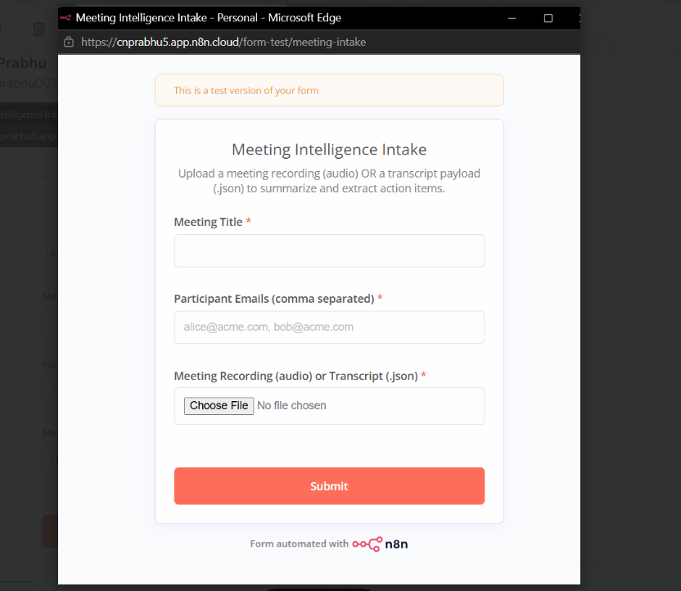
Figure 2: Meeting intake form, accepting an audio recording or a JSON transcript
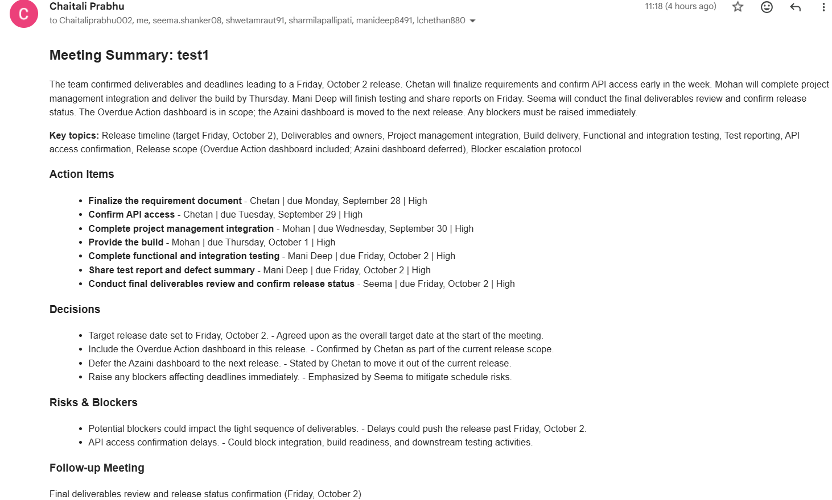
Figure 3: Meeting summary generated by the workflow
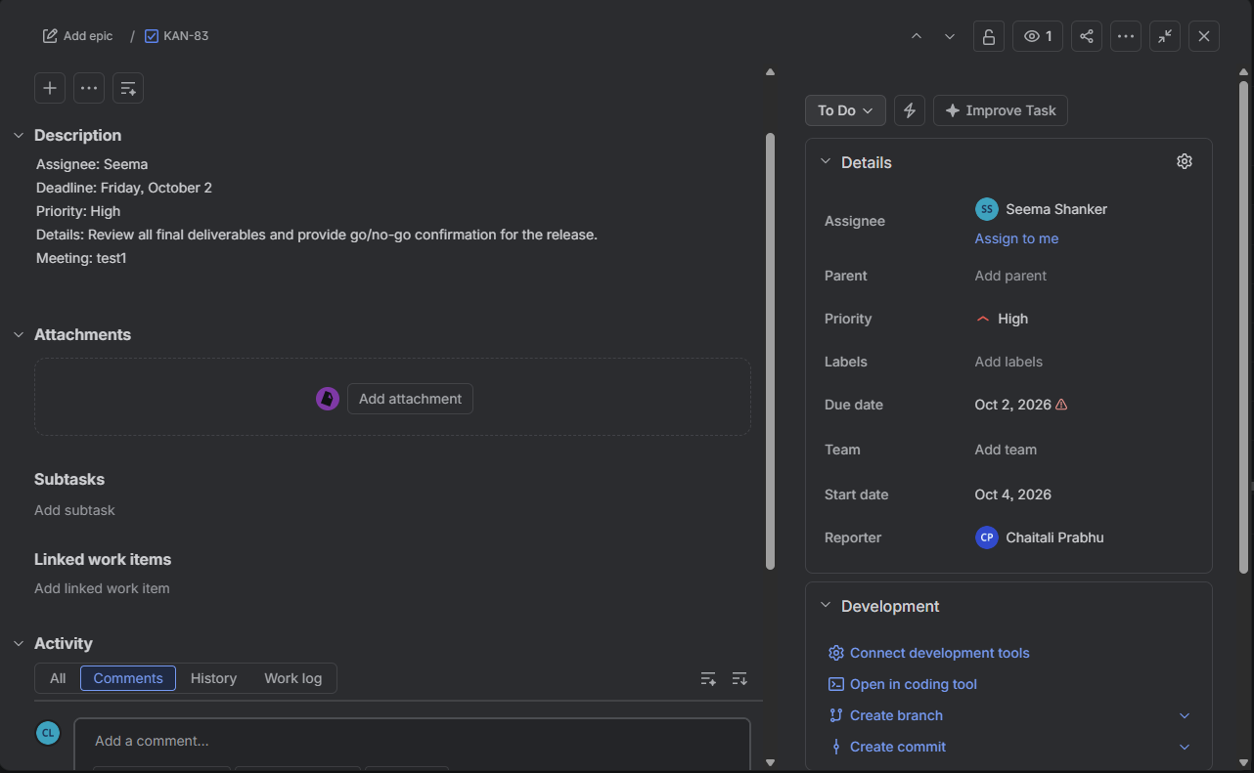
Figure 4: Jira tickets created and assigned in the initial meeting (1 of 2)
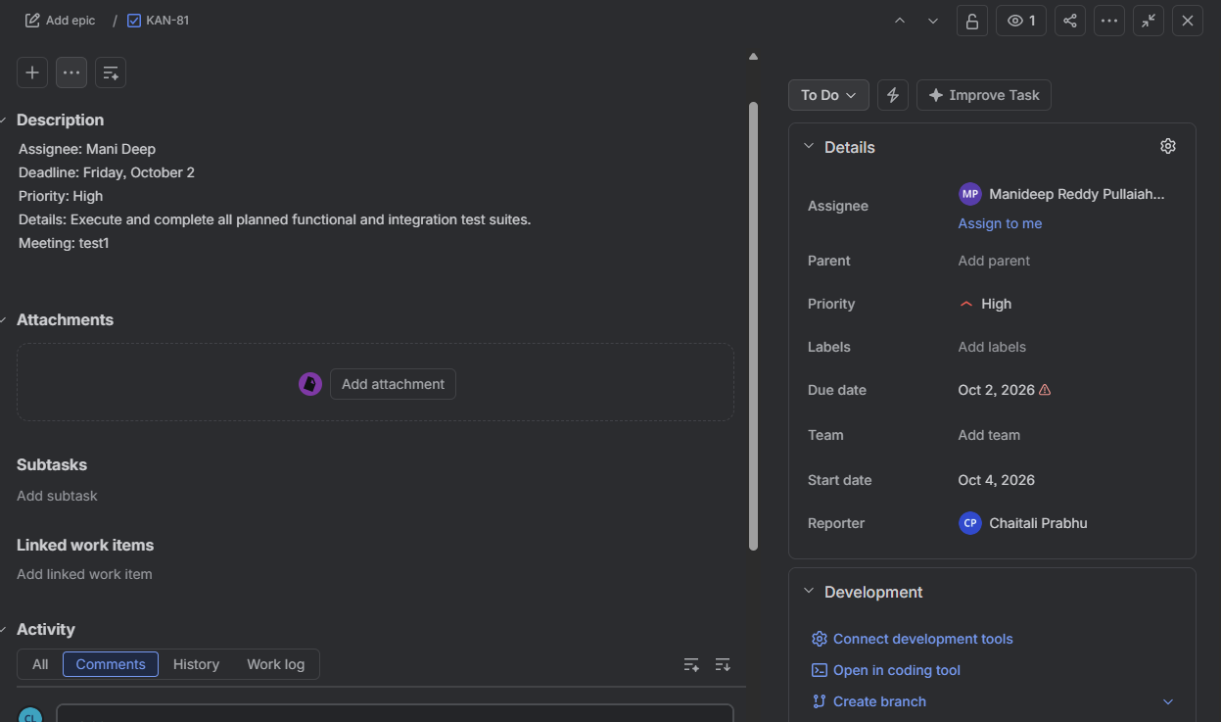
Figure 5: Jira tickets created and assigned in the initial meeting (2 of 2)
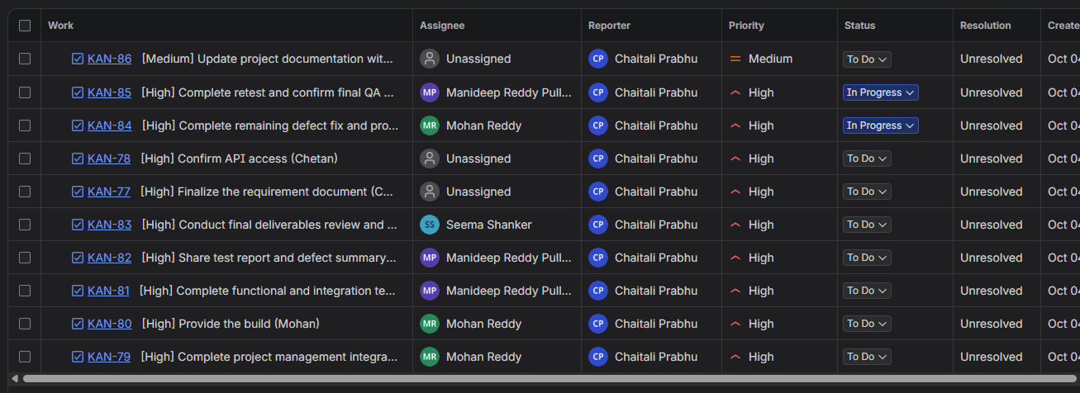
Figure 6: Jira tickets updated in the follow-up meeting (1 of 2)
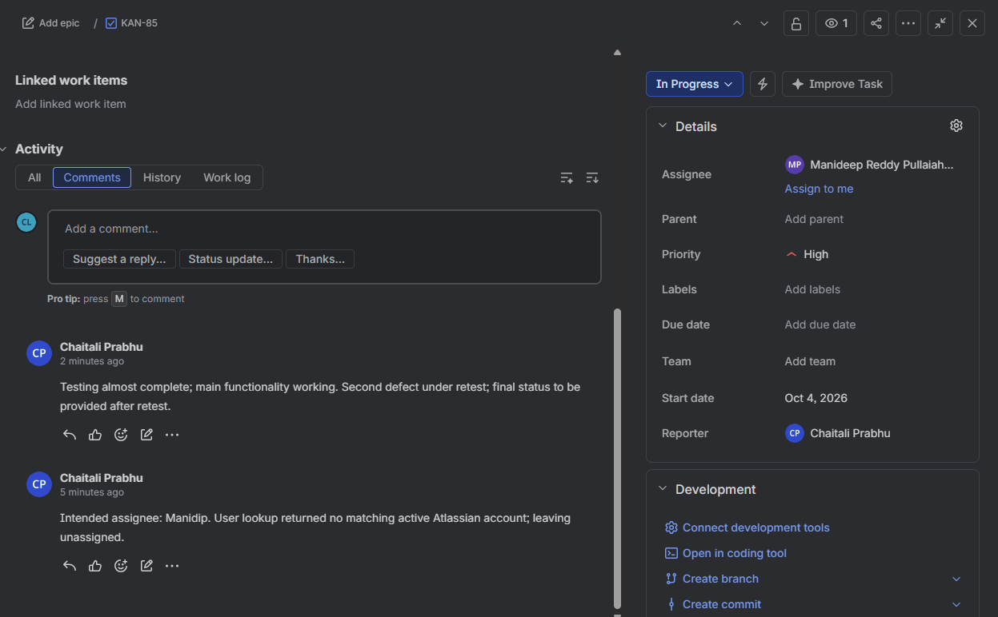
Figure 7: Jira tickets updated in the follow-up meeting (2 of 2)
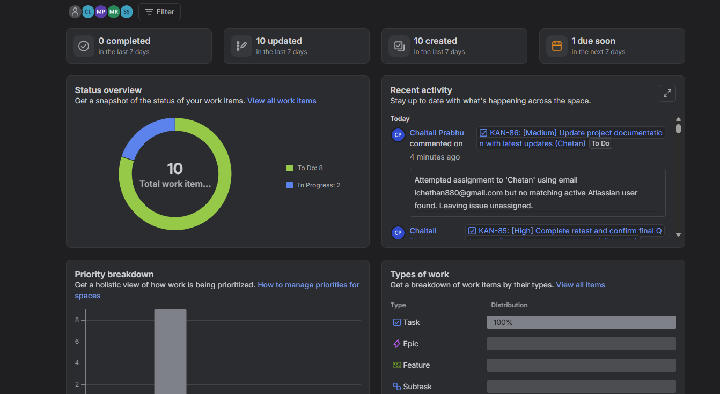
Figure 8: Jira dashboard (1 of 2)
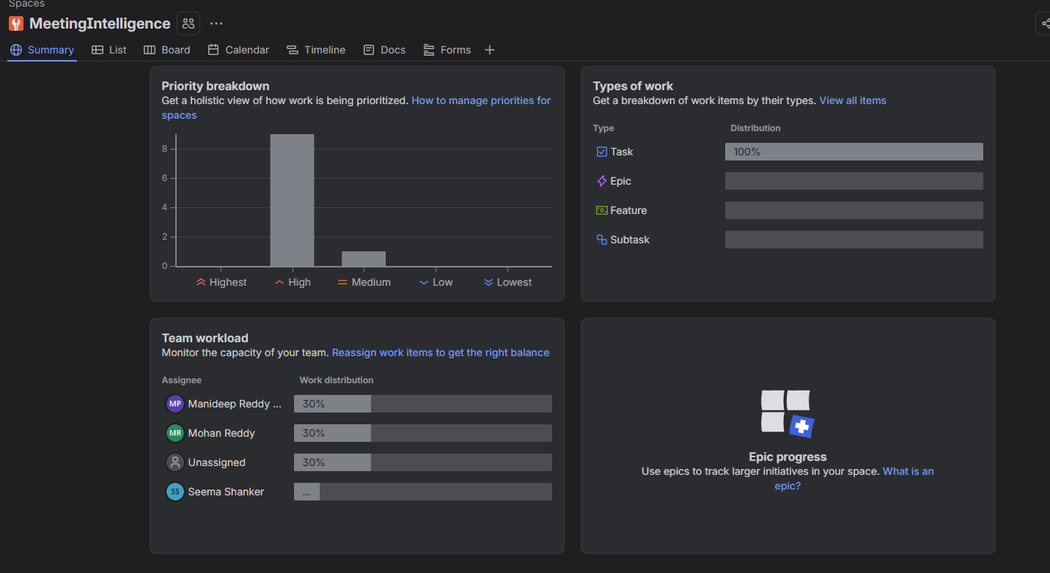
Figure 9: Jira dashboard (2 of 2)
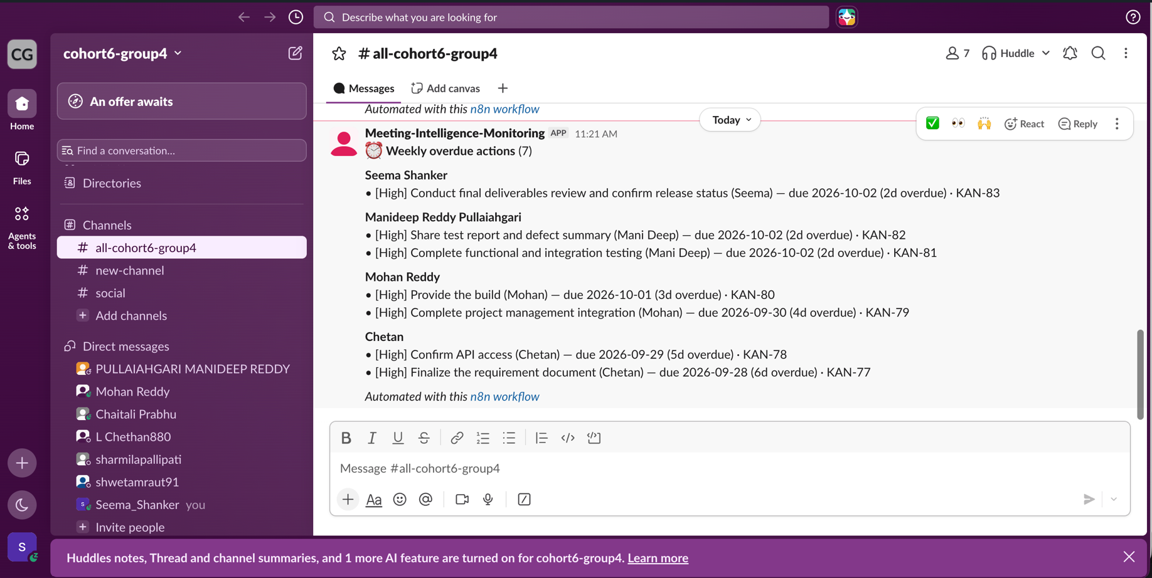
Figure 10: Weekly overdue-actions digest posted to Slack

