Col. Thomas Sprigg

Information found on findagrave.com and geni.com
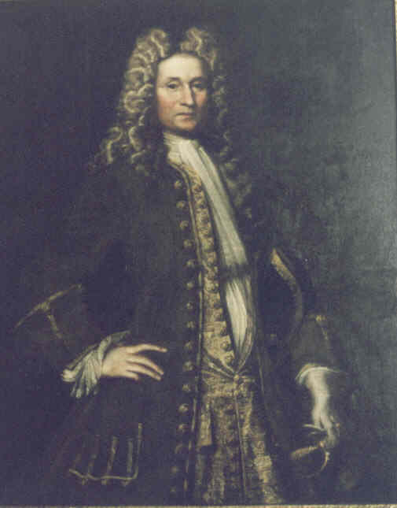

Founded Northampton Plantation, a 1000-acre tract of land granted by Charles, 3rd Baron Baltimore in 1673. The site is now Northampton Plantation Slave Quarters & Archaeological Park in Bowie, Maryland

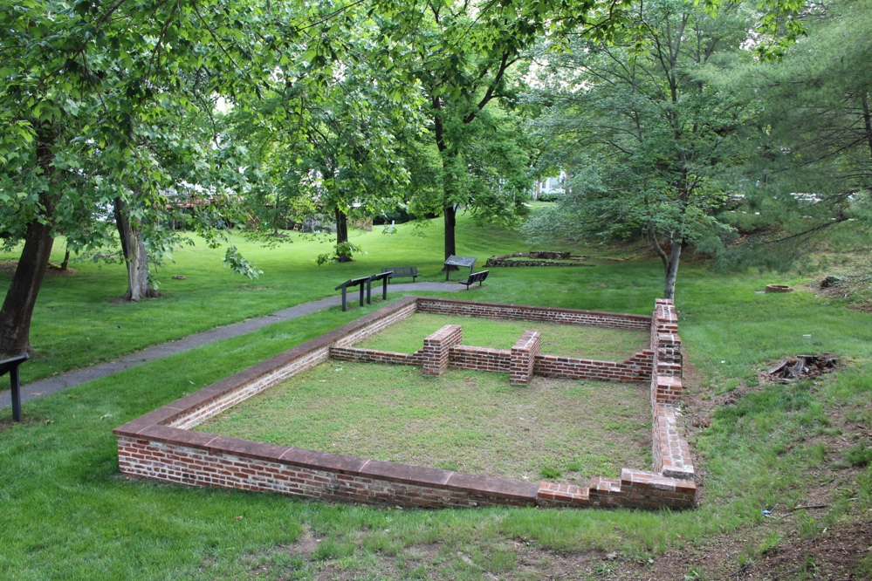

Emigrated from England to Virginia, arriving around 1669, and resided in Northampton County, removed to Maryland; served against Nanticoke Indians before 1678; commander, for Calvert Co,. 1661; justice, 1667-1674;presiding justice, 1674; high sheriff 1663-64.
Thomas Sprigg's biographers said he was "an officer in the Royal Lancers." Sharon Doliante's book (cited before) says they are unable to confirm this, but that in 1653, in Virginia, he "signed himself as 'Leift. Sprigge,' meaning he was an officer in the military. He came to Virginia as a "Cavalier" and left England "immediately after the execution of Charles I in 1649 . . . " Burke’s Landed Gentry says this for the lineage of a James Cresap Sprigg: "Lieut. Thomas Sprigg of Kettering, Northamptonshire England, b. 1630, officer with Royal army, left Great Britain to settle in America before 1650 . . . .”
Cap badge (motto) of the Queen's Royal Lancers
There is a picture in Doliante's book of a painting of Thomas Sprigg by Jacob Huysman (shown on this page). The painting is still in the possesion of a descendant, says Doliante. At any rate, he is in full Court dress and is left-handed (he is holding the handle of a rapier in his left hand).
Three of his descendants were governors of Maryland: Robert Bowie (1803-4-5 and 1811); Samuel Sprigg (1819-1822) and Oden Bowie (1869). He was the owner of “Northampton” (destroyed by fire in 1909) in Prince George’s County, MD, as well as Resurection Manor. He served as a commissioner (justice) in both Virginia and Maryland. His will, includes a list of goods and chattels and slaves, and begins on p. 945 in Doliante's book (which is in our possession)..
From Tidewater Maryland Architecture and Gardens, a Sequel to Early Manor and Plantation Houses of Maryland, by Henry Chandlee Forman:
In the section "Sprigg's Northampton and L'Enfant's Garden: "One of the important estates of Prince George's County is Northampton, a tract of 1000 acres surveyed on May 26, 1673, for Thomas Sprigg I, born in Northamptonshire, England, and who later became High sheriff, Justice, and Commissioner of Calvert County, Maryland. He was married twice, first to Katherine Roper, as sister-in-law of Governor William Stone of Maryland . . . , then to Eleanor Nuthall, a granddaughter of John Nuthall, who owned the Manor of Cornwaleys Crosse and St. Elizabeth's Manor near St. Mary's City.
"When Sprigg died in 1704 he bequeathed to his son, Thomas II, 'my dwelling home and all houses and land of Northampton and Rolling that I have not disposed of, and one part of five hundred acres of land I patented for me, The Manor Collington.' In 1707, fifty acres of Northampton were possessed by Thomas Brooke, and 850 by Thomas Sprigg II.
"It is evident that the timber-framed gambrel-roofed house which stood on the Northampton tract had been erected by Thomas Sprigg I before his death in 1704." (There is a description of the house, a photograph taken about fourteen years before it burned down in 1909, and a drawing of the garden.)
"At Northampton once lived Samuel Sprigg, who was Governor of Maryland from 1819 to 1822. In 1811, on New Year's Day, he brought his bride, Violette Lansdale, to this homestead; and in 1812 their daughter Sally was born. When the British military forces made their attack on Washington, they came to Northampton and, out of regard for the helplessness of the young Violette and her baby, they refrained from burning the home.
"President Madison took refuge here from the British after the Battle of Bladensburg on August 14, 1814 . . . . The event most significant to Northampton was the visit of Pierre L'Enfant, that great French engineer, who planned the Federal City on the banks of the Potomac. He is credited with designing and laying out, in whole, or in part, the gardens at Northampton in the year 1788 — the date of the wing of the house.
"Off to the south once stood a little brick schoolhouse, and to the west stands a 'switch willow,' grown up from a little switch planted over 40 years ago (ca. 1916). The great locust tree, adjacent to the rose beds, has a trunk covered with ivy sentimentally brought from the Fairfax domicile, Leeds Castle, England. Down the hill and below the garden are two large slave quarters, one a brick duplex, the other with vertical-board walls, each having a central chimney."
From "The Pedigree of Fletcher Garrison Hall," by Garrison Kent Hall, Boston, NEHGS, 1979, page 239. ". . . nr. Northampton City, VA. 1651; nr. Resurrection Manor, Calver Co., Md.; Northampton Manor, Md. "Thomas Sprigg, the colonist and Lord of Northampton Manor, probably came from Northamptonshire, England, and first settled in Northampton County, Virginia, where he and John Nuthall signed the 'Submission to Parliament' in 1651. He probably came to Maryland with Gov. Stone. He was a party to a suit against John Nevill in the Provincial Court in October 1657. He lived at first near Resurrction Manor in that part of Calvert County that was afterwards called Prince George's County and later at Northampton, which in 1910 was still in possession of the descendant Lord Fairfax of Cameron.
"Sprigg was one of the Justices of the Peace and of the Quorum for Calvert County in 1658-1661-1667-1669-1670-1674, commisioned High Sheriff of Calvert County April, 1664, and held the office until May, 1665. He was Justice of the Peace and of the Quorum in Prince George's County in 1696. Thomas Sprigg's first wife, Catherine, died after August 17, 1661, probably without issue.
"He built Northampton Manor house, encircled by a plantation of 800 acres, prior to 1661. His direct descendants have owned and occupied this manor though seven generations. The full length portrait, in which Thomas Sprigg is in full court costume, ks still in the possession of his descendants. No other family other than the Sprigg family and their kindred ever owned the manorial rights of Northampton Manor although the Fairfax family about the end of the Civil War, 1865, became owners of the land."

Lord of Northampton Manor
came to VA @1650
Moved from Virginia to Maryland in about 1630 After Katherine's death, married Eleanor Nuthall
Emigrated from England to Virginia, arriving around 1669, and resided in Northampton County, removed to Maryland; served against Nanticoke Indians before 1678; commander, for Calvert Co,. 1661; justice, 1667-1674;presiding justice, 1674; high sheriff 1663-64. Thomas Sprigg's biographers said he was "an officer in the Royal Lancers." Sharon Doliante's book (cited before) says they are unable to confirm this, but that in 1653, in Virginia, he "signed himself as 'Leift. Sprigge,' meaning he was an officer in the military. He came to Virginia as a "Cavalier" and left England "immediately after the execution of Charles I in 1649 . . . " Burke’s Landed Gentry says this for the lineage of a James Cresap Sprigg: "Lieut. Thomas Sprigg of Kettering, Northamptonshire England, b. 1630, officer with Royal army, left Great Britain to settle in America before 1650 . . . .”
Cap badge (motto) of the Queen's Royal Lancers
There is a picture in Doliante's book of a painting of Thomas Sprigg by Jacob Huysman (shown on this page). The painting is still in the possesion of a descendant, says Doliante. At any rate, he is in full Court dress and is left-handed (he is holding the handle of a rapier in his left hand).
Three of his descendants were governors of Maryland: Robert Bowie (1803-4-5 and 1811); Samuel Sprigg (1819-1822) and Oden Bowie (1869). He was the owner of “Northampton” (destroyed by fire in 1909) in Prince George’s County, MD, as well as Resurection Manor. He served as a commissioner (justice) in both Virginia and Maryland. His will, includes a list of goods and chattels and slaves, and begins on p. 945 in Doliante's book (which is in our possession)..
From Tidewater Maryland Architecture and Gardens, a Sequel to Early Manor and Plantation Houses of Maryland, by Henry Chandlee Forman:
In the section "Sprigg's Northampton and L'Enfant's Garden: "One of the important estates of Prince George's County is Northampton, a tract of 1000 acres surveyed on May 26, 1673, for Thomas Sprigg I, born in Northamptonshire, England, and who later became High sheriff, Justice, and Commissioner of Calvert County, Maryland. He was married twice, first to Katherine Roper, as sister-in-law of Governor William Stone of Maryland . . . , then to Eleanor Nuthall, a granddaughter of John Nuthall, who owned the Manor of Cornwaleys Crosse and St. Elizabeth's Manor near St. Mary's City.
"When Sprigg died in 1704 he bequeathed to his son, Thomas II, 'my dwelling home and all houses and land of Northampton and Rolling that I have not disposed of, and one part of five hundred acres of land I patented for me, The Manor Collington.' In 1707, fifty acres of Northampton were possessed by Thomas Brooke, and 850 by Thomas Sprigg II.
"It is evident that the timber-framed gambrel-roofed house which stood on the Northampton tract had been erected by Thomas Sprigg I before his death in 1704." (There is a description of the house, a photograph taken about fourteen years before it burned down in 1909, and a drawing of the garden.)
"At Northampton once lived Samuel Sprigg, who was Governor of Maryland from 1819 to 1822. In 1811, on New Year's Day, he brought his bride, Violette Lansdale, to this homestead; and in 1812 their daughter Sally was born. When the British military forces made their attack on Washington, they came to Northampton and, out of regard for the helplessness of the young Violette and her baby, they refrained from burning the home.
"President Madison took refuge here from the British after the Battle of Bladensburg on August 14, 1814 . . . . The event most significant to Northampton was the visit of Pierre L'Enfant, that great French engineer, who planned the Federal City on the banks of the Potomac. He is credited with designing and laying out, in whole, or in part, the gardens at Northampton in the year 1788 — the date of the wing of the house.
"Off to the south once stood a little brick schoolhouse, and to the west stands a 'switch willow,' grown up from a little switch planted over 40 years ago (ca. 1916). The great locust tree, adjacent to the rose beds, has a trunk covered with ivy sentimentally brought from the Fairfax domicile, Leeds Castle, England. Down the hill and below the garden are two large slave quarters, one a brick duplex, the other with vertical-board walls, each having a central chimney."
From "The Pedigree of Fletcher Garrison Hall," by Garrison Kent Hall, Boston, NEHGS, 1979, page 239. ". . . nr. Northampton City, VA. 1651; nr. Resurrection Manor, Calver Co., Md.; Northampton Manor, Md. "Thomas Sprigg, the colonist and Lord of Northampton Manor, probably came from Northamptonshire, England, and first settled in Northampton County, Virginia, where he and John Nuthall signed the 'Submission to Parliament' in 1651. He probably came to Maryland with Gov. Stone. He was a party to a suit against John Nevill in the Provincial Court in October 1657. He lived at first near Resurrction Manor in that part of Calvert County that was afterwards called Prince George's County and later at Northampton, which in 1910 was still in possession of the descendant Lord Fairfax of Cameron.
"Sprigg was one of the Justices of the Peace and of the Quorum for Calvert County in 1658-1661-1667-1669-1670-1674, commisioned High Sheriff of Calvert County April, 1664, and held the office until May, 1665. He was Justice of the Peace and of the Quorum in Prince George's County in 1696. Thomas Sprigg's first wife, Catherine, died after August 17, 1661, probably without issue.
"He built Northampton Manor house, encircled by a plantation of 800 acres, prior to 1661. His direct descendants have owned and occupied this manor though seven generations. The full length portrait, in which Thomas Sprigg is in full court costume, ks still in the possession of his descendants. No other family other than the Sprigg family and their kindred ever owned the manorial rights of Northampton Manor although the Fairfax family about the end of the Civil War, 1865, became owners of the land."
Sprigg - Nuthall Will
Thos. Spriggs John Nuthall and Elizabeth Bacon Holloway - info 1668 in Maryland
Direct descendant Thomas Sprigg 1630-1704 As of the date of this posting, Volume 8 of the Maryland Historical Magazine -- published in 1913 by Maryland Historical Society -- is available online via Google Books. The following information regarding Captain Sprigg is from that publication.
SPRIGG FAMILY. Christopher Johnston.
Thomas Sprigg, the ancestor of this family, was born in 1630 and died in 1704. In a deposition, made in 1665, "Mr. Thomas Sprigge" gives his age as 35 years (Prov. Court, Lib. FF, fol. 91), and in another deposition, made in 1694, his age is stated as 64 years (ibid., Lib. W. R. C., no. 1, fol. 696). His will was proved 29 Dec. 1704.
He appears as party to a suit in the Provincial Court in October 1657 (Arch., x, 546), and may have been a resident of Maryland for some years previously. 18 January 1658, a patent issued to Thomas Sprigg, who had transported to Maryland "himself, Catherine his wife, Verlinda Roper, Edward Bushell, Nathaniel Sprigge, and Hugh Johnson," for a tract of 6OO acres called "Sprigley" in Chester River (Land Office, "Torn Book").
In the opinion of the late George L. L. Davis, the author of the "Day Star of American Freedom," and a very able and conscientious genealogist, Thomas Sprigg arrived about 1655 and probably came from Northamptonshire, in England. Mr. Davis points out that one of the tracts taken up by him was called "Kettering," and that he held another tract called "Northampton" (Day Star, p. 265).
The records of the Maryland Land Office show that he obtained grants for a large amount of land. He lived on or near Resurrection Manor, in Calvert County, a district later included in Prince George's, and he was twice married.
His first wife, Catherine, was living in 1661 and executed a deed with her husband in that year. 17 August 1661, Thomas Sprigg of Resurrection Manor, Calvert County, and Catherine his wife convey to Simon Carpenter 600 acres in Worrell Hundred, Talbot County (Prov. Court, Lib. B. B., fol. 176).
Mrs. Catherine Sprigg may have been a sister of Gov. William Stone, or the latter may have married a sister of Thomas Sprigg. Gov. Stone in his will, dated 3 Dec. 1659 and proved 21 Dec. 1660 (Annapolis, Lib. 1, fol 89), mentions "my brother Sprigg," and Thomas Stone, son of the governor, executes an assignment, 3 August 1662, of his right to 100 acres of land to "my uncle Thomas Sprigg" (Land Office, Lib. 5, fol. 182).
Mrs. Catherine Sprigg seems to have died without issue and, before 1668, Thomas Sprigg married Eleanor, daughter of John Nuthall. In September 1668, the Council of Maryland passed an order dividing the estate of John Nuthall, deceased, among his three children John and James Nuthall, and Eleanor wife Thomas Sprigg (Arch., v, 34).
Mrs. Eleanor Sprigg was living in 1696, when she joined her husband in a deed. 2 July 1696, Thomas Sprigg and Eleanor his wife convey to John Nuthall of St. Mary's County, 250 acres in Resurrection Manor, purchased by the said Thomas Sprigg from Capt. Thomas Cornwallis; John and Elias Sprigg witness the deed (Prov. Court, Lib. W.R. C. no. 1, fol. 760. 771).
She was probably dead before the date of the following deed, in which she does not join. 16 March 1700/1, Thomas Sprigg of Prince George's County, Gent., to his eldest daughter Sarah Pearce, his grandson John Pearce, only son of said Sarah, and Sarah wife of John Bell daughter of said Sarah Pearce:- gift of certain lands (parts of Northampton, Kettering, etc.) lately in the tenure and occupation of John Sprigg deceased (Pr. Geo. Co., Lib. A., fol. 362).
Thomas Sprigg was one of the Justices of Calvert County, and of the Quorum, in 1658, 1661, 1667, 1669-70, 1674 (Arch., iii. 424; v, 14. 61; xv, 37; Lib. S.? 54; Lib. C. D., 412). In 1661 his name stands at the head of the Commission showing that he was Presiding Justice of the County (Arch., iii, 424). He was commissioned High Sheriff of Calvert County 1 April 1664 and held office until 4 May 1665 (Arch., iii, 490. 491. 520).
The following is a brief abstract of his will. Thomas Sprigg Sen'r. of Prince George's County— will dated 9 May 1704, proved 29 Dec. 1704 (Pr. Geo. Co., Lib. 1, fol. 23). Mentions daughter Sarah Pearce; son Thomas Sprigg; daughters Martha Prather, Eleanor Nuthall, Elizabeth Wade, and Anne Gittens; Thomas Stockett and my grandson Thomas Stockett; Eleanor Stockett; my son Thomas Sprigg and my sons-in-law James Wade, Philip Gittens, and Thomas Prather executors. The name James Wade is evidently a clerical error for Robert Wade. No James Wade appears in the records, and the following extract is conclusive:
5 January 1704/5, bond of Robert Wade, of Pr. George's County, as one of the executors of Thomas Sprigg, late of said County deceased, in the sum of £600 sterling; sureties Philip Gittings, Thomas Prather, and Samuel Magruder all of Pr. George's County (Test. Proc., Lib. 10, fol. 18).
Thomas Sprigg and Eleanor (Nuthall) his wife had issue:
i. Col. Thomas Sprigg. ? ii. John Sprigg, d. about 1700. ? iii. Elias Sprigg. iv. Sabah Sprigg, mar. . . . Pearce. v. Martha Sprigg, mar. Thomas Prather. vi. Eleanor Sprigg, mar. 1st. Thomas Hilleary (d. 1697) [my 8th great-grandparents]; 2nd. her cousin John Nuthall, son of her uncle John Nuthall of St. Mary's County. vii. Elizabeth Sprigg, mar. Robert Wade, viii. Anne Sprigg, mar. Philip Gittings. ix. Maby Sprigg, d. 27 Jan'y 1694; mar. 12 March 1689, Thomas Stockett of Anne Arundel Co. (Stockett Genealogy, pp. 14-15).

