La Palma Earthquakes

Steve Purves

Rowan Cockett

2023-09-26

Abstract

In September 2021, a significant jump in seismic activity on the island of La Palma (Canary Islands, Spain) signaled the start of a volcanic crisis that still continues at the time of writing. Earthquake data is continually collected and published by the Instituto Geográphico Nacional (IGN). …

## 1 Introduction

Source: [Article Notebook](https://quarto-ext.github.io/manuscript-template-jupyter/index.ipynb.html)

Source: [Article Notebook](https://quarto-ext.github.io/manuscript-template-jupyter/index.ipynb.html)

|  |
| --- |
| Figure 1: Timeline of recent earthquakes on La Palma |

Source: [Article Notebook](https://quarto-ext.github.io/manuscript-template-jupyter/index.ipynb.html)

Source: [Article Notebook](https://quarto-ext.github.io/manuscript-template-jupyter/index.ipynb.html)

Based on data up to and including 1971, eruptions on La Palma happen every 79.8 years on average.

Source: [Article Notebook](https://quarto-ext.github.io/manuscript-template-jupyter/index.ipynb.html)

Studies of the magma systems feeding the volcano, such as Marrero et al. (2019), have proposed that there are two main magma reservoirs feeding the Cumbre Vieja volcano; one in the mantle (30-40km depth) which charges and in turn feeds a shallower crustal reservoir (10-20km depth).

Source: [Article Notebook](https://quarto-ext.github.io/manuscript-template-jupyter/index.ipynb.html)

Eight eruptions have been recorded since the late 1400s (Figure 1).

Source: [Article Notebook](https://quarto-ext.github.io/manuscript-template-jupyter/index.ipynb.html)

Data and methods are discussed in Section 2.

Source: [Article Notebook](https://quarto-ext.github.io/manuscript-template-jupyter/index.ipynb.html)

Let $x$ denote the number of eruptions in a year. Then, $x$ can be modeled by a Poisson distribution

$$p\left(x\right)=\frac{e^{−λ}λ^{x}}{x!}$$

{#eq-poisson}where $λ$ is the rate of eruptions per year. Using **?@eq-poisson**, the probability of an eruption in the next $t$ years can be calculated.

Source: [Article Notebook](https://quarto-ext.github.io/manuscript-template-jupyter/index.ipynb.html)

| Name | Year |
| --- | --- |
| Current | 2021 |
| Teneguía | 1971 |
| Nambroque | 1949 |
| El Charco | 1712 |
| Volcán San Antonio | 1677 |
| Volcán San Martin | 1646 |
| Tajuya near El Paso | 1585 |
| Montaña Quemada | 1492 |

Recent historic eruptions on La Palma

Table 1 summarises the eruptions recorded since the colonization of the islands by Europeans in the late 1400s.

Source: [Article Notebook](https://quarto-ext.github.io/manuscript-template-jupyter/index.ipynb.html)

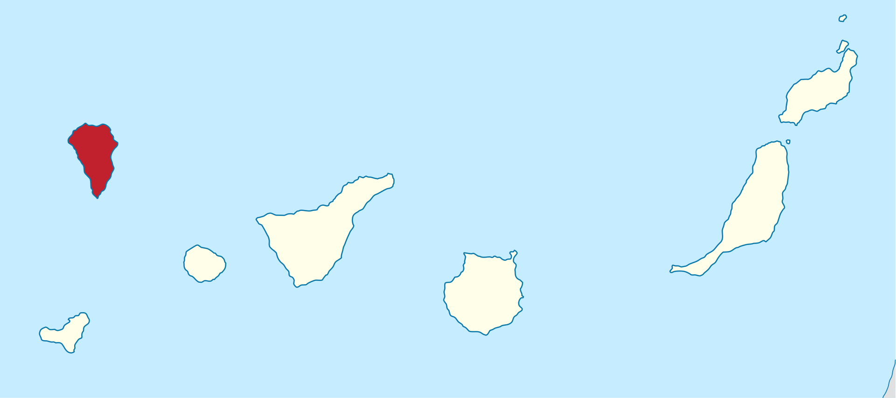

Map of La Palma

La Palma is one of the west most islands in the Volcanic Archipelago of the Canary Islands (Figure 2).

Source: [Article Notebook](https://quarto-ext.github.io/manuscript-template-jupyter/index.ipynb.html)

|  |
| --- |
| Figure 3: Locations of earthquakes on La Palma since 2017. |

Source: [Article Notebook](https://quarto-ext.github.io/manuscript-template-jupyter/index.ipynb.html)

Figure 3 shows the location of recent Earthquakes on La Palma.

Source: [Article Notebook](https://quarto-ext.github.io/manuscript-template-jupyter/index.ipynb.html)

## 2 Data & Methods

Source: [Article Notebook](https://quarto-ext.github.io/manuscript-template-jupyter/index.ipynb.html)

## 3 Conclusion

Source: [Article Notebook](https://quarto-ext.github.io/manuscript-template-jupyter/index.ipynb.html)

## References

Source: [Article Notebook](https://quarto-ext.github.io/manuscript-template-jupyter/index.ipynb.html)

Marrero, José, Alicia García, Manuel Berrocoso, Ángeles Llinares, Antonio Rodríguez-Losada, and R. Ortiz. 2019. “Strategies for the Development of Volcanic Hazard Maps in Monogenetic Volcanic Fields: The Example of La Palma (Canary Islands).” *Journal of Applied Volcanology* 8 (July). <https://doi.org/10.1186/s13617-019-0085-5>.