Spectral Analysis of Transiting Exoplanetary Systems
Name: Luke Hyndman
Student Number: 32098455
Date: 2/8/24

- ABSTRACT

Exoplanets whose orbits cause them to transit between their star and Earth present a unique opportunity to study their atmospheres using spectroscopy. During a transit, the star's light passes through the planet’s atmosphere. By comparing the spectrum observed during transit to that observed outside of transit, a transmission spectrum of the planet’s atmosphere can be obtained. This method provides crucial insights into the planet’s composition, thermal profile, and potential habitability, offering clues about its formation and evolutionary history. This approach is precious for studying exoplanets that differ from those in our solar system.

The primary objective of this investigation is to examine the transmission spectra of exoplanets with characteristics dissimilar to those found in our solar system, looking for absorption lines that would indicate the presence of various common atmospheric gasses.

Pi Mensae c, a Neptune-like, Super-Earth-sized planet orbiting its G0V host star at a close distance (~0.07 AU), and WASP-18 b, a gas giant with an even closer orbit (~0.02 AU) around its F6IV/V star, are prime candidates for such an analysis. Despite sharing some key characteristics, such as their close orbits, these planets exhibit significant differences that could manifest in their respective transmission spectra. Atmospheric escape is likely for both targets due to their high irradiation, which could result in weak or null detections. Previous attempts have been made to detect H₂ in Pi Men c’s atmosphere, and there are conflicting reports of water vapour in WASP-18 b’s atmosphere. This investigation will attempt to recreate and verify these findings.

Should a null result arise when analysing the transmission spectrum of each planet, the aim of the investigation will pivot to examining the characteristics of their host stars’ spectra. The focus will shift to discerning their radial velocities, effective temperatures, and metallicities. Given that the two stars are of different spectral types, this comparison will enhance our understanding of main sequence stars and their spectral properties. If time allows, this secondary investigation will be conducted following the completion of the primary one.

This study will provide insights into the diversity of exoplanetary atmospheres, particularly those of close-orbiting planets and hot Jupiters. The findings could advance our understanding of planet formation and evolution, refine models used to study exoplanets, and ultimately enhance the search for habitable worlds.

- Summary of observing runs requested and scheduling constraints
I request 4 separate observing runs with HERCULES on the 1-meter McLellan telescope, each corresponding with a transit. The first 3 transits are 2hrs 13min long. The last is 3hrs 17min in duration. Due to the small transit depth for one target and the low brightness of the other, I require maximum time to collect data on the transit. Therefore, I request 4x30-minute exposures for each of first 3 nights to capture as much of each transit as possible. For the fourth transit, I request 6x30 minute exposures. This would give a total of 9 hours of transit observation time.

Additionally, I require observations of the stars outside of the transit periods, ideally when the stars are at maximum elevation. To have roughly equivalent SNRs, the time observing the stars out of transit should be equal to the time spent observing during transit. Thus, request 2 further runs to observe the stars at their maximum elevations. 6 on WASP-18 and 3 on Pi Men, totalling 9 hours.
Run | Telescope | Instrument | Object  (RA, DEC)  (J2000.0) | Mag | Observations  (eg exposure time, filters) | Total Hours  (nights x hours) | Visibility
1 | 1m | Hercules | WASP-18 b  01:37:25.07  -45:40:40.06 | V=9.3 | 4 x 30min exposures R=41K | 1 night x 2hrs | Transiting 01:13 to 03:25 on night of Sat 24/8/24  Start observing at 1:14
2 | 1m | Hercules | WASP-18 b  01:37:25.07  -45:40:40.06 | V=9.3 | 4 x 30min exposures R=41K | 1 night x 2hrs | Transiting 23:48 to 02:01 on Sun 25/8/24  Start observing at 23:49
3 | 1m | Hercules | WASP-18 b  01:37:25.07  -45:40:40.06 | V=9.3 | 4 x 30min exposures R=41K | 1 night x 2hrs | Transiting 22:24 to 00:37 on Mon 26/8/24  Start observing at 22:25
4 | 1m | Hercules | Pi Men c  05 37 11.83  -80 27 52.57 | V=5.7 | 6 x 30min exposures R=41K | 1 night x 3 hours | Transiting 18:55 to 21:53 on Tue 3/9/24
5 | 1m | Hercules | WASP-18  01:37:25.07  -45:40:40.06 | V=9.3 | 12 x 30min exposures R=41K | 12 nights x 6 hours | Azimuth is ~4am on 24/8, moving closer to 3:30am on 3/9. Start observing at 3am on each of the 12 nights.
6 | 1m | Hercules | Pi Men  05 37 11.83  -80 27 52.57 | V=5.7 | 6 x 30min exposures R=41K | 6 nights x 3 hours | Start observing at midnight on the last 6 days of observation.

Comments:
Given the specific timing required for transit observations, scheduling flexibility is limited. However, I am willing to adjust the stellar observations if necessary. If time cannot be allocated for any of the transits, they, are listed in decreasing order of priority. All observations should be made at the lowest resolving power of R=41,000 to capture as much light as possible. To minimise lunar illumination, Pi Mensae should be observed during the second half of the observing window.

3. Scientific Justification

Primary Objective

The primary objective of this investigation is to detect the presence of various molecular gases in the atmospheres of Pi Mensae c and WASP-18 b by examining their transmission spectra for absorption lines. Previous studies have attempted similar analyses for both planets, but this project aims to provide further confirmation or new insights.

Spectral Analysis of Pi Mensae c
A 2019 study attempted to find hydrogen in Pi Mensae c’s atmosphere but was unable to detect it. This may be due to the planet’s high irradiation levels—approximately 2000 times that of Earth —which likely lead to significant atmospheric escape [1,2]. We will look to confirm this result by examining the optical band for potential signatures of gases such as O₂, H₂O, O₃, NO₂, Na, TiO, K, etc. Given the planet’s low transit depth of 0.32 ppt, detecting these gases may be challenging. However, the system remains a valuable target for investigation as Pi Mensae is one of the optically brightest known systems with a transiting planet (Vmag = 5.7), making it well-suited for observations with HERCULES, which is optimized for the optical band [3]. Interestingly, the planet is likely to have formed much farther out from its star and migrated inwards thanks to interactions with the brown dwarf Pi Mensae b [8]. The intricacies of planetary migration are still being understood by astronomers. By analysing the composition of Pi Men c, we could speculate on the makeup of the protoplanetary disk of the system.

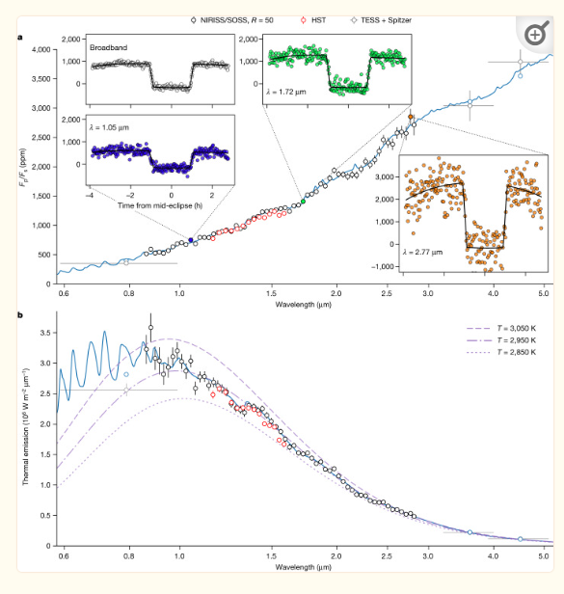
Spectral Analysis of WASP-18 b
WASP-18 b is the more compelling candidate of the two, primarily because it is a confirmed ‘Hot Jupiter’ with an extremely close orbit around its host star [4]. Something not seen in our solar system. Due to the planet’s severe proximity to its star, it is expected to spiral into WASP-18 in the next million years because of tidal deceleration. Carbon monoxide and water vapour have been detected in its atmosphere through previous transmission spectroscopy studies [5,6]. However, the presence of water vapour is contested, and our investigation aims to verify this finding. WASP-18 b’s significant transit depth of 18.0 ppt enhances its suitability for this analysis [7]. Fig. 2 shows a broad-band spectrum of WASP-18 b [6]. Our investigation will attempt to replicate this figure on a much narrower band of wavelengths.
Figure 2 courtesy of Coulombe, L., et al. [6]:
A spectral analysis of WASP-18 b.

In Case of a Null Result: Secondary Objective

If no atmospheric features are discernible in the spectra of either planet, the investigation will pivot to examining the host stars. This secondary objective will focus on determining the stars' radial velocities (through redshift), metallicities, and effective temperatures. This backup plan is advantageous due to the availability of detailed literature on these stellar parameters, which can serve as a robust foundation for comparison. Time permitting, this secondary investigation will begin after the completion of the primary objective.

Project Significance
This project is significant on multiple levels. First, it represents the first attempt by an ASTR211 student to conduct exoplanetary spectroscopy with HERCULES. Should the project succeed, it would serve as a proof of concept for future projects along similar lines.

Moreover, this research contributes to the broader scientific community's understanding of exoplanetary atmospheres, particularly those of close-orbiting planets and hot Jupiters, which differ significantly from the planets in our solar system. By identifying or confirming the presence of molecular gases in these exoplanetary atmospheres, we can refine models of planetary formation and atmospheric evolution. This is particularly relevant for understanding the processes that drive atmospheric escape, as seen in Pi Mensae c, or the atmospheric composition of extreme environments, like that of WASP-18 b.

The implications of this research extend beyond individual planetary systems. By improving our knowledge of exoplanetary atmospheres, we also enhance our ability to identify potentially habitable worlds in other star systems. This is crucial in the ongoing search for life beyond Earth. Additionally, the secondary objective of this study—analysing the host stars' spectra—could yield valuable data that contributes to our understanding of stellar properties, which is fundamental to many areas of astrophysics.

4. Technical Justification
Use of the 1-meter McLellan telescope with the HERCULES spectrograph is a requirement as it is the only spectrograph at UCMJO. It is also well suited to the requirements of the investigation as it is centred on the optical band, which is where many of the absorption lines we wish to investigate are located. The targets have been selected because of their brightness, transit depth, transit duration, and visibility from UCMJO. The timing and duration of the requested observing periods are informed by data on when and for how long each transit will occur, with the best visibility and minimum lunar illumination [9]. Both Transits are approximately 2-3 hours in duration, ideal for gathering multiple long exposures for the best SNR possible. For both targets, we have requested an equal amount of time observing the star itself to keep the SNRs of each measurement roughly equivalent.

The first target, WASP-18 b, is dim (Vmag = 9.3) however it has an excellent transit depth of ~1.8%. This, in combination with 4 sets of 30-minute exposures on each of the 3 transits will maximise SNR and capture as much of the 2hr 13min transit duration as possible. A rough estimation of the SNR over all transits and exposures is 625. The second target, Pi Mensae c, is much brighter (Vmag = 5.7) with a longer transit duration of 3hr 17min. its primary drawback is its 0.032% transit depth and that there will only be one visible transit during the observation window. We estimate an SNR of 784. Attached below are the paths of each system on the sky on the night of each transit.
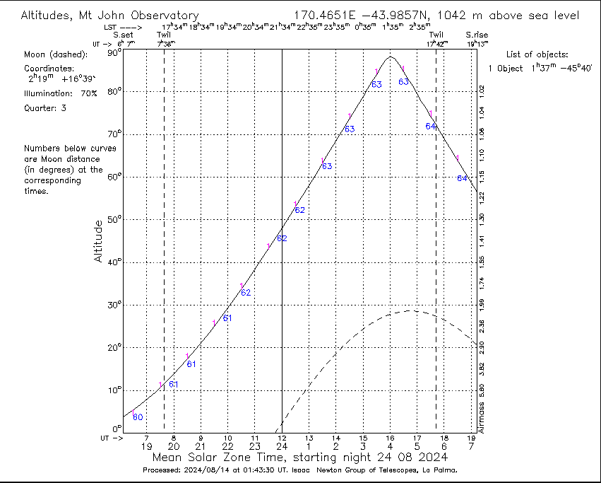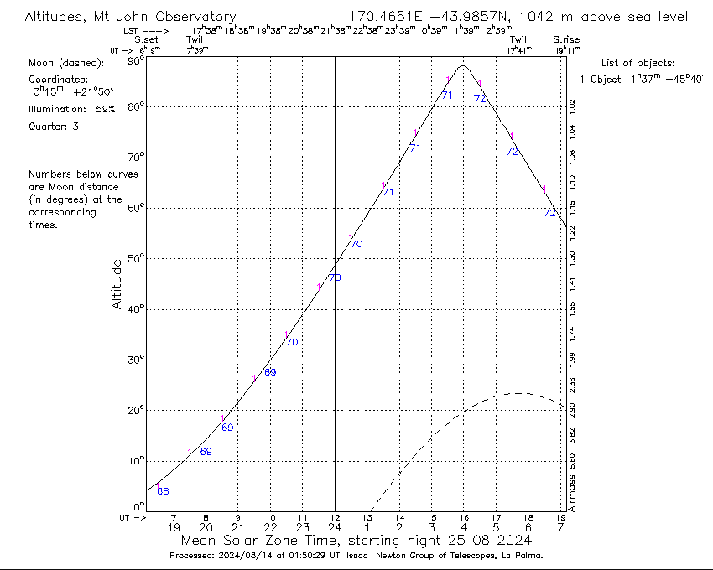
Figure 1: WASP-18 b on night of 24/8 Figure 2: WASP-18 b on night of 25/8
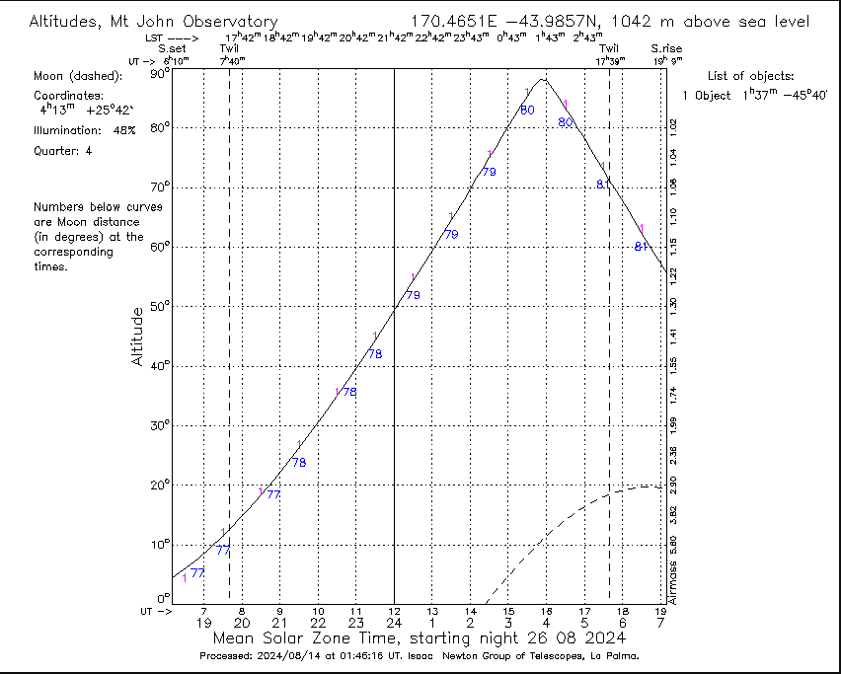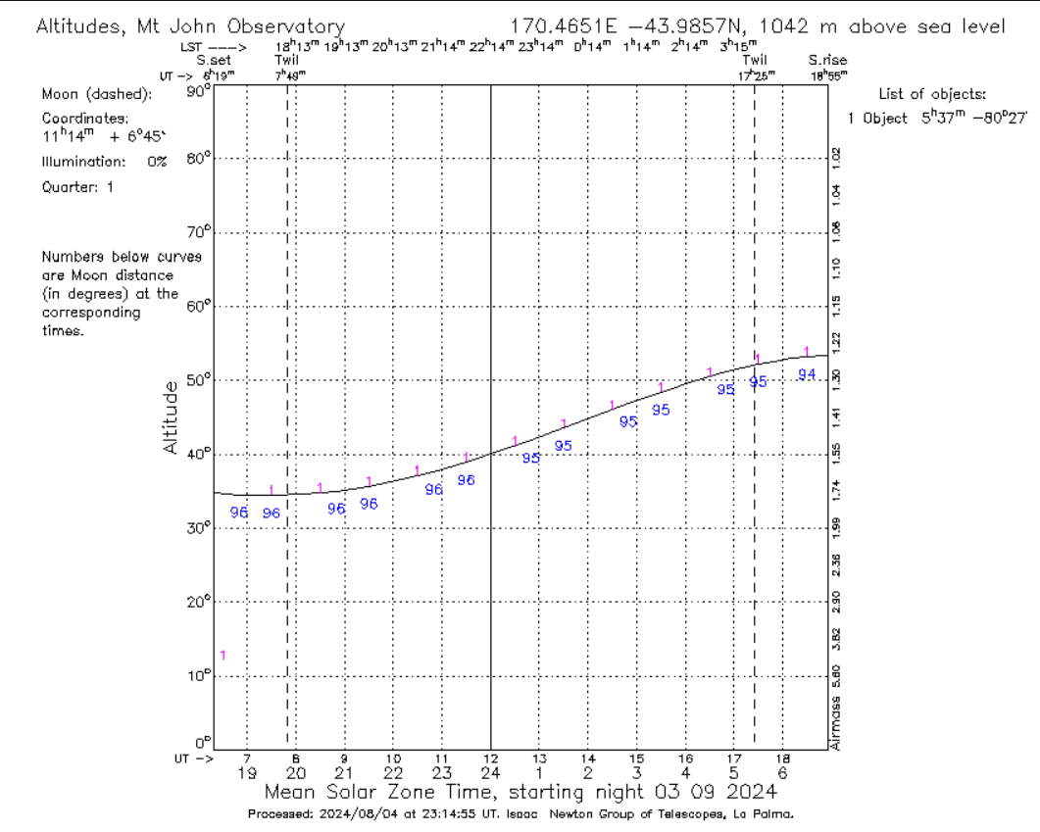
Figure 3: WASP-18 b on night of 26/8 Figure 4: Pi Men c on night of 3/9

5. Analysis Plan
Data Reduction:
- The FITS files obtained from the HERCULES spectrograph will be processed using custom scripts developed during the labs in Jupyter Notebook.
- Standard reduction techniques will be applied, including bias subtraction, flat-field correction, and wavelength calibration.
- Stellar parameters will be derived using a pipeline provided by Ethan Bull.
Transmission Spectrum Extraction:
- For each target, the spectra will be extracted during and outside the transit period.
- The extracted spectra will be normalized, and the transmission spectra will be computed by subtracting the in-transit spectra from the out-of-transit spectra.
Spectral Analysis:
- The resulting transmission spectra will be analyzed for the presence of absorption features, particularly those corresponding to molecular gases such as H₂O, CO, Na, and others.
- If no significant features are detected, the analysis will pivot to focus on the host stars' spectra, using the same pipeline to extract stellar parameters and compare them against literature values.

6. References
- Garcia Munoz, A., et al. 2019, arXiv:1912.06913 (H₂ in Pi Mensae c’s atmosphere)
- King, G., et al. 2019, MNRAS Letters, 484, L49 (Pi Mensae c irradiation)
- Huang, C. X., et al. 2018, Astrophysical Journal Letters, 868, L39 (Pi Mensae c discovery/transit depth)
- Hellier, C., et al. 2009, Nature, 460, 1098 (WASP-18 b discovery)
- Sheppard, K. B., et al. 2017, Astrophysical Journal Letters, 850, L32 (WASP-18 b carbon monoxide)
- Coulombe LP., 2023, Nature, 620(7973):292-298. (WASP-18 b water vapor)
- Shporer, A., et al. 2019, Astronomical Journal, 157, 178 (WASP-18 b transit depth)
- Hodzic, V. K., et al. 2021 arXiv:2007.11564 (Pi Men c migration)
- https://astro.swarthmore.edu/transits/transits.cgi (Swarthmore College Transit finder)

