**AirPlan – Online Flight Booking System**

AirPlan Architecture Document

EECE 419 Assignment 3

Document Ref.: EECE419-Pod-10_Architecture

First Issue- October 2, 2012



**CIRCULATION / DISTRIBUTION LIST**

|  |  |
| --- | --- |
| **NAME** | **STUDENT#** |
| Anuj Mehta | 23610082 |
| Ryan Randhawa | 62768080 |
| Kevin Chow | 44692093 |
| Nathaniel Sham | 65635088 |
| Yu Han | 43088087 |
| Louie Yuen | 75658096 |
| Yonathan Indrajaya | 42087072 |
| Scott Pearson | 43821081 |
| Shirley Gong | 63769087 |

**DOCUMENT IDENTIFICATION SHEET**

|  |  |  |  |
| --- | --- | --- | --- |
|  | | | |
| Date of first issue: 28/09/2012 | | Current version number : Version 1.0 | |
|  | | | |
| Prepared by : | EECE 419 Pod 10 | | Date : 02/10/2012 |
|  |  | |  |
| Verified by : | Ryan Randhawa | | Date : 02/10/2012 |
|  |  | |  |
| Approved by : | Anuj Mehta | | Date : 02/10/2012 |
|  |  | |  |
| Status : | COMPLETED | | Applicability Date: 02/10/2012 |
|  | | | |

**Copyright notice**

This document may not be reproduced (even partially) or communicated to third parties without the written authorization of Pod 10 Project Management.

DOCUMENT CHANGE RECORD

|  |  |  |
| --- | --- | --- |
| **Date** | **Description** | **Affected sections** |
| 29/09/2012 | First Issue | All |
| 02/10/2012 | Version 1.0 | All |
| 25/11/2012 | Version 2.0 | All |

Contents

1. Introduction 2

1.1. Purpose 2

1.2. Scope 2

1.3. Overview 2

2. Class Diagram 3

3. Sequence Diagrams 4

3.1. Search Flight 4

3.2. Reserve Flight 5

3.3. Manage Payment 6

3.4. Modify/ Cancel Reservation 6

3.5. View and Print Boarding Passes 7

3.6. View Flight Manifest (Airline Staff) 8

3.7. View Flight Manifest (Airline Managers) 9

3.8. View Flight Statistics 9

3.9. Modify/Cancel Reservation on Behalf of Customer 10

3.10. View Graphical Representation 11

4. Deployment Architecture 12

# Introduction

## Purpose

The purpose of this document is to describe the initial architecture of the AirPlan flight reservation and management system. The major components of the system will be defined here, as will the relationships between them. This document is for use by developers and testers to implement and debug the system.

## Scope

The scope of this document includes the initial architecture of the AirPlan flight reservation and management system. An overall high level design is described here. Use case and sequence diagrams are presented to the reader, as well as class diagrams laying out the components of the system and the relationships that exist between them. The sequence diagrams describe a series of events that will take place for each use case, and the flow of execution behind the scenes. This document also defines the database structure and the tables that will be used to store all of the necessary data such as Users, Bookings, and Flights. Also included is the deployment architecture, which is how it is intended to be deployed in the real world.

## Overview

This document aims to provide an initial architecture for AirPlan.

AirPlan defines 3 different types of users: Customers, Airline Employees, and Airline Managers. Customers are able to reserve flights, manage payments, modify or cancel reservations, and view and print boarding passes. Airline Employees can view the flight manifest, and Airline Employees can view the flight manifest, and view statistics for all flights.

To store user and flight data, the database will hold the following tables: Users, Points, Billing, Bookings, Flight Mappings, Flights, and Staff. AirPlan will consist of a layered structure, providing services that act as a wrapper around the database, providing the rest of the application with a clean interface that is separate from the data. These services include: the registration service, flight service and the user service.

# Class Diagram

The following class diagram shows an overview of the AirPlan system. The next section – featuring sequence diagrams - goes into detail about the relationships between each of these classes.

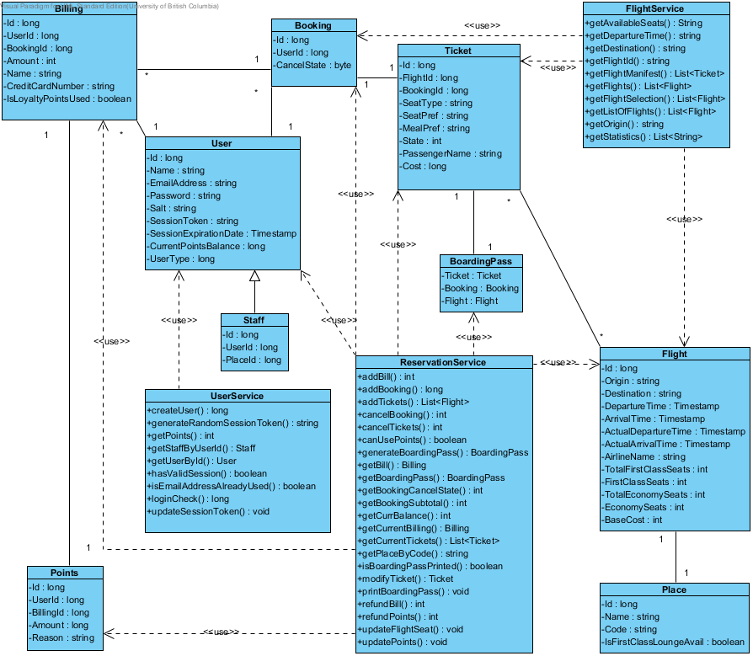

Figure 1: Class Diagram

# Sequence Diagrams

This section includes one sequence diagram for each use case specified in the initial requirements document. The diagrams are shown in the same order as the use cases were initially written.

## Search Flight

The following sequence diagram describes how a customer can search for flights over the Internet.

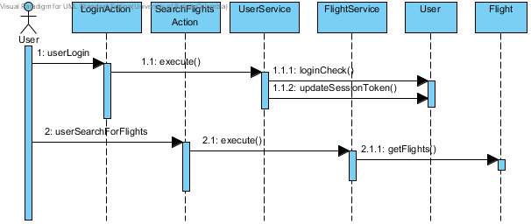

Figure 2: Search Flights Sequence Diagram

## Reserve Flight

The following sequence diagram describes how a customer can reserve flights using the AirPlan reservation system.

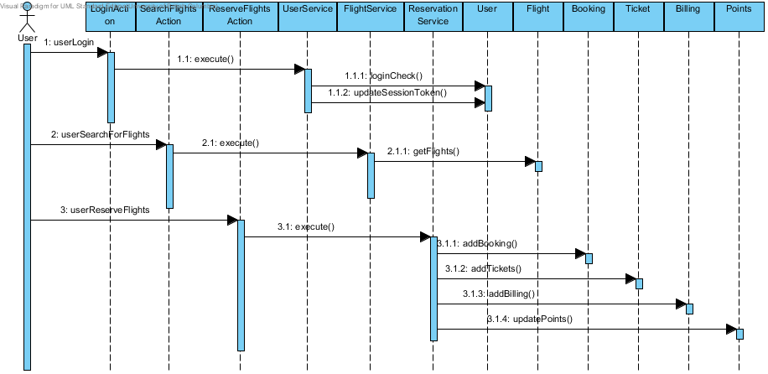

Figure 3: Reservation Sequence Diagram

## View Transaction History

The following sequence diagram describes how a customer can view all their past

transactions and check their loyalty points usage and history.

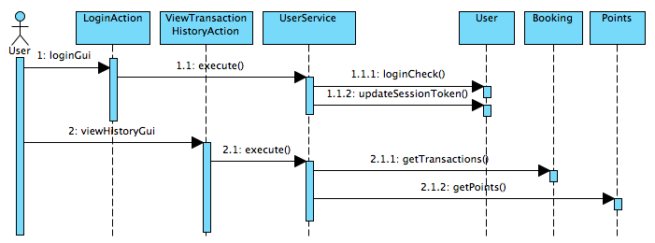

Figure 4: Manage Payment Sequence Diagram

## Modify Booking

The following sequence diagram describes how a customer can modify their ticket reservation over the Internet.

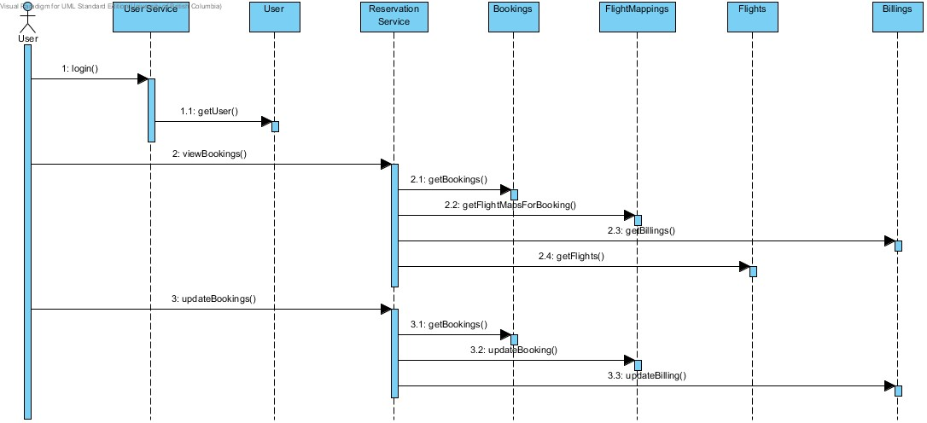

Figure 5: Modify Booking Sequence Diagram

## Cancel Booking

The following sequence diagram describes how a customer can cancel their booking over the Internet.



Figure 6: Cancel Reservation Sequence Diagram

## View and Print Boarding Passes

The following sequence diagram describes how a customer can view and/or print their boarding pass for the purchased flight tickets.

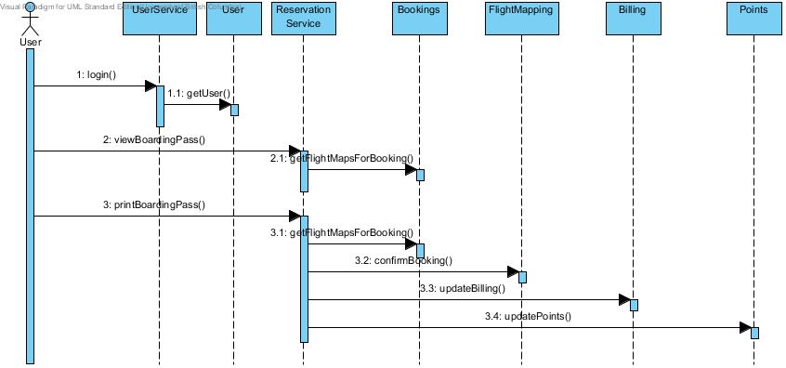

Figure 7: Boarding Passes Sequence Diagram

## View Flight Manifest (Airline Staff)

The following sequence diagram describes how airline staff can view a flight manifest.

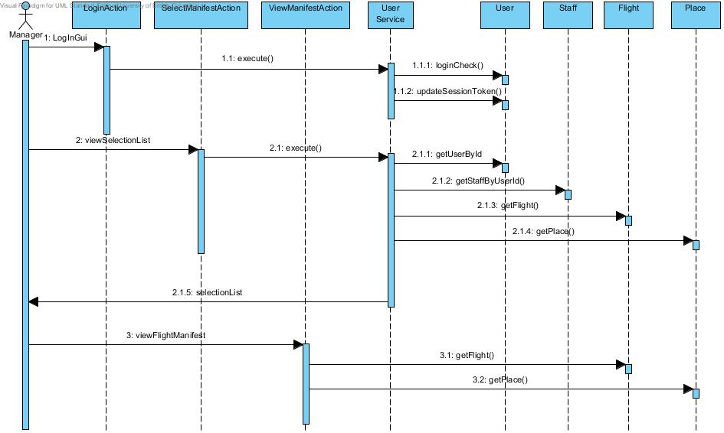

Figure 8: View Flight Manifest Sequence Diagram

## View Flight Manifest (Airline Managers)

The following sequence diagram describes how airline managers can view a flight manifest.



Figure 9: View Flight Manifest Sequence Diagram

## View Flight Statistics

The following sequence diagram describes how airline managers can view flight statistics.

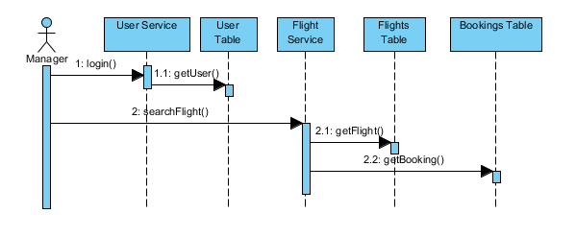

Figure 10: View Flight Statistics Sequence Diagram

## Modify Ticket Reservation on Behalf of Customer

The following sequence diagram describes how airline staffs/managers can modify ticket reservations on behalf of customers.

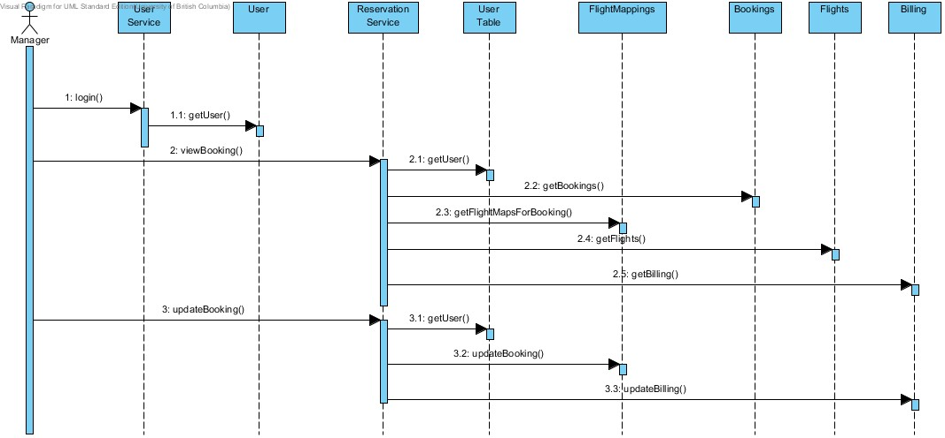

Figure 11: Modify Ticket Reservation Sequence Diagram

## Cancel Booking on Behalf of Customer

The following sequence diagram describes how airline staffs/managers can cancel bookings on behalf of customers.



Figure 12: Cancel Booking Sequence Diagram

## View Graphical Representation

The following sequence diagram describes how airline staffs/managers can view a graphical representation of flights in the system.

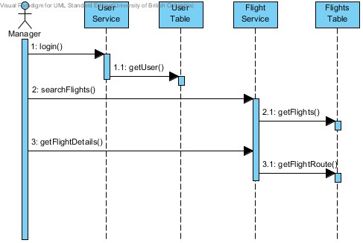

Figure 13: View Graphical Representation Sequence Diagram

# Deployment Architecture

The AirPlan flight management and reservation system will be deployed on a web application server such as Apache Tomcat. This web application server will be deployed on a server rented from a hosting service provider such as Amazon or Rackspace. AirPlan’s database will be deployed on a dedicated server so that it can be scaled independently of the application server.

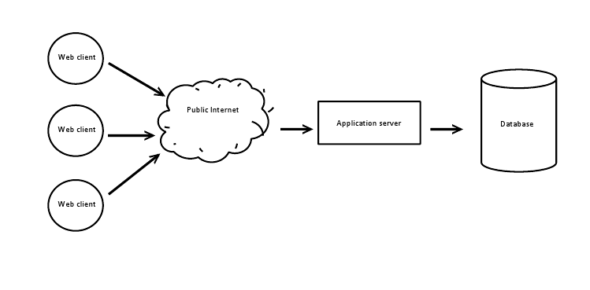

Figure 14: Deployment Diagram