Do inflation forecasters under-react to news? Four preregistered tests on ECB staff projections and professional forecasters
[Author]
November 2026
Abstract
When ECB/Eurosystem staff revise an inflation projection, does inflation end up beyond the revised number? Four preregistered tests, recomputed from public data, and one decisive replication give a qualified answer. A correction rule estimated in real time on past errors would not have predicted staff errors (mean block correlation 0.02, 90% interval [−0.07, 0.10]; verdict: eliminated). After the fact, errors two quarters ahead do follow revisions over 1999–2026 (correlation 0.44, [0.12, 0.76]; survives), but the correlation falls to 0.05 without 2021–2022 and to 0.14 without 2021–2023. Individual ECB SPF forecasters under-react too once reporting noise is handled with an instrument (2SLS slope 1.15, [0.36, 1.94]; the predicted over-reaction is eliminated), again mostly through 2021–2023. The ECB SPF consensus under-reacts on average (base slope 0.37), but that under-reaction does not grow with the size of the news: in a decisive replication, the extra slope after large news is −0.11 ([−0.26, 0.05]), so the predicted +0.40 is excluded (eliminated). The same test on the US SPF consensus gives a similar estimate (−0.03, [−0.15, 0.09]) but stays formally inconclusive because a schema guard failed.

1 Introduction
A forecaster under-reacts when news moves the forecast in the right direction but not far enough. The standard measure is the slope of the forecast error (outturn minus forecast) on the forecast revision (new minus old forecast for the same target). If forecasts used all available information, the revision could not predict the error and the slope would be zero. A positive slope is under-reaction: an upward revision is followed, on average, by inflation higher still. A negative slope is over-reaction.
This matters to a central bank. Staff projections feed policy decisions. If they systematically move too little, policy based on them may move too little too, and the 2021–2022 surge made that cost visible. And if errors were predictable from revisions, a simple correction might improve the projections. Whether such a correction would have worked in real time is a different question from whether a slope exists in a full sample studied after the fact.
This note reports four tests of the question and one decisive replication of the last of them. Each was preregistered and sealed by a SHA-256 hash before any statistic was computed. Each verdict was applied by code to numbers recomputed by an independent verifier, and a separate pipeline then rebuilt every number from raw public data. The answer, in three sentences:
- A revision-based correction rule estimated in real time would not have predicted the errors of ECB/Eurosystem staff inflation projections over 2004–2025.
- Over 1999–2026, staff errors two quarters ahead do follow revisions, and so do the errors of individual forecasters in the ECB Survey of Professional Forecasters (SPF), but in both cases the size of the effect comes mostly from the 2021–2023 surge.
- Under-reaction does not grow with the size of the news: in the ECB SPF consensus, which under-reacts on average, a decisive replication excludes the predicted extra under-reaction after large news; the same test on the US Survey of Professional Forecasters, with similar point estimates, stays inconclusive for a formal reason.
How the question arose. The question did not come from one insight but from a sequence of tests, each prompted by the previous one. It started from a textbook tool, the regression of forecast errors on forecast revisions (Coibion and Gorodnichenko, 2015), applied to the forecaster that matters most to a euro-area central bank, ECB staff, whose 2021–2022 inflation misses were public. The first, practical question was whether a correction could have helped in real time; the ECB’s own in-sample evaluation (Chahad et al., 2024) had left that open. When the real-time rule failed, the natural next step was the in-sample slope over the full sample, surge included; when that slope turned out to rest on 2021–2022, the next question was who under-reacts — the institution, or forecasters in general — which is the question Bordalo, Gennaioli, Ma and Shleifer (2020) asked for US data, where individuals over-react while the consensus under-reacts. A student could follow the same path without any AI tool: start from a standard regression, apply it to one well-known forecaster, ask whether the finding is usable in real time, then whether it is specific to that forecaster or to one episode. Section 8 describes how the steps were actually run.

2 Related work
ECB staff projections. Granziera, Jalasjoki and Paloviita (2021) ran this regression on quarterly ECB staff inflation projections over targets 1999Q4–2019Q4, on data then confidential. Two quarters ahead they found 0.20 (standard error 0.21) points of error per point of revision: positive, not significant. Their published version (2025) extends the sample to 2023Q4 but studies bias only. The ECB’s own evaluation up to 2024Q1 (Chahad et al., 2024) rejects “no oversmoothing” up to three quarters ahead in rolling 32-quarter windows, without publishing a coefficient or sign. At two quarters ahead the rejection disappears once errors are adjusted for technical assumptions, which an earlier box (Chahad et al., 2022) credits with about three quarters of the 2021 and early 2022 errors. Kontogeorgos and Lambrias (2019) and Conrad, Enders and Müller (2025) find the projections broadly unbiased and efficient in earlier samples. This note adds one full-sample slope through 2026Q3 on the public projection database, with a size threshold fixed in advance, and a real-time test of whether the slope was usable.
Real-time correction. Eva and Winkler (2023) re-estimate the Coibion–Gorodnichenko regression recursively on US surveys. The out-of-sample correction usually hurts; for CPI the gain is about 1% of squared error, almost all in 2021–2022. Arai (2014) finds modest gains for the Fed’s Greenbook. The project’s search found no such real-time test on ECB staff projections, which is not proof that none exists.
Consensus versus individuals. A positive consensus slope is what dispersed, noisy information predicts even with rational forecasters (Coibion and Gorodnichenko, 2015). Bordalo, Gennaioli, Ma and Shleifer (2020) find that the US consensus under-reacts while individuals over-react. On the ECB SPF over 2000Q1–2020Q1, Broer and Kohlhas (2024) find a consensus slope of 0.740 (0.406) and an individual slope of −0.169 (0.182). Kučinskas and Peters (2024) find strong over-reaction in a within-period version on US data, while noting they cannot rule out autocorrelated measurement error. Juodis and Kučinskas (2023) show that reporting noise alone pushes individual slopes negative. Gemmi and Valchev (2026) find neither over- nor under-reaction in the Fed’s Greenbook. Andrade and Le Bihan (2013) document predictable errors in the ECB SPF without this regression.
Size of news. Coibion and Gorodnichenko (2015) find less rigidity in turbulent periods. Coibion and Gorodnichenko (2012) show that in the sticky-information model the normalised response does not depend on shock volatility. Kučinskas and Peters (2024) find more under-reaction when inflation is high. Baker, McElroy and Sheng (2020) find less rigidity after large disasters, and de Silva et al. (2025) over-reaction to extreme news in firms’ sales forecasts. No estimate of an extra slope after large surprises on the US SPF consensus was found.

3 Data
ECB Macroeconomic Projection Database (MPD). One series per projection exercise (“vintage”) from the ECB data API (MPD/Q.U2.HIC.A.<vintage>.0000: quarterly year-on-year euro area HICP inflation). The MPD has no publication timestamp. Each vintage was identified by its letter (W = March, G = June, S = September, A = December), checked against the exercise name in TITLE_COMPL and against the first quarter flagged as projected (F). Only values with status F were read as projections. The annual series (MPD/A.U2.HIC.A.<vintage>.0000, 97 vintages) supplied staff projections for annual targets in K01.
ECB SPF individual forecasts. SPF_microdata_by_variable.zip, file 1_HICP.csv: point forecasts of annual average HICP inflation for the current and the next year. Rounds 2002Q1–2025Q4, target years 2002–2025, forecasters present in at least eight complete rounds: 8,595 revisions, 94 forecasters, 96 rounds.
Eurostat HICP. For quarterly targets, the monthly index prc_hicp_minr (2015 = 100, ECOICOP v2), with the outturn computed as the year-on-year change of the quarterly average. For annual targets, the annual average rate prc_hicp_ainr. Both are latest vintages.
Philadelphia Fed SPF. Mean forecasts (meanLevel.xlsx, meanGrowth.xlsx; medians as a check) of the GDP deflator, real GDP, unemployment, CPI inflation and the 3-month T-bill, three and four quarters ahead, with annualised growth rates for the deflator and real GDP. Targets 1969Q4–2026Q3 (1982Q3 onward for CPI and the T-bill); real GDP and unemployment exclude targets 2020Q1–2021Q4. In all, 1,004 rows over 223 target quarters.
Outturns for K20. First releases from the Philadelphia Fed real-time data set (pQvQd.xlsx, routputQvQd.xlsx) for the deflator and real GDP; the latest FRED vintage of UNRATE, CPIAUCSL and TB3MS, which are revised little or not at all. USRECQP dated the episode windows. ALFRED was checked but is not used by any test.
Real-time conventions. Only H03-v2 is a real-time exercise. There the outturn of a target quarter was read in the MPD vintage published two quarters later (three or four if missing), and the rule at each vintage used only pairs whose outturn had been published by then. J02, K01 and K20 are in-sample tests. The ECB exercise of a quarter is finalised about two months after the SPF round of the same quarter, so the two do not share an information set.

4 Method

4.1 The four tests and the replication
In all tests the revision is the new forecast minus the previous one for the same target, and the error is the outturn minus the new forecast. Each preregistration fixed three outcomes: survives, eliminated and inconclusive. “Inconclusive” applies when a data or schema guard fails, or when the 90% interval contains both “no effect” and the predicted effect.
H03-v2: real-time correction (ECB staff, horizons 1–4, targets 2004–2025). At each vintage and horizon, a slope of error on revision was estimated by OLS on the pairs whose error was already known (at least eight). The announced correction was that slope times the current revision. The statistic is the mean, over 11 two-year blocks of targets, of the uncentred correlation between correction and realised error, with a Student-t interval allowing for similar neighbouring blocks. Rule: survive if the lower bound is above 0, the mean outside 2020–2023 is positive and the geometric mean of block MSE ratios (corrected over published) is below 1. Eliminate if the interval excludes 0.22, the smallest predicted effect (a 5% fall in squared error).
J02: full-sample slope (ECB staff, two quarters ahead, 108 targets 1999Q4–2026Q3). The standardised slope of error on revision, which equals their correlation, with a Newey-West standard error (4 lags). Rule: survive if the 90% lower bound is above 0, the upper bound is at least 0.40 (the predicted size) and the correlation stays positive when any two consecutive years of targets are removed. Eliminate if the upper bound is below 0.40.
K01: individual forecasters (ECB SPF, targets 2002–2025). A pooled two-stage least squares (2SLS) slope of the individual error on the individual revision, with a constant per horizon and no time or forecaster fixed effects. Driscoll-Kraay standard errors (round-level sums, 8 lags), critical value 1.714 (t with 23 degrees of freedom for 24 target years). Rule: survive (over-reaction) if the upper bound is below 0 and the slope without targets 2021–2023 is negative. Inconclusive if the first-stage F is below 23.1 or the interval contains both 0 and −0.15, the predicted slope. Otherwise eliminate, which includes an interval wholly above −0.15.
K20: large surprises (US SPF consensus, five variables). A surprise is the gap between a data release, published between the two surveys that define the revision, and the consensus nowcast of it. “Large” is the top third of absolute surprises for each variable. The statistic is the extra slope c of the standardised error on the standardised revision after large surprises, with variable-specific constants, class effects and base slopes, and Driscoll-Kraay standard errors (4 lags in calendar quarters). Rule: survive if the 90% lower bound exceeds a mechanical-bias floor, max(0.10, the bias implied by a 20% noise share), the upper bound is at least 0.40, and t ≥ 1 after removing each of seven recession-based episodes. Inconclusive if any schema check fails, among other conditions. Otherwise eliminate.
K20-ZE: the same question on the euro area (ECB SPF consensus, three variables, target years 2000–2025). After K20’s inconclusive verdict, the question was preregistered again, blind, on the ECB SPF: the consensus (mean of the individual point forecasts) for HICP inflation, real GDP growth and unemployment, current and next calendar year, one row per variable, target year and round (578 rows, 107 rounds, 26 target years; GDP and unemployment targets of 2020–2021 excluded). The news is the change, between two rounds, in the latest published figure the ECB sends to the forecasters, so it contains no survey noise; “large” is again the top third. The statistic is the same extra slope c, with Driscoll-Kraay standard errors (8 lags by round, critical value 1.708). The rule keeps K20’s three survival conditions (three euro-area episodes), counts schema failures only on rows in the computation, and adds a positive control: the base under-reaction must be visible, so that a null c cannot come from a blind instrument. This test is not recomputed by this note’s pipeline; a sibling project rebuilds it from raw data with separate code (Section 4.3).

4.2 Why an instrument, in plain words
The natural individual test compares forecasters within the same survey round. It cannot work. In a round, every forecaster faces the same outturn, so a forecaster’s error relative to the round average is exactly minus the deviation of the forecast from that average. The outturn drops out, and the within-round slope depends only on how the dispersion of forecasts changes between rounds. If dispersion is stable it equals −1/2 by construction, whatever forecasters do.
The pooled slope keeps the outturn, but a typo or rounding in a reported number enters the revision with a plus sign and the error with a minus sign. That creates a negative slope even for rational forecasters, and fixed effects do not remove it.
Each forecaster reports two annual forecasts per round, the current year and the next. News about inflation, such as an oil price move or a monthly print, moves both; a typo in one number has no reason to appear in the other. So the revision of target year y was instrumented with the same forecaster’s revision of the other target year in the same round. The instrument moves with news but not with the noise in the number evaluated. The forecaster knows it, so under rationality it cannot predict the error and the 2SLS slope is zero. Noise common to both numbers of a round is not removed, and the preregistration required reporting how much of it would be needed to explain a negative slope.

4.3 Preregistration and verification
A preregistration author who could see only file headers, column names and counts of present cells wrote the data, sample, statistic, thresholds, guards, tolerances and verdict rule, with a machine-readable copy of the rule. The text was then sealed by its SHA-256 hash (Appendix B). An experimenter in a fresh session built the analysis file and computed every field. A verifier on a different model read only the preregistration and the analysis file and recomputed everything, without seeing the experimenter’s code or numbers. A separate script checked agreement within the preregistered tolerances and applied the sealed rule to the verifier’s numbers.
For this note, a separate pipeline rebuilt the four analysis datasets from the raw files with its own code. It reproduced all 149 sealed verifier numbers within tolerance and gives the same four verdicts (Appendix A). K20-ZE is reproduced in full in the sibling project projects/spf-news-size-underreaction/ (65 of 65 verifier numbers within tolerance, analysis file bit-identical to the sealed one, same verdict); its numbers below are the sealed verifier numbers, also recorded in results/results.json. Every number below comes from results/results.json, except a few block-level and per-year descriptive values from tables in results/RESULTS.md produced by the same run, which are marked.

5 Results
Primary statistics and verdicts.
Test | Primary statistic | 90% interval | Sealed verdict
H03-v2, real-time rule | mean block correlation 0.016 (se 0.049) | [−0.074, 0.105] | eliminated
J02, full-sample slope | correlation 0.443 (NW se 0.196, t = 2.27) | [0.122, 0.765] | survives
K01, individuals | 2SLS slope 1.151 (DK se 0.463; first-stage F 514) | [0.357, 1.945] | eliminated
K20, large surprises | extra slope c = −0.030 (DK se 0.071) | [−0.146, 0.086] | inconclusive (schema guard)
K20-ZE, replication on the ECB SPF | extra slope c = −0.106 (DK se 0.090, t = −1.18) | [−0.259, 0.047] | eliminated

5.1 A real-time correction would not have worked (H03-v2)
The rule produced 352 evaluated projections in 11 blocks. The mean block correlation between announced correction and realised error was 0.016, 90% interval [−0.074, 0.105]. The interval contains zero and lies below 0.22. The verdict is eliminated: the rule estimated in real time did not announce the errors of ECB staff inflation projections over 2004–2025, and the data exclude, at the 5% level, the smallest effect predicted.
Without the 2020–2023 blocks the mean was −0.030. Over all evaluated rows the corrected projection had 3% less squared error than the published one (ratio 0.970), but 9.6% more without targets in 2021–2022 (ratio 1.096). In a typical block the correction made errors larger (geometric mean of block ratios 1.097). It helped in 44.8% of the projections it changed. The 2024–2025 block had a ratio of 1.81 (RESULTS.md): a slope learned during the surge over-corrected the disinflation. By horizon the mean correlation was 0.145, 0.128, 0.111 and −0.087 (one to four quarters ahead). The original idea’s own test (horizon 4, vintages from 2020, 21 rows) gave an MSE ratio of 1.010 and a Diebold-Mariano-HLN p-value of 0.911. A placebo with a two-year-old revision gave 0.075 (se 0.062), below the preregistered 1.8 standard errors that would have signalled a slow bias.
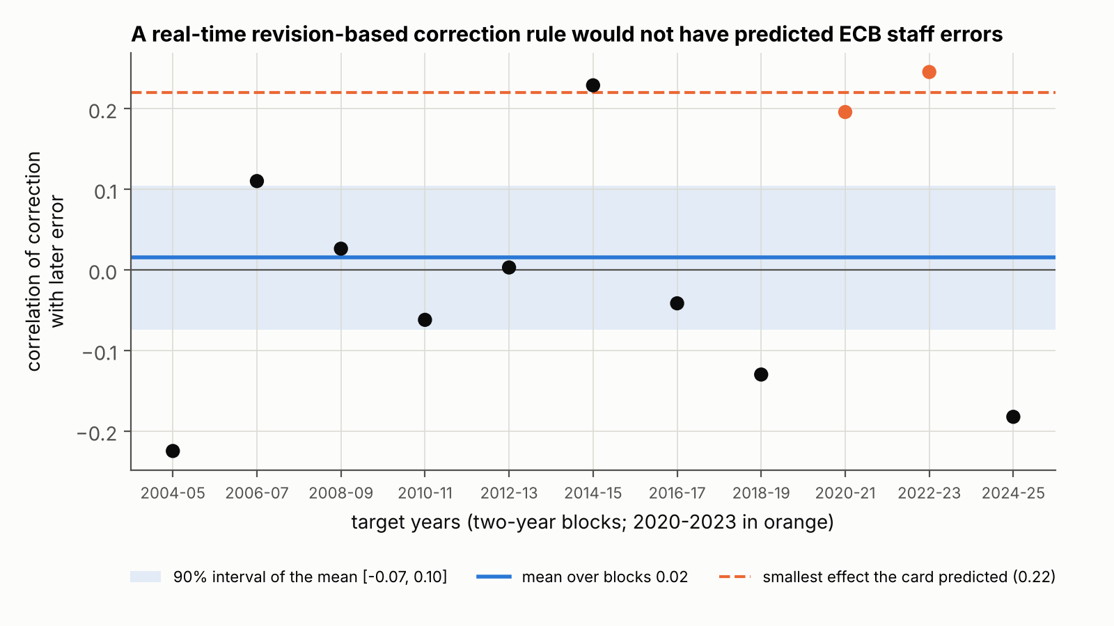
H03-v2. Correlation of the real-time correction with the later error, by two-year block of target years. Shaded band: 90% interval of the mean; dashed line: smallest predicted effect (0.22).

5.2 Under-reaction in the full sample, carried by 2021–2022 (J02)
Over 108 target quarters, the correlation between revision and error was 0.443 (Newey-West se 0.196, t = 2.27), 90% interval [0.122, 0.765]. In raw units, 0.678 points of error per point of revision (se 0.299). The smallest correlation after removing two consecutive years was 0.050, when 2021–2022 is removed. That is above zero, so the guard passed, and the verdict is survives. In the preregistered wording: over 1999Q4–2026Q3 the errors of the ECB’s two-quarter-ahead inflation projections followed their revisions, compatibly with the 0.40 predicted and positively whichever two consecutive years are removed. The test does not say whether this comes from under-reaction, deliberate smoothing or the technical assumptions.
The guard passed by a margin of 0.05. Removing a single year leaves the correlation between 0.43 and 0.46, except 2022 (0.084) and 2023 (0.572; RESULTS.md). Without targets in 2021–2023 (96 quarters) it was 0.144 (se 0.065). Before 2020 (81 quarters) it was 0.134, and the raw slope 0.192 (se 0.111), close to the 0.20 (0.21) of Granziera et al. (2021) for the same period, here from public data. A small positive correlation outside the surge is plausible. The 0.40 size exists only with 2021–2022. With 8 lags the standard error was 0.162. A moving-block bootstrap gave [0.051, 0.592]. In Figure 1, the four target quarters of 2022 have errors of 3.5 to 4.4 standard deviations, three of them after upward revisions of roughly three standard deviations or more.
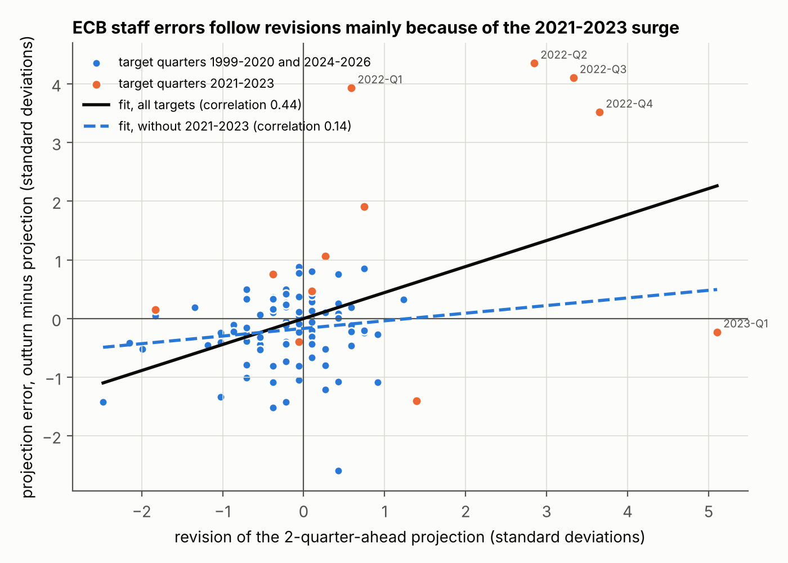
J02. Error against revision, both standardised, ECB staff projections two quarters ahead. Orange: target quarters 2021–2023. Solid line: fit on all targets (0.44); dashed: fit without 2021–2023 (0.14).
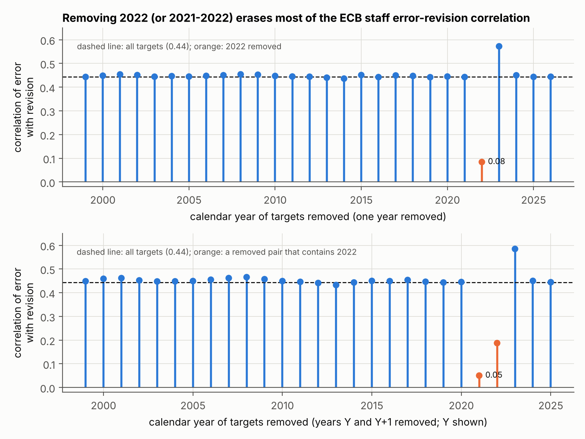
J02. Correlation after removing one calendar year of targets (top) or two consecutive years (bottom). The preregistered guard is the minimum of the bottom panel (0.050, removing 2021–2022).
The two ECB results do not conflict. A slope can exist in a full sample studied after the fact without being usable in real time, as Eva and Winkler (2023) found for US surveys. Here it came mostly from one episode that no rule estimated on earlier data could anticipate, and a rule that learned from it then over-corrected.

5.3 Individuals under-react too; the naive negative slope is mechanical (K01)
The first stage was strong: coefficient 0.496, F = 514, far above 23.1. The 2SLS slope was +1.151 (Driscoll-Kraay se 0.463, t = 2.48), 90% interval [0.357, 1.945]. The reduced form, a weak-instrument-robust test of a zero slope, gave t = 2.59. The verdict is eliminated: the data exclude, at the 5% level, individual over-reaction of the predicted size. Because the lower bound is also above zero, the preregistered reading is that individual forecasters under-react as well, so the under-reaction of the consensus and the ECB is not simply an aggregation effect. This runs against the US pattern of Bordalo et al. (2020), and it must be weighed against 2021–2023.
That weight is large. Without targets 2021–2023 the 2SLS slope was 0.168 (se 0.466, F = 315): positive, far from significant. The largest slope after removing one target year was 1.320. With forecaster fixed effects it was 1.099 (0.434). Before 2020 the 2SLS slope was 0.134 (0.604), and OLS with forecaster fixed effects 0.043 (0.095), against −0.169 (0.182) in Broer and Kohlhas (2024). The pre-2020 numbers are too imprecise to contradict them.
The naive within-round slope was −0.452 (se 0.066, clustered by round), close to the −1/2 of Section 4.2. As the preregistration requires us to write, it measures the change in the dispersion of forecasts, not their accuracy. The naive pooled OLS slope, 0.419 (0.188), lies below the 2SLS estimate, as reporting noise would predict. Both noise bounds were zero: with positive pooled slopes there is no negative slope for noise to explain.
On the same annual targets, the consensus slope was 0.918 (0.238) and the ECB staff slope 0.774 (0.294). Their difference, −0.143 (0.146), is not evidence of equality: the preregistered power analysis put the smallest detectable difference at 0.5–0.9. Without 2021–2023 the consensus slope was 0.515 and the staff slope 0.162.
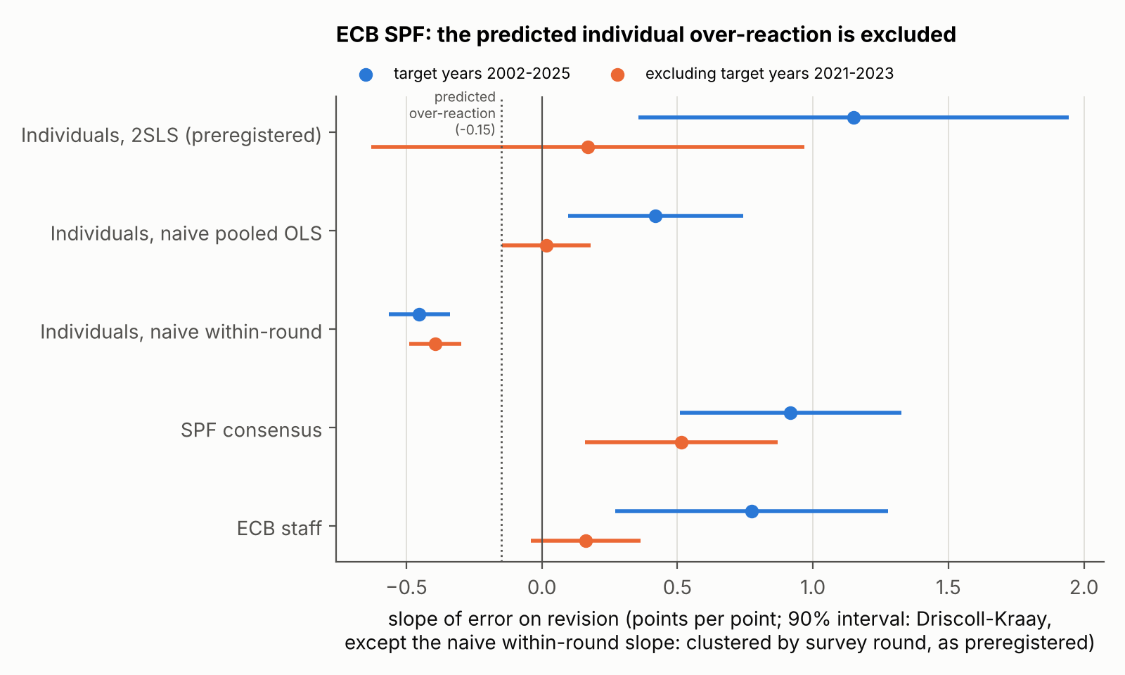
K01. Slopes of error on revision with 90% intervals (critical value 1.714), full sample (blue) and without target years 2021–2023 (orange). Dotted line: predicted individual over-reaction (−0.15). Intervals use Driscoll-Kraay standard errors, except the naive within-round row, which uses standard errors clustered by survey round, as preregistered.

5.4 No extra under-reaction after large surprises, but an inconclusive verdict (K20)
The verdict is inconclusive. Schema check 9 failed on one row, CPI for target 2026Q1. The check required the previous-quarter CPI level whenever the current one is present, and it is missing because October 2025 is missing in FRED. The preregistration had claimed the source structure guaranteed this check without verifying the last row. The row enters no regression. Experimenter and verifier each judged it correct, but the guard was not rewritten after the fact, and any schema violation makes the test inconclusive.
The numbers are informative but are not a verdict. On 1,004 rows (334 after large surprises) the extra slope was c = −0.030 (se 0.071), 90% interval [−0.146, 0.086]. The sort worked: revisions were 3.06 times more variable after large surprises, above the 1.25 relevance threshold. The base slope averaged 0.194 across variables, and 0.164 after large surprises. Without each episode, c ranged from −0.084 to 0.014. By variable it ranged from −0.311 (T-bill, se 0.180) to 0.173 (deflator, se 0.183). It was −0.067 since 1985, −0.037 before 2020, −0.095 with the pandemic quarters, 0.075 with medians, and −0.003 on the original card’s cut (absolute standardised revision above 1). The reading written after the verdict, which states that it does not change the verdict, notes that with check 9 passed the rule would have given “eliminated” (upper bound 0.086 < 0.40). Its conclusion is that the consensus’s under-reaction does not grow after large surprises, at least as measured here. That is a reading, not a verdict; Section 5.5 gives a verdict on the same question in the euro area.
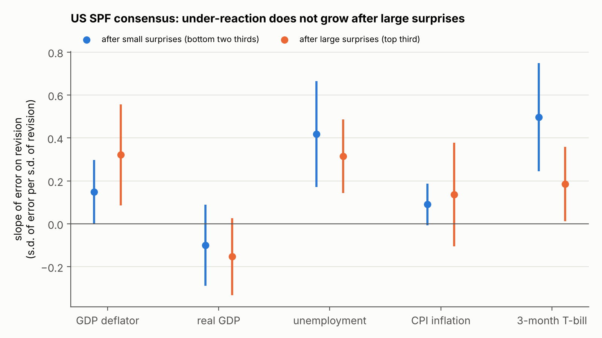
K20. US SPF consensus: slope of error on revision after small (blue) and large (orange) surprises, by variable, with 90% intervals.

5.5 In the euro area, under-reaction does not grow with the size of the news (K20-ZE)
The verdict is eliminated, with no protocol reservation: 0 schema violations on the 578 rows of the computation and 0 anomalies elsewhere. The instrument sees the base effect. The positive control passed: the common base slope was 0.366 (se 0.057, 90% lower bound 0.268), 0.447 after small news and 0.341 after large news. So the ECB SPF consensus under-reacts on average, and a null extra slope is not the silence of a blind instrument. On 196 rows after large news the extra slope was c = −0.106 (se 0.090, t = −1.18), 90% interval [−0.259, 0.047]. The upper bound is below 0.40: the data exclude, at the one-sided 5% level, the predicted extra under-reaction after large news. Without each of the three euro-area episodes c stayed negative, from −0.185 to −0.064.
The secondary analyses, outside the verdict, point the same way with one exception. By variable, c was 0.127 for HICP inflation (se 0.171), −0.217 for real GDP and −0.151 for unemployment; none comes near 0.40. Putting back the 2020–2021 GDP and unemployment targets, excluded before any data were seen, gives +0.177 (se 0.077): positive, still below 0.40, and descriptive. This decisive replication, not the formal inconclusiveness of K20, is the last word here on size-dependence. The full analysis, with figures comparing the surveys, is in the sibling project (projects/spf-news-size-underreaction/, its results/RESULTS.md and paper/paper.md).

6 Discussion
What holds. Four results meet the preregistered standard. A mechanical real-time correction of ECB staff projections based on revisions would not have helped over 2004–2025, and it raised squared errors in a typical two-year block. Over 1999–2026, staff errors two quarters ahead are positively correlated with revisions, at a size compatible with 0.40. Individual ECB SPF forecasters do not over-react as measured by the pooled instrumented slope: the predicted −0.15 is excluded. And in the ECB SPF consensus, which under-reacts on average, the under-reaction does not grow after large news: the predicted +0.40 is excluded.
What does not hold. The positive results do not describe ordinary times. The J02 correlation falls from 0.44 to 0.05 without 2021–2022. The individual slope falls from 1.15 to 0.17 without 2021–2023, and the staff and consensus slopes on annual targets fall too. The negative within-round slope, which a naive analysis would read as individual over-reaction, is a property of the statistic. The idea that bigger news brings more under-reaction is eliminated in the euro area and gets no support from the US point estimates, whose formal verdict stays inconclusive.
How the four fit together. One episode, the 2021–2022 surge, accounts for most of the measured under-reaction in euro area inflation forecasts over 1999–2026. Staff, consensus and individual forecasters all revised up too little during it. Without it the slopes are smaller: staff 0.14 on quarterly targets (about two standard errors above zero) and 0.16 on annual targets, consensus 0.51, individuals 0.17 with a standard error of 0.47. Because the effect was concentrated in time, a rule learned from the past could not use it, and once learned it over-corrected the disinflation. Nor is there a general law in which under-reaction grows with the size of news: the euro-area replication eliminates it, and the US estimates, with an inconclusive verdict, point the same way. These tests cannot say what was special about 2021–2022. The ECB’s own work points to energy and other technical assumptions (Chahad et al., 2022, 2024), which this project did not test.
What a central bank could take from this. (i) A full-sample error-on-revision slope that includes 2021–2022 overstates how projections behave in a typical year; evaluations should report leave-episode-out estimates next to it. (ii) A simple revision-based correction is not a free improvement: here it would not have predicted errors in real time, and it hurt after the surge. (iii) “Individual forecasters over-react” is sensitive to measurement: on the ECB SPF, a statistic without the mechanical component points the other way, in a sample dominated by one episode. None of this says whether staff should have revised faster in 2021–2022.

7 Limitations
- One episode drives every positive result. The J02 guard removed two consecutive years and passed by 0.05. The preregistration warned that three years in the same direction could carry the slope through it, and the breakdown shows exactly that. J02’s survival is a statement about 1999–2026 as a whole.
- Under-reaction cannot be told apart from deliberate smoothing. A positive slope also fits an institution that revises in small steps on purpose, an average of rational but differently informed forecasters (Coibion and Gorodnichenko, 2015), conditioning on market-based technical assumptions, or autocorrelated shocks. Hence the wording “errors follow revisions”, not “forecasters are irrational”.
- The K20 guard failure. The verdict is inconclusive for a reason unrelated to the hypothesis: a check the preregistration called guaranteed was not verified on the last row. Repairing it after seeing the numbers would have defeated the purpose of the seal. The question was instead asked again on the euro area (K20-ZE); the US verdict itself stays inconclusive.
- What the euro-area replication does and does not show. K20-ZE was preregistered after K20’s numbers were known, on annual targets of a different survey. Its mechanical-bias floor turned out at 0.43, far above the 0.10 its decisiveness simulation assumed (revision variance ratio 8.4, not about 3): that would have blocked a survival, but the elimination rests on the upper bound of c, which the floor does not enter. HICP inflation alone gives +0.13 (se 0.17), and with the 2020–2021 activity targets the extra slope is +0.18 (se 0.08); both are descriptive and below 0.40, but the second leaves open a size effect in an exceptional shock. K20-ZE is reproduced in a sibling project, not by this note’s pipeline.
- Power and standard errors. J02’s standard error (0.196) matched the pessimistic preregistered scenario (0.19). K01’s (0.463) was worse than the pessimistic scenario (0.40) and decided only because the estimate was far from −0.15. K20’s (0.071) beat the optimistic scenario (0.10). Newey-West and Driscoll-Kraay errors tend to be too small with about 24 independent target years (K01) or 108 overlapping quarters (J02); the J02 bootstrap interval keeps the verdict.
- The plans were not blind to history. The preregistrations were written in 2026 by agents who knew the surge, the literature and, for K01 and K20, J02’s numbers. No outcome data were read before sealing, but design choices cannot be proven independent of that knowledge.
- Data. Outturns are latest vintages except in H03-v2 and for US national accounts. Projections are rounded to 0.1 point, which attenuates slopes. The 1999–2000 MPD vintages were not published at the time with quarterly detail. Vintages are identified by letter codes, and a swapped mapping voided the first H03 run. Eurostat revisions mean a fresh download may differ slightly. K20 mixes first releases and latest vintages, CPI and the T-bill start in 1981, and the pandemic exclusion for real GDP and unemployment is a choice.
- Selection across the programme. These tests came out of a pipeline that tested other ideas. Each verdict is a one-sided 5% decision under its own rule, with no correction for the number of ideas tested.

8 How this project was run
The project came out of an AI-agent research pipeline run under a fixed protocol. The human set the question, the constraints (public and free data only, a laptop, a few weeks of part-time work, methods defensible before economists), the selection criterion (interest to an admissions committee and to recruiters), and took the decision at every node between stages.
Proposal and selection. AI agents from up to four model families (Kimi, Gemini, OpenAI Astra and Claude; the very first round used Claude models only) proposed ideas as cards in a fixed format, each with a falsifiable hypothesis, a numerical prediction and a test that would kill it. Judges from the same families ranked the cards blind to their origin; code sealed before judging aggregated the ranks. Agents then checked the retained ideas for novelty, recording which sources they had opened, and tested data access.
Testing. Each retained idea got a preregistration by a separate agent who saw only headers and counts, sealed by SHA-256 before any data were read for results. An experimenter agent ran it. A verifier agent on another model recomputed every number from the analysis file without seeing the experimenter’s code. A separate script applied the sealed verdict rule.
Generations and errors. Surviving ideas became parents of the next generation; there were three. A first-generation idea on the real-time predictability of ECB projection errors became test H03. Its first run was voided: the preregistration had swapped the June and September vintage letters, and the schema check meant to catch it read an empty column. The voiding, its reason and the voided run’s number (mean correlation −0.06) were recorded, not erased (audit/H03/annulation.md). The test was re-preregistered as H03-v2 before any statistic was computed under the correct mapping, and was eliminated. In the second generation a Kimi-family agent proposed J02, motivated by the H03 record, and it survived. In the third, a Claude-family agent proposed K01 and K20 as daughters of J02. After K20’s inconclusive verdict, K20-ZE was preregistered as a blind replication of K20 on the ECB SPF and eliminated.
This repository rebuilds the four analyses from raw public files, checks the seals and reproduces all 149 sealed verifier numbers. K20-ZE is rebuilt in the sibling project; this repository keeps its sealed records and checks its seal.
Division of labour. Agents proposed, judged, checked novelty, wrote preregistrations, ran experiments, verified and drafted. [To be completed by the author: what the author personally wrote, checked or re-derived; the decision taken at each node; the models and versions in each role; whether an economist reviewed the results.]
What the protocol does not guarantee. The verifier checked computations from the analysis file, not the construction of that file from raw data; the independent rebuild covers that only insofar as its code was written separately. [To be completed by the author.]

References
Andrade, P. and Le Bihan, H. (2013). Inattentive professional forecasters. Journal of Monetary Economics, 60(8), 967–982. https://econpapers.repec.org/RePEc:eee:moneco:v:60:y:2013:i:8:p:967-982
Arai, N. (2014). Using forecast evaluation to improve the accuracy of the Greenbook forecast. International Journal of Forecasting, 30(1), 12–19. https://econpapers.repec.org/RePEc:eee:intfor:v:30:y:2014:i:1:p:12-19
Baker, S. R., McElroy, T. S. and Sheng, X. S. (2020). Expectation formation following large, unexpected shocks. Review of Economics and Statistics, 102(2), 287–303. https://econpapers.repec.org/RePEc:tpr:restat:v:102:y:2020:i:2:p:287-303
Bordalo, P., Gennaioli, N., Ma, Y. and Shleifer, A. (2020). Overreaction in macroeconomic expectations. American Economic Review, 110(9), 2748–2782. https://econpapers.repec.org/RePEc:aea:aecrev:v:110:y:2020:i:9:p:2748-82; NBER WP 24932: https://www.nber.org/system/files/working_papers/w24932/w24932.pdf
Broer, T. and Kohlhas, A. N. (2024). Forecaster (mis-)behavior. Review of Economics and Statistics, 106(5), 1334–1351. https://econpapers.repec.org/RePEc:tpr:restat:v:106:y:2024:i:5:p:1334-1351
Chahad, M., Hofmann-Drahonsky, A.-C., Krause, W., Landau, B. and Sigwalt, A. (2024). The empirical performance of ECB/Eurosystem staff inflation projections since 2000. ECB Economic Bulletin, Issue 5/2024. https://www.ecb.europa.eu/press/economic-bulletin/articles/2024/html/ecb.ebart202405_03~492166f5d2.en.html
Chahad, M., Hofmann-Drahonsky, A.-C., Meunier, B., Page, A. and Tirpák, M. (2022). Box, ECB Economic Bulletin, Issue 3/2022. https://econpapers.repec.org/article/ecbecbbox/2022_3a0003_3a5.htm
Coibion, O. and Gorodnichenko, Y. (2012). What can survey forecasts tell us about information rigidities? Journal of Political Economy, 120(1), 116–159. https://econpapers.repec.org/RePEc:ucp:jpolec:doi:10.1086/665662
Coibion, O. and Gorodnichenko, Y. (2015). Information rigidity and the expectations formation process: a simple framework and new facts. American Economic Review, 105(8), 2644–2678. https://www.aeaweb.org/articles?id=10.1257/aer.20110306
Conrad, C., Enders, Z. and Müller, G. (2025). Inflation forecast targeting revisited. CEPR DP20467 / CESifo WP 12006. https://ideas.repec.org/p/ces/ceswps/_12006.html
de Silva, T., Larsen-Hallock, E., Rej, A. and Thesmar, D. (2025). Expectations formation with fat-tailed processes: evidence and theory. NBER WP 33808. https://www.nber.org/system/files/working_papers/w33808/w33808.pdf
Eva, K. and Winkler, F. (2023). A comprehensive empirical evaluation of biases in expectation formation. FEDS 2023-042. https://www.federalreserve.gov/econres/feds/files/2023042pap.pdf
Gemmi, L. and Valchev, R. (2026). Biased surveys. Journal of Monetary Economics, 157, 103868. NBER WP 31607: https://www.nber.org/system/files/working_papers/w31607/w31607.pdf
Granziera, E., Jalasjoki, P. and Paloviita, M. (2021). The bias and efficiency of the ECB inflation projections: a state dependent analysis. Norges Bank Working Paper 1/2021. https://www.norges-bank.no/contentassets/7b0610e058b042fab94bd4c3cbe2d8d5/wp_01_2021.pdf?ft=.pdf
Granziera, E., Jalasjoki, P. and Paloviita, M. (2025). The bias of the ECB inflation projections: a state-dependent analysis. Journal of Forecasting, 44(3), 922–940. https://econpapers.repec.org/RePEc:wly:jforec:v:44:y:2025:i:3:p:922-940
Juodis, A. and Kučinskas, S. (2023). Quantifying noise in survey expectations. Quantitative Economics, 14(2), 609–650. https://pure.uva.nl/ws/files/167529930/quan200274.pdf
Kontogeorgos, G. and Lambrias, K. (2019). An analysis of the Eurosystem/ECB projections. ECB Working Paper 2291. https://www.ecb.europa.eu/pub/pdf/scpwps/ecb.wp2291~6b06275781.en.pdf
Kučinskas, S. and Peters, F. S. (2024). Measuring under- and overreaction in expectation formation. Review of Economics and Statistics, 106(6), 1620–1637. https://econpapers.repec.org/RePEc:tpr:restat:v:106:y:2024:i:6:p:1620-1637
Note. Only references that the project’s literature notes record as opened and verified are listed. Standard estimators named in the text (Newey-West, Driscoll-Kraay, Diebold-Mariano with the Harvey-Leybourne-Newbold correction, two-stage least squares) are used as defined in the sealed preregistrations; their original papers are not listed.

Appendix A: Reproduction summary
The pipeline recomputed every field listed in the sealed verdicts and compared it with the independent verifier’s sealed number, using each preregistration’s tolerance (0 for counts; 0.005 for slopes, correlations and standard errors; 0.01 for interval bounds; 0.02 for t statistics; 1 for F statistics and effective sample sizes). The largest absolute gap on any field was of the order of 10⁻¹².
Sealed verifier numbers reproduced by the pipeline (field by field in results/reproduction.md). K20-ZE is reproduced by the sibling project projects/spf-news-size-underreaction/, not by this pipeline.
Test | Fields within tolerance | Verdict from pipeline numbers | Sealed verdict
H03-v2 | 25 / 25 | eliminated | eliminated
J02 | 26 / 26 | survives | survives
K01 | 45 / 45 | eliminated | eliminated
K20 | 53 / 53 | inconclusive | inconclusive
Total | 149 / 149
K20-ZE, replication | 65 / 65, in the sibling project | eliminated | eliminated

Appendix B: Audit trail
The preregistrations are kept byte for byte, in French as written, in audit/<ID>/preenregistrement.md. Their seals, recomputed on these copies before writing this note:
Seals of the preregistrations.
Test | SHA-256 of the sealed preregistration
H03-v2 | ca1b83452e562a4bbb9f4ba309bc1b709ce199b2297d03d2a6e3b599930f6d6d
J02 | 6cbe19eac13e77331aa0bcb7d51cb96f10e0d07c5618e61b2d4b2b35fb441ed0
K01 | 0808bd18fc0f748fe7703773d4e7b53ec640532202560cbaa10383be13c733cc
K20 | 2c34e6f5ff86721f1ae903f2dce8f91d79324d94a909cff19aee569a16451ad7
K20-ZE | 91c3f919cbf571abfeee2e087b387b4962960e183f832a7e4983de7bb802e63a
H03, voided first run | ea611aca877077d8b5014037d777c31041f8bbf131ced534c7f622e9de9633b7
Each hash also appears as sceau_preenregistrement in the test’s verdict.json, and run_all.py stops if a copy no longer matches. Each verdict.json holds the verifier’s numbers, the machine-readable rule and, for K20, the reason for the inconclusive verdict (“condition de non-conclusion tenue : n_violations_schema > 0”). audit/K20/lecture-apres-coup.md is the reading written after that verdict and states that it does not change it; audit/K20-ZE/ holds the same kind of reading for K20-ZE, its verifier numbers (verification.json) and the experimenter’s record of deviations and ambiguities (ecarts.md). audit/H03/annulation.md records why the first H03 run was voided; the verdict script was never run on it, so it has no verdict file.

