Overall – 1h (0’ – 60’)

0’ – 10’

0’ – 20’

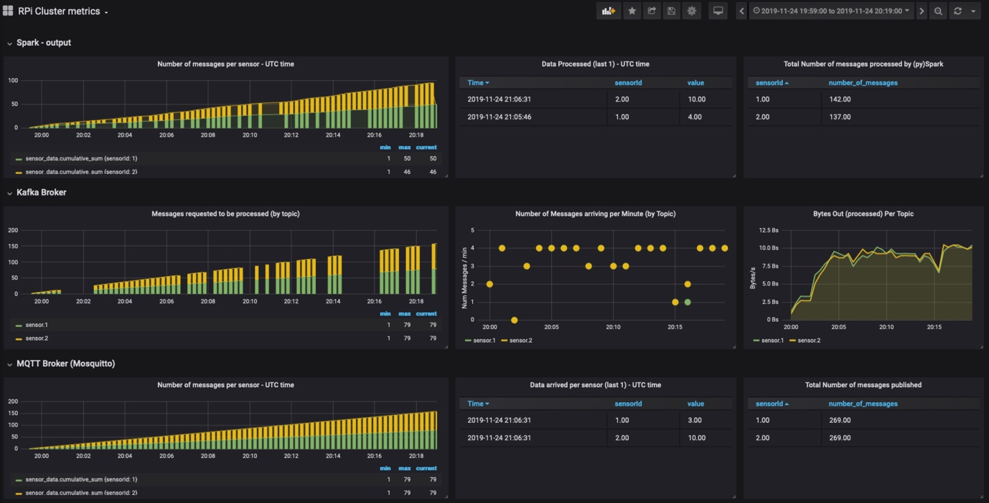

0’ – 30’

0’ – 40’

0’ – 50’

