testing the different things

heading 2

heading 3

heading 1

heading 4
paragraph
paragraph

where the image goes:
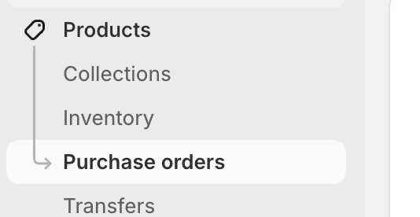

color styling test
color styling test

color styling test

subtitle text

italicized bold underlined strikethrough

