**2003版不能用怎么办？**

**允许运行Excel宏**

1. 点菜单【工具】下的【选项】
2. 选择【安全性】下的【宏安全性】选项

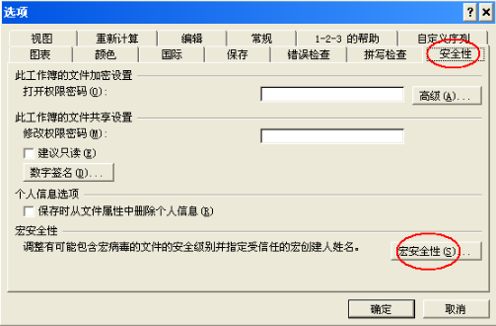

1. 修改宏安全级为中

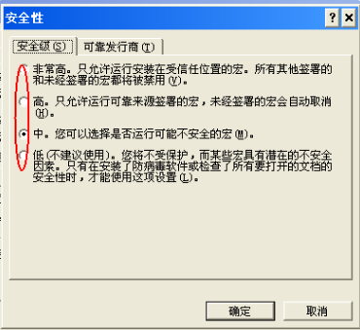

1. 重启Excel后 选择启用

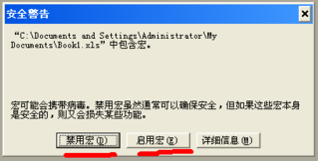

**请复制完整的表格进行处理 缺少行/列可能不能识别**

**代码使用方法：**

1. **创建一个形状**

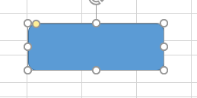

1. 在形状上右键->“指定宏” 点击新建

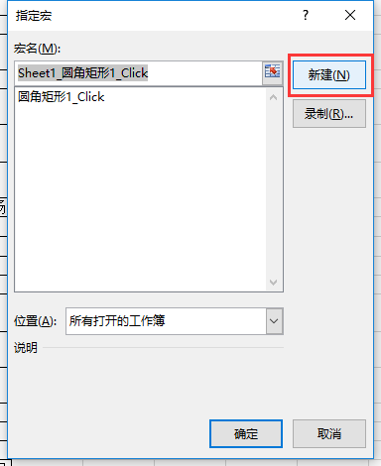

1. 将代码复制到图中空白位置，保存Excel表格

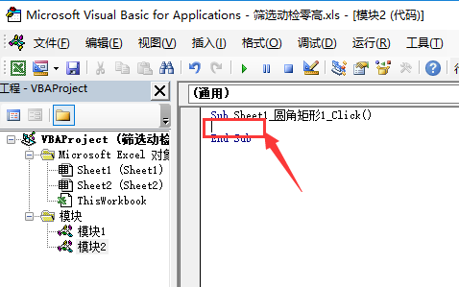

1. 点击形状即可使用

## 零高动检筛选– 逐个删除，可取消

x = ActiveSheet.UsedRange.Rows.Count

For i = 3 To x

strA = Worksheets("sheet1").Cells(i, 3).Value

strB = Worksheets("Sheet1").Cells(i, 8).Value

If InStr(strA, "郑州东") > 0 And InStr(strB, "动车所") > 0 Then

Response = MsgBox(Str(i) + strA + "-" + strB + "1", vbOKCancel, "提示")

If Response = vbCancel Then

Exit For

End If

Rows(i).Delete

GoTo A

End If

If InStr(strA, "动车所") > 0 And InStr(strB, "郑州东") > 0 Then

Response = MsgBox(Str(i) + strA + "-" + strB + "1", vbOKCancel, "提示")

If Response = vbCancel Then

Exit For

End If

Rows(i).Delete

GoTo A

End If

If Not InStr(strA, "郑州东") > 0 Then

If Not InStr(strB, "郑州东") > 0 Then

If InStr(strA, "动车所") > 0 Or InStr(strB, "动车所") > 0 Then

GoTo B

Else

Response = MsgBox(Str(i) + strA + "-" + strB + "1", vbOKCancel, "提示")

If Response = vbCancel Then

Exit For

End If

Rows(i).Delete

GoTo A

End If

End If

End If

GoTo B

A: i = i - 1

x = x - 1

If Len(strA) = 0 Then

Exit For

End If

If Len(strB) = 0 Then

Exit For

End If

B:

Next i

## 零高动检筛选 – 全自动删除

x = ActiveSheet.UsedRange.Rows.Count

For i = 3 To x

strA = Worksheets("sheet1").Cells(i, 3).Value

strB = Worksheets("Sheet1").Cells(i, 8).Value

If InStr(strA, "郑州东") > 0 And InStr(strB, "动车所") > 0 Then

Rows(i).Delete

GoTo A

End If

If InStr(strA, "动车所") > 0 And InStr(strB, "郑州东") > 0 Then

Rows(i).Delete

GoTo A

End If

If Not InStr(strA, "郑州东") > 0 Then

If Not InStr(strB, "郑州东") > 0 Then

If InStr(strA, "动车所") > 0 Or InStr(strB, "动车所") > 0 Then

GoTo B

Else

Rows(i).Delete

GoTo A

End If

End If

End If

GoTo B

A: i = i - 1

x = x - 1

If Len(strA) = 0 Then

Exit For

End If

If Len(strB) = 0 Then

Exit For

End If

B:

Next i

## 筛选预售 – 逐个删除

x = ActiveSheet.UsedRange.Rows.Count

For i = 6 To x

strA = Worksheets("sheet1").Cells(i, 4).Value

If Not InStr(strA, "郑州东" + Chr(-24150)) > 0 Then

If Len(strA) = 0 Then

GoTo B

Else

Response = MsgBox(strA, vbOKCancel, "提示")

If Response = vbCancel Then

Exit For

End If

Rows(i).Delete

GoTo A

End If

End If

GoTo B

A: i = i - 1

x = x - 1

If Len(strA) = 0 Then

If Len(Worksheets("sheet1").Cells(i, 5).Value) = 0 Then

Exit For

End If

End If

B:

Next i

## 筛选预售 – 全自动

x = ActiveSheet.UsedRange.Rows.Count

For i = 6 To x

strA = Worksheets("sheet1").Cells(i, 4).Value

If Not InStr(strA, "郑州东" + Chr(-24150)) > 0 Then

If Len(strA) = 0 Then

GoTo B

Else

Rows(i).Delete

GoTo A

End If

End If

GoTo B

A: i = i - 1

x = x - 1

If Len(strA) = 0 Then

If Len(Worksheets("sheet1").Cells(i, 5).Value) = 0 Then

Exit For

End If

End If

B:

Next i