Candidate Name : Lee Choong Meng

Time Taken : About 14 hours (coding and writing summary)

**Summary**

**Console Project**

Included a console project for the solution. Executing this console will calculate all the questions (non brackets, brackets, and nested brackets) and **return the correct answers**. During execution, it will ask to choose result output method to either file or console.

Also added validation on the input string to be calculated. Only input string that pass the validation will get calculated for result.

Pass Condition (only 2 but can add more if needed to)

1. Brackets must come in pairs
2. Scan for only 4 allowed operators (+ - / *)

The calculation engine is based on BODMAS rule.

Dependency Injection is used on logging implementation of CustomLogger class.

Single Responsible Principle is used on CalculatorEngine, Math, and StringUtil classes.

**Unit Test Project**

Included a test unit project to test out the code written.

1. Test on the logging for console
2. Test on the string calculator
3. Test on the calculator engine
4. Test on the string utility

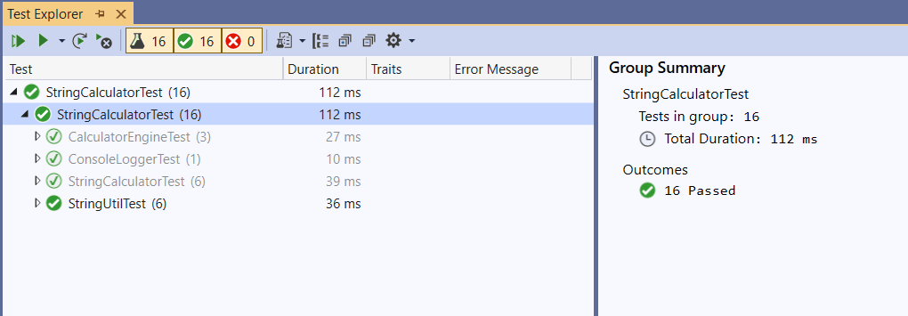

**SonarQube**

Included the SonarQube scanning (3 screenshots)

It has strong security rating and releasable to production.

