Background
The original BIBFRAME profile solicitation states that the software is necessary for the library “to lead and work collaboratively with external communities” (Section C, part 3). To this end, Smart Software Solutions will include an export functionality that will enable the user to export a BIBFRAME profile in JSON format using the following use case.
- The user clicks the export button.
- The editor prepares the profile in the form for export.
- The editor serializes the form as a JSON string.
- The editor presents the user with a download popup.
- The user confirms the download.
- The user's browser downloads the profile.

Design Overview
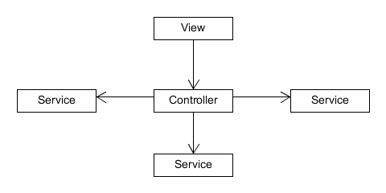
Smart Software Solutions will leverage the AngularJS framework to facilitate development of the editor. AngularJS separates web applications into different parts, namely, views, controllers, services, filters and directives. A view, a controller, and several services will provide the export functionality. The view will call a controller function when the user clicks export. The controller will then coordinate the actions of several services to obtain the form data, prepare it for export, serialize it, and trigger the download. A simple diagram of the relationships between the view, controller and services is presented below.

The View
The view will be a combination of html and css that dictates what the user sees on the screen. The view will contain a simple export button, and when this button is pressed, the view will call a method in the export controller that begins the download process.

The Export Controller
The controller exists to coordinate the actions of several services, and to serve as a link between the services and the view. To export a file and display it on the screen, several things need to happen in sequence. First, the controller must get the data in the form. Second, the form data needs to be formatted for export. Third, the data needs to be serialized as JSON. Fourth, the JSON needs to be pushed to the user as a download. Each of these tasks will be handled by a different service, and the controller will call each service in turn, ensuring that they are executed in the proper sequence.
The Services
The first service, called simply form handler, will be responsible for gathering data from the form. In addition to gathering the form data, this service maps the form data to “Profile”, and wraps it as a javascript object.
Upon the successful return of the form's contents from the form handler, the controller will pass the object to the profile handler to be prepared for export. This service will take the raw object obtained from the form, and return a copy of it with the proper keys for a BIBFRAME Profile. This step is necessary because the database that stores profiles for the editor requires some extra fields, and requires others to be renamed. This formatting step, ensures that every profile that leaves the application matches the standards set by the Library of Congress.
Next, the controller uses a built-in AngularJS function to serialize the formatted object as a JSON string. It then passes this string to the export service. Although some browsers allow javascript to trigger downloads, this is not always the case. For this reason, the export service sends the JSON string to the server as a post request, returning a promise to the controller. When the controller receives a success message from the promise, it triggers the browser to open a new window with a URL that triggers the server to send the JSON string as a file download.
The export view, export controller, and each of its service dependencies are depicted in the diagram below.
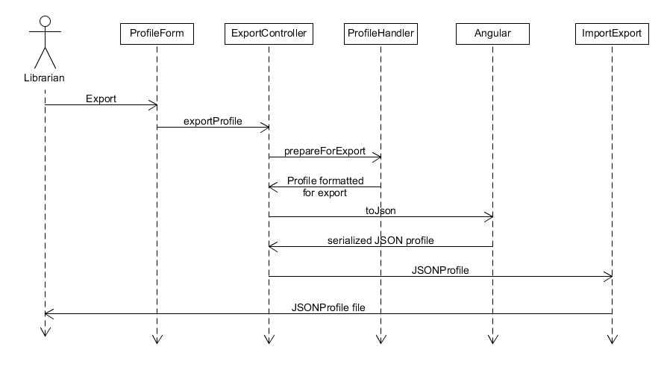

Export Flow
The complete flow of the export is as follows, and appears on a diagram on the next page. The user will click on export, triggering the view to call the export controller. The export controller will use the form handler to get the data in the form. The export controller will then have the profile handler format this data to match the BIBFRAME Profile specifications before using a built-in AngularJS function to serialize the object as a JSON string. The export controller will then pass this string to the export service, which will post it to the server. The controller will wait for a response, and if that response is success, the controller will open a window, navigating to the URL that triggers the server to send the JSON string as a JSON file download.
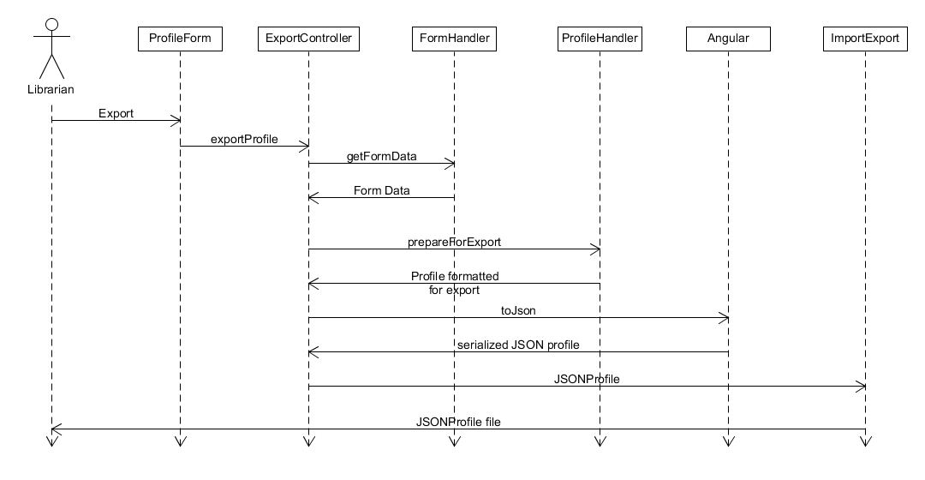

Summary
The export functionality relies on AngularJS's views, controllers and services. It divides work between services and uses a controller to coordinate their activities. This division of labor makes it easier for other parts of the program to reuse the code, and makes the Profile editor easier to maintain over time.

