Background
The original BIBFRAME profile solicitation requests that the software be designed “to list all local BIBFRAME Profiles, to load one such Profile, to modify the Profile and to save the Profile” (Section C, part 3). It is implicit in this request that the editor be equipped to easily import existing profiles into its database. For this reason, Smart Software Solutions, inc. will build and deploy an import functionality to enable the following use case:
- The user clicks the import button.
- The app displays a dialog box for file browsing.
- The user selects a file from the dialog box.
- The user clicks 'ok'.
- The system parses the file and displays it on the screen within the profile form
- The user may alter the profile in the form.
- The user clicks save.
- The system saves the data in the form to its database.

Design Overview
Smart Software Solutions will leverage the AngularJS framework to facilitate development of the editor. AngularJS separates web applications into different parts, namely, views, controllers, services, filters and directives. A view, a controller, and several services will provide the import functionality. The view will call a controller function when the user uploads a file. The controller will then coordinate the actions of several services to parse the file, validate its contents and display it on the screen. A simple diagram of the relationships between the view, controller and services is presented below.

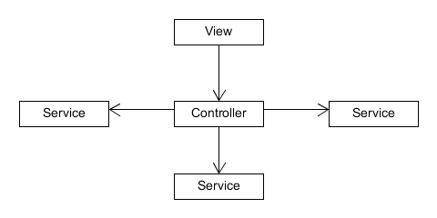
The View
The view will be a combination of html and css that dictates what the user sees on the screen. It will also enable the file dialog box, and contain a reference to the controller. After selecting a file and clicking 'ok', the view will call a method in the controller that will begin the import process.

The Import Controller
The controller exists to coordinate the actions of several services, and to serve as a link between the services and the view. To import a file and display it on the screen, several things need to happen in sequence. First, the file must be read, and its contents placed into memory. Second, the contents must be converted into an object that javascript can manipulate. Third, the object must be validated against the BIBFRAME profile. Finally, if the object is a valid profile, it must be displayed back on the screen. Each of these tasks will be handled by a different service, and the controller will call each service in turn, ensuring that they are executed in the proper sequence.

The Services
The first service, called simply import service, will be responsible for reading the file and placing its contents into memory. For newer browsers, this will be handled client-side by HTML5's FileAPI. For older browsers, the service will send the file to the server (to a class called ImportExport) via an AJAX call, and the server will echo back the file's contents. Javascript handles both processes asynchronously, and neither is guaranteed to succeed. Therefore, the service will return a promise containing the file's contents on success, but an error message on failure. Returning a promise allows the controller to pause any further processing related to the file until it receives a response from the import service.
Upon the successful return of the file's contents from the import service, the controller will use a built-in method from AngularJS's library to parse the JSON object held in the file into a Javascript object. The Profile editor assumes that all imports will be in JSON form, and invalid JSON strings will cause an error.
The next step is for the controller to pass the deserialized JSON object to another service, called profile handler, for validation. The profile handler will expect a javascript object, and will parse it recursively, starting at the Profile level. The profile handler will check that all of the profile's keys are specified in the BIBFRAME Profile specification, and that the Profile contains an id, title and at least one profile template. It will then validate each resource template following the specifications, and ensuring that each one has a resource URI, id and at least one property template. It will then validate each property template following the specifications and ensuring that each property contains a property URI. Finally, any value constraints and value data types will be validated to ensure that each key exists in the BIBFRAME Profile specifications.
The profile handler will handle each validation step as an if-statement. If the profile fails any step, the profile handler will throw an exception with a message that explains which part of the profile is invalid. If no invalid properties are found, and all required elements exist, the profile handler will throw no exceptions and return true.
The controller will call the profile inside a try/catch block that looks for any exception, and displays the error message received to the user. If no error messages are received, and the profile handler returns true, the controller will hand off the validated javascript object to the profile controller to be displayed on the form. A diagram of the import structure is presented below.
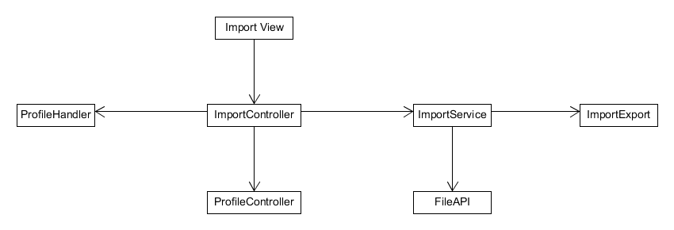

Import Flow
The complete flow of the import is as follows, and appears on a diagram on the next page. The user will click on import, browse for a file, select one and submit it. The html will call the import controller. The import controller will then call the import service, which will read the file using either the FileAPI or the import export class on the server. The import service will return the file's contents, which the controller will deserialize using a built-in AngularJS function. The controller will then pass the deserialized object to the profile handler for validation. The profile handler will either throw an exception (if anything is invalid) or return true. If it returns true, the import controller will pass the validated object to the profile controller, which will display the profile in the screen, using the profile form.

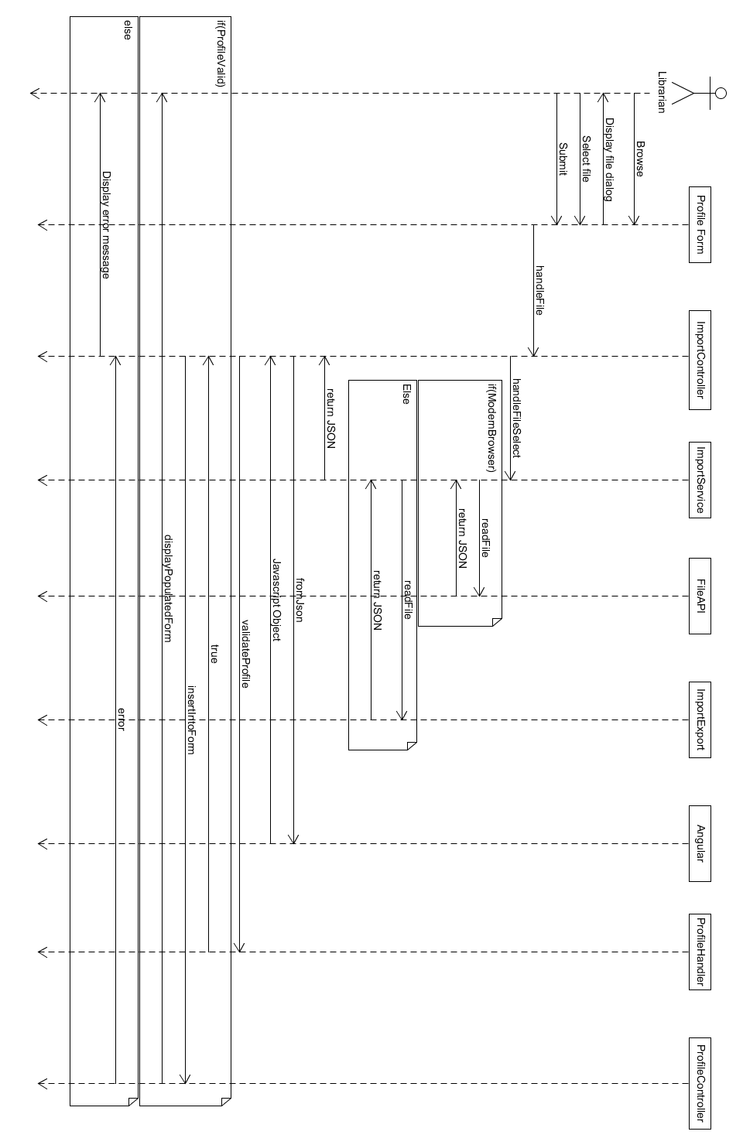
Summary
The import functionality relies on AngularJS's views, controllers and services. It divides work between services and uses a controller to coordinate their activities. This division of labor makes it easier for other parts of the program to reuse the code, and makes the Profile editor easier to maintain over time.

