Lynne Lammers
EECS 448
Lab 3

3. The best picture from photomatix initially was produced with exposure values -1, 0, 2, and 5 for frames 1-4 respectively. The default was the most visually pleasing.
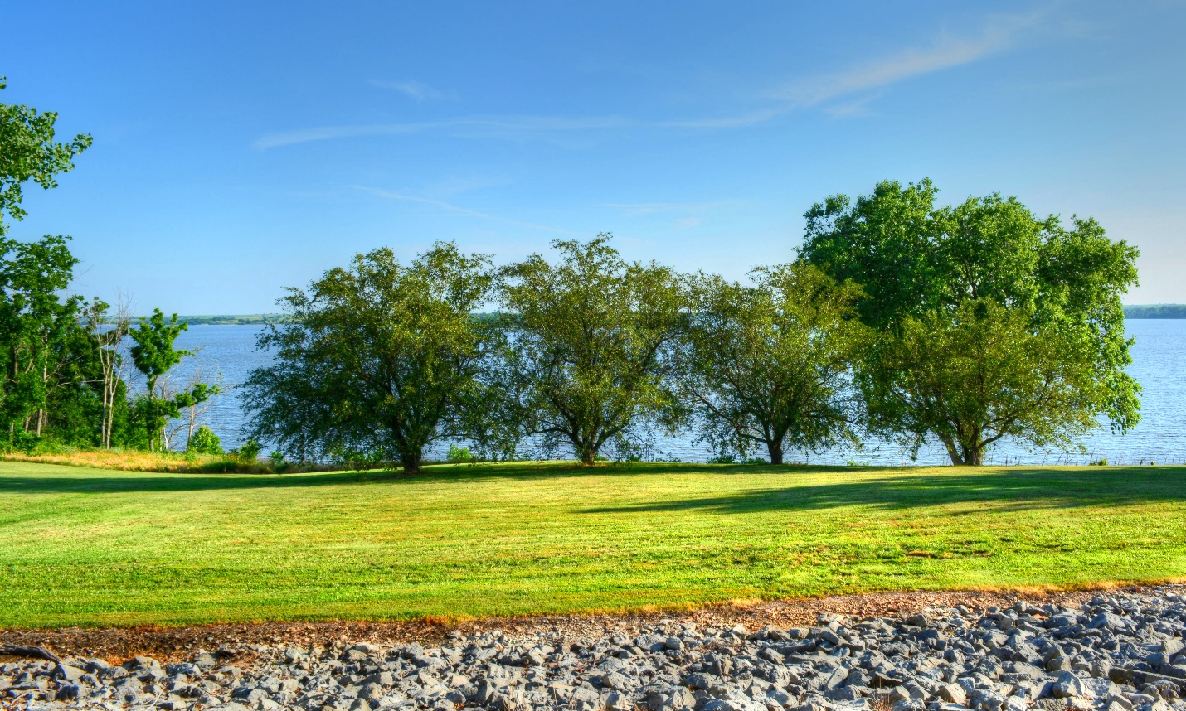

4. To improve the image, I slightly decreased the strength to 65, kept the saturation at 46, increased tone compression to 1, decreased detail contrast to -0.7, and increased the lighting adjustments to 3.0.
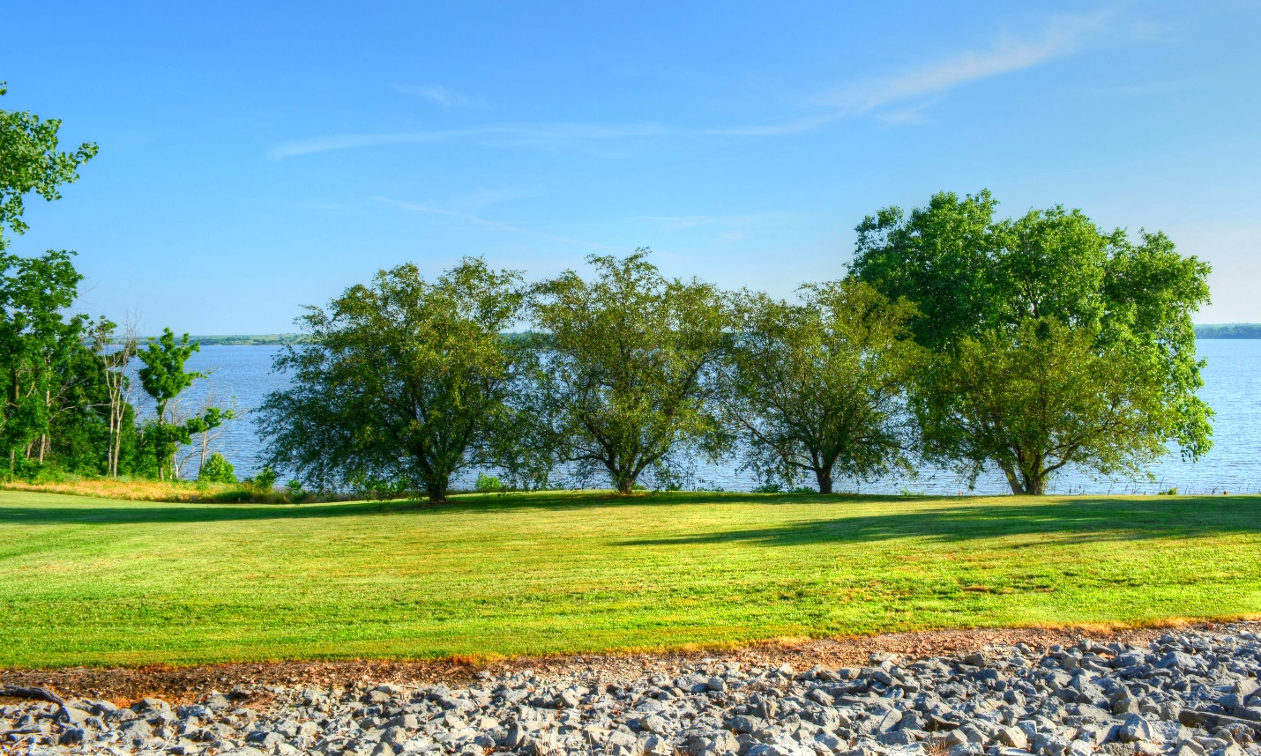

5. To improve the image, I increased Smooth Highlights to 20, increased White Point to 0.401%, increased Black Point to 0.062%, left Gamma at 1.00, and increased Temperature to 1.0.
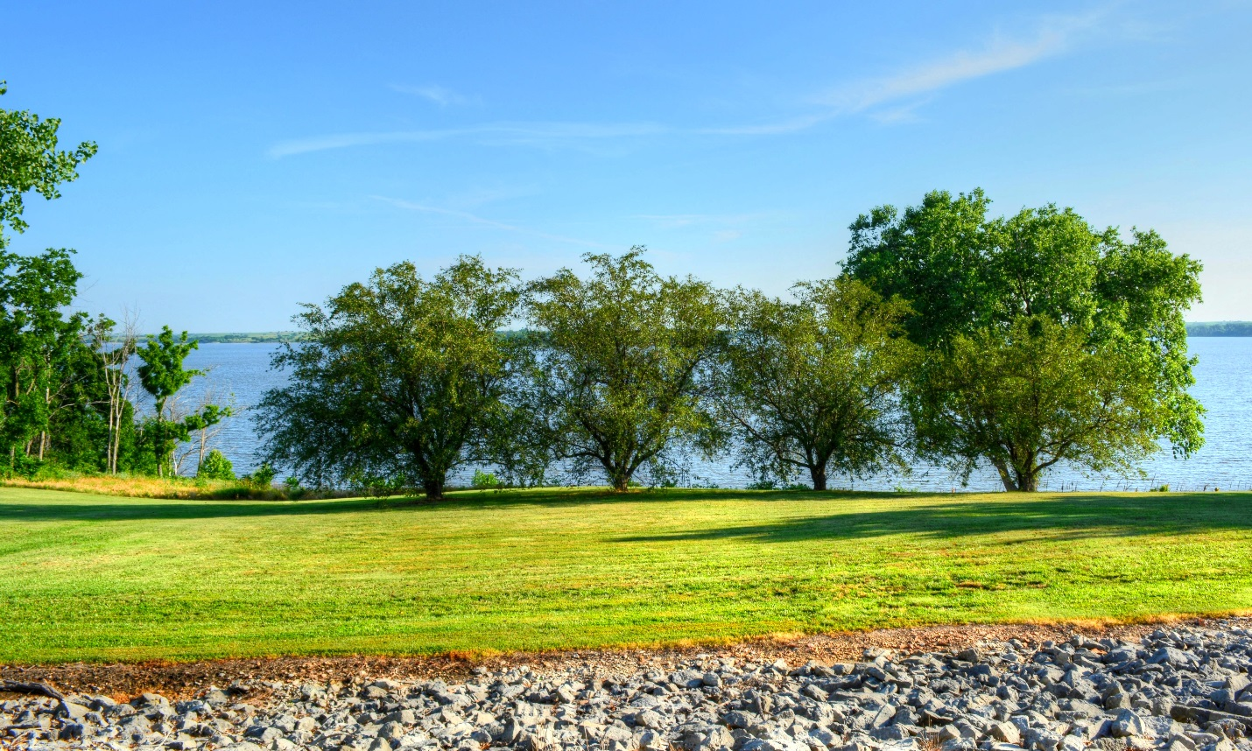

6. I replaced the rocks with the rocks from Frame 3.
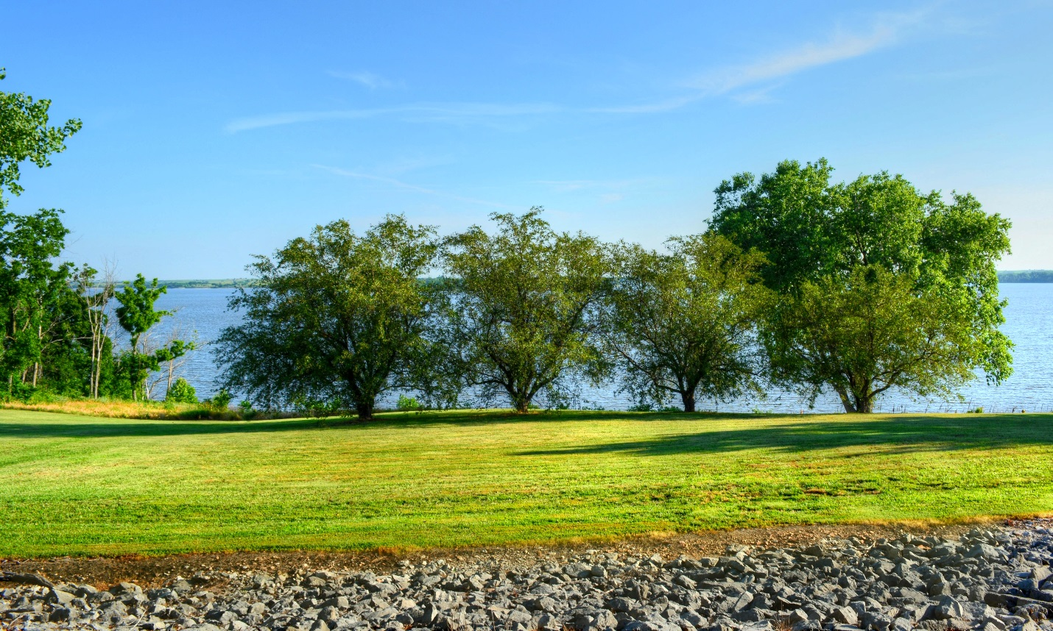

7.

