9. For the first unnatural image, I started with the Grunge image, which has very high strength, color saturation, tone compression, and detail contrast, and very little smoothing of highlights. I increased the white point to 1.8% and the black point to 5.047%. I also set the temperature to -10.
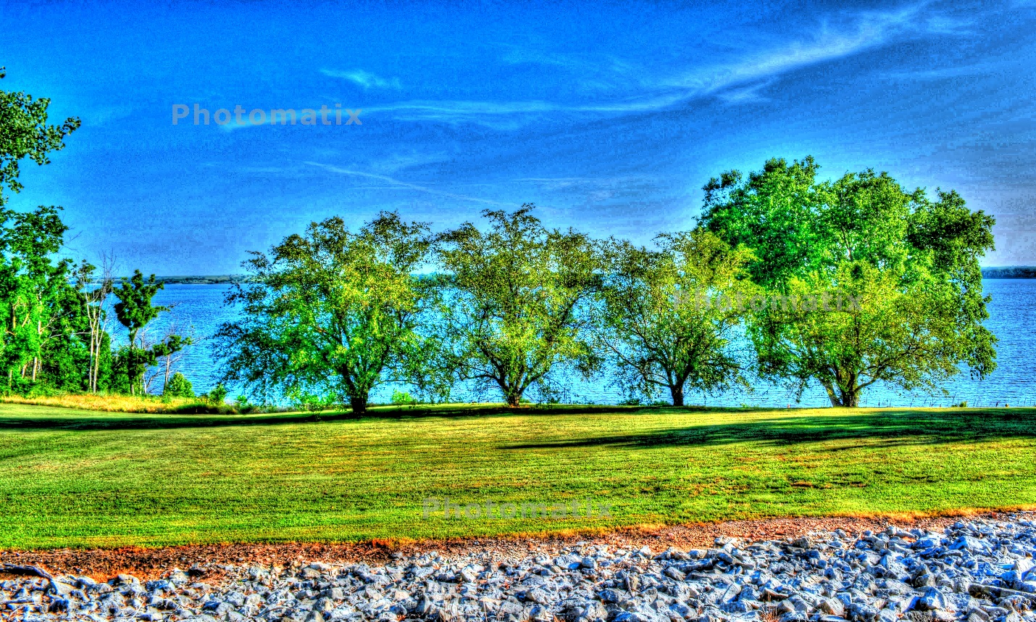
For the second unnatural image, I started with Creative 2, which has very low detail contrast, very high strength, and very high tone compression. I increased the temperature to 9.6 and decreased smooth highlights to 5.
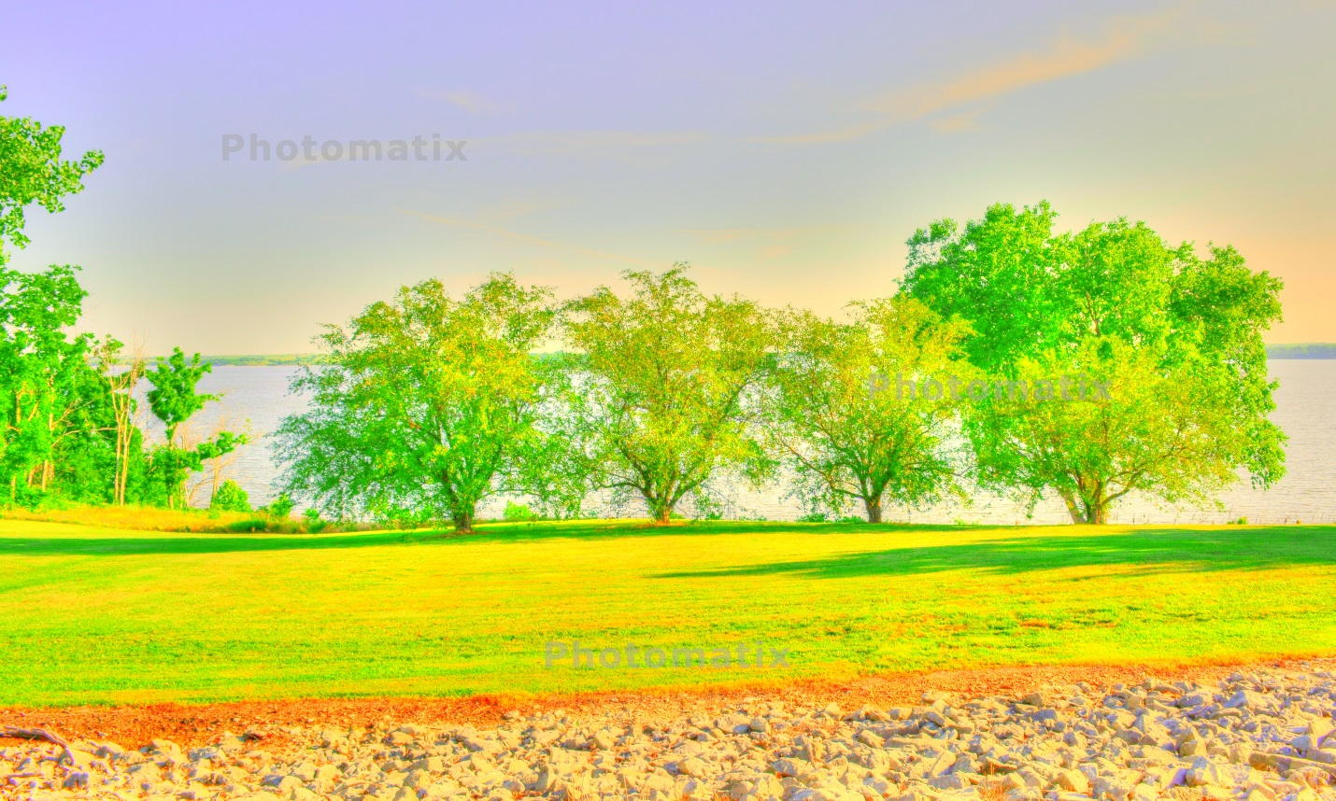

For the third unnatural photo, I started with surreal, which has very high strength, tone compression, and detail contrast, as well as a max white point. I increased the temperature to 4.1 and the black point to 1.986%.
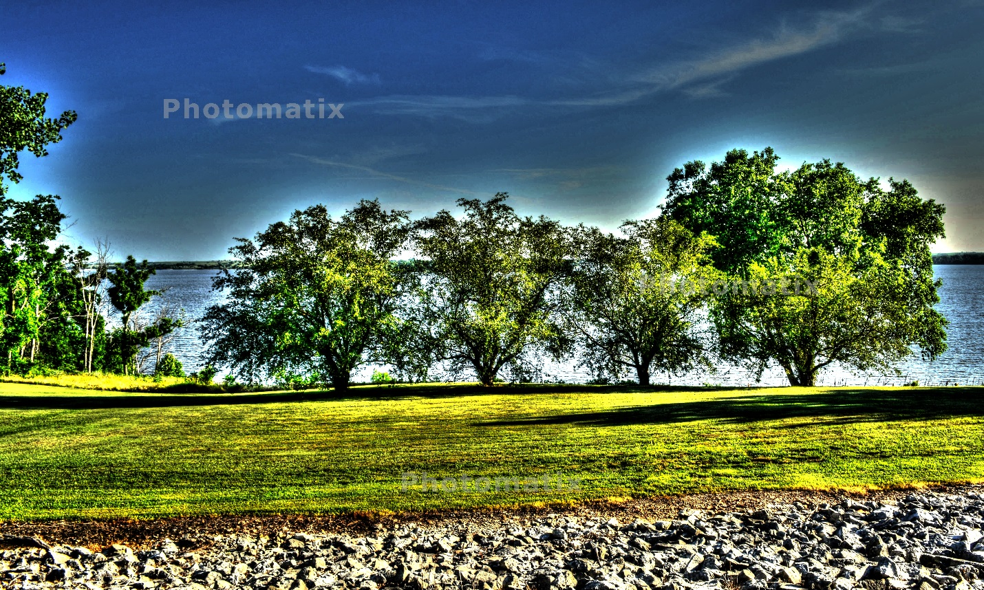
Finally, for the fourth unnatural photo, I started with deep which has high tonal range compression and low brightness. I increased the color temperature and color saturation to 10. I also increased the contrast adaptation to 7.9 and decreased the brightness to -8.2.
