PSN-ADC24 4-Channel 24-Bit Analog to Digital Board

Documentation

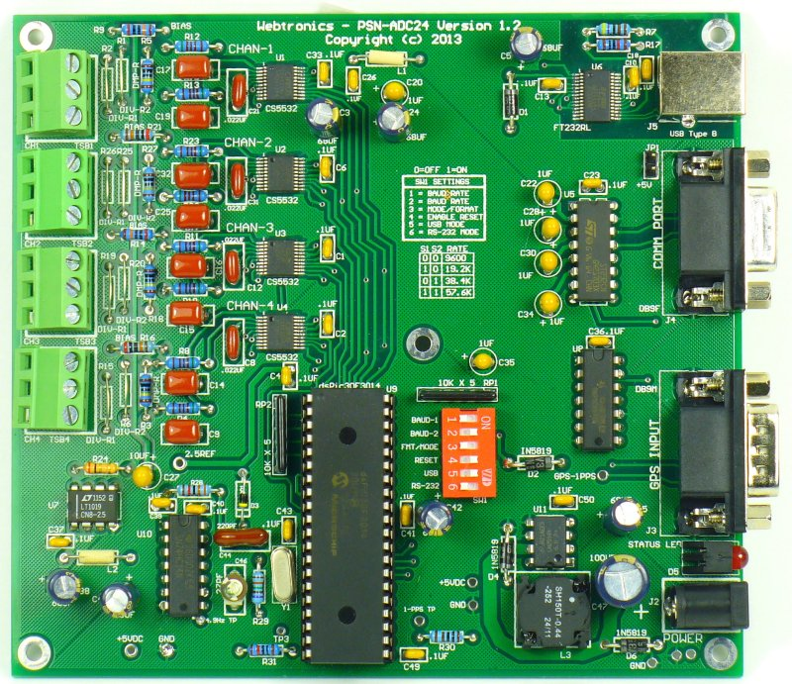

Block Diagram
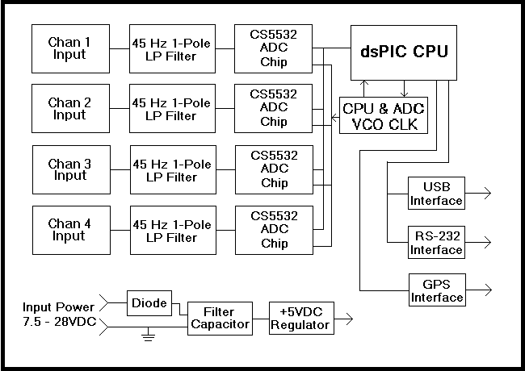

Description:
The PSN-ADC24 is a 4-Channel 24-Bit Delta-Sigma Analog to Digital Converter specially designed for seismic monitoring and other low frequency data collection. Each channel is digitized using a 24-Bit Delta-Sigma Analog to Digital Converter (Note 1) manufactured by Cirrus Logic. The datasheet for the Cirrus Logic CS5532 ADC chip can be viewed here. Supported sample rate are: 15, 25, 30, 50, 60, 100, 120 and 200SPS.
The PSN-ADC24 board supports both USB and RS-232 Comm Port interfaces. A GPS receiver can be connected to the board for accurate time stamping of the ADC data.

Applications:
- Earthquake Detection and Location
- Seismic Studies
- Structural Testing
- Vibration Monitoring

Features:
- Dynamic Range: > 115dB at 100 Samples Per Second
- Wide Input Power Range: 7 to 28VDC
- Low Power Operation: < 1 watt with Garmin GPS18x Receiver
- ADC Programmable Gain Range: 1, 2, 4, 8, 16, 32 and 64
- RS-232 and USB Interface

Specifications:
- Analog Inputs: 4
- Resolution: 20 Bits at 100 Samples Per Second
- A/D Converter Chip: Cirrus Logic CS5532
- Convert Type: 24-Bit Delta-Sigma
- Sample Rates: 15, 25, 30, 50, 60, 100, 120 and 200SPS
- GPS Support: Garmin GPS 18x LVC or Sure Electronic MG1613S
- Timing Accuracy with GPS Receiver: < 2 Milliseconds
- Board Size: 5.5 x 5.0 inches or 13.97 x 12.7 cm

Power Requirements:
The PSN-ADC24 digitizer board can operate on a wide input voltage range. The minimum input voltage is ~7.5VDC and the maximum ~28VDC. A diode on the board is used to prevent damage to the board if the input power is reversed. The table below list the power requirements in milliamps with and without the Garmin GPS 18x receiver connected to the sensor board.
Input Voltage | No GPS | W/GPS
7.50VDC | 78ma | 118ma
12.0VDC | 50ma | 73ma
18.0VDC | 30ma | 48ma
24.0VDC | 28ma | 40ma

Software:
WinSDR (Download) can be used to record data using the PSN-ADC24 digitizer board. This program is included with the purchase of the board. WinSDR will run on Windows XP, VISTA and Win7. Both 32-Bit and 64-Bit version of the program are available.
This Windows DLL Driver and Linux Library can be used by programmers who would like to write their own datalogger program or add the sensor board to an existing program. The DLL Driver zip file or Linux Library includes an example, written in VC++ 8.0, showing how to use the PSNADBoard.DLL file.
Earthworm, a powerful seismic software package that can run under various operating systems, can receive data using the PSN-ADC24 board or WinSDR. See this link for more information.

Input Channels:
This channel has a differential input with a input voltage range of +-2.5V or 5V Peak-to-peak when the Programmable Gain Instrument Amplifier gain set to 1. With the gain set to 64, the maximum PGIA gain, the input voltage range is +- 39 millivolts. A differential voltage divider can be placed on the board to allow for larger input voltage swings. See schematic below. R2 can be used as a damping resistor for the sensor or used as one leg of the voltage divider.
The user should use shielded 2 conductor wire when connecting a senor like a Geophone to the input. The + output of the sensor should connect to J1 screw terminal 2 and the - output to terminal 1. The shielded part of the wire should be connected to terminal 3. At the other end of the wire the shield can be left open or connected to the metal case of the sensor. Before connecting the shield to the case of the sensor the should check with a Digital Volt Meter to make sure there is no resistance between the case and one of the output coil terminals. If the sensor is going to set right next to the PSN-ADC24 board the user can use a short run of twisted pair wire without the shield. Just leave the ground screw terminal 3 disconnected and only connect terminals 1 and 2 to the sensor's output coil.
If the user is going to drive the input with something other then a coil the put terminals must be biased at +2.5V and swing up to 5V and down to ground. Since the input is differential one terminal needs to be going +V while the other -V.
Input Schematic
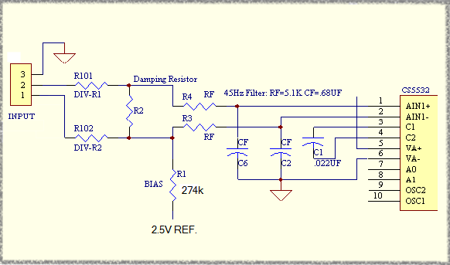
Maximum Input Voltage Range with PGIA Gain = 1
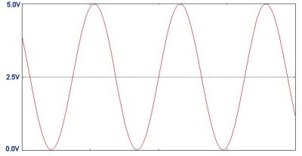

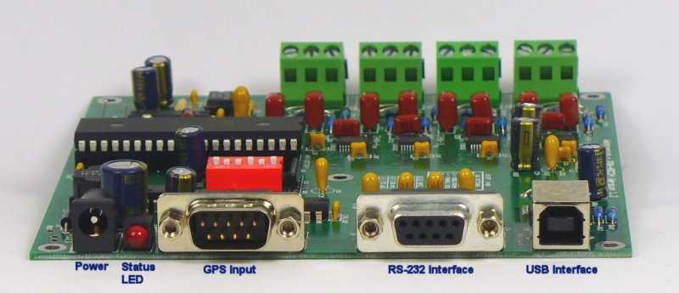

Input/Output Connector Information:

Input Connectors TSB1 to TSB4:
These connectors are three terminal screw blocks or 3 Pin Molex male connectors. While looking at the top of the board with TSB1 to your left the connector pinout is as follows:
- Top Screw Terminal / Pin = -IN
- Center Screw Terminal / Pin = +IN
- Bottom Screw Terminal / Pin = Ground

Power Supply Connector J2:
The power connector on the board is a standard 2.1mm X 5.5mm male jack. Positive voltage must be applied to the center pin. A diode on the board will prevent damage if the power is reversed. The DC input range is 7.5 volts to 28 volts. See power requirements above for more information.

GPS Comm Connector J3:
This connector is a 9 pin, DB-9 male connector used to communicate to a GPS receiver. A straight through serial cable should be used between the A/D board and the GPS's receiver interface board. See this page for a GPS timing system compatible with the PSN-ADC24 board. The connector has the following pinout:
- Pin 1 - CD (Carrier Detect) Input, Used for the 1 PPS signal from the GPS receiver
- Pin 2 - Receiver Data Input from the GPS Receiver
- Pin 3 - Transmit Data Output to the GPS Receiver
- Pin 4 - +5 VDC for Garmin GPS 16/18 Power
- Pin 5 - Ground
- Pin 7 - Ground for Garmin GPS 16
- Pins 6, 8 and 9 - Not Connected

Comm Connector J4:
This connector is a 9 pin DB-9 female connector used to communicate to the PC running WinSDR. A straight through serial cable should be used between the A/D board and the your computer. The connector has the following pinout:
- Pin 1 - Not Connected
- Pin 2 - Transmit Data Output
- Pin 3 - Receive Data Input
- Pin 4 - DTR (Data Terminal Ready) Input - CPU Reset Line
- Pin 5 - Ground
- Pin 6 - Not Connected
- Pin 7 - Not Connected
- Pin 8 - Not Connected
- Pin 9 - +5VDC if jumper JP1 is installed
The DTR line ( Pin 4 ) is used to reset the CPU on the A/D board. This line should be below 2 VDC for normal operation. If the LED on the board does not come on, it may be do to this line holding the CPU in the reset state. Position 1 of Switch SW1 can be used to disable this feature. If disabled, off position, the host computer can not reset the CPU on the A/D board.

USB Interface J5:
This USB Type B connector is used to communicate with the PC. The USB interface chip used on the A/D board is a FTDI FT232RL. Windows or Linux drivers (32-Bit or 64-Bit) can be downloaded from here.
Jumper Settings:

JP1 is used to supply +5VDC to pin 9 of the DB9 Comm Port connector.
Switch SW1:

- Switches 1 and 2: Controls the Baud Rate. See table below.
- Switch 3: Not Used
- Switch 4: On = Allows CPU on the ADC board to be reset by the host computer using the DTR line.
- Switch 4: Host computer can not reset the CPU.
- Switch 5: USB Interface Mode. See note #2.
- Switch 6: RS-232 Interface Mode. See note #2.

Baud Rate Table:

SW1 | SW2 | Rate
Off | Off | 9600
On | Off | 19200
Off | On | 38400
On | On | 57600

Notes:
- Usable ADC bits dependent on sample rate and on-chip programmable Gain Instrument Amplifier (PGIA) gain setting.
- Only one interface can be selected. Switched 5 and 6 should never be turned on at the same time.

Board Configuration Settings:

Baud Rate: ____9600 ____19.2K ____38.4K ____57.6K

Interface: ______USB _____RS-232

USB Reset: ______ On ______ Off

Channels with +/- 10 Volt Ground Referenced Input Option:

1 ______

2 ______

3 ______

4 ______

Divider Resistors Used: _________________________

Note: Channels with the +/10V Input Option must use a Programmable Gain of 2 or higher to work properly. A gain of 2 will yield a maximum input voltage of +/- 10V. A gain of 4 will yield a maximum input voltage to +/- 5V etc.

