# Quantitative Intracerebral Hemorrhage Localization

John Muschelli1*,∗*, ScM; Natalie L. Ullman2, BS; Elizabeth M. Sweeney1, ScM; Ani Eloyan1, PhD; Neil Martin3, MD; Paul Vespa3, MD; Daniel F. Hanley2, MD; Ciprian M. Crainiceanu1, PhD

### Department of Biostatistics, Bloomberg School of Public Health, Johns Hopkins University, Baltimore, MD

1. **Department of Neurology, Division of Brain Injury Outcomes, Johns Hopkins Medical Institutions, Baltimore, MD**
2. **Department of Neurosurgery, David Geffen School of Medicine at UCLA, Los Angeles, CA**

**\* E-mail:** [**jmusche1@jhu.edu**](mailto:jmusche1@jhu.edu)**,**

**Address: Department of Biostatistics**

**615 N Wolfe St, Baltimore MD 21205**

**Phone: 6102917685**

# Cover title: Quantitative Intracerebral Hemorrhage Localization

# Table 1; Figure 1; Figure 2

**Keywords:** computed tomography; intracerebral hemorrhage; imaging

**Subject Codes:**

[43] Acute Cerebral Hemorrhage

[58] Computerized tomography and Magnetic Resonance Imaging

[62] Intracerebral Hemorrhage

**Word count: 2313**

**Background and Purpose:** The location of intracerebral hemorrhage (ICH) is currently described in a qualitative way; we provide a quantitative framework for estimating ICH engagement and its relevance to stroke outcomes.

**Methods:** We analyzed 111 patients with ICH from the MISTIE II clinical trial. We estimated ICH engagement at a population level using image registration of CT scans to a template and a previously labeled atlas. Predictive regions of NIHSS and GCS stroke severity scores, collected at enrollment, were estimated.

**Results:** The percent coverage of the ICH by these regions strongly outperformed the reader-labeled locations. The adjusted R2 almost doubled from 0*.*129 (reader-labeled model) to 0*.*254 (quantitative-location model) for NIHSS and more than tripled from 0*.*069 (reader-labeled model) to 0*.*214 (quantitative-location model). A permutation test confirmed that the new predictive regions are more predictive than chance: *p<.*001 for NIHSS and *p<.*01 for GCS.

**Conclusions:** Objective measures of ICH location and engagement using advanced CT imaging processing provide finer, objective, and more quantitative anatomic information than that provided by human readers.

Clinical Trial Registration-URL: <http://www.clinicaltrials.gov>.

Unique identifier: NCT00224770.

**List of Tables and Figures**

Table 1. Distribution of the top 5 areas of engagement

Figure 1. ICH engagement prevalence.

Figure 2. Highest Predictive Region (HPR) Analysis.

# Introduction

Intracerebral hemorrhage (ICH) results from a blood vessel rupturing into the brain. Quantification of hemorrhage location using X-ray computed tomography (CT) is complicated as ICH may extend into multiple brain areas, distend tissues, and break through the ventricular wall. Current practice is qualitative and identifies only one primary affected anatomic region [1–3].

Detailed localization information can be estimated by registering scans to a common template with a labeled anatomical atlas. After registration, each ICH can be quantified as its overlap with anatomic regions in the standard reference template. We used this framework to 1) create a 3-dimensional (3D) histogram of ICH location, 2) measure ICH engagement with specific anatomical regions, 3) estimate regions related to stroke severity measures, and 4) compare the predictive ability of these regions to reader-labeled ICH locations.

# Methods

The population studied consists of 111 patients from the MISTIE (Minimally Invasive Surgery plus recombinant-tissue plasminogen activator for Intracerebral Evacuation) [4] trial recruited from 26 centers with lobar and deep ICHs ≥20mL in volume. This sample contained 35 females and had mean (SD) age of 60.8 (11.2) years.

Diagnostic CT images were acquired under a standard protocol but with differences across sites. Scans were acquired using GE (N =46), Siemens (N =37), Philips (N =20), and Toshiba (N =8) scanners, had gantry tilt (N =87), and the slice thickness of the image varied within some scans (N =14). Therefore, scans had different voxel dimensions and image resolution before template registration.

ICH was manually segmented using OsiriX (v.4.1, Pixmeo; Geneva, Switzerland) by expert readers. Readers identified the anatomic location most engaged by the ICH: putamen (N=68), lobar (N=33), globus pallidus (N=6), and thalamus (N=4). The initial mean (SD) ICH volume of this sample was 37.4 (20.1) mL.

The brain image was spatially registered to a CT template using the Clinical toolbox [5] and the statistical parametric mapping software (SPM8, Wellcome Trust Centre for Neuroimaging, London, UK) in MATLAB (Mathworks, Natick, Massachusetts, USA). The binary hemorrhage mask was transformed into the template space. No scans were excluded due to inadequate registration, determined by visual inspection.

## ICH Localization and Engagement

After registration, all scans and hemorrhage masks are in the same template space. We calculated the percentage of patients with hemorrhage at each voxel in template space, resulting in a 3D histogram of ICH presence.

The “Eve” atlas [6], located in template space, labels gray matter (GM) and white matter (WM) regions. Ventricular regions were not explicitly segmented; any region not classified was labeled cerebrospinal fluid (CSF). Using “Eve”, we calculated the percent of the ICH engaged by region (e.g. putamen engages 20% of the ICH).

## Prediction of Severity Score Based on Hemorrhage Location

We investigated the prediction performance of ICH region engagement with the following stroke severity scores collected at enrollment in the trial: National Institutes of Health Stroke Scale (NIHSS) and Glasgow Coma Scale (GCS). We analyzed voxels in the template space where at least 10 patients exhibit ICH (*V* =166*,*202).

At each voxel, we tested if the mean score (NIHSS or GCS) was different in patients with ICH at each voxel,giving a voxel-wise p-value. We selected voxels, referred as “highest predictive regions” (HPR), based on the 1000, 2000, or 3000 smallest p-values or 3 different p-value thresholds: *.*05, *.*01, and *.*001. Selected voxels are referred as “highest predictive regions” (HPR).

For each HPR, we calculated the overlap of the patient-level ICH and the HPR, which we will call HPR coverage. If ICH in a scan covers the entire HPR, coverage is 100%; 0% coverage indicates no overlap. For each HPR coverage and severity score, we fit the following linear model:

where scan. We fit the same model replacing with a categorical indicator for each reader-labeled ICH location: thalamus, globus pallidus, putamen, or lobar.

For each model, we estimated the adjusted *R*2. The HPR with the highest adjusted *R*2 was selected and compared to the adjusted *R*2 for the reader-labeled model. We calculated engagement of these HPR with the Eve-atlas-labeled neuroanatomic regions.

To determine if these regions were predictive above chance, a permutation test was conducted: the severity score was randomly permuted, an HPR was estimated using the permuted severity scores, and the adjusted *R*2 was calculated for each permutation. Comparing the permutation distribution of the adjusted *R*2 with the adjusted *R*2 obtained from the original data provided the p-value.

# Results

## ICH Localization and Engagement

Figure 1 represents the 3D histogram of hemorrhage prevalence–colors represent the percentage of patients with ICH engagement at that area. ICH is distributed medially in the brain, with a lower concentration at the cortical surface and higher on the left side. Most voxels have a low prevalence of ICH engagement; the median number of patients with ICH at a given voxel is 3 (3%), though a small group of voxels (*V*=5685) has a high prevalence (*>*40%).

## Prediction of Severity Score Based on Hemorrhage Location

## Figure 2 displays the HPRs for p-values smaller than *.*01 for NIHSS (A) and the smallest 1000 p-values for GCS (B). Panels C and D display the NIHSS and GCS relationship with HPR coverage. The larger the HPR coverage, the higher (more severe) the NIHSS score and the lower (deeper unconsciousness) the GCS score.

Adjusted *R*2 model estimates indicated HPR coverage models strongly outperform reader-labeled location models: it almost doubled from 0*.*129 (reader-labeled model) to 0*.*254 (best coverage model) for NIHSS and more than tripled from 0*.*069 (reader-labeled model) to 0*.*214 (best coverage model) for GCS.

The permutation test p-values for HPR coverage were *<.*001 for NIHSS and *<.*01 for GCS; HPRs were more predictive than HPRs obtained by chance.

### ICH Localization and Engagement

Table 1 represents the 5 most-engaged regions for the population 3D histogram and the HPRs from the GCS and NIHSS (Figure 2). The engagement represents the percent engagement of a specific area compared to all areas engaged. The 3D histogram of ICH engages the insular, putamen, and primarily the CSF, especially the ventricles. The NIHSS HPR engages primarily areas of the internal capsule, thalamus, superior corona radiata, and CSF regions. The GCS HPR engages primarily the thalamus and superior corona radiata.

# Discussion

We have characterized the localization of ICH in a population from prospective clinical trial images using a 3D histogram. These 3D histograms provide detailed visualization and allow a finer comparison of ICH location across groups.

We also demonstrate how labeled atlases can automatically describe ICH engagement by neuroanatomic regions at a patient or population level. These measures are more interpretable for clinical relevance and may translate to better determination of disability. The HPR for NIHSS engages primarily areas of the internal capsule, thalamus, superior corona radiata, and CSF regions. Venkatasubramanian et al. [7] found degeneration in the corticospinal tract (CST) relate to worse NIHSS. Jang et al. [8] demonstrated those with intact CST had better outcomes on the motricity index of upper extremity (UMI) and Modified Brunnstrom classification (MBC), indicating many similar motor functions captured by the NIHSS would be affected. Schaechter et al. [9] found, using diffusion tensor imaging that decreased fractional anisotrophy in the precentral gyrus, superior and anterior corona radiata and orbitofrontal region correlated to a poorer motor outcome in patients with ischemic stroke.

The HPR for GCS engages primarily the thalamus and superior corona radiata. In a study with thalamic hemorrhagic bleeds, Kumral et al. [10] found GCS related to thalamic hemorrhage volume. Therefore, we have found areas of engagement previously related to each outcome. Moreover, these regions derived from voxel-wise tests were shown to be more predictive of severity scores than reader-labeled location.

The strength of our study is that the MISTIE trial is prospective with standardized protocols. This analysis is limited by a relatively small sample size and thus generalizing these results are limited by the inclusion criteria of the MISTIE trial population: ICH ≥ 20mL. We have done permutation testing on these pilot results, but a larger cohort is needed to validate the predictive models and ICH location distribution.

## Summary

The summary of Eve-atlas ICH engagement provides a more refined description of location than that provided by expert human readers. We have shown that using image-based measurements better predicts initial severity scores compared to using clinical location.

# Sources of Funding

The project described was supported by the grant RO1EB012547 (NIH), T32AG000247 (NIA), R01NS046309, R01NS060910, R01NS085211, R01NS046309, U01NS080824 and U01NS062851 (NINDS), and RO1MH095836 (NIMH).

# Disclosures

Johns Hopkins University holds a use patent for intraventricular tissue plasminogen activator. Dr. Daniel F Hanley received significant (over 5% effort) support on NIH Grant R01NS046309.

# References

[1]   Mendelow, AD, Gregson, BA, Rowan, EN, Murray, GD, Gholkar, A, and Mitchell, PM.

Early surgery versus initial conservative treatment in patients with spontaneous supratentorial lobar intracerebral haematomas (STICH II): a randomised trial. The Lancet. 2013;382:397–408.

[2]   Anderson, CS, Huang, Y, Wang, JG, Arima, H, Neal, B, Peng, B, et al. Intensive blood

pressure reduction in acute cerebral haemorrhage trial (INTERACT): a randomised pilot trial. The Lancet Neurology. 2008;7:391–399.

[3]   Acute Cerebral Hemorrhage (ATACH) investigators, AT of. Antihypertensive treatment of acute cerebral hemorrhage. Critical Care Medicine February 2010. 2010;38:637–648.

[4]   Morgan, T, Zuccarello, M, Narayan, R, Keyl, P, Lane, K, and Hanley, D. Preliminary findings of the minimally-invasive surgery plus rtPA for intracerebral hemorrhage evacuation (MISTIE) clinical trial. Cerebral Hemorrhage. Springer. 2008. 147–151.

[5]   Rorden, C, Bonilha, L, Fridriksson, J, Bender, B, and Karnath, HO. Age-specific CT and MRI templates for spatial normalization. NeuroImage. 2012;61:957–965.

[6]   Oishi, K, Zilles, K, Amunts, K, Faria, A, Jiang, H, Li, X, et al. Human brain white matter atlas: identification and assignment of common anatomical structures in superficial white matter. NeuroImage. 2008;43:447–457.

[7] Venkatasubramanian, C, Kleinman, JT, Fischbein, NJ, Olivot, JM, Gean, AD, Eyngorn, I,

et al. Natural history and prognostic value of corticospinal tract Wallerian degeneration in intracerebral hemorrhage. *Journal of the American Heart Association.* 2013;2:e000090.

[8] Jang, SH, Ahn, SH, Sakong, J, Byun, WM, Choi, BY, Chang, CH, et al. Comparison of

TMS and DTT for predicting motor outcome in intracerebral hemorrhage. *Journal of the Neurological Sciences.* 2010;290:107–111.

[9] Schaechter, JD, Fricker, ZP, Perdue, KL, Helmer, KG, Vangel, MG, Greve, DN, et al.

Microstructural status of ipsilesional and contralesional corticospinal tract correlates with motor skill in chronic stroke patients. *Human Brain Mapping.* 2009;30:3461– 3474.

[10] Kumral, E, Kocaer, T, Ertbey, N, and Kumral, K. Thalamic hemorrhage a prospective

study of 100 patients. *Stroke.* 1995;26:964–970.

# Figure Legends

**Figure 1. ICH engagement prevalence.** The proportion of patients with ICH engaging a voxel is represented in a 3D histogram (right side of image is left side of brain) overlaid on an MRI T1 template. There is a higher prevalence of ICH on the left side of the brain, localized in the middle of the brain, with few extensions in the anterior and posterior areas. The interactive version of this figure is located at <http://muschellij2.github.io/CT_Pipeline/index.html>.

**Figure 2. Highest Predictive Region** **(HPR) Analysis.** Panels (A) and (B) correspond to the HPR for the top-performing model for NIHSS and GCS scores. The HPR in (A) represents a p-value threshold of *.*0100 (19047 voxels) for the voxel-wise p-value of ICH on NIHSS. The HPR in (B) represents 1000 with the lowest p-values for the voxel-wise ICH on GCS score regressions. Panels (C) and (D) plot the HPR coverage and severity score relationship (red-linear fit, blue-LOESS fit). The larger the HPR coverage the higher (more severe) the NIHSS and the lower (deeper unconsciousness) the GCS.

# Tables

|  |  |  |  |
| --- | --- | --- | --- |
| Area | Population Prevalence | NIHSS HPR | GCS HPR |
| CSF (ventricular & subarachnoid spaces) | 7.9 | 10.9 |  |
| Insular | 7.6 |  |  |
| Superior temporal gyrus | 5.5 |  |  |
| Putamen | 4.8 |  |  |
| External capsule | 3.9 |  |  |
| Posterior limb of internal capsule |  | 12.0 |  |
| Superior corona radiata |  | 11.0 | 27.9 |
| Thalamus |  | 10.1 | 33.9 |
| Caudate nucleus |  | 8.4 | 9.6 |
| Postcentral WM |  |  | 6.7 |
| Superior longitudinal fasciculus |  |  | 5.9 |

**Table 1.** Distribution of the top 5 areas of engagement

# Figures

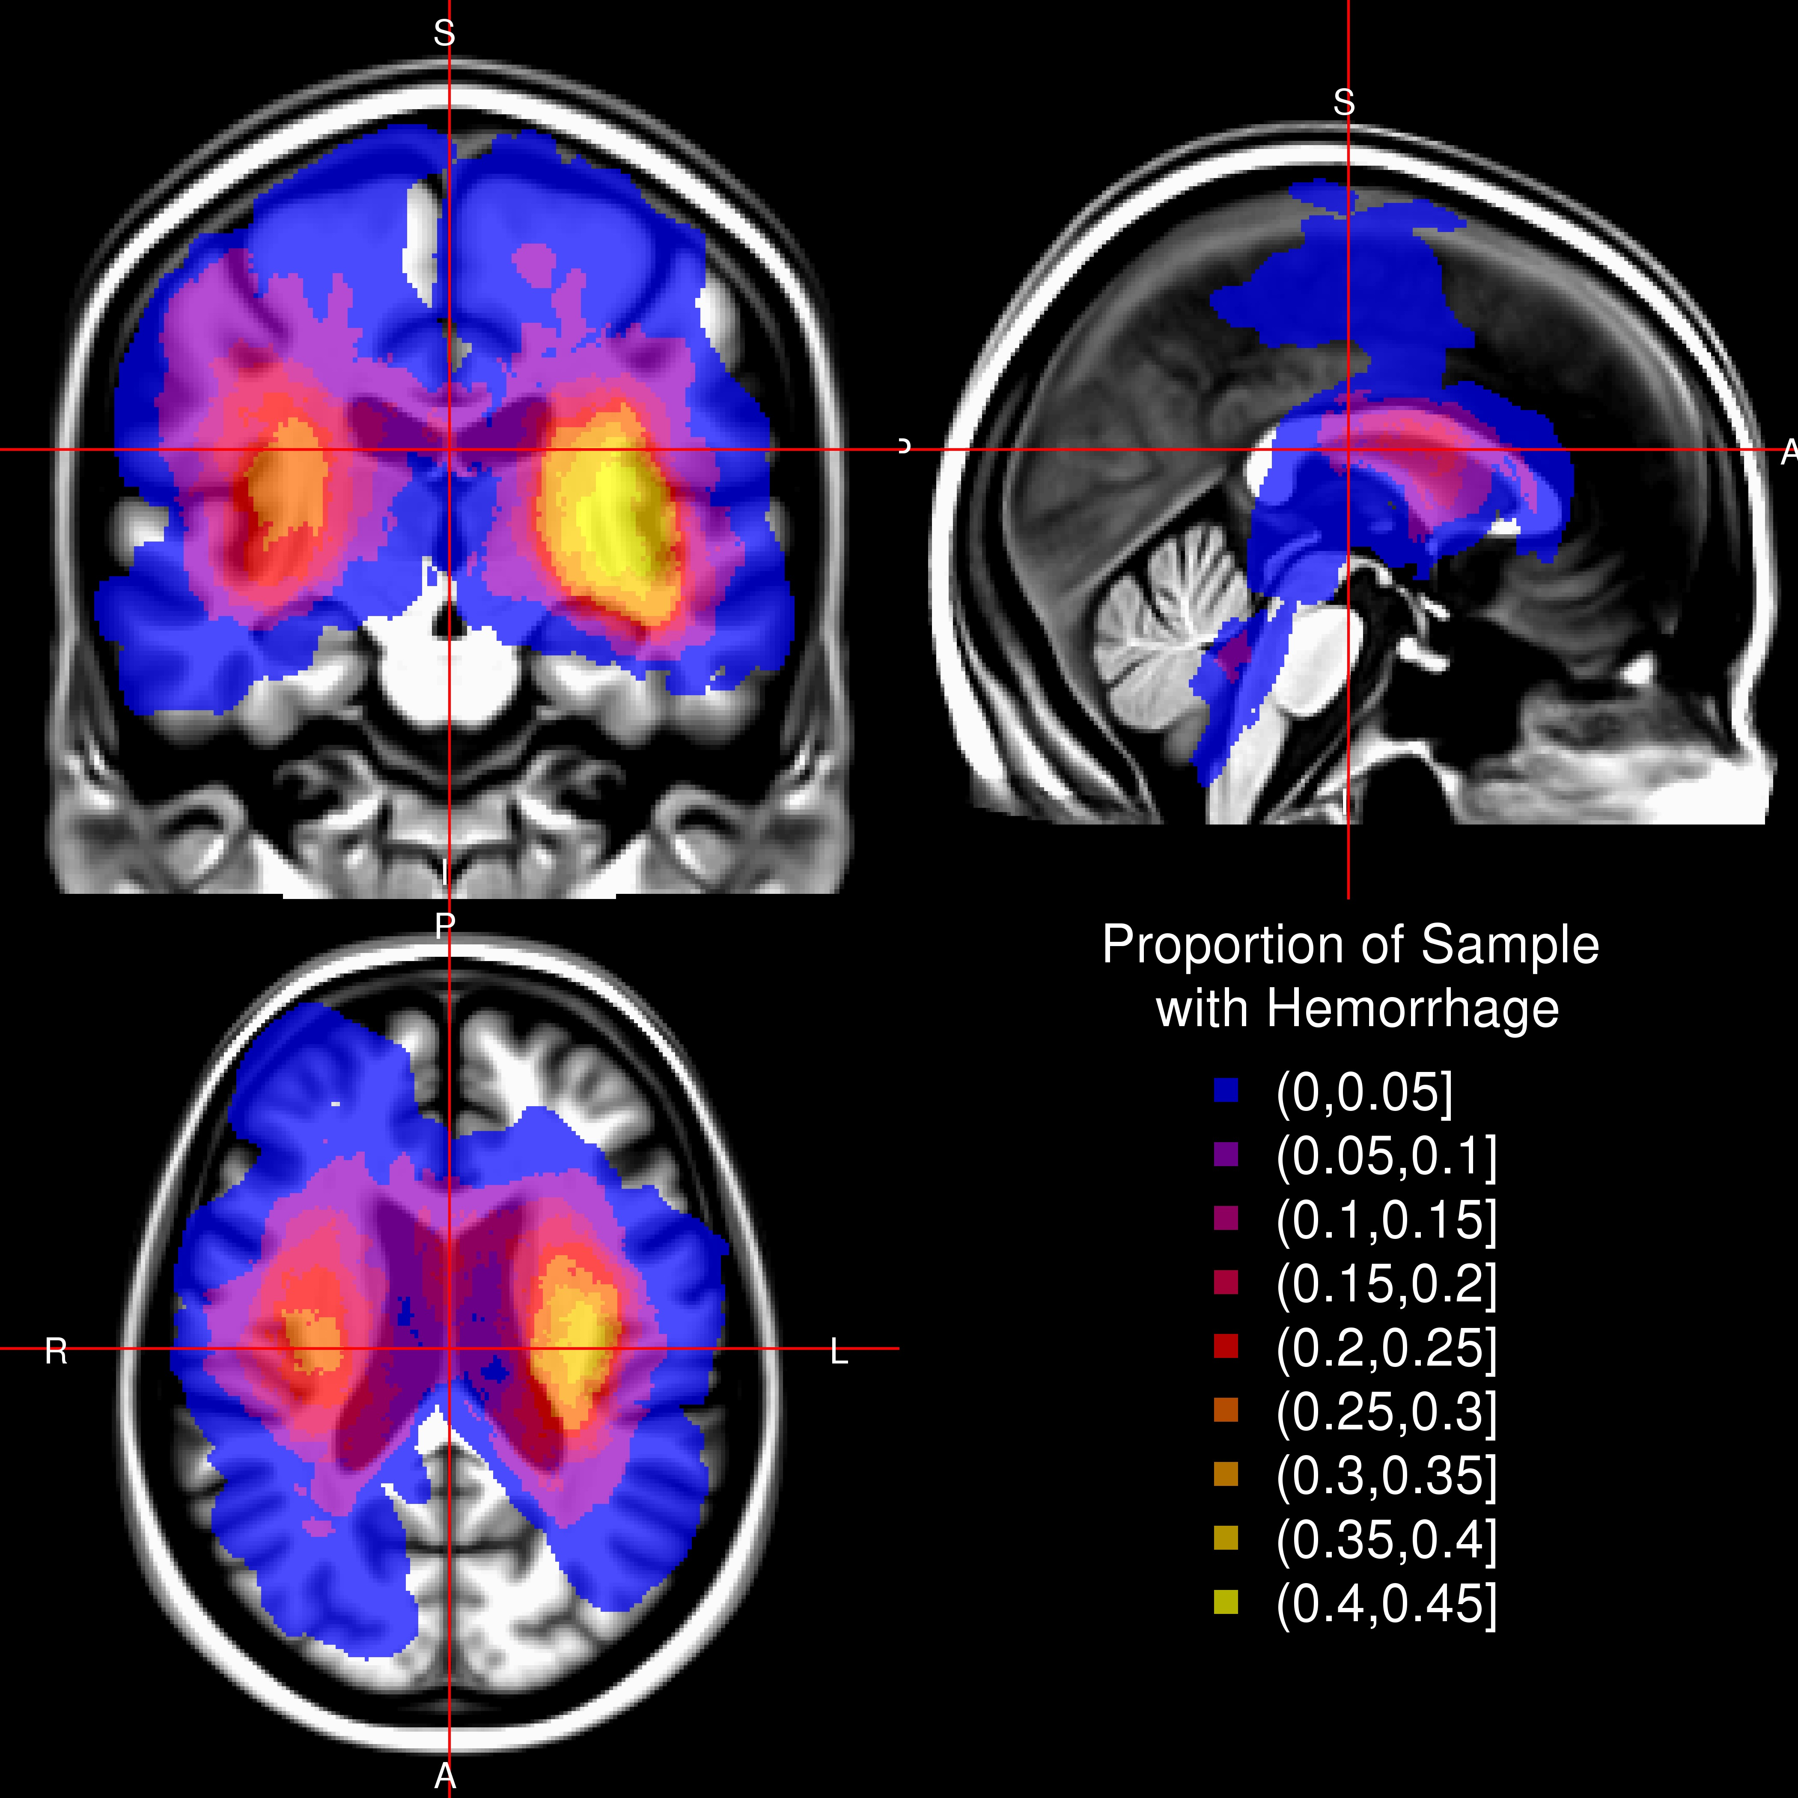

### Figure 1

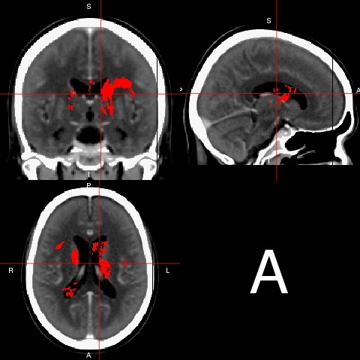 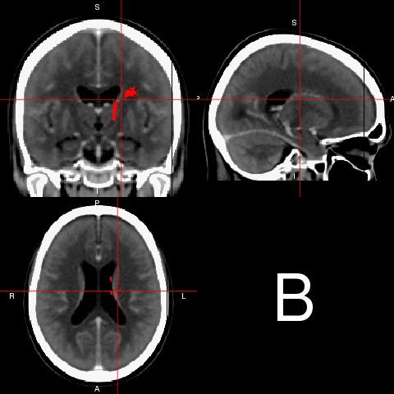

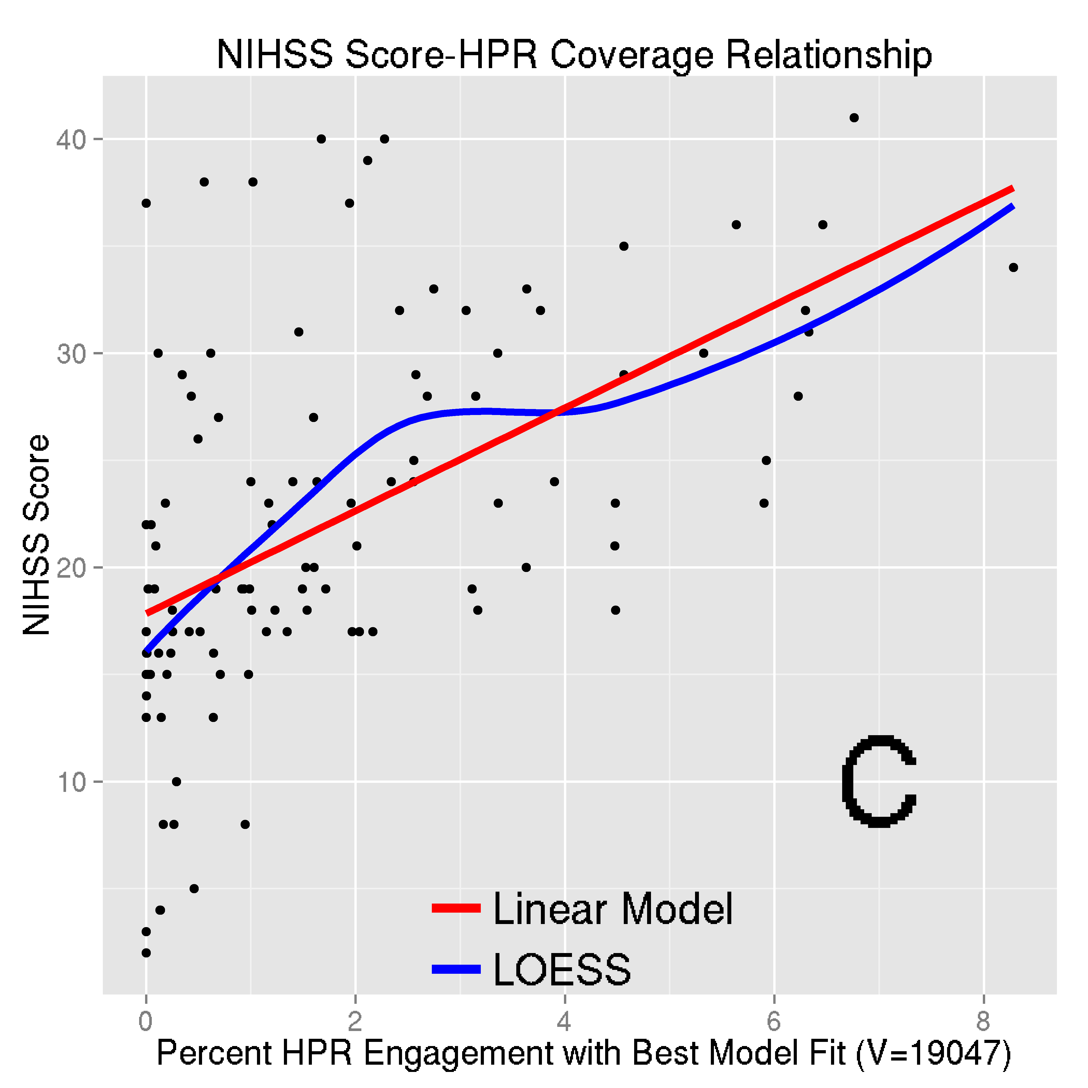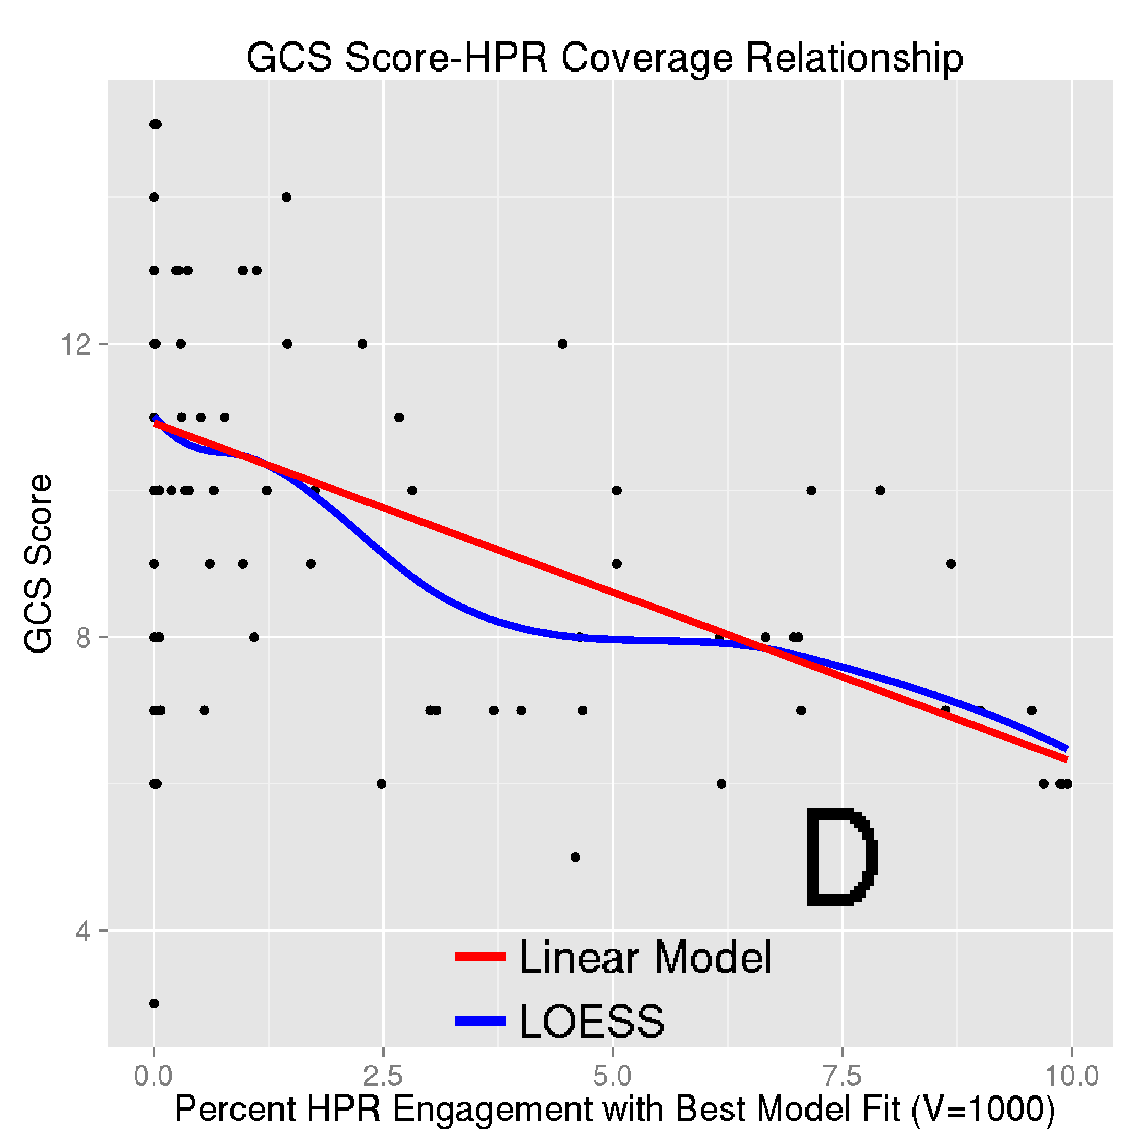

### Figure 2