%HL7 Ballot Code%

Vol3_Rendering_Guidance_Appendix



**HL7 CDA® R2 Implementation Guide: Reportability Response, Release 1**

**Standard for Trial Use Release 1.0**

May 2017

**Prototype of HL7 Standard for Trial Use**

**Sponsored by:**

**Public Health and Emergency Response Group**

**Structured Documents Work Group**

Copyright © 2016-2017 Health Level Seven International ® ALL RIGHTS RESERVED. The reproduction of this material in any form is strictly forbidden without the written permission of the publisher. HL7 and Health Level Seven are registered trademarks of Health Level Seven International. Reg. U.S. Pat & TM Off**.**

Use of this material is governed by HL7's [**IP Compliance Policy**](http://www.hl7.org/legal/ippolicy.cfm?ref=nav).

**Table of Contents**

1 Introduction 3

1.1 Purpose 3

1.2 Audience 3

2 Rendering / Visualization Guidance 4

2.1 Stylesheet 4

2.2 Example 4

2.3 CDA Header Information 4

# Introduction

## Purpose

This appendix contains informative guidance on rendering and visualization of a Reportability Response CDA document.

## Audience

The audience for this work is developers of software systems who want to enable their systems for displaying Reportability Response CDA documents.

# Rendering / Visualization Guidance

For normative rendering constraints, see the "Receiver Responsibilities" section in Volume 1 of the IG.

## Stylesheet

An example stylesheet has been provided to illustrate the desired format of the rendered Reportability Response CDA document.

## Example

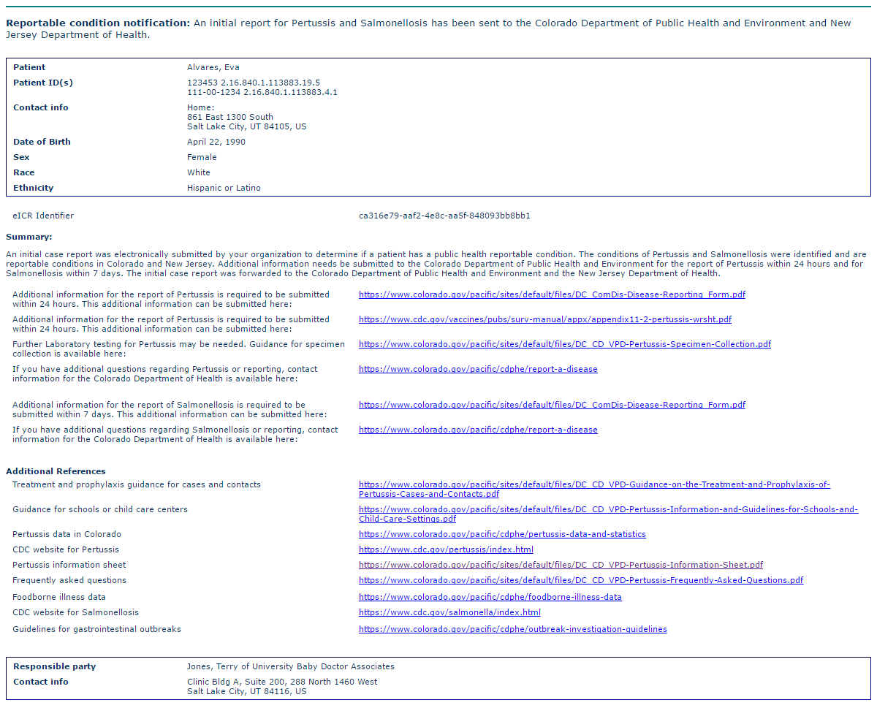

## CDA Header Information

The only information contained in the CDA header that should be displayed in the rendering of the CDA document is selected information about:

* the patient (recordTarget)
  + name (last, first)
  + id(s)
  + contact information
  + date of birth
  + sex
  + race
  + ethnicity
* the provider (encompassingEncounter/ responsibleParty)
  + name
  + organization
  + contact information