Section 1:
Microprocessor

Team name: Team T.L.D.C.S. (Team Learned Designers Collaborating Sensibly)
Members:
Shuying Fan
Donald Pomeroy
Corey Stappenbeck
Leonard Robinson - Verification Master
Tong Zhang – Design Master

Section 2: Design Overview
In this project, a MIPS pipeline processor is designed. It fetches two instructions and can commit at most four instructions every cycle. It allows out-of-order execution of certain instructions when there is no data dependency. The branch prediction strategy adopted in our design is “always not taken”. We assume that there is no WAW hazard among the instructions.
The top-level module consists of six parts. They are issue stage, register file, buffer stage, pc control unit, branch control unit and branch delay unit.
It has input ports for two new instructions and their valid bits, and since we do not design the memory, it also has output ports sending out data and address for load and store instructions, and input ports for load data and memory done bits.
The design has five stages. The first one is the combination of fetch, decode, instruction queue and hazard checker. The second stage is the register file. The third stage is ALU and results buffer. The fourth stage is the memory. The fifth stage is for writing back data to registers.
Section 3: Unit Level interfaces
Issue
Input | Meaning
clk | The clock
rst | Reset
new_instr1_in[31:0] | New Instruction 1 in
new_instr2_in[31:0] | New Instruction 2 in
ins_new_1_vld | Instruction 1 valid
ins_new_2_vld | Instruction 2 valid
ins_back_1_vld | Valid Instruction 1 coming back
ins_back_1_des[3:0] | Destination Instruction 1 coming back
ins_back_2_vld | Valid Instruction 2 coming back
ins_back_2_des[3:0] | Destination Instruction 2 coming back
ins_back_3_vld | Valid Instruction 3 coming back
ins_back_3_des[3:0] | Destination Instruction 3 coming back
ins_back_4_vld | Valid Instruction 4 coming back
ins_back_4_des[3:0] | Destination Instruction 4 coming back
flush_en | Flush enable
flush_id | Branch id to flush
flush_reg | Register to flush
Output | Meaning
iq_out_1_vld | Instruction 1 valid
iq_out_2_vld | Instruction 2 valid
iq_out_3_vld | Instruction 3 valid
iq_out_4_vld | Instruction 4 valid
iq_out_1_des[3:0] | Instruction 1 destination
iq_out_2_des[3:0] | Instruction 2 destination
iq_out_3_des[3:0] | Instruction 3 destination
iq_out_4_des[3:0] | Instruction 4 destination
iq_out_1_s1[3:0] | Instruction 1 source 1
iq_out_2_s1[3:0] | Instruction 2 source 1
iq_out_3_s1[3:0] | Instruction 3 source 1
iq_out_4_s1[3:0] | Instruction 4 source 1
iq_out_1_s2[3:0] | Instruction 1 source 2
iq_out_2_s2[3:0] | Instruction 2 source 2
iq_out_3_s2[3:0] | Instruction 3 source 2
iq_out_4_s2[3:0] | Instruction 4 source 2
iq_out_1_op[3:0] | Instruction 1 op code
iq_out_2_op[3:0] | Instruction 2 op code
iq_out_3_op[3:0] | Instruction 3 op code
iq_out_4_op[3:0] | Instruction 4 op code
iq_out_1_bid[2:0] | Instruction 1 branch id
iq_out_2_bid[2:0] | Instruction 2 branch id
iq_out_3_bid[2:0] | Instruction 3 branch id
iq_out_4_bid[2:0] | Instruction 4 branch id
iq_out_1_ime[4:0] | Instruction 1 immediate
iq_out_2_ime[4:0] | Instruction 2 immediate
iq_out_3_ime[4:0] | Instruction 3 immediate
iq_out_4_ime[4:0] | Instruction 4 immediate

Register File
Decodes the instruction, renames registers to prevent WAR and WAW hazards, and stores the decoded instructions in an issue queue.
Input | Meaning
clk | Clock
rst | Reset
in_1_vld | Instruction 1 valid
in_2_vld | Instruction 2 valid
in_3_vld | Instruction 3 valid
in_4_vld | Instruction 4 valid
in_1_des[3:0] | Instruction 1 destination
in_2_des[3:0] | Instruction 2 destination
in_3_des[3:0] | Instruction 3 destination
in_4_des[3:0] | Instruction 4 destination
in_1_s1[3:0] | Instruction 1 source 1
in_2_s1[3:0] | Instruction 2 source 1
in_3_s1[3:0] | Instruction 3 source 1
in_4_s1[3:0] | Instruction 4 source 1
in_1_s2[3:0] | Instruction 1 source 2
in_2_s2[3:0] | Instruction 2 source 2
in_3_s2[3:0] | Instruction 3 source 2
in_4_s2[3:0] | Instruction 4 source 2
in_1_op[3:0] | Instruction 1 op code
in_2_op[3:0] | Instruction 2 op code
in_3_op[3:0] | Instruction 3 op code
in_4_op[3:0] | Instruction 4 op code
in_1_branch[2:0] | Instruction 1 branch id
in_2_branch[2:0] | Instruction 2 branch id
in_3_branch[2:0] | Instruction 3 branch id
in_4_branch[2:0] | Instruction 4 branch id
in_1_ime[4:0] | Instruction 1 immediate
in_2_ime[4:0] | Instruction 2 immediate
in_3_ime[4:0] | Instruction 3 immediate
in_4_ime[4:0] | Instruction 4 immediate
back_1_vld | Instruction 1 write back valid
back_2_vld | Instruction 2 write back valid
back_3_vld | Instruction 3 write back valid
back_4_vld | Instruction 4 write back valid
back_1_des[3:0] | Instruction 1 write back destination
back_2_des[3:0] | Instruction 2 write back destination
back_3_des[3:0] | Instruction 3 write back destination
back_4_des[3:0] | Instruction 4 write back destination
back_1_data[31:0] | Instruction 1 write back data
back_2_data[31:0] | Instruction 2 write back data
back_3_data[31:0] | Instruction 3 write back data
back_4_data[31:0] | Instruction 4 write back data
Output | Meaning
out_1_vld | Instruction 1 valid
out_2_vld | Instruction 2 valid
out_3_vld | Instruction 3 valid
out_4_vld | Instruction 4 valid
out_1_des[3:0] | Instruction 1 destination
out_2_des[3:0] | Instruction 2 destination
out_3_des[3:0] | Instruction 3 destination
out_4_des[3:0] | Instruction 4 destination
out_1_s1[3:0] | Instruction 1 source 1
out_2_s1[3:0] | Instruction 2 source 1
out_3_s1[3:0] | Instruction 3 source 1
out_4_s1[3:0] | Instruction 4 source 1
out_1_s2[3:0] | Instruction 1 source 2
out_2_s2[3:0] | Instruction 2 source 2
out_3_s2[3:0] | Instruction 3 source 2
out_4_s2[3:0] | Instruction 4 source 2
out_1_op[3:0] | Instruction 1 op code
out_2_op[3:0] | Instruction 2 op code
out_3_op[3:0] | Instruction 3 op code
out_4_op[3:0] | Instruction 4 op code
out_1_branch[2:0] | Instruction 1 branch id
out_2_branch[2:0] | Instruction 2 branch id
out_3_branch[2:0] | Instruction 3 branch id
out_4_branch[2:0] | Instruction 4 branch id
in_1_ime[4:0] | Instruction 1 immediate
in_2_ime[4:0] | Instruction 2 immediate
in_3_ime[4:0] | Instruction 3 immediate
in_4_ime[4:0] | Instruction 4 immediate

Buffer Stage
Input | Meaning
in_1_s1_data[31:0] | Instruction 1 source 1 data
in_2_s1_data[31:0] | Instruction 2 source 1 data
in_3_s1_data[31:0] | Instruction 3 source 1 data
in_4_s1_data[31:0] | Instruction 4 source 1 data
in_1_s2_data[31:0] | Instruction 1 source 2 data
in_2_s2_data[31:0] | Instruction 2 source 2 data
in_3_s2_data[31:0] | Instruction 3 source 2 data
in_4_s2_data[31:0] | Instruction 4 source 2 data
in_1_des[3:0] | Instruction 1 destination
in_2_des[3:0] | Instruction 2 destination
in_3_des[3:0] | Instruction 3 destination
in_4_des[3:0] | Instruction 4 destination
in_1_op[3:0] | Instruction 1 op code
in_2_op[3:0] | Instruction 2 op code
in_3_op[3:0] | Instruction 3 op code
in_4_op[3:0] | Instruction 4 op code
in_1_vld | Instruction 1 valid
in_2_vld | Instruction 2 valid
in_3_vld | Instruction 3 valid
in_4_vld | Instruction 4 valid
in_1_branch[2:0] | Instruction 1 branch
in_2_branch[2:0] | Instruction 2 branch
in_3_branch[2:0] | Instruction 3 branch
in_4_branch[2:0] | Instruction 4 branch
in_1_immediate | Instruction 1 immediate
mem_in_done | Memory in done
load_data[31:0] | Data to load
flush_en | Flush enable
flush_id | Branch id to flush
clk | Clock
rst | Reset
Output | Meaning
out_1_des[3:0] | Instruction 1 destination
out_2_des[3:0] | Instruction 2 destination
out_3_des[3:0] | Instruction 3 destination
out_4_des[3:0] | Instruction 4 destination
out_1_data[31:0] | Instruction 1 data
out_2_data[31:0] | Instruction 2 data
out_3_data[31:0] | Instruction 3 data
out_4_data[31:0] | Instruction 4 data
out_1_vld | Instruction 1 valid
out_2_vld | Instruction 2 valid
out_3_vld | Instruction 3 valid
out_4_vld | Instruction 4 valid
out_1_mem_addr[31:0] | Memory address
out_1_mem_data[31:0] | Memory data
out_load_flag | High if load
out_store_flag | High if store
buffer_full | High is buffer is full
buffer_empty | High if buffer empty
reg_out_to_raw_history[3:0] | Raw history

Stage 4 Execute – top buffer
Checks for RAW hazards, accesses the register file, decodes the instruction to determine which datapaths to use (memory/register).
Input | Meaning
clk | Clock
rst | Reset
in_1_s1_data[31:0] | Instruction 1 source 1 data
in_1_s2_data[31:0] | Instruction 1 source 2 data
in_2_s1_data[31:0] | Instruction 2 source 1 data
in_2_s2_data[31:0] | Instruction 2 source 2 data
in_3_s1_data[31:0] | Instruction 3 source 1 data
in_3_s2_data[31:0] | Instruction 3 source 2 data
in_4_s1_data[31:0] | Instruction 4 source 1 data
in_4_s2_data[31:0] | Instruction 4 source 2 data
in_1_des[3:0] | Instruction 1 destination
in_2_des[3:0] | Instruction 2 destination
in_3_des[3:0] | Instruction 3 destination
in_4_des[3:0] | Instruction 4 destination
in_1_op[3:0] | Instruction 1 op code
in_2_op[3:0] | Instruction 2 op code
in_3_op[3:0] | Instruction 3 op code
in_4_op[3:0] | Instruction 4 op code
in_1_vld | Instruction 1 valid
in_2_vld | Instruction 2 valid
in_3_vld | Instruction 3 valid
in_4_vld | Instruction 4 valid
in_1_immediate[4:0] | Instruction 1 immediate
in_1_branch[2:0] | Instruction 1 branch
in_2_branch[2:0] | Instruction 2 branch
in_3_branch[2:0] | Instruction 3 branch
in_4_branch[2:0] | Instruction 4 branch
mem_in_done | Memory input done
flush_en | High to flush register
flush_id[2:0] | Branch id to flush
load_data[31:0] | Data to load
out_1_des[3:0] | Instruction 1 output destination
out_2_des[3:0] | Instruction 2 output destination
out_3_des[3:0] | Instruction 3 output destination
out_4_des[3:0] | Instruction 4 output destination
out_1_data[31:0] | Instruction 1 output data
out_2_data[31:0] | Instruction 2 output data
out_3_data[31:0] | Instruction 3 output data
out_4_data[31:0] | Instruction 4 output data
out_1_vld | Instruction 1 output valid
out_2_vld | Instruction 2 output valid
out_3_vld | Instruction 3 output valid
out_4_vld | Instruction 4 output valid
out_1_mem_addr[31:0] | Output 1 memory address
out_load_flag | High if load
out_store_flag | High if store
buffer_full | High is the buffer is full
buffer_empty | High if the buffer is empty
reg_out_to_raw_history[15:0] | History for RAW conflicts
out_1_mem_data | Output data for Instruction 1

Branch Delay
Input | Meaning
clk | Clock
rst | Reset
flush | High if flush
Bid[2:0] | Branch id
Output | Meaning
buffer_flush | Buffer to flush
buffer_bid[2:0] | Buffer branch id to flush

Branch Control
Input | Meaning
ins1_op[3:0] | Instruction 1 op code
ins2_op[3:0] | Instruction 2 op code
ins3_op[3:0] | Instruction 3 op code
ins4_op[3:0] | Instruction 4 op code
ins1_data1[31:0] | Instruction 1 data 1
ins2_data1[31:0] | Instruction 2 data 1
ins3_data1[31:0] | Instruction 3 data 1
ins4_data1[31:0] | Instruction 4 data 1
ins1_data2[31:0] | Instruction 1 data 2
ins2_data2[31:0] | Instruction 2 data 2
ins3_data2[31:0] | Instruction 3 data 2
ins4_data2[31:0] | Instruction 4 data 2
ins1_bid[2:0] | Instruction 1 branch id
ins2_bid[2:0] | Instruction 2 branch id
ins3_bid[2:0] | Instruction 3 branch id
ins4_bid[2:0] | Instruction 4 branch id
ins1_addr[4:0] | Instruction 1 address
ins2_addr[4:0] | Instruction 2 address
ins3_addr[4:0] | Instruction 3 address
ins4_addr[4:0] | Instruction 4 address
Output | Meaning
flush | High upon flush
bid | Branch id
addr | Address

Program Counter Control
Input | Meaning
vld_1 | Valid Instruction 1
vld_2 | Valid Instruction 2
iq_full | Instruction queue full
iq_empty | Instruction queue empty
bid_full | Branch id full
flush | High upon flush
addr | Address
clk | Clock
rst | Reset
Output | Meaning
pc | Program Counter

Section 4: Subunit partitioning and interfaces, Test harness structure
Stage 1
Format:
31-26 | 25-22 | 21-18 | 17-14 | 13-9 | 8-0
Opcode | Destination | Source1 | Source2 | immediate | Reserved bits

Add instruction, imm == 0, opcode == 000000
Load instruction, source2 == 0, opcode == 100011
Store instruction, des == 0, opcode == 101011
Branch instruction, des == 0, opcode == 000101
5-bit immediate indicates the size of icache/datacache is 32.

Flush & bid are sent back from branch_ctrl
Write back information comes from the last stage of our pipeline design. It is used to update the raw_history.

Five units are included in this stage:
- Decode
Pure combinational, decode the instructions.
Input: two instructions every cycle in the format shown above.
Output: ins1_op, ins1_des, ins1_s1,ins1_s2, ins1_imm and same for ins2.
- Issue queue
It has four basic functionalities: new instruction allocation, instruction issuing and deallocation, shift and flush.
Its inputs come from three parts: decode, precalculation and branch control.
It has 16 entries. When it’s full, a full signal will be set to high and it will go down to 0 only after the issue queue is empty. This signal is used to control the pc. (Notice: when there is only 1 or 0 empty entry, full signal will be high.)
Every instruction that comes into this queue will be assigned to a branchID, which is 3-bit wide. When the branchID is used up, branch_full signal will be high. It will go down only when the queue and the buffer are empty again.
- All_checker
It consists of four submodules:
raw_history_check: It keeps track of the usage of each register and checks if new instructions will read from any register which will be written in the next few cycles. If so, those instructions can’t be issued.
load_store_check: It makes sure that every cycle, at most 1 memory instruction can be issued and instructions after the second valid memory instruction (which can’t be issued) can’t be issued out of order.
raw_war_checker: it checks the data dependency among the four instructions every cycle
branch_check: it makes sure that branches won’t be issued out of order.
- ins_swap:
If a memory instruction should be issued, it has to stay in the “first” thread because the first ALU will be used for effective address calculation. Therefore, after all_checker, the four instructions (now all potential hazards are eliminated) will be sent into this unit for “reordering”
- Precalculation
It consists of three submodules: entry_select, shift_amount, and new_ins_addr_calculation
Entry_select
Since in each cycle, the number of instructions that can be issued varies, and only at the positive edge of the next cycle can we know the index of the instructions that are actually issued. Therefore, this module is used to choose the index of instructions that should be sent out from the issue queue.
Shift_amount
The shift function of the queue is realized by the help of this module which calculate the number of entries the instructions stored in the issue queue should shift up.
new_ins_addr_calculation
Calculate the index for new instruction allocation.

Stage 2
This stage is for register file with 8 read ports and 4 write ports. It has 16 entries each of which records a 32-bit data of the corresponding register.
In every cycle, instructions will access the register file based on their opcode and source registers. If it is a branch instruction, the data read from the register file will only go into the branch_ctrl unit. If it is a load/store instruction, the data stored in the source register, the immediate number and the destination register will all be fed into the next stage.
When an instruction is finally committed, data will be written back into the register file.

Stage 3
In this stage, data will first be sent to ALU for the addition, and then all the results will write back to the buffer. The buffer will try to commit up to four instructions per cycle. Components of the stage include alu_and_buffer, entry_select, shift_amount and buffer_new_addr_calculation. The top module for the stage is top_stage_buffer.
entry_select:
It is same as the one in stage 1. It generates the address of which entries should the buffer commit for the next clock cycle.
shift_amount:
It is also same as the one in stage 1. It generates how many entries each entry in the buffer should shift in the next clock cycle.
buffer_new_addr_calculation:
This module calculates what the addresses the new instructions should be stored in the buffer for the next clock cycle.
alu_and_buffer:
This is the core part of the stage. It receives all the outputs of the previous described three modules, and stores all the instructions results before commit. The buffer has 32 entries, and stores the calculation results of ALU, destination register number, branch ID, and op code of the instruction. Like the instruction queue, it will do the entry shifting, write in new entries and try to send out up to four output set each cycle. Those sending out entries must have the branch ID smaller than the already given ID result. Once the branch prediction is wrong, all the entries in the buffer with ID equal or bigger than the prediction ID will be flushed. So are the instructions in issue queue. The buffer_full signal will enlightened when more than 16 entries of the buffer is filled, and then no more new instruction will be fetched until both buffer and queue are empty. The remaining 16 entries are to make sure all instructions that in stage 1 or stage 2 can reach the buffer.

PC Control
The module pc_ctrl is used for the controlling the process of the program. Five factors can affect the program counter.
a) new_ins_vld
If the instructions we fetch into the pipeline is valid, the program counter will increment by 4 for each instruction. Otherwise, it remains the same.
b) status of the issue queue
When the issue queue is full, we need to stop fetching new instructions into the pipeline. Therefore, the program counter is stalled. To avoid any possible confliction, we assume that the pc will be reactivated only after the issue queue is empty.
c) status of the buffer
The buffer we design in this project has 32 entries. When it is half full—when the 16th entry is occupied, a full signal will be set to high and thus stall the program counter. But the pipeline won’t be stopped. Instead, all the instructions, whether they are stored in the issue stage, accessing the register file, or executed in the third stage, will continue running until when the buffer is empty. Then an empty signal will be set to high to reactivate the program counter.
d) status of the branch ID
Since we only assign three bits to indicate the branch ID of an instruction, when we have more than 8 instructions in a program (which is very likely), we need to be able to manage the counting and assigning the branch ID in a way that the pipeline can function correctly. Therefore, whenever the pipeline is running out of the branch ID, the signal branch_full will become high and the pc will be stalled. It will be reactivated only when both the issue queue and the buffer are empty.
e) branch misprediction
Whenever a branch is mispredicted, the program counter will point to the address specified by the branch instruction.

Branch Control
The branch_ctrl module is a pure combinational module designed for the speculative execution of the pipeline. Its inputs all come from the second stage of the pipeline and are listed below.
ins1_op, ins1_data1, ins1_data2, ins1_bid, ins1_addr
ins2_op, ins2_data1, ins2_data2, ins2_bid, ins2_addr
ins3_op, ins3_data1, ins3_data2, ins3_bid, ins3_addr
ins4_op, ins4_data1, ins4_data2, ins4_bid, ins4_addr
It has three outputs: flush, bid and addr. The flush and bid signal will be sent to the issue stage and the branch delay stage while the flush and addr signals will go into the pc_ctrl module.
It consists of three submodules. They are compare_equal, branch_priority and branch_mux.
a) Compare_equal module compares two source registers for branch instructions every cycle. When there is misprediction, the corresponding output signal will be set to high. If the instruction is not a branch, the output of the module will be 0. If any of the instructions is a branch and if it mispredicts, the output of the module will be set to 1.
b) Branch_priority: a priority encoder. Since the pipeline allows issuing at most four branches (when there is no data dependency) but does not allow out-of-order execution of branch instructions, the first mispredicting branch is the dominant.
c) Branch_mux module takes in the output of the previous unit to choose the dominant branch ID.

Branch Delay
Whenever a branch mispredicts, if we flush the buffer right away, there is a possibility that some instructions with the same ID as the mispredicted branch haven’t reached to the buffer. In this case, the flush is not thoroughly. In order to completely flush the pipeline whenever a branch mispredicts, we insert three cycles delay of the flush signal to make sure all the instructions with a branch ID equal or larger than the mispredicted branch ID can be flushed.
Section 5: Microarchitecture design
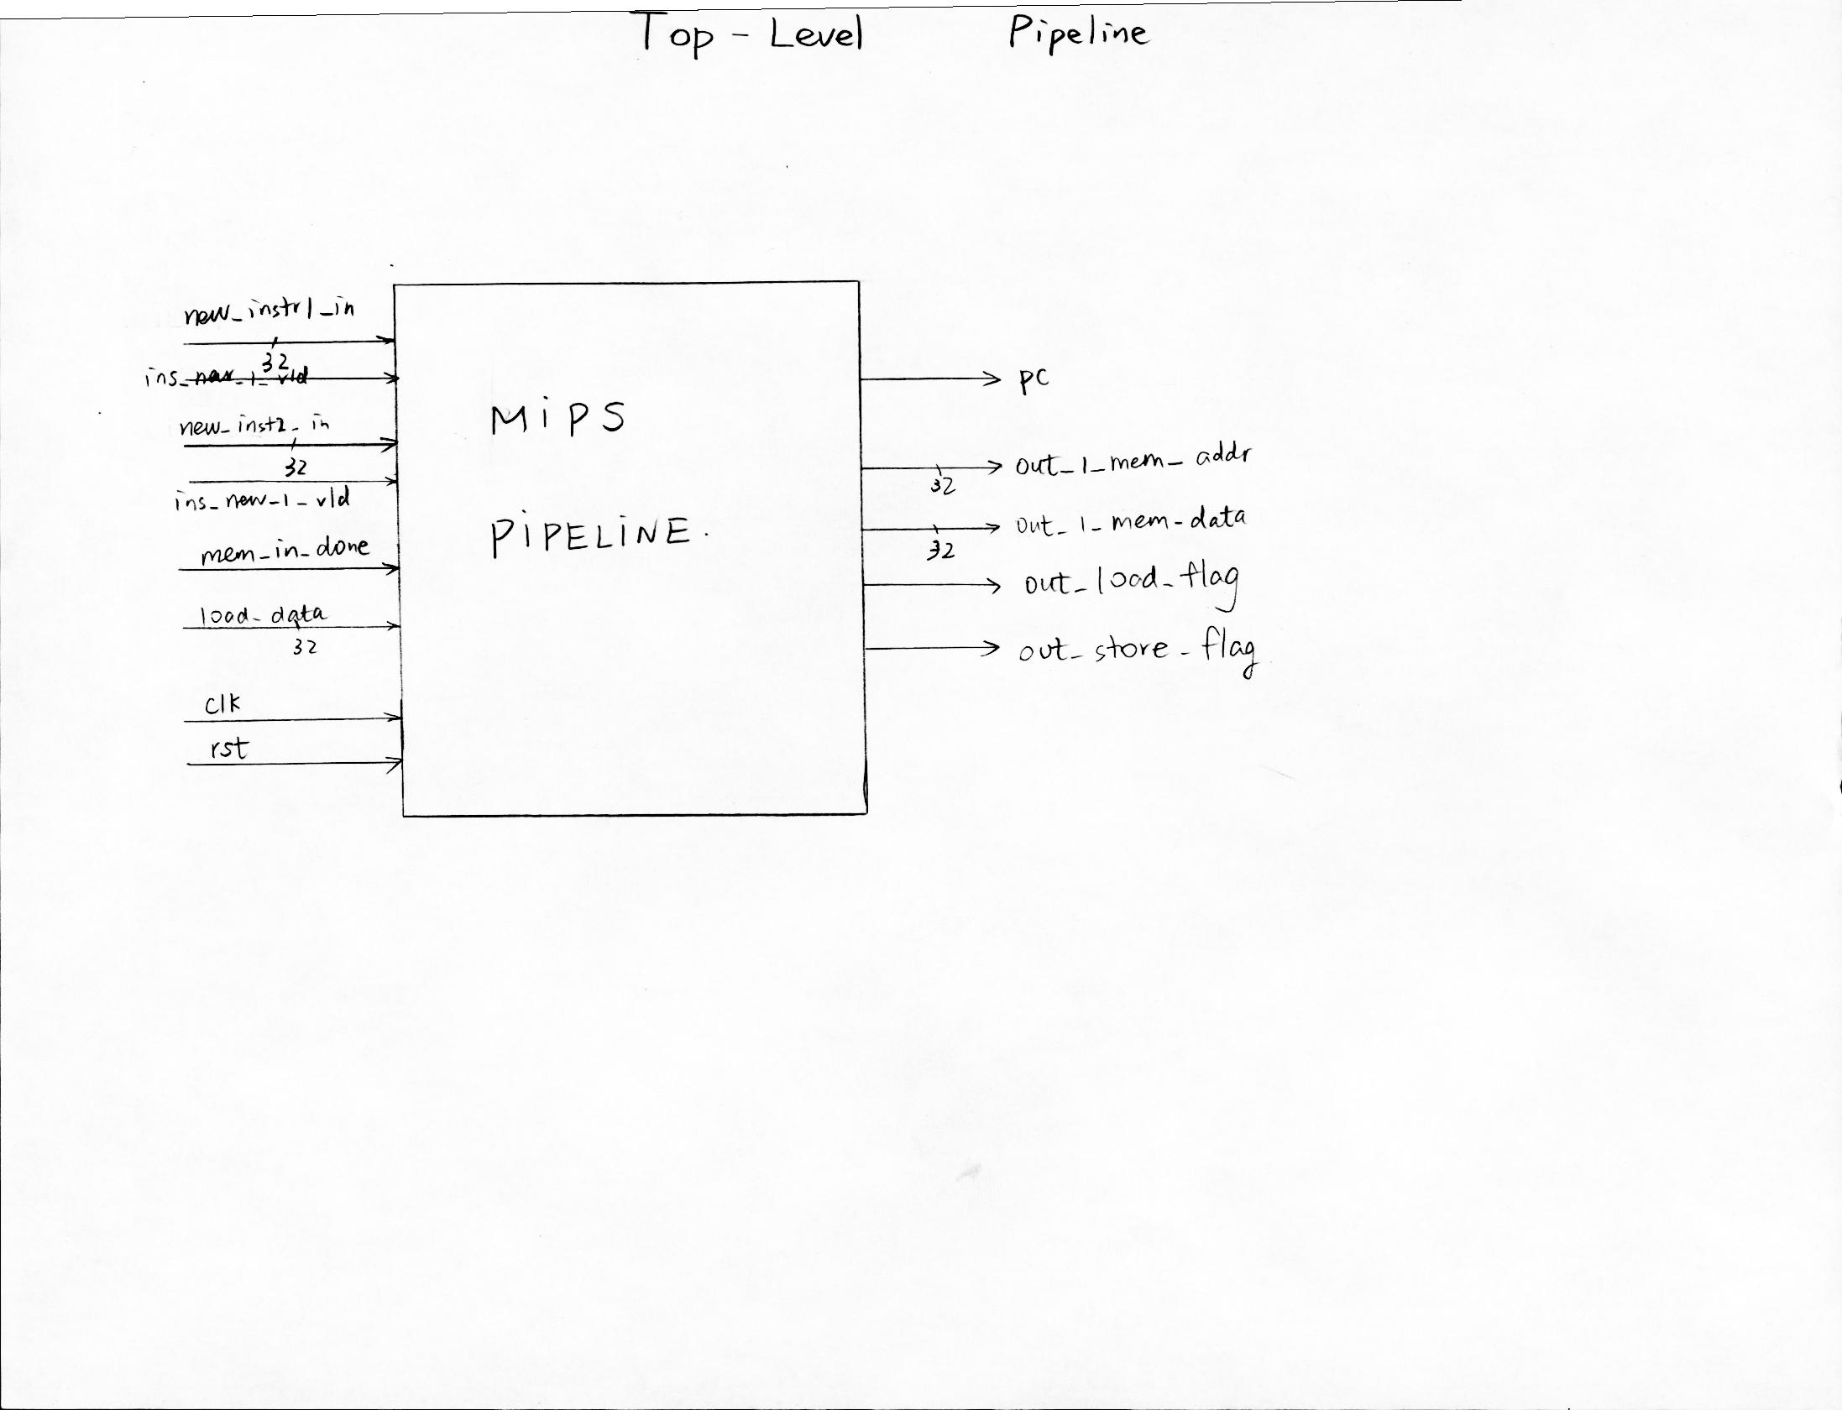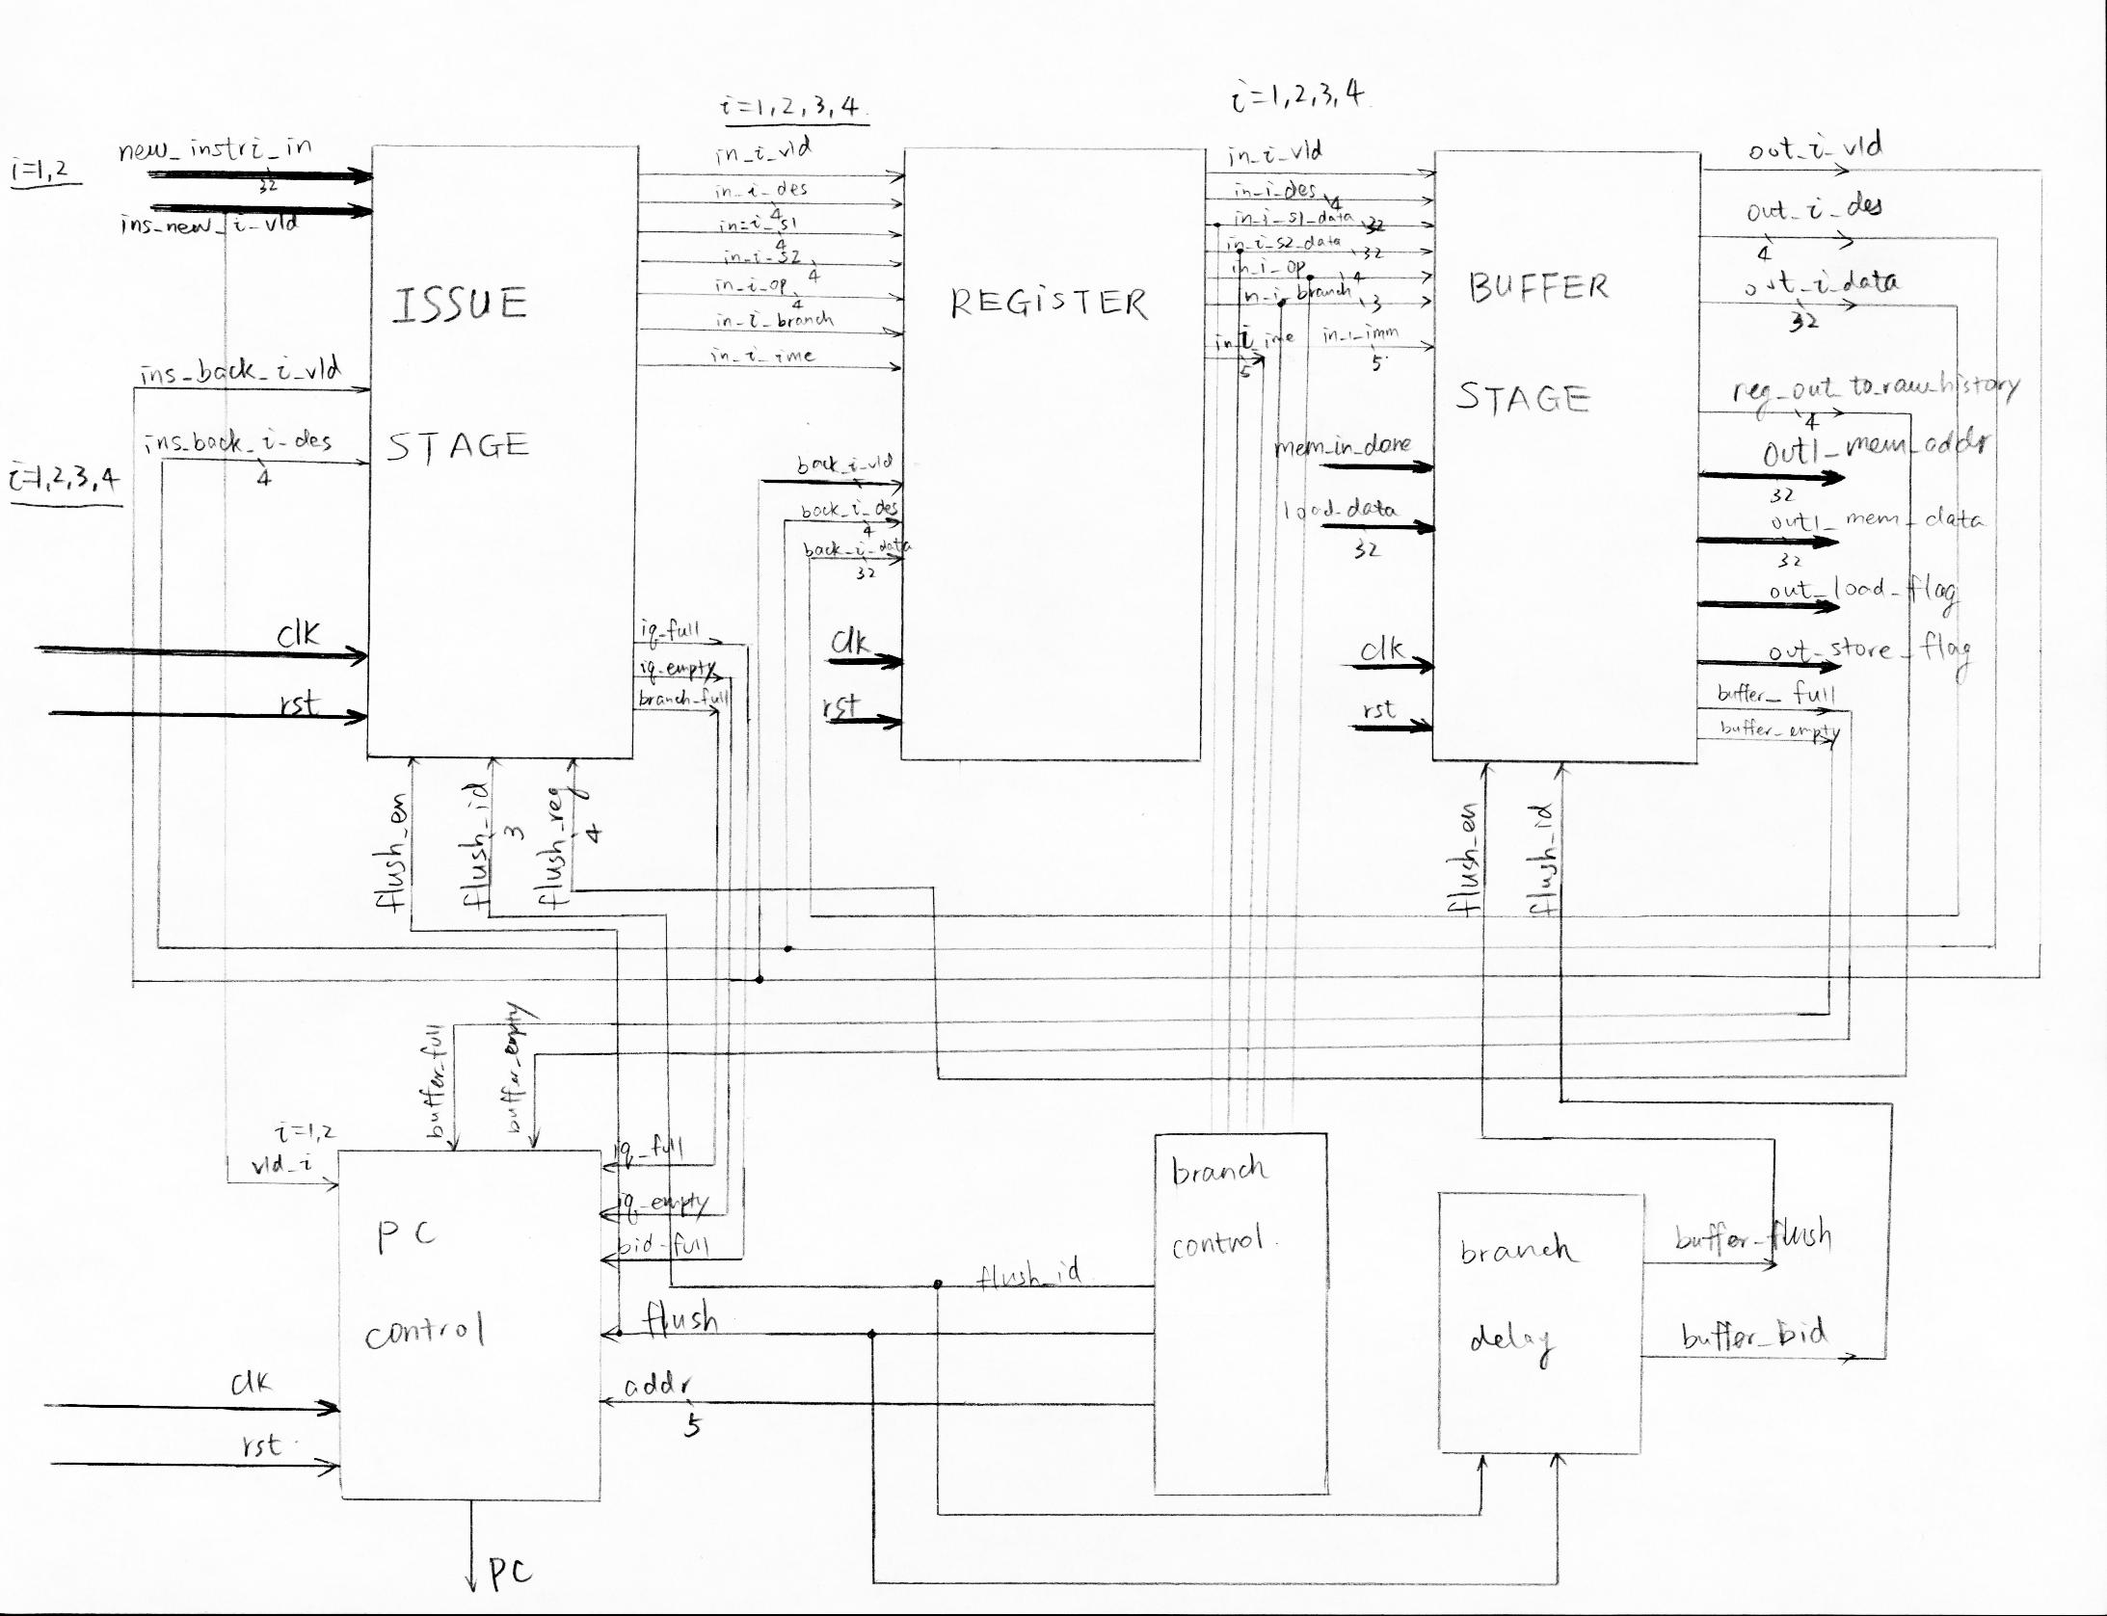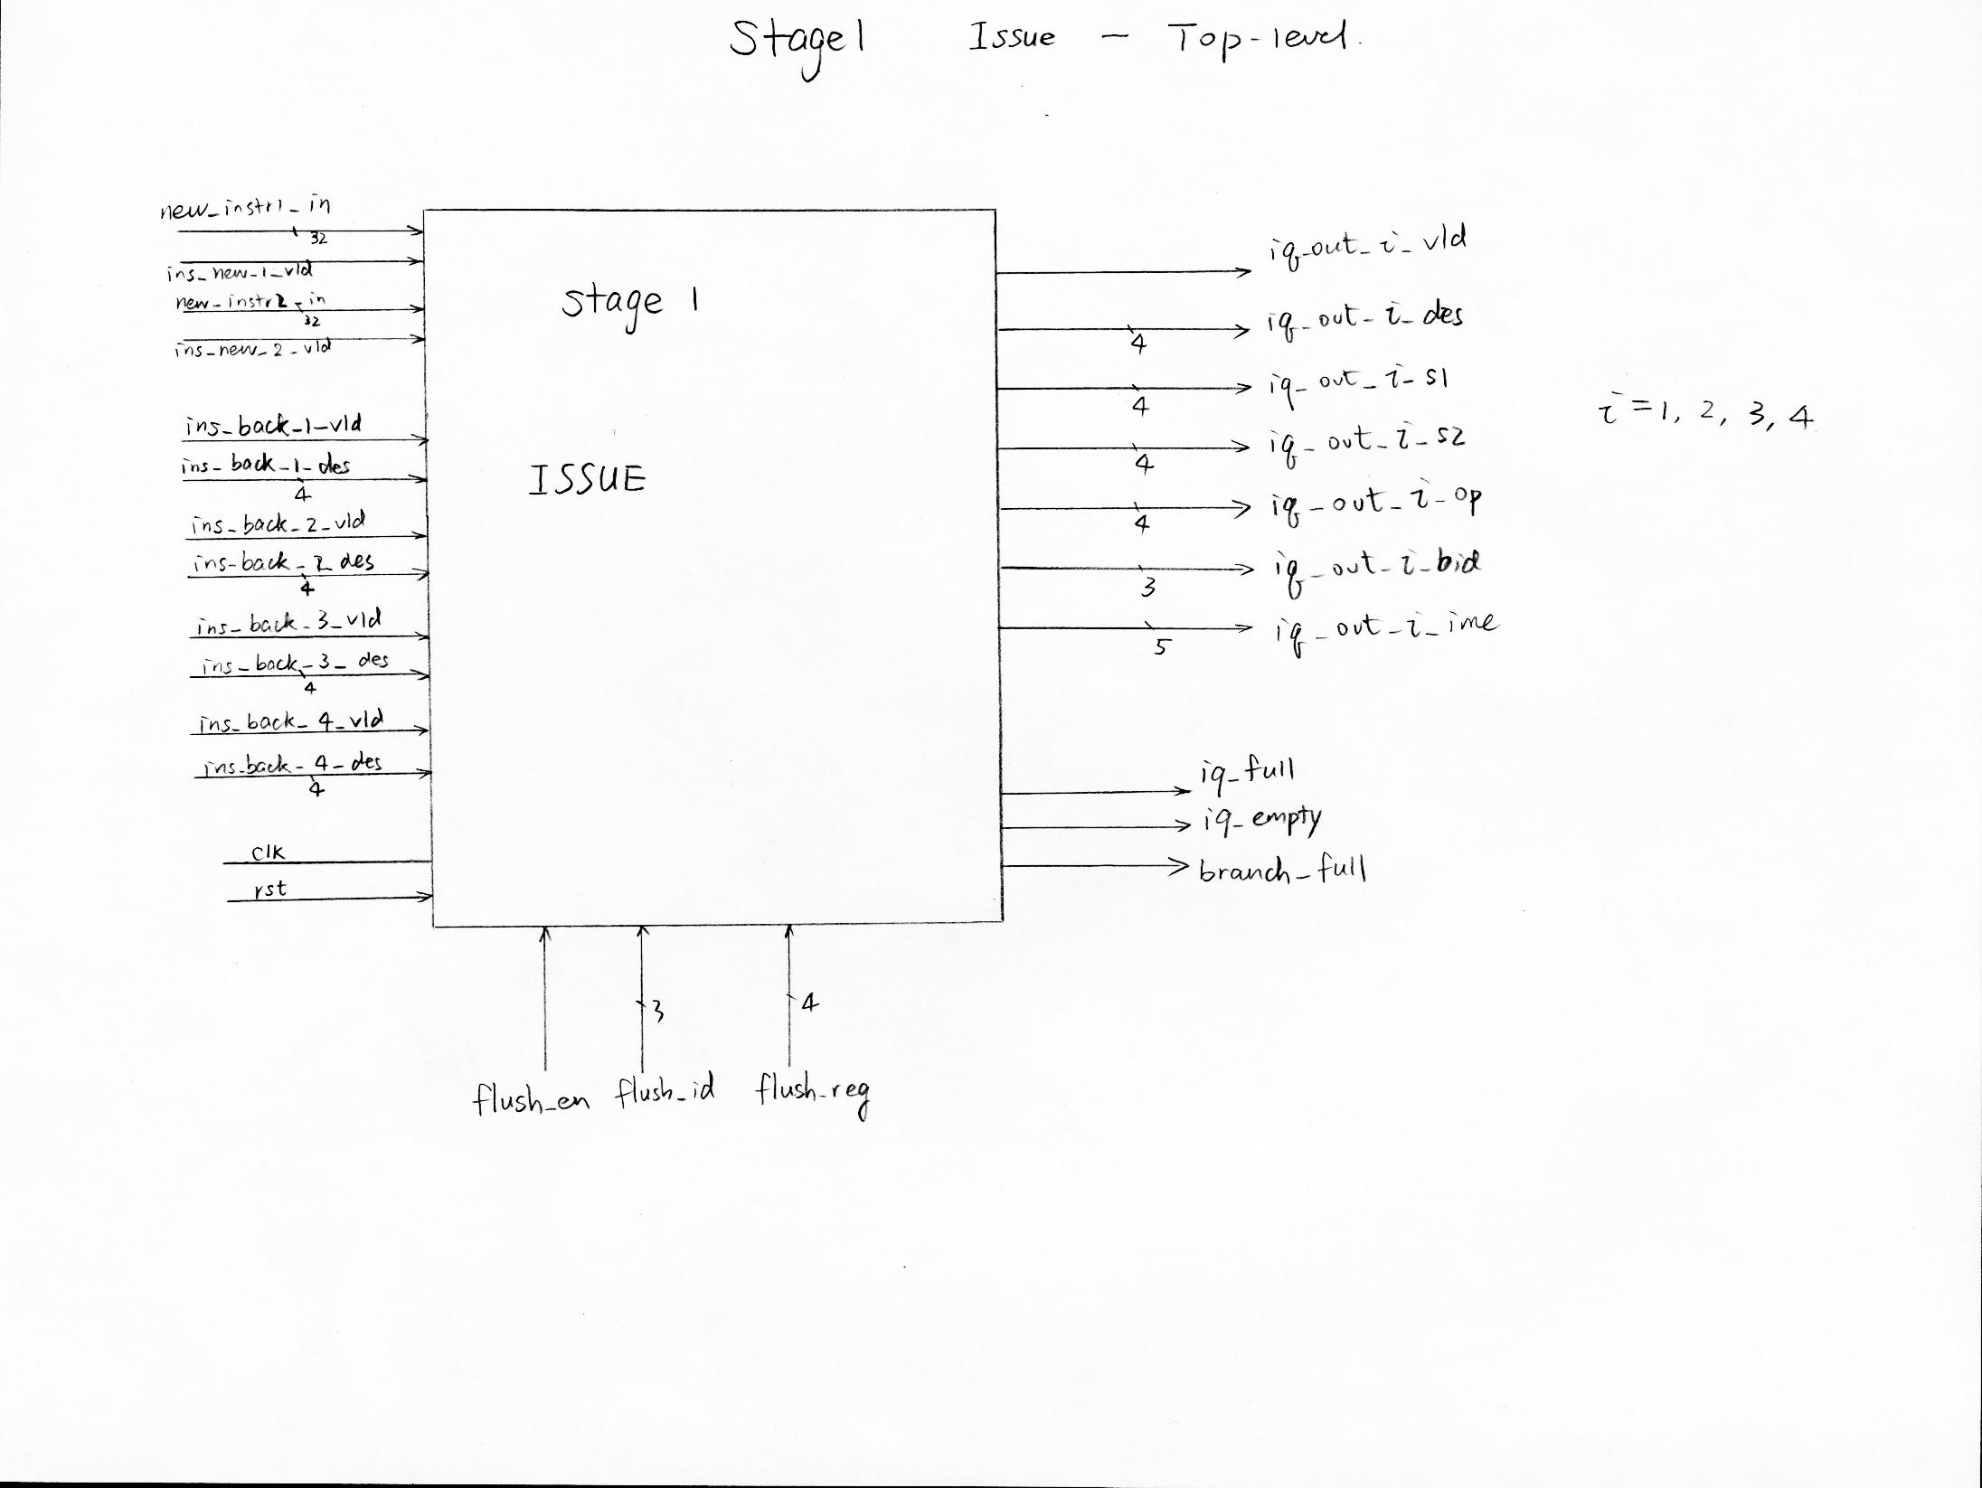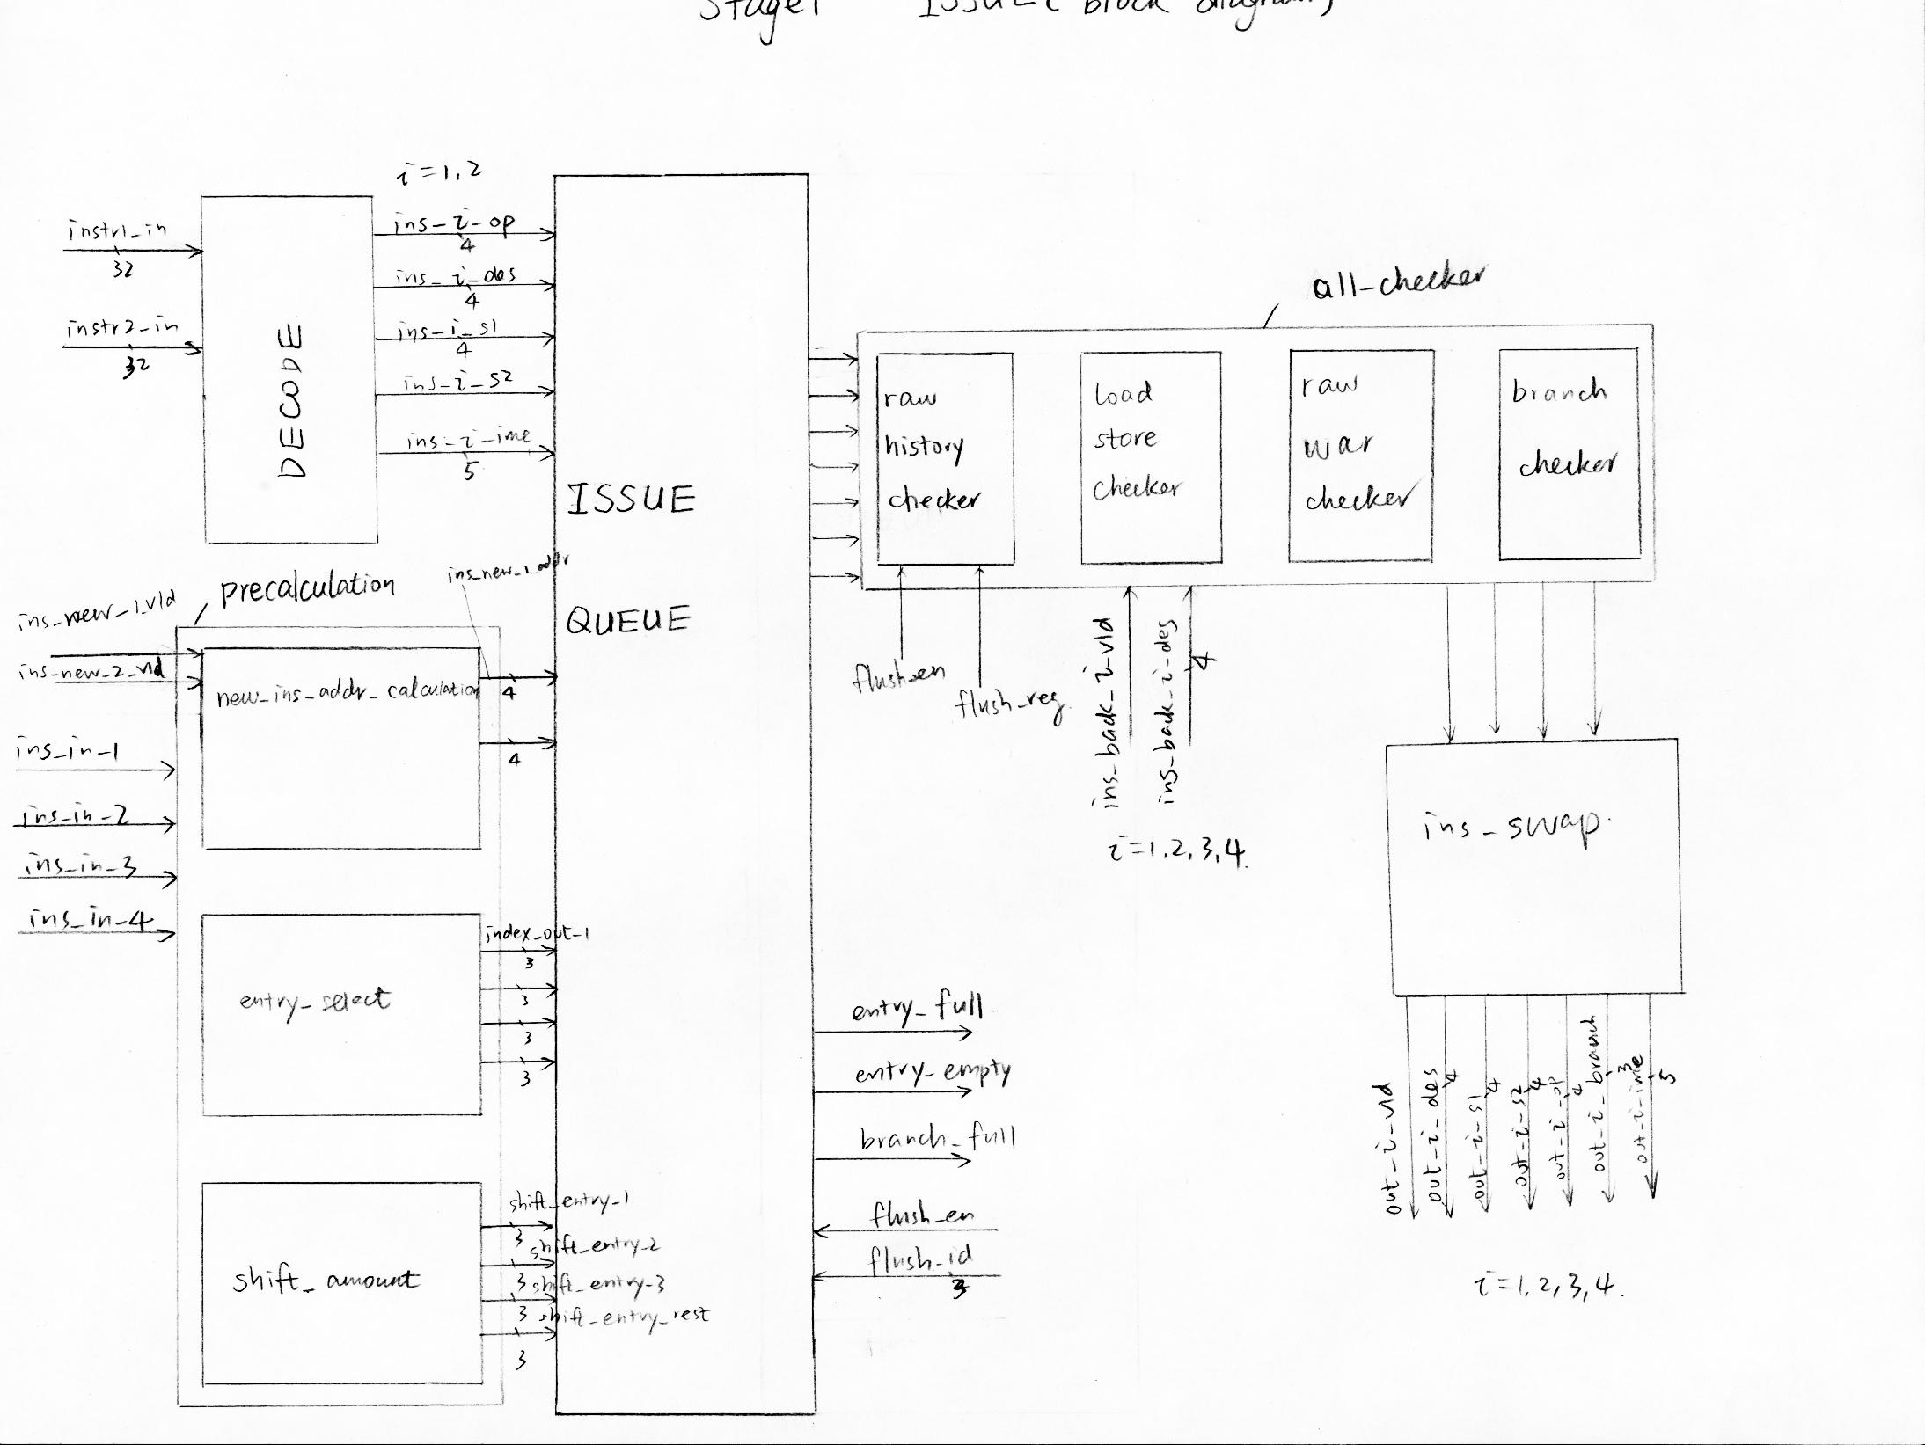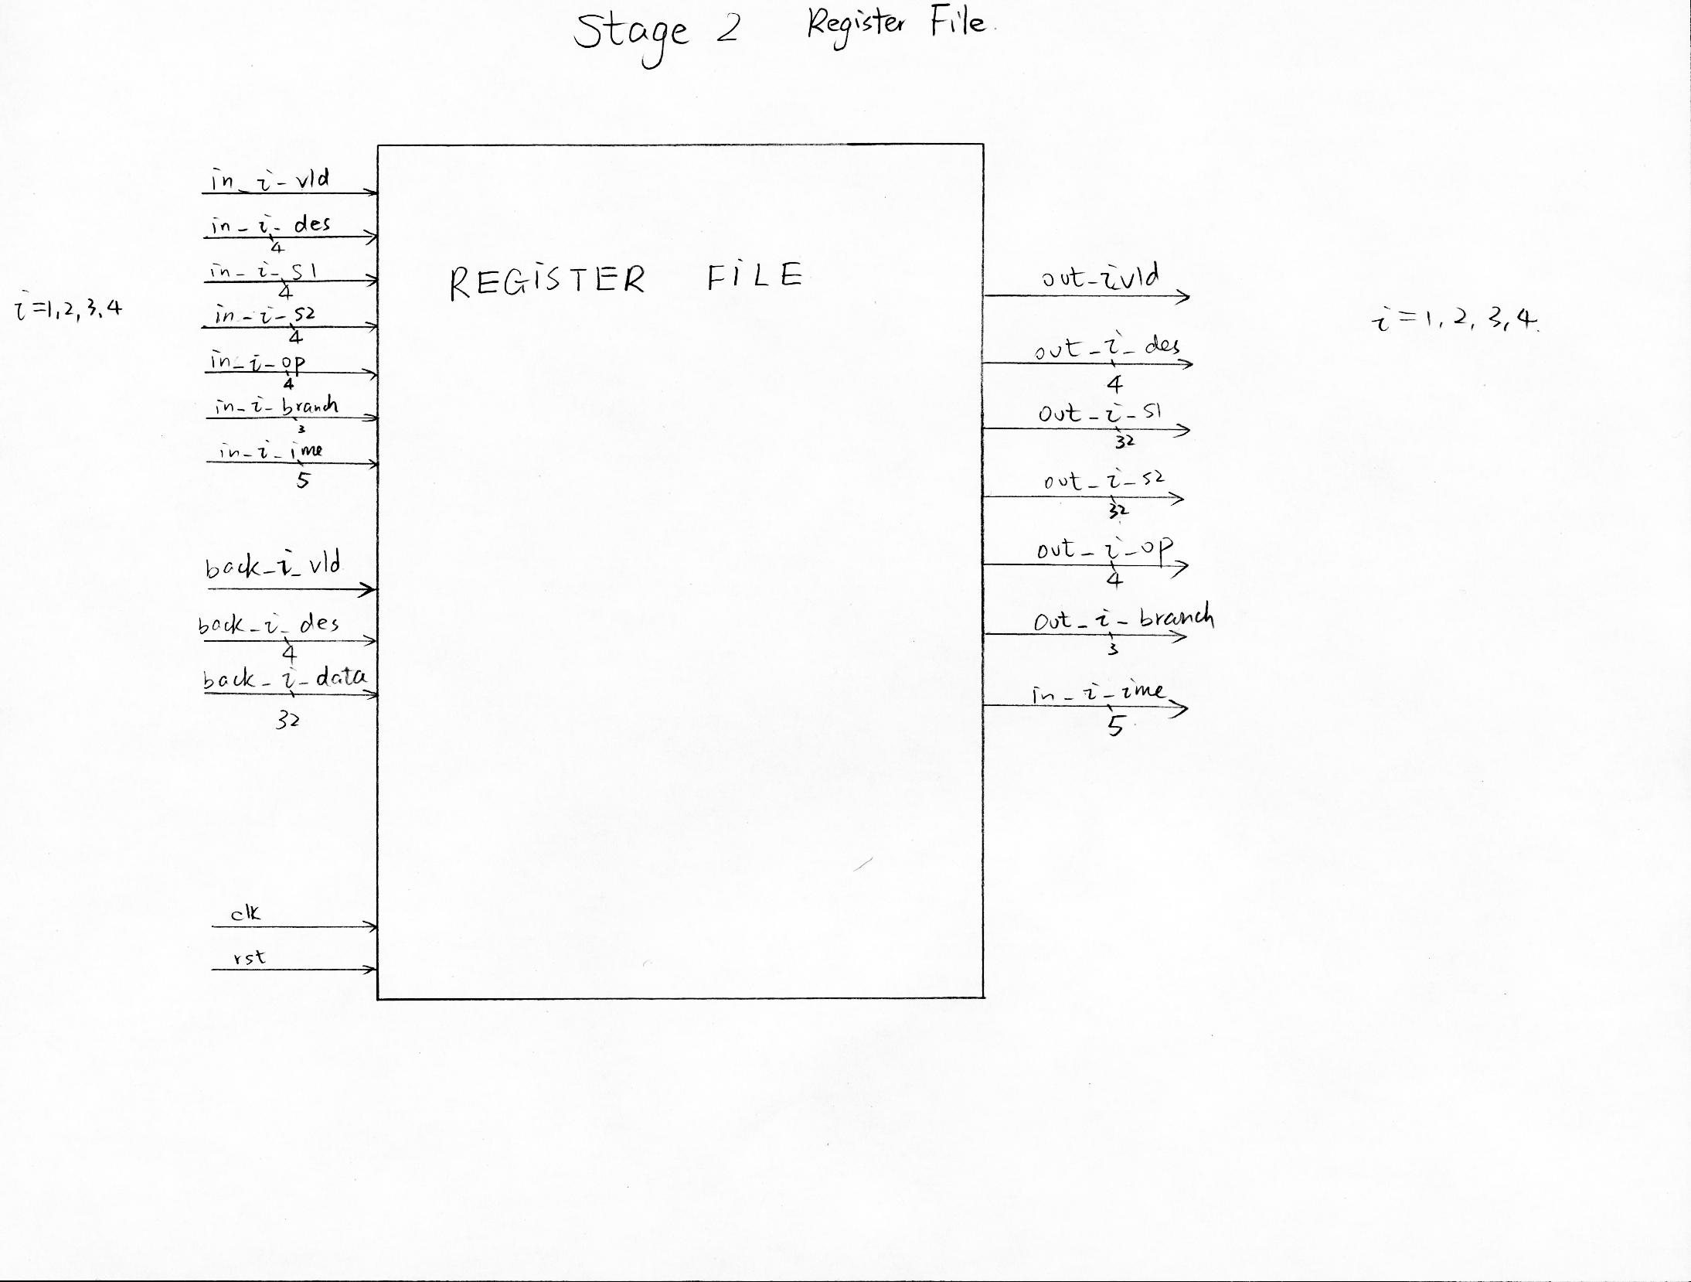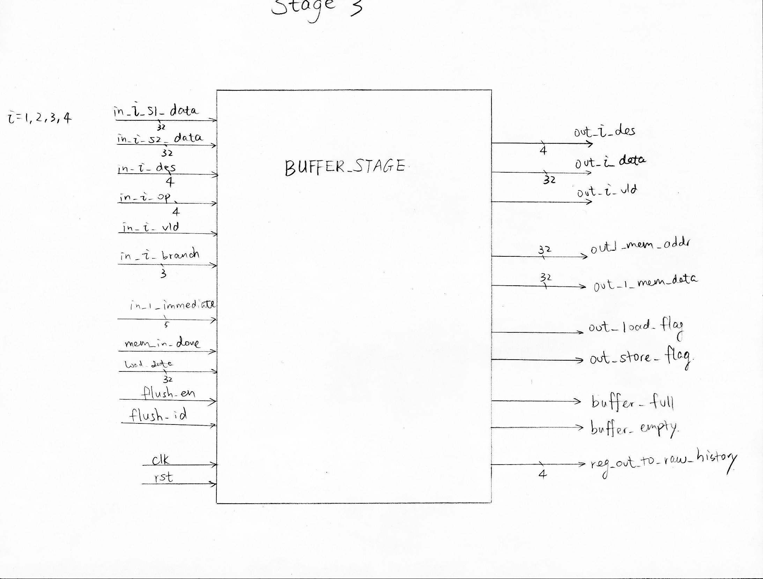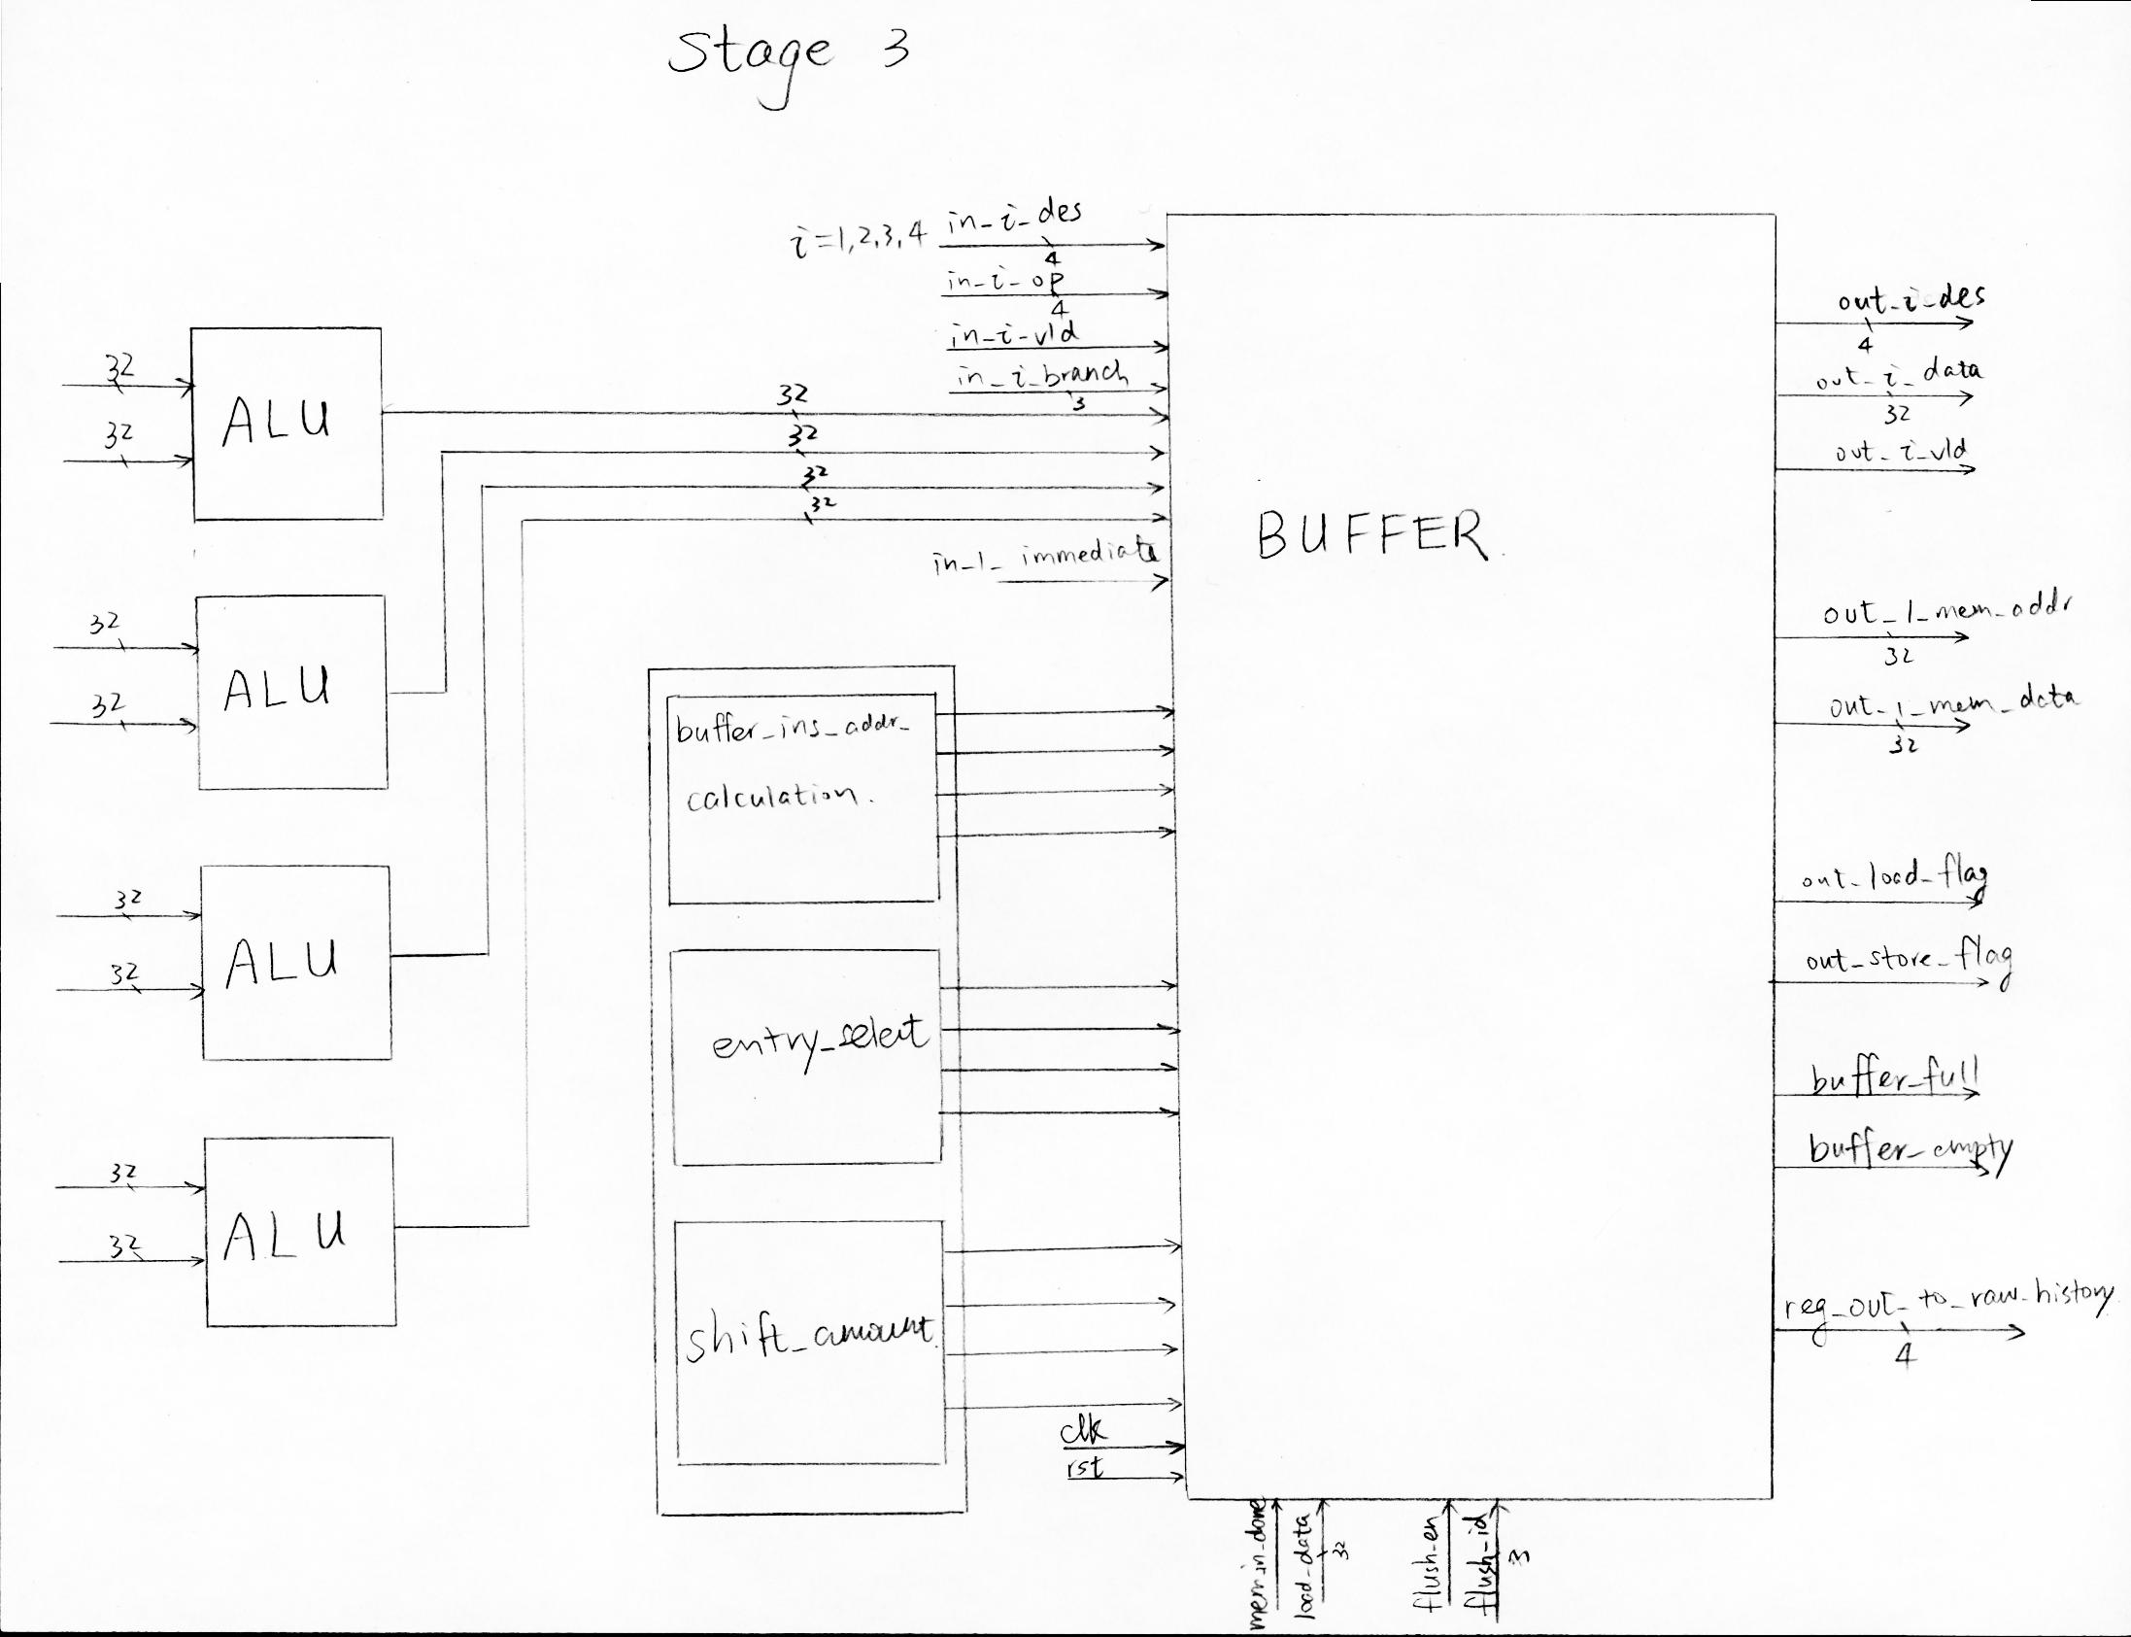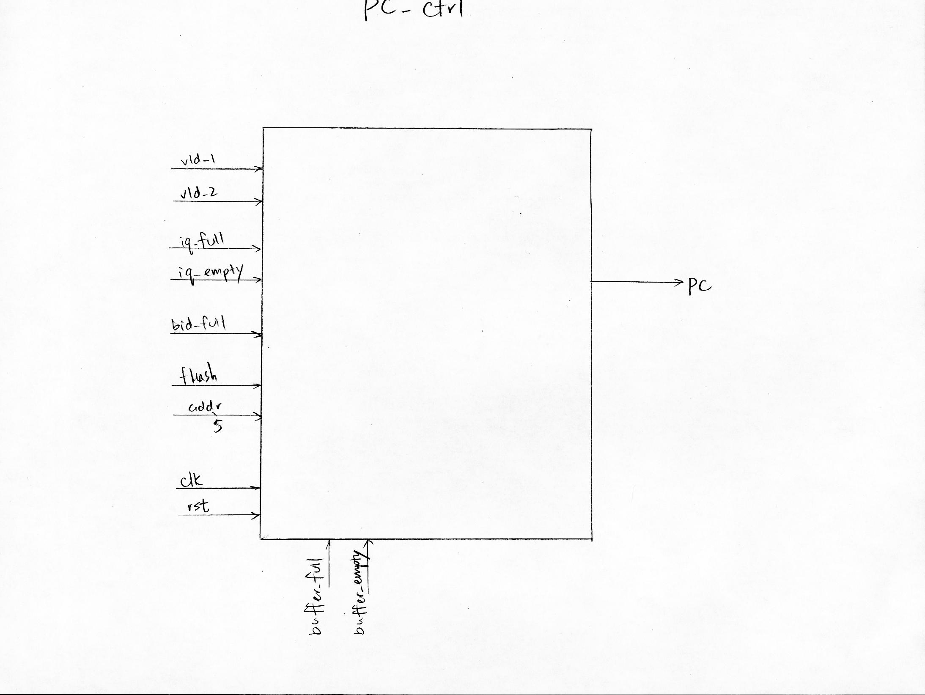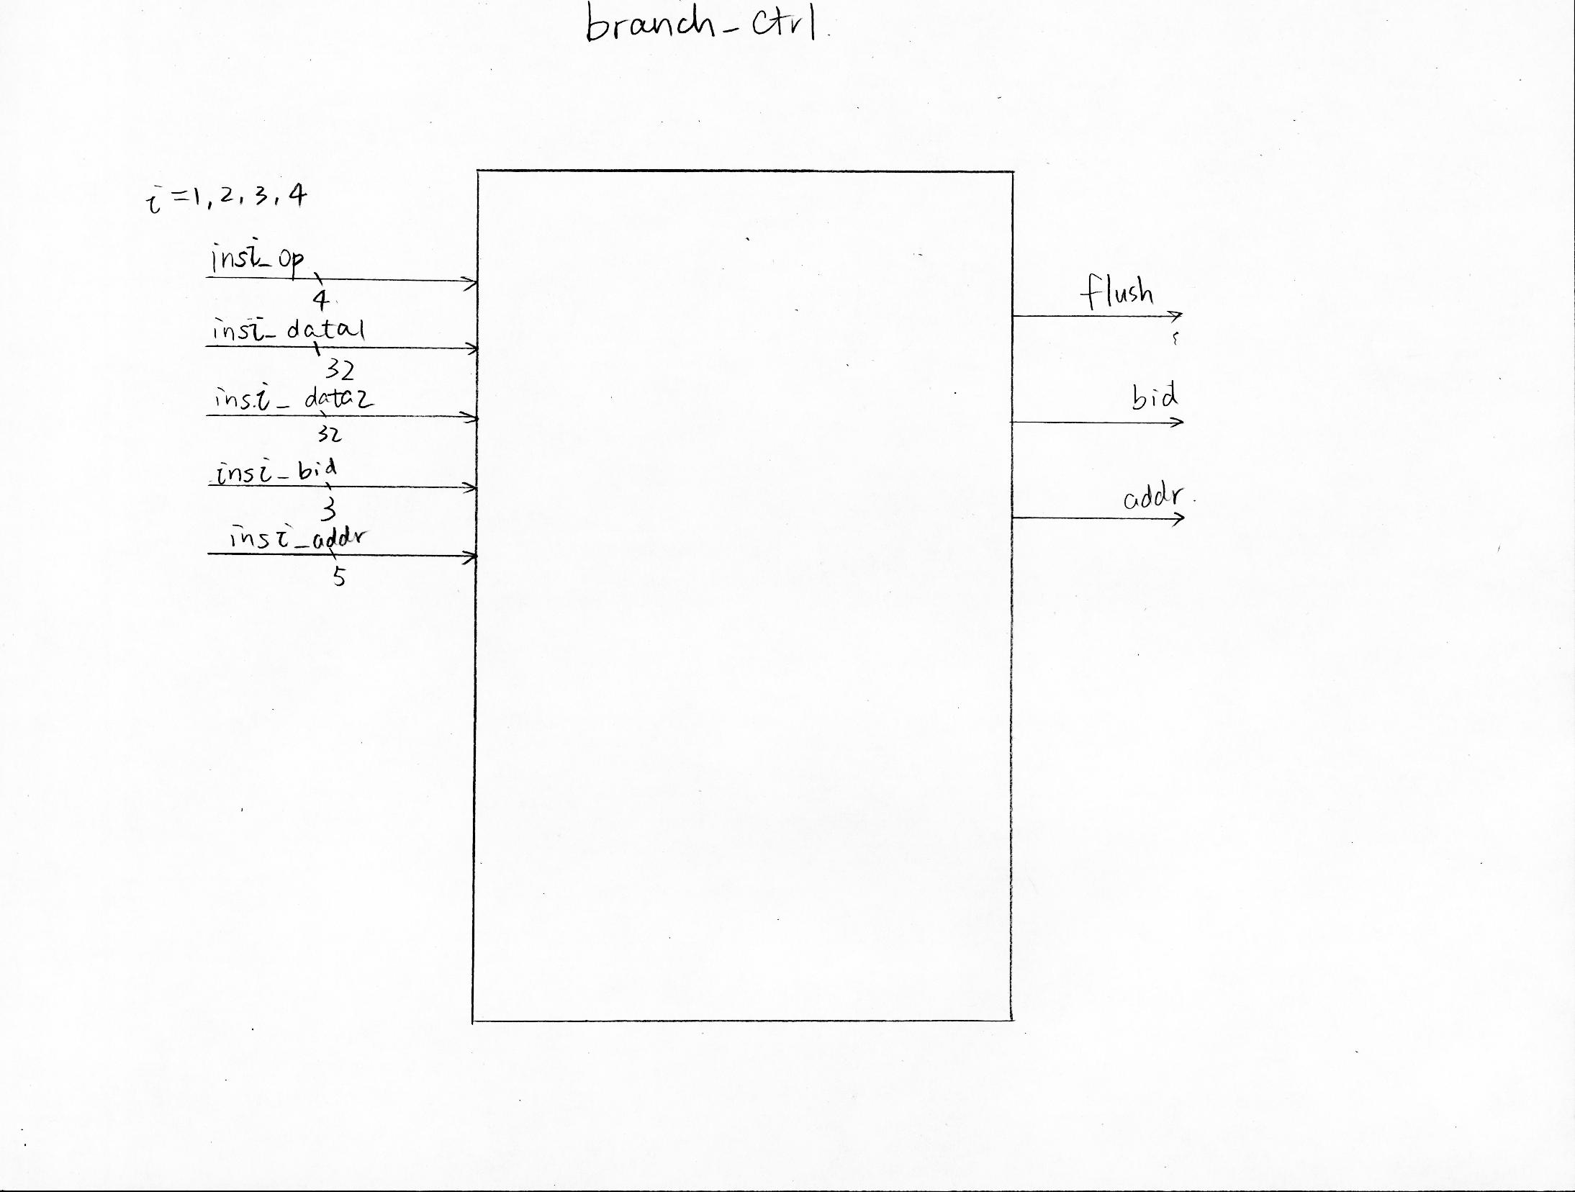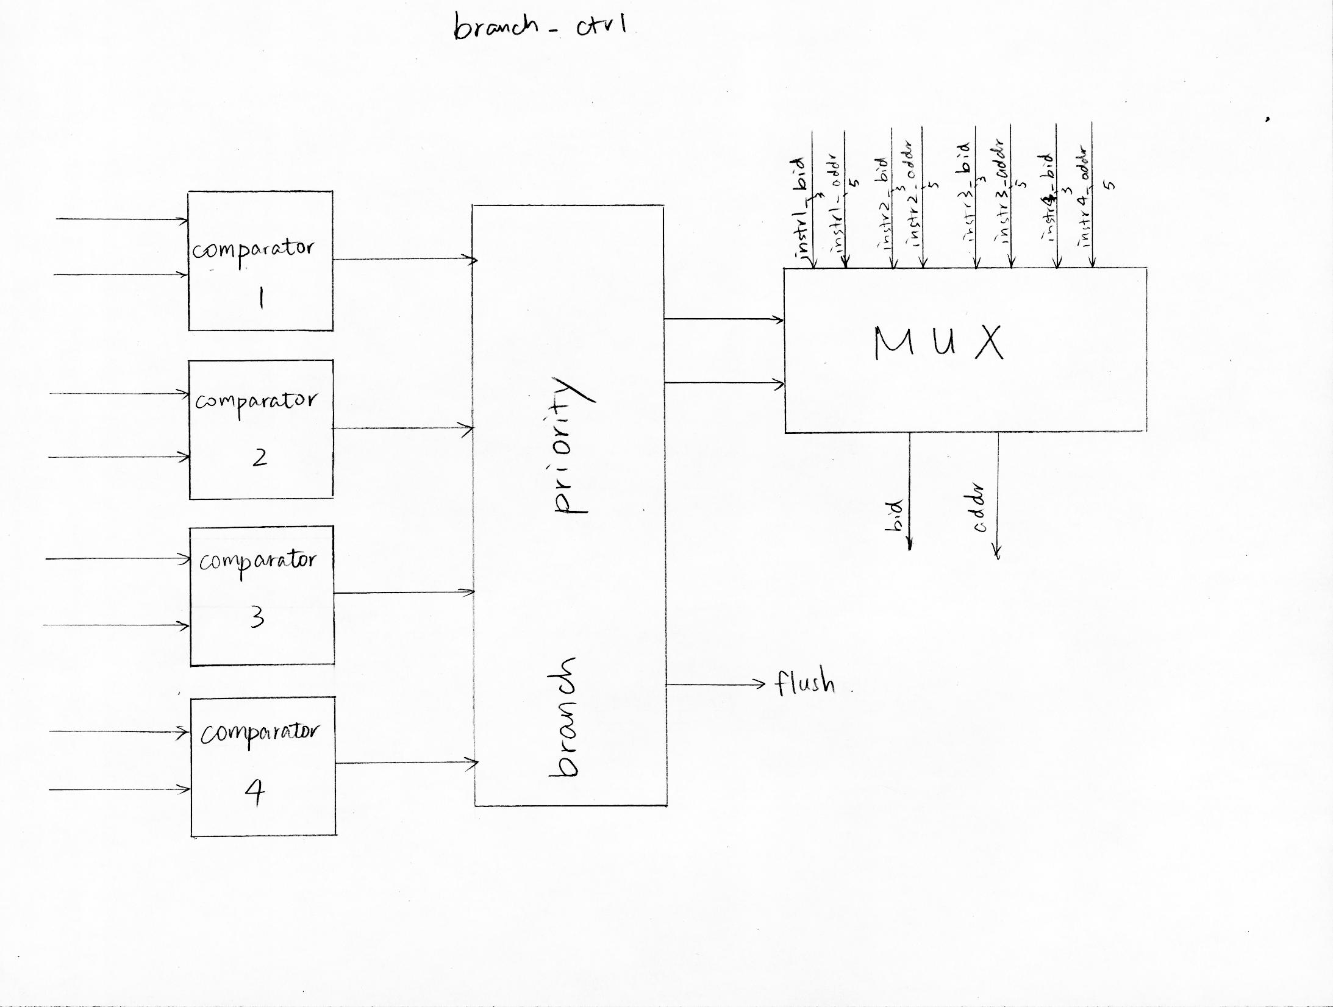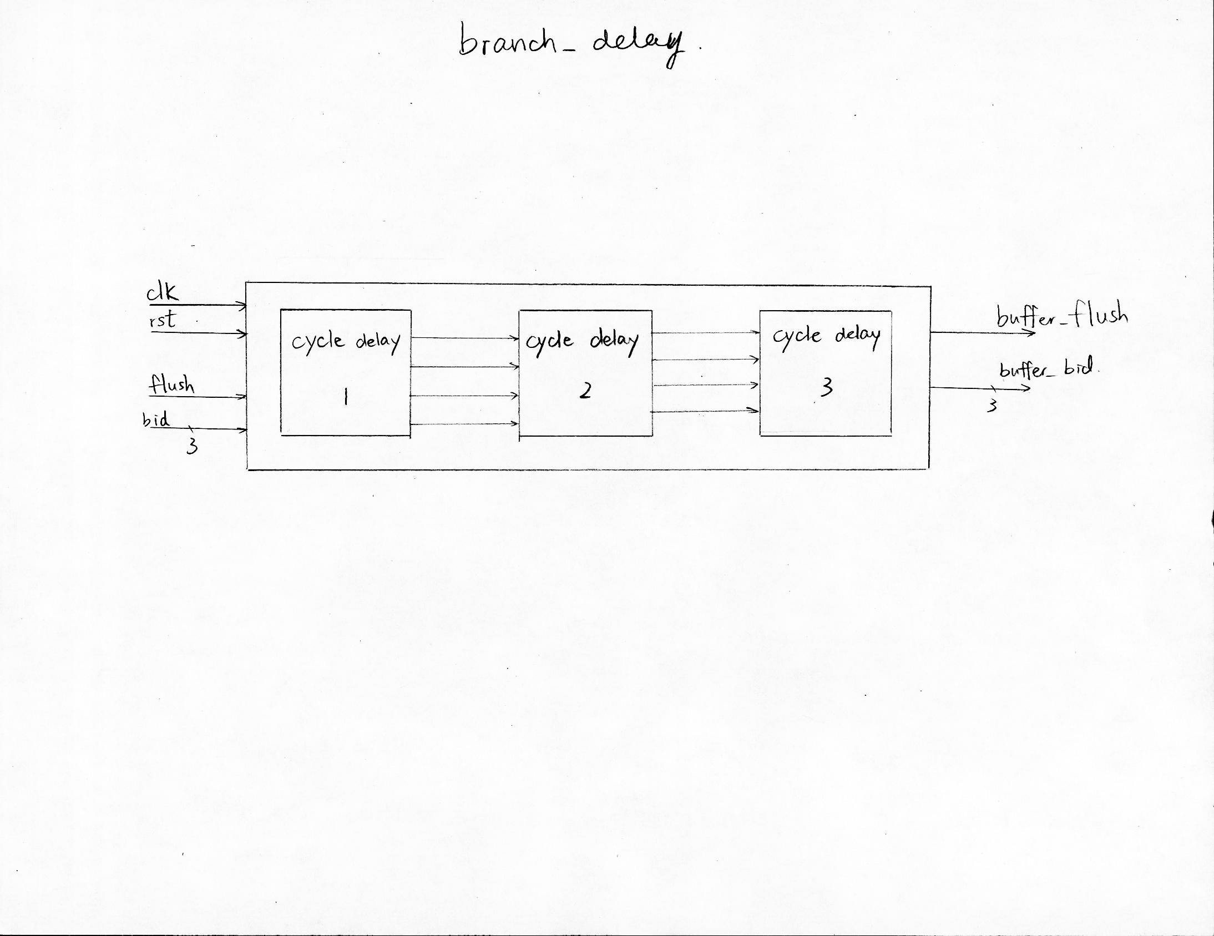
Section 6: Verification strategy
The testbench has three processors: one is the device under test, and the other two are verification models. One verification model, the golden result, is extremely simple. It simulates the result of one MIPS instruction at a time (using an array for memory and another for registers), without performing out-of-order execution or pipelining. Because it is made of only a few lines of code and has no advanced features, it is very trustworthy. However, it is too simple to help the design team if there are any bugs.

The second verification model is detailed and mimics our design. There are subprograms for each pipeline stage, which are executed in sequence to simulate one clock cycle. It is much more complicated than the golden result processor, so the testbench has a Check Model feature that runs a program on the very simple processor and on the pipelined processor and compares the results. This allows us to find any bugs in the verification model and gain confidence in its correctness. Once the detailed pipeline processor seems to be working correctly, it can be used to verify the DUT.

To verify the design, the pipelined model processor in the bench simulates one cycle while the DUT runs for one cycle. The contents of data memory are compared as well as any other signals of interest. This is repeated for any number of cycles.

The inputs to the DUT and bench processor are instructions that come from a random program generator. The generator can produce programs that use only a subset of registers, instructions, and immediate operands, based on the settings in the config file. It can generate programs that are free of data hazards. By turning off more complicated instructions like branching and by removing hazards, we can verify the critical parts of the processor first, then try out more challenging inputs.
Rather than randomly seeding our PC, we will write a program that creates an extensive PC, and run from these effectively seeded test cases.
Section 7: Performance estimates
From the results of dysn.tcl:
data arrival time -24.66
With a 1ns clock speed this corresponds to a clock frequency of approximately 40.55 MHz.
The data required time was 1.91, which gives us a violated slack of -22.75.
Below is the timing through the datapath:
Point | Incr | Path
clock clk (rise edge) | 0.00 | 0.00
clock network delay (ideal) | 0.00 | 0.00
stage1/pre_calculation_and_queue1/instruction_queue1/out_4_s2_reg[3]/CLK (DFFARX1) | 0.00 | 0.00
stage1/pre_calculation_and_queue1/instruction_queue1/out_4_s2_reg[3]/Q (DFFARX1) | 0.23 | 0.23
stage1/pre_calculation_and_queue1/instruction_queue1/out_4_s2[3] (instruction_queue) | 0.00 | 0.23
stage1/all_checker1/ins_in_4_source2[3] (all_checker) | 0.00 | 0.23
stage1/all_checker1/U527/QN (NAND2X1) | 1.20 | 1.43
stage1/all_checker1/U204/QN (NAND2X0) | 0.07 | 1.50
stage1/all_checker1/U622/QN (NAND3X0) | 0.09 | 1.59
stage1/all_checker1/U526/QN (NAND3X0) | 0.09 | 1.67
stage1/all_checker1/U168/QN (NOR2X0) | 0.11 | 1.79
stage1/all_checker1/U57/ZN (INVX0) | 0.11 | 1.90
stage1/all_checker1/U816/QN (NOR3X0) | 0.12 | 2.01
stage1/all_checker1/U316/QN (NOR2X0) | 0.10 | 2.11
stage1/all_checker1/U817/QN (NAND3X0) | 0.12 | 2.23
stage1/all_checker1/ins1_swap (all_checker) | 0.00 | 2.23
stage1/U6/ZN (INVX0) | 0.60 | 2.83
stage1/U8/QN (NOR2X0) | 0.46 | 3.29
stage1/U7/QN (NAND2X0) | 0.37 | 3.67
stage1/U307/Z (NBUFFX2) | 0.57 | 4.24
stage1/U113/Q (MUX21X2) | 1.50 | 5.73
stage1/iq_out_3_s1[2] (top_issue_stage) | 0.00 | 5.73
file1/in_3_s1[2] (register_file) | 0.00 | 5.73
file1/U4163/ZN (INVX0) | 0.59 | 6.32
file1/U151/QN (NAND2X0) | 0.50 | 6.82
file1/U4149/ZN (INVX0) | 0.53 | 7.35
file1/U5044/Q (AND2X1) | 0.48 | 7.83
file1/U4146/ZN (INVX0) | 0.57 | 8.40
file1/U4875/Q (OA21X1) | 1.01 | 9.41
file1/U245/QN (NAND3X1) | 0.39 | 9.80
file1/U249/QN (NOR4X1) | 0.57 | 10.37
file1/U250/QN (NAND4X0) | 0.51 | 10.88
file1/ins3_data1[28] (register_file) | 0.00 | 10.88
U252/Q (XOR2X2) | 1.08 | 11.96
U251/QN (NOR2X0) | 0.60 | 12.57
U362/QN (NAND2X0) | 0.41 | 12.98
U220/QN (NOR3X0) | 0.74 | 13.72
U223/Q (AND4X1) | 0.44 | 14.16
U222/QN (NOR2X0) | 0.61 | 14.77
U224/Q (OR2X1) | 1.04 | 15.82
U387/QN (NOR2X0) | 0.60 | 16.42
U34/QN (NAND2X0) | 0.45 | 16.87
U471/Z (NBUFFX2) | 0.74 | 17.61
stage1/flush_en (top_issue_stage) | 0.00 | 17.61
stage1/pre_calculation_and_queue1/instruction_queue1/flush_en (instruction_queue) | 0.00 | 17.61
stage1/pre_calculation_and_queue1/instruction_queue1/U652/ZN (INVX0) | 0.66 | 18.27
stage1/pre_calculation_and_queue1/instruction_queue1/U2248/ZN (IBUFFX4) | 0.58 | 18.85
stage1/pre_calculation_and_queue1/instruction_queue1/U2808/QN (NOR2X0) | 1.61 | 20.45
stage1/pre_calculation_and_queue1/instruction_queue1/U2580/QN (NOR2X0) | 0.54 | 20.99
stage1/pre_calculation_and_queue1/instruction_queue1/U2576/ZN (INVX0) | 0.53 | 21.52
stage1/pre_calculation_and_queue1/instruction_queue1/U725/Q (OR2X4) | 0.61 | 22.14
stage1/pre_calculation_and_queue1/instruction_queue1/U2078/ZN (INVX0) | 0.56 | 22.70
stage1/pre_calculation_and_queue1/instruction_queue1/U1002/QN (NAND2X0) | 0.85 | 23.55
stage1/pre_calculation_and_queue1/instruction_queue1/U3833/Q (AND3X1) | 0.33 | 23.88
stage1/pre_calculation_and_queue1/instruction_queue1/U3834/QN (NAND3X0) | 0.50 | 24.39
stage1/pre_calculation_and_queue1/instruction_queue1/entry_5_reg[0]/D (DFFARX1) | 0.28 | 24.66

As you can see the combinational elements were the most time consuming steps of the pipeline.
The power results are as followed:
Cell Internal Power = 706.6104 uW (33%)

Net Switching Power = 1.4528 mW (67%)

---------

Total Dynamic Power = 2.1594 mW (100%)

Cell Leakage Power = 1.5139 mW

Internal Switching Leakage Total

Power Group Power Power Power Power ( % ) Attrs

--------------------------------------------------------------------------------------------------

io_pad 0.0000 0.0000 0.0000 0.0000 ( 0.00%)

memory 0.0000 0.0000 0.0000 0.0000 ( 0.00%)

black_box 0.0000 0.0000 0.0000 0.0000 ( 0.00%)

clock_network 263.7309 778.7761 6.0747e+08 1.6500e+03 ( 44.92%)

register 24.9667 30.6230 3.5222e+08 407.8092 ( 11.10%)

sequential 0.0000 0.0000 0.0000 0.0000 ( 0.00%)

combinational 417.9126 643.3984 5.5421e+08 1.6155e+03 ( 43.98%)

--------------------------------------------------------------------------------------------------

Total 706.6102 uW 1.4528e+03 uW 1.5139e+09 pW 3.6733e+03 uW
Section 8: Area estimates
Cell Count
-----------------------------------
Hierarchical Cell Count: 6
Hierarchical Port Count: 2016
Leaf Cell Count: 37319
Buf/Inv Cell Count: 5013
CT Buf/Inv Cell Count: 30
Combinational Cell Count: 34153
Sequential Cell Count: 3166
-----------------------------------
Area
-----------------------------------
Combinational Area: 275110.504246
Noncombinational Area:
101869.979216
Net Area: 64395.855297
Net XLength : 1281021.50
Net YLength : 1194169.38
-----------------------------------
Cell Area: 376980.483461
Design Area: 441376.338759
Net Length : 2475191.00
Section 9: Bugs, Coverage,
Net Functionality – Top
Subunits compile and simulate clean | BUGS | BUGS | DONE
VCS compile for each subunit without unexpected warnings | BUGS | DONE | DONE | DONE
DC compile (elaborate and check) for each subunit without unexpected warnings | BUGS | BUGS | DONE | DONE
Subunits with their own testbench should sim clean | BUGS | BUGS | DONE | DONE
Unit compiles clean | BUGS | BUGS | DONE
VCS compile for unit without unexpected warnings | BUGS | BUGS | DONE | DONE
DC compile (elaborate and check) for unit without unexpected warnings | BUGS | BUGS | DONE | DONE
Reset tests | BUGS | BUGS | BUGS | DONE
Basic reset (beginning of simulation) | BUGS | BUGS | BUGS | DONE
Dynamic reset (middle of simulation) | BUGS | BUGS | BUGS | DONE
Pipeline | BUGS | BUGS | BUGS
Fetch | BUGS | BUGS | DONE | DONE
Decode | BUGS | BUGS | DONE | DONE
Execute | BUGS | BUGS | BUGS | DONE
Write | BUGS | BUGS | BUGS
Corner Cases (May Require Stalling) | BUGS | BUGS | BUGS
Issue Queue Full | BUGS | BUGS | BUGS | DONE
Buffer Full | BUGS | BUGS | BUGS | DONE
Code (Opcode, Registers, Data) | BUGS | BUGS | BUGS | DONE
4 Instructions (6 Bit) | BUGS | BUGS | DONE | DONE
Decoding | BUGS | BUGS | DONE | DONE
Address Handling | BUGS | BUGS | BUGS | DONE
Data Handling | BUGS | BUGS | BUGS | DONE
4 Type Instruction Handling | BUGS | BUGS | BUGS
Handles Opcode Instances | BUGS | BUGS | BUGS | DONE
Load Word Instruction | BUGS | BUGS | BUGS | DONE
Store Word Instruction | BUGS | BUGS | BUGS
Branch Instruction | BUGS | BUGS | BUGS | DONE
Add Instruction | BUGS | BUGS | BUGS | DONE
Corner cases | BUGS | BUGS | BUGS
All Adds | BUGS | BUGS | BUGS | DONE
RAW Hazard | BUGS | BUGS | BUGS | DONE
WAR Hazard | BUGS | BUGS | BUGS | DONE
Undefined Opcode (Potential Bit Error) | BUGS | BUGS | BUGS
Memory Functions – Load & Store
Read from Memory Address | BUGS | BUGS | BUGS | DONE
Write to Memory Address | BUGS | BUGS | BUGS
Enable Memory | BUGS | BUGS | BUGS
Disable Memory | BUGS | BUGS | BUGS
Simultaneous Read and Write | BUGS | BUGS | BUGS
Simultaneous Read and Write to the same Address | BUGS | BUGS | BUGS
Read from an empty address | BUGS | BUGS | BUGS | DONE
Load From an Empty Memory Cell | BUGS | BUGS | BUGS | DONE
Load From A Memory Cell Already Written To | BUGS | BUGS | BUGS
Receive two memory instructions in one stage (Only Execute One) | BUGS | BUGS | BUGS
Corner cases | BUGS | BUGS | BUGS
Out of Order Execution | BUGS | BUGS | BUGS | DONE
Branch | BUGS | BUGS | BUGS
Branch To A Different Line | BUGS | BUGS | BUGS | DONE
Multiple Branch Instructions Issued | BUGS | BUGS | BUGS | DONE
Corner cases | BUGS | BUGS | BUGS
Out of Order Execution | BUGS | BUGS | BUGS | DONE
Branch To a Non-Existent PC Line | BUGS | BUGS | BUGS
Branch Prediction | BUGS | BUGS | BUGS
Follows First Branch Prediction When issued More than 1 | BUGS | BUGS | BUGS | DONE
General test case | BUGS | BUGS | BUGS | DONE
 |  |  | BUGS
Corner cases | BUGS | BUGS | BUGS
Incorrect Prediction | BUGS | BUGS | BUGS | DONE
Hazard Detection | BUGS | BUGS | BUGS
Find a WAR/RAW Hazard | BUGS | BUGS | BUGS | DONE
Get Instructions Without a Hazard | BUGS | BUGS | BUGS | DONE
Random halts and related events | BUGS | BUGS | BUGS
Randomly halt and resume | BUGS | BUGS | BUGS
Randomly halt, do cache flush, and resume | BUGS | BUGS | BUGS
Final random testing and coverage assessment | BUGS | BUGS | BUGS
Randomize the testbench parameters | DONE | DONE | DONE
Run at least 1 million cycles of random simulation | BUGS | BUGS | BUGS

Section 10: Document revision history
Nov 8, 2012: Original document
Nov 15, 2012: Added sections 3 and 4, revised section 2.
Dec 2, 2012: Section 5: Completed
Dec 3, 2012: Section6: Updated Verification Parameters and Template
Dec 4, 2012: Added more test cases to the verification spreadsheet.
Dec 5, 2012: Revised architecture, began work on bench.
Dec 6, 2012: MIPS instruction generator added to generate random programs.
Dec 9, 2012: Basic instructions simulated in bench. Lower level pipeline functions implemented.
Dec 12, 2012: Issue stage designed.
Dec 13, 2012: Top stage added, validation of code begun.
Dec 14, 2012: Decoder stage and instruction swap designed.
Dec 15, 2012: Make file and configuration added, bench modified to cover single stages.
Dec 16, 2012: Bench fully simulates pipelined design.
Dec 17, 2012: Top level issue stage added, work on verification.
Dec 18, 2012: Modification of stage one modules and continued verification.
Dec 19, 2012: Continued debugging and verification.
Dec 20, 2012: Continued debugging, verification, and documentation.

