**SOFTWARE DESIGN DOCUMENT (SDD)**



**A-Peer Tutoring System (A-PTS)**



**Version 0.3**

**Prepared By:**

**Jason Pinkisan**

**Frederick F. Layus Jr.**

**Genesis Fernandez**

**Wayne Justine Cena**

**Edmyr Esmeralda**

**Jesus Manalo III**

Home Page:

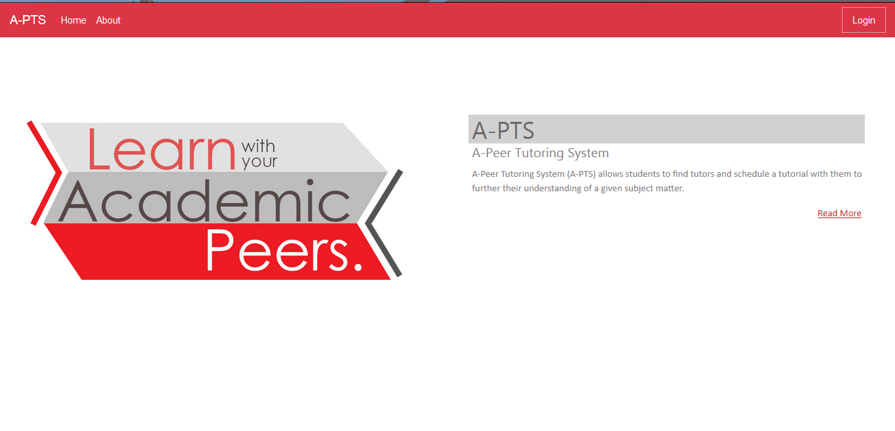

Login:

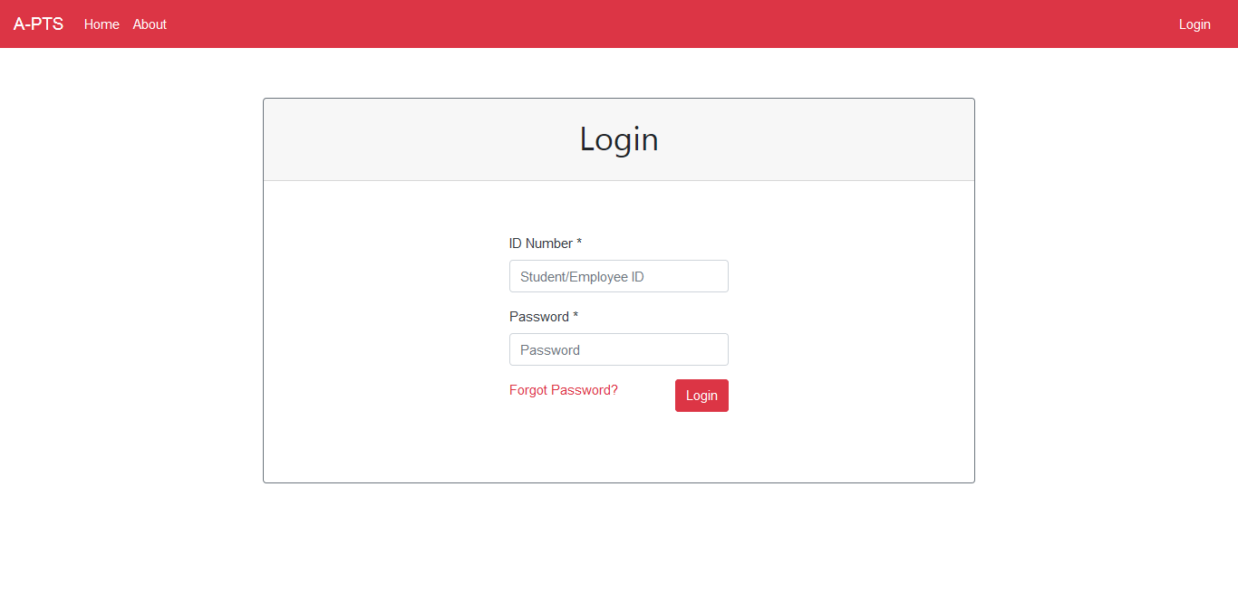

Tutorial List (Admin):

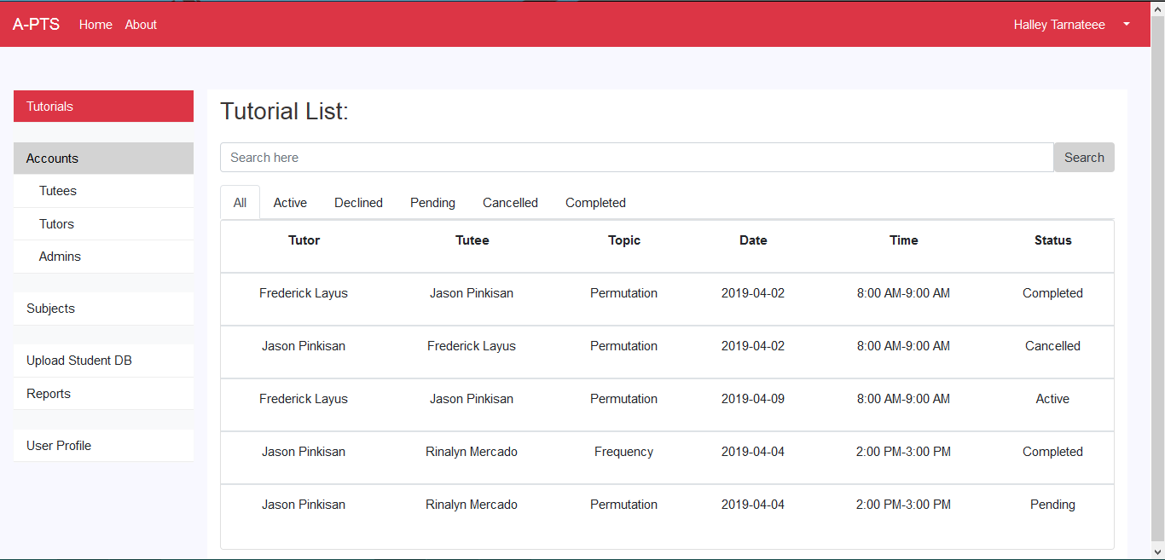

Student List (Admin):

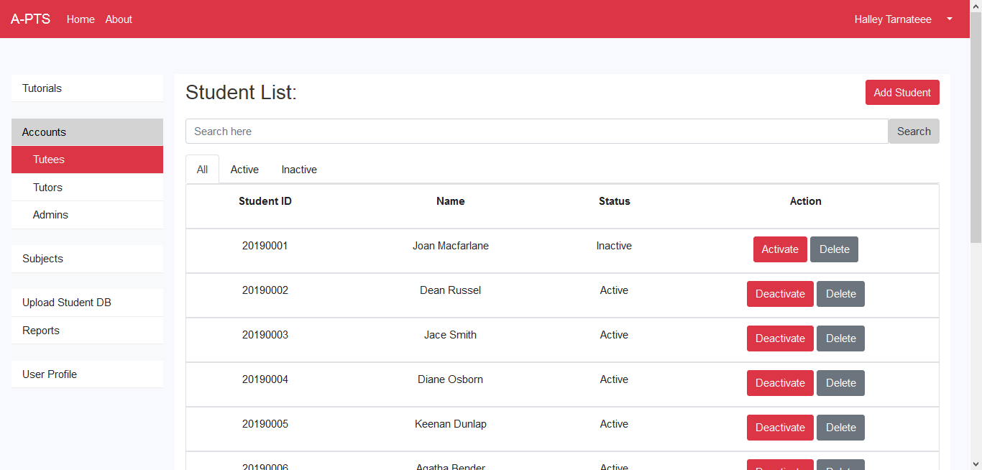

Add Student (Admin):

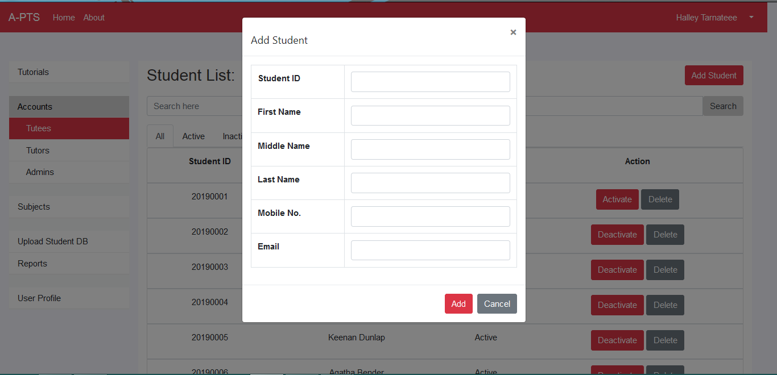

Tutor List (Admin):

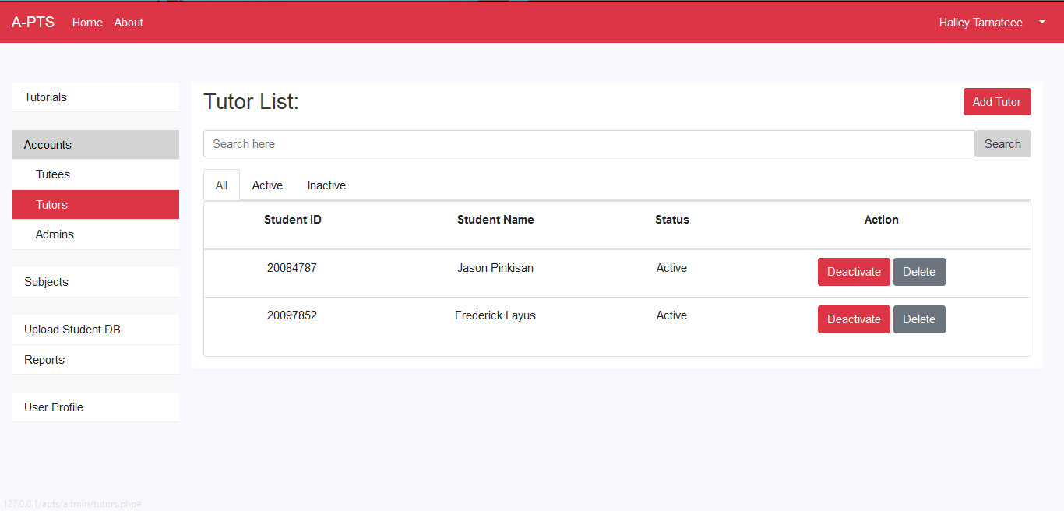

Add Tutor (Admin):

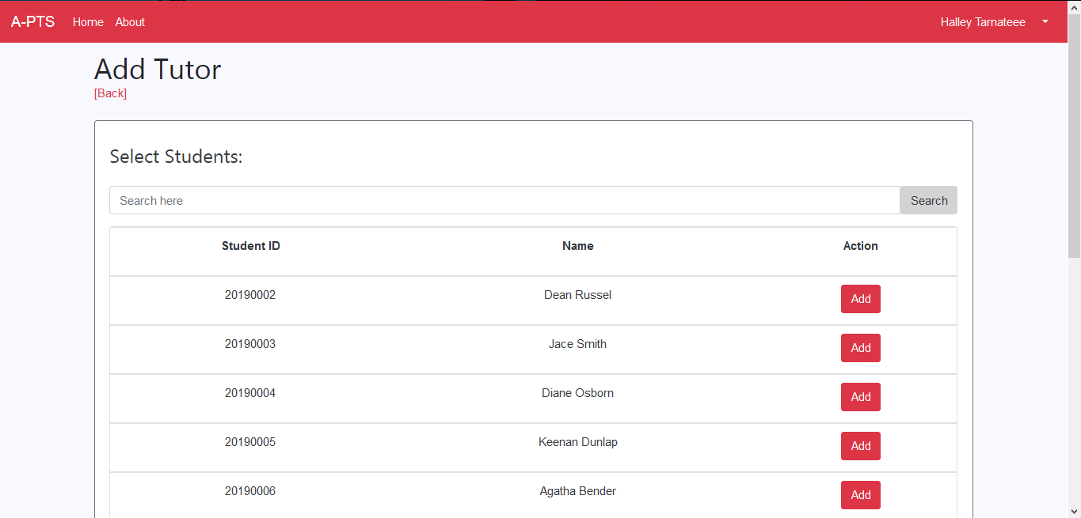

Admin List (Admin):

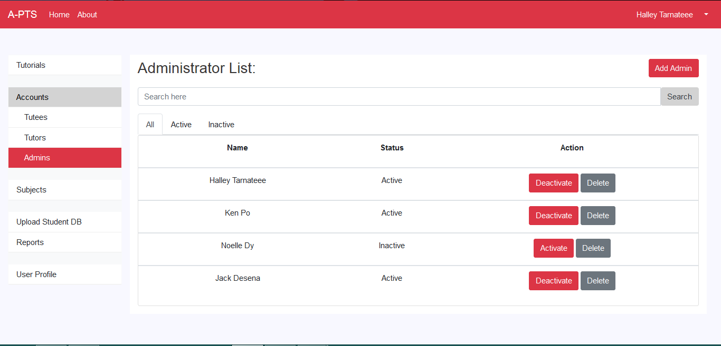

Subject List (Admin):

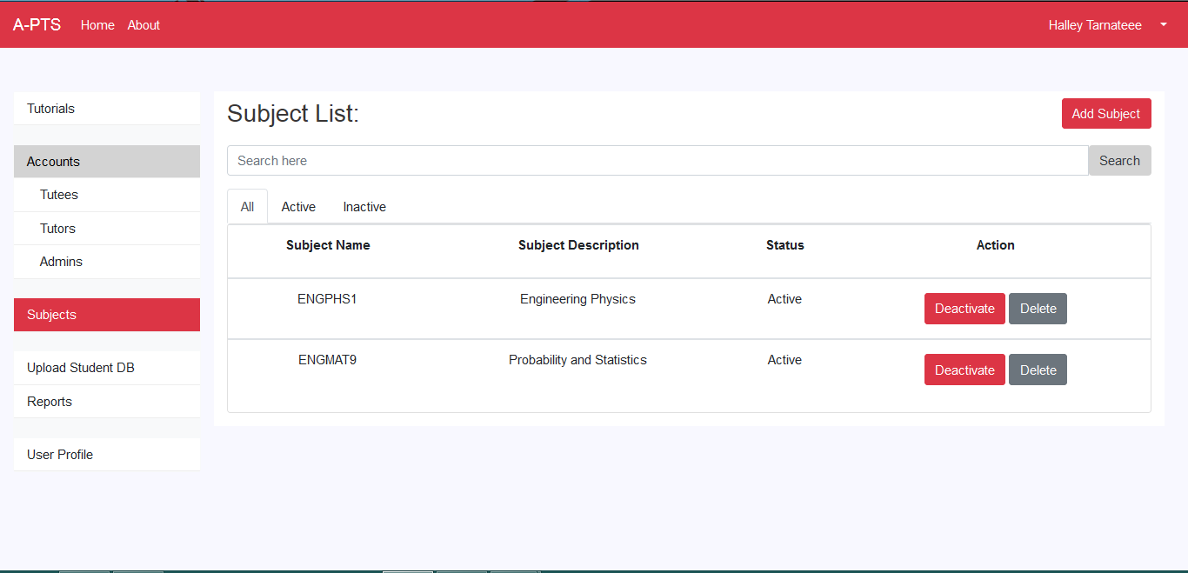

Add Subject (Admin):

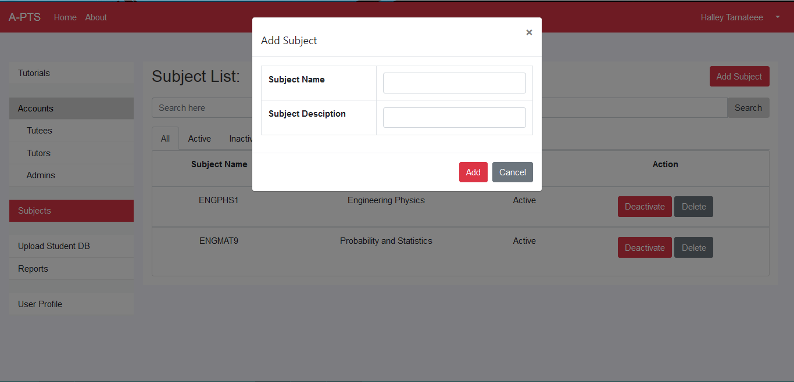

View Tutorial (Admin):

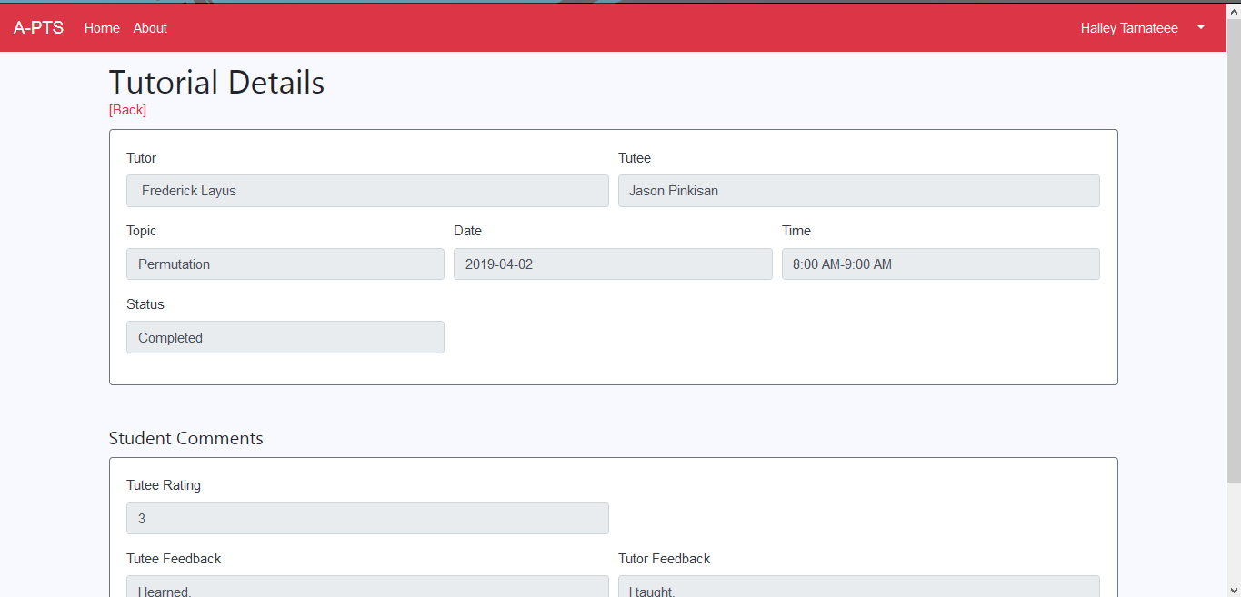

View Account (Admin):

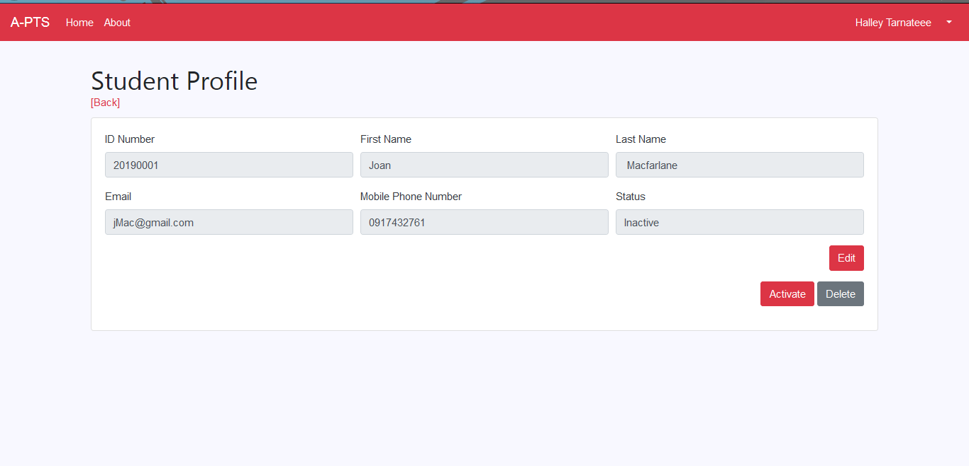

View Tutor (Admin):

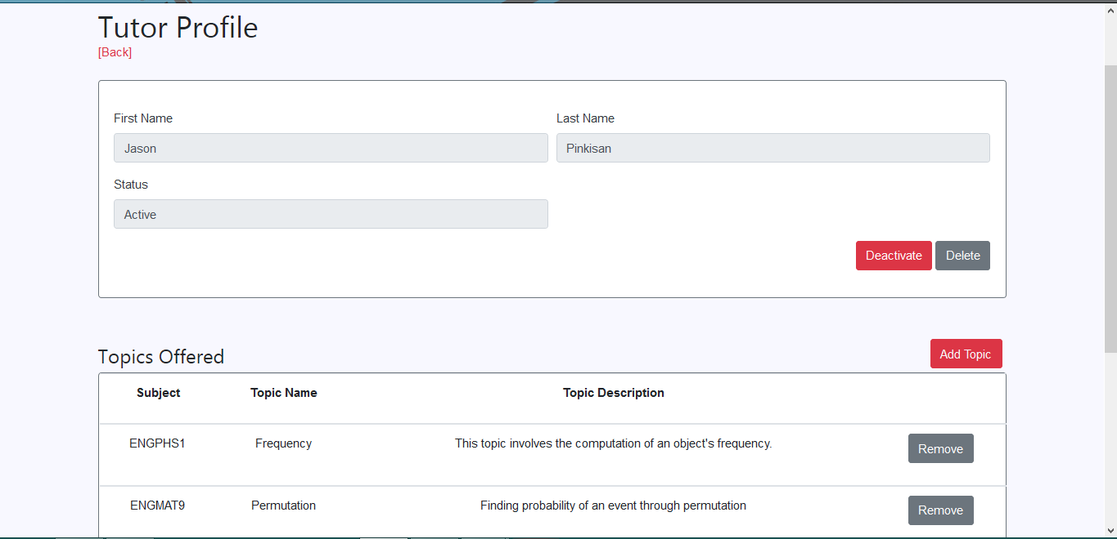

Add Tutor Topic (Admin):

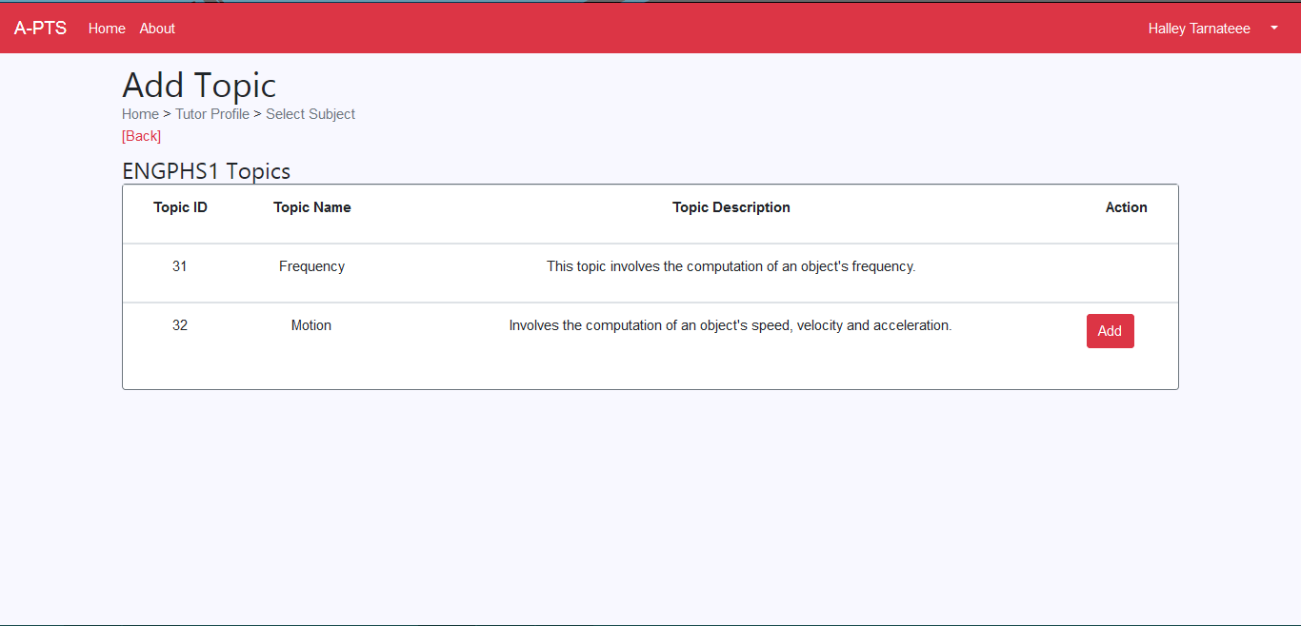

View Subject (Admin):

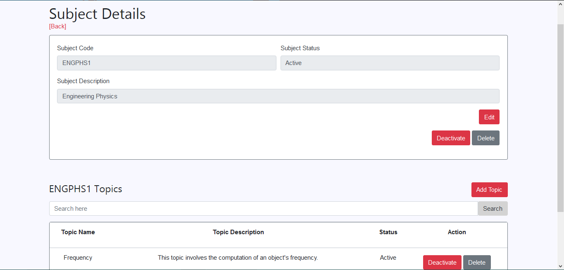

Add Subject Topic (Admin):

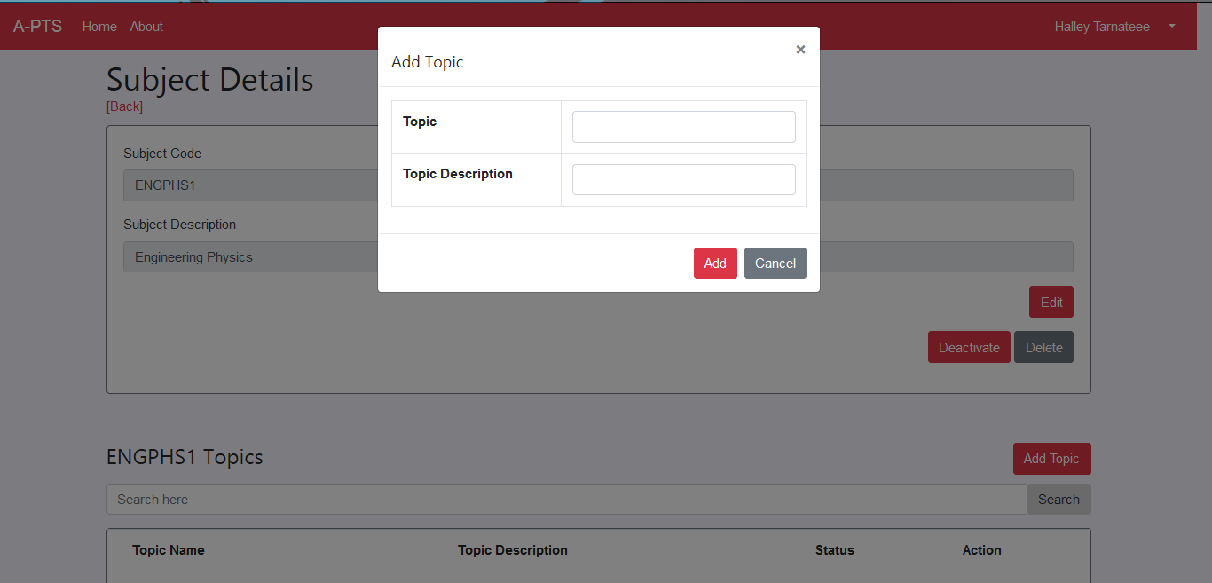

Upload Student Table (Admin):

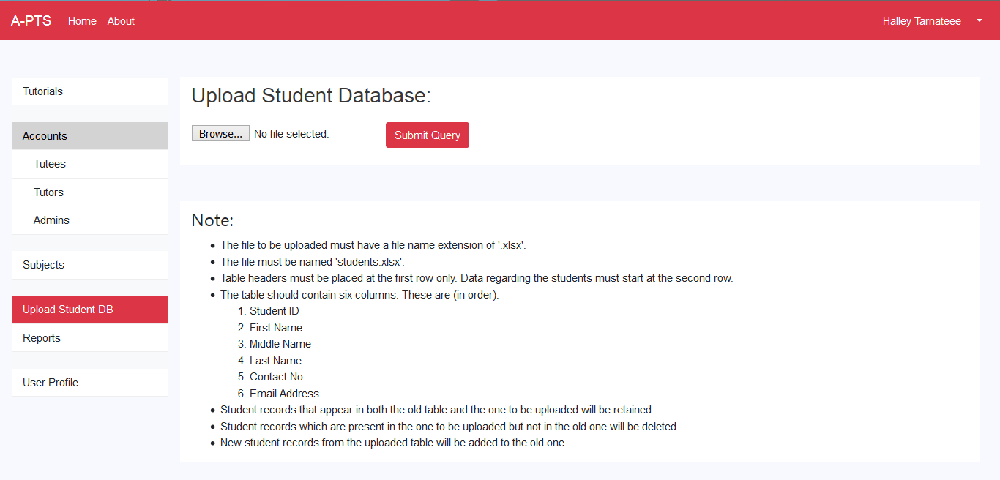

Generate Reports (Admin):

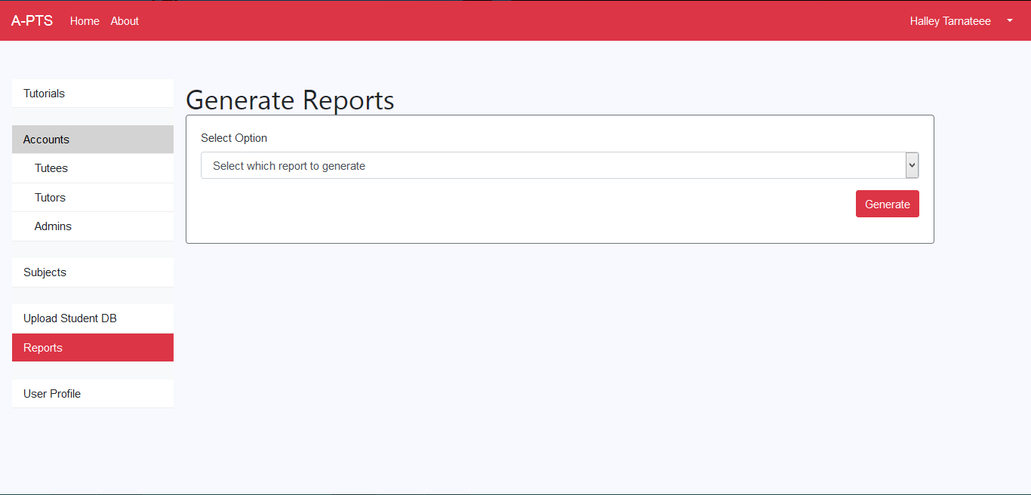

User Profile (Admin):

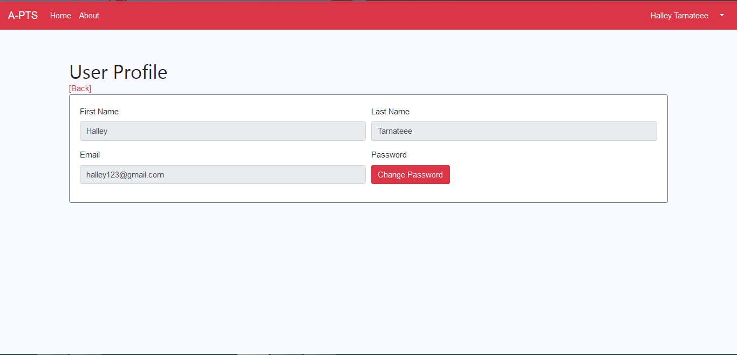

Tutorial List (Tutor, Tutee):

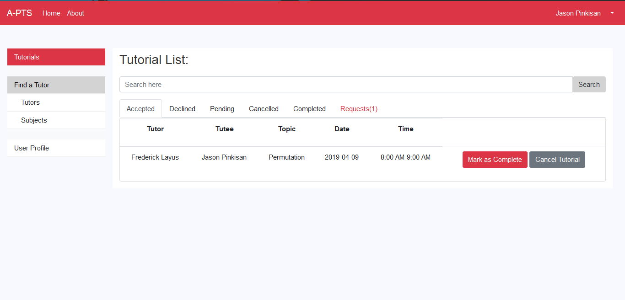

Tutor List (Tutor, Tutee):

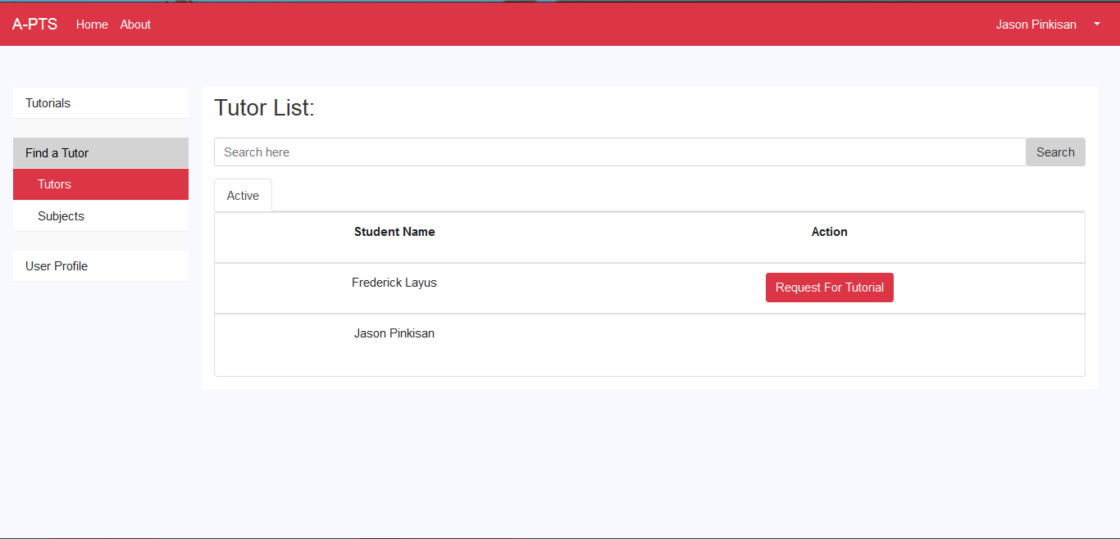

Subject List (Tutor, Tutee):

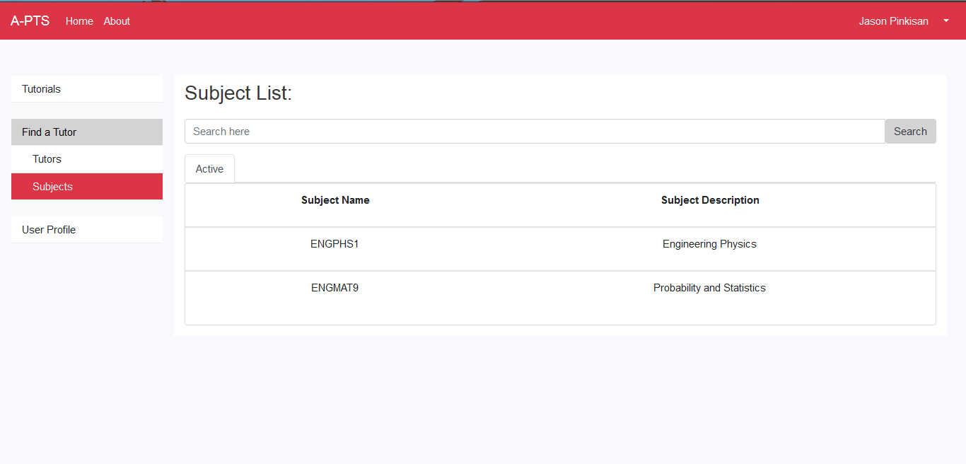

User Profile (Tutor, Tutee):

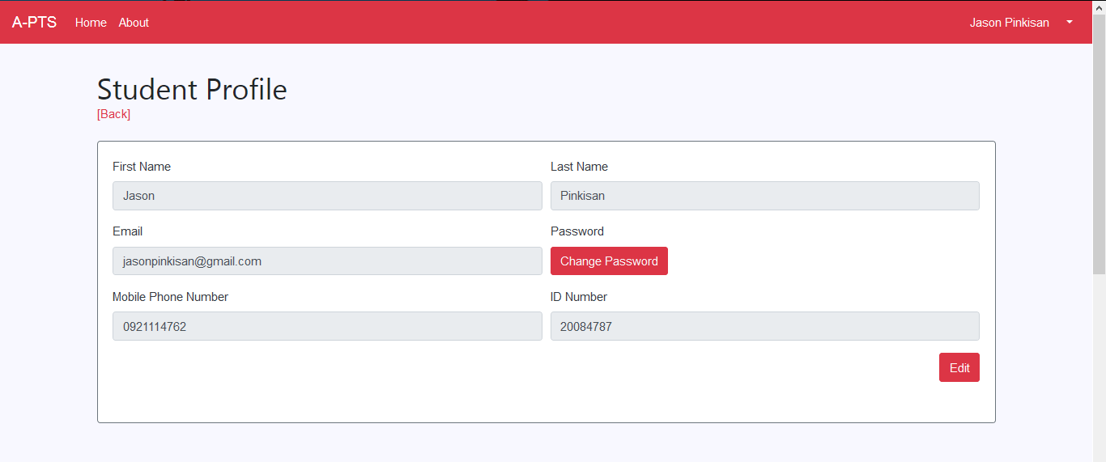

Tutor Profile (Tutor):

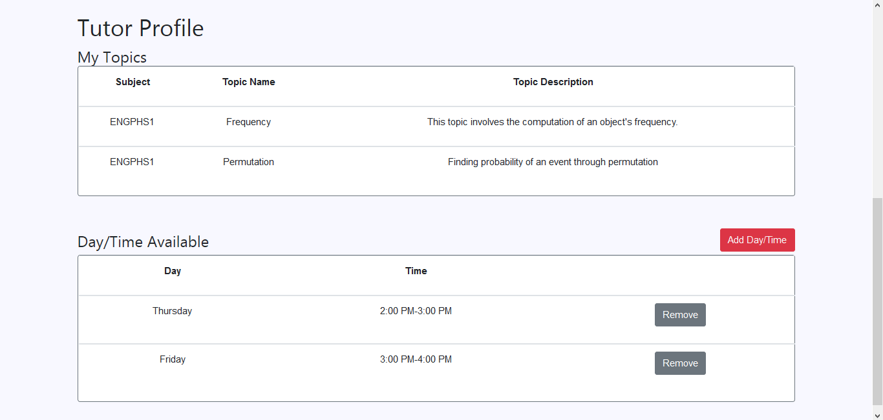

Add Day/Time (Tutor):

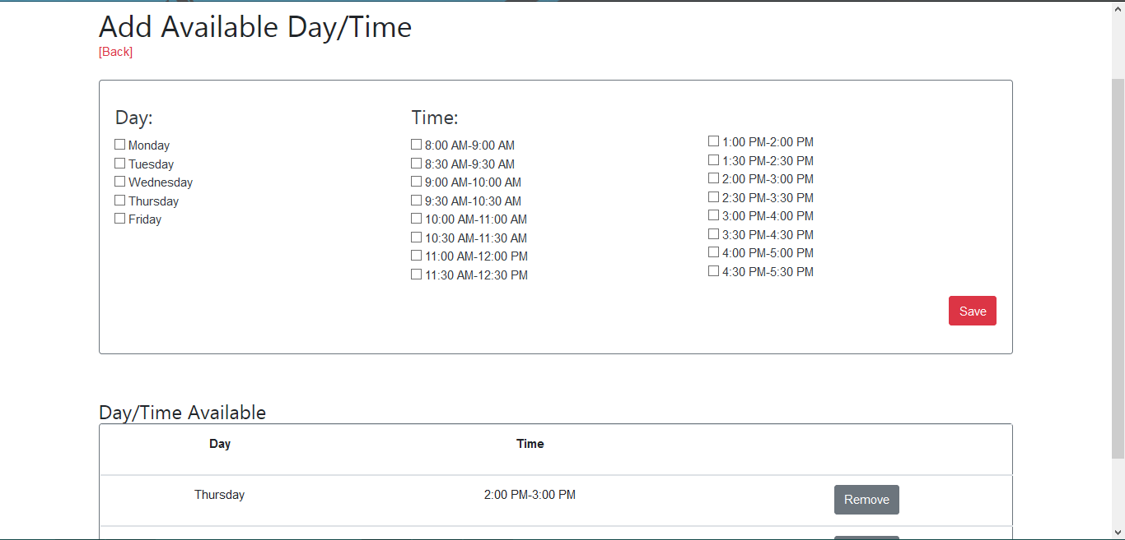

View Tutor Profile (Tutee):

