**Help Guide for GO Programming Language**

**Steps to get started:**

1. Download GO from the link: <https://golang.org/dl/>
2. Install GO using the downloaded executable.
3. Set system level variables:
   1. Right click on ‘This PC’ -> Properties -> Advanced system settings -> Environment variables
   2. Select Path variable and edit its value -> Add the location of GO installation’s bin folder at the end of path variable (Example: C:\Go\bin)
   3. Create a new user variable which tells our GO command where our GO libraries are available -> Variable = GOROOT, value = C:\Go (Just an Example)
4. Write a demo program
   1. Create a standard folder structure for the program

*Example:* SPL_Project -> bin

-> pkg

-> src -> main -> hello-world.go

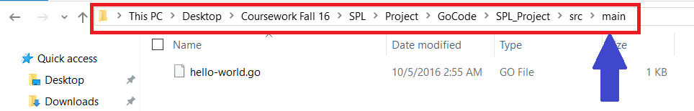

b) Use a text editor for writing the code. (Example: Sublime Text)

c) To execute the code open the command prompt, traverse to the folder where the code is saved.

* For each Go project we have to set project level variables such as GOPATH and GOBIN. Also, we need to make sure these variables are set in every new command prompt instance
* Example:
  + set GOPATH=C:\Users\Tejaswi\Desktop\Coursework Fall 16\SPL\Project\GoCode\SPL_Project
  + set GOBIN=C:\Users\Tejaswi\Desktop\Coursework Fall 16\SPL\Project\GoCode\SPL_Project\bin

d) Compile and Run the program:

Syntax: go run programName.go

Example: go run hello-world.go

**Note:** A helpful video for initial setup of GO on windows OS: <https://www.youtube.com/watch?v=_b-9kcq-xmA>

Source: <https://www.youtube.com/watch?v=_b-9kcq-xmA>