**Project Part 3:**

**Topic: Contacts Directory**

**GO LANGUAGE**

**Help Guide for GO Programming Language**

**Team Members:**

**TEJASWI KONDURI (800965883)**

**CHAITANYA SRI KRISHNA LOLLA (800960353)**

**NAGAMANIKANTA SRIVENKATA JONNALAGADDA (800975714)**

**ABHISHEK CHANDRATRE (800961657)**

**Steps to Run the Program:**

1. Download GO from the link: <https://golang.org/dl/>
2. Install GO using the downloaded executable.
3. Set system level variables:
   1. Right click on ‘This PC’ -> Properties -> Advanced system settings -> Environment variables
   2. Select Path variable and edit its value -> Add the location of GO installation’s bin folder at the end of path variable (Example: C:\Go\bin)
   3. Create a new user variable which tells our GO command where our GO libraries are available -> Variable = GOROOT, value = C:\Go (Just an Example)
4. Open a Command Prompt, and traverse till the bin folder in the root folder of the project. If the bin folder isn’t already present, create one.
5. Build the project by running the instruction on the command prompt:

>go build application

1. Run the Program, by entering the following command:

> application.exe

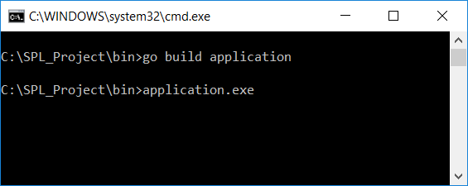

1. Open a web explorer (like Chrome), with 127.0.0.1:8080 in the URL bar.

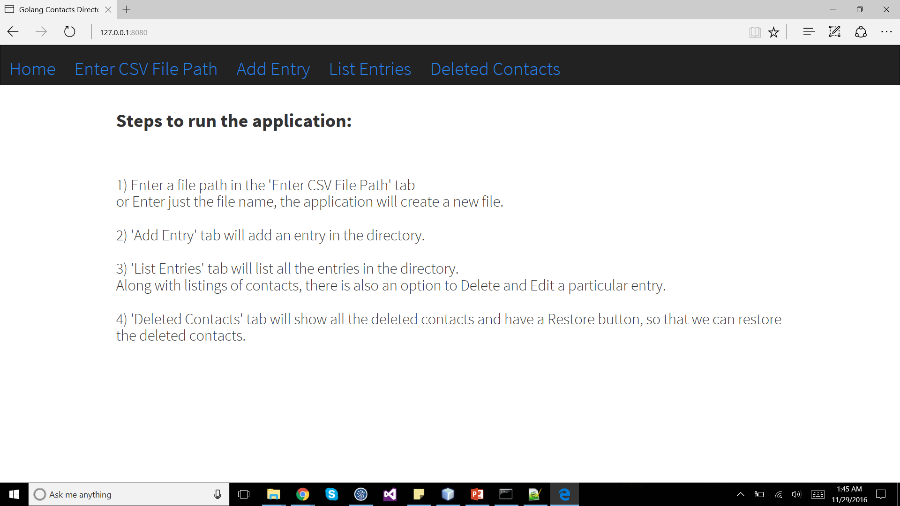

8) Enter a file path in the 'Enter CSV File Path' tab,

or Enter just the file name, the application will create a new file.

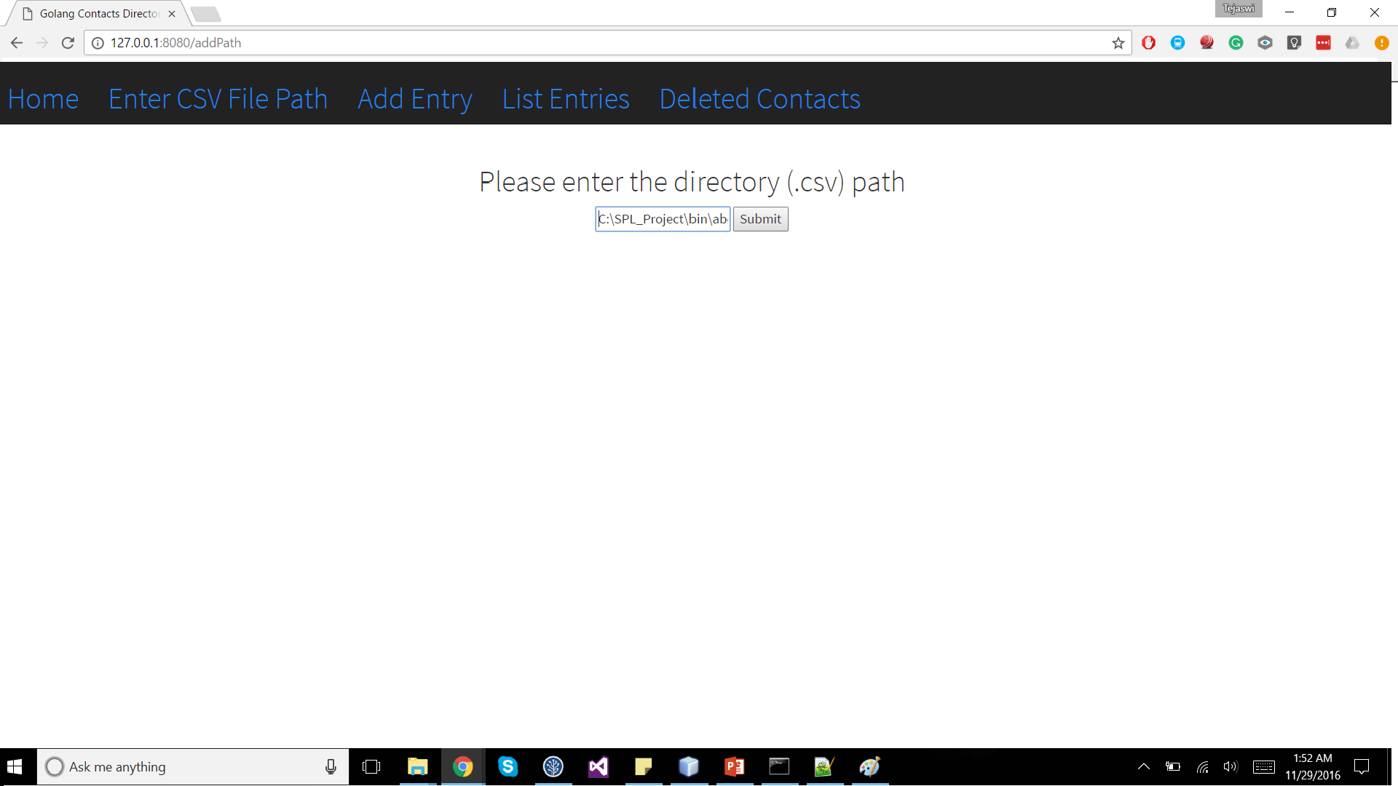

9) 'Add Entry' tab will add an entry in the directory.

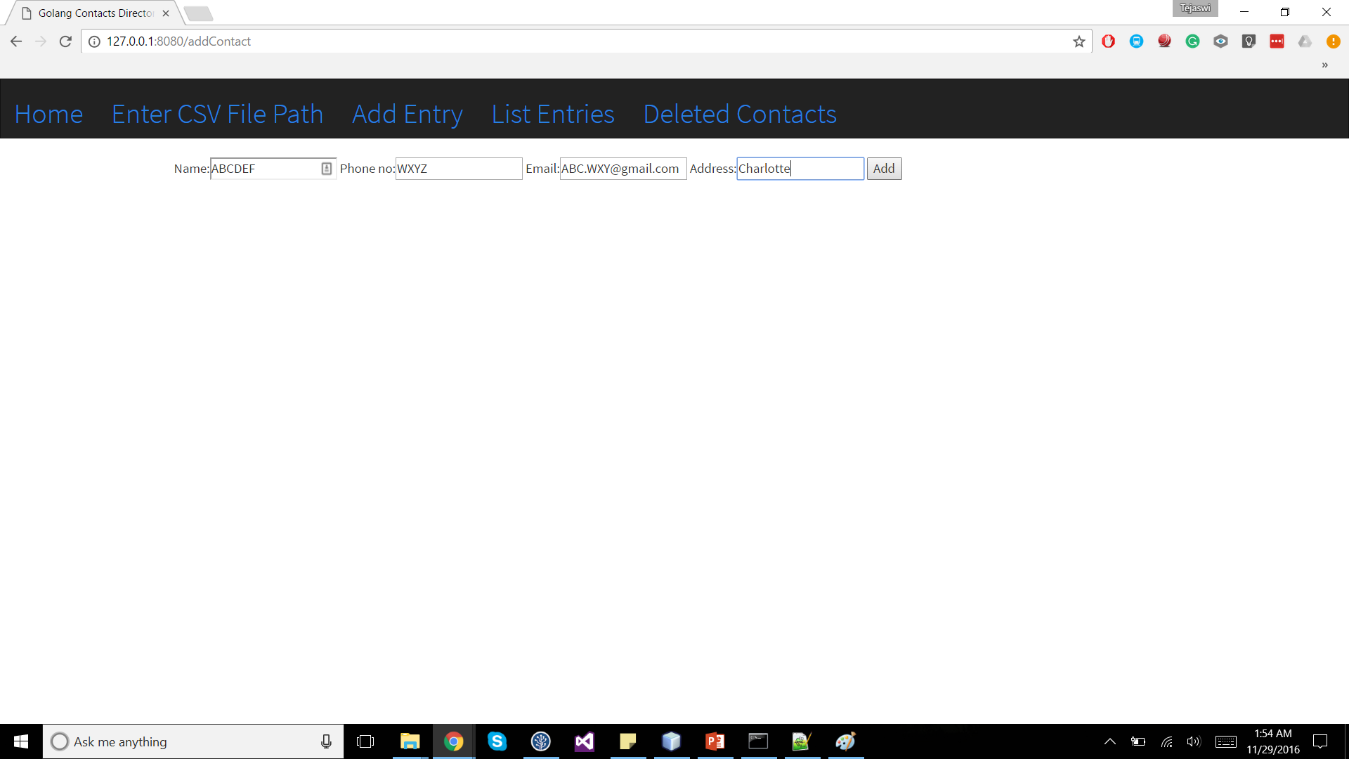

10) 'List Entries' tab will list all the entries in the directory.

Along with listings of contacts, there is also an option to Delete and Edit an entry.

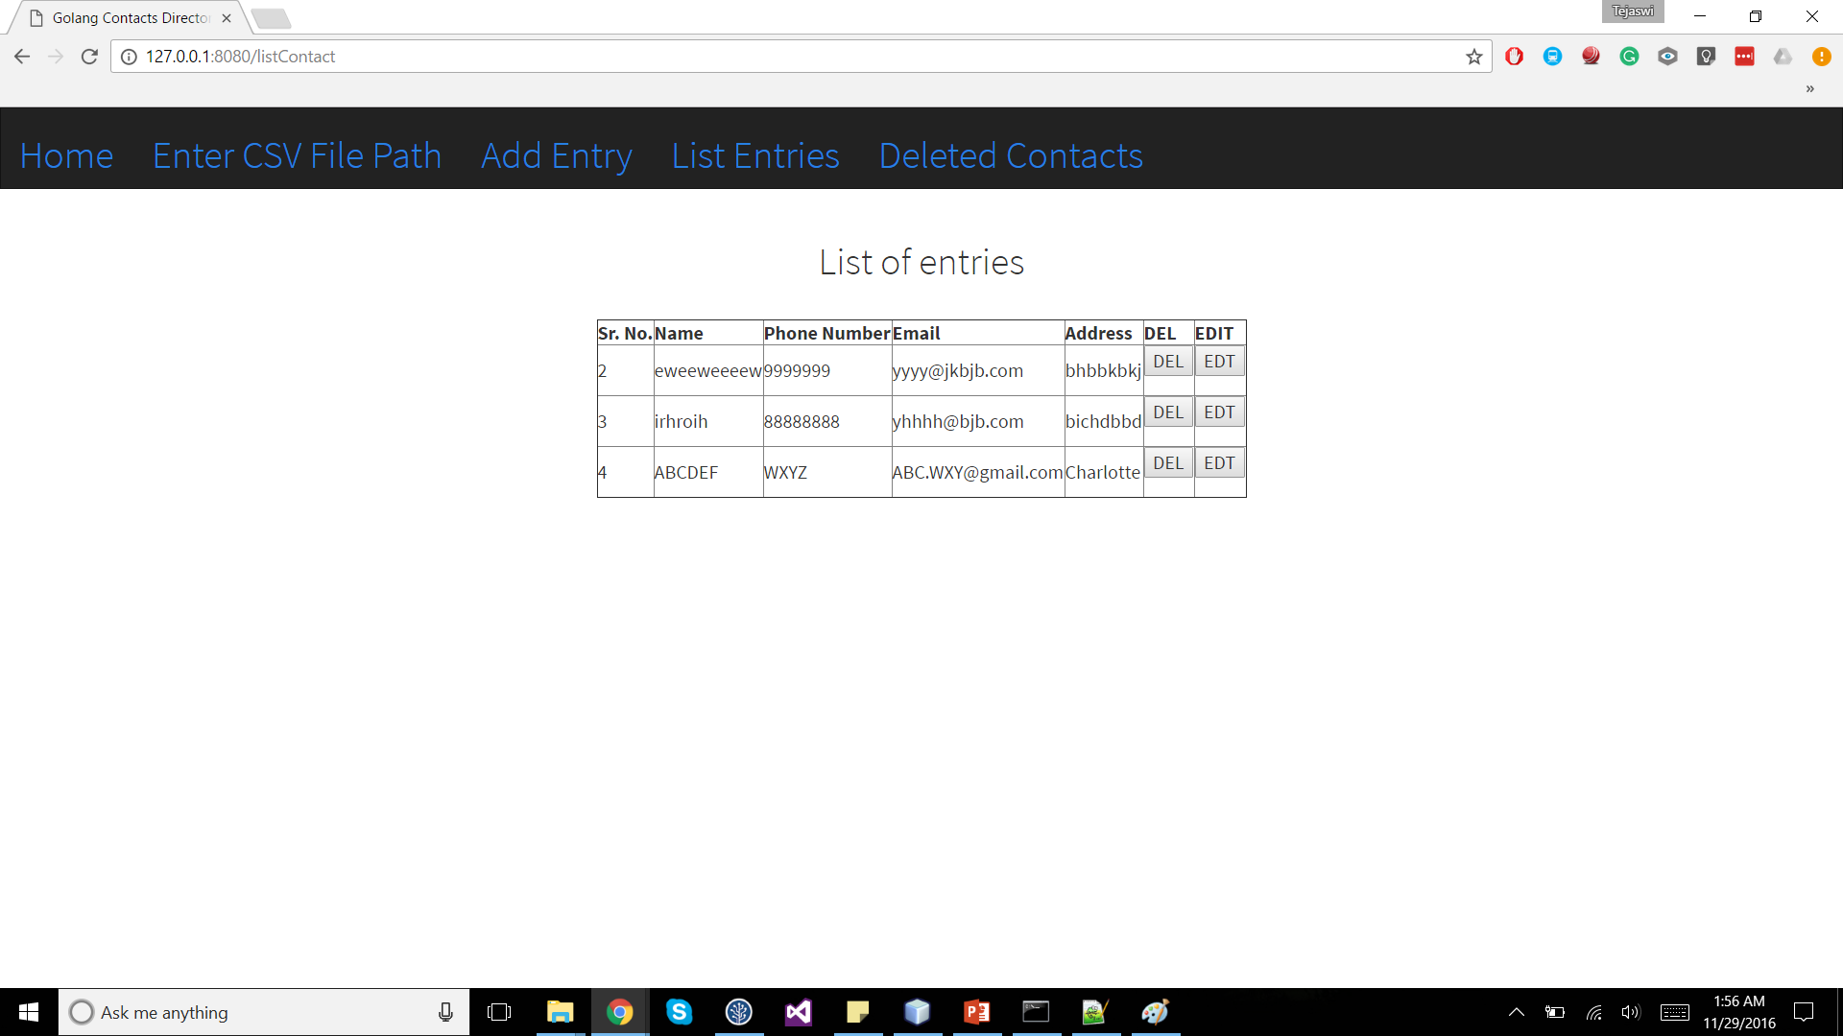

11) 'Deleted Contacts' tab will show all the deleted contacts and have a Restore button, so that we can restore the deleted contacts.

