class04.R

lorenacuellar

2022-10-06

# This is a comment  
x <- 1:50  
plot(x,sin(x))

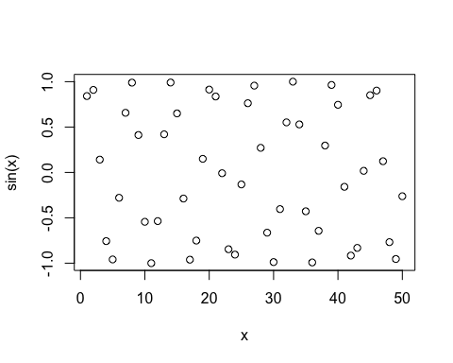

# Add more arguments to get this how we want it  
plot(x, sin(x), typ="l", col="blue", lwd=3)

