5. Objects and Classes (2)

Lab Exercise 5-1: Create Customer Accounts

Objective
In this exercise you will expand the Banking project by adding a Customer class. A customer will contain one Account object.
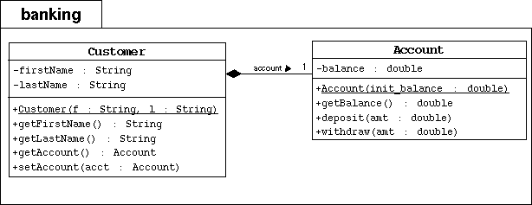
Note: You should know the UML notations to understand this diagram. For example, the accountrelationship can be implemented as a data attribute in the Customer class; even though, it is not mentioned in the "attributes" section of the Customer class block.

Directions
Start by changing your working directory to lab05/exercise1 on your computer.
- Make the banking directory.
- Copy the Banking project files from the previous Banking lab to this directory.
- Create the Customer class in the file Customer.java under the banking directory. This directory represents the Java package structure for your program. This class must implement the model in the above UML diagram.
  - declare three private object attributes: firstName, lastName, and account
  - declare a public constructor that takes two parameters (f and l) that populate the object attributes
  - declare two public accessors for the object attributes; these methods getFirstName and getLastName simply return the appropriate attribute
  - declare the setAccount method to assign the account attribute
  - declare the account method to retrieve the account attribute
- In the main exercise1 directory, compile and run the TestBanking program. You shoud see the following output:
- Creating the customer Jane Smith.
- Creating her account with a 500.00 balance.
- Withdraw 150.00
- Deposit 22.50
- Withdraw 47.62
Customer [Smith, Jane] has a balance of 324.88

5. Objects and Classes (2)

Lab Exercise 5-2: Use Arrays to Represent Associations

Objective
In this exercise you will use arrays to implement the multiplicity on the association between a bank and its customers.
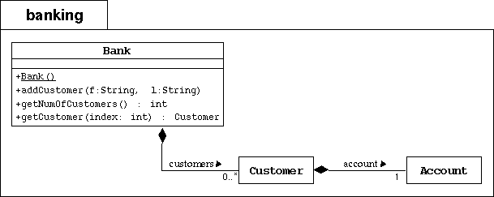

Directions
To the banking package, you will add the Bank class as modeled by the UML diagram above. A bank object simply keeps track of an association between itself and its customers. We will implement this aggregate association with an array of Customer objects. We will also need to keep a integer attribute that keeps track of how many customers currently exist in the bank.
- Create the banking directory. Copy the previous Banking project files in this package directory.
- Add two attributes to the Bank class: customers (an array of Customer objects) and numberOfCustomers (an integer that keeps track of the nextcustomers array index).
- Add a public constructor that initializes the customers array with some appropriate maximum size (at least bigger than 5).
- Add the addCustomer method. This method must construct a new Customer object from the parameters (first name, last name) and place it on thecustomers array. It must also increment the numberOfCustomers attribute.
- Add the getNumOfCustomers accessor method, which returns the numberOfCustomers attribute.
- Add the getCustomer method. This method returns the customer associated with the given index parameter.
- Compile and run the TestBanking program. You shoud see the following output:
- Customer [1] is Simms, Jane
- Customer [2] is Bryant, Owen
- Customer [3] is Soley, Tim
Customer [4] is Soley, Maria

