CS 360 – PROJECT (Homework 1-6)
Team
Members:

Assignment for Lecture 1:

- What are the differences between procedural programming and object-oriented programming?

Student:

Feature | Procedural Programming | Object-Oriented Programming (OOP)
Focus | Functions and procedures | Objects and their interactions
Data and behavior | Separate | Bundled together inside objects
Encapsulation | Not enforced | Strongly enforced
Code reusability | Limited through functions | Higher via inheritance and polymorphism
Abstraction | Low | High, real-world modeling
Inheritance & Polymorphism | Not supported | Supported
Complexity management | Harder as systems grow | Easier to manage and extend in large systems

- Find an example in the real world where the Object Technology is applied with success.

Student:

- Application of artificial intelligence in cars when controlling utilities through voice use.

- Setup the environment for compiling and running Java programs. Follows the guide in the section 1.10 Test-Driving a Java Application in the text book Java How to Program 9th edition, run the ATMCaseStudy and take the snapshot of the screen in each step.

Students:

Step 1: Entering a PIN
- Enter the account number: 12345
- Enter the PIN: 54321
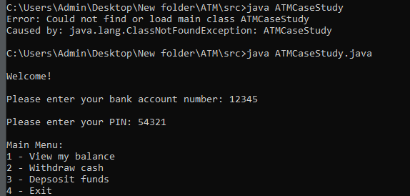
Step 2:
- Viewing the account balance
- Enter choice 1.
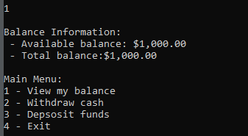
- Withdrawing money from the account
- Enter choice 2.
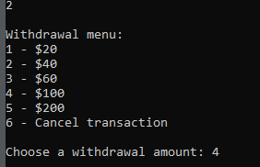

- Choose a withdrawal amount

- Enter choice 4.

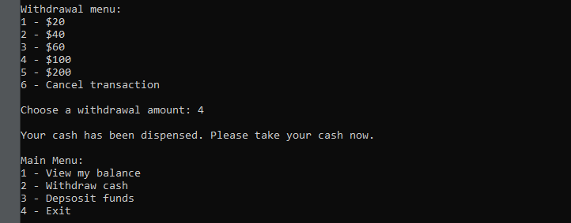

Step 3: Confirming that the account information has been updated and Exiting the ATM and closing the Command Prompt window.
- Entering number 1 to check information of the account balance and entering number 4 to exit program.

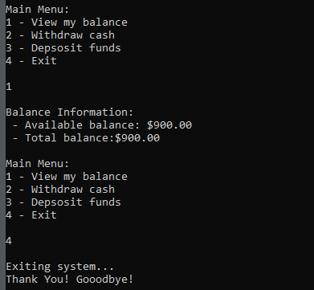

Assignment for Lecture 2

- Write a program displaying on the screen two first letters of your name. For example: Thủy -> Display TH:

Student:

- Using command Sytem.out.println() to print each line in the two letter
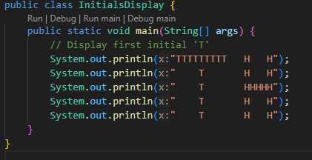

- Result:

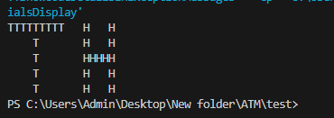

- Programming Challenges
- Programming Challenges 17, 18, 19 Chapter 2 Starting Out Java 6ed - p108 - 109 Tony Gaddis Java Textbook.

Student:

17. Ingredient Adjuster
A cookie recipe calls for the following ingredients:
• 1.5 cups of sugar
• 1 cup of butter
• 2.75 cups of flour
The recipe produces 48 cookies with these amounts of the ingredients. Write a program that asks the user how many cookies he or she wants to make, and then displays the number of cups of each ingredient needed for the specified number of cookies.

ANSWER:

- The original recipe makes 48 cookies with the same amount of -ingredients.
- The program will receive the number of cookies the user wants to make.
- Based on the ratio between the desired number of cookies and the original recipe quantity, the program calculates the corresponding quantity of ingredients.
- The figures are printed in a format with two decimal places for easy reading.
- Calculate the ratio of ingredients:
sugarNeeded = (sugarCups / cookiesRecipeMakes) * cookiesWanted
butterNeeded = (butterCups / cookiesRecipeMakes) * cookiesWanted
flourNeeded = (flourCups / cookiesRecipeMakes) * cookiesWanted

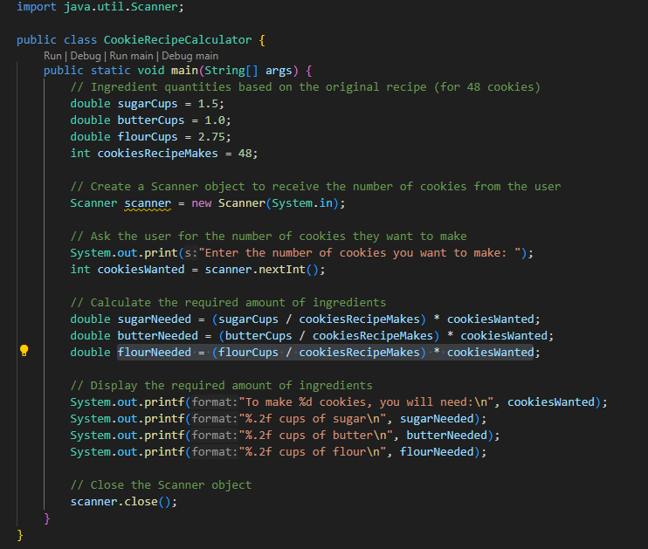

The program returns results when entering the number of cakes you want to make, which is 5 cookies:

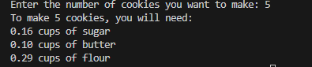

- Write a program that ask for input 2 integer number and display them on dialogs
Students:

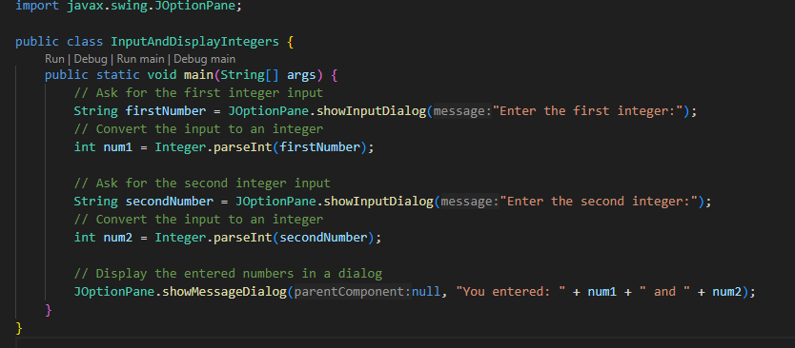

Explanation:
- JOptionPane.showInputDialog: This method is used to display a dialog that prompts the user for input.
- Integer.parseInt: Converts the input string from the dialog into an integer.
- JOptionPane.showMessageDialog: Displays a message dialog showing the two integers that the user entered.
Result:
When running the program, a notification window will be displayed:

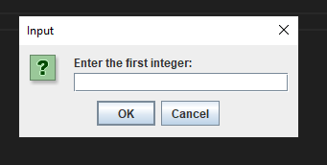

Enter number 12:
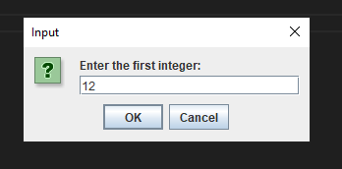

Enter number 34:

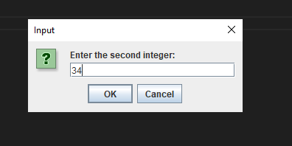
When click into OK, there is a Message display string “ You entered: 12 and 34”.

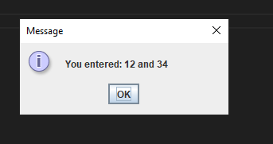

Assignment for Lecture 3
- BMI measure
Student:
Body Mass Index (BMI) is a measure of health based on height and weight. It can be calculated by taking your weight in kilograms and dividing it by the square of your height in meters. The interpretation of BMI for people 20 years or older is as follow:
BMI < 18.5 Underweight
18.5 ≤ BMI < 25.0 Normal
25.0 ≤ BMI < 30.0 Overweight
30.0 ≤ BMI Obese
Write a program that prompts the user to enter a weight in pounds and height in inches and displays the BMI. Note that one pound is 0.45359237 kilograms and one inch is 0.0254 meters.

Conversion constants:
- 1 pound = 0.45359237 kilograms.
- 1 inch = 0.0254 meters.
User input:
- The user is prompted to enter their weight in pounds and height in inches.
BMI Calculation:
- The weight is converted from pounds to kilograms, and the height is converted from inches to meters.
- BMI is then calculated as: BMI = weight (kg) / (height (m)^2).
BMI Categories:
- The program determines the category (Underweight, Normal, Overweight, Obese) based on the calculated BMI and outputs the result.

- Declare data variables and use the Scanner function for users to enter BMI indices.

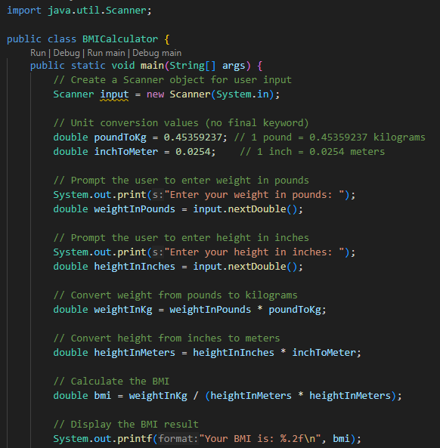

- Use an if statement to compare the index calculated from the data the user enters from the keyboard and the given index.

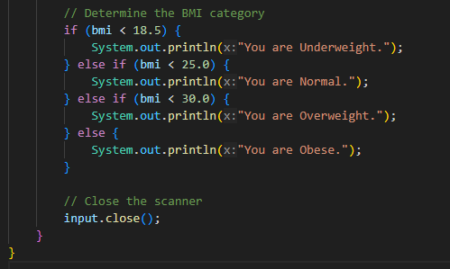

Result:
When entering different indicators, the displayed results will be different. Below are the results of the 4 severe cases mentioned above.
Overweight:
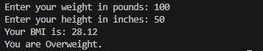

Obese:
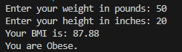
Underweight:
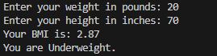

Normal:
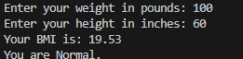
* Programming Challenges
3.8 Software Sales
Student:

A software company sells a package that retails for $99. Quantity discounts are given according to the following table:
Quantity | Discount
10–19 | 20%
20–49 | 30%
50–99 | 40%
100ormore | 50%

Write a program that asks the user to enter the number of packages purchased. The program should then display the amount of the discount (if any) and the total amount of the purchase after the discount.

Explanation
This program is designed to prompt the user to enter the number of software packages purchased, then calculate and display the amount of discount (if any) and the total cost after applying the discount.
The program creates a Scanner object to read user input from the keyboard. It initializes the price of a software package at $99 and sets an initial discount rate of 0.0 (indicating no discount).
After prompting the user to enter the number of software packages purchased, the program checks the quantity using an if-else structure to determine the applicable discount rate. If the quantity is 100 or more, a 50% discount is applied. For quantities between 50 and 99, a 40% discount is applied, and so on, down to a 20% discount for quantities between 10 and 19. If fewer than 10 packages are purchased, no discount is applied.
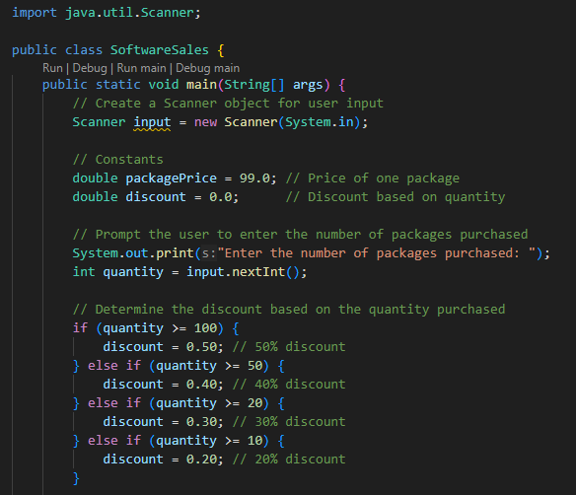
The program calculates the total price of the packages before any discounts and then determines the discount amount. Finally, it computes the total amount payable after the discount has been applied.

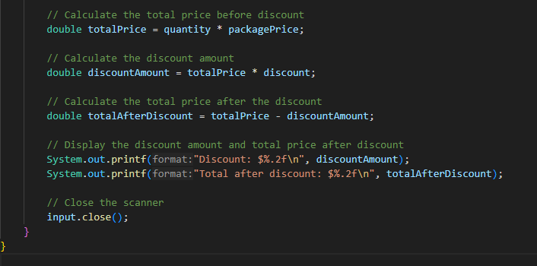

The results, including the discount amount and the total after the discount, are displayed in a formatted manner, ensuring that monetary values are presented with two decimal places.
Result:
- This is the result when entering the number of packages in each discount range.
15 packages (10–19):

25 packages (20–49):

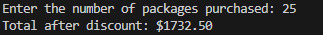

55 packages (50–99):

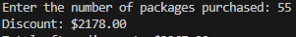

200 packages (100 or more):

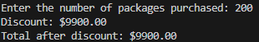

  - Shipping Charges
Student:

The Fast Freight Shipping Company charges the following rates:

Weight of Package | Rate per 500 Miles Shipped
2 pounds or less | $1.10
Over 2 pounds but not more than 6 pounds | $2.20
Over 6 pounds but not more than 10 pounds | $3.70
Over 10 pounds | $3.80

The shipping charges per 500 miles are not prorated. For example, if a 2-pound package is shipped 550 miles, the charges would be $2.20. Write a program that asks the user to enter the weight of a package and then displays the shipping charges

ANSWER
The Fast Freight Shipping Company has a specific pricing structure for shipping packages based on their weight. This program calculates the shipping charges for a user-entered package weight and displays the cost.

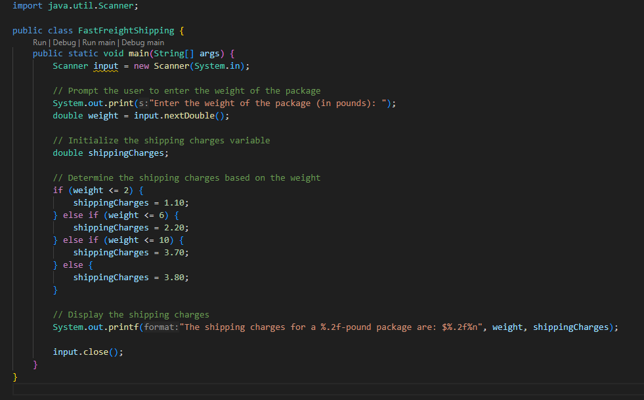

Result:
The program uses a series of if, else if, and else statements to determine the shipping charge based on the weight:
- If the weight is 2 pounds or less, the shipping charge is $1.10.
- If the weight is over 2 pounds but not more than 6 pounds, the charge is $2.20.
- If the weight is over 6 pounds but not more than 10 pounds, the charge is $3.70.
- If the weight is over 10 pounds, the charge is $3.80.

Assignment for Lecture 4

1. Mirror Drawin
Student:
a) Write a program running in Console, that asks user to input the width and the height of the Mirror. They are even numbers.
Draw the mirror.
b) Write an Applet for doing the same thing.

ANSWER:
This program will ask the user to input the width and height of the mirror (both even numbers) and then draw the mirror accordingly.

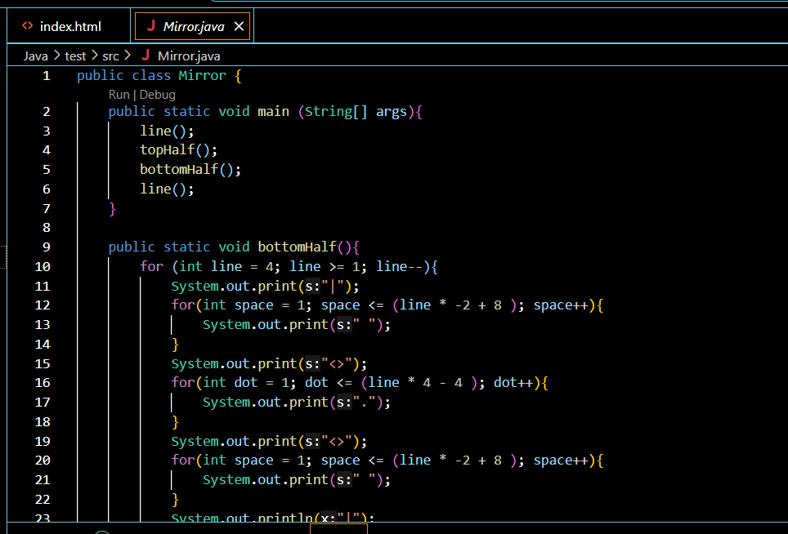
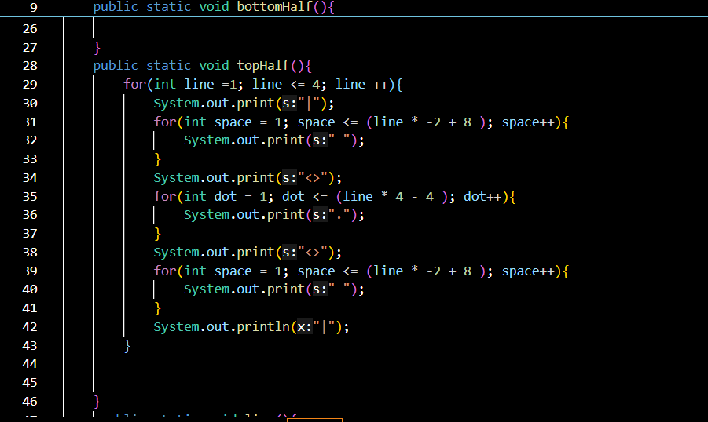

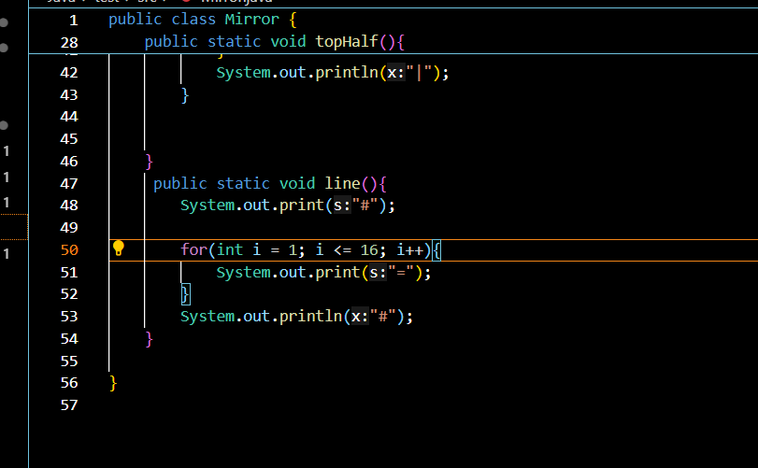

Result:
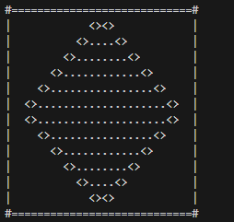

2. Programming Challenges.

4.18 Random Number Guessing Game Enhancement
Student:
Enhance the program that you wrote for Programming Challenge 17 so it keeps a count of the number of guesses that the user makes. When the user correctly guesses the random number, the program should display the number of guesses.
ANSWER:
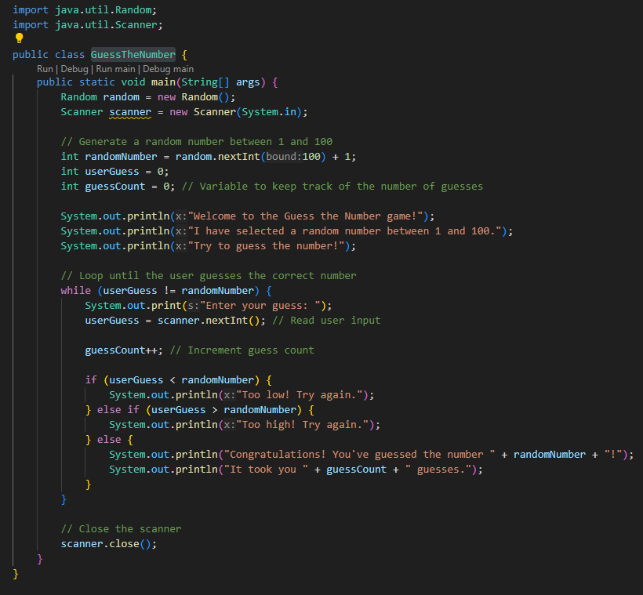

Explanation:
- Imports:
  - import java.util.Random; allows us to generate random numbers.
  - import java.util.Scanner; allows us to read input from the user.
- Class Declaration:
  - public class GuessTheNumber defines the main class of the program.
- Main Method:
  - public static void main(String[] args) is the entry point of the program.
- Random Number Generation:
  - Random random = new Random(); creates a Random object.
  - int randomNumber = random.nextInt(100) + 1; generates a random number between 1 and 100.
- Variables:
  - int userGuess = 0; initializes the variable to store the user's guess.
  - int guessCount = 0; initializes a counter to keep track of the number of guesses.
- User Interaction:
  - The program welcomes the user and explains the game.
- Guessing Loop:
  - The while loop continues until the user guesses the correct number.
  - userGuess = scanner.nextInt(); reads the user's guess from the console.
  - guessCount++; increments the guess count each time the user makes a guess.
  - The program provides feedback on whether the guess is too low, too high, or correct.
  - When the user guesses correctly, the program displays the random number and the total number of guesses.
- Closing the Scanner:
  - scanner.close(); closes the scanner to avoid resource leaks.
Result:
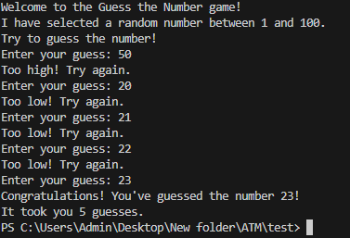
4.19 ESP Game
Student:
Write a program that tests your ESP (extrasensory perception). The program should randomly select the name of a color from the following list of words:
Red, Green, Blue, Orange, Yellow
To select a word, the program can generate a random number. For example, if the number is 0, the selected word is Red, if the number is 1, the selected word is Green, and so forth. Next, the program should ask the user to enter the color that the computer has selected. After the user has entered his or her guess, the program should display the name of the randomly selected color. The program should repeat this 10 times and then display the number of times the user correctly guessed the selected color.

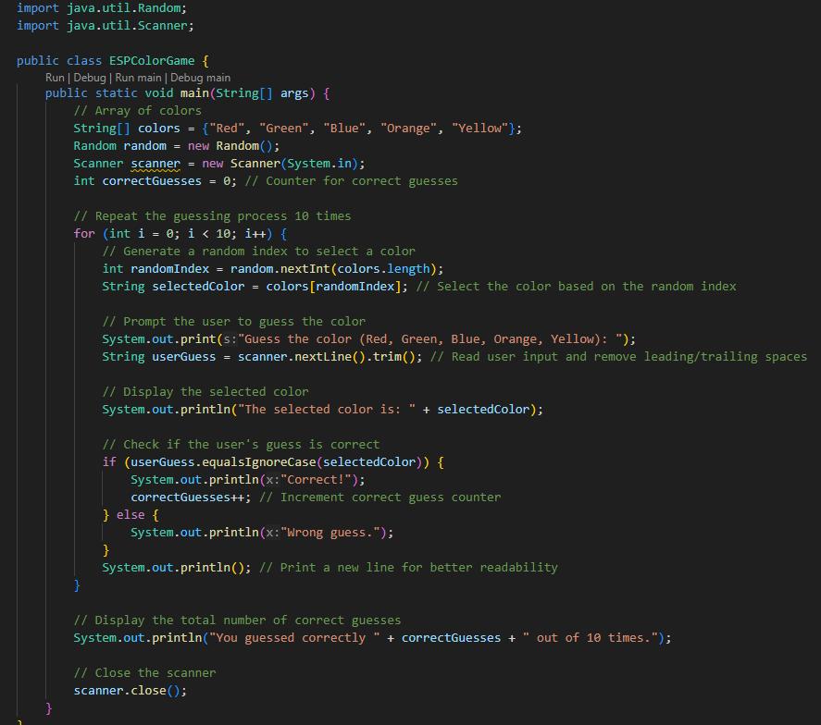

Explanation:
- Imports:
  - import java.util.Random; allows us to generate random numbers.
  - import java.util.Scanner; allows us to read input from the user.
- Class Declaration:
  - public class ESPColorGame defines the main class of the program.
- Main Method:
  - public static void main(String[] args) is the entry point of the program.
- Array of Colors:
  - String[] colors = {"Red", "Green", "Blue", "Orange", "Yellow"}; creates an array containing the list of colors.
- Random Number Generator:
  - Random random = new Random(); creates a Random object to generate random indices.
- Scanner Initialization:
  - Scanner scanner = new Scanner(System.in); initializes a scanner to read user input.
- Correct Guess Counter:
  - int correctGuesses = 0; initializes a counter for tracking correct guesses.
- Guessing Loop:
  - The for loop runs 10 times to allow the user to guess the color.
  - int randomIndex = random.nextInt(colors.length); generates a random index to select a color from the array.
  - String selectedColor = colors[randomIndex]; retrieves the color corresponding to the random index.
  - The program prompts the user to guess the color and reads the input.
- Display and Check Guess:
  - The program displays the randomly selected color.
  - It checks if the user's guess matches the selected color (ignoring case) and increments the correct guess counter if it's correct.
- Final Output:
- After the loop, the program displays the total number of correct guesses made by the user.
- Closing the Scanner:
- scanner.close(); closes the scanner to avoid resource leaks.

Result:
Enter one of the four given patterns in the middle of ten numbers in the selection machine to win.
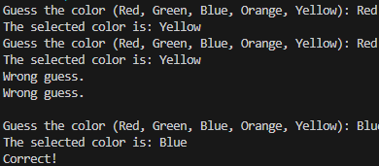

4.21 Dice Game
Student:
Write a program that plays a simple dice game between the computer and the user. When the program runs, a loop should repeat 10 times. Each iteration of the loop should do the following:
• Generate a random integer in the range of 1 through 6. This is the value of the computer’s die.
• Generate another random integer in the range of 1 through 6. This is the value of the user’s die.
• The die with the highest value wins. (In case of a tie, there is no winner for that particular roll of the dice.)
As the loop iterates, the program should keep count of the number of times the computer wins, and the number of times that the user wins. After the loop performs all of its iterations, the program should display who was the grand winner, the computer or the user
ANSWER:

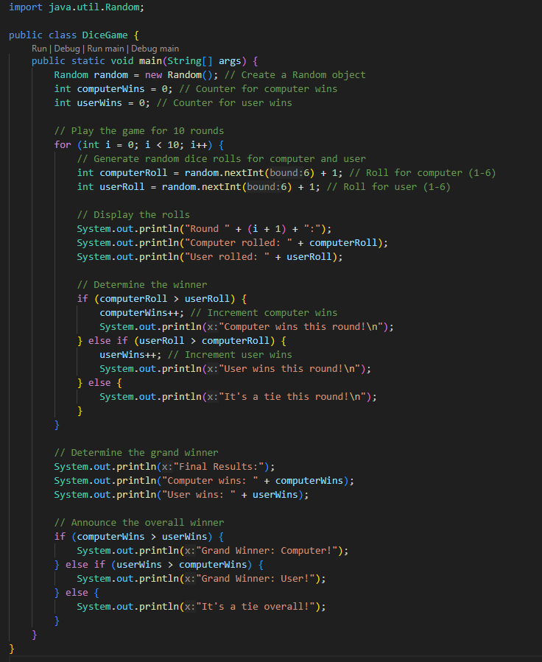

Explanation:
- Imports: The program imports the Random class to generate random numbers.
- Main Method:
  - The main method is where the program starts executing.
  - Two counters, computerWins and userWins, are initialized to keep track of the number of wins for each player.
- Loop for 10 Rounds:
  - A for loop runs 10 times, representing each round of the game.
  - Inside the loop:
    - Random integers are generated using random.nextInt(6) + 1 to simulate dice rolls (values from 1 to 6) for both the computer and the user.
    - The results of the rolls are printed.
    - A comparison is made to determine the winner of each round:
      - If the computer's roll is greater, computerWins is incremented.
      - If the user's roll is greater, userWins is incremented.
      - If both rolls are equal, it results in a tie.
- Final Results:
  - After all rounds are completed, the program prints the total number of wins for both the computer and the user.
  - The overall winner is determined and printed based on who has more wins, or if it’s a tie overall.
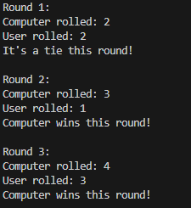

3. Write a program that asks the user to enter two numerical values (integers) and then select an operation (addition, subtraction, multiplication and division) then prints the result based on operation selected. The code below shows examples of the output (text shown in boldface is supposed to be user input.

Student:
ANSWER:
Declare the variables and print out the selection menu:

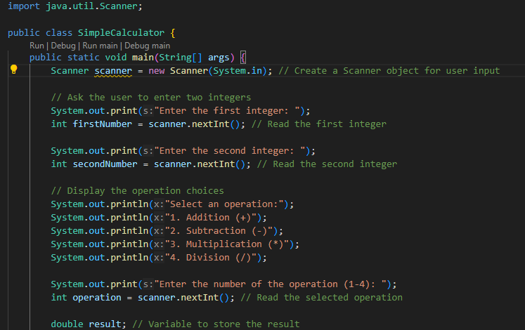

Imports: The program imports the Scanner class to read user input.
Main Method:
- The main method is where the program execution begins.
- A Scanner object is created to read input from the console.
User Input:
- The program prompts the user to enter two integers.
- It then asks the user to select an operation from the provided list (addition, subtraction, multiplication, or division).

Use switch cases to let the user enter menu choices:

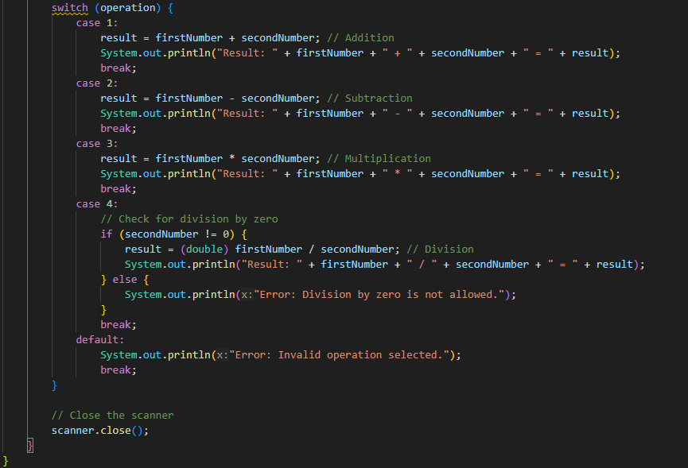

Operation Selection:
- The program uses a switch statement to determine which operation to perform based on the user's selection.
- For each case (1 to 4):
  - The corresponding operation is performed, and the result is printed.
- In the case of division, it checks if the second number is zero to avoid division by zero errors.
Result:
Addition:
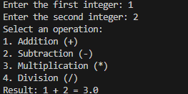

Subtraction:

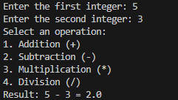

Multiplication:

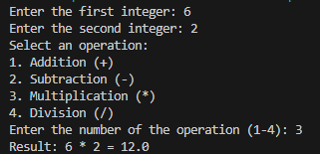
Division:

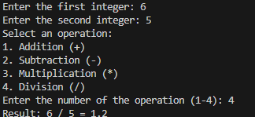

Assignment for Lecture 5

1. (Occurrence of max numbers)
Write a program that reads integers, finds the largest of them, and counts its occurrences. Assume that the input ends with number 0. Suppose that you entered 3 5 2 5 5 5 0; the program finds that the largest is 5 and the occurrence count for 5 is 4.

Student:
DESCRIPTION:
- The program uses a Scanner to read integers from the user.
- It keeps track of the largest number (max) and its occurrences (count).
- When a new maximum is found, max is updated and count is reset to 1.
- If the number matches the current max, count is incremented.
- The loop terminates when the user inputs 0, and then it displays the largest number and its occurrence count
Solution:
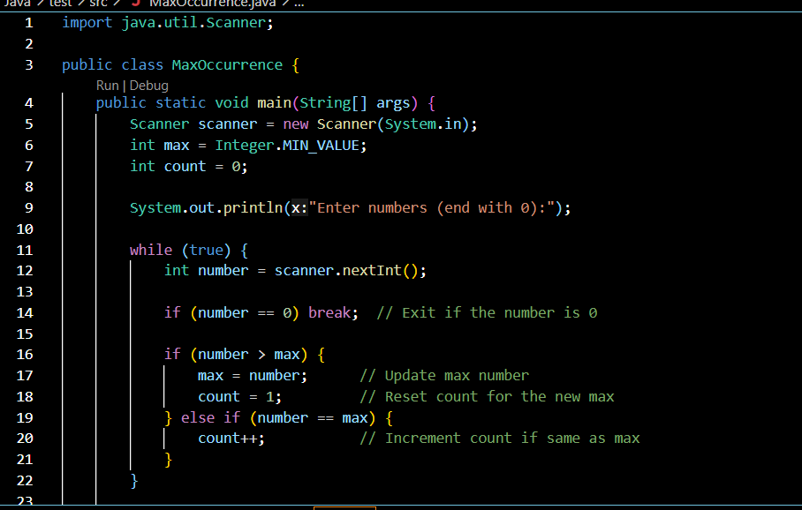

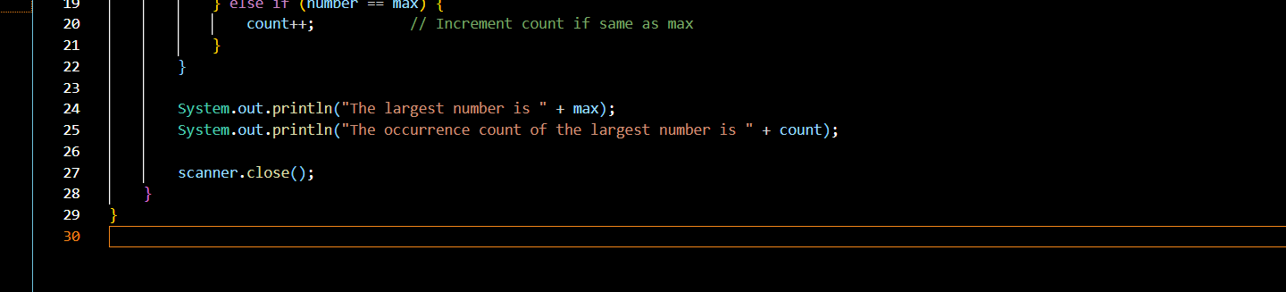

Result:

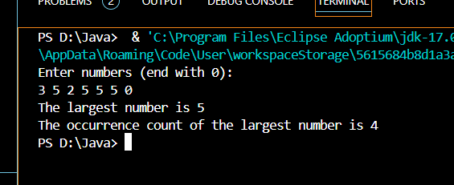
- Programming Challenges

5.1. Showchar method:

Student:
Write a method named showChar. The method should accept two arguments: a reference to a String object and an integer. The integer argument is a character position within the String, with the first character being at position 0. When the method executes, it should display the character at that character position. Here is an example of a call to the method:
showChar("New York", 2);
In this call, the method will display the character w because it is in position Demonstrate the method in a complete program.

Description:
- Method Definition: The showChar method takes a String (str) and an integer (position). It checks if position is within the bounds of the string's length.
- Character Display: If the position is valid, it prints the character at that index using str.charAt(position). If it's invalid, it prints an error message.
- Demonstration: The main method includes examples of valid and invalid calls to showChar.

Solution:

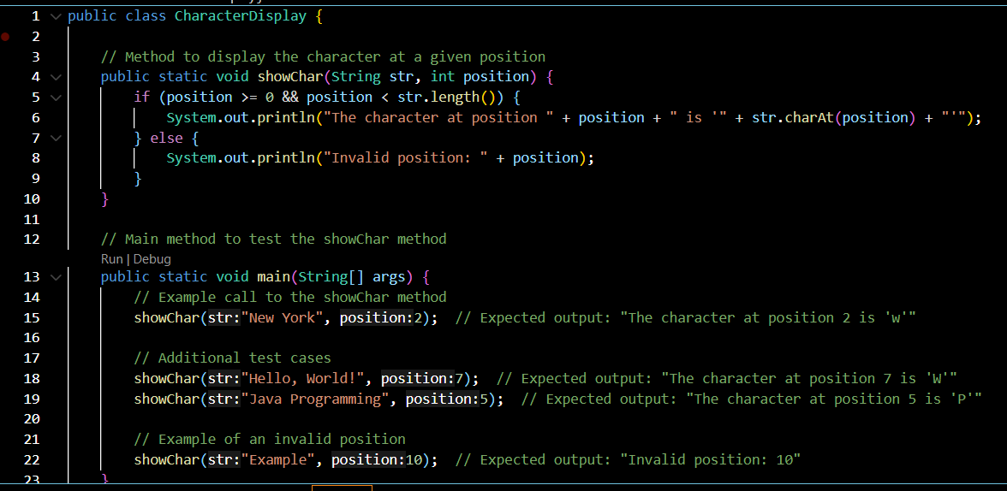
Result:

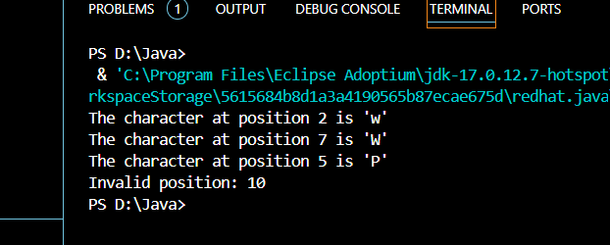

  - Retail Price Calculator
Student:
Write a program that asks the user to enter an item's wholesale cost and its markup percent- age. It should then display the item's retail price. For example:
If an item's wholesale cost is 5.00 and its markup percentage is 100 percent, then the item's retail price is 10.00.
If an item's wholesale cost is 5.00 and its markup percentage is 50 percent, then the item's retail price is 7.50.
The program should have a method named calculateRetail that receives the wholesale cost and the markup percentage as arguments, and returns the retail price of the item.
Description:
- Method Definition: The calculateRetail method takes the wholesale cost and markup percentage as arguments and calculates the retail price using the formula:
- User Input: In the main method, a Scanner is used to get input from the user for the wholesale cost and markup percentage.
- Displaying Result: The calculated retail price is formatted to two decimal places and displayed.
Solution:
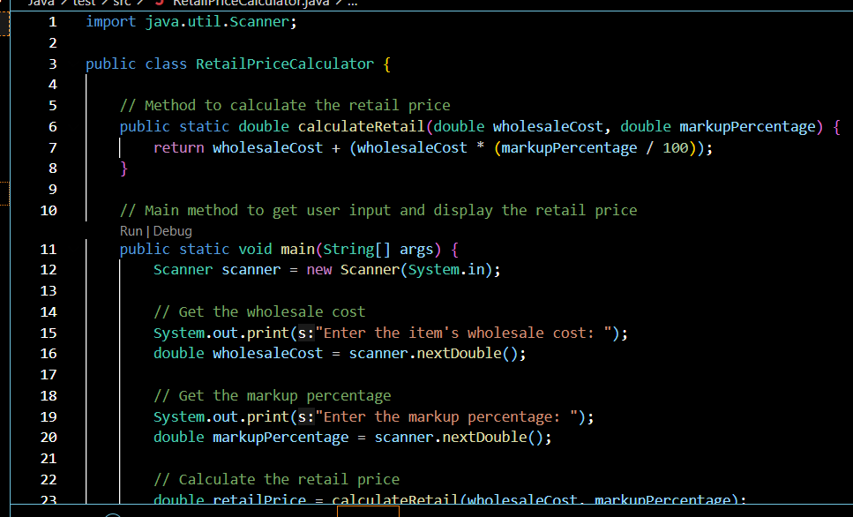
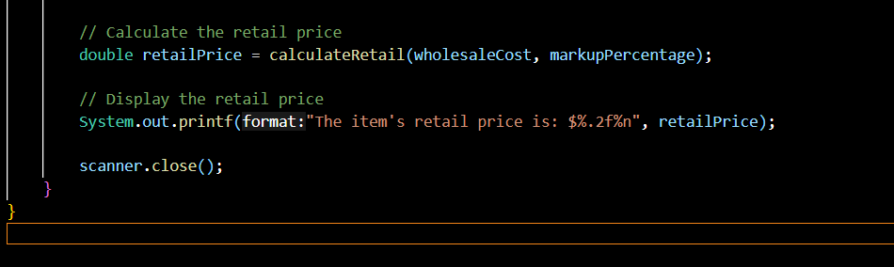
Result:
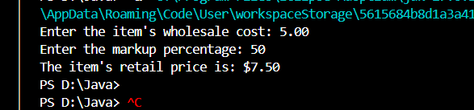

5.4. Paint Job Estimator
Student:
A painting company has determined that for every 115 square feet of wall space, one gallon of paint and eight hours of labor will be required. The company charges $18.00 per hour for labor. Write a program that allows the user to enter the number of rooms to be painted and the price of the paint per gallon. It should also ask for the square feet of wall space in each room. The program should have methods that return the following data:
• The number of gallons of paint required
• The hours of labor required
• The cost of the paint
• The labor charges
• The total cost of the paint job
Then it should display the data on the screen.
Description:
  - Methods:
- calculateGallons: Calculates the number of gallons of paint required based on total square feet.
- calculateLaborHours: Calculates the total hours of labor required, with 8 hours per gallon.
- calculatePaintCost: Calculates the cost of paint based on the number of gallons and the price per gallon.
- calculateLaborCost: Calculates the labor charges based on the total hours of labor and hourly rate.
  - User Input:
- The program asks the user to enter the number of rooms, the price of paint per gallon, and the square feet of wall space for each room.
  - Calculations:
- The total square feet is used to determine the number of gallons of paint and labor hours.
- The paint cost, labor charges, and total cost are then computed.
  - Output:
- The program displays the calculated values in a clear format.

Solution:
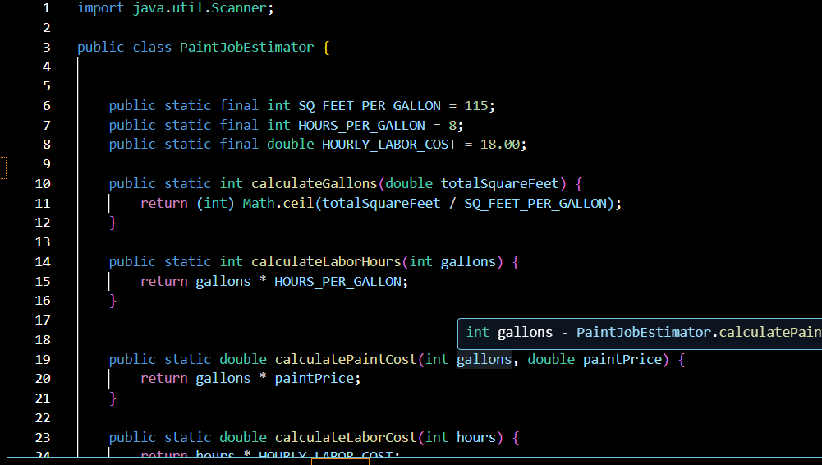

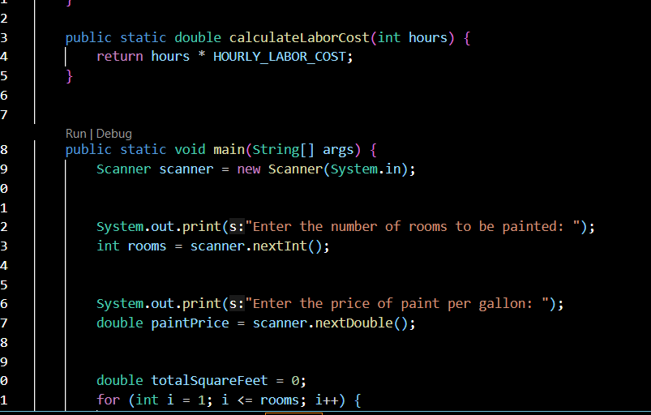

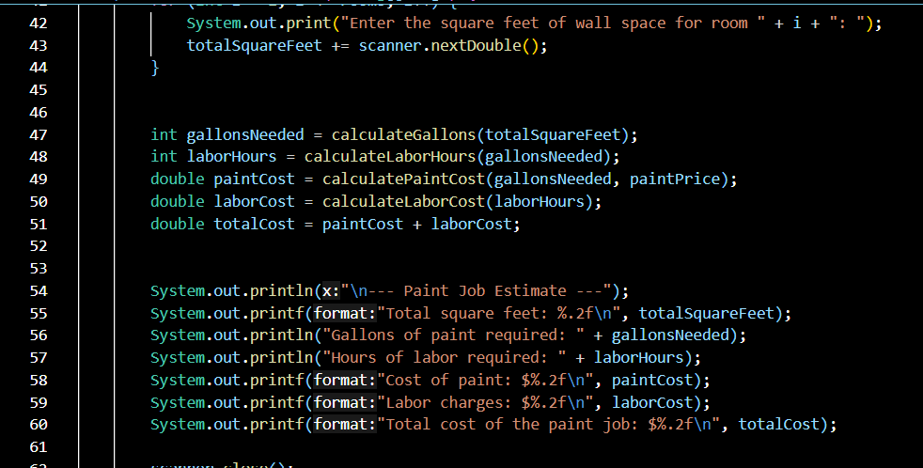

Result:
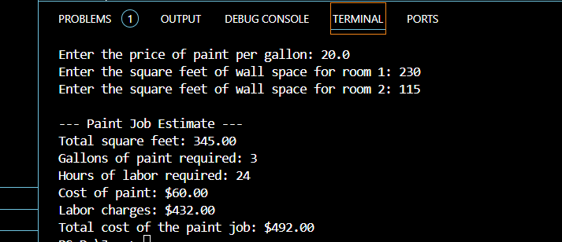

- Write a program that uses nested for loops to print a multiplication table inside a dialog as follows:

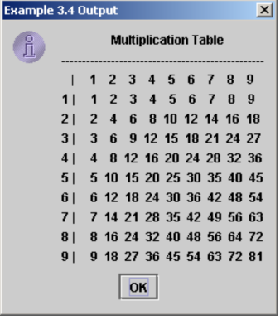

Student:
Description:
- StringBuilder: Used to construct the multiplication table as a single string for display in the dialog box.
- Table Headers: The top row and column headers are formatted to align properly using String.format.
- Nested for Loops: The outer loop represents the row numbers, and the inner loop represents the column numbers. The product of i and j is appended to the table.
- JOptionPane: Displays the multiplication table in an information dialog.
Solution:
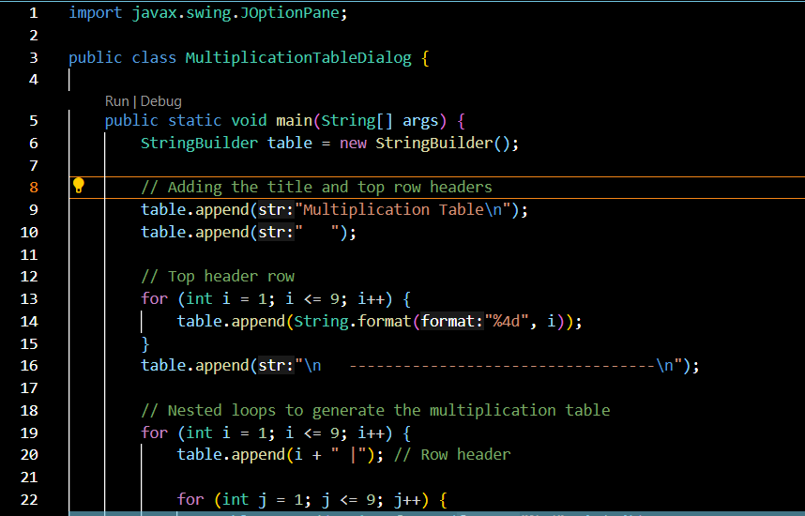

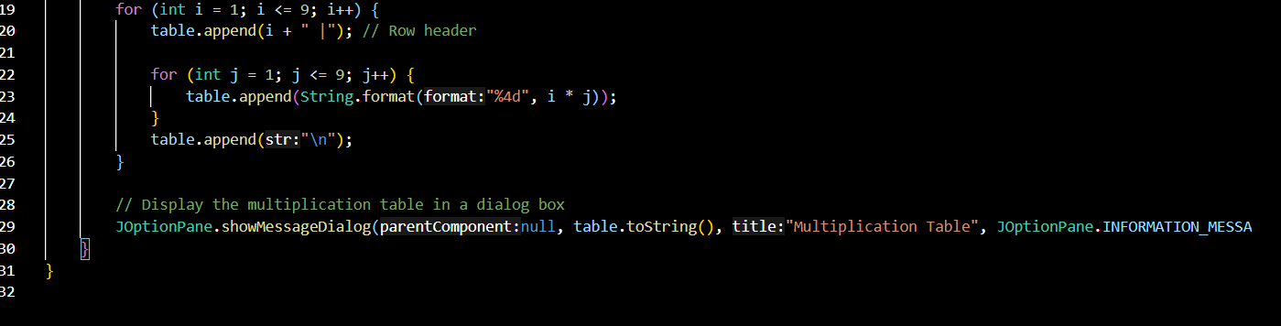

Result:

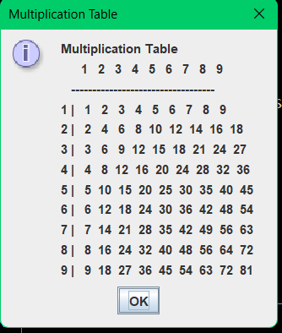

Assignment for Lecture 6

1. Implementation of Student Class
a) Write a class Student which models students with their:
ID: string, name, accumulated CPA, prefer courses (an array of String).
b) Write a program that create and display about the following students:
(TROY1231, Bob Walker, 3.21, {"Math", "Philosophy", "Art"})
(TROY1217, Bao Trung, 2.67, {"Computer Science I", "Math")}
(TROY1362, Nina Gigi, 2.99, {"Sing", "Dance", "Physics"})
the find the course that is most prefer by Student.
Don't use constructor, private methods in this exercises.

Student:

Description:
Class Attributes: The Student class has four public fields: id, name, cpa, and preferredCourses.
Methods:
- displayInfo(): Displays all information about a student.
- getMostPreferredCourse(): Returns the first course in the preferredCourses array as the "most preferred" course. If no courses are listed, it returns a placeholder message.
Main Program:
- Three Student objects are created with specific details.
- Information about each student is displayed, and their most preferred course is shown.

Solution:

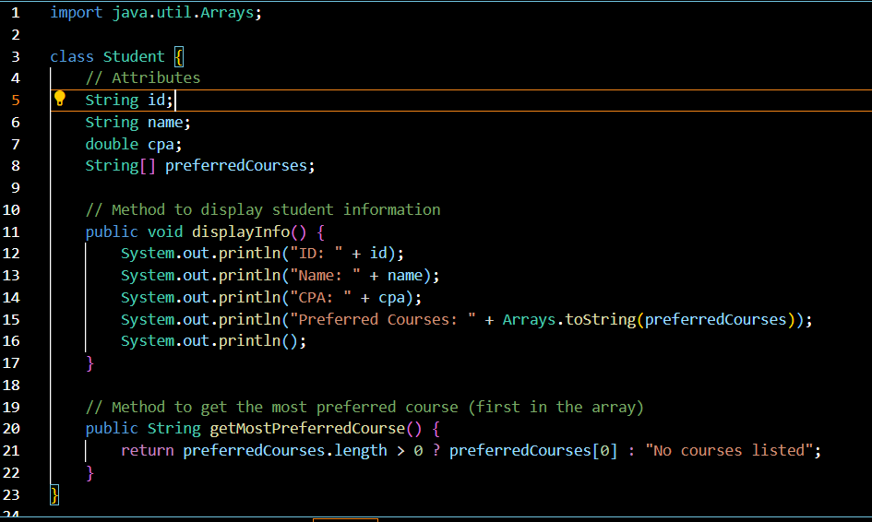

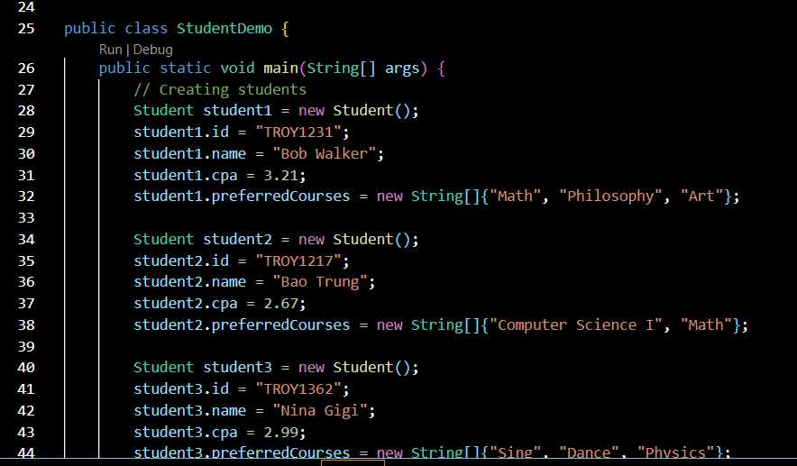

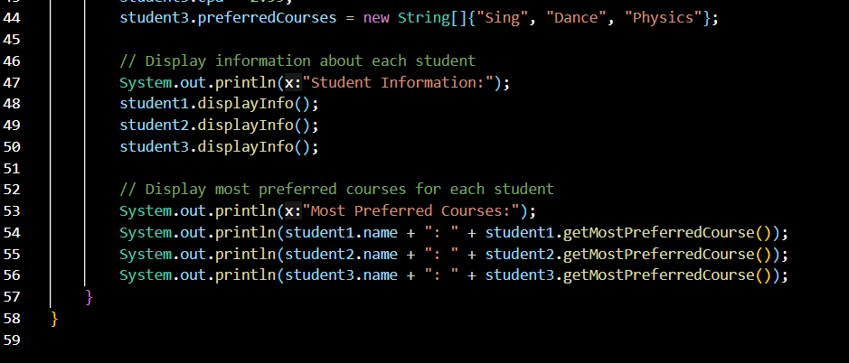

Result:
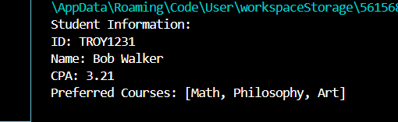
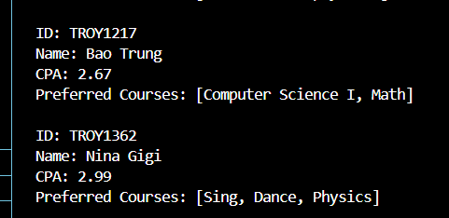
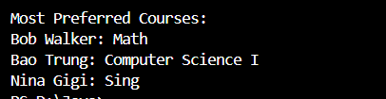
2. Implementation of TV Class
Consider television sets. Each TV is an object with states (current channel, current volume level, power on or off) and behaviors (change channels, adjust volume, turn on/off). Write a class to model TV sets and demo their usages in a program.
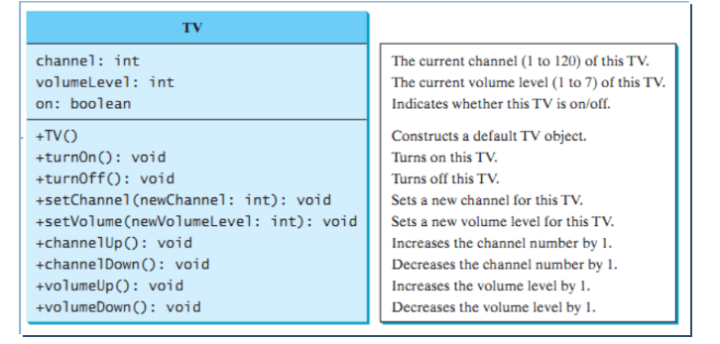
Student:

Description:
- The class has private fields for channel, volumeLevel, and on (indicating power state).
- The constructor initializes these fields to default values.
- Methods are provided to turn the TV on/off, set channel and volume (within specified limits), and increment/decrement channel and volume.
- The main method demonstrates usage by creating a TV object, turning it on, setting channel and volume, and then performing actions like increasing channel and volume.
Solution:
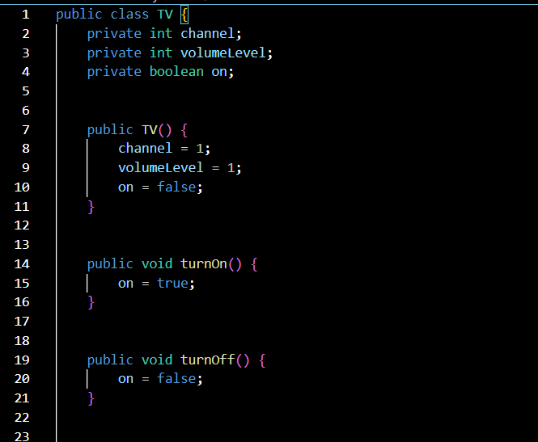

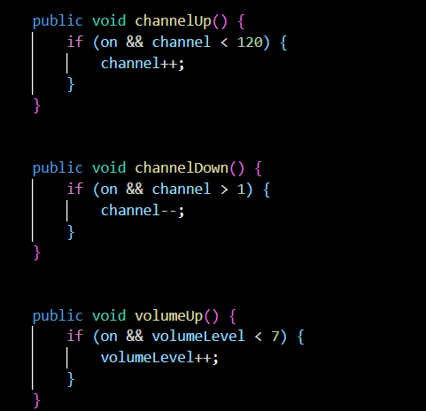
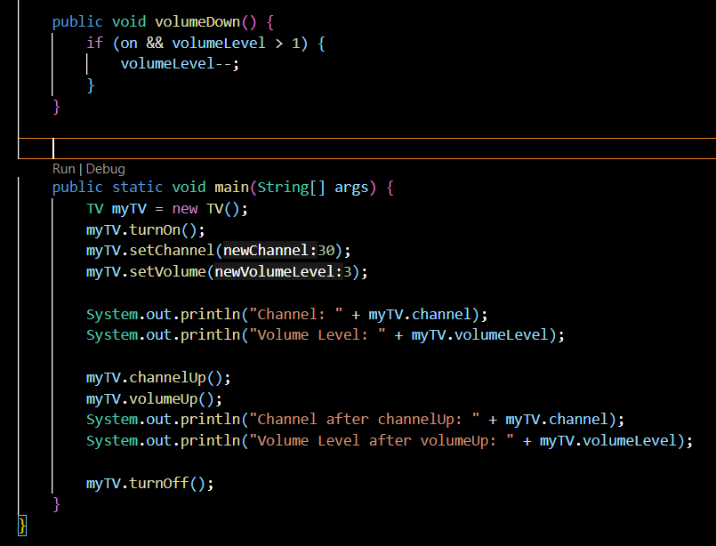
Result:

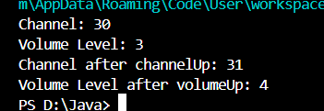

3. Programming Challenges (Array topic)

6.1. Employee Class
Write a class named Employee that has the following fields:
name. The name field references a String object that holds the employee's name.
• idNumber. The idNumber is an int variable that holds the employee's ID number.
department. The department field references a String object that holds the name of the department where the employee works.
position. The position field references a String object that holds the employee's job title.
The class should have the following constructors:
• A constructor that accepts the following values as arguments and assigns them to the appropriate fields: employee's name, employee's ID number, department, and position.
• A constructor that accepts the following values as arguments and assigns them to the appropriate fields: employee's name and ID number. The department and position fields should be assigned an empty string ("").
• A no-arg constructor that assigns empty strings ("") to the name, department, and position fields, and 0 to the idNumber field.
Write appropriate mutator methods that store values in these fields and accessor methods that return the values in these fields. Once you have written the class, write a separate pro- gram that creates three Employee objects to hold the following data:
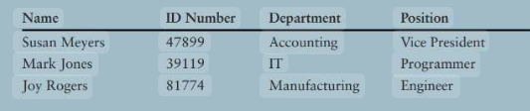
The program should store this data in the three objects and then display the data for each employee on the screen.

Student:

Description:

- The Employee class has four private fields: name, idNumber, department, and position.
- It includes three constructors:
  - A constructor that initializes all fields.
  - A constructor that only initializes name and idNumber, setting department and position to empty strings.
  - A no-argument constructor that sets all fields to default values.
- The class also has getter and setter methods for each field.
- The main method creates three Employee objects with the given data, then prints the information in a table format similar to the one in the image.

Solution:
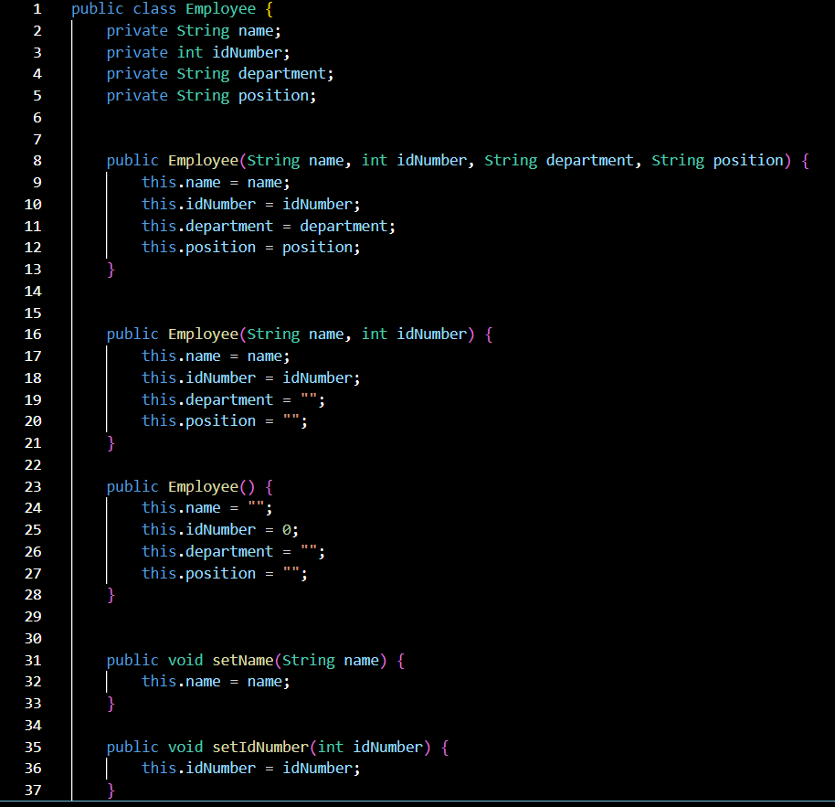

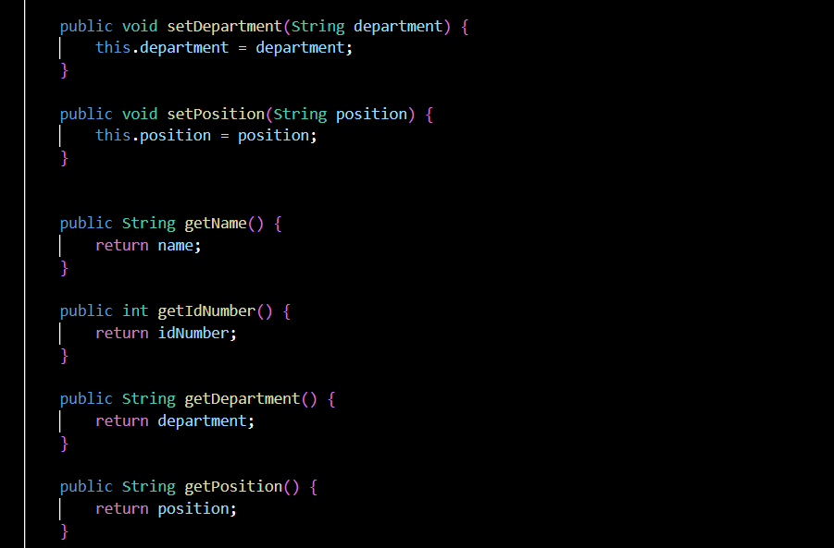
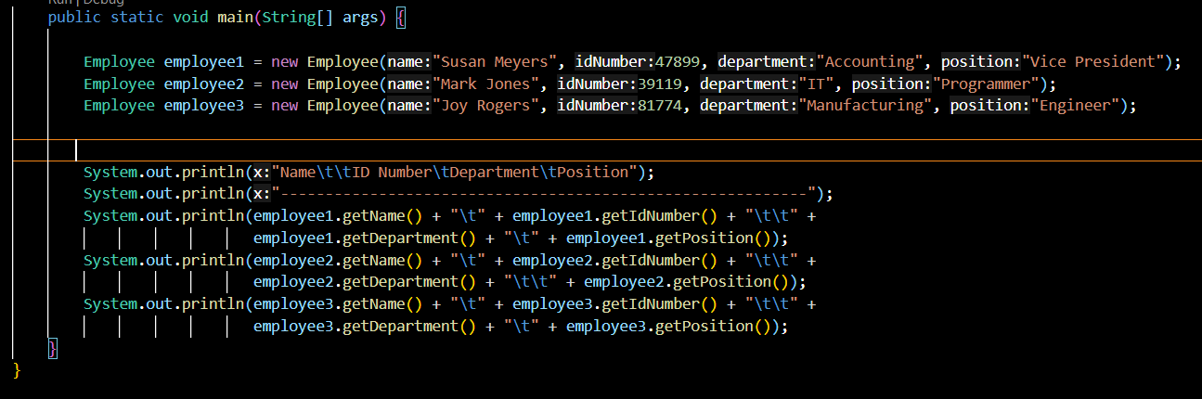

Result:

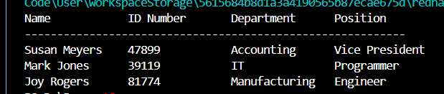

6.2. Car Class

Write a class named car that has the following fields:
yearModel. The yearModel field is an int that holds the car's year model.
• make. The make field references a string object that holds the make of the car.
speed. The speed field is an int that holds the car's current speed.
In addition, the class should have the following constructor and other methods.
• Constructor. The constructor should accept the car's year model and make as argu- ments. These values should be assigned to the object's yearModel and make fields. The constructor should also assign 0 to the speed field.
• Accessors. Appropriate accessor methods should get the values stored in an object's yearModel, make, and speed fields.
accelerate. The accelerate method should add 5 to the speed field each time it is called.
brake. The brake method should subtract 5 from the speed field each time it is called.
Demonstrate the class in a program that creates a Car object, and then calls the accelerate method five times. After each call to the accelerate method, get the current speed of the car and display it. Then call the brake method five times. After each call to the brake method, get the current speed of the car and display it.
Student:

Description:

- The Car class has three private fields: yearModel, make, and speed.
- The constructor accepts yearModel and make as arguments and initializes the speed to 0.
- The accelerate method increases the speed by 5 each time it is called.
- The brake method decreases the speed by 5 each time it is called but does not allow speed to go below 0.
- The main method demonstrates the class by creating a Car object and calling accelerate five times, displaying the speed after each call. It then calls brake five times, displaying the speed after each call.

Solution:

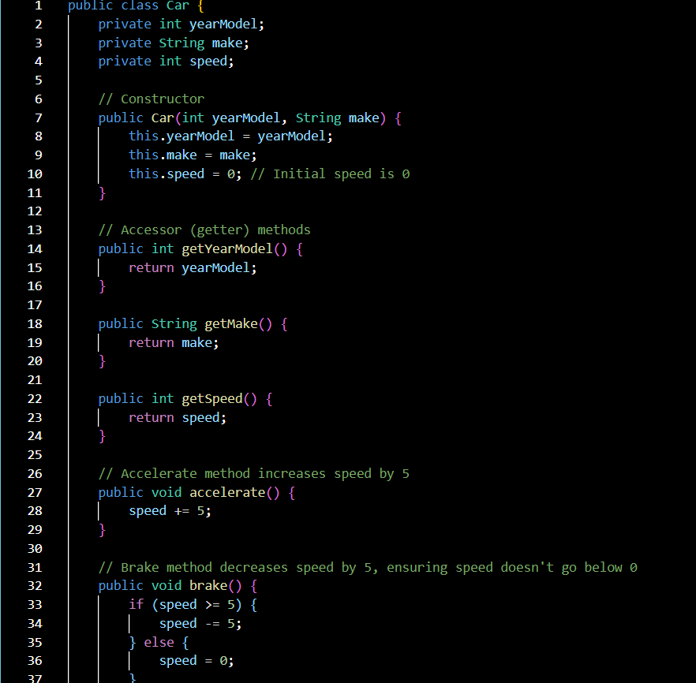
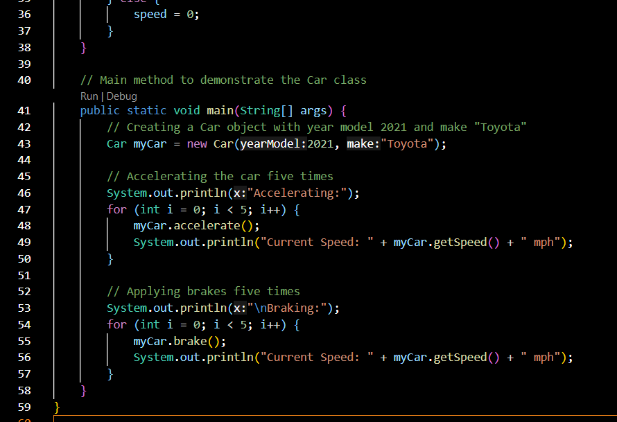

Result:
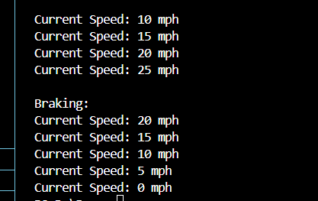

6.3. Personal Information Class
Design a class that holds the following personal data: name, address, age, and phone number. Write appropriate accessor and mutator methods. Demonstrate the class by writing a program that creates three instances of it. One instance should hold your information, and the other two should hold your friends' or family members' information.
Student:

Description:
- The PersonalInfo class has four private fields: name, address, age, and phoneNumber.
- The constructor initializes all four fields.
- The class includes getter and setter methods for each field.
- In the main method, three instances of PersonalInfo are created, each representing a different person (yourself, a friend, and a family member).
- The program then displays the information for each person using the getter methods.
Solution:
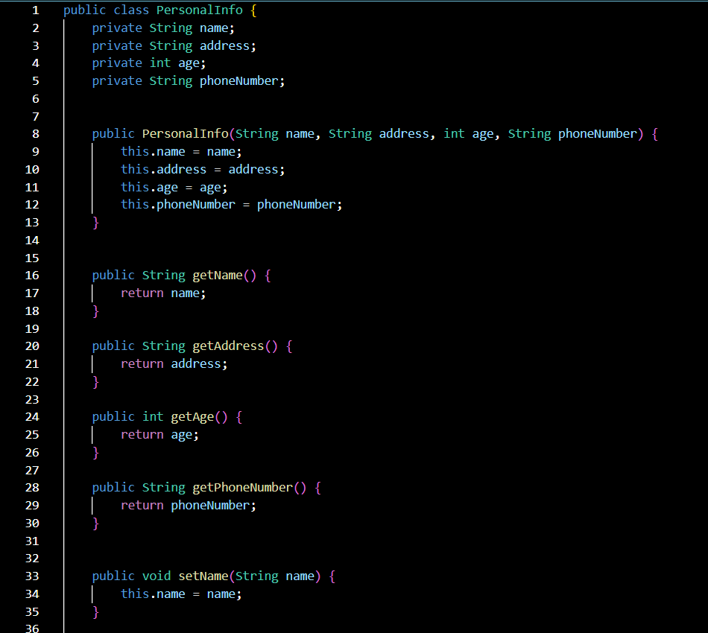

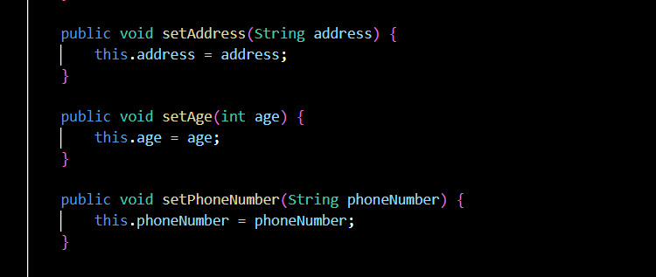
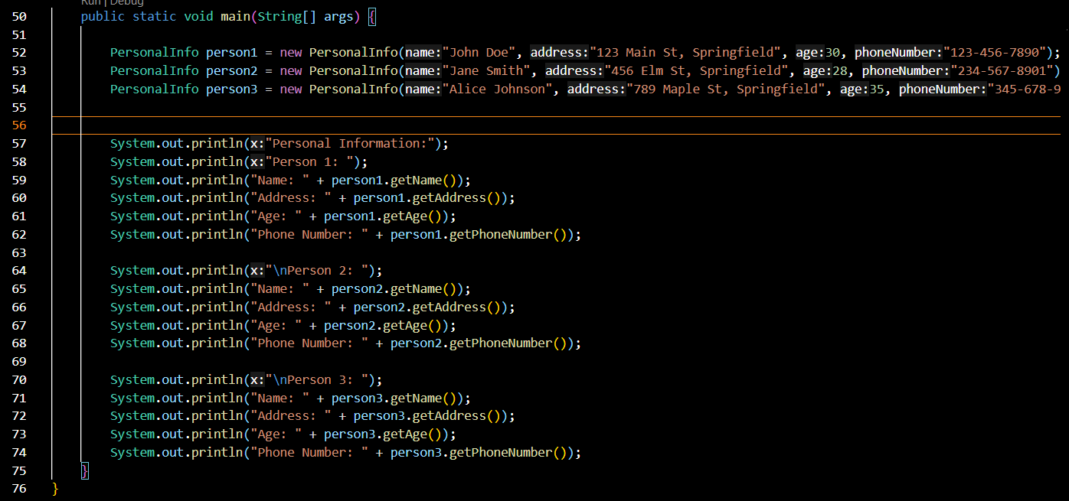

Result:
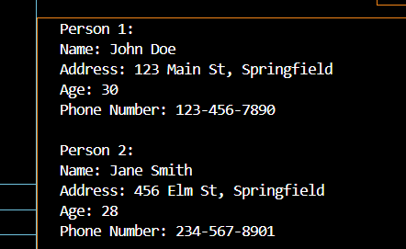

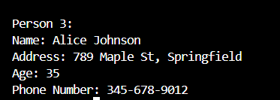
6.4. RetailItem Class
Write a class named RetailItem that holds data about an item in a retail store. The class should have the following fields:
description. The description field references a String object that holds a brief description of the item.
• unitsOnHand. The unitsOnHand field is an int variable that holds the number of units currently in inventory.
price. The price field is a double that holds the item's retail price.
Write a constructor that accepts arguments for each field, appropriate mutator methods that store values in these fields, and accessor methods that return the values in these fields. Once you have written the class, write a separate program that creates three RetailItem objects and stores the following data in them:
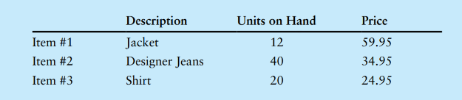

Student:

Description:

- Class Definition: The RetailItem class has three fields: description, units_on_hand, and price.
- Constructor: Initializes each field with the provided arguments.
- Mutator Methods: set_description, set_units_on_hand, and set_price allow setting values to each field.
- Accessor Methods: get_description, get_units_on_hand, and get_price return values of each field.
- Objects Creation: Three RetailItem objects (item1, item2, item3) are created with data from the table and printed.
Solution:

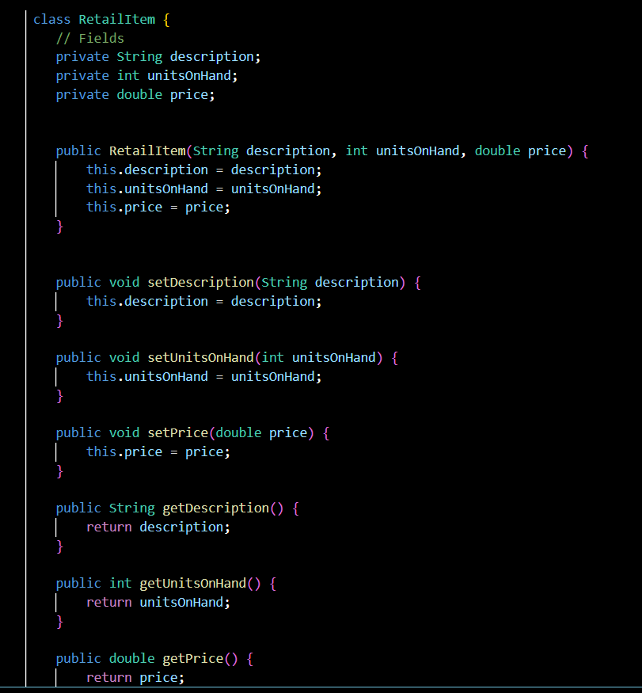
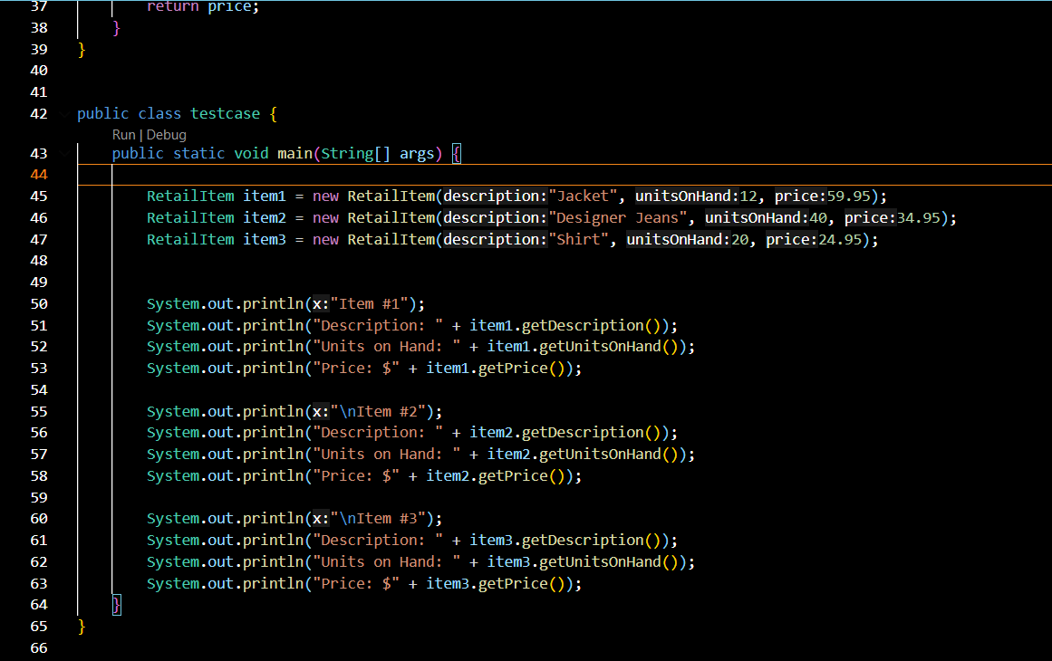

Result:

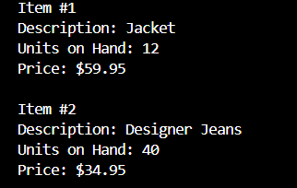

public class BankAccount {
private String accountNo;
private String owner;
private double balance;
// Constructor
public BankAccount(String accountNo, String owner, double balance) {
this.accountNo = accountNo;
this.owner = owner;
this.balance = balance;
}
// Getters and Setters
public String getAccountNo() {
return accountNo;
}
public void setAccountNo(String accountNo) {
this.accountNo = accountNo;
}
public String getOwner() {
return owner;
}
public void setOwner(String owner) {
this.owner = owner;
}
public double getBalance() {
return balance;
}
public void setBalance(double balance) {
this.balance = balance;
}
// Method to display account information
public void printAccInfo() {
System.out.println("Account No: " + accountNo + ", Owner: " + owner + ", Balance: " + balance);
}
// Method to transfer money to another account
public void transferMoney(BankAccount targetAccount, double amount) {
if (amount <= 0) {
System.out.println("Transfer failed: Transfer amount must be greater than zero.");
} else if (amount > balance) {
System.out.println("Transfer failed: Insufficient funds in " + owner + "'s account.");
} else {
balance -= amount;
targetAccount.balance += amount;
System.out.println("Transfer successful: " + amount + " transferred from " + owner + " to " + targetAccount.owner + ".");
}
}
// Deposit money into the account
public void deposit(double amount) {
if (amount <= 0) {
System.out.println("Deposit failed: Deposit amount must be greater than zero.");
} else {
balance += amount;
System.out.println("Deposit successful: " + amount + " deposited into " + owner + "'s account.");
}
}
// Withdraw money from the account
public void withdraw(double amount) {
if (amount <= 0) {
System.out.println("Withdrawal failed: Withdrawal amount must be greater than zero.");
} else if (amount > balance) {
System.out.println("Withdrawal failed: Insufficient funds in " + owner + "'s account.");
} else {
balance -= amount;
System.out.println("Withdrawal successful: " + amount + " withdrawn from " + owner + "'s account.");
}
}
public static void main(String[] args) {
// Create BankAccount objects for the family
BankAccount accountDad = new BankAccount("10002008BIDV", "Super Dad", 50000);
BankAccount accountMum = new BankAccount("13002018BIDV", "Rich Mum", 30000);
BankAccount accountYou = new BankAccount("40682018BIDV", "Poor Me", 1000);
// Display initial information and total family balance
displayFamilyInfo(accountDad, accountMum, accountYou);
// Perform transactions
// Deposit $2000 to your account
accountYou.deposit(2000);
// Withdraw $35000 from dad's account
accountDad.withdraw(35000);
// Withdraw $15000 from mum's account
accountMum.withdraw(15000);
// Display information after deposits and withdrawals
displayFamilyInfo(accountDad, accountMum, accountYou);
// Transfer money between accounts
// Mum -> You: 5000
accountMum.transferMoney(accountYou, 5000);
// Dad -> Mum: 40000
accountDad.transferMoney(accountMum, 40000);
// Display final information
displayFamilyInfo(accountDad, accountMum, accountYou);
}
// Method to display information for all accounts and total family balance
public static void displayFamilyInfo(BankAccount accountDad, BankAccount accountMum, BankAccount accountYou) {
accountDad.printAccInfo();
accountMum.printAccInfo();
accountYou.printAccInfo();
double totalBalance = accountDad.getBalance() + accountMum.getBalance() + accountYou.getBalance();
System.out.println("Total Family Balance: " + totalBalance + "\n");
}
}

