手工搭建三层神经网络分类器实验报告

一.项目结构：

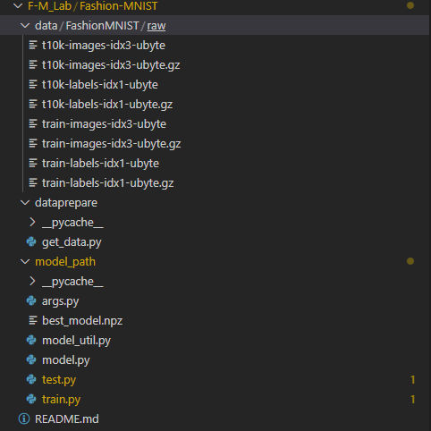

Data 目录保存下载的数据集

Dataprepare 数据集处理

Model_path 目录下包含模型（库）、训练、测试和参数文件

二．代码介绍

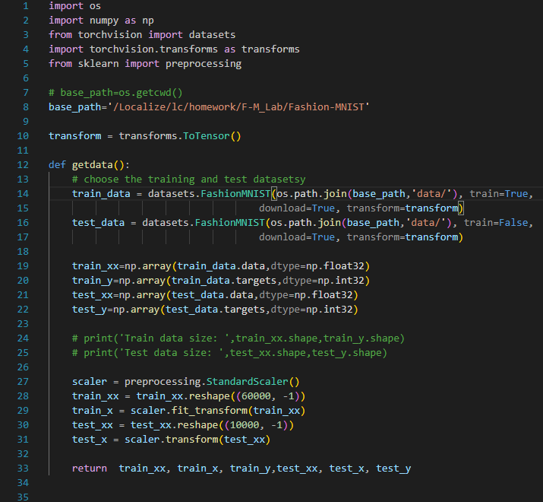

数据处理返回训练集测试集数据

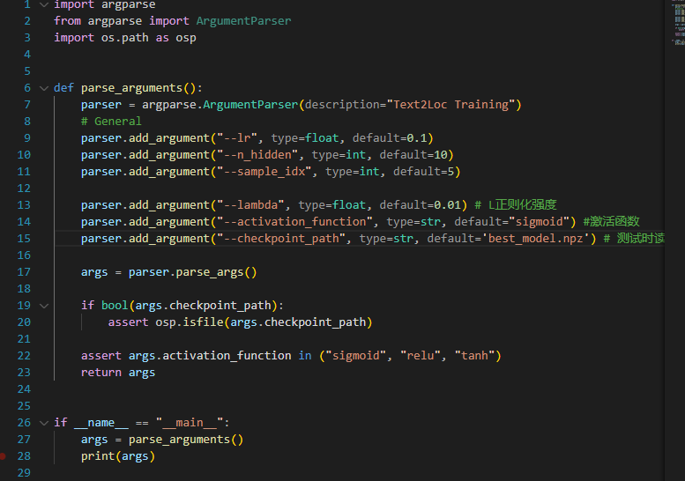

设置超参数用于训练测试

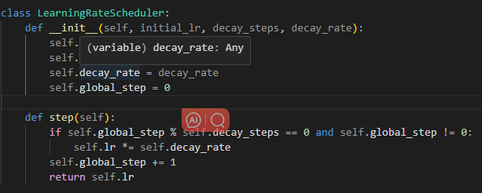

学习率下降函数

class NeuralNet():

    """只有一层隐藏的MLP"""

    def __init__(self,input_size,hidden_size,output_size):

        self.W_h=np.random.uniform(size=(input_size,hidden_size),high=0.01,low=-0.01)

        self.b_h=np.zeros(hidden_size)

        self.W_o = np.random.uniform(size=(hidden_size, output_size), high=0.01, low=-0.01)

        self.b_o = np.zeros(output_size)

        self.output_size = output_size

    def forward(self,X,keep_activations=False):

        z_h=np.dot(X,self.W_h)+self.b_h

        h = sigmoid(z_h)  #激活函数

        z_o = np.dot(h, self.W_o) + self.b_o

        y = softmax(z_o)

        if keep_activations:

            return y, h, z_h

        else:

            return y

    def loss(self, X, y):

        return nll(one_hot(self.output_size, y), self.forward(X))

    def grad_loss(self, x, y_true):    #反向传播设计

        y, h, z_h = self.forward(x, keep_activations=True)

        grad_z_o = y - one_hot(self.output_size, y_true)

        grad_W_o = np.outer(h, grad_z_o)

        grad_b_o = grad_z_o

        grad_h = np.dot(grad_z_o, np.transpose(self.W_o))

        grad_z_h = grad_h * dsigmoid(z_h)

        grad_W_h = np.outer(x, grad_z_h)

        grad_b_h = grad_z_h

        grads = {"W_h": grad_W_h, "b_h": grad_b_h,

                 "W_o": grad_W_o, "b_o": grad_b_o}

        return grads

    def train(self, x, y, learning_rate):    #SGD优化器

        grads = self.grad_loss(x, y)

        self.W_h = self.W_h - learning_rate * grads["W_h"]

        self.b_h = self.b_h - learning_rate * grads["b_h"]

        self.W_o = self.W_o - learning_rate * grads["W_o"]

        self.b_o = self.b_o - learning_rate * grads["b_o"]

    def predict(self, X):

        if len(X.shape) == 1:

            return np.argmax(self.forward(X))

        else:

            return np.argmax(self.forward(X), axis=1)

    def accuracy(self, X, y):

        y_preds = np.argmax(self.forward(X), axis=1)

        return np.mean(y_preds == y)

    def save_weights(self, file_name):

        np.savez(file_name, W1=self.W_h, B1 =self.b_h,W2=self.W_o, B2 =self.b_o)

    def load_weights(self, file_name):

        data = np.load(file_name)

        self.W_h=data['W1']

        self.b_h=data['B1']

        self.W_o = data['W2']

        self.b_o = data['B2']

    def get_weights(self,file_name):

        data = np.load(file_name)

        print('W_h:',data['W1'])

        print('b_h:',data['B1'])

        print('W_o:',data['W2'])

        print('b_o:',data['B2'])

        return data['W1'],data['B1'],data['W2'],data['B2']

模型以及功能代码

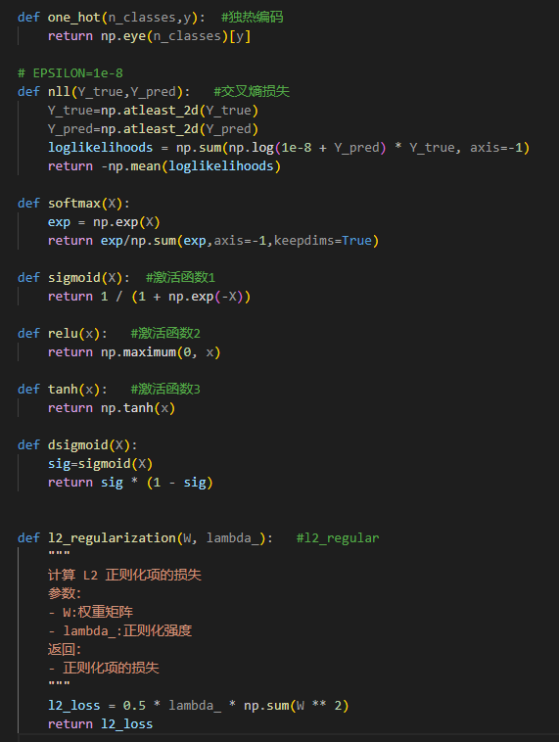

激活函数，交叉熵损失，L2正则化

def plot_prediction(model, sample_idx=0, classes=range(10)):

    fig, (ax0, ax1) = plt.subplots(nrows=1, ncols=2, figsize=(10, 4))

    ax0.imshow(test_xx[sample_idx].reshape(28,28))   #28*28图片

    ax0.set_title("True image label: %d" % test_y[sample_idx]); #标签

    ax1.bar(classes, one_hot(len(classes), test_y[sample_idx]), label='true')

    ax1.bar(classes, model.forward(test_x[sample_idx]), label='prediction', color="red")

    ax1.set_xticks(classes)

    prediction = model.predict(test_x[sample_idx])

    ax1.set_title('Output probabilities (prediction: %d)'

                  % prediction)

    ax1.set_xlabel('Digit class')

    ax1.legend()

    plt.show()

图片可视化以及预测结果可视化函数

def eval():

    n_features = train_x.shape[1]

    n_classes = len(np.unique(train_y))

    model = NeuralNet(n_features, n_hidden, n_classes)

    model.load_weights(checkpoint_file) # 读取模型的权重

    W1, b1, W2, b2 =model.get_weights(checkpoint_file)  #权重参数可视化(参数查找)

    print('TEST Accuracy:',model.accuracy(test_x, test_y))  #测试结果

    if sample_idx is not None:

        plot_prediction(model, sample_idx=sample_idx)

    # 可视化权重矩阵的直方图

    plt.figure(figsize=(10, 10))

    plt.subplot(2, 2, 1)

    plt.hist(W1.flatten(), bins=50)

    plt.title('Layer 1 Weights Histogram')

    plt.xlabel('Weight Value')

    plt.ylabel('Frequency')

    plt.subplot(2, 2, 2)

    plt.hist(b1.flatten(), bins=50)

    plt.title('Layer 1 bias Histogram')

    plt.xlabel('Weight Value')

    plt.ylabel('Frequency')

    plt.subplot(2, 2, 3)

    plt.hist(W2.flatten(), bins=50)

    plt.title('Layer 2 Weights Histogram')

    plt.xlabel('Weight Value')

    plt.ylabel('Frequency')

    plt.subplot(2, 2, 4)

    plt.hist(b2.flatten(), bins=50)

    plt.title('Layer 2 bias Histogram')

    plt.xlabel('Weight Value')

    plt.ylabel('Frequency')

    plt.tight_layout()

    plt.show()

测试函数，权重数据可视化

def train():

    print("Evaluation of the untrained model:")

    n_features = train_x.shape[1]

    n_classes = len(np.unique(train_y))

    model = NeuralNet(n_features, n_hidden, n_classes)

    model.loss(train_x, train_y)

    model.accuracy(train_x, train_y)

    losses, accuracies, accuracies_test = [], [], []

    losses.append(model.loss(train_x, train_y))

    accuracies.append(model.accuracy(train_x, train_y))

    accuracies_test.append(model.accuracy(test_x, test_y))

    print("Random init: train loss: %0.5f, train acc: %0.3f, test acc: %0.3f"

        % (losses[-1], accuracies[-1], accuracies_test[-1]))

    best_acc= 0

    lr_scheduler = LearningRateScheduler(initial_lr=learning_rate, decay_steps=20, decay_rate=0.8)

    for epoch in range(10):

        # 计算测试集准确率

        test_acc = model.accuracy(test_x, test_y)

        # print(f"Epoch #{epoch + 1}, Test Accuracy: {test_acc}")

        for step in range(2):

            lr = lr_scheduler.step()

            for i, (x, y) in enumerate(zip(train_x, train_y)):

                model.train(x, y, lr)

            # print(f"Epoch {epoch + 1}, Step {step + 1}, Learning Rate: {lr}")

            # 保存最佳模型

            if test_acc > best_acc:

                best_acc = test_acc

                if os.path.exists(checkpoint_file):

                    os.remove(checkpoint_file)

                model.save_weights(checkpoint_file)

        # 记录训练损失和准确率

        losses.append(model.loss(train_x, train_y))

        accuracies.append(model.accuracy(train_x, train_y))

        # accuracies_test.append(test_acc)

        accuracies_test.append(model.accuracy(test_x, test_y))

        print("Epoch #%d, train loss: %0.5f, train acc: %0.3f, test acc: %0.3f"

            % (epoch + 1, losses[-1], accuracies[-1],accuracies_test[-1]))

    plt.figure(figsize=(10, 5))

    plt.subplot(1, 2, 1)

    plt.plot(losses)

    plt.title("Training loss");

    plt.subplot(1, 2, 2)

    plt.plot(accuracies, label='train')

    plt.plot(accuracies_test, label='test')

    plt.ylim(0, 1.1)

    plt.ylabel("accuracy")

    plt.legend(loc='best');

    plt.show()

    if sample_idx is not None:

        plot_prediction(model, sample_idx=sample_idx)

训练函数，loss 以及acc 输出以及可视化

1. 实验

参考readme文件

1. 结果

训练

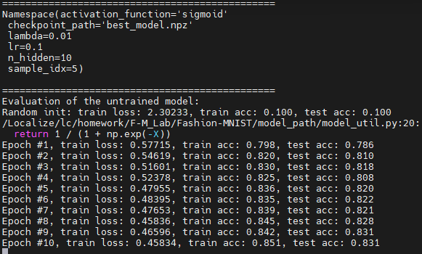

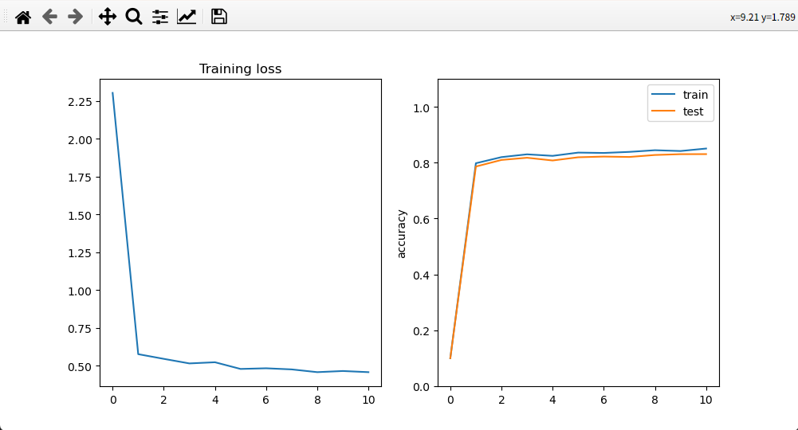

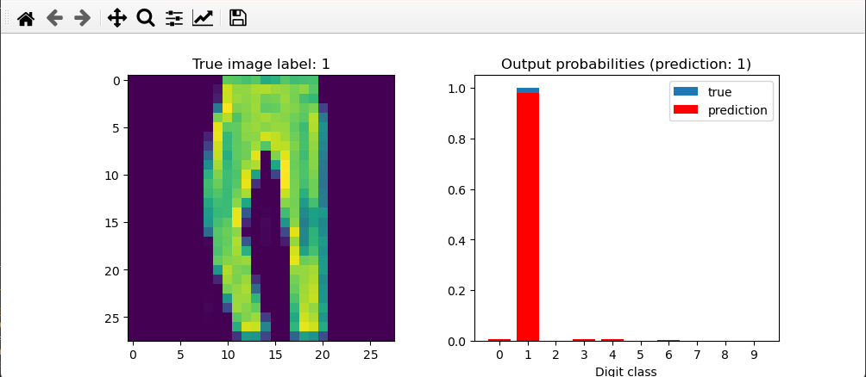

测试

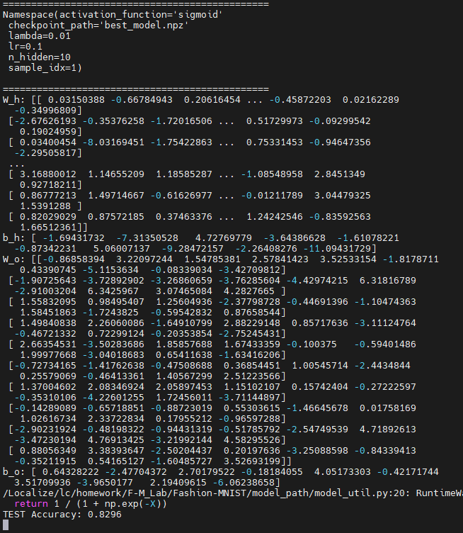

预测

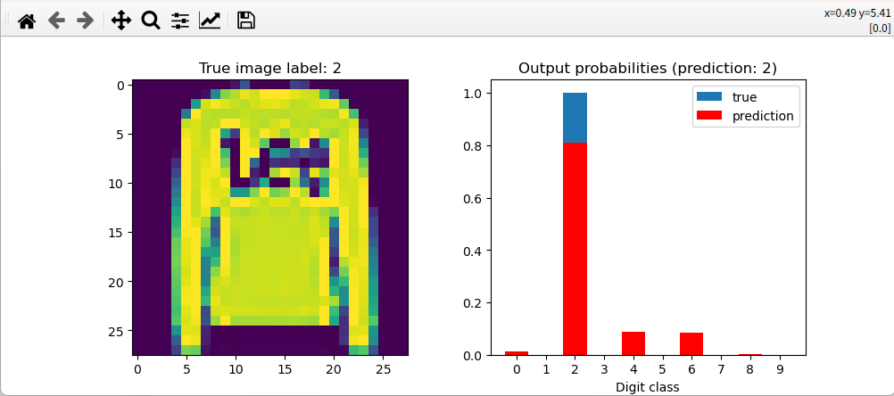

权重可视化

