Abolishing Elected District Councils in Vietnam
Project Memo: Research Question, Data, and Descriptive Statistics
Landon Worrich · lworrich@tamu.edu · POLS 209, Fall 2026

1. Research question
My Main Question is whether, in 2010, communes in districts that had their elected council abolished had a different number of basic infrastructure services than communes in districts that kept their council. In 2009 Vietnam ran a pilot where it got rid of the elected District People’s Councils in some districts. This let the central and provincial government run those districts more directly, and I want to know if that showed up in what the communes actually got.
X is treated_district (1 if the commune’s district lost its council, 0 if it kept it). Y is infrastructure_index, a count from 0 to 5 of how many basic services the commune has. Because X is binary, this mostly comes down to comparing two group averages.
I expect communes in abolition districts to have a little fewer services, around 0.25 fewer per commune. Council members live in the district and know which villages need a road fixed or a new market, and they can push for that when the district budget gets decided. Once the council is gone, the people making those calls answer to the province, and my guess is they lean toward bigger, more visible projects over small rural communes.
I’m not very confident in this, though. Vietnam is a one-party state, and the councils may not have had much real power to begin with. Malesky, Nguyen and Tran (2014) also point out that councils can turn into veto points for local elites, so removing them might actually speed things up. That’s part of why I went with a small number, and I would honestly not be surprised if it came out close to zero.
I’d call anything under about 0.1 services small. With only 272 treated communes and an SD of about 1.09, a gap that size could easily come from noise alone (the standard error of the difference is roughly 0.07). A gap of 0.5 or more would be large, since that’s about half an SD on an index that only goes up to 5. My 0.25 guess sits in between.
2. Data and measures
The data come from the commune module of the Vietnam Household Living Standards Survey (VHLSS), which Malesky, Nguyen and Tran (2014) use in their APSR article. Per the codebook, analysis.csv covers rural communes in 58 provinces across two survey rounds, 2008 (2,081 communes) and 2010 (2,045 communes). It leaves out the five Central Highlands provinces and any records missing household density. The 2009 pilot abolished the councils in selected districts in 10 of the 58 provinces.
Each row is one commune in one survey year. There’s no ID linking the same commune across 2008 and 2010, so the file is a repeated cross-section rather than a panel. I treat every row as its own observation and don’t try to follow communes over time.
The full file has 4,126 rows across both waves. My question is only about 2010, so I kept that wave, which gives 2,045 rows. X and Y have no missing values in 2010, so nothing else got dropped, and my final sample is 2,045 communes.
X (treated_district): 1 if the commune’s district lost its elected council in the 2009 pilot, 0 if it kept it.
Y (infrastructure_index): how many of five basic services the commune has, from 0 to 5. The five are a village road usable all year (year_round_road), any village road (village_road), public transport (public_transport), tap water as the main water source (tap_water), and a government socioeconomic-development and infrastructure project (socioeconomic_infrastructure_project). Each is coded 0/1 and Y is just the sum. I left both X and Y on their original scales.
To describe the communes I used three other variables:
• households_in_commune: registered households in the commune, as a rough measure of size.
• distance_to_nearest_town_km: kilometers to the nearest town. Remote communes are probably harder and more expensive to build services in.
• program_135_commune: 1 if the commune is in Program 135, the government’s program for especially poor and disadvantaged communes. I used this instead of poverty_rate because the codebook says 2010 poverty was measured after abolition, so it could be picked up by the treatment itself.
Most communes are fairly big and somewhat rural. The average one has about 2,129 households (median 1,966) and sits about 11.7 km from a town (median 8 km). Around 19.5% are Program 135 communes, and 13.3% are in districts that lost their council.
3. Descriptive statistics and distributions
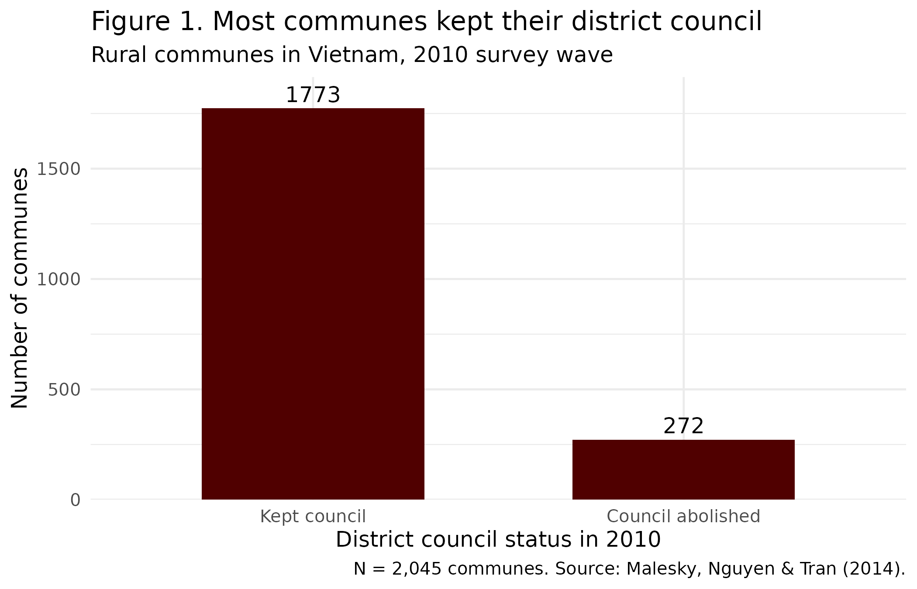
Figure 1 shows how lopsided X is. Only 272 of the 2,045 communes (13.3%) are in abolition districts, against 1,773 that kept their council. With that few treated communes, the treated average is going to be noisier than the comparison average.
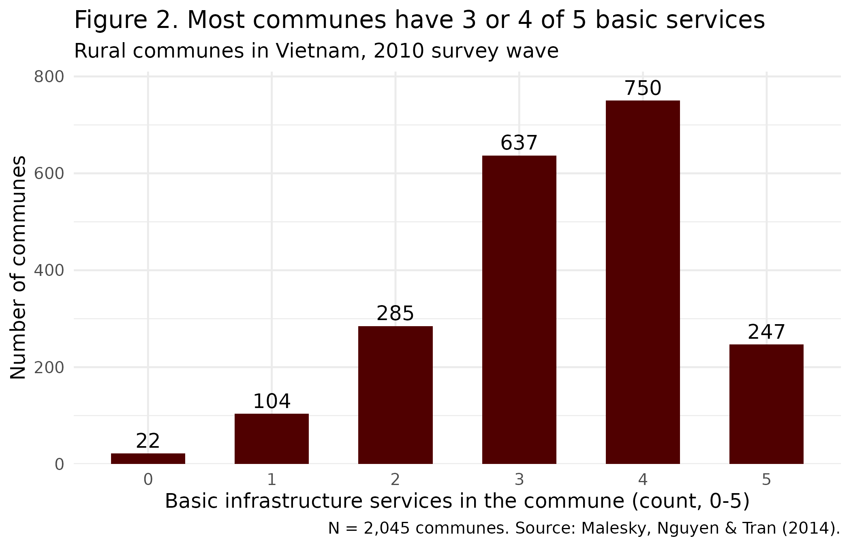
Figure 2 shows that Y is bunched in the middle and upper part of its range. About 68% of communes have 3 or 4 of the 5 services, and only a few have 0 or 1. The mean is 3.34, the median is 3, and the SD is 1.09. There’s also a ceiling: about 12% of communes already have all 5, so if abolition helped, those communes couldn’t show it.
Table 1. Summary statistics, retained sample (2,045 rural communes, 2010)
Variable | N | Mean | SD | % observed
In council-abolition district (X; 1 = yes) | 2,045 | 0.133 | 0.340 | 100%
Basic infrastructure services (Y; count, 0-5) | 2,045 | 3.335 | 1.085 | 100%
Households in commune (count) | 2,045 | 2,128.8 | 1,457.6 | 100%
Distance to nearest town (km) | 2,045 | 11.67 | 12.86 | 100%
Program 135 commune (1 = yes) | 2,045 | 0.195 | 0.396 | 100%
Note: N counts recorded values. % observed = N / 2,045 x 100. For a 0/1 variable the mean is the share coded 1. Source: Malesky, Nguyen & Tran (2014).
Table 2. Percentiles, retained sample (2,045 rural communes, 2010)
Variable | Min | P1 | P10 | P25 | P50 | P75 | P90 | P99 | Max
In council-abolition district (X; 1 = yes) | 0 | 0 | 0 | 0 | 0 | 0 | 1 | 1 | 1
Basic infrastructure services (Y; count, 0-5) | 0 | 0 | 2 | 3 | 3 | 4 | 5 | 5 | 5
Households in commune (count) | 155 | 336 | 755 | 1,295 | 1,966 | 2,743 | 3,539 | 5,362 | 43,583
Distance to nearest town (km) | 0 | 0 | 0.64 | 4 | 8 | 15 | 25 | 60.6 | 160
Program 135 commune (1 = yes) | 0 | 0 | 0 | 0 | 0 | 0 | 1 | 1 | 1
Note: P1 is the 1st percentile, P50 the median, and so on. Source: Malesky, Nguyen & Tran (2014).
Households and distance both have long right tails. The median commune has 1,966 households but the biggest has 43,583, which is why the mean (2,129) is above the median. Distance looks similar: a median of 8 km, but 60.6 km at the 99th percentile and 160 km at the max. A handful of very large or very remote communes pull the means up, so the medians give a better sense of a typical commune.
My predicted drop of 0.25 services works out to about 0.23 SD. The actual raw gap went the other way. Abolition communes average 3.39 services and communes that kept their council average 3.33, so the treated group is ahead by 0.06. That’s small by my cutoff, and it’s the opposite sign from what I predicted.
This doesn’t settle it. The pilot districts weren’t picked at random, so they could have been different before 2009 too. The article deals with that by comparing changes from before to after the reform (difference-in-differences) instead of looking at one year. For now, though, the 2010 numbers don’t support my prediction of a modest drop. If anything they point to no effect or a tiny positive one, and I’ll need the 2008 data to see if that holds up.

