POLS 209 · Fall 2026

Homework 3 Answer Sheet
20 points: lab record 5 (including 1 for your R script), write-up 15
Name
Email
Friday-section TA

Lab: Friday, October 30 · Use HW3_Lab.html. Type in the spaces provided; they expand as you write.

What to submit
Submit two files on Canvas by Thursday, November 5, at 11:59 PM Central: your answer sheet (HW3_Answer_Sheet.docx, as Word or PDF) and your R script (pols209_hw3.R). A missing script costs one point.

Lab record
Record these as you work through the page.

Line 1 Your chart with its line
Use block 3C. Paste texas_line.png here, with your own title, subtitle, and axis labels. (Posit Cloud: in the Files pane, tick texas_line.png and choose More → Export; then insert the downloaded picture here.)
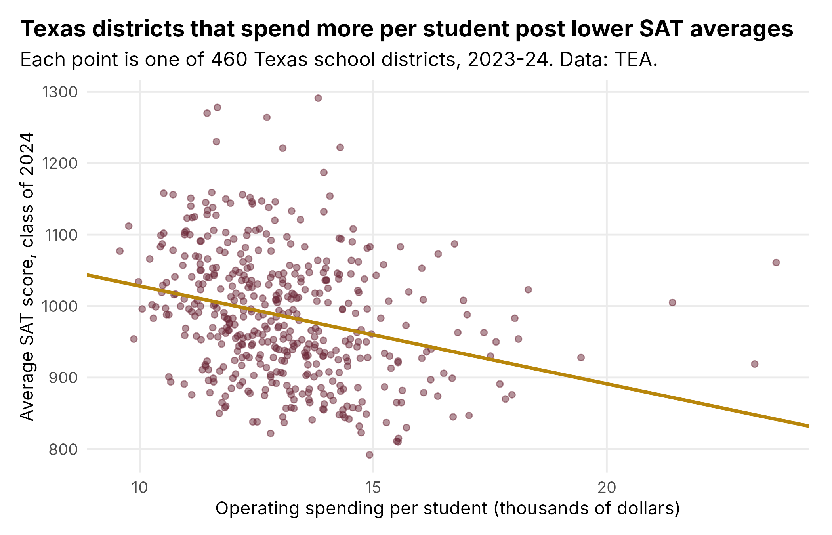

Line 2 Your district
Use block 4B. Record the district you chose and the numbers in its row: spend as the file shows it (in thousands of dollars), sat, and pred and resid to one decimal place.
District | spend | sat | pred | resid
College Station ISD | 11.84 | 1150 | 1002.9 | 147.1

Write-up
Answer each lettered part separately; short answers are fine. Report SAT points to one decimal place and spending in dollars per student.

1. What the OLS estimates mean
In block 3, you fit Mr. Fenske’s line, the OLS line that predicts a district’s SAT average from its operating spending per student. The Representative wants a one-sentence explanation of what the line’s slope means, to give at the next hearing. Since she stops anyone who gives her a statistic without clear and coherent units, the sentence had better have them.
a. Write that sentence for her. It should compare two districts whose operating spending differs by $1,000 per student and say how many SAT points higher or lower the line’s predicted SAT average is for the district that spends more.
Comparing two Texas districts whose operating spending differs by $1,000 per student, the OLS line predicts an SAT average 13.7 points lower for the district that spends more.

b. Whether the slope is big depends on how big a difference $1,000 per student is between Texas districts.
1. Choose either one standard deviation of spending or the difference between the 25th and 75th percentiles of spending, and report it in dollars per student. Both come from block 1, in the units of spend, operating spending per student in thousands of dollars.
2. For two districts whose spending differs by that amount, how many SAT points higher or lower is the line’s predicted SAT average for the district that spends more? Use the difference in thousands of dollars, since the slope is per $1,000.
1. One standard deviation of spending is 1.816 thousand dollars, or $1,816 per student.
2. −13.68 × 1.816 = −24.8. For two districts whose spending differs by $1,816 per student, the line's predicted SAT average is 24.8 points lower for the district that spends more.

2. A hypothesis test and a 95% confidence interval for the true slope
A superintendent who testified at the last hearing told the Representative that a downward slope as steep as Mr. Fenske’s could easily turn up by chance.
a. Check the superintendent’s claim with a test of a null hypothesis about the true slope. In block 5A, R printed the test’s t-statistic (R labels it t value, and lecture and K&W call it the t-ratio), its p-value, and three stars beside the slope.
1. State that null hypothesis.
2. Report the t-statistic and say what it measures, in terms of the OLS slope estimate and its standard error.
3. Report the p-value and say what it means.
4. Using the t-statistic or the p-value (the two give the same evidence about the null hypothesis, in different terms), say whether the results provide evidence against the superintendent’s claim.
1. Null hypothesis: the true slope is 0. On the true line, the expected SAT average does not differ with spending per student.
2. t = −6.26. It is the OLS slope estimate divided by its standard error (−13.681 / 2.184): the estimate sits 6.26 standard errors below 0, the value the null hypothesis says.
3. p = 8.69e-10 = 0.000000000869. If the true slope were 0, the chance of getting an OLS slope at least as far from 0 as −13.68 (in either direction) would be less than one in a billion.
4. Yes. The t-statistic of −6.26 is far beyond the critical value of about ±1.97, and the p-value is far below 0.05 (and 0.001, hence the three stars). A slope this steep would almost never turn up by chance if the true slope were 0, so the results are strong evidence against the superintendent's claim. (This only rules out chance; it does not say the spending causes the lower scores.)

b. The Representative’s next question is about the two districts you compared in question 1(b). On the true line, how much lower could the expected SAT average of the district that spends more plausibly be? Just as the OLS slope estimates the true slope, the difference in the OLS line’s predicted SAT averages that you found in question 1(b) estimates the difference between the two districts’ expected SAT averages on the true line. As lecture did on the slide “Two Nominees One SD Apart (Redux),” you can find a 95% confidence interval for that difference from the slope’s 95% confidence interval, which ran from −17.97 to −9.39 SAT points per $1,000 (block 5C):
Lower end for the difference = (lower end of the slope’s 95% confidence interval) × (spending difference)
Upper end for the difference = (upper end of the slope’s 95% confidence interval) × (spending difference)
1. Compute both ends, using the spending difference you chose in question 1(b) in thousands of dollars.
2. Answer the Representative’s question in a sentence, with units.
1. Lower end = −17.97 × 1.816 = −32.6 SAT points. Upper end = −9.39 × 1.816 = −17.0 SAT points.
2. On the true line, the expected SAT average of the district that spends $1,816 more per student is plausibly between 17.0 and 32.6 SAT points lower (95% confidence interval).

3. How well does the OLS line fit?
Ms. Oyervides, the Representative’s chief of staff, wants to know how well the OLS line predicts a district’s SAT average.
a. The R-squared from the regression model (i.e. the line) is 0.079 (block 6B).
1. Say what this R-squared measures for the 460 districts.
2. If you ignored spending and predicted the mean SAT average, 985.6, for every district, you would miss a typical district by approximately the standard deviation of SAT averages, 88.4 points (block 1). The OLS line misses a typical district by its root mean-squared error, 85.0 points (block 6B). Compare 88.4 and 85.0 to explain why R-squared is so small. An explanation in words is enough.
1. The line on spending accounts for 7.9% of the total variation (TSS) in SAT averages across the 460 districts; the other 92.1% is left over in the residuals.
2. Using the line instead of the flat line cuts the typical miss only from 88.4 to 85.0 SAT points, about 3.4 points (4%). Because knowing a district's spending barely improves the prediction, almost all of the variation in SAT averages is still there in the residuals, so R-squared is small. (In squared terms, 85.0² / 88.4² ≈ 0.92, so 1 − 0.92 ≈ 0.08.)

b. The Representative is speaking in Austin next week. She tries out a talking point on Ms. Oyervides: “Our line predicts an SAT average of 970 for Austin ISD. Our slope’s standard error is only 2.18, so Austin’s SAT average must be within a few points of 970.” Ms. Oyervides reaches for her list of things the Representative must never say. Austin ISD’s actual SAT average is 1,046.
1. Say what the slope’s standard error, 2.18 SAT points per $1,000, describes.
2. Say what the root mean-squared error, 85.0 SAT points, describes.
3. Which of these two numbers should she have used to judge how close to 970 Austin’s actual SAT average would be? Use that number to explain what is wrong with her talking point.
1. The slope's standard error, 2.18 SAT points per $1,000, describes how precisely the slope is estimated: about how far the OLS slope would typically fall from the true slope if the random parts of the districts' SAT averages had come out differently. It is about the line, not about any one district.
2. The root mean-squared error, 85.0 SAT points, describes the typical size of a residual: about how far a district's actual SAT average sits above or below the line's predicted SAT average.
3. She should have used the root mean-squared error. A typical district's SAT average is about 85.0 points away from the line, so Austin ISD's could easily be 85 or more points above or below 970. A small standard error means the line is pinned down well, not that every district sits close to it. In fact, Austin's actual SAT average, 1,046, is 76 points above 970, a fairly typical miss.

4. How well does a straight line capture how SAT averages differ with spending?
At the last hearing, a committee member asked Mr. Fenske whether he had ever tried fitting anything other than a straight line. Mr. Fenske said a straight line had been good enough since 2013. A straight line says that the average SAT score at each level of spending drops by the same amount for every extra $1,000, whether districts spend $10,000 or $20,000 per student. The Representative wants to know how closely the average SAT score follows the OLS line as spending rises. Use the plot and the table from block 7’s binscatter, which sorted the 460 districts by spending into 20 groups of 23.
a. Compare the group averages with the OLS line, using the plot and the table’s gap column. A group’s gap is the average of its districts’ SAT averages (avg_sat) minus the line’s prediction at the group’s average spending, so gap is positive when the group’s average sits above the line.
1. Describe where the group averages sit above or below the line, from the lowest-spending group to the highest. Give the overall pattern (for example, where the gaps are mostly positive and where they are mostly negative), not every group’s gap.
2. Say how well the straight line follows the group averages as spending rises.
1. The four lowest-spending groups (about $10,000 to $11,600 per student) all sit above the line (gaps of +9.6 to +26.8). Across the middle groups (about $11,600 to $15,200), the gaps go back and forth, mostly small and negative (for example −7.7, −19.4, −15.1, and −45.0 for group 14) with a few positive ones (+21.0, +17.2, +16.7, +13.8). Group 19 (about $15,300 to $16,200) sits well below the line (−31.5), and the highest-spending group (about $16,400 to $23,600) sits well above it (+31.8).
2. Over most of the range, the straight line follows the group averages fairly closely: they drift down about as the line does, and a typical group average sits within about 20 points of it. At the ends it fits less well. It predicts too low for the lowest spenders, and the group averages stop falling at the highest spending (group 20's average of 949.7 is higher than group 19's 918.5), while the line keeps going down. So the drop does not look the same for every extra $1,000; it flattens out among the biggest spenders.

b. Lecture gave two reasons a line can fit poorly:
• At each value of X, Y can have a large variance around its average.
• The average of Y can curve across X in a way no straight line can follow.
Which reason seems to explain more of the line’s poor fit in question 3? Compare how far districts sit from their own group’s average (the sd_in_group column, the standard deviation of the SAT averages of the 23 districts in each group) with how far the group averages sit from the line (the gap column). A rough comparison of their typical sizes is enough.
The first reason explains much more. The sd_in_group column runs from about 54 to 119 SAT points and is typically about 80 points, so districts sit far from their own group's average. The gaps are typically about 17 to 20 points (largest 45). Districts are about four times farther from their group's average than the group averages are from the line. Most of the poor fit comes from the large variation in SAT averages among districts with about the same spending, not from curvature that a straight line cannot follow.

5. Could something other than spending explain why the OLS line slopes down?
The Representative wants to know what sets the eight districts farthest below the OLS line apart from the rest, and what sets apart the eight farthest above it. She also wants to know whether any of the traits that set them apart could have produced a downward slope like Mr. Fenske’s even if spending had no effect on SAT averages.
Two facts about Texas school districts will help you answer her:
1. Texas’s school-finance formula gives a district extra money for each student who is eligible for free or reduced-price lunch.
2. Where few of a district’s graduates take the SAT, most of those who take it sign up on their own, often on top of the ACT. Students who choose to take a second admissions test tend to be strong students applying to selective colleges. Ms. Oyervides went to high school in a district where every senior took the ACT and only six also took the SAT, all of them applying to colleges out of state. So her district’s SAT average described those six students, not her senior class.
a. Compare those 16 districts with a typical district, using two of the columns in block 8A’s tables. pct_disadv is the low-income share, the percent of students eligible for free or reduced-price lunch or other public assistance. pct_sat is SAT participation, the percent of graduates who took the SAT. Use the medians you printed in block 8A to think about what a “typical district” looks like.
1. How do the eight districts farthest below the line differ from a typical district?
2. Four of the eight farthest above the line differ from a typical district in one way, and the other four in another. How does each group of four differ from a typical district?
1. All eight districts farthest below the line have much larger low-income shares than a typical district (70.5% to 94.4%, against a median of 62.75%). They also have higher SAT participation (71.3% to 93.8%, against a median of 63.9%), so most of their graduates take the SAT, not just the strongest students.
2. Coppell, Carroll, Eanes, and Highland Park have very small low-income shares (0.4% to 9.9%, against the median of 62.75%). Karnes City, Pleasant Grove, Mount Vernon, and Carthage have very low SAT participation (3.2% to 12.0%, against the median of 63.9%), with low-income shares near or below typical (39.0% to 64.0%). Their SAT averages describe a few self-selected students, likely strong ones applying to selective colleges, not their whole graduating classes.

b. Fill in the table below. Each row compares two districts one standard deviation apart on that row’s variable. For the district with the larger value, how much higher (+) or lower (−) are its predicted spending per student and its predicted SAT average? Use the slopes of the four OLS lines you fit in block 8B and the two standard deviations you printed there. Those lines predict spending per student (spend) from each of the two variables, and the SAT average (sat) from each. As you did in question 1(b):
Predicted difference = (slope) × (one standard deviation of the row’s variable)
Remember that spend is in thousands of dollars.
Variable | One standard deviation of the variable (percentage points) | Difference in predicted spending (dollars per student) | Difference in predicted SAT average (SAT points)
Low-income share (pct_disadv) | 20.3 | +$872 | −54.1
SAT participation (pct_sat) | 29.9 | −$313 | −38.8

c. Which of the two variables, the low-income share or SAT participation, could explain the negative relationship between spending and SAT averages even if spending had no effect on SAT averages? Explain how, using the signs of its two predicted differences in your table from part (b).
Then suppose the Representative’s office wants to learn whether spending (causally) affects SAT averages. If you could control for (i.e. hold constant) one of these two variables, which would be the more important confounder to grapple with? Otherwise put, if you could compare spending and SAT averages only among districts with approximately the same value of one of these two variables, which variable would you pick, and why?
The low-income share. A district with a low-income share one standard deviation (20.3 points) higher is predicted to spend $872 more per student (+), as the school-finance formula would lead us to expect, and to have an SAT average 54.1 points lower (−). So the districts that spend more tend to be the ones with more low-income students, and these students score lower for reasons that have nothing to do with spending. That alone would make the line of SAT averages on spending slope down, even if spending had no effect on SAT averages. SAT participation cannot explain it: higher participation goes with lower spending (−$313) and lower SAT averages (−38.8). Two negative signs would make high-spending districts tend to have higher SAT averages, the opposite of the slope we see.
I would control for the low-income share. It is related to both spending and SAT averages in the direction that produces a downward slope, and its relationship with spending is much larger ($872 against $313 per standard deviation). By comparing spending and SAT averages only among districts with about the same low-income share, we can see whether districts that spend more still score lower once the funding formula's extra money for low-income students is no longer mixed in with the difference in their students.

For any variable Y, predicting its mean for every case misses a typical case by approximately its standard deviation, because the standard deviation is calculated from exactly those misses. Those misses, squared and added up, are the TSS, the total variation in Y; the OLS line’s misses, squared and added up, are the RSS. That is why R-squared, 1 − RSS/TSS, is called the share of the variation in Y that the OLS line accounts for.
Lecture made the same kind of argument in Chapter 3’s police example (the slide “Cities Hire Police When Crime Is Rising”).

