Abolishing Elected District Councils in Vietnam:
Research Question, Data, and Descriptive Statistics

Landon Worrich
lworrich@tamu.edu
Department of Political Science, Texas A&M University
POLS 209
Professor Jares
November 12, 2026

Abolishing Elected District Councils in Vietnam
1. Research Question
The main question for my project is: In 2010, did rural communes in districts whose elected council was abolished have a different number of basic infrastructure services than communes in districts that kept their council? In 2009, Vietnam tried removing the elected District People's Councils in some districts as a test, which led to the province and the national government that ran those districts more directly. I want to understand if losing the council subsequently changed how many basic services the communes in those districts had.
My X variable is treated_district, which is 1 if a commune is in a district that lost its council and 0 if the district kept it. My Y variable is infrastructure_index, which counts how many of five basic services a commune has, so it goes from 0 to 5. X only has two values, so I am just comparing two groups: The average number of services in communes that lost their council (X = 1) and in communes that kept it (X = 0).
I think communes that lost their council will have slightly fewer services, about 0.25 fewer per commune. My reasoning is that council members live in the district and they will still voice their opinions on certain matters. When the district decides how to spend its money, council members can speak up for a village that needs a road fixed or wants a market. Without the council, those choices are made by officials who work for the province instead of for the people in the commune. I think that those officials would care more about big projects that make them look good and less about small villages that would not be noticed. As a result, the communes lose some of their say but would not lose their voice entirely.
I am not very confident in my next prediction as Vietnam has only one political party, so these councils may not have had much power anyway, and taking them away might not change anything. It is also possible that cutting out a level of government will quicken the political process all together. The authors of the study point out both sides of this. He states that elected councils are supposed to make officials do their jobs, but they can also be taken over by powerful local people who block projects (Malesky et al., 2014, Introduction section). Because of all of these factors, I picked a small number, and I would not be surprised if the real difference turned out to be close to zero.
To decide what counts as a small or huge difference, I think about it in terms of whole services. A difference under 0.1 services per commune would be a small difference. While a difference of 0.5 services + would be considered a big difference, because that would be close to half of all communes losing a whole service. My guess of 0.25 is in the middle, so I would call it a medium-small effect.
2. Data and Measures
The data I am using comes from the commune part of the Vietnam Household Living Standards Survey (VHLSS), which is the same survey Malesky et al. (2014) used in their American Political Science Review article. The project file, analysis.csv, has rural communes from 58 provinces in Vietnam over two survey years, 2008 and 2010. It does not include the five Central Highlands provinces or any communes that were missing the household-density number (POLS 209, 2026). Out of these 58 provinces, 10 had their councils removed in some of their districts (Malesky et al., 2014, p. 144).
Each row in the file is one commune in one survey year. There is no way to match the same commune in 2008 and 2010, so the data is a repeated cross-section and not a panel. This means that each row counts on its own, and I am not trying to follow any commune over time.
The file starts with 4,126 rows, with 2,081 from 2008 and 2,045 from 2010. Since my question is only about 2010, I kept the 2010 rows, which left me with 2,045. After that I checked for any blanks in X and Y, and there were none, so I did not have to drop any more rows. My final sample is 2,045 communes.
For X, treated_district is 1 if the commune's district lost its elected council in 2009 and 0 if the district kept it, which is the exact change my question is asking about. For Y, infrastructure_index adds up five yes or no services: a village road that can be used all year (year_round_road), any village road (village_road), public transport (public_transport), tap water as the main water source (tap_water), and a government building project (socioeconomic_infrastructure_project). Each one is either 0 or 1, so one point on Y means the commune has one more service. I used both variables the way they came and did not change their scale.
I also picked three other variables to help describe the communes:
• households_in_commune is the number of registered households in the commune, which tells me how big each commune is.
• distance_to_nearest_town_km is how far the commune is from the nearest town in kilometers. I chose this because it shows how out of the way a commune is, and I think being far away would make services harder and more expensive to build.
• program_135_commune is 1 if the commune is in Program 135, which is the government's program for very poor communes, and 0 if it is not. I used this instead of the poverty rate to show which communes are poor. The codebook says the 2010 poverty rate was measured after the councils were removed, so the change itself could have affected it.
Overall, the typical commune in my sample is pretty big and a little far from town. The average commune has about 2,129 households (the median is 1,966) and is about 11.7 km from the nearest town (the median is 8 km). About 19.5% of the communes are Program 135 communes, and 13.3% are in districts that lost their council.
3. Descriptive Statistics and Distributions
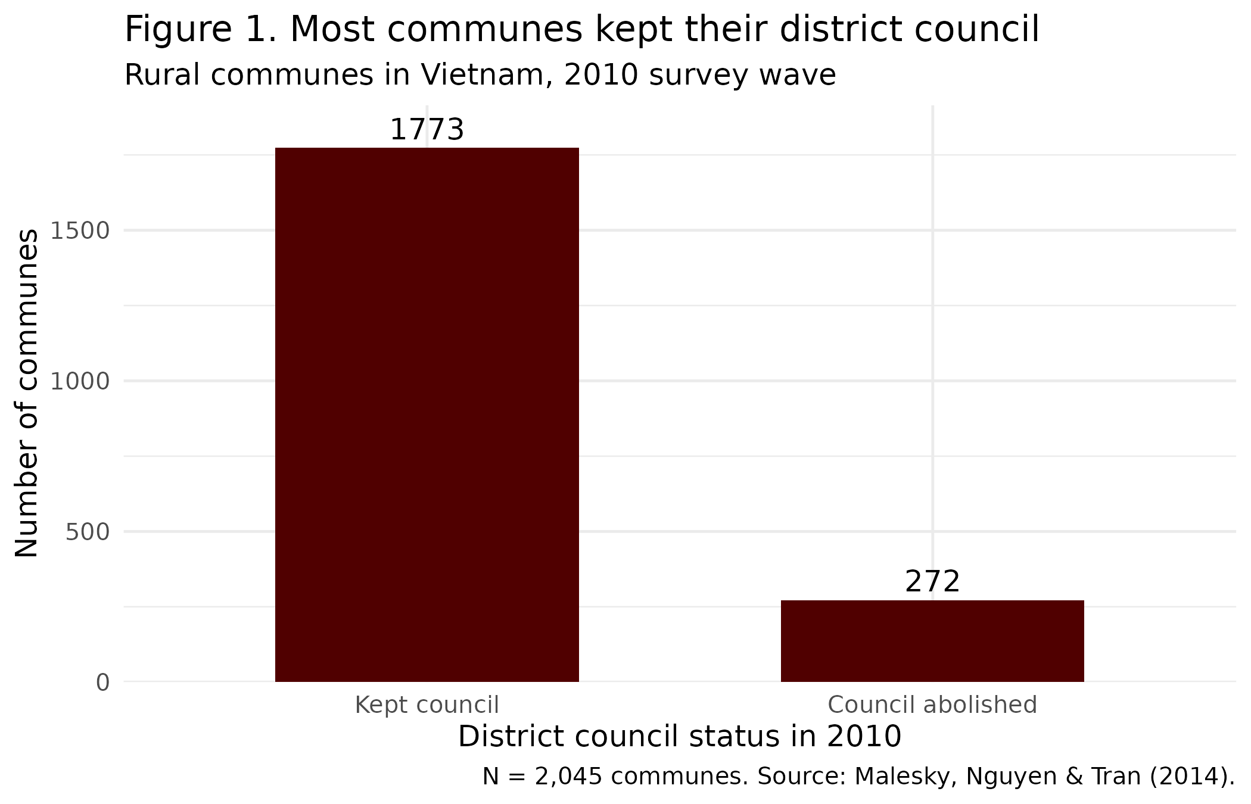
Figure 1 shows that the two groups are very different in size. Only 272 of the 2,045 communes (13.3%) are in districts that lost their council, while 1,773 are in districts that kept it. Since the group that lost its council is so small, its average is based on a lot fewer communes, which means it will be less exact than the other group's average.
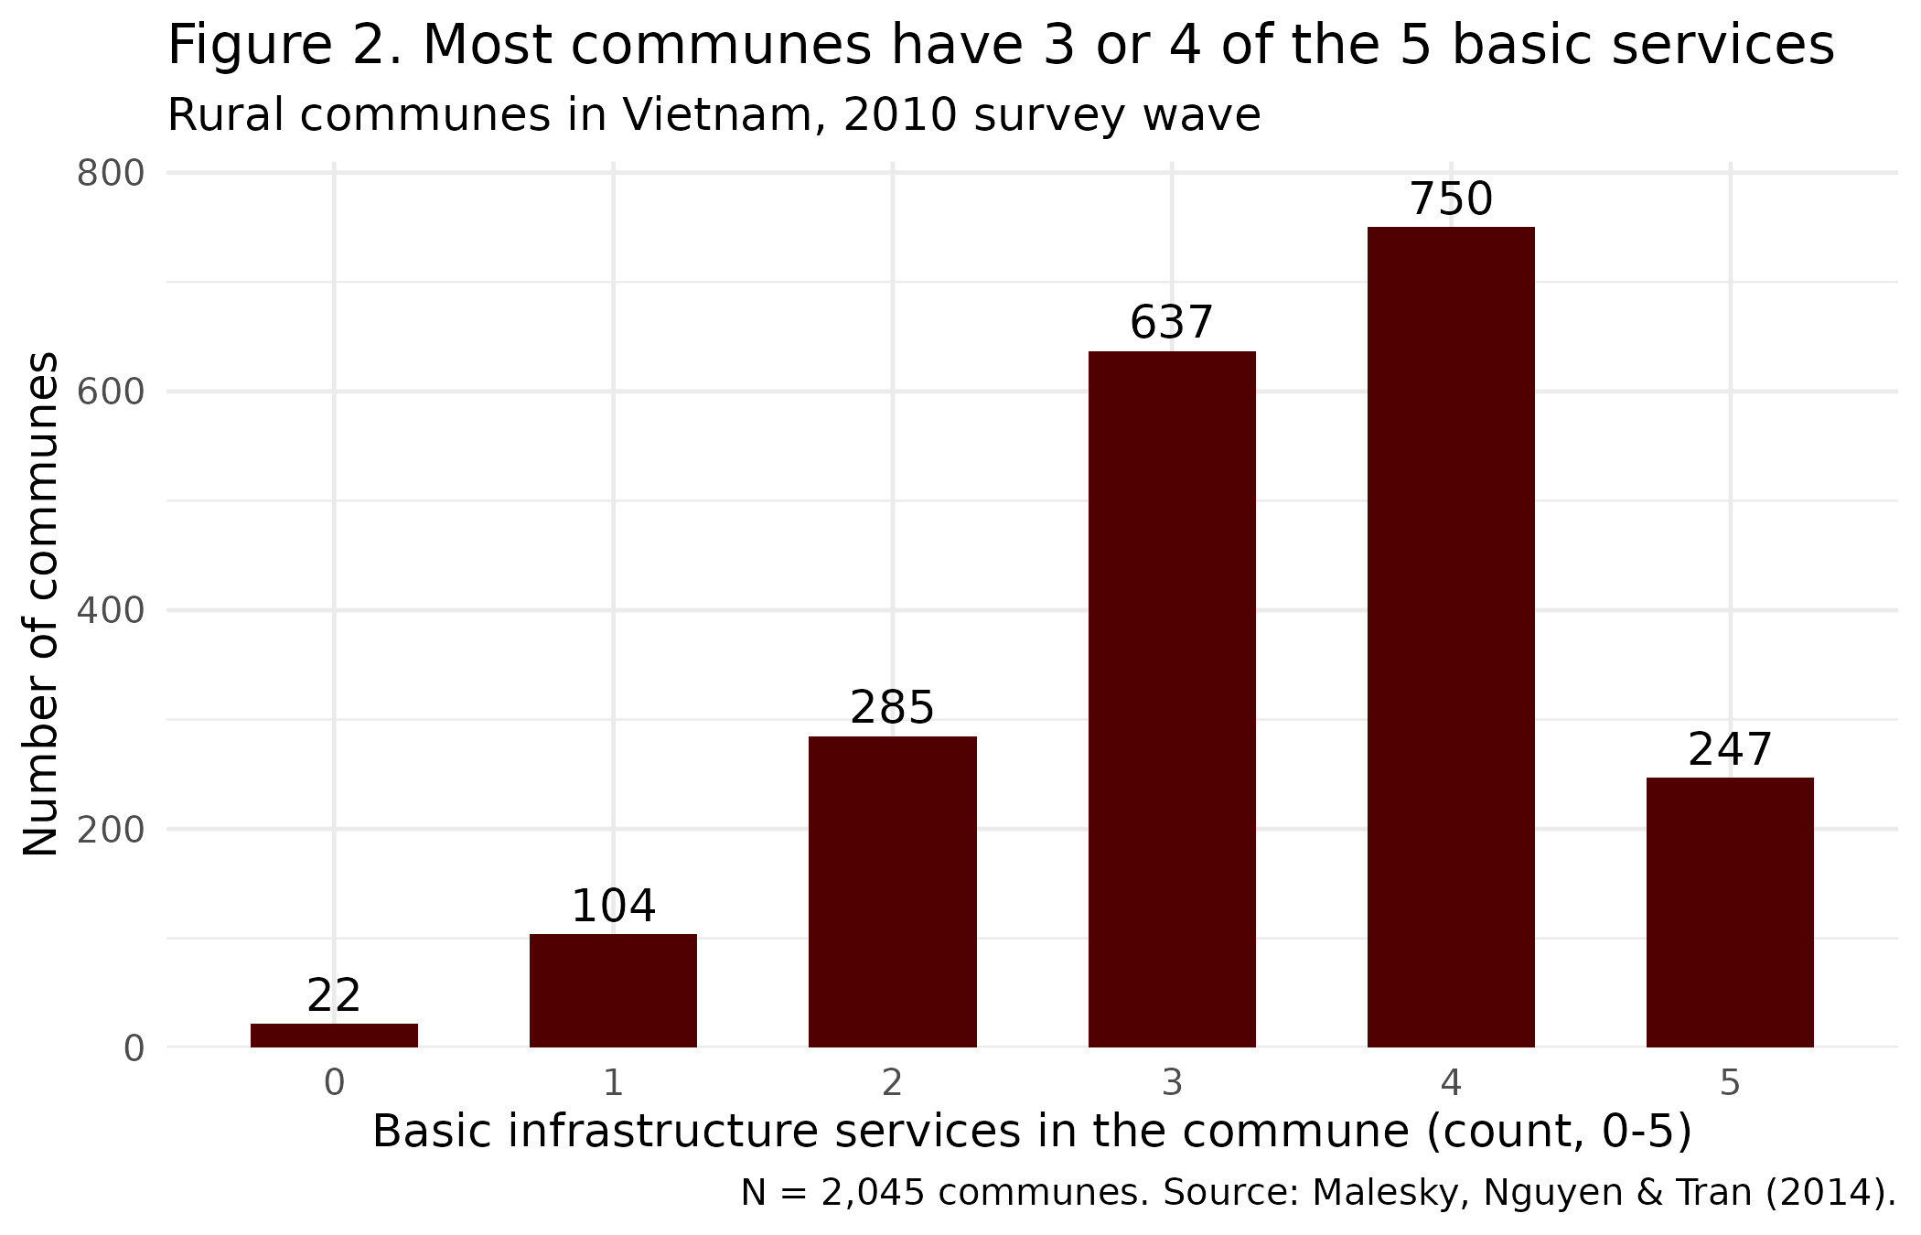
Figure 2 shows that most communes already have a good number of services. About 68% have 3 or 4 of the 5, and only about 6% have 0 or 1. The mean is 3.34, the median is 3, and the standard deviation is 1.09. Table 2 also shows that the middle half of communes (P25 to P75) has 3 or 4 services. About 12% of communes already have all 5, so they cannot go any higher. This matters for my question, because if losing the council actually helped services, those communes would have no way to show it.
Table 1. Summary statistics (2,045 communes, 2010)
Variable | N | Mean | SD | % observed
In council-abolition district (X; 1 = yes, 0 = no) | 2,045 | 0.133 | 0.340 | 100%
Basic infrastructure services (Y; count, 0-5) | 2,045 | 3.335 | 1.085 | 100%
Households in commune (count) | 2,045 | 2,128.800 | 1,457.611 | 100%
Distance to nearest town (km) | 2,045 | 11.674 | 12.861 | 100%
Program 135 disadvantaged commune (1 = yes, 0 = no) | 2,045 | 0.195 | 0.396 | 100%

Table 2. Percentiles (2,045 communes, 2010)
Variable | Min | P1 | P10 | P25 | P50 | P75 | P90 | P99 | Max
In council-abolition district (X; 1 = yes, 0 = no) | 0 | 0 | 0 | 0 | 0 | 0 | 1 | 1 | 1
Basic infrastructure services (Y; count, 0-5) | 0 | 0 | 2 | 3 | 3 | 4 | 5 | 5 | 5
Households in commune (count) | 155 | 335.9 | 754.6 | 1,295 | 1,966 | 2,743 | 3,539 | 5,361.6 | 43,583
Distance to nearest town (km) | 0 | 0 | 0.6 | 4 | 8 | 15 | 25 | 60.6 | 160
Program 135 disadvantaged commune (1 = yes, 0 = no) | 0 | 0 | 0 | 0 | 0 | 0 | 1 | 1 | 1
Source: Malesky, Nguyen & Tran (2014), APSR 108(1): 144-168.
Two of the other variables have a few really large values that stand out. The median commune has 1,966 households, but the biggest one has 43,583, which pulls the mean up to 2,129. Distance to town follows the same pattern, with a median of 8 km, a 99th percentile of 60.6 km, and a farthest commune that is 160 km away. Because of this, I think the median gives a better picture of a normal commune than the mean does for both of these variables.
When I compare my guess to how much Y varies, 0.25 fewer services is about 0.23 standard deviations of Y (0.25 divided by 1.09). It is also about a quarter of the gap between the 25th percentile (3 services) and the 75th percentile (4 services). I think that would be noticeable but not huge. However, when I compare the actual 2010 averages, the difference is even smaller than my guess and actually goes the other way. Communes that lost their council average 3.39 services, and the others average 3.33, which is a gap of +0.06 services, or about 0.06 standard deviations. Based on the cutoff I set earlier, that is a small difference.
Looking at just one year does not prove that my guess is wrong. The districts that lost their councils were not picked at random, so they could have been different from the others even before 2009. The article deals with this by using a difference-in-differences design, which compares how services changed from 2006 to 2010 in both groups instead of only looking at one year (Malesky et al., 2014, p. 144). Also, since most communes have 3 or 4 services, there is still room for a drop of 0.25 services to show up, but communes that are already at 5 cannot show an increase. For now, the numbers point to a small effect, which makes me think the councils may not have mattered as much for local services as I first thought. I would need the before-and-after comparison to really test my prediction.

References
Malesky, E. J., Nguyen, C. V., & Tran, A. (2014). The impact of recentralization on public services: A difference-in-differences analysis of the abolition of elected councils in Vietnam. American Political Science Review, 108(1), 144–168. https://doi.org/10.1017/S0003055413000580
POLS 209. (2026). Codebook: Abolishing elected district councils in Vietnam [Unpublished course material]. Department of Political Science, Texas A&M University.

