POLS 209 · Fall 2026

Homework 2 Answer Sheet
Parts A and B · 40 points total
Name
Email
Friday-section TA

One answer sheet for both labs
Part A (Friday, October 16) and Part B (Friday, October 23) each have a lab record. Part A has six write-up questions and Part B has four. Use HW2_Part_A_Lab.html for Part A and HW2_Part_B_Lab.html for Part B. Copy your Part A answers from HW2_Part_A_Answer_Sheet.docx into Part A below. Type in the spaces provided; they expand as you write.

What to submit
Submit three files on Canvas by Thursday, October 29, at 11:59 PM Central: the combined answer sheet (HW2_Answer_Sheet.docx, as Word or PDF) and both R scripts (pols209_hw2.R for Part A and pols209_hw2_partB.R for Part B). A missing script costs one point in its part of the homework.

Part A · 20 points
Lab: Friday, October 16 · Use HW2_Part_A_Lab.html.
Record the lab results below as you work through the page. Finish the code at home before the October 23 lab, because Part B starts from your Part A script (pols209_hw2.R).

Part A lab record

Line 1 Your own poll of 401
Use block 3. Write the number you gave set.seed(), then fill in the rest. Report the share and the two ends of the interval as shares to three decimal places (for example, 0.491).
Your set.seed() number | my_share | my_lower | my_upper | Contains 0.502? (yes or no)
4229 | 0.456 | 0.408 | 0.505 | yes

Line 2 Your Gazette histogram
Use block 5E. Paste gazette_10000.png here, with your own title. (Posit Cloud: in the Files pane, tick gazette_10000.png and choose More → Export; then insert the downloaded picture here.)
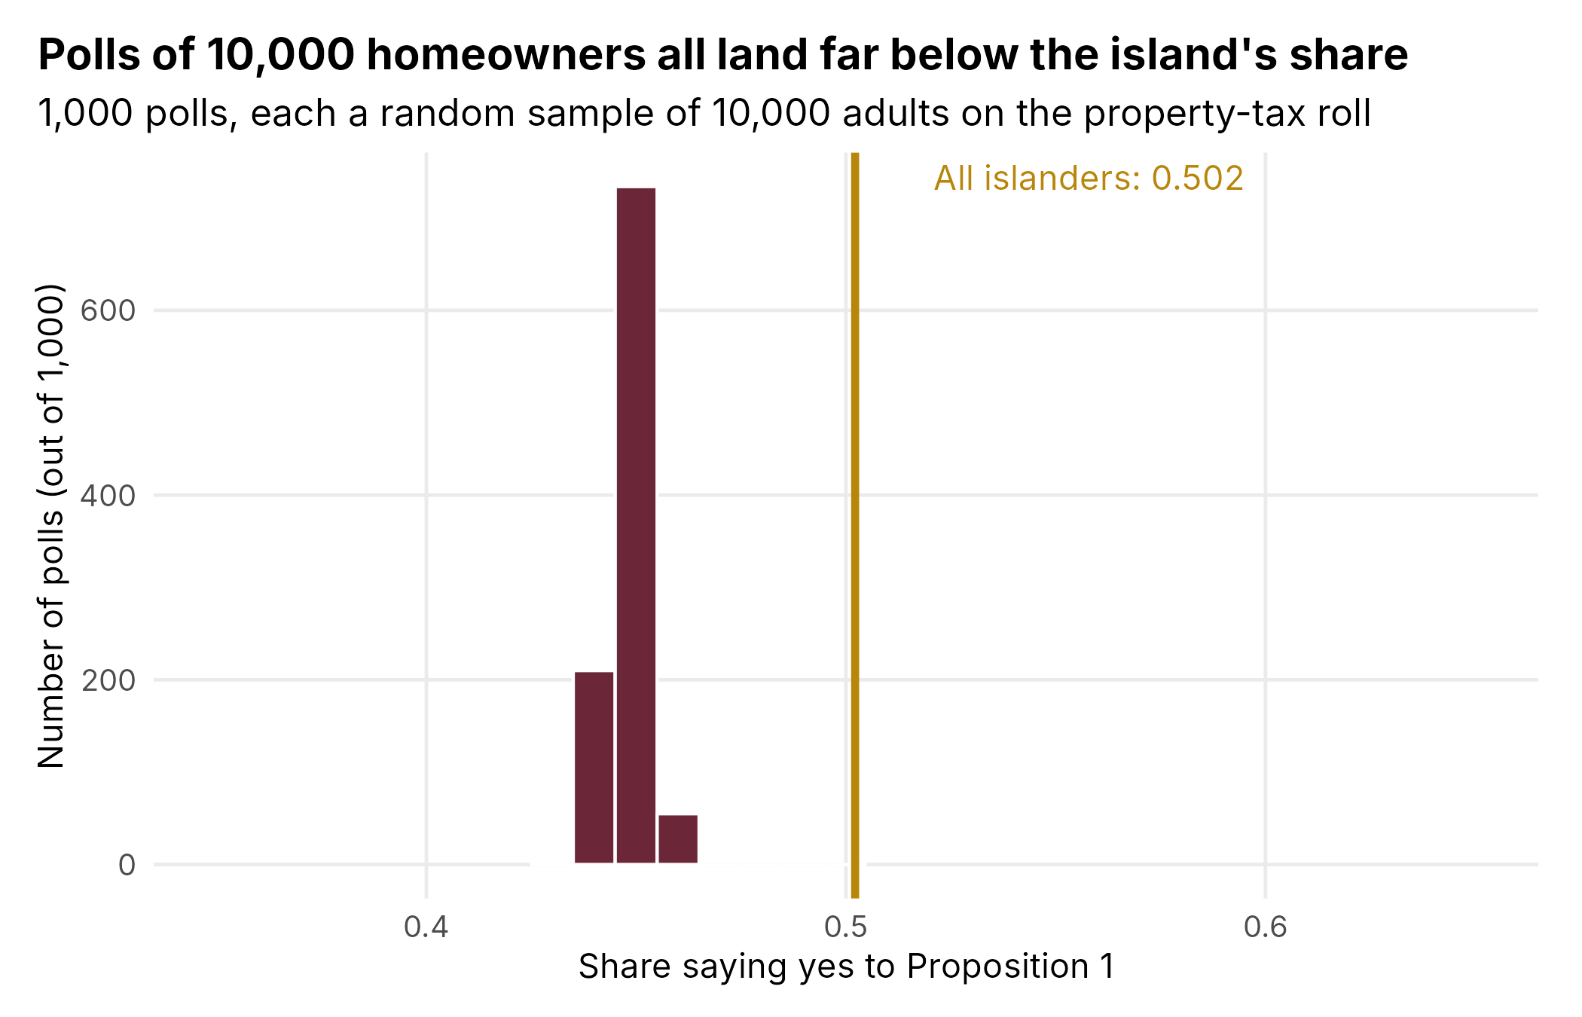

Part A write-up
Answer each lettered part separately; short answers are fine. Report shares as percentages, and standard errors and margins of error in percentage points, to one decimal place (0.0250 is 2.5 points).

1. Whose opinion each poll measures
a. What population is the station’s poll of 401 (block 2) meant to describe, and what quantity is it estimating (its estimand)? Give that quantity’s value from the census (block 1), as a percentage.
The poll of 401 is meant to describe all 59,838 adults on Merrow (the census list). Its estimand is the island's yes share on Proposition 1, which the census puts at 50.2%.

b. The Gazette’s front page said THE ISLAND SPEAKS: NO, 55 TO 45. Replace THE ISLAND with the group of islanders whose vote the Gazette’s 10,000 cards measured, and write out the new headline. Then give the percentage of that group who voted yes in the census (block 4C).
HOMEOWNERS SPEAK: NO, 55 TO 45. The 10,000 cards came from the property-tax roll, so they measured homeowners only. In the census, 44.8% of homeowners voted yes.

2. The sampling distribution and the standard error
a. Open polls_401.png (block 5C). In two sentences, say what one bar counts, where the 1,000 yes shares center, and a rough range that holds nearly all of them, read off the picture.
Each bar counts how many of the 1,000 polls of 401 had a yes share inside that bar's narrow range. The 1,000 shares center on about 50.2%, the island's share, and nearly all of them fall between about 44% and 57%.

b. Your news director reads your draft and says: “So our standard error is 2.5 points. That means our poll was 2.5 points off.” Use your 1,000 polls of 401 (block 5B) to tell her what the 2.5 points describes instead. Then use the census to say how far the station’s poll actually was from the island’s share, in percentage points.
The 2.5 points is the standard error: the standard deviation of the 1,000 poll shares, or how far a typical poll of 401 lands from the center of the sampling distribution. It describes the spread of all the polls the station could have drawn. It does not say how far this one poll missed. The station's poll actually found 49.1% against the island's 50.2%, so it was 1.1 percentage points off (low).

3. How often would a poll of 1,001 put “no” ahead?
Yes won with 50.22%, which is 0.22 percentage points above 50%. A poll of 1,001 has a standard error of about 1.6 percentage points, and the sampling distribution of the “yes” shares in polls of 1,001 resembles a bell curve centered on the island’s share. How many standard errors above 50% is the island’s share? Use your below_50_1001 from block 6C to say what fraction of polls of 1,001 should put “no” ahead. Then compare that fraction with your 1,000 polls of 1,001, of which 437 put “no” ahead (1,000 minus the 563 with “yes” ahead in block 6C).
The island's share is 0.22 / 1.6 ≈ 0.14 standard errors above 50%, which is barely above it. My below_50_1001 is 0.445, so about 44.5% of polls of 1,001 should put "no" ahead. That is close to the 437 of 1,000 (43.7%) that did in my simulated polls of 1,001. Even a fairly big random poll calls this vote wrong almost half the time, because the true margin is far smaller than the standard error.

4. What “95%” promises
The station’s poll of 401 found 49.1% yes, with a 95% interval from 44.2% to 54.0%.
a. A classmate says: “There is a 95% chance that the island’s share is between 44.2% and 54.0%.” That is not what a 95% confidence interval means. State what the “95%” does mean, and back it up with your block 7 count (948 of 1,000 intervals contained the island’s share).
The island's share is a fixed number, so this one interval either contains it or it doesn't. No 95% chance is involved after the fact. The 95% describes the method: if we drew many random polls of 401 and built a 95% interval from each, about 95% of those intervals would contain the island's share. My block 7 bears this out: 948 of 1,000 intervals (94.8%) contained 50.2%.

b. Suppose each of the 280 or so students in POLS 209 drew a random poll of 401 islanders and built its 95% interval, as you did in block 3. About how many of those intervals would miss the island’s share? Was yours one of them? Without a census, could a student with only their own interval find out that it missed?
About 5% of 280, so roughly 14 intervals would miss. Mine (seed 4229: 40.8% to 50.5%) did contain 50.2%, so it was not one of them. Without the census, a student would have no way to know whether their own interval missed, because the island's share is exactly what the poll is trying to estimate.

5. Ten thousand cards from the property-tax roll
a. The week after the vote, Mr. Mull wrote: “Every poll has a margin of error, and this year the luck went against us. Next October the Gazette will mail 20,000 cards.” Your 1,000 Gazette polls averaged 44.8% yes at every size (blocks 5D and 7C). You can use that average as the expected value of a Gazette poll’s share, E[Ȳ]. Compute the Gazette’s bias, E[Ȳ] − μ, where μ is the island’s share, 50.2%. Then say what 20,000 cards would do to each of these: the standard error, the margin of error, the center of the sampling distribution of the Gazette’s polls, and the bias. Was the miss bad luck?
Bias = E[Ȳ] − μ = 44.8% − 50.2% = −5.4 percentage points. With 20,000 cards, the standard error would shrink by a factor of 1/√2, from about 0.50 to about 0.35 points. The margin of error would shrink from about 1.0 to about 0.7 points. The center of the Gazette's sampling distribution would stay at 44.8%, the homeowners' share, so the bias would stay at −5.4 points. The miss was not bad luck. It was bias from polling only homeowners, and more cards cannot fix it.

b. Gazette intervals at 401 cards contained the homeowners’ share (44.8%) 945 times in 1,000, and the island’s share (50.2%) 429 times. As the poll grew to 1,001 and then 10,000 cards, the count containing 50.2% fell to 76 and then 0. Explain why a bigger Gazette poll contains the island’s share less often. (What does a Gazette interval stay centered on?)
A Gazette interval is always centered on a share near 44.8%, the homeowners' share, not the island's 50.2%. As the poll grows, the interval gets narrower around 44.8%, while 50.2% stays 5.4 points away. At 401 cards the interval (about ±4.9 points) is wide enough to reach 50.2% fairly often. At 1,001 (about ±3.1) it seldom does, and at 10,000 (about ±1.0) it never does. Bigger Gazette polls just get more precise about the wrong number.

c. Before this year, the Gazette’s poll had called every referendum correctly except two, both about housing. On one referendum it did call correctly, 62% of homeowners and 56% of everyone else voted yes, so the island voted 59.5% yes. What would the Gazette’s polls have centered on, what was their bias, and did they name the winner? Then say in one sentence how a poll can name the winner while its share is biased.
The Gazette's polls would have centered on about 62%, the homeowners' share. Their bias was 62 − 59.5 = +2.5 percentage points, and they still named the winner, since yes was above 50% both among homeowners and on the island. A biased poll can still name the winner when its bias isn't big enough to push its share across 50%, to the other side from the true result.

6. Planning Radio Merrow’s next poll
a. Your news director is cost-conscious: she will pay for the smallest poll whose margin of error is at most 3.5 percentage points. Set the margin of error, 1.96 × σ/√n, equal to 0.035 and solve for n, showing each step. Use σ = 0.5: it is the largest standard deviation a yes-or-no question can have, so the margin cannot come out bigger than planned, and Proposition 1 split almost 50-50. How many islanders should the station interview?
1.96 × 0.5 / √n = 0.035
0.98 / √n = 0.035
√n = 0.98 / 0.035 = 28
n = 28² = 784
The station should interview 784 islanders.

b. Radio Merrow will post a methods note under next year’s poll. Write it in four sentences: (1) how many islanders were interviewed and how they were chosen; (2) the poll’s margin of error; (3) one way even a random poll can miss by more than its margin of error, and how often that happens; (4) another way a poll can miss by more than its margin of error, with the Gazette as the example.
(1) Radio Merrow interviewed 784 adult islanders, drawn at random from the census list of every adult on Merrow. (2) The poll's margin of error is about 3.5 percentage points. (3) Even a random poll can miss by more than its margin of error through bad luck in which islanders happen to be drawn, and that happens in about 1 poll in 20. (4) A poll can also miss when it is drawn from a list that leaves out part of the island. The Gazette's mailing to homeowners only is an example: its polls centered on the homeowners' 44.8% instead of the island's 50.2%, however many cards it mailed.

Part B · 20 points
Lab: Friday, October 23 · Use HW2_Part_B_Lab.html.
Part B starts from a copy of your Part A script, saved as pols209_hw2_partB.R. Record the lab results below as you work through the page.

Part B lab record

Line 1 Your district scatterplot
Use block 5B. Paste districts.png here, with your title, subtitle, axis labels, and the labeled dashed line. (Posit Cloud: in the Files pane, tick districts.png and choose More → Export; then insert the downloaded picture here.)
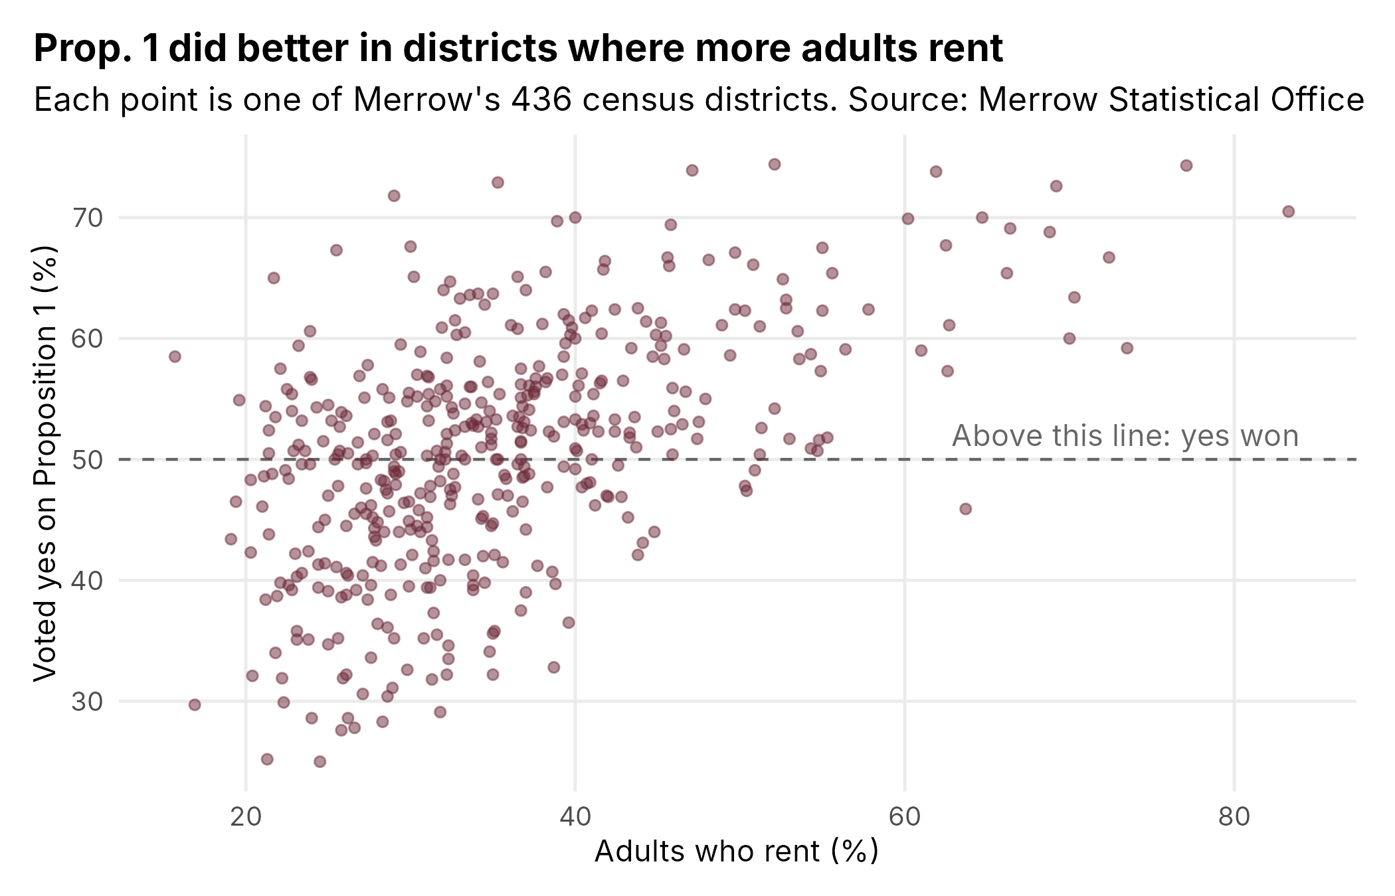

Line 2 Your comparison, before you run it
Use block 6A. Fill this in before you run block 6B.
Item | Your entry
The two groups, first and second, and their column | First: "Progressive Alliance"; second: "Old Harbor Party" (column: party)
The outcome column | homes_tax_break (1 = support a tax break for building cheaper homes)
Your null hypothesis, in one sentence about the island | On the whole island, Progressive Alliance and Old Harbor Party identifiers support the tax break for building cheaper homes at the same rate.

Line 3 Your comparison: the poll, then the census
Use blocks 6B and 6C. Report shares as percentages and gaps in percentage points, to one decimal place (political acts to two decimal places), and the p-value to three decimal places or as “below .001.”
Quantity | Result
Poll: islanders in the first group, and in the second | 373 Progressive Alliance; 260 Old Harbor Party
Poll: the gap, first group minus second | 89.0% − 56.2% = 32.9 percentage points
Poll: the 95% interval for the gap | 26.0 to 39.7 percentage points
Poll: the p-value | below .001
Poll: your decision at .05 (reject or do not reject) | Reject
Census: the first group’s share (or average acts), and the second group’s | Progressive Alliance 89.8%; Old Harbor Party 55.5%
Census: the gap, first group minus second | 34.3 percentage points
Is the census gap inside your poll’s interval? (yes or no) | Yes

Part B write-up
Answer each lettered part separately; short answers are fine. Report shares as percentages and gaps in percentage points, to one decimal place; political acts to two decimal places; and p-values to three decimal places, or as “below .001.”

1. Mr. Mull’s 99.3 percent
In block 3, you found that among the renters and owners in the station’s poll of 1,001 who answered the question on political acts, renters averaged 0.24 fewer acts than owners, with p = .007. Mr. Mull’s next column: “Radio Merrow’s own poll gives a p-value of .007. I make that a 99.3 percent chance that I am right, which is about my usual rate.”
a. That is not what a p-value means. State what p = .007 does measure here, in a sentence about Merrow’s renters and owners.
If renters and owners on Merrow averaged the same number of political acts, a random poll of 1,001 would show a gap at least as big as the one we found (0.24 acts, in either direction) only about 0.7% of the time. p is the probability of data like ours if the null is true. It is not the probability that the null is false, or that Mr. Mull is right.

b. On its own, does p = .007 tell you whether the gap between renters and owners is substantively big or small? Why or why not? Then, offer your own assessment of how meaningful this gap is. Pick one or more of the averages or standard deviations you computed in block 3B, and for each, say what fraction of that number a gap of 0.24 acts is. Next to each number, does the gap look big or small? Whether the gap is big or small is ultimately somewhat subjective, and there are multiple correct answers here.
No. The p-value measures how far the gap is from zero in standard errors, and the standard error shrinks as the poll grows. A large poll can give a tiny p-value for a gap that is substantively trivial, so p says nothing about size by itself. My assessment: the gap of 0.24 acts is 28% of the owners' average (0.87) and 38% of the renters' average (0.63). Next to the averages it looks sizable, since renters do roughly a quarter to a third fewer acts. But it is only about 20% of the standard deviation of political acts (0.24 / 1.19 for everyone; 0.24 / 1.22 for owners; 0.24 / 1.13 for renters). Next to how much individual islanders vary, it looks small. Overall I'd call it a real but modest difference: most renters and most owners both do zero or one act.

2. Mr. Mull’s September poll
In block 4, you tested the null hypothesis that renters and owners on Merrow voted yes on Proposition 1 at the same rate. In the Gazette’s September poll of 101 islanders, renters’ yes share was 14.5 percentage points higher than owners’, with a 95% interval from −6.1 to 35.2 percentage points and p = .164. In the station’s poll of 1,001, renters’ yes share was 15.8 percentage points higher, with a 95% interval from 9.2 to 22.4 percentage points and p below .001. In the census, renters’ yes share is 14.0 percentage points higher than owners’.
a. Mr. Mull read the September result, “no statistically significant difference in their support for Proposition 1,” as showing that renters and owners vote alike. Does the September poll’s interval rule out a gap of zero? Does it rule out a gap of 14 percentage points, the size of the census gap? Use your two answers to say whether the September result shows that renters and owners vote alike. Then use the census gap to say which error the September test made: a false positive or a false negative.
No. The September interval, −6.1 to 35.2 points, includes zero, so it does not rule out a gap of zero. It also includes 14 points, so it does not rule out a gap the size of the census gap either. The poll is consistent both with no difference and with a large one. It is inconclusive and does not show that renters and owners vote alike: failing to reject the null is not evidence that the null is true. Because the census gap is 14.0 points, the null hypothesis is false, and the September test failed to reject it. That is a false negative (Type II error).

b. The two polls found gaps of about the same size, 14.5 percentage points in the September poll and 15.8 in the poll of 1,001. Yet the September test did not reject the null hypothesis that renters and owners voted yes at the same rate, and the test in the poll of 1,001 did. Give each poll’s margin of error for its gap (half the width of its 95% interval), in percentage points. Why is the September poll’s margin of error so much bigger? Compare each gap with its margin of error to explain why only the poll of 1,001’s test rejected the null hypothesis.
Margin of error: September poll (35.2 − (−6.1)) / 2 ≈ 20.6 points; poll of 1,001 (22.4 − 9.2) / 2 ≈ 6.6 points. The September margin is so much bigger because that poll had only 40 renters and 55 owners, against 338 and 601 in the poll of 1,001. The standard error of the gap depends on each group's size, so small groups give an imprecise gap. In September the gap (14.5) is smaller than its margin of error (20.6), so the interval stretches past zero and the test cannot reject. In the poll of 1,001 the gap (15.8) is more than twice its margin of error (6.6), so the whole interval is above zero and the test rejects.

c. The poll of 1,001 has about 10 times as many islanders as the September poll. Is the margin of error 10 times smaller in the bigger poll? Divide the September poll’s margin of error from part (b) by the poll of 1,001’s to compute the ratio. Then, use the formula for the standard error of the gap, √(s²₁/n₁ + s²₂/n₂), to explain why the ratio is or is not approximately 10. Then, use the formula to reason about how much precision each added respondent buys as a poll grows. For example, suppose 50 more islanders, 25 renters and 25 owners, could be added to one of the two polls. Would they shrink that poll’s margin of error more in the September poll or in the poll of 1,001? In general, does each additional respondent shrink the margin of error by more, by less, or by the same amount as the poll’s sample size grows?
No. The ratio is 20.6 / 6.6 ≈ 3.1, not 10. In √(s²₁/n₁ + s²₂/n₂), the n's sit inside a square root, so multiplying both group sizes by about 10 divides the standard error (and the margin of error) by about √10 ≈ 3.2, not by 10. Adding 25 renters and 25 owners (using s ≈ 0.5): in the September poll the margin would fall from about 20.4 to 16.4 points, a drop of about 4 points. In the poll of 1,001 it would fall only from about 6.7 to 6.5 points, a drop of about 0.2. So the 50 islanders shrink the margin far more in the September poll. In general, each additional respondent shrinks the margin of error by less as the sample grows (diminishing returns), because the margin falls with 1/√n.

3. What the district plot shows
In block 5, you found that across Merrow’s 436 districts, the correlation between the percent of adults who rent and the percent who voted yes on Proposition 1 is r = 0.53. cor.test() gave p < 2.2e-16, the smallest p-value R prints.
Your news director wants this caption under your plot: “Renter share almost perfectly predicts how a district voted (p < 0.00000000000000022).” Does the tiny p-value show that the relationship is close to perfect? Explain using what the p-value measures. Then say what r tells readers, and rewrite the caption so every claim in it is true. It may keep the p-value or drop it.
No. The p-value measures how likely a correlation as strong as 0.53 would be if renter share and the yes vote were actually unrelated (r = 0). With 436 districts, even a moderate correlation is very unlikely to arise by chance, so p is tiny. That tells us the relationship is not zero. It does not tell us the relationship is close to perfect. (The 436 districts are also the whole island, so there is no larger population left to infer to.) r = 0.53 tells readers how strong and in what direction the relationship is: a moderate positive one. Districts with more renters tended to vote yes more often, but there is lots of scatter, and many districts with similar renter shares voted very differently. Rewritten caption: "Districts with more renters tended to vote yes on Proposition 1, but renter share is far from a perfect predictor of how a district voted (r = 0.53)."

4. Why the Gazette’s poll missed
Mr. Mull defends polling only homeowners by saying that whether an islander owns a home, rents one, or does neither has nothing to do with how they vote. As in Part A, a poll’s bias is E[Ȳ] − μ. E[Ȳ] is the average yes share of all the polls that could be drawn the same way as that poll, and μ is the island’s yes share.
a. What would have to be true of the yes share among all the island’s homeowners for a poll drawn at random from homeowners alone to give an unbiased estimate of the island’s yes share? Explain why.
The homeowners' yes share would have to equal the island's yes share (50.2%). A random poll from homeowners alone is centered on, and so has expected value equal to, the homeowners' share: E[Ȳ] = homeowners' share. Its bias, E[Ȳ] − μ, is zero only if the homeowners' share equals μ. In other words, owners would have to vote like everyone else, which is exactly Mr. Mull's claim.

b. In the station’s poll of 1,001, 41.9% of the 601 owners and 47.9% of all 1,001 islanders in the poll voted yes. Use those two shares to estimate the bias of a poll drawn at random from homeowners alone, in percentage points. Say which share estimates E[Ȳ] and which estimates μ, and why a random poll of the whole island can estimate both E[Ȳ] and μ. In the census, 44.8% of owners and 50.2% of all islanders voted yes, so the bias is −5.4 percentage points, as you found in Part A’s question 5(a). Why does your estimate from the station’s poll differ from it?
Estimated bias = 41.9% − 47.9% = −6.0 percentage points. The owners' share (41.9%) estimates E[Ȳ], the share a homeowners-only poll would center on. The whole-poll share (47.9%) estimates μ, the island's share. A random poll of the whole island can estimate both because it is a random sample of every islander. The 601 owners in it are therefore themselves a random sample of the island's homeowners, so their share is an unbiased estimate of the homeowners' share, while all 1,001 together give an unbiased estimate of the island's share. My estimate (−6.0) differs from the census value (−5.4) because of sampling error: each of the two poll shares is subject to random error (47.9% is 2.3 points below 50.2%, and 41.9% is 2.9 points below 44.8%), so their difference also misses the true bias by chance.

