POLS 209 · Fall 2026

Homework 2, Part A Answer Sheet
This sheet is for Part A. A combined answer sheet for Parts A and B will be posted with Part B, and that is the sheet you submit: copy your Part A answers into it.
Name
Email
Friday-section TA

Type in the spaces provided; they expand as you write.

What to submit
Submit three files on Canvas by Thursday, October 29, at 11:59 PM Central: the combined answer sheet (HW2_Answer_Sheet.docx, as Word or PDF) and both R scripts (pols209_hw2.R for Part A and pols209_hw2_partB.R for Part B). A missing script costs one point in its part of the homework.

Part A · 20 points
Lab: Friday, October 16 · Use HW2_Part_A_Lab.html.
Record the lab results below as you work through the page. Finish the code at home before the October 23 lab, because Part B starts from your Part A script (pols209_hw2.R).

Part A lab record

Line 1 Your own poll of 401
Use block 3. Write the number you gave set.seed(), then fill in the rest. Report the share and the two ends of the interval as shares to three decimal places (for example, 0.491).
Your set.seed() number | my_share | my_lower | my_upper | Contains 0.502? (yes or no)
73519 | 0.504 | 0.455 | 0.553 | yes

Line 2 Your Gazette histogram
Use block 5E. Paste gazette_10000.png here, with your own title. (Posit Cloud: in the Files pane, tick gazette_10000.png and choose More → Export; then insert the downloaded picture here.)
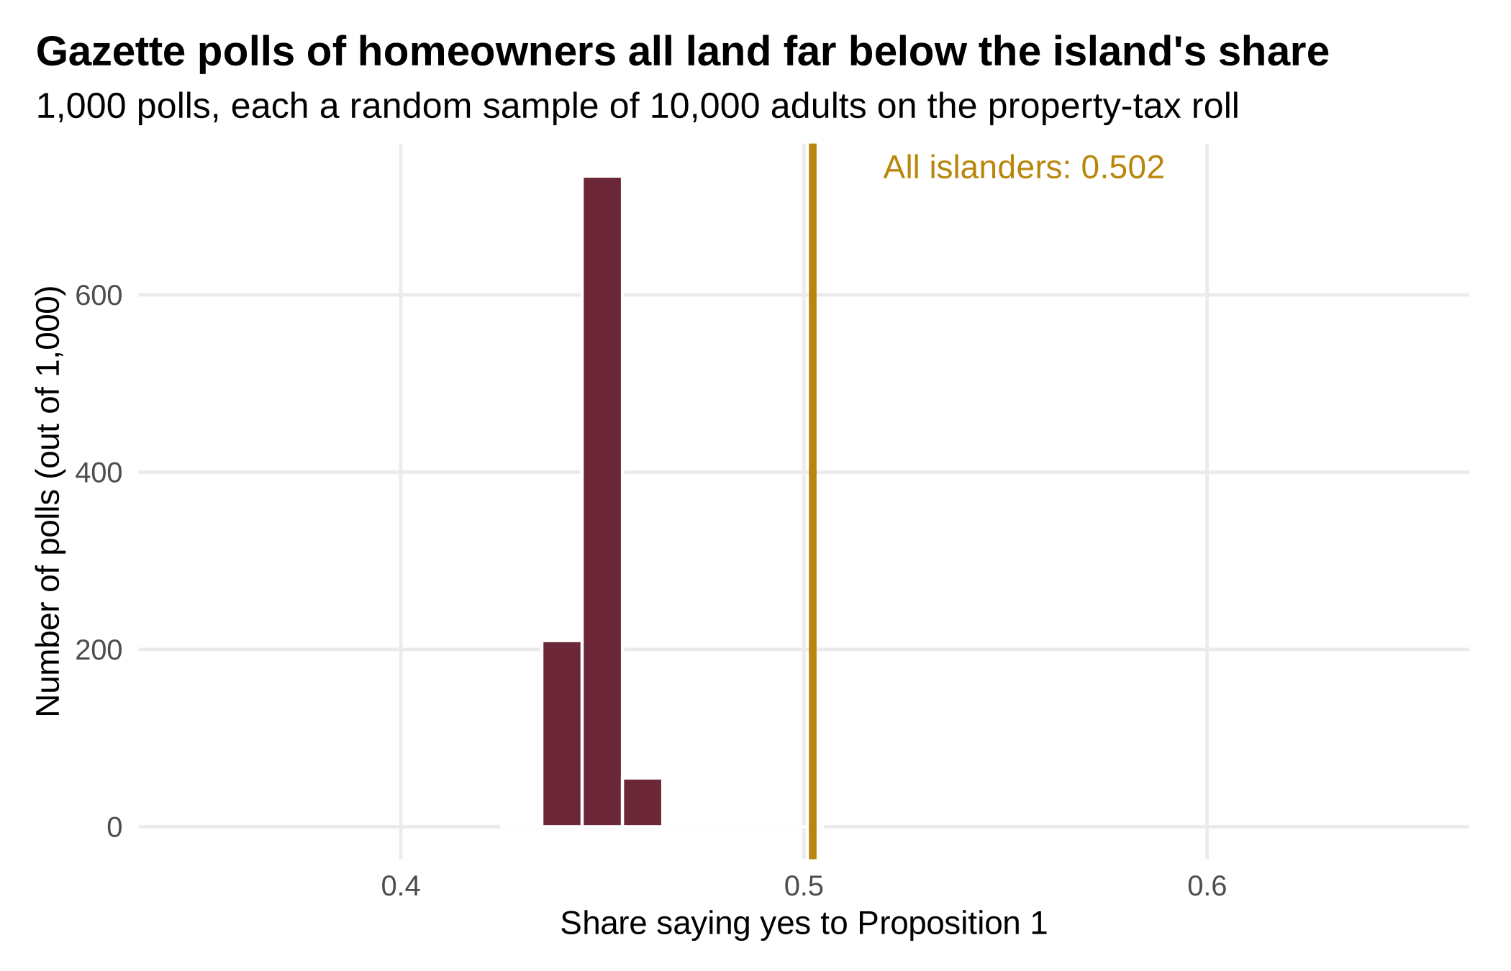

Part A write-up
Answer each lettered part separately; short answers are fine. Report shares as percentages, and standard errors and margins of error in percentage points, to one decimal place (0.0250 is 2.5 points).

1. Whose opinion each poll measures
a. What population is the station’s poll of 401 (block 2) meant to describe, and what quantity is it estimating (its estimand)? Give that quantity’s value from the census (block 1), as a percentage.
The population is all 59,838 adults on Merrow. The estimand is the share of those adults who voted yes on Proposition 1, which the census puts at 50.2%.

b. The Gazette’s front page said THE ISLAND SPEAKS: NO, 55 TO 45. Replace THE ISLAND with the group of islanders whose vote the Gazette’s 10,000 cards measured, and write out the new headline. Then give the percentage of that group who voted yes in the census (block 4C).
THE HOMEOWNERS SPEAK: NO, 55 TO 45. The cards were drawn from the property-tax roll, so they measured only adults who own their homes. In the census, 44.8% of homeowners voted yes.

2. The sampling distribution and the standard error
a. Open polls_401.png (block 5C). In two sentences, say what one bar counts, where the 1,000 yes shares center, and a rough range that holds nearly all of them, read off the picture.
Each bar counts how many of the 1,000 random polls of 401 had a yes share inside that one-percentage-point range. The shares center at about 50.2%, the island's share, and nearly all of them fall between roughly 43% and 57%.

b. Your news director reads your draft and says: “So our standard error is 2.5 points. That means our poll was 2.5 points off.” Use your 1,000 polls of 401 (block 5B) to tell her what the 2.5 points describes instead. Then use the census to say how far the station’s poll actually was from the island’s share, in percentage points.
The 2.5 points is not how far off our poll was. It describes how much polls of 401 scatter from one random sample to the next: across my 1,000 polls, the yes shares had a standard deviation of 2.5 points (sd_share_401 = 0.0250) around the island's share, so a typical poll lands about 2.5 points from the truth, some closer and some farther. Our actual poll found 49.1% yes against the census's 50.2%, so it was 1.1 percentage points too low.

3. How often would a poll of 1,001 put “no” ahead?
Yes won with 50.22%, which is 0.22 percentage points above 50%. A poll of 1,001 has a standard error of about 1.6 percentage points, and the sampling distribution of the “yes” shares in polls of 1,001 resembles a bell curve centered on the island’s share. How many standard errors above 50% is the island’s share? Use your below_50_1001 from block 6C to say what fraction of polls of 1,001 should put “no” ahead. Then compare that fraction with your 1,000 polls of 1,001, of which 437 put “no” ahead (1,000 minus the 563 with “yes” ahead in block 6C).
The island's share is (50.22 − 50) / 1.58 ≈ 0.14 standard errors above 50%. below_50_1001 is 0.445, so about 44.5% of polls of 1,001 should put “no” ahead. In my 1,000 polls of 1,001, 437 (43.7%) put “no” ahead, within about one point of the prediction. The vote was so close that even a poll of 1,001 is not much better than a coin flip at naming the winner.

4. What “95%” promises
The station’s poll of 401 found 49.1% yes, with a 95% interval from 44.2% to 54.0%.
a. A classmate says: “There is a 95% chance that the island’s share is between 44.2% and 54.0%.” That is not what a 95% confidence interval means. State what the “95%” does mean, and back it up with your block 7 count (948 of 1,000 intervals contained the island’s share).
The 95% describes the method, not this one interval. The island's share is a fixed number, and any single interval either contains it or does not. If we drew many random samples and built an interval the same way from each, about 95% of those intervals would contain the island's share. My block 7 count backs this up: 948 of 1,000 intervals from random polls of 401 (94.8%) contained 50.2%.

b. Suppose each of the 280 or so students in POLS 209 drew a random poll of 401 islanders and built its 95% interval, as you did in block 3. About how many of those intervals would miss the island’s share? Was yours one of them? Without a census, could a student with only their own interval find out that it missed?
About 5% of 280, or roughly 14 intervals, would miss the island's share. Mine was not one of them: my interval, from 45.5% to 55.3%, contained 50.2%. Without a census, a student could not find out that their interval missed: they see only their own sample, and an interval that misses looks just like one that hits.

5. Ten thousand cards from the property-tax roll
a. The week after the vote, Mr. Mull wrote: “Every poll has a margin of error, and this year the luck went against us. Next October the Gazette will mail 20,000 cards.” Your 1,000 Gazette polls averaged 44.8% yes at every size (blocks 5D and 7C). You can use that average as the expected value of a Gazette poll’s share, E[Ȳ]. Compute the Gazette’s bias, E[Ȳ] − μ, where μ is the island’s share, 50.2%. Then say what 20,000 cards would do to each of these: the standard error, the margin of error, the center of the sampling distribution of the Gazette’s polls, and the bias. Was the miss bad luck?
Bias = E[Ȳ] − μ = 44.8% − 50.2% = −5.4 percentage points. With 20,000 cards, the standard error would shrink by a factor of √2, from about 0.5 to about 0.35 points, and the margin of error would shrink from about 1.0 to about 0.7 points. The center of the sampling distribution would stay at 44.8%, the homeowners' share, so the bias would stay at −5.4 points. The miss was not bad luck. The property-tax roll leaves out renters and other non-owners, who voted yes more often, so more cards only measure homeowners more precisely.

b. Gazette intervals at 401 cards contained the homeowners’ share (44.8%) 945 times in 1,000, and the island’s share (50.2%) 429 times. As the poll grew to 1,001 and then 10,000 cards, the count containing 50.2% fell to 76 and then 0. Explain why a bigger Gazette poll contains the island’s share less often. (What does a Gazette interval stay centered on?)
A Gazette interval stays centered near 44.8%, the homeowners' share, at every size. As the poll grows, the interval gets narrower around 44.8%: about ±4.9 points at 401 cards, ±3.1 at 1,001, and ±1.0 at 10,000. The wide intervals at 401 cards still reach up to 50.2% fairly often (429 times), the narrower ones at 1,001 rarely do (76 times), and at 10,000 cards an interval never stretches 5.4 points to reach 50.2% (0 times). A bigger Gazette poll is just more confident about the wrong number.

c. Before this year, the Gazette’s poll had called every referendum correctly except two, both about housing. On one referendum it did call correctly, 62% of homeowners and 56% of everyone else voted yes, so the island voted 59.5% yes. What would the Gazette’s polls have centered on, what was their bias, and did they name the winner? Then say in one sentence how a poll can name the winner while its share is biased.
The Gazette's polls would have centered on 62%, the homeowners' share. Their bias was 62% − 59.5% = +2.5 percentage points. They did name the winner, since both 62% and 59.5% are above 50%, so the Gazette called yes and yes won. A biased poll can still name the winner as long as its bias is not large enough to push its share to the other side of 50%.

6. Planning Radio Merrow’s next poll
a. Your news director is cost-conscious: she will pay for the smallest poll whose margin of error is at most 3.5 percentage points. Set the margin of error, 1.96 × σ/√n, equal to 0.035 and solve for n, showing each step. Use σ = 0.5: it is the largest standard deviation a yes-or-no question can have, so the margin cannot come out bigger than planned, and Proposition 1 split almost 50-50. How many islanders should the station interview?
1.96 × 0.5 / √n = 0.035
0.98 / √n = 0.035
√n = 0.98 / 0.035 = 28
n = 28² = 784
The station should interview 784 islanders.

b. Radio Merrow will post a methods note under next year’s poll. Write it in four sentences: (1) how many islanders were interviewed and how they were chosen; (2) the poll’s margin of error; (3) one way even a random poll can miss by more than its margin of error, and how often that happens; (4) another way a poll can miss by more than its margin of error, with the Gazette as the example.
Radio Merrow interviewed 784 adults chosen at random from the full census list of all adults on Merrow, so every islander, whether they own, rent, or neither, had the same chance of being picked. The poll's margin of error is ±3.5 percentage points at 95% confidence. Even a properly random poll can miss by more than its margin of error through chance alone, about once in every 20 polls. A poll can also miss when the list it draws from leaves out part of the population: the Gazette samples only homeowners from the property-tax roll, so its polls center on homeowners' 44.8% yes instead of the island's 50.2%, and mailing more cards does not fix that.

