Luke Watson

958

9-24-24

**Exercise 4**

*Part One*

I made a figure of the individual subject results in the first experiment looking into how mean correct answers changed across probabilities of detection (Figure 1). There are many more female subjects than male, but upon initial look, it looks like most males have different intercepts and slopes. Harder to judge for the females, but it looks like they see less intercept variability but similar slope variability.

**Figure 1**

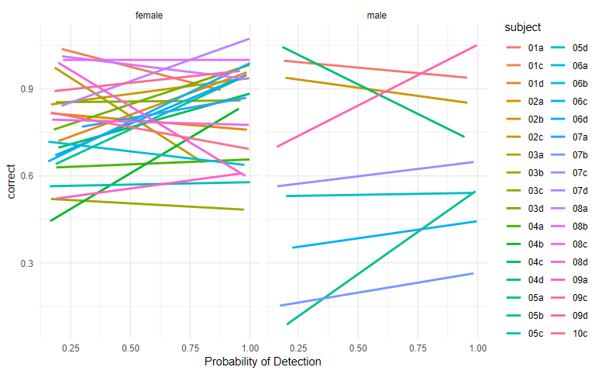

Next, I conducted a generalized mixed effects model using a full factorial structure between sex and centered probability of detection as fixed effects and included a random intercept of subject. The results of the model are plotted by subject in Figure 2.

**Figure 2**

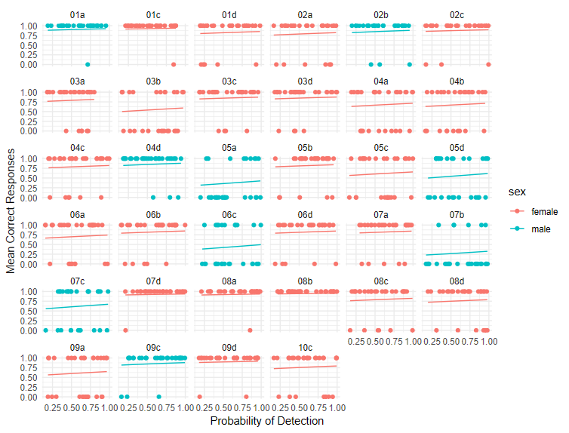

Then, I compared a few models inserting and removing predictors to find the best fit to the data. I chose to run two additional models and compare them to the full factorial model with random intercept described above. The first model included both fixed effects of centered probability of detection and sex, but dropped the interaction and kept the random intercept of subject. The second model included fixed effects of sex and a random intercept of subject. After running each model using the glmer command of the lme4 package in R, I settled on the first model which included both predictors as fixed effects as my preferred model. Using the Akaike weights, I was able to surmise that both the models that dropped the interaction, model one and model two, were more likely to fit the data (see Table 1). Given the small discrepancy between these two candidates though, I opted to go with the model which included both of my predictors of interest. The results of this model are summarized in Table 2.

**Table 1**

|  |  |  |  |
| --- | --- | --- | --- |
| Model (Fixed Effects Included) | Full factorial | Prob. + Sex | Sex only |
| Akaike weights | .16 | .40 | .44 |

*Note.* Model comparison between nested models including various fixed effects of interest. The first model includes all predictors and their interactions as fixed effects, and the following models drop the interaction keeping only probability of detection and sex, or just sex, as fixed effect. Each model used the same random intercept structure. Weights are interpreted as probabilities of the model having produced the observed data, with higher values indicating higher likelihood of that model.

**Table 2**

|  |  |  |  |  |
| --- | --- | --- | --- | --- |
| Term | Estimate | SE | Statistic | p |
| (Intercept) | 1.52 | .22 | 6.94 | <.001 |
| Probability of Detection | .50 | .33 | 1.50 | .134 |
| Sex | -.78 | .42 | -1.86 | .063 |

*Note*. Model results for the chosen model including both probability of detection and sex as fixed effects and random intercept structure. Take note that the estimates are in terms of log odds, and positive values indicate higher odds of being correct and negative values indicate lower odds of being correct.

Lastly, I tried a model with a random effects structure of slope included along with the intercept and compared it to my preferred model described above. Using the same Akaike weights procedure, I compared the model fits to get a good estimate of which was the better model. The weight for the best fitting model of intercept only had a weight of .88, indicating that it was 88% likely to have produced the data compared to the random slope model’s 12%.

*Part Two*

In this study, participants gave estimates for what kind of value they would take now over $100 guaranteed after variable delays ranging from now to 10 months later from now. Because I am not familiar much with the research and especially the methods of model fitting in the delay discounting area, I conducted an exploratory analysis starting first with a simple linear fit using delay (in months) to predict acceptable values of smaller sooner rewards. Using the check_model command from the performance package in R, I found that this model had some serious flaws most notably with the distribution of errors appearing bimodal and truncated at either end of its range. Using a box cox analysis (from the MASS package), I determined that the best transformation to the outcome was to square root it. After transforming the outcome, I still found similar issues but less severe than the previous untransformed model. Because these subjects provided several judgments in succession, there was a dependency in the data that must be taken into account. So, I ran another model that used delay as a fixed effect and a random intercept of subject to predict the transformed value. Checking the assumptions, this model was a good improvement on the previous models. Further, I wondered if the random effect of slope also needed to be modeled, so I reran the model adding in the slope to the random effects structure. Checking my assumptions again, I found this model was trending in the wrong direction, with more clear violations of linearity and homogeneity of variance assumptions than the previous model. To further compare these models, I did another Akaike weight procedure, the results are displayed in Table 3. This procedure revealed that the preferred model based on likelihood of fit to the data was the model including the slope. This is the model I will go with, and the results are summarized in Table 4. Finally, I have visualized the model results in Figure 4, that shows as the delay increases, there is a non-linear decrease in dollar value of smaller sooner alternatives that participants are willing to take over the larger later option.

**Table 3**

|  |  |
| --- | --- |
| Model (Random Effects) | Akaike weight |
| Intercept | .14 |
| Intercept and Slope | .86 |

*Note*. Akaike weights for each of the models with the specified random effects structure. According to the weight, the model including slope in the structure was 86% likely to have produced the data compared to the intercept only model’s 14%.

**Table 4**

|  |  |  |  |
| --- | --- | --- | --- |
| Term | Estimate | SE | t |
| (Intercept) | 9.23 | 0.35 | 26.12 |
| Delay | -0.46 | 0.05 | -8.31 |

*Note.* Model results for the model using fixed effect of delay in months to predict square root value of smaller sooner preferred alternatives.

**Figure 3**

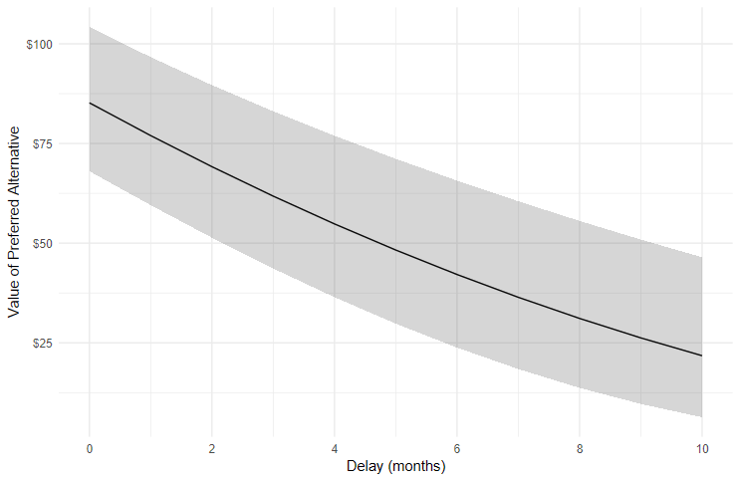

*Figure 3* – Visualized model results over all subjects for model. Value of preferred smaller sooner alternative has been back transformed into the original dollar value for ease of interpretation. Error ribbon represents 95% C.I.