Luke Watson

HW 1

**Figure 1**

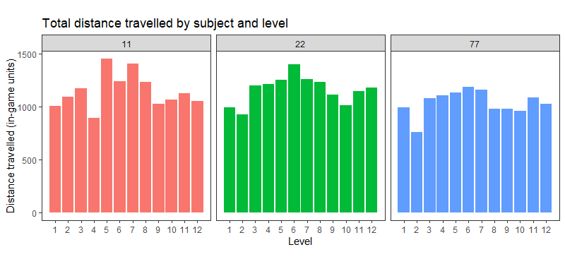

**Figure 2**

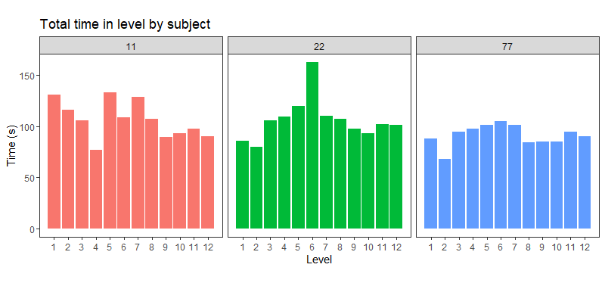

**Figure 3**

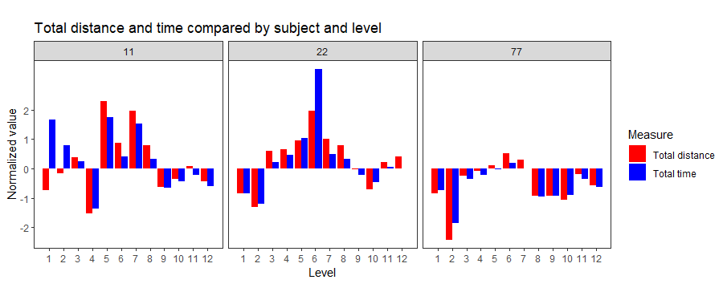

For this assignment, I loaded in my dataset from my pilot game that I ran with 3 participants last April. In this game, the participants navigated an avatar to collect foods that were dispersed around a virtual environment in different patchy formations. They completed 12 levels of the game where I manipulated the location and sizes of the foods contained within the environment. I tried to explore all combinations of size variability between clumps/patches of foods, within clumps/patches, and distances between the patches. My goal was to explore how participants developed strategies to complete the levels in an efficient manner. Efficiency could be a great way to compare these strategies and hone-in on what rules participants use to guide their problem-solving and decision-making approaches. For this assignment, I wanted to use my knowledge of R to create and compare metrics of efficiency between and within participants.

The game writes the location of the player to file every 200 ms. However, I want a way to be able to quantify the distance the player travels throughout the level. To collect the foods and complete the level, the players must route through the foods in a continuous tour. The total distance of this tour could be an interesting measure of efficiency, so I created a custom function (see PathAnalyses.R if interested) that takes the input of the player location data and uses some functions from the dplyr package (mutate, lag, if_else) to calculate distances between points and store it in a new column appended to the same data frame. I could then use another pair of dplyr functions (group_by and summarize) to find the total distance drawn by the player’s path in the level for each of the levels they played the game and plotted the results to compare subjects’ performance (Figure 1).

Another potential efficiency measure could be time spent collecting rewards in the level. Less time to complete the level could indicate greater efficiency or better strategies for completion. Something that can be captured by total time (but not total distance) would be idle time. Some participants could have gotten distracted while playing and idled while the game kept writing their time and location data. If so, plotting the total time data in the same manner as the distance data could reveal deviations that point to a player likely idling for significant portions of the level. These results are displayed in Figure 2.

To get a better look at this, I tried a different method to plot them on the same chart. To compare, I normalized both of the measures (total distance and time) then plotted them on the same chart as dodged bars (Figure 3). I did this so that I could get a sense of the general direction of the differences like with subject 11, who on the first two levels was above average on time to complete but below or at average with distance. I am a little unsure about this method, I may have needed to normalize based on level rather than all levels since the levels were quite different in terms of number of foods and dispersion of them.