Reproducing Framework:

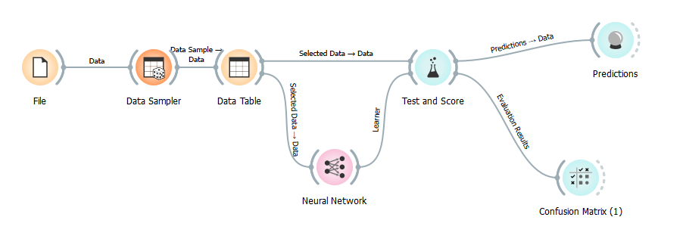

Dataset:

Data Science Salaries 2024

https://www.kaggle.com/datasets/sazidthe1/data-science-salaries?resource=download

Attributes Setup:

Skip “Salary Currency”.

Make “Company Size” the target.

Data Sampler Setup:

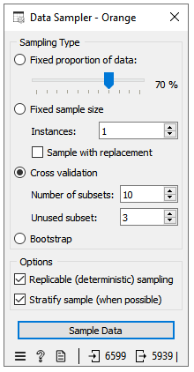

Neural Network Setup and Result:

Round 1: (3 hidden layers, ReLU activation functions)

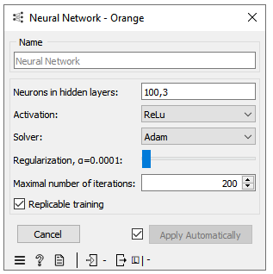

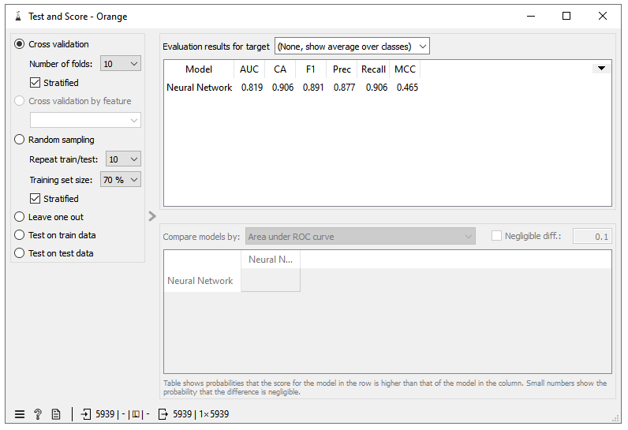

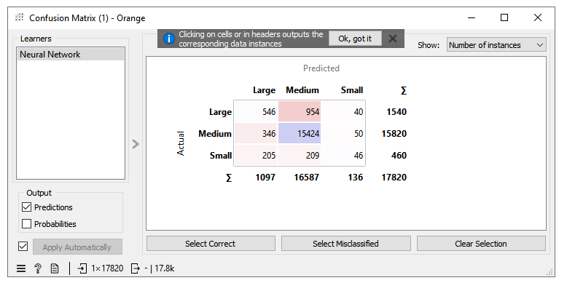

Prediction Errors:

| Algorithm | Class | | |
| --- | --- | --- | --- |
| L | M | S |
| Neural Networks (3 hidden layers, ReLU activation functions) | 994 | 396 | 414 |

Round 2: (2 hidden layers, logistic activation functions)

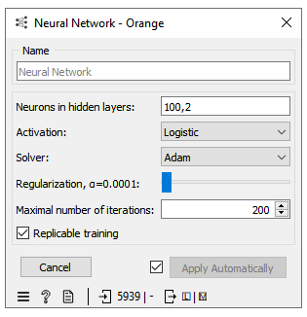



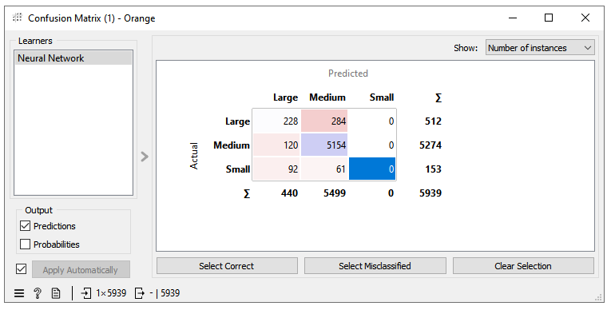

Prediction Errors:

| Algorithm | Class | | |
| --- | --- | --- | --- |
| L | M | S |
| Neural Networks (2 hidden layers, logistic activation functions) | 284 | 120 | 153 |

Conclusion:

1. Both setups for the Neural Network achieve a decent Classification Accuracy (CA) of around 0.9 and a good precision of over 0.87.
2. The Neural Network model works extremely well in classifying medium-sized companies but poorly in classifying large and small-sized companies.
3. The solver, regularization, and the number of iterations from the original paper aren’t found.
4. The authors say they use 3 hidden layers with the ReLU activation functions but their confusion matrix plot shows they use 2 hidden layers.

Limitation of Orange Neural Network:

1. Weight and bias in each hidden layer cannot be adjusted.
2. The activation function in the output layer is not shown.
3. Do not show the learning rate.
4. Only has Adam, L-BFGS-B, and SGD Optimization Agorithms.

Possible Ways to Improve:

1. Add more hidden layers.
2. Add more neurons in each hidden layer.
3. Increase the number of iterations (May lead to overfitting).
4. Set the Reguralization value to avoid overfitting.

Neural Network Background Information:

1. Consists of an Input Layer, Hidden Layer/Layers, and an Output Layer.
2. Weight, bias, and activation functions in each Hidden Layer:

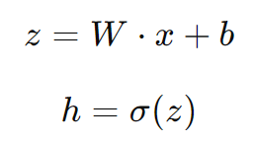

W means weight matrix; x is input; b is the bias; σ is the activation function; z is the result from the linear combination; h is the output to the next hidden layer.

1. Backpropagation.
2. Optimization Algorithms: Adam, L-BFGS-B, and SGD.