In the ASS2, my partner and I rebuild the project. It is different with ASS1.

1. We have verified the login by connecting to the server, and the course selection status of different users is different.

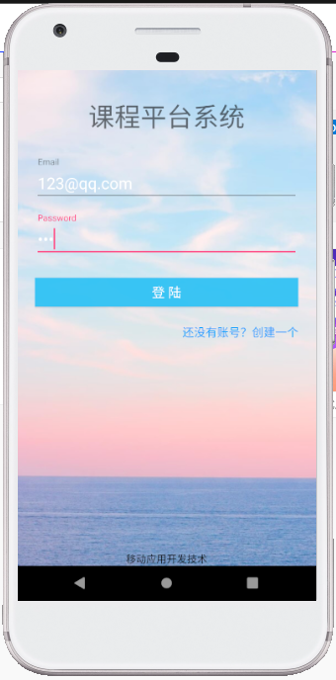

1. New users can register and their information will be added to the database.

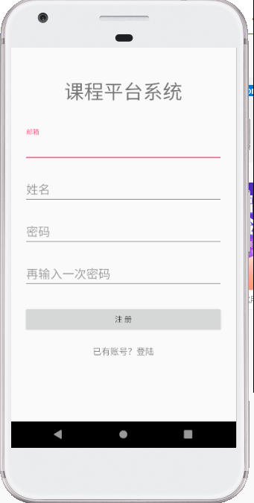

1. We use recyclerview and adapter to display different information of different courses.

In this interface, you can choose to subscribe or withdraw the course.

