17301097@bjtu.edu.cn

Assignment 1

Due date:   2019 -10- 14

Date of submission: 2019 -10- 13

移动应用开发技术

17301097 李程遥

**Abstract:**

This project uses Java language and XML language development, Android studio 3.5 as the development platform. we will focus on the topic and the use case scenarios of a E-learning system or the so called learning management system(LMS).

**INTRODUCTION：**

Start the project and get the following interface

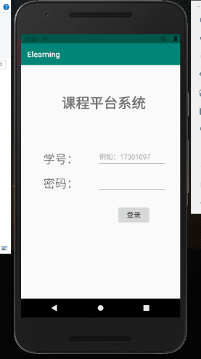

Then, you can enter the student number password according to the sample.

Click the login button, and you will get the course list:

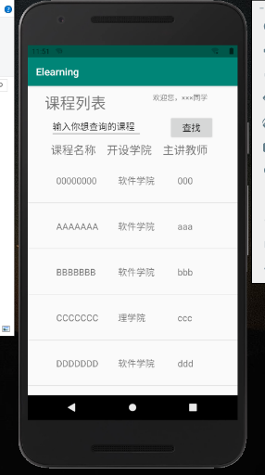

Every list view is produced by adapter, it has three components, course name, dept and course’s teacher.

As the follow, if you click the course, you will get the course information:

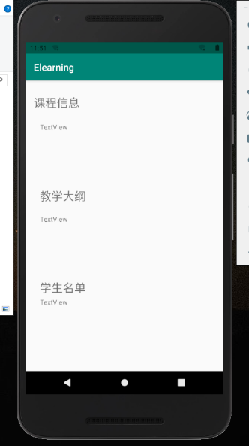

Also, if you long click the course, it will show you the course resources, you can get ppt or study video on it.

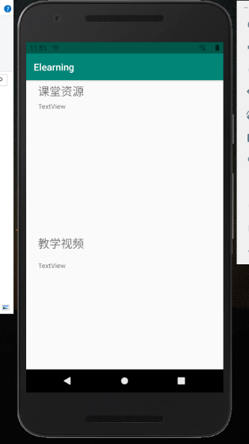

These are the whole layout design from assignment1.