**MALLOC DEMO:**

Metrics:

Implicit- Average utilization = 59.7%. Average throughput = 5195 Kops/sec(33)  
Seg lists- Average utilization = 60.3%. Average throughput = 17241 Kops/sec(66)  
Footer- **Average utilization = 69.0%. Average throughput = 11435 Kops/sec (88)**  
  
#no of seg lists:

5- Average utilization = 68.9%. Average throughput = 7553 Kops/sec(72)

8- Average utilization = 69.0%. Average throughput = 11459 Kops/sec(88)

10- Average utilization = 69.0%. Average throughput = 13736 Kops/sec(88)

12- **Average utilization = 69.0%. Average throughput = 11324 Kops/sec(88)**

15- Average utilization = 69.0%. Average throughput = 12199 Kops/sec(88)

First n fit:

1- Average utilization = 68.8%. Average throughput = 14670 Kops/sec(88)

3- **Average utilization = 69.0%. Average throughput = 11435 Kops/sec (88)**

5- Average utilization = 69.0%. Average throughput = 10598 Kops/sec

Chunk size:

32- Average utilization = 68.6%. Average throughput = 11438 Kops/sec (87)

**512- Average utilization = 69.0%. Average throughput = 11435 Kops/sec (88)**

1024- Average utilization = 68.0%. Average throughput = 11814 Kops/sec(86)

4096- Average utilization = 68.7%. Average throughput = 12166 Kops/sec(87)

On initialization:

Extending the heap:

Place:

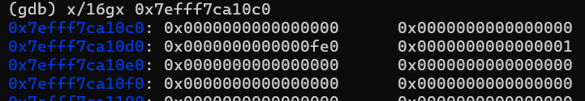

2nd Malloc:

Free (Before Coalesce):

Free(2):

Allocating 25bytes of memory:  
