时间 | 地点 | 班级 | 姓名 | 学号 | 成绩
 | 机-320 | 计科2632 | 段辉园 | 266430069

实验三 数据库的多表查询操作
一、实验目的
- 掌握多表连接的几种连接方式。
- 掌握相关子查询与嵌套子查询的区别。。
- 掌握带IN谓词的子查询的使用方法。
- 掌握带比较运算符的子查询的使用方法。

二、实验原理
- 连接查询：
隐式形式
SELECT 列 FROM 表1，表2 WHERE 连接条件（筛选）
显示形式
交叉连接: SELECT FROM 表1 CROSS JOIN 表2
自然连接: SELECT FROM 表1 NATURAL JOIN 表2
内连接: SELECT FROM 表1 INNER JOIN 表2 ON 条件
左外连接: SELECT FROM 表1 LEFT JOIN 表2 ON 条件
右外连接: SELECT FROM 表1 RIGHT JOIN 表2 ON 条件
- 嵌套查询：
不相关子查询：
子查询的查询条件 不依赖 于父查询。
相关子查询：
子查询的查询条件 依赖 于父查询。
使用谓词： IN 、 比较运算符、
EXISTS 、 ANY·SOME·ALL
三、实验内容和步骤
导入实验一中备份的db_school数据库，进行如下操作：
1、多表连接查询。
(1) 查询计算机工程系女学生的学生学号、姓名及考试成绩。
答：代码：select student.sno as '学号', student.sname as '姓名', sc.degree as '考试成绩' from student join sc on student.sno = sc.sno where student.sdept = '计算机工程系' and student.ssex = '女';
截图：
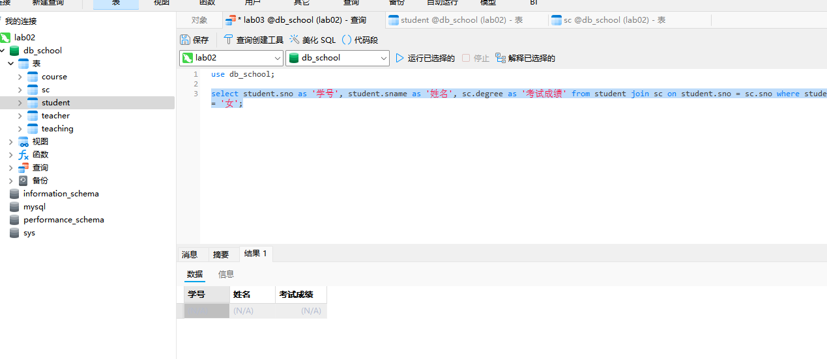
(2) 查询“李勇”同学所选课程的成绩。(不考虑重名)
答：代码：select course.cname as '课程名', sc.degree as '成绩' from student join sc on student.sno = sc.sno join course on course.cno = sc.cno where student.sname = '李勇';
截图：
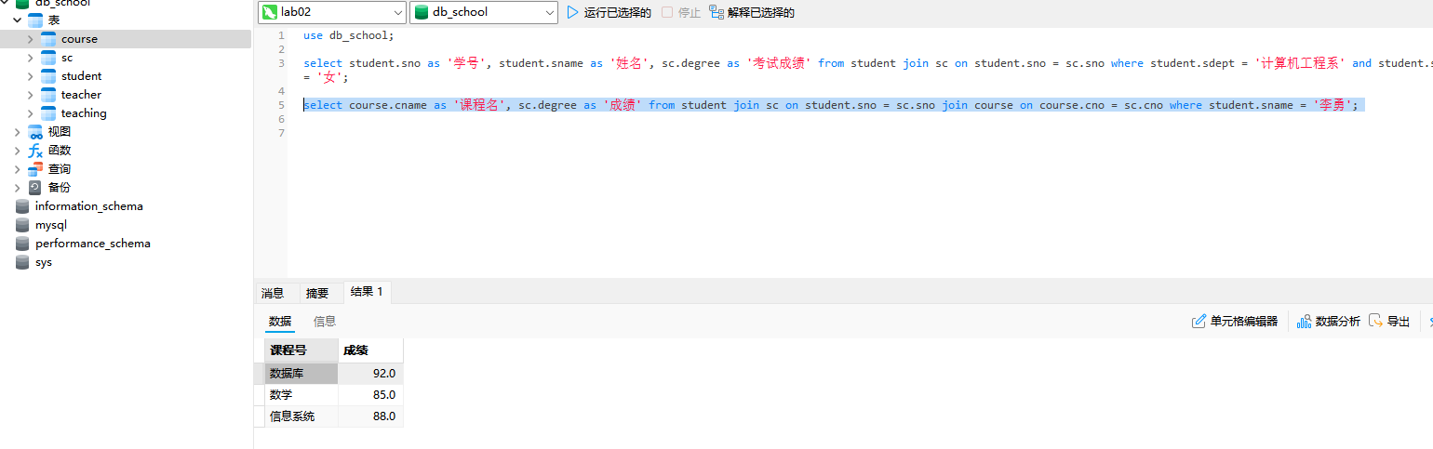
(3) 查询“李新”老师所授课程的课程名称。
答：代码:select course.cname as '课程名' from teacher join teaching on teaching.tno = teacher.tno join course on course.cno = teaching.cno where teacher.tname = '李新';
截图：
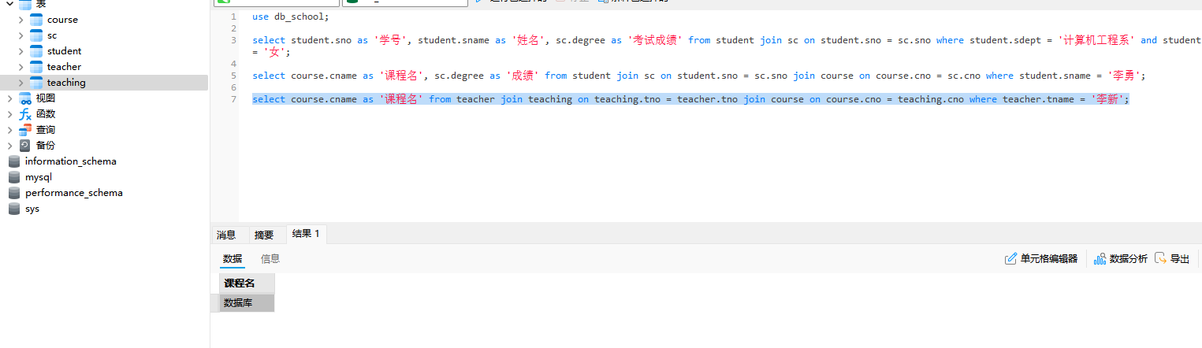
(4) 查询女教师所授课程的课程号及课程名称。
答：代码：select course.cno as '课程号', course.cname as '课程名' from teacher join teaching on teacher.tno = teaching.tno join course on course.cno = teaching.cno where teacher.tsex = '女';
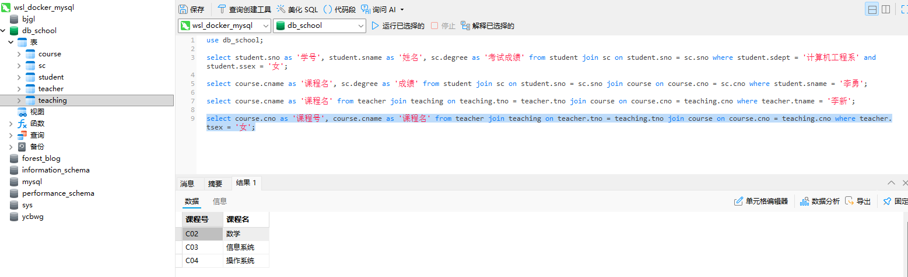
截图：
(5) 查询至少选修一门课程的女学生姓名。
答：代码：select distinct student.sname as '学生姓名' from student join sc on student.sno = sc.sno where student.ssex = '女';
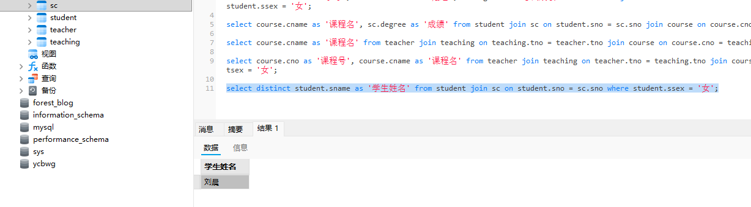
截图：

(6) 查询姓“王”的学生所学的课程名称。
答：代码：select course.cname as '课程名' from student join sc on sc.sno = student.sno join course on course.cno = sc.cno where student.sname like '王%';
截图：

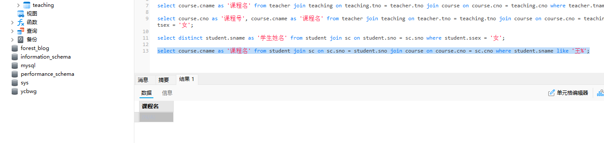
(7) 查询选修“数据库”课程且成绩在80～90分之间的学生学号及成绩。
答：代码：select distinct sc.sno as '学号', sc.degree as '成绩' from sc join course on sc.cno = course.cno where (sc.degree between 80 and 90) and course.cname = '数据库';
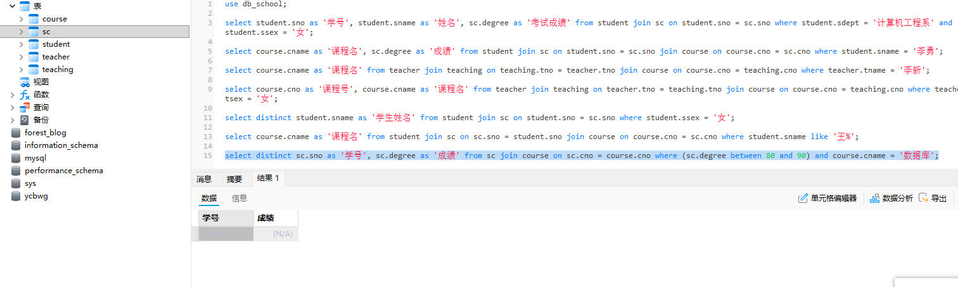
截图：
(8) 查询选修“数据库”课程且成绩在80～90分之间的学生姓名及成绩。
答：代码：select s.sname as '学生姓名', sc.degree as '成绩' from student s join sc on s.sno = sc.sno join course c on sc.cno = c.cno where c.cname = '数据库' and sc.degree between 80 and 90;
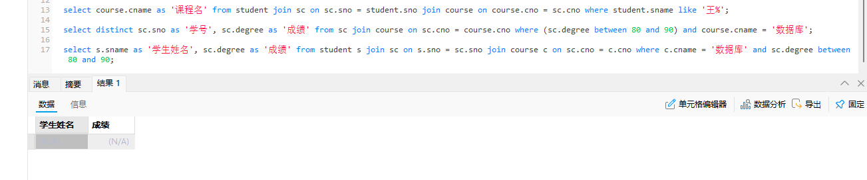
截图：
(9) 查询课程成绩及格的男同学的学生信息及课程号与成绩。
答：代码：select s.*, sc.cno, sc.degree from student s join sc on s.sno = sc.sno where s.ssex = '男' and sc.degree >= 60;
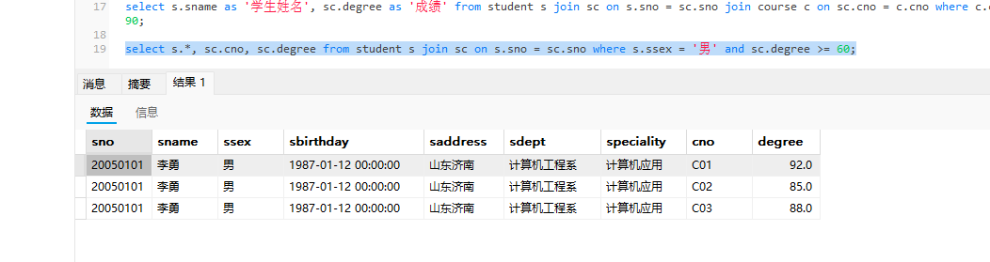
截图：
(10) 查询选修“c04”课程的学生的平均年龄。
答：代码：select avg(year(CURDATE()) - year(s.sbirthday)) as '平均年龄' from student s join sc on s.sno = sc.sno where sc.cno = 'C04';
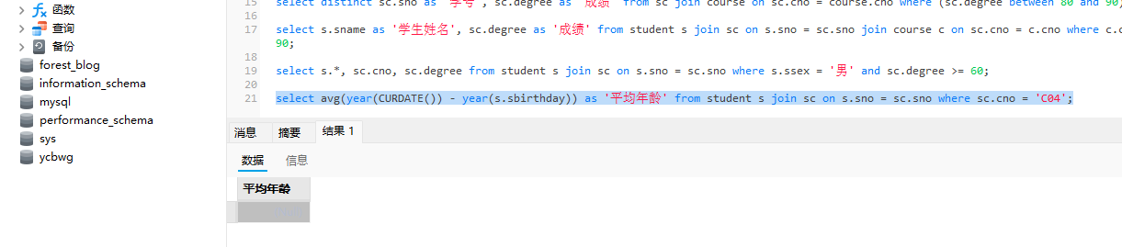
截图：
(11) 查询学习课程名为“数学”的学生学号和姓名。
答：代码：select distinct student.sno, student.sname from student join sc on student.sno = sc.sno join course on sc.cno = course.cno where course.cname = '数学';
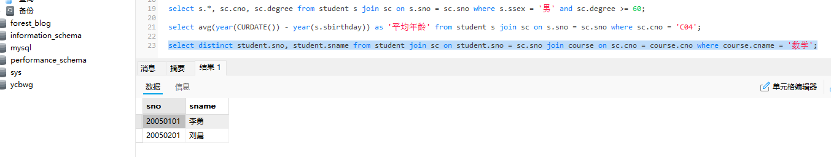
截图：
(12) 查询“钱军”教师任课的课程号，选修其课程的学生的学号和成绩。
答：代码：select teaching.cno, sc.sno, sc.degree from teacher join teaching on teacher.tno = teaching.tno join sc on teaching.cno = sc.cno where teacher.tname = '钱军';
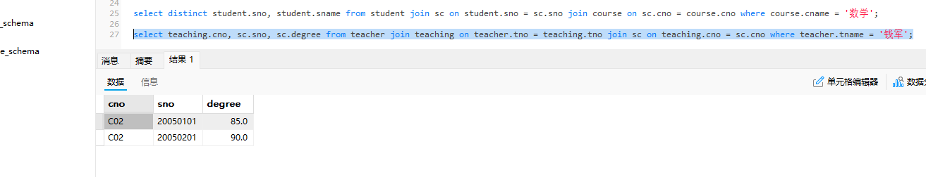
截图：
(13)查询“钱军”教师任课的课程号，选修其课程的学生的姓名。
答：代码：select distinct teaching.cno, student.sname from teacher join teaching on teacher.tno = teaching.tno join sc on teaching.cno = sc.cno join student on sc.sno = student.sno where teacher.tname = '钱军';
截图：

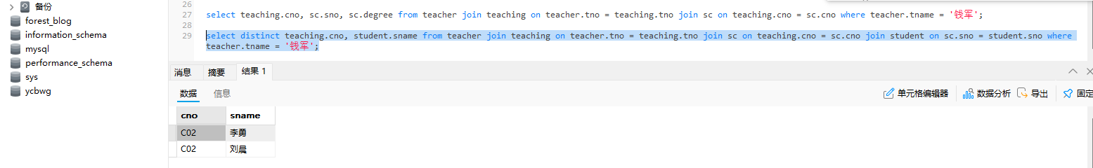
(14)查询在第3学期所开课程的课程名称及成绩。
答：代码：select distinct course.cname, sc.degree from teaching join course on teaching.cno = course.cno join sc on teaching.cno = sc.cno where teaching.cterm = 3;
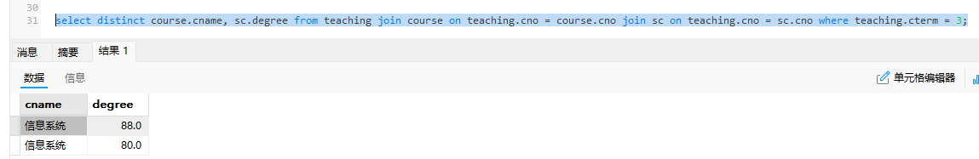
截图：
(15)查询“c02”号课程不及格的学生信息。
答：代码：select student.* from student join sc on student.sno = sc.sno where sc.cno = 'C02' and sc.degree < 60;
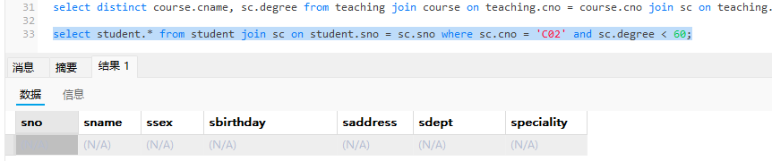
截图：
(16)查询软件工程系成绩在90分以上的学生姓名、性别和课程名称。
答：代码：select student.sname, student.ssex, course.cname from student join sc on student.sno = sc.sno join course on sc.cno = course.cno where student.sdept = '软件工程系' and sc.degree > 90;
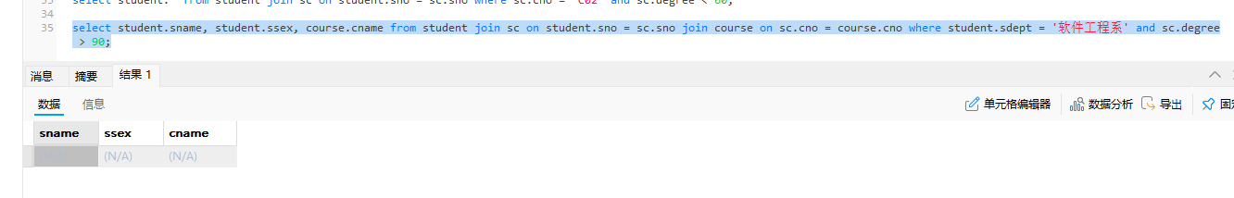
截图：
(17) 查询同时选修了“c04”和“c02”课程的学生姓名和成绩。
答：代码：SELECT s.sname, sc1.degree AS 'C04成绩', sc2.degree AS 'C02成绩' FROM student s JOIN sc sc1 ON s.sno = sc1.sno AND sc1.cno = 'C04' JOIN sc sc2 ON s.sno = sc2.sno AND sc2.cno = 'C02';
截图：
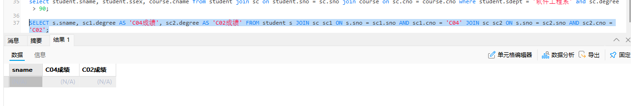
2、嵌套查询。
(1) 查询“李勇”同学所选课程的成绩。
答：代码：select course.cname as '课程名', sc.degree as '成绩' from sc join course on sc.cno = course.cno where sno = (select student.sno from student where student.sname = '李勇');
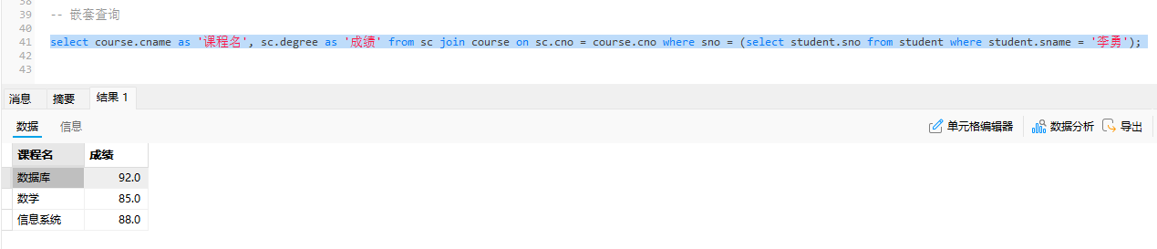
截图：
(2) 查询“李新”老师所授课程的课程名称。
答：代码：select cname from course where cno in (select cno from teaching where tno = (select tno from teacher where tname = '李新'));
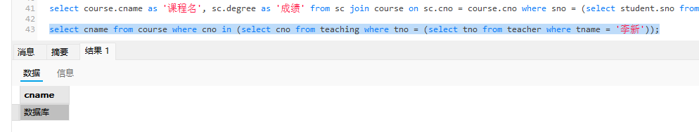
截图：
(3) 查询女教师所授课程的课程号及课程名称。
答：代码：select course.cno as '课程号', course.cname as '课程名称' from course where cno in (select teaching.cno from teaching where teaching.tno in (select teacher.tno from teacher where teacher.tsex = '女'));
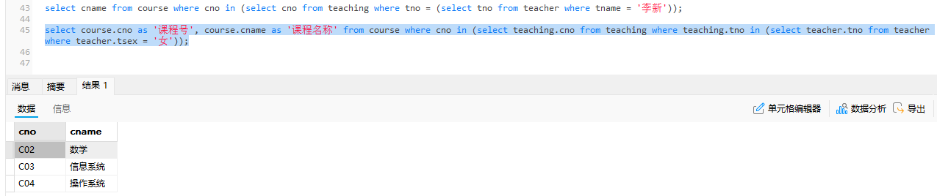
截图：
(4) 查询姓“王”的学生所学的课程名称。
答：代码：select distinct cname as '课程名称' from course where cno in (select cno from sc where sno in (select sno from student where sname like "王%"));
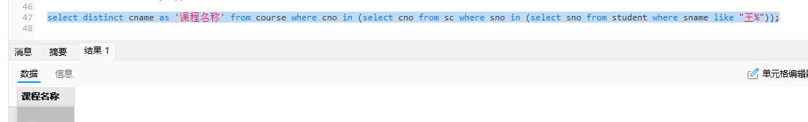
截图：
(5) 查询选修“数据库”课程且成绩在80～90分之间的学生学号及成绩。
答：代码：select distinct sno as '学生学号', degree as '成绩' from sc where cno = (select cno from course where cname = '数据库') and degree between 80 and 90;
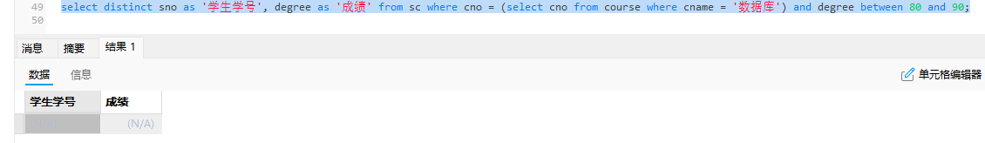
截图：
(6) 查询学习课程名为“数学”的学生学号和姓名。
答：代码：select sno as '学号', sname as '姓名' from student where sno in (select sno from sc where cno = (select cno from course where cname = '数学'));
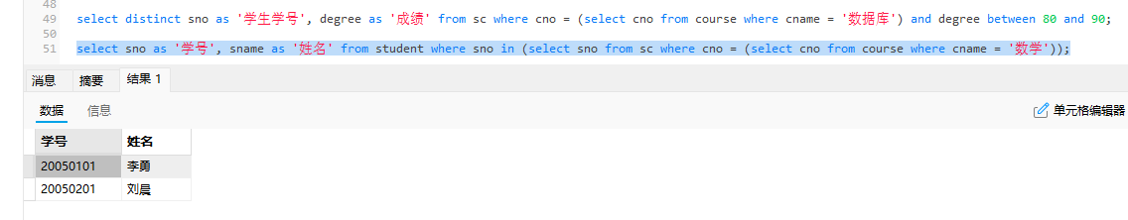
截图：
(7) 查询选修“C04”课程的学生的平均年龄。
答：代码：select avg(year(CURDATE()) - year(sbirthday)) as '平均年龄' from student where sno in (select sno from sc where cno = 'C04');
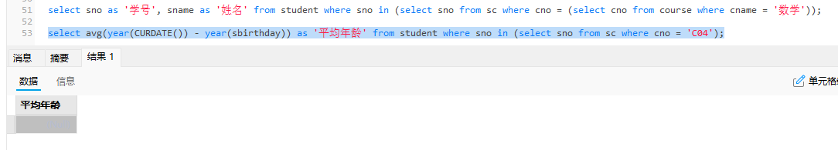
截图：

(8) 查询在第3学期所开课程的课程名称及成绩。
答：代码：select cname, degree from sc join course c on sc.cno = c.cno where c.cno in (select teaching.cno from teaching where cterm = 3);
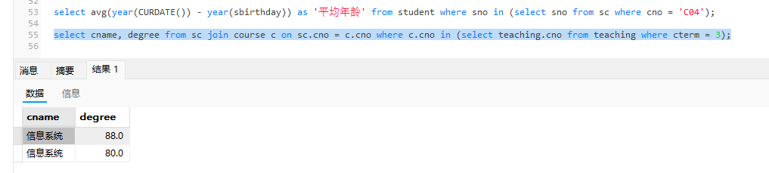
截图：
(9) 查询“钱军”教师任课的课程号，选修其课程的学生的学号和成绩。
答：代码：SELECT cno, sno, degree FROM sc WHERE cno IN (SELECT cno FROM teaching WHERE tno = (SELECT tno FROM teacher WHERE tname = '钱军'));
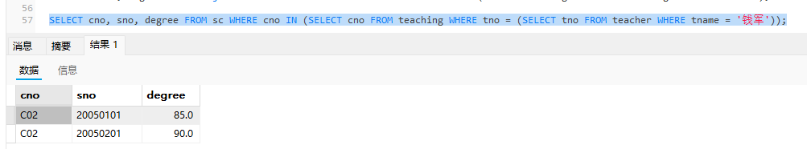
截图：
(10) 查询与“李勇”同一个系的同学姓名。
答：代码：select sname as '姓名' from student where sdept = (select sdept from student where sname = '李勇') and sname != '李勇';
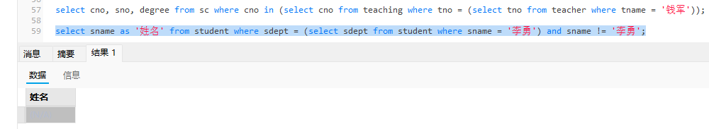
截图：
(11) 查询学号比“刘晨”同学大，而出生日期比他小的学生姓名。
答：代码：select sname as '姓名' from student where sno > (select sno from student where sname = '刘晨') and sbirthday < (select sbirthday from student where sname = '刘晨');
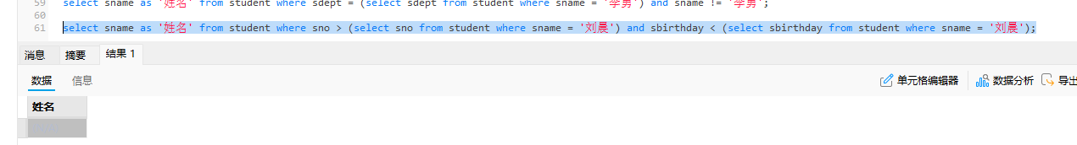
截图：

(12) 查询出生日期大于所有女同学出生日期的男同学的姓名及系别。
答：代码：select sname as '姓名', sdept as '系别' from student where ssex = '男' and sbirthday > all(select sbirthday from student where ssex = '女');
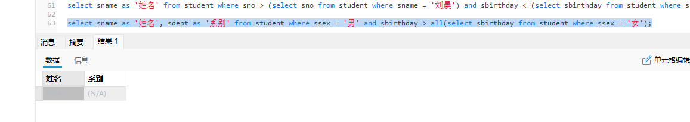
截图：
(13) 查询成绩比该课程平均成绩高的学生的学号及成绩。
答：代码：select sno as '学号', degree as '成绩' from sc a where degree > (select AVG(degree) from sc b where a.cno = a.cno);
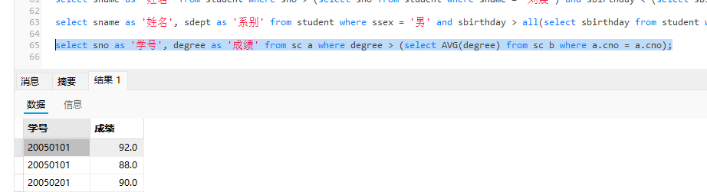
截图：
(14) 查询不讲授“C01”课的教师姓名。
答：代码：select tname as '教师姓名' from teacher where tno in (select tno from teaching where cno != 'C01');
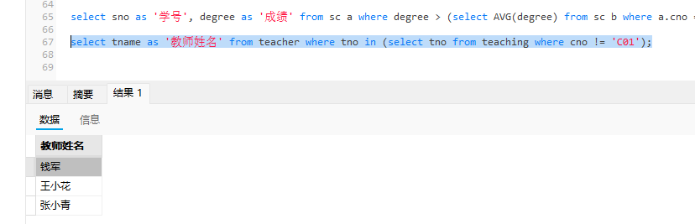
截图：
(15) 查询“C02”号课程不及格的学生信息。
答：代码：select * from student where sno in (select sno from sc where degree < 60 and cno = 'C02');
截图：
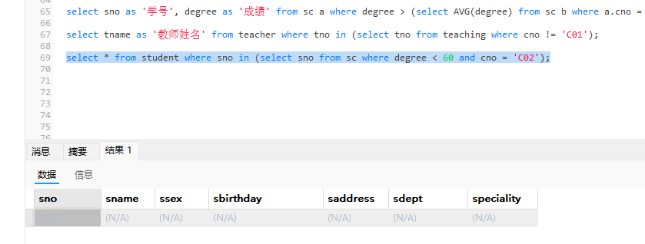
(16) 查询没有选修“C02”课程的学生学号及姓名。
答：代码：select sno as '学号', sname as '姓名' from student where sno not in (select sno from sc where cno = 'C02');
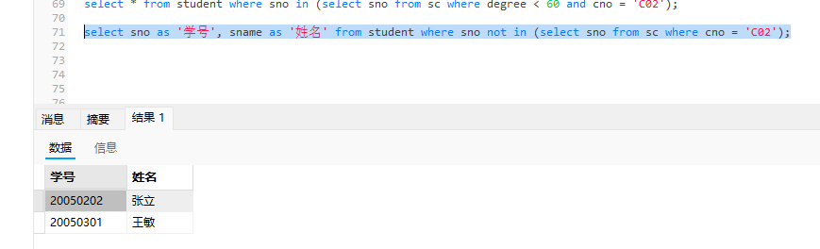
截图：
- 查询选修了“数据库”课程的学生学号、姓名及系别。
答：代码：select sno as '学号', sname as '姓名', sdept as '系别' from student where sno in (select sno from sc where cno = (select cno from course where cname = '数据库'));
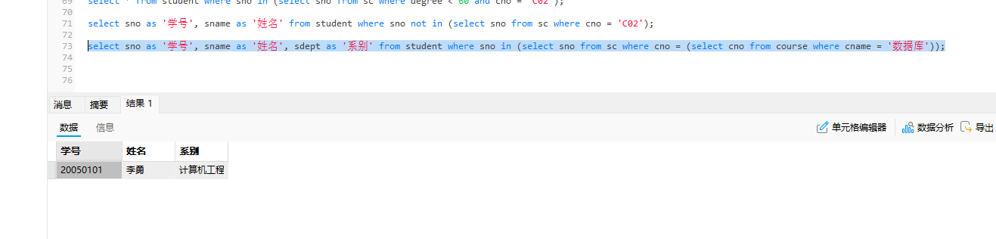
截图：

四、实验中遇到的问题和解决方法以及心得体会
(1) 指定一个较短的别名有什么好处？
答：
简化SQL语句：当表名较长或需要多次引用同一个表（如自连接）时，使用别名（如 s、sc、t）可以大幅缩短代码，提高可读性。

提高可维护性：代码更简洁，便于后续修改和调试。

区分同名字段：在多表连接时，不同表可能有同名字段（如 sno），使用别名可以明确指定字段属于哪个表，避免歧义。

(2) 内连接与外连接有什么区别？
答：内连接（INNER JOIN）：只返回两个表中匹配成功的行（即满足连接条件的记录）。如果某行在另一个表中没有匹配项，则不会出现在结果中。

外连接（OUTER JOIN）：除了返回匹配成功的行外，还会返回某个表中不匹配的行。
- 左外连接（LEFT JOIN）：返回左表所有行，右表无匹配时以 NULL 填充。
- 右外连接（RIGHT JOIN）：返回右表所有行，左表无匹配时以 NULL 填充。

(3) “=”与IN在什么情况下作用相同？
答：
当子查询返回的结果集只有一个值时（即标量子查询），= 和 IN 的作用相同。
例如：WHERE sno = (SELECT sno FROM student WHERE sname = '李勇') 和 WHERE sno IN (SELECT sno FROM student WHERE sname = '李勇') 效果一样。
但如果子查询返回多个值，则只能用 IN，不能用 =。

(4) 子查询一般分为几种？
答：
1. 按结果集维度：标量子查询（返回单值）、列子查询（返回一列多行）、行子查询（返回一行多列）、表子查询（返回多行多列）。

2. 按与父查询的依赖关系：
不相关子查询：子查询可以独立运行，不依赖父查询的字段。
相关子查询：子查询的执行依赖于父查询的当前行（如带有 EXISTS 或比较运算符引用外部表字段）。

(5) 相关子查询的执行过程是什么？
答：
- 首先执行父查询，取出第一行数据。
- 将该行数据中与子查询相关的字段值（如 a.cno）代入子查询中，执行子查询。
- 根据子查询返回的结果判断该行数据是否满足父查询的条件（如 WHERE degree > (SELECT AVG(degree) FROM sc b WHERE b.cno = a.cno)）。
- 如果满足，则将该行加入结果集；否则丢弃。
- 然后父查询继续取下一行数据，重复上述步骤，直到父查询的所有行都处理完毕。

