W2_Intro_to_Time_Series_Analysis

Yansong Liu

5/6/2020

autocovariance coefficents

rnorm() routine: r:random - norm:normal random variables -rnorm(100): generate 100 data points from standard normal distribution -100 data points->dataset(SRS) ts() routine: take the dataset generated - put time series structure on it -indexed set of r.v. put some transparent structure on it - no special pattern in that time series -> purely_random_process print - time series object

purely_random_process = ts(rnorm(100))  
print(purely_random_process)

## Time Series:  
## Start = 1   
## End = 100   
## Frequency = 1   
## [1] -1.258004303 -0.664646796 -0.321238711 1.182276153 -0.438042149  
## [6] 0.570846322 0.952614473 -3.152558828 1.537414399 -1.066274410  
## [11] -1.201656893 -0.360116224 1.077045183 1.053807590 -1.433389771  
## [16] 0.371258563 -0.106122565 0.221704168 -0.830723470 0.596882120  
## [21] -0.163143576 -0.010101002 1.045818775 0.459424370 0.245713523  
## [26] -0.217395403 0.558492543 -2.967693065 0.604091194 0.365814914  
## [31] -0.211424173 -0.388188483 1.577140452 0.176569615 -1.362573075  
## [36] -0.110836033 1.069749640 -1.386537416 -0.723881976 1.139752893  
## [41] -1.184393996 0.151697953 -0.227224869 2.011960014 0.260173876  
## [46] 0.305885551 1.551397190 0.097363483 -1.701671202 -0.266173952  
## [51] 0.899735356 0.356084868 1.063722794 -0.538998189 -1.387952981  
## [56] 0.623284738 0.220813601 1.596265825 1.241138834 -0.200879991  
## [61] -0.420427160 -0.903473186 0.385200130 -0.192503598 0.001608930  
## [66] 0.442079519 -0.627133048 0.310409068 -1.633151885 0.155059655  
## [71] -1.464476810 -0.381344899 -0.991172968 -0.164717159 0.467212105  
## [76] 2.162408656 0.778499114 -2.727771567 -1.885786663 -0.426350557  
## [81] 0.352404471 -0.008893172 -1.832139178 0.180821133 -0.718425255  
## [86] 0.109204745 0.734104874 -1.973454215 2.136287164 -1.642257595  
## [91] 0.149439389 0.875051110 -1.107832300 0.402127391 2.259144608  
## [96] 0.033377814 -1.116129476 -0.555056150 0.105146699 -1.027867448

acf() routine - usually give plot -process, put specific pattern:autocovariance function - gamma(k), k:diff lag -give autocovariance coefficient at every lag

acf(x = purely_random_process, type = 'covariance')

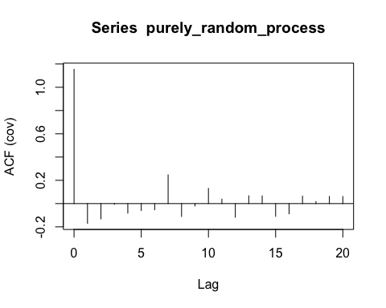

(acf(x = purely_random_process, type = 'covariance'))



##   
## Autocovariances of series 'purely_random_process', by lag  
##   
## 0 1 2 3 4 5 6 7 8   
## 1.1544 -0.1694 -0.1317 -0.0066 -0.0823 -0.0594 -0.0528 0.2469 -0.1108   
## 9 10 11 12 13 14 15 16 17   
## -0.0202 0.1307 0.0387 -0.1174 0.0670 0.0663 -0.1093 -0.0882 0.0647   
## 18 19 20   
## 0.0174 0.0614 0.0611

Correlogram -purely_random_process -give a title : ‘correlogram of a purely random process’ -give a plot - correlogram -give autocorrelation coefficent at every lag r0 = 1 - always start 1 -later: do not have much correlation between diff. lags - generate data as purely random process -dashline: significance level -plots: not much significant lags in the previous steps - 2 - chaos

acf(x = purely_random_process, main = 'Correlogram of a purely random process')

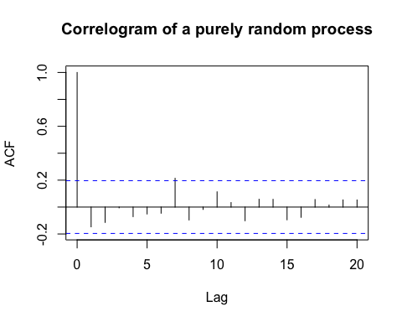 put () - get plot + autocorrelation coefficents

(acf(x = purely_random_process, main = 'Correlogram of a purely random process'))



##   
## Autocorrelations of series 'purely_random_process', by lag  
##   
## 0 1 2 3 4 5 6 7 8 9   
## 1.000 -0.147 -0.114 -0.006 -0.071 -0.051 -0.046 0.214 -0.096 -0.017   
## 10 11 12 13 14 15 16 17 18 19   
## 0.113 0.034 -0.102 0.058 0.057 -0.095 -0.076 0.056 0.015 0.053   
## 20   
## 0.053

x = NULL  
x[1] = 0 # start point is 0  
  
# start from previous step - add some noise to it  
# for:generate 1000 data points-dataset  
# noise - standard normal r.v. - rnorm, add 1 noise to it - rnorm(1)  
for (i in 2:1000) {  
 x[i] = x[i-1] + rnorm(1)  
}   
  
# generate datasets  
#print(x) # have thousand data points - do not have time series structure on it  
random_walk = ts(x) # transform a dataset to a time series - have random walk:time series object  
  
# plot  
plot(random_walk, main = 'A random walk', xlab = ' ', ylab = 'Days', col = 'blue', lwd = 2)

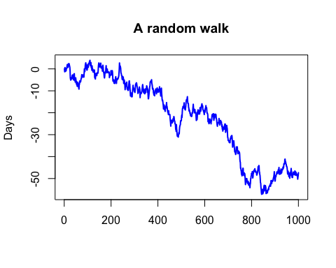

#typical time plot for a random walk  
#random walk - normal r.v.- non-stationary time series - not make sense to find acf to it

acf(random_walk) #there is high correlation in 30 lags - no stationarity

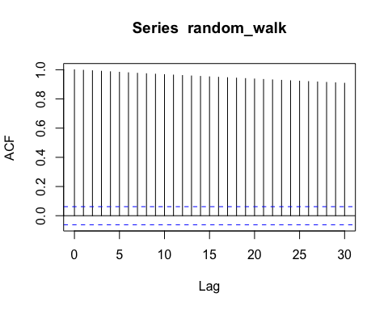

diff(random_walk)

## Time Series:  
## Start = 2   
## End = 1000   
## Frequency = 1   
## [1] -1.3163977673 1.9148291945 -0.3941363040 -1.3513032498 1.1372624852  
## [6] 0.0775555403 -0.9550970626 1.1292909464 -0.1869758755 0.4081963439  
## [11] 0.7833545134 0.7210002563 -0.5291772638 -0.6076352628 -0.1555824896  
## [16] 0.5026363850 1.1926150438 -0.9973984889 0.3836451966 0.5997498669  
## [21] -0.6925923923 -0.3861741614 -0.6103830195 -1.5289659017 -3.1795757848  
## [26] -0.7367752810 -0.3519822377 0.6247234470 0.5303262249 -0.6590070461  
## [31] 0.0003166876 0.1376769429 1.5106133088 -0.2534997883 0.5032142252  
## [36] -0.5648357351 -0.4956294873 -0.5118482282 -0.7457341208 1.7134912975  
## [41] 1.0967355532 0.0596453453 -2.3541548073 -0.7507411053 0.7126798969  
## [46] -1.4334701839 1.2422581171 0.6956413906 -0.9668610392 -1.1165098771  
## [51] -0.7900168708 1.2282586630 -0.4923477725 -1.6146773539 -0.1510879643  
## [56] 1.2092474846 0.5291106901 -0.5822866840 -0.0938312558 -0.3570122942  
## [61] -1.5369434374 -0.4283877330 2.1952549473 -0.0210355179 1.5267765844  
## [66] -0.6666660998 0.5903312805 0.0434992455 -0.3375971925 0.7521911557  
## [71] 0.6578300169 -0.0055883141 0.9888847789 0.8969202742 -0.1815688464  
## [76] -0.0035367572 -0.5285840789 -0.4472131833 0.6902535942 0.3504472577  
## [81] -0.1389118341 -0.3621522706 -0.5122042955 1.6843272288 2.0699566734  
## [86] -0.2185456777 -1.0206437206 1.0414635245 1.8658209100 0.7252037480  
## [91] 0.3721362139 -0.6990055790 -0.0856377789 -1.8913040198 0.0123934401  
## [96] -0.6944080823 0.0994221462 0.7669255879 1.3014853930 0.4890908683  
## [101] -0.8346014163 -0.5034895284 1.4471136252 0.4334759198 -0.2948068194  
## [106] 0.1672129651 1.0511558604 -0.7371968524 1.1145344273 -1.8896135077  
## [111] -0.5575746730 1.0135295673 0.3984139111 -1.8759167952 -0.5487598706  
## [116] 0.6443649597 -1.7428002483 2.0285577560 -1.5046717932 0.2892786861  
## [121] -0.8333489388 -0.7589330625 0.4054529494 0.5216479057 -0.9853961165  
## [126] 0.9771755683 -1.1741241284 1.1550683038 -3.2109561254 -0.4630500507  
## [131] 1.4051779505 -1.8413575804 1.5127252335 0.7132678213 0.4070742883  
## [136] -0.9647070993 0.5960445256 -0.7084815319 0.7332890304 0.2443195346  
## [141] 0.4009080804 0.0979125837 -0.3379701084 1.3695111471 1.7492607480  
## [146] 1.0893529155 0.4595383942 -0.5935625884 0.1333791894 -1.3861514231  
## [151] 1.1974542436 0.1168802203 -0.4449346376 -0.4765104511 1.3484332696  
## [156] -2.1705077897 0.4851033055 -0.5991332784 0.6599583510 -0.5516712636  
## [161] -0.3008033213 -1.1780300041 1.7551230564 0.9584857937 -0.7836629737  
## [166] -1.6454207072 -0.8542487853 -0.0291802447 -1.0341928219 -1.1715956097  
## [171] -0.2996995823 0.9171594304 1.6785093912 -0.5312607870 0.9208316629  
## [176] -0.2656603360 1.8555701930 1.0191144725 -1.8196402897 0.0686549061  
## [181] -1.4755154678 1.4217029046 0.2848087278 -1.5477150750 0.1802143360  
## [186] 0.2176035494 -0.1789541638 -0.3475827334 -0.1616891231 0.4813924303  
## [191] -0.1051731546 -2.4601535991 0.8206884882 -0.0873083366 0.1294179680  
## [196] 0.3068785922 0.0571035338 0.2047466726 1.6644102193 -1.8935824586  
## [201] 0.0508853023 0.5019690147 0.3133225803 1.1224194982 -0.5728690901  
## [206] -1.8154198923 -2.3644039114 0.8026486786 -0.3398948225 -0.0415950863  
## [211] -1.0284362842 -0.3905407215 1.3612861526 -0.4345429482 -1.0305549673  
## [216] 1.6378391441 -0.6915681758 1.7754209603 0.3641242187 -1.5021667468  
## [221] -0.5810475822 -0.9865489826 1.5300669125 -0.0166599119 0.3076346204  
## [226] 0.4428704410 -0.4643847663 0.5491094230 -0.2180139884 0.4221720236  
## [231] 0.4568471668 0.4846427141 1.3185620681 1.7757609186 2.7442790080  
## [236] -1.2435690108 -0.2899991491 0.1734216081 -0.5109572103 -0.4614893033  
## [241] -1.8919338752 -0.5785484799 -0.2111712464 -0.7834459779 -0.0942570490  
## [246] -1.2017723516 -0.4992047804 -0.0507531365 1.4980999584 -1.4825259998  
## [251] 1.1397482809 -1.0324453950 -1.7955836319 -0.0709028002 1.6470447910  
## [256] -0.4062454403 -0.9296918669 -1.2461415167 -1.8657551623 1.5160280977  
## [261] 0.1516730764 1.2336993303 -1.2867877838 0.3912747383 0.2986353909  
## [266] 1.1443951617 -2.3635374308 -0.8467207036 0.5233689446 0.2313077894  
## [271] -1.3018099115 -0.0410614235 0.1215692991 1.6797517959 1.0857838108  
## [276] 1.3511115983 0.1321220964 -1.5034188565 0.0087019658 -2.2926803125  
## [281] -1.0906792363 -2.0154181427 1.1046102082 0.3275906574 -0.7023253183  
## [286] -1.0727597411 0.3715305823 0.4387832566 -0.8202636726 1.7710534084  
## [291] 1.2316802466 1.1219093948 1.0944231581 -1.5697204674 0.3680840829  
## [296] -0.7894806720 0.6681767076 -1.4391818709 0.6388685090 -0.9126724522  
## [301] -0.2286044368 1.2931236697 1.4637832904 1.1038346375 -0.6458155620  
## [306] 0.8897905176 0.3259430667 -0.1173918919 -0.8124606450 -0.7406182950  
## [311] -0.3742013784 -0.7235997784 -1.2171672979 -0.9099060623 0.7130006756  
## [316] -0.2165883070 1.2974924941 0.0450148942 -0.1468152337 1.2808054598  
## [321] -0.6136159921 -0.5029338468 -3.7478723013 1.7208350363 -0.1118171098  
## [326] 0.7372319663 -0.2093352529 -0.2574519102 0.4740996511 0.3071618369  
## [331] 0.8116487538 0.7973811632 1.1603566843 0.5366918622 -0.9221008448  
## [336] -0.9748704733 -1.5376679425 1.3169858563 -1.7314496279 0.6205720929  
## [341] 0.6747966945 -0.9802602523 -0.6944904634 0.9840671200 1.2608520256  
## [346] -0.0116560059 -1.6751090995 1.5503809300 -0.0201854876 0.3503529188  
## [351] 1.2083079490 -0.1596192179 -1.2366554708 0.3910727219 -1.9762937476  
## [356] 1.4106946938 -2.4490601365 -1.8965848530 0.0292847081 1.0175892489  
## [361] 0.9991549209 1.2108306596 0.7875750176 1.6185846945 0.0749761670  
## [366] 1.9074295900 -0.1147179899 0.4933307438 -0.3783910813 0.5365829628  
## [371] 0.1145039850 0.4197754059 -1.6229435935 -0.4119682568 -0.7090099004  
## [376] -1.5373973846 0.0849645220 0.2614494166 -0.5936134435 -1.3297376829  
## [381] -0.4458366585 -0.7061505746 1.0470889648 -1.0290457728 -0.3509861354  
## [386] 1.7832189075 0.6628832792 -0.0321576932 0.2595816524 0.4357418123  
## [391] -0.0067569106 -1.1658960227 -1.0460174830 1.0369471714 0.8924932984  
## [396] 0.7566779822 -1.0178813457 -0.8770143934 1.2665467189 -0.1395861430  
## [401] -0.7578387976 -0.3601187081 0.8536496608 -0.0208917219 0.6441162480  
## [406] 0.9616771959 -1.5387408119 -0.1261682586 -0.9408834684 -0.2868381764  
## [411] -1.3207526157 2.1494888730 1.3120255366 0.1206465176 -2.2935649998  
## [416] -1.2329230366 -1.5712632730 -0.6807031355 0.3373690191 -0.6901837274  
## [421] -0.8462341056 -1.0295798244 -1.5021375577 0.4308376923 0.6033558749  
## [426] 0.7643491096 -1.3111310732 -0.9444492682 0.0335197622 -0.6722766429  
## [431] 1.4404637302 0.6373122878 -0.5610630783 1.1195577033 0.0938829604  
## [436] 1.2895329115 -1.7861667332 0.0381188041 -0.9237023540 -0.8333819343  
## [441] -0.8899997849 0.5414738961 -1.2270877743 -0.4134325174 1.7432005655  
## [446] -1.7238644475 0.0376035734 -0.0928940504 0.0468405882 0.0515759653  
## [451] -1.5345378177 -1.2420611006 -0.9371762827 -1.6030094978 1.6527382620  
## [456] 0.5067551623 -0.1825046129 0.7680432767 -0.1645826834 -1.1393798408  
## [461] 0.5469066339 0.6346693626 -0.6629278337 1.4623033847 -0.6552263111  
## [466] 0.3512879614 1.2592322910 -0.2545061332 -1.0574127731 -0.8677517734  
## [471] 0.0778665590 -1.2191245179 0.1352988270 -0.8393238267 -1.8104738075  
## [476] -0.1648331465 -0.7744660703 3.0636038021 -1.9258928356 -0.7929185164  
## [481] -1.8317199059 -0.7132190714 0.1941502316 -0.0223979298 -0.4218800690  
## [486] -0.1580535127 0.9437609634 0.8078159307 0.4011139817 -0.6693557712  
## [491] 1.9833347264 1.1547191197 0.5206545435 0.3059516002 0.3002423947  
## [496] 1.7275485080 -0.1424691309 0.1045630438 0.0851447193 1.6010323674  
## [501] 0.9784194784 -1.1131268284 2.1941868849 1.8727723223 0.0324893297  
## [506] 0.8381183238 0.0873861359 -0.0793286116 -0.4650361760 1.1562925820  
## [511] 1.0171907761 -2.5844649999 -0.2044346874 0.0466229925 -0.2765451705  
## [516] -0.2678363244 0.8444101583 0.8111222033 1.6338488688 0.9780899212  
## [521] 0.4469897932 -0.2276442317 -0.0473164399 1.0060193182 0.6461230054  
## [526] -2.0389959901 -1.0139838785 -0.0468478742 -0.0377146208 -1.8486061303  
## [531] -0.1222303659 -1.4370317842 0.5674797328 -0.3636562748 -0.5074258704  
## [536] -0.8534911714 0.3830237329 -1.1006637144 -0.3674348462 0.3832852432  
## [541] 0.0773174903 -0.7168842588 0.0125105381 0.1406579134 1.5292954851  
## [546] 0.1025604853 -0.2851141671 1.7813591359 1.1669250780 1.1301272188  
## [551] -1.7790971651 -0.3933233186 -0.0016670253 -0.8987072670 -0.8206242169  
## [556] 0.3723637733 1.1205040350 -1.2523299223 -0.3781986458 0.0876561369  
## [561] 0.1738280699 -1.9124081335 -1.7136173120 0.1682112616 0.2253285248  
## [566] -0.0162534168 1.1143412993 2.4065077623 -0.2711803187 1.2225342383  
## [571] -0.1838095153 -0.9755088482 -0.7715563255 1.5002447974 0.1157303837  
## [576] -0.2493312184 -1.3215847385 0.7132111979 2.1901121720 -0.0920365737  
## [581] -1.4539260251 -0.0835428294 0.9948967205 0.9385507700 0.4865809305  
## [586] 0.5251180255 0.4223195652 -0.6055789863 -0.8283690313 0.5045797613  
## [591] -1.7543616608 -0.0200159104 -0.4317484304 -0.4404488971 0.0532016092  
## [596] -0.8438350001 -0.5302046550 1.7526965405 0.1616484228 -0.8621075429  
## [601] 1.3958656699 0.5311859595 -0.0671827591 1.1477176870 -1.3152670075  
## [606] 0.3446179738 0.0432925642 -1.6608947645 -0.8652904767 0.1164618881  
## [611] -0.3520736942 -0.5003131209 -3.1046580279 0.9405562233 0.3473861949  
## [616] -1.8211553415 -0.4073500221 0.1002089637 0.3827472211 0.1599343505  
## [621] 1.4751190449 -0.7101802845 0.1175028181 0.0125293240 -0.7170680916  
## [626] -0.8881258798 1.3683974481 -0.0387325586 1.0008962756 1.5467912854  
## [631] 0.3841387092 0.0002757989 -0.4242478696 0.6377248211 -1.1901669044  
## [636] 1.3369782141 -1.8558111570 -1.1461668052 0.8585793512 1.8812751495  
## [641] -1.6967566412 1.1181375475 0.1597643339 -0.1692276588 0.6469186886  
## [646] -0.1416185704 -0.0892225968 -1.5498540013 -0.3084927706 -0.7200445056  
## [651] -1.2028143590 -0.9082652956 -0.5971709890 1.0763161268 -0.0948663725  
## [656] 0.5954205693 0.1703962385 -0.1194559857 0.2138381286 1.6976154459  
## [661] -1.6436850482 -0.2922619437 -1.0394003761 0.5594809522 0.8316783145  
## [666] 0.7085134898 -0.0513469182 -0.4602242502 -0.1056215246 -0.0235698126  
## [671] -1.1158140316 -1.1130107245 0.8432364511 -1.9761168530 1.1965446909  
## [676] -2.0725214379 0.3189182227 1.0841322315 -0.3437731657 0.2135956752  
## [681] 0.5637648589 -0.9813686145 1.3862696526 0.4948712830 0.5162878152  
## [686] -1.1700691228 1.0788888364 -3.7184565641 0.5409488716 1.1427433568  
## [691] 0.4717888895 0.1646806767 0.8165161287 -0.9869503001 -0.4280470463  
## [696] -2.0033662949 -2.0788312545 -0.0568532750 -1.2303499648 -0.1377770946  
## [701] -0.1179804617 0.1813710001 -0.6625076036 -0.3004150560 0.2889915623  
## [706] -0.2864973364 -0.0680871905 1.8598494335 0.2900521092 -0.4476819033  
## [711] 1.1379846672 0.0745543304 0.2641341325 -0.3928063495 0.5077628762  
## [716] -1.1418833514 -1.8983952806 -2.2476928453 0.8195304049 0.6203324749  
## [721] 0.2192791459 1.1685637255 0.0483547028 -1.2280360088 -1.4818142772  
## [726] -0.8559761001 -1.4083665567 -0.1730496801 -0.2184271693 -0.1313977064  
## [731] -0.7406030085 0.2777755269 1.6909514140 1.4933773539 -1.2469176452  
## [736] 1.0798990073 -1.0467117993 1.2336897633 -1.7392281969 -1.1637333806  
## [741] -0.2515016413 0.6396505941 0.6609039000 -0.1742578948 -0.1732847879  
## [746] -0.6013325369 0.3390915516 -0.7105687834 -2.3650444313 -1.1783948845  
## [751] -0.3569599001 -2.7076923845 0.2125054043 -1.1586973204 -0.3065611922  
## [756] -1.5093994479 1.7422572367 -2.4230103248 0.1501896239 2.1170500385  
## [761] 0.1175901152 1.1100596104 -0.0426917694 -2.5060550466 -0.3150520563  
## [766] -0.4896834626 1.0946281809 0.0858001752 -0.7523071950 0.3888460458  
## [771] -1.1730022849 -2.2040079808 -1.5547155231 1.4700251117 0.9700944650  
## [776] 0.3272233196 -1.0910122202 0.7393442422 0.2707034367 -1.5159734548  
## [781] -0.3488668294 -0.3053882157 0.2696063238 0.7472117694 -0.2585465593  
## [786] -1.4330319697 0.9721207944 -0.6442658057 -0.5889975593 1.0314805870  
## [791] -1.2645659159 -0.7825192576 1.4801076068 0.4728237646 2.1875178511  
## [796] -0.0847293013 1.2574221035 0.1384926960 0.9943297754 -0.0427310949  
## [801] 0.2765848944 0.6653797473 -0.5492069720 -2.3580398312 0.4256304859  
## [806] 1.6528911244 -0.0019720114 1.1145089975 0.3637974147 -0.4297525568  
## [811] -0.0535020833 0.7328663084 0.4211726317 -0.6793815301 -0.8202791275  
## [816] 0.0604348655 0.3795588585 -0.5484671817 0.0903136513 -0.3704393312  
## [821] -1.0195531575 0.0562780445 0.8335011200 -0.0846261532 1.0226167205  
## [826] 0.7156221707 1.3032159675 0.0006479411 -1.5476983024 2.0765834385  
## [831] -0.2111940894 -2.7897493468 0.0361882242 -1.1517475215 -0.3887204888  
## [836] -1.6085594748 -1.6810014455 -0.3282462776 -1.8097154677 -0.9324489739  
## [841] -1.5754169880 -0.6956730638 1.9715665067 -0.7423186785 -0.8661130504  
## [846] 1.8779581986 -2.0170020470 1.3368739366 -0.8983487419 1.3317731367  
## [851] 1.0334187559 0.7253221974 0.3708478019 -2.5606549049 1.0621802964  
## [856] 1.0881098284 -1.0625235184 1.3172024213 -0.4818138718 -0.6387414296  
## [861] -2.5165185316 0.4636073542 0.6752651073 0.1841968013 -0.0315343797  
## [866] -1.0257866748 0.3902377731 0.5654601150 0.6148417478 0.2816967976  
## [871] -0.1063388363 -0.2461008228 1.2368336666 0.1885049436 0.0260419991  
## [876] 0.4021295062 0.0705318324 0.1793824449 0.5191713695 -1.0513715410  
## [881] 1.0210689982 1.5646777833 -0.0453845257 -0.2524872334 -1.0903532539  
## [886] 1.4067322889 0.0411690038 -0.1385891981 -0.3300523872 0.6411924464  
## [891] -0.1512795552 1.0757900898 0.2370986251 0.5457097230 0.7506385547  
## [896] 1.3604597253 -1.7952155603 -1.3136752027 -1.1344403195 0.0872358241  
## [901] 1.6772958192 0.6400512196 -0.4585380781 0.8694317851 0.2452017663  
## [906] 0.2313732259 0.8623531473 -0.5669875296 0.0458118029 0.1567660940  
## [911] -0.3982091492 1.0764300721 0.6599372099 -0.4198577247 0.5004444556  
## [916] 0.9683911198 -1.7984682619 -1.3085260876 0.3867464855 0.5922356421  
## [921] 0.6992225298 -0.8615639028 -0.6897700350 1.2303406915 1.0648054568  
## [926] -1.2607321354 -0.5929336709 0.4279347481 1.0386962366 0.1800065289  
## [931] -0.0366361548 -0.1204233498 1.2156431224 -0.3530384051 -0.1521326784  
## [936] 0.5151675292 1.5483034079 -0.3867085208 0.2444913917 0.0879461854  
## [941] 2.0368590188 0.1113296294 -0.9903336876 -0.1557920824 -0.4420680431  
## [946] -0.6777267166 -0.1410945058 -0.8779860963 0.0374155895 -0.3545996207  
## [951] -0.7740396857 -0.9859647921 -1.4399877535 0.5908576163 0.7133436925  
## [956] -0.5744229657 -0.5935310520 -1.2659473186 1.4952931171 -1.6701157026  
## [961] 0.3827522450 -1.0025988648 2.4792393871 -1.3964424861 0.6425997326  
## [966] 1.1327302715 0.5343603853 1.0707302355 -1.3127686969 -0.8691814765  
## [971] -1.1124703079 -0.8317253170 0.2096910547 -0.2209612220 1.4426207348  
## [976] 0.0661675879 0.9825172336 -0.0779859059 -0.2786359277 -0.5736743304  
## [981] -0.2972489632 0.9476917173 0.0542162147 0.7240617401 -0.6122571591  
## [986] 0.3137194251 -1.6846015266 0.6495424568 0.6701366888 -0.8108327158  
## [991] 0.1999019892 -0.1630265939 -0.7058776142 0.2698814615 -0.8097279763  
## [996] -1.0551148749 0.8979806070 0.6863503936 1.3528015510

#difference operator   
#-give difference of 1: X2-X1, X3-X2...X1000 -X999 - miss 1 at beginning   
#-have another time series: differences - purely random process  
  
plot(diff(random_walk)) # get like white noise

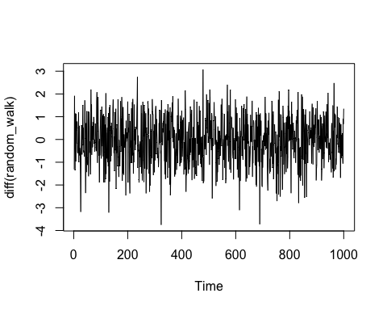

acf(diff(random_walk))

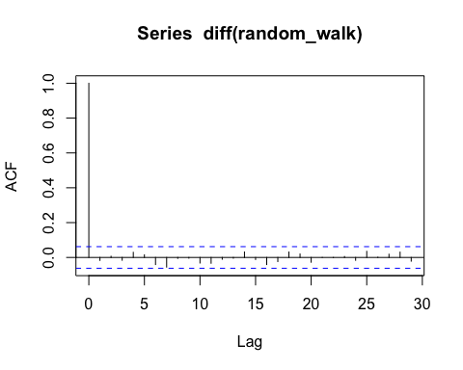

# generate noise  
# generate 10000 data points from standard normal distribution  
noise = rnorm(10000)   
  
# introduce a varible  
ma_2 = NULL  
  
# loop for generating MA(2) process  
# i: index in loop  
# Z3 - Z2, Z1 - start from index 3  
for (i in 3:10000) {  
 ma_2[i] = noise[i] + 0.7*noise[i-1] + 0.2*noise[i-2]   
}  
  
# generate a dataset - first 2 points are missing   
# shift all by 2 units to the left  
# a new process: moving_average_process - still data points,do not have time series structure on it  
moving_average_process = ma_2[3:1000]  
  
# put time series structure on a vanilla data  
# ts operator - make it a time series   
# put back to moving average process  
moving_average_process = ts(moving_average_process)  
  
# partition output graphics as a multi frame of 2 rows and 1 column  
par(mfrow = c(2, 1))  
  
# plot the process and plot acf  
plot(moving_average_process, main = 'A moving average process of order 2', ylab = ' ', col='blue')  
acf(moving_average_process, main = 'Corellogram of a moving average process of order 2')

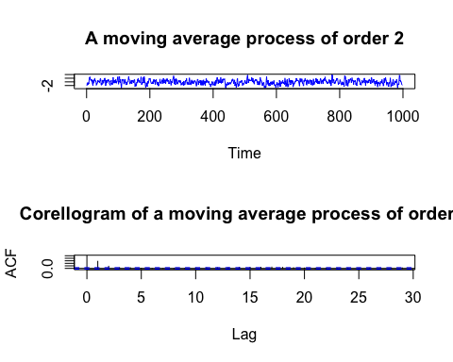

# high correlation in lag1 - still get noise from previous step  
# high correlation from 2 days back - then there is nothing  
# acf - correlation will cutoff at lag(q) - reason to model data using MA process