Các lệnh cơ bản thao tác với Docker
1 | docker –version  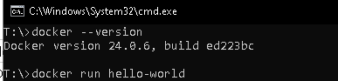
2 | docker run hello-world  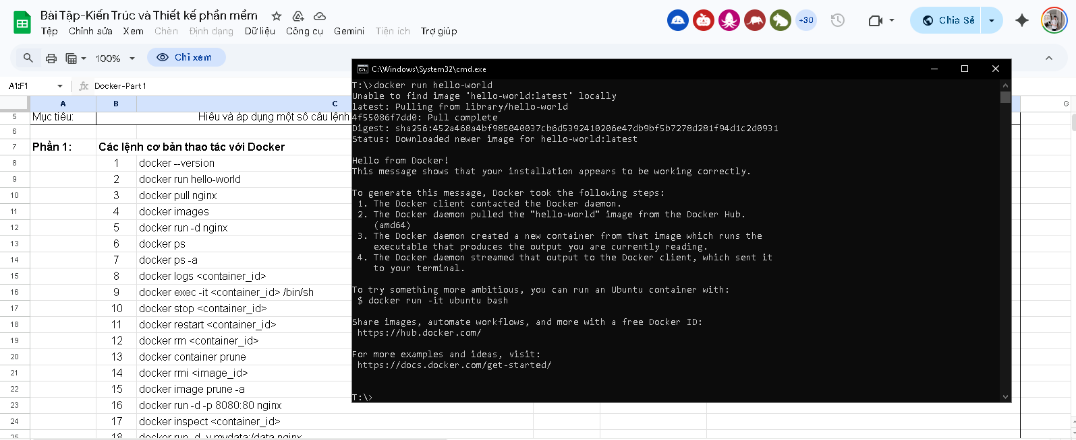
3 | docker pull nginx  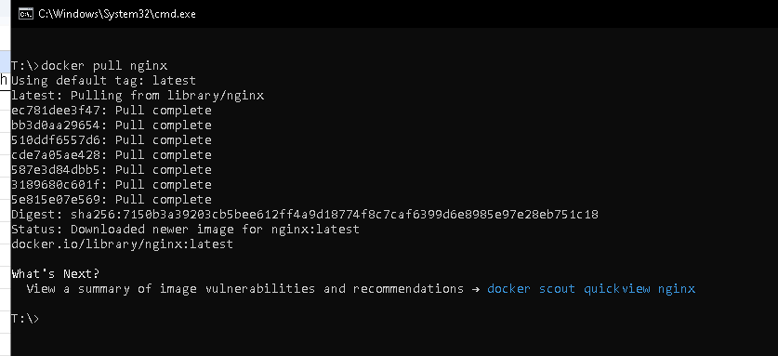
4 | docker images  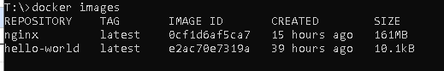
5 | docker run -d nginx  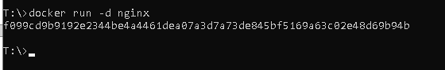
6 | docker ps  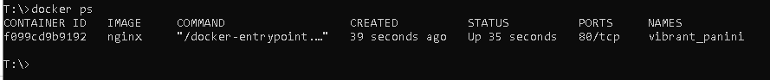
7 | docker ps –a  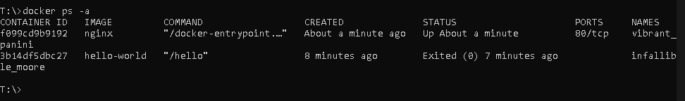
8 | docker logs <container_id>  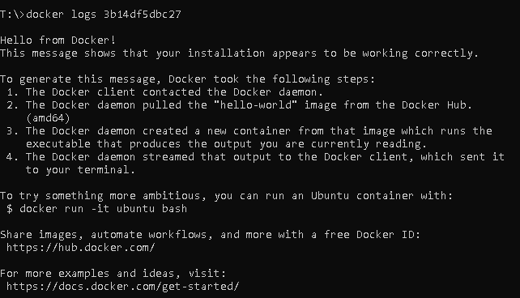
9 | docker exec -it <container_id> /bin/sh  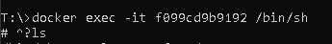
10 | docker stop <container_id>
11 | docker restart <container_id>
12 | docker rm <container_id>
13 | docker container prune
14 | docker rmi <image_id>
15 | docker image prune -a
16 | docker run -d -p 8080:80 nginx
17 | docker inspect <container_id>
18 | docker run -d -v mydata:/data nginx
19 | docker volume ls
20 | docker volume prune
21 | docker run -d --name my_nginx nginx
22 | docker stats
23 | docker network ls
24 | docker network create my_network
25 | docker run -d --network my_network --name my_container nginx
26 | docker network connect my_network my_nginx
27 | docker run -d -e MY_ENV=hello_world nginx
28 | docker logs -f my_nginx
29 | FROM nginx
 | COPY index.html /usr/share/nginx/html/index.html
30 | docker build -t my_nginx_image .
31 | docker run -d -p 8080:80 my_nginx_image

