
INTEGRATED HR & PRODUCT SYSTEM
Final Release Document
SWP391 - Team 6 | Class SE20A07
Release Version 1.0.0
– Da Nang, July 2026 –

Document Control
Field | Value
Document title | Integrated HR & Product System (HRP) - Final Release Document
Document version | 1.0.0
Release status | Submission build; ready after closure of the release gates in Section 10
Project / group | SWP391 RBL Project - Team 6
Course / semester | SWP391 (Software Project) - Summer 2026
Prepared by | SWP391 Team 6
Source package | integrated-hr-and-product-system-recruitment.zip
Repository | https://github.com/ldanh270/integrated-hr-and-product-system.git
Branch / commit | feat/recruitment / 8ac5fc07791a3c2c8196713a039a5b823eb89210
Class / lecturer | SE20A07 / Nguyen Thi Hanh

Revision History
Version | Date | Author | Description
1.0.0 | 24 Jul 2026 | SWP391 Team 6 | Comprehensive final-release document generated from the supplied source baseline.

Team Members and Submission Metadata
Full name | Student ID | Project role | Main responsibilities
Lê Đức Anh | DE190254 | Tech Lead / Full-stack Lead / Recruitment Lead | System architecture, backend/frontend integration, Prisma schema and migrations, recruitment subsystem, employee/contract flows, routing, UI standards, seed data and release coordination.
Tạ Thị Bích Loan | DE190707 | Backend & Security/RBAC Developer | Authentication service, employee service fixes, security controller, RBAC permission updates, application hooks, type safety, deployment lint/build fixes and backend tests.
Trần Phước Đoàn Nhật | DE190483 | Backend & Project/Attendance Developer | Backend services, repositories, controllers, schemas, migrations, seeders, project/task workflows, attendance-related implementation and service tests.
Đỗ Xuân Thắng | DE190405 | Capacity Copilot & Attendance Developer | Capacity Copilot backend/frontend, cron and forecasting logic, part-time availability assignment, PT shift suggestion utilities, tests and documentation.
Nguyễn Ánh Tuyết | DE201074 | Frontend & Feature Integration Developer | Frontend pages/components, hooks, backend service support, schemas, configs, route/API integration, tests and UI fixes across feature modules.

Table of Contents
Document Control | 2
1. Executive Release Summary | 4
2. Deliverable Package | 6
3. Release Architecture and Technology | 8
4. Installation and Configuration Guide | 11
5. Release Verification and Quality Evidence | 15
6. Representative Release Interface | 18
7. User Manual | 23
8. Key Status Dictionary | 33
9. API Module Inventory | 34
10. Known Limitations, Risks and Release Gates | 35
Appendix A. Source Evidence Used | 38
Appendix B. Final Submission Checklist | 39
Appendix C. Release Handover Statement | 40

Page numbers are synchronized with the rendered submission build. Recheck them after any later content change.

1. Executive Release Summary
The Integrated HR & Product System (HRP) is a full-stack enterprise-style platform that combines human-resource administration, employee self-service, attendance and scheduling, payroll, recruitment, project execution and role-based system governance in one monorepo. The inspected release baseline is the feat/recruitment branch at commit 8ac5fc0.
69  Prisma data models | 40  Prisma enums | 56  Migration folders
32  Backend route modules | 73  React page components | 36  Test/spec files

1.1 Release Objectives
- Deliver a unified system for operational HR, employee self-service and project delivery.
- Apply role-based access control through dynamic roles, permissions and route-level authorization.
- Provide traceable workflows for applications, attendance, payroll, recruitment and project work.
- Support extensibility through layered backend architecture, configuration-driven frontend navigation and an optional MCP server.
- Provide a reproducible local setup using Bun, Prisma migrations and environment-based configuration.

1.2 Included Business Scope
Subsystem | Primary capabilities | Typical users
HRM | Employee profiles, employment contracts, insurance view, activity logs and security overview. | Admin, HR Manager, General Manager
Applications | Create personal requests, route approvals and review organization-wide applications. | Employee, Team Leader, HR Manager
Attendance | Personal schedule, part-time availability, shifts, weekly schedules, attendance records and holidays. | Employee, Team Leader, HR Manager, Admin
Payroll | Salary components/variables, templates, cycles, payroll runs, salary configuration and personal payslips. | HR/Payroll administrators, employees
Recruitment | Requisitions, job postings, OAuth connectors, candidate intake, Kanban pipeline, interviews, offers and background checks. | Recruiters, HR Manager, approvers
Projects | Project portfolio, members, tasks, Kanban/Gantt, spent time, task review and Capacity Copilot. | General Manager, Team Leader, employees
Settings & Security | Users, roles, permissions, positions, permission matrix, audit logs and login history. | Admin and authorized managers

Source basis: frontend/src/config/subsystem.config.ts; frontend/src/pages; backend/src/routes

1.3 Release Baseline and Interpretation

Item | Baseline
Git remote | https://github.com/ldanh270/integrated-hr-and-product-system.git
Branch | feat/recruitment
Commit | 8ac5fc07791a3c2c8196713a039a5b823eb89210
Explicit release tag | No release tag was found in the supplied archive
Backend package | hrm-backend 0.0.0
MCP package | @ldanh270/hrp-mcp-server 1.0.0

1.4 Release Notes
- Release 1.0.0 consolidates HRM, applications, attendance, payroll, recruitment, project work and role/permission administration in one monorepo.
- The inspected branch places particular emphasis on the recruitment lifecycle from requisition and posting through candidate pipeline, interviews, offers and background checks.
- The release includes committed Prisma migration history, seeded core accounts, backend/frontend test specifications and a compiled frontend bundle.
- Release approval remains conditional on the explicit quality, security and packaging gates documented in Sections 5 and 10.

1.5 Out of Scope for This Academic Release
- Organization-specific production infrastructure, TLS termination, monitoring, backups, disaster-recovery automation and operational support processes.
- Real third-party credentials and production accounts for Resend, Cloudinary, Google OAuth, AI providers or MCP deployment.
- Certification of production readiness before all release gates, security actions and clean-environment tests are completed.
- Business-policy approval for payroll, employment, recruitment or data-retention rules beyond what is implemented in the supplied source baseline.

2. Deliverable Package

2.1 Items Confirmed in the Supplied Package
No. | Deliverable | Location / evidence | Release use
1 | Complete monorepo source code | backend/, frontend/, mcp-server/, docs/ | Implementation baseline
2 | PostgreSQL database definition | backend/prisma/schema.prisma | Final data model with 69 models and 40 enums
3 | Database migration history | backend/prisma/migrations/ | 56 migration folders available for deployment
4 | Seed and maintenance scripts | backend/src/scripts/ | Core accounts, demo data, attendance/capacity data and database utilities
5 | Backend automated tests | backend/src/__tests__/ | Service and utility test suites
6 | Frontend and E2E tests | frontend/tests/, frontend/e2e/ | Route resolution and recruitment workflow specifications
7 | Technical documentation | README.md, docs/, mcp-server/README.md | Setup, architecture guidance, coding standards and MCP usage
8 | Frontend production output | frontend/dist/ | Compiled interface included in the archive
9 | Release document | This document | Installation, verification, user manual and release gates

2.2 Submission Package Checklist
Item | Expected filename / artifact | Status in inspected archive
Source code archive | Team6_HRP_Source_v1.0.0.zip | Available as supplied archive; rename for submission
Database schema/migrations | Included under backend/prisma | Available
RDS / requirements document | Team6_HRP_RDS_Final.docx | Not verified in supplied archive
SDS / design document | Team6_HRP_SDS_Final.docx | Not verified in supplied archive
Project tracking / backlog | Team6_HRP_Project_Tracking.xlsx | Not verified in supplied archive
Issue report / test report | Team6_HRP_Issues_Report.xlsx | Not verified in supplied archive
AI audit log | Team6_HRP_AI_Audit_Log.xlsx | Not verified in supplied archive
Demonstration video | Public or lecturer-accessible video URL | Not verified in supplied archive
Tagged Git release | v1.0.0 at approved commit | No tag found; release gate
Final release document | SWP391_Team6_HRP_Final_Release_Document.docx | Generated

2.3 Repository Structure
integrated-hr-and-product-system/
|-- backend/ Express REST API, Prisma, services, tests
| |-- prisma/ Schema and migration history
| `-- src/ Configs, controllers, services, repositories, routes
|-- frontend/ React SPA, page modules, feature UI and E2E tests
|-- mcp-server/ Optional Model Context Protocol integration
|-- docs/ Architecture and engineering guidance
|-- package.json Root orchestration commands
`-- README.md Project setup and command overview

2.4 Codebase Inventory Metrics
Artifact family | Count | Interpretation
Backend route modules | 32 | Registered domain-facing API route files
Controllers / services / repositories | 35 / 46 / 44 | Layered implementation depth across transport, business and data access
React page components | 73 | Route-level and feature-level screens
Prisma models / enums | 69 / 40 | Relational business scope and controlled status vocabularies
Migration folders | 56 | Committed database evolution history
Test/spec files | 36 | Backend service/utility tests plus frontend unit/E2E specifications

3. Release Architecture and Technology
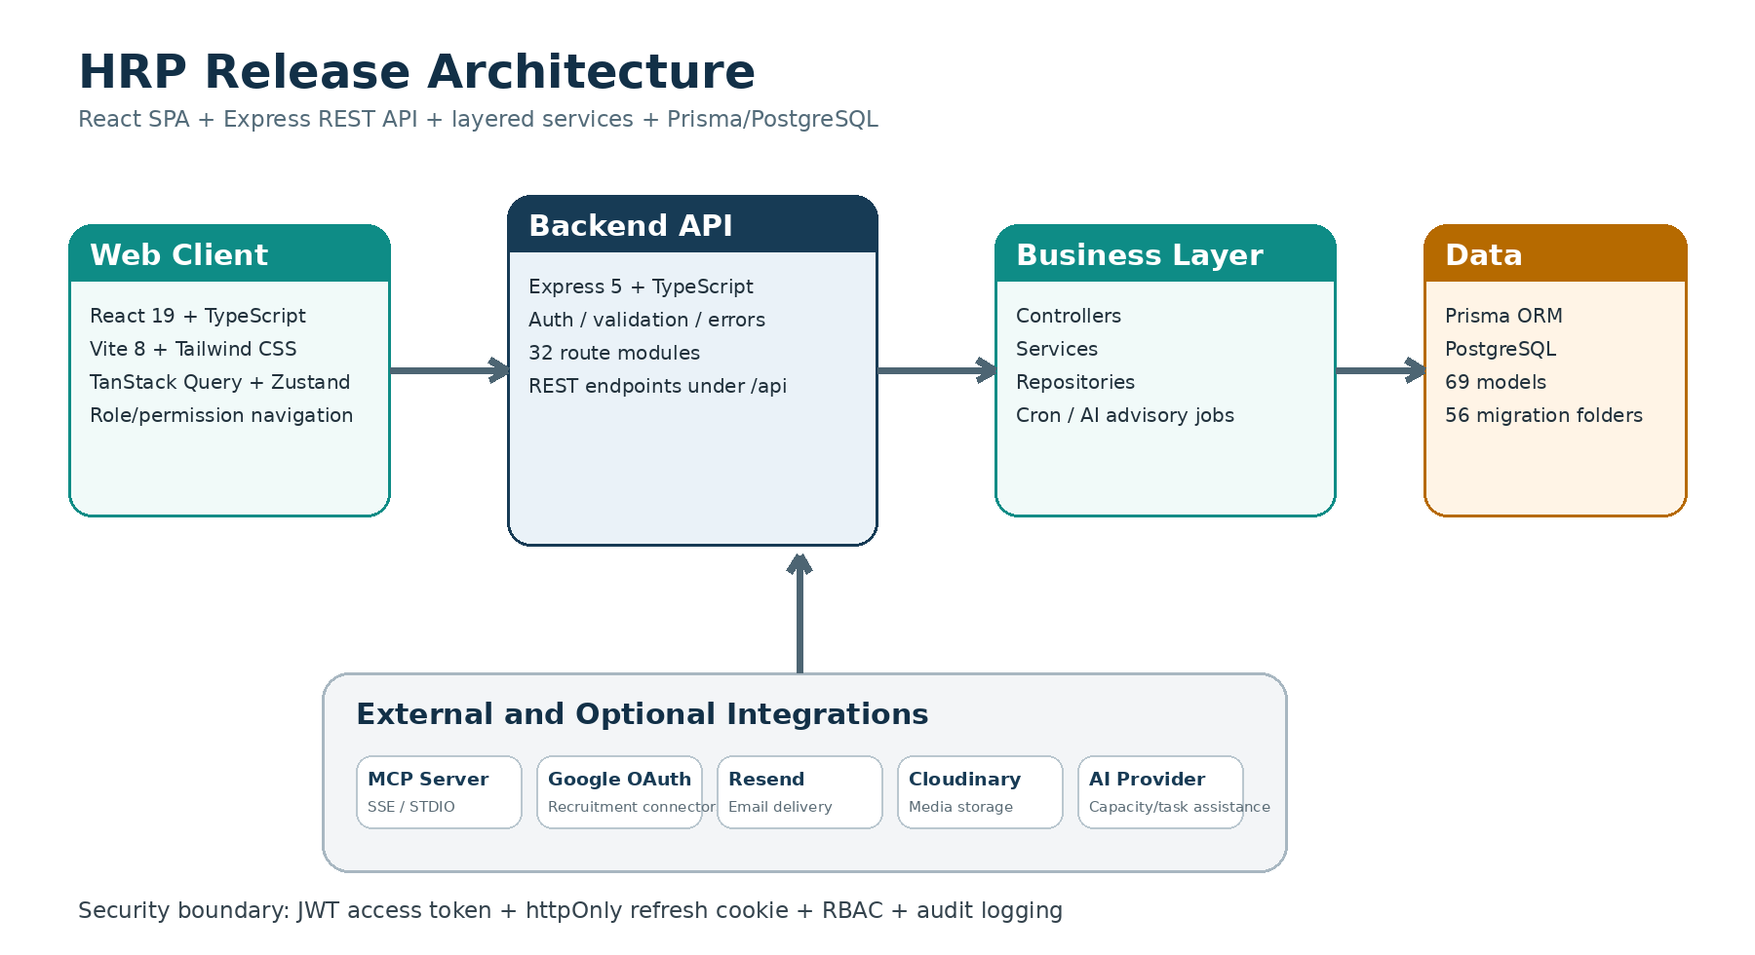
Figure 1. Release architecture derived from the source-code structure and runtime configuration.

3.1 Architecture Style
The application is a client-server monorepo. A React single-page application communicates with an Express REST API. Backend routes delegate to controllers, services and repositories, while Prisma maps domain operations to PostgreSQL. Cross-cutting concerns are handled by middleware and shared libraries. Background cron jobs support payroll, weekly scheduling and capacity forecasts.
Layer | Primary responsibility | Source evidence
Presentation | Role-aware navigation, forms, dashboards, tables, Kanban/Gantt and self-service screens. | frontend/src/components, features, pages
API / transport | HTTP routing, request parsing, authentication boundaries and response handling. | backend/src/routes, controllers, index.ts
Business services | Validation of domain rules, workflow transitions and orchestration. | backend/src/services
Data access | Typed repository queries and Prisma operations. | backend/src/repositories
Persistence | PostgreSQL schema, migrations and seed scripts. | backend/prisma
Integration | Email, media, OAuth, AI and MCP adapters. | package dependencies and integration modules

3.2 Technology Stack
Area | Technology | Release version / detail
Runtime / package manager | Bun | Primary runtime; root commands orchestrated with ni/nr/nlx
Backend | Express 5 + TypeScript | Express 5.2.1; TypeScript 6.0.3
ORM / database | Prisma + PostgreSQL | Prisma 7.8.0; pg 8.21; Prisma PostgreSQL adapter
Frontend | React + Vite + TypeScript | React 19.2.6; Vite 8.0.12; TypeScript ~6.0.2
UI / state | Tailwind, TanStack Query, Zustand | Tailwind 4.3; Query 5.100; Zustand 5.0
Forms / validation | React Hook Form + Zod | Typed client validation and backend Zod validation
Authentication | JWT + cookie | 15-minute access token; 7-day httpOnly refresh cookie per README
Testing | Jest, Supertest, Playwright | Backend services/utilities; frontend E2E recruitment workflow
Optional AI integration | Configurable API provider | AI base URL/model/key supplied through environment variables
Optional agent bridge | MCP Server | SSE and STDIO transports; browser-based login flow

3.3 Data Model Overview
The final Prisma schema defines 69 models and 40 enums. The following grouping summarizes the model families without reproducing every field.
Domain | Representative models
Employee & organization | Employee, EmployeeContract, Position, AppRole, Permission, EmployeeRole, RolePermission
Scheduling & attendance | WorkingShift, ShiftSchedule, EmployeeShift, AttendanceRecord, RealShift, WeeklyScheduleTemplate, PartTimeWeeklyAvailability, HolidayCalendar
Applications & approvals | Application plus leave, overtime, shift-swap, work-from-home, business-trip, late/early, regime, forgot-card and recruitment detail models
Payroll | SalaryComponent, SalaryVariable, PayslipTemplate, EmployeeSalaryConfig, Payroll, Payslip, PayslipDetail
Projects | Project, ProjectMember, ProjectRole, ProjectTracker, ProjectTaskStatus, Task, SpentTime
Recruitment | JobRequisition, JobPosting, RecruitmentIntakeRecord, RecruitmentOAuthAccount, Candidate, RecruitmentApplication, InterviewRound, Scorecard, RecruitmentOffer, BackgroundCheck
Security & traceability | RefreshToken, PasswordResetRequest, ActivityLog, AuthorizationAuditLog, AdminStateLock, CustomQuery

3.4 Security Design
- JWT-based authentication with access and refresh-token separation.
- httpOnly cookie transport for refresh tokens, reducing direct JavaScript access to long-lived credentials.
- Role and permission data are persisted and enforced through authorization services and route guards.
- Audit and activity-log modules provide traceability for sensitive operations.
- Password hashing uses bcryptjs; reset requests and refresh tokens are modeled in the database.
- Rate-limiting support is included and server startup performs administrative safety assertions.

3.5 External and Optional Integrations
Integration | Purpose | Configuration
Resend | Email delivery for system communications. | RESEND_API_KEY, EMAIL_FROM
Cloudinary | Image or file media storage used by the backend package. | Cloudinary credentials in runtime environment; do not commit them
Google OAuth 2.0 | Recruitment connectors, including Google Forms-related flows. | GOOGLE_OAUTH_CLIENT_ID, GOOGLE_OAUTH_CLIENT_SECRET and callback URL
AI provider | Task estimation, Capacity Copilot and configured assistance capabilities. | AI_API_KEY, AI_BASE_URL, AI_MODEL; separate test-generation settings also exist
MCP server | Allows authorized AI agents to call HRP tools through SSE or STDIO. | HRP_API_BASE_URL, PUBLIC_BASE_URL and browser-based login

4. Installation and Configuration Guide

4.1 Prerequisite Software
Software | Recommended release | Purpose
Git | 2.40 or later | Clone the repository and select the approved baseline
Bun | 1.x or later | Primary runtime and package manager
Node.js | 20+ recommended | Useful for tooling compatibility; MCP production runtime is Node-compatible
PostgreSQL | 14 or later, or Supabase PostgreSQL | Primary relational database
Browser | Current Chrome / Edge / Firefox | Run and verify the React interface
Optional: pnpm | 11.x | MCP server package declares pnpm as its development package manager

4.2 Clone and Pin the Release Baseline
git clone https://github.com/ldanh270/integrated-hr-and-product-system.git
cd integrated-hr-and-product-system
git fetch --all --tags
git checkout feat/recruitment
git checkout 8ac5fc07791a3c2c8196713a039a5b823eb89210

4.3 Install Dependencies
Run the command from the repository root:
bun run i:all

4.4 Configure Backend Environment
cp backend/.env.example backend/.env
# Windows PowerShell equivalent:
Copy-Item backend/.env.example backend/.env

Configure at least the variables below. Use development-only values locally and production secrets through a secure secret manager.
Variable | Required | Purpose / safe example
SERVER_URL | Yes | Backend origin, for example http://localhost:5000
CLIENT_URL / FRONTEND_URL | Yes | Frontend origin, for example http://localhost:5173
DATABASE_URL | Yes | Pooled PostgreSQL connection string
DIRECT_URL | Yes for migrations | Direct PostgreSQL connection string
PORT | Yes | Backend port; source default is 5000
NODE_ENV | Yes | development, test or production
ACCESS_TOKEN_SECRET | Yes | Long random value used to sign access tokens
REFRESH_TOKEN_SECRET | Yes | Independent long random value for refresh tokens
SEED_CORE_ACCOUNTS_PASSWORD | Required for core seeding | Temporary seed password; rotate or disable after use
RESEND_API_KEY / EMAIL_FROM | When email is enabled | Email provider credentials and sender identity
GOOGLE_OAUTH_CLIENT_ID / SECRET | When connectors are enabled | Google OAuth application values
AI_API_KEY / BASE_URL / MODEL | When AI features are enabled | Provider endpoint and model selection
Cloudinary variables | When media upload is enabled | Runtime-only media account credentials

4.5 Prepare the PostgreSQL Database
- Create a dedicated PostgreSQL database and account with schema/migration privileges.
- Set DATABASE_URL and DIRECT_URL in backend/.env.
- Generate the Prisma client and apply committed migrations.
- Seed only the data required for the demonstration environment.
bun run db:generate
bun run db:deploy
bun run db:seed:admin
# Optional, destructive demo reset/seed:
bun run db:seed

4.6 Seeded Demonstration Accounts
The seed-admin script creates or updates core role accounts. All accounts use a password obtained from SEED_CORE_ACCOUNTS_PASSWORD; no password is reproduced here.
Username | Email pattern | Role / purpose | Password source
admin | admin@example.com | System administrator | SEED_CORE_ACCOUNTS_PASSWORD
hr_manager | hr_manager@example.com | Human-resource manager | SEED_CORE_ACCOUNTS_PASSWORD
general_manager | general_manager@example.com | General manager | SEED_CORE_ACCOUNTS_PASSWORD
team_leader | team_leader@example.com | Team/project leader | SEED_CORE_ACCOUNTS_PASSWORD
employee | employee@example.com | Regular employee | SEED_CORE_ACCOUNTS_PASSWORD
part_time | part_time@example.com | Part-time work-schedule demonstration | SEED_CORE_ACCOUNTS_PASSWORD

4.7 Start the Application
Recommended development modes from the repository root:
# Backend + frontend
bun run dev
# Backend + frontend + MCP server
bun run dev:stage
# Backend + frontend + MCP server + Prisma Studio
bun run dev:all

Service | Default address | Verification
Backend API | http://localhost:5000 | GET / returns { message: "Connect to server successfully" }
Frontend | http://localhost:5173 | Login page loads and API proxy/connectivity works
Prisma Studio | http://localhost:5555 | Available when dev:all is used
MCP server | Configured separately; HTTP endpoints under /mcp | GET /mcp/sse and browser login flow when enabled

4.8 Optional MCP Server Setup
The MCP server provides AI-agent access without asking users to type passwords in chat. Authentication begins with a browser login URL and returns an internal sessionId used by subsequent tools.
cd mcp-server
cp .env.example .env
# Configure HRP_API_BASE_URL and PUBLIC_BASE_URL
pnpm install
pnpm build
node dist/server.js --stdio # local agent mode
# or pnpm start # SSE/HTTP mode

4.9 Production Deployment Guidance
- Set NODE_ENV=production and terminate TLS at a trusted reverse proxy or application gateway.
- Use explicit CORS origin allowlists; never reflect arbitrary origins in production.
- Apply migrations using bun run db:deploy or an equivalent non-destructive CI step.
- Build the frontend separately with bun run build:frontend after a clean dependency install.
- Serve the frontend static bundle through a CDN or web server and proxy /api to the backend.
- Store secrets in environment/secret management, not in source or release archives.
- Back up PostgreSQL before migration and verify restore procedures.
- Run only one intended instance of each cron responsibility or implement distributed locking.
- Restrict debug routes and development tooling from public production access.

4.10 Common Installation Problems
Problem | Likely cause | Resolution
Backend cannot connect to database | Invalid DATABASE_URL/DIRECT_URL, database unavailable or SSL mismatch | Verify connection strings, network access, privileges and production SSL settings.
Prisma client errors after schema changes | Client was not regenerated | Run bun run db:generate and restart the backend.
Frontend API calls fail | Backend is not running or VITE_API_BASE_URL/proxy is wrong | Start backend on port 5000 and verify frontend Vite proxy configuration.
401 / refresh loop | Secrets changed, stale cookies or mismatched frontend/backend origins | Clear site cookies, confirm token secrets and verify credentialed CORS.
OAuth callback fails | Callback URI or Google client values do not match | Use the exact configured callback URI and enable required Google APIs.
Email is not sent | Resend key/sender missing or sender not verified | Verify RESEND_API_KEY, EMAIL_FROM and provider domain settings.
Vite native binding missing | node_modules copied from another OS or optional dependency absent | Delete node_modules and perform a clean Bun/npm install on the target OS.
Seed command fails | SEED_CORE_ACCOUNTS_PASSWORD or database setup missing | Set the seed password, apply migrations and rerun only the required seed script.

4.11 Database Backup, Migration and Rollback Procedure
1. Create a timestamped logical backup before applying release migrations.
2. Apply committed Prisma migrations with the non-destructive deployment command.
3. Run smoke checks against the migrated database.
4. If a release-blocking failure occurs, stop application writes and restore the verified backup into a clean database or approved recovery target.
5. Document backup location, migration result, restore result, operator and date in the release evidence package.
# Backup
pg_dump --format=custom --file=hrp_v1_0_0.backup <database_name>
# Apply release migrations
bun run db:deploy
# Restore to a clean recovery database
pg_restore --clean --if-exists --dbname=<recovery_database> hrp_v1_0_0.backup

5. Release Verification and Quality Evidence
The following checks were re-executed against the current Windows workspace on 24 July 2026. Results distinguish source-quality findings from environment-specific dependency issues.
Verification item | Result | Evidence / interpretation
Backend TypeScript typecheck | PASS | node node_modules/typescript/bin/tsc --noEmit completed with exit code 0.
Frontend TypeScript project build check | PASS | node node_modules/typescript/bin/tsc -b completed with exit code 0.
Frontend ESLint | 14 errors / 10 warnings | Lint reported 24 findings, including effect state updates, explicit any, unused variables and purity issues.
Backend Jest suite | FAIL - 15 failed / 595 passed | Default Jest worker run hit spawn EPERM; single-process run executed with bunx jest --config jest.config.cjs --runInBand --passWithNoTests. Result: 34 suites total, 29 passed, 5 failed; 610 tests total, 595 passed, 15 failed.
Vite production bundle | Environment blocked | Current Windows build failed while loading Vite config because @tailwindcss/oxide-win32-x64-msvc native binding could not be loaded and Vite also hit spawn EPERM. Clean target-OS install and rerun required.
Test inventory | 36 files present | 34 backend unit/service specs, one frontend unit test and one recruitment E2E specification were identified.
Database migration inventory | 56 folders present | A substantial committed Prisma migration history is present.

5.1 Required Verification Commands Before Tagging
# Clean install from repository root
rm -rf backend/node_modules frontend/node_modules mcp-server/node_modules
bun run i:all
# Backend
cd backend
bun run typecheck
bun run test
# Frontend
cd ../frontend
bun run lint
bun run build
npx playwright test
# MCP
cd ../mcp-server
pnpm build

5.2 Functional Smoke-Test
Area | Smoke-test scenario
Authentication | Login with each seeded role; refresh session; logout; reset-password initiation.
Authorization | Verify hidden navigation and API denial for roles lacking required permissions.
Employee HRM | Create/update an employee, assign position/role, create contract, review status.
Applications | Create a leave or attendance-related application, approve/reject and verify state history.
Attendance | View personal schedule, record/inspect attendance, assign part-time availability and verify holidays.
Payroll | Configure components/variables, create a payroll period, generate payslips and open personal payslip.
Recruitment | Create requisition, approve it, publish a job, intake candidate, move Kanban stages, schedule interview, issue offer and complete background check.
Projects | Create project, add members, create/assign tasks, log spent time, review Kanban/Gantt and capacity advice.
Security | Review audit/activity logs, login history, roles, permissions, positions and permission matrix.
Integrations | Verify email, media upload, OAuth connector, AI provider and MCP only when configured.

5.3 Release Readiness Summary
Verification item | Result | Evidence / interpretation
Functional breadth | Ready | Core modules and UI routes are implemented across all stated subsystems.
Type safety | Ready | Backend and frontend TypeScript checks passed in the inspection environment.
Lint quality | Action required | 14 errors and 10 warnings must be resolved or formally waived.
Automated tests | Conditional | The suite was executed single-process; 29 suites passed and 5 suites failed. Fix failing specs in auth, application, payroll, project and part-time availability areas before final acceptance.
Production build | Conditional | Clean target-OS dependency installation and build verification are required.
Security packaging | Blocker | A real backend/.env file was present in the supplied archive. Remove it and rotate any exposed credentials.
Release tagging | Action required | No v1.0.0 tag was found. Create it after all gates pass.
Documentation consistency | Action required | README command mismatch, stale early PDR and generic SECURITY.md template require cleanup.

5.4 Immediate Release Priorities
- Remove backend/.env from every shared copy and rotate any exposed credential.
- Resolve the 14 ESLint errors, then rerun lint with zero errors.
- Fix failing Jest specs, resolve frontend lint errors, perform a clean dependency installation, then rerun Jest, Vite build and Playwright tests.
- Restrict production CORS origins and protect or disable development debug routes.
- Synchronize README, SECURITY.md and legacy project documentation before creating v1.0.0.

6. Representative Release Interface
The screenshots below were rendered from the supplied compiled frontend using sanitized demonstration state. Empty-list states are intentional and demonstrate the final navigation/layout without exposing private employee or candidate data.
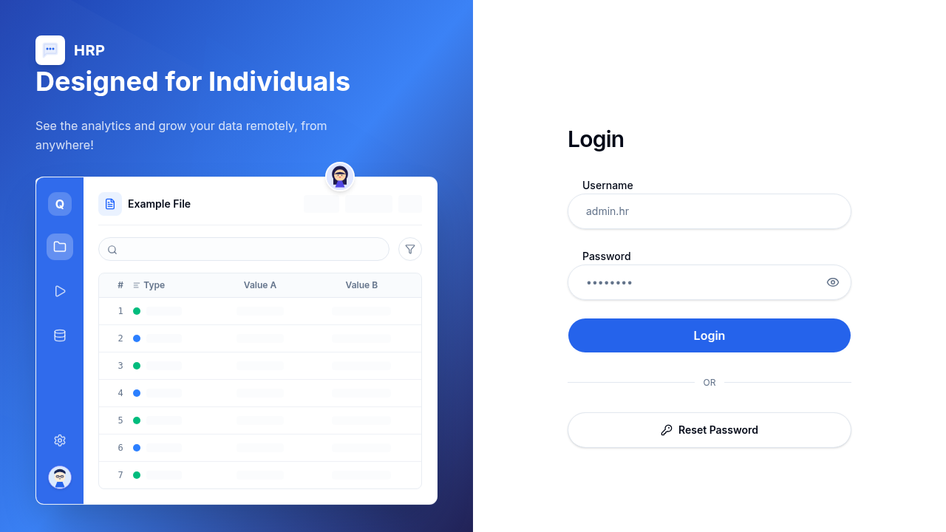
Figure 2. HRP login page and authentication entry point.
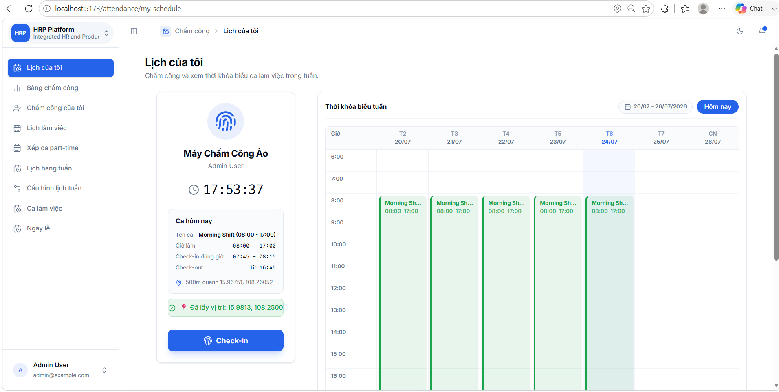
Figure 3. Employee personal schedule and virtual time-clock interface.
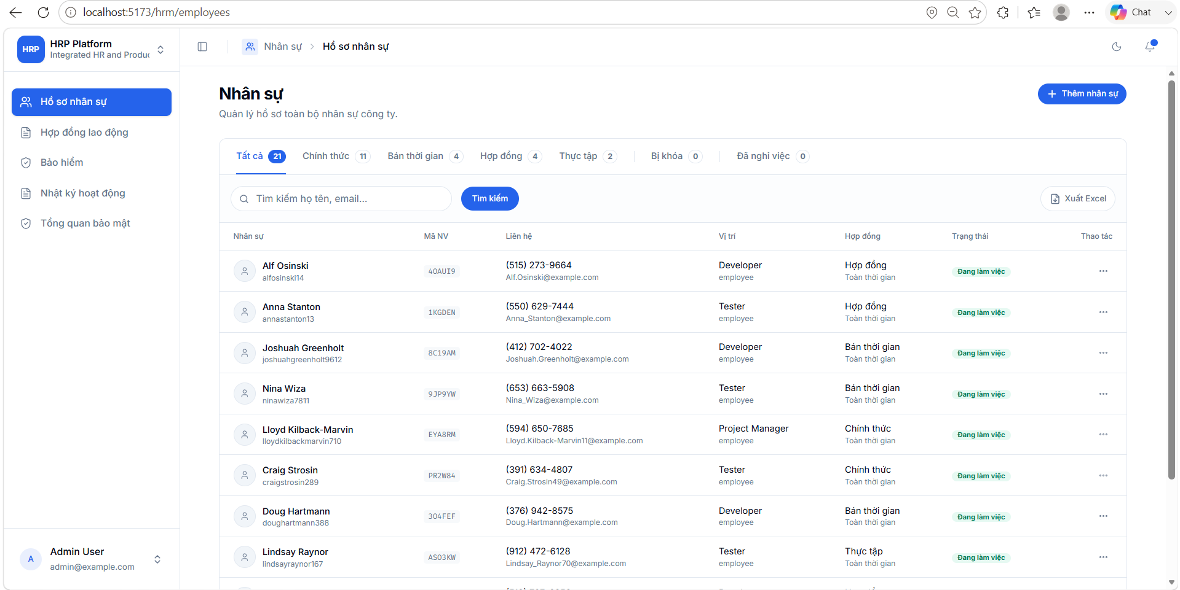
Figure 4. Employee-management list in the HRM subsystem.
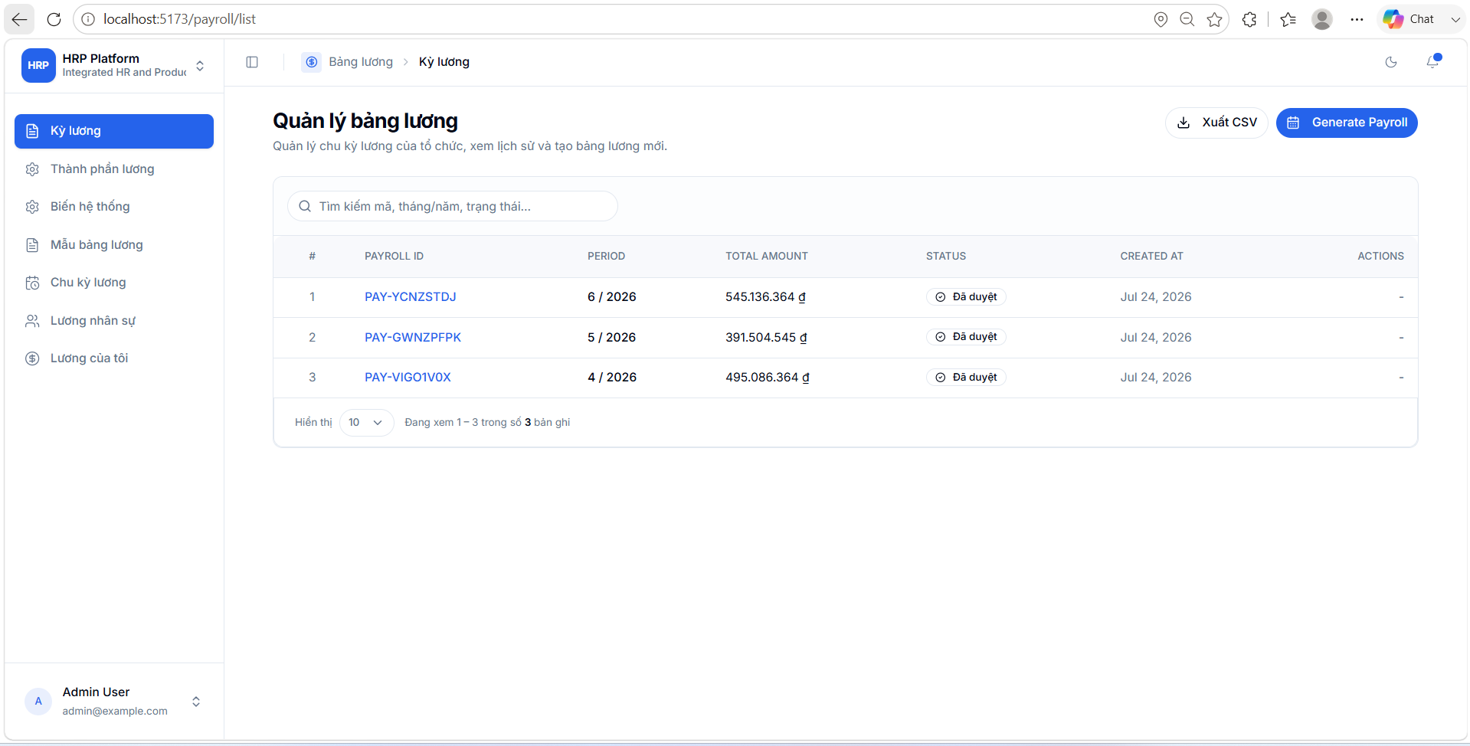
Figure 5. Payroll-period management interface.
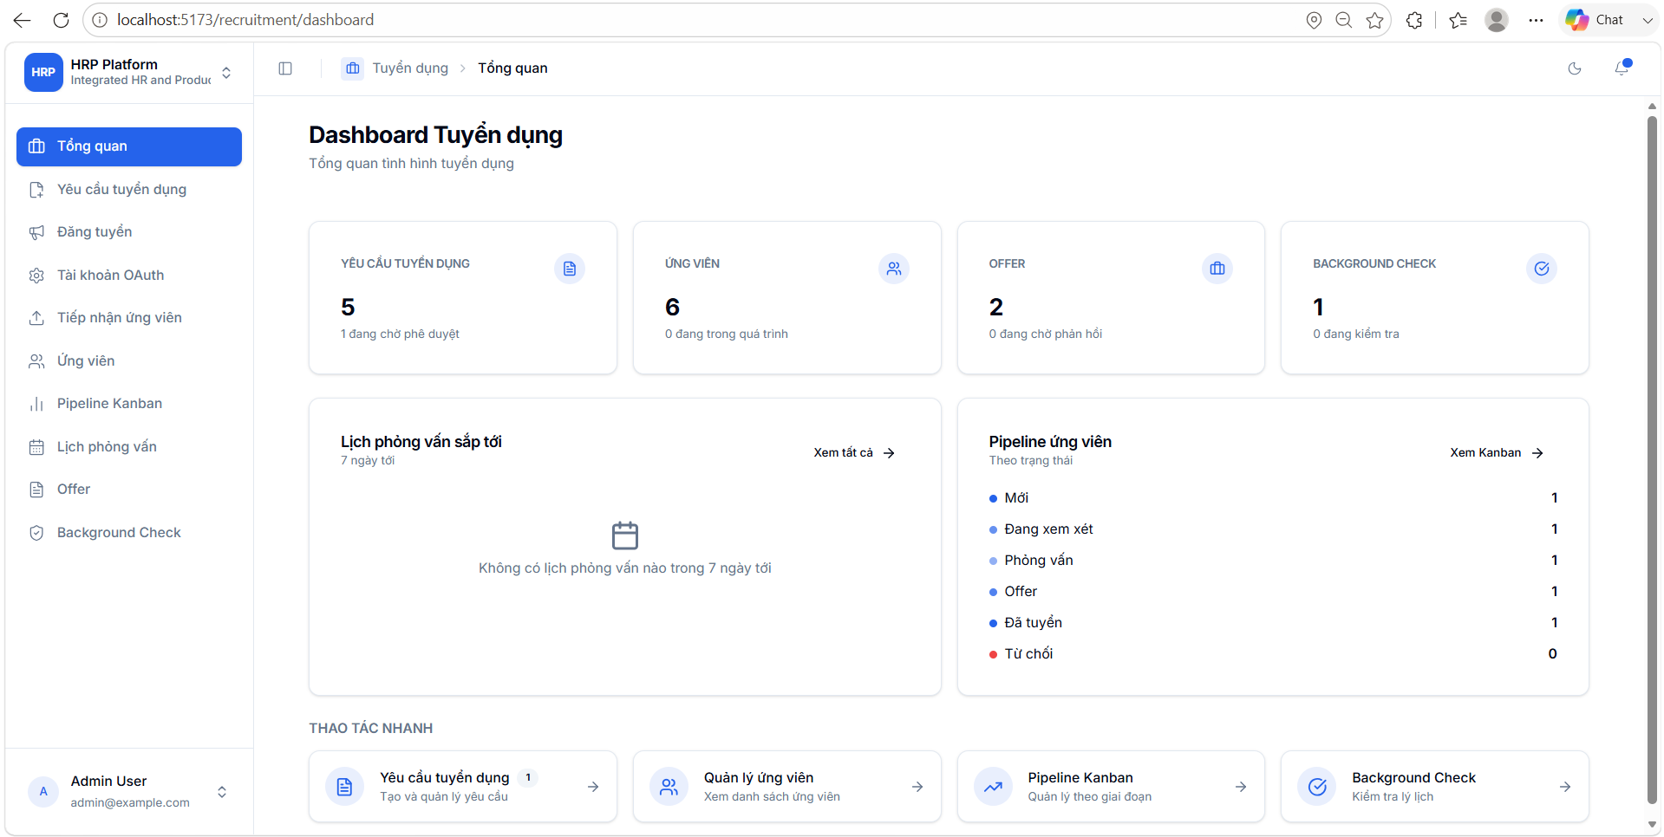
Figure 6. Recruitment dashboard with KPI cards and quick actions.
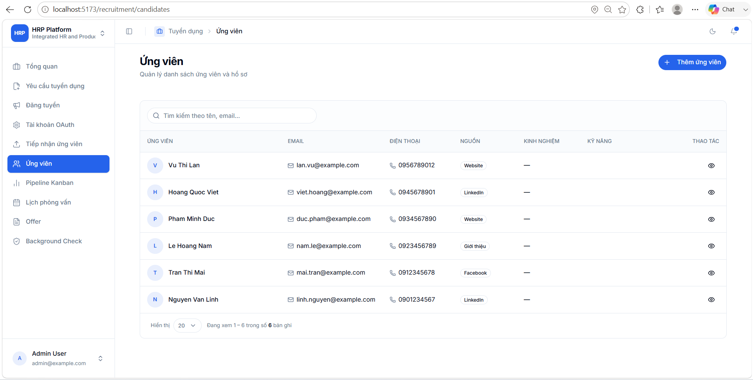
Figure 7. Candidate list and intake-oriented actions.
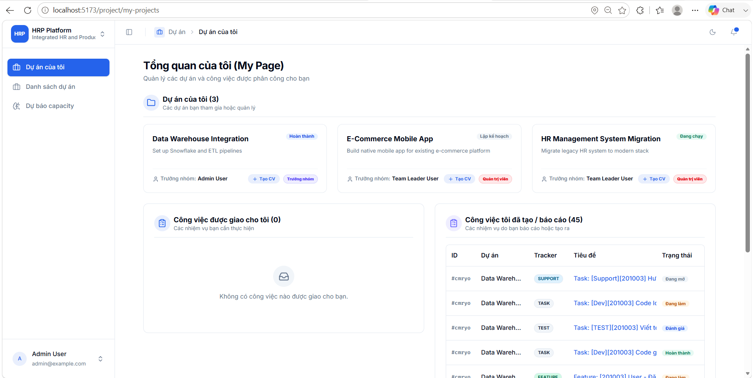
Figure 8. Project portfolio list and project creation entry point.

6.1 UI Release Observations
Observation | Release interpretation
Consistent subsystem shell | HRM, payroll, recruitment and project pages share a stable header/sidebar pattern.
Permission-oriented navigation | Visible menu items are driven by role and permission configuration rather than one static menu.
Safe demonstration state | The captured pages use empty or sanitized data states and do not expose real employee/candidate records.
Action-oriented pages | Primary actions such as create employee, generate payroll, add candidate and create project are easy to locate.

6.2 Required Workflow Evidence for the Submission Copy

Area | Minimum evidence
Authentication and RBAC | Successful login for representative roles; denied navigation/API access for a role without permission.
Employee HRM | Create or update an employee and confirm role/position/contract data.
Applications | Create an application, approve or reject it and show the final state/history.
Attendance | Assign or view a schedule, perform timekeeping where configured and inspect attendance result.
Payroll | Create a payroll period, generate/review payslips and open an employee payslip.
Recruitment | Requisition -> approval -> posting -> candidate -> Kanban -> interview -> offer -> background check/hire.
Projects | Create a project/task, update Kanban/Gantt state and record spent time.
Security and audit | Show audit/login history after a controlled sensitive change.

6.3 Recommended Demonstration Sequence
Step | Role | Demonstration focus
1 | Admin | Sign in; show users, roles, permissions and security/audit overview.
2 | HR Manager | Create/review employee data, applications, attendance administration and payroll configuration.
3 | Recruiter / HR Manager | Demonstrate the complete recruitment flow with prepared test data.
4 | Team Leader | Approve a request, review projects, assign tasks and inspect capacity.
5 | Employee | Show personal schedule, attendance, applications, payslip and assigned project work.
6 | Closeout | Show release tag/commit, test report, known limitations and final submission folder.

7. User Manual

7.1 User Roles and Responsibilities
Role | Vietnamese label | Primary responsibility
admin | Quản trị viên | System configuration, users, roles, permissions, positions, security oversight and full authorized operations.
hr_manager | Quản lý nhân sự | Employee HRM, applications, attendance administration, payroll and recruitment according to permissions.
general_manager | Tổng quản lý | Organization-wide approval and project/business supervision.
team_leader | Trưởng nhóm | Team approvals, project execution, task assignment and employee coordination.
employee | Nhân viên | Personal profile, applications, schedule, attendance, payslips and assigned project work.

7.2 Authentication and Common Navigation

7.2.1 Sign In
Purpose. Authenticate an employee and open the role-appropriate workspace.
Preconditions. The account exists, is enabled and has a valid role assignment.
Step 1: Open the frontend URL and enter the username and password.
Step 2: Submit the login form.
Step 3: Wait for the backend to return the access token and refresh-cookie session.
Step 4: Confirm that the subsystem landing page and sidebar match the assigned permissions.
Expected result. The user enters HRP with only the modules allowed by current roles and permissions.

7.2.2 Reset a Forgotten Password
Purpose. Request a password reset and set a new password through the implemented reset flow.
Preconditions. The employee account has a reachable identity/email configuration.
Step 1: Open the reset-password entry point from the login page.
Step 2: Enter the required account identifier and submit the request.
Step 3: Complete the verification step delivered by the configured backend flow.
Step 4: Enter and confirm a new strong password.
Step 5: Return to login and authenticate with the new password.
Expected result. The previous password is no longer accepted and the new password opens a valid session.

7.2.3 View Profile and Log Out
Purpose. Review personal information and end the authenticated session.
Preconditions. The user is signed in.
Step 1: Open the profile control from the application header or navigation.
Step 2: Review the identity, role, position and personal fields exposed to the current user.
Step 3: Apply permitted profile changes and save them.
Step 4: Use the logout action and confirm return to the login page.
Expected result. Saved profile fields are reflected in the interface, and protected pages require a new login after logout.

7.3 Employee Self-Service

7.3.1 View Personal Schedule and Attendance
Purpose. Allow an employee to understand upcoming work, assigned shifts and personal attendance state.
Preconditions. The employee is active and has a work-schedule type.
Step 1: Open Chấm công > Lịch của tôi.
Step 2: Select the relevant week and review assigned work blocks.
Step 3: Use the virtual clock/timekeeping action when enabled and location rules are satisfied.
Step 4: Open Chấm công của tôi to inspect attendance summaries or records.
Step 5: Review holidays that affect expected working time.
Expected result. The employee can distinguish planned schedule, actual attendance and exceptions.

7.3.2 Declare Part-Time Availability
Purpose. Submit weekly free-time windows for part-time shift assignment.
Preconditions. The employee workScheduleType is part_time.
Step 1: Open Đăng ký thời gian rảnh / personal availability.
Step 2: Choose the target week and enter available day/time windows.
Step 3: Submit the availability record.
Step 4: Review its status and update only while the workflow permits.
Expected result. Managers can use the submitted windows when assigning part-time shifts.

7.3.3 Create a Personal Application
Purpose. Request leave, overtime, work from home, shift swap, business trip, late/early handling, regime support, resignation or other configured application types.
Preconditions. The user is authenticated and the chosen application type is available.
Step 1: Open Đơn từ > Đơn của tôi and select Tạo đơn.
Step 2: Choose the application type.
Step 3: Complete the common fields and type-specific details.
Step 4: Submit for approval and monitor the status.
Step 5: Cancel only when the current workflow state allows cancellation.
Expected result. The application enters the approval workflow with a traceable status.

7.3.4 View Personal Payslips
Purpose. Review salary results released to the current employee.
Preconditions. A payroll run and payslip exist for the employee.
Step 1: Open Bảng lương > Phiếu lương của tôi.
Step 2: Select the payroll period.
Step 3: Review earnings, deductions, variables and final net pay.
Step 4: Report discrepancies through the team-approved support process.
Expected result. The employee can view only their own authorized payslip information.

7.3.5 Work on Assigned Projects
Purpose. View project membership, assigned tasks and spent-time responsibilities.
Preconditions. The user is assigned to a project or task.
Step 1: Open Dự án > Dự án của tôi.
Step 2: Open a project and review overview, members, status and tracker information.
Step 3: Use Kanban or Gantt views to understand task sequence and progress.
Step 4: Open an assigned task, update allowed fields and log spent time.
Step 5: Submit work for review when the project workflow requires it.
Expected result. Project progress and time records reflect the employee contribution.

7.4 Human Resource Management

7.4.1 Create and Maintain Employee Records
Purpose. Create a complete employee identity and maintain employment data.
Preconditions. The user has employee create/update permissions.
Step 1: Open Nhân sự > Hồ sơ nhân sự.
Step 2: Search for an existing employee before creating a duplicate.
Step 3: Choose Thêm nhân sự and enter account, identity, contact, employment category, work schedule, position and role information.
Step 4: Save the employee and verify role/position assignments.
Step 5: Use the detail drawer or edit action for later authorized updates.
Expected result. A unique employee record is available to scheduling, payroll, projects and authorization.

7.4.2 Manage Employment Contracts
Purpose. Create, activate and track employee contracts.
Preconditions. The employee exists and the user has employee-management permission.
Step 1: Open Hợp đồng lao động.
Step 2: Create a contract with number, title, type, effective dates and employment terms.
Step 3: Review status transitions such as draft, pending_signature and active.
Step 4: Renew, expire or terminate the contract only according to business policy.
Expected result. The employee contract history remains traceable and consistent with employment status.

7.4.3 Review Insurance and Employment Status
Purpose. Review insurance-related presentation and employee status.
Preconditions. The user has employee.read permission.
Step 1: Open Bảo hiểm or the employee details view.
Step 2: Search/filter the employee list.
Step 3: Review available insurance/employment fields.
Step 4: Update employee status only with appropriate authority and supporting records.
Expected result. The HR record reflects the current status: active, inactive, on leave or terminated.

7.5 Applications and Approvals

7.5.1 Review Applications Awaiting Your Approval
Purpose. Approve or reject applications routed to the current approver.
Preconditions. The current user is an assigned approver or has application-management permission.
Step 1: Open Đơn từ > Bạn duyệt.
Step 2: Filter by type, employee, date or status.
Step 3: Open the request and review common information plus type-specific details.
Step 4: Approve, reject with a reason or return/cancel only when supported by the workflow.
Step 5: Confirm the resulting application and partner approval state.
Expected result. The application progresses to approved, rejected or the next configured approval state.

7.5.2 Review All Applications
Purpose. Provide authorized HR/administrative oversight across application types.
Preconditions. The user has application.read permission.
Step 1: Open Đơn từ > Đơn thư.
Step 2: Choose a type-specific filter or search criteria.
Step 3: Review the status, employee and date information.
Step 4: Open details for investigation or authorized correction.
Expected result. Authorized managers can audit and manage application records across the organization.

7.6 Attendance and Scheduling Administration

7.6.1 Manage Working Shifts
Purpose. Maintain reusable shift definitions and actual-shift information.
Preconditions. The user has attendance.update permission.
Step 1: Open Chấm công > Ca làm việc.
Step 2: Create or edit shift code, time boundaries and applicable status/rules.
Step 3: Verify the shift is not being changed in a way that invalidates assigned historical data.
Step 4: Save and review availability in scheduling screens.
Expected result. Current shift definitions are available to schedule assignment and attendance calculations.

7.6.2 Configure Weekly Schedules
Purpose. Define weekly schedule templates and assign employee schedules.
Preconditions. Attendance-administration permission is available.
Step 1: Open Cấu hình lịch tuần to maintain weekly templates and day/time rules.
Step 2: Open Lịch hàng tuần or Lịch làm việc.
Step 3: Select employees, templates and effective dates.
Step 4: Generate or update schedules and inspect conflicts.
Step 5: Verify the employee personal schedule after assignment.
Expected result. Employees receive consistent weekly schedules based on approved templates and assignments.

7.6.3 Assign Part-Time Shifts
Purpose. Use submitted availability windows to assign part-time work.
Preconditions. Part-time employees have submitted availability for the target week.
Step 1: Open Xếp ca part-time.
Step 2: Select the week and review submitted availability slots.
Step 3: Choose suitable shifts/employees and resolve conflicts.
Step 4: Confirm the assignment.
Step 5: Verify the result on the employee personal schedule.
Expected result. Part-time schedules are assigned within employee-declared availability.

7.6.4 Review Attendance Dashboard and Summary
Purpose. Inspect attendance status and exceptions.
Preconditions. The user has attendance.read; the administrative dashboard additionally requires the admin role in current navigation.
Step 1: Open Bảng chấm công for the administrative view or Chấm công của tôi for self-service.
Step 2: Select the date range and filters.
Step 3: Review attendance records, real shifts and calculated metrics.
Step 4: Investigate missing, late, early or exception states with supporting applications.
Expected result. Attendance status is traceable to schedules, real shifts and approved exceptions.

7.7 Payroll Administration

7.7.1 Configure Salary Components and Variables
Purpose. Define reusable earnings, deductions and formula inputs.
Preconditions. The user has payroll.read and the required write permissions.
Step 1: Open Thành phần lương and create or update component definitions.
Step 2: Open Biến hệ thống and maintain approved payroll variables.
Step 3: Validate component types, value types and formulas against payroll policy.
Step 4: Deactivate obsolete items rather than breaking historical payroll records.
Expected result. Payroll templates can reference controlled components and variables.

7.7.2 Configure Payslip Templates and Employee Salary
Purpose. Define the structure and employee-specific payroll configuration.
Preconditions. Salary components and employee records exist.
Step 1: Open Mẫu bảng lương and select the components included in each template.
Step 2: Open Lương nhân sự and configure employee-level salary data.
Step 3: Confirm effective periods and required values.
Step 4: Review sample calculations before a payroll run.
Expected result. Each eligible employee has a valid salary configuration and template.

7.7.3 Generate, Approve and Pay Payroll
Purpose. Run the payroll lifecycle for a period.
Preconditions. Schedules, attendance, applications and salary configuration are complete for the period.
Step 1: Open Kỳ lương and create a payroll period.
Step 2: Generate payroll/payslips using the configured period and data.
Step 3: Review calculations and exception records.
Step 4: Submit for approval; approve or reject through authorized roles.
Step 5: Mark the payroll paid only after the external payment process is confirmed.
Expected result. Payroll progresses through draft, pending approval, approved/rejected and paid states with employee payslips available when released.

7.8 Recruitment Management
The recruitment module is a major focus of the inspected branch. It supports requisition-to-hire flow, external connector intake and a detailed candidate pipeline.

7.8.1 Create and Approve a Job Requisition
Purpose. Request authorization to recruit for a position.
Preconditions. The user has recruitment access and the target position/department data exist.
Step 1: Open Tuyển dụng > Yêu cầu tuyển dụng.
Step 2: Create a requisition and enter role, headcount, priority, justification and required details.
Step 3: Save as draft or submit for approval.
Step 4: The authorized reviewer approves or rejects the request.
Step 5: After approval, continue to job-posting creation.
Expected result. The requisition reaches approved, rejected, closed or filled according to the workflow.

7.8.2 Create and Publish a Job Posting
Purpose. Turn an approved requisition into an open recruitment channel.
Preconditions. An approved requisition exists and the user has recruitment.posting.manage.
Step 1: Open Đăng tuyển and choose the approved requisition.
Step 2: Enter public title, description, requirements, channel and application details.
Step 3: Select or configure a Google OAuth account when using Google-related connectors.
Step 4: Save as draft, then open/publish the posting.
Step 5: Pause, close or archive the posting when appropriate.
Expected result. A controlled posting is available on the selected recruitment channel.

7.8.3 Configure OAuth Recruitment Accounts
Purpose. Connect authorized Google accounts for recruitment connectors.
Preconditions. Google OAuth client credentials and callback URI are configured.
Step 1: Open Tài khoản OAuth.
Step 2: Start the Google authorization flow.
Step 3: Complete consent in the browser.
Step 4: Return to HRP and verify account/connector status.
Step 5: Use the account only for approved postings and intake sources.
Expected result. The connected account can support enabled recruitment connector operations.

7.8.4 Intake Candidates
Purpose. Import or receive applicant data into the recruitment domain.
Preconditions. A posting and supported intake source exist.
Step 1: Open Tiếp nhận ứng viên.
Step 2: Choose the configured intake source or upload method.
Step 3: Validate applicant identity, contact information and source mapping.
Step 4: Resolve duplicates or invalid records before final import.
Step 5: Confirm candidate and application creation.
Expected result. Valid applicant records become candidates and recruitment applications with traceable sources.

7.8.5 Manage Candidate and Kanban Pipeline
Purpose. Review candidates and move active applications through non-terminal stages.
Preconditions. Candidate applications exist and the user has recruitment.read/update access.
Step 1: Open Ứng viên to search and inspect candidate profiles.
Step 2: Open Pipeline Kanban.
Step 3: Review columns such as new, reviewing, shortlisted, interviewing, final review and offer stages.
Step 4: Move an application only when transition requirements are met.
Step 5: Record notes and supporting decisions.
Expected result. The pipeline provides a current, auditable view of candidate progress.

7.8.6 Schedule and Score Interviews
Purpose. Plan interview rounds and capture results.
Preconditions. The application is ready for interviewing and interviewers are available.
Step 1: Open Lịch phỏng vấn and create an interview round.
Step 2: Choose interview type/format, date, time, location or video information and interviewers.
Step 3: Conduct the interview and complete the scorecard.
Step 4: Record result as pass, fail, pending or no-show.
Step 5: Update the application stage based on the approved result.
Expected result. Interview history and scorecards are linked to the candidate application.

7.8.7 Create and Manage Offers
Purpose. Prepare, send and track employment offers.
Preconditions. The candidate has passed final review and compensation/position details are approved.
Step 1: Open Offer and create a draft linked to the candidate application.
Step 2: Enter position, compensation, currency, start date, expiry and terms.
Step 3: Review and send the offer through the approved channel.
Step 4: Record accept, decline or negotiation responses; create versions when terms change.
Step 5: Rescind or expire an offer only with authorization and documented reason.
Expected result. The offer status and application stage remain synchronized.

7.8.8 Complete Background Check and Hire
Purpose. Complete required checks before onboarding.
Preconditions. The candidate has accepted an offer and the organization requires background checks.
Step 1: Open Background Check and create/select the candidate check record.
Step 2: Assign the required check group and begin processing.
Step 3: Record evidence and outcome without exposing unnecessary sensitive data.
Step 4: Mark passed or failed according to approved policy.
Step 5: Move the recruitment application to pending onboarding or hired when all gates pass.
Expected result. The candidate reaches a terminal or onboarding state with traceable decisions.

7.9 Project and Product Work Management

7.9.1 Create a Project and Add Members
Purpose. Establish a project workspace, roles and member capacity.
Preconditions. The user has project create/update permission.
Step 1: Open Danh sách dự án and choose Tạo dự án.
Step 2: Enter project identity, dates, status and governance settings.
Step 3: Add members and assign project roles/work modes.
Step 4: Configure task statuses or tracker behavior where supported.
Step 5: Verify project visibility for each member.
Expected result. The project becomes an authorized container for tasks, time and progress reporting.

7.9.2 Plan and Execute Tasks
Purpose. Create tasks and track them through Kanban, Gantt and review flow.
Preconditions. The project exists and the user has the required project/task permission.
Step 1: Open the project and create a task with priority, estimate, dates and dependencies.
Step 2: Assign one or more responsible members according to policy.
Step 3: Use the Kanban board to update workflow status.
Step 4: Use Gantt to review schedule and dependencies.
Step 5: Complete review and reopen/cancel only according to project rules.
Expected result. Task status accurately reflects planned, active, review and completed work.

7.9.3 Log and Approve Spent Time
Purpose. Capture effort against project tasks.
Preconditions. The employee is a member and has an assigned/eligible task.
Step 1: Open the task or project spent-time tab.
Step 2: Create a time entry with date, duration and description.
Step 3: Submit or update the entry according to status rules.
Step 4: The authorized reviewer approves/rejects where configured.
Expected result. Project reporting can compare estimated and actual effort.

7.9.4 Use Capacity Copilot and AI Assistance
Purpose. Review advisory capacity forecasts or AI-supported task decisions.
Preconditions. AI provider configuration is valid and the user has project.update permission for the capacity board.
Step 1: Open Dự báo capacity or the project Capacity Copilot view.
Step 2: Select the relevant project/week or available filters.
Step 3: Review shortage/surplus and allocation suggestions.
Step 4: Treat recommendations as advisory and verify them against current staffing constraints.
Step 5: Apply approved changes through normal project/member/task workflows.
Expected result. Authorized managers receive explainable advisory information without bypassing business controls.

7.10 Security and System Administration

7.10.1 Manage Roles, Permissions and Positions
Purpose. Maintain dynamic authorization and organizational positions.
Preconditions. The user has system-administration permissions.
Step 1: Open Cài đặt > Vai trò or Phân quyền.
Step 2: Create/update roles only when needed and avoid duplicating core roles.
Step 3: Assign permission codes through the role-permission mapping or permission matrix.
Step 4: Open Quản lý chức vụ to maintain position definitions.
Step 5: Test access with a non-admin account after each sensitive authorization change.
Expected result. Role-based navigation and backend authorization reflect approved permission assignments.

7.10.2 Review Security, Audit and Login History
Purpose. Investigate system activity and access events.
Preconditions. The user has security.read or audit.read as required.
Step 1: Open Tổng quan bảo mật, Nhật ký hoạt động or Lịch sử đăng nhập.
Step 2: Filter by user, action, resource, date, IP or status when available.
Step 3: Open a record and compare actor, timestamp and changed values.
Step 4: Escalate suspicious activity and preserve evidence.
Expected result. Authorized reviewers can trace sensitive actions without editing audit history.

7.10.3 Manage Users Safely
Purpose. Control user access while preserving business records.
Preconditions. The user is an authorized administrator.
Step 1: Search for the employee/user before creating a new account.
Step 2: Assign only the minimum roles and permissions required.
Step 3: Use status, lock or termination workflows rather than destructive deletion when records are referenced.
Step 4: Verify access after any reset or role change.
Expected result. User access remains aligned with current employment and least-privilege policy.

7.11 MCP Agent Usage

7.11.1 Start an MCP Login Session
Purpose. Authorize an AI agent without exposing credentials in chat.
Preconditions. The MCP server and HRP backend are running; PUBLIC_BASE_URL is configured.
Step 1: The agent calls login_start and receives a login URL plus loginId.
Step 2: Open the URL in a trusted browser and enter HRP credentials there.
Step 3: The agent polls login_status using the loginId.
Step 4: When completed, retain the returned sessionId for authorized tools.
Step 5: Pass sessionId to every protected MCP tool until the session expires.
Expected result. The agent can call tools within the authenticated user permission boundary.

7.12 Common Validation and Error Cases

Scenario | Expected controlled behavior
Invalid or locked login | Reject authentication without revealing whether a username or password was incorrect; preserve audit/login-history evidence where implemented.
Insufficient permission | Hide unauthorized navigation and return an authorization error for direct API access.
Duplicate employee or candidate identity | Prevent unintended duplicates or require the user to resolve the duplicate before creating the record.
Application transition not allowed | Prevent cancellation, approval or rejection when the current state does not permit the action.
Schedule/shift conflict | Reject or clearly flag overlapping schedules, invalid time boundaries or part-time assignments outside declared availability.
Incomplete payroll configuration | Prevent final payroll generation or expose a clear exception requiring salary/template correction.
Recruitment prerequisite missing | Prevent publishing without an approved requisition and prevent offer/hire transitions before required review/check gates.
Project dependency or assignment conflict | Prevent invalid task dependencies or unauthorized updates and preserve the current workflow state.
External integration unavailable | Display a controlled error and keep the core record consistent when email, OAuth, AI, media or MCP is not configured.

7.13 Demo Credential Handover
The document intentionally does not reproduce the shared seed password. Provide the temporary demonstration password separately through a lecturer-approved channel, rotate it after the demonstration and never include real secrets in the submission archive.

8. Key Status Dictionary

8.1 Employee, Contract and Application Statuses
Object | Statuses
Employee | active, inactive, on_leave, terminated
Employee type | full_time, part_time (legacy category), contractor, intern
Work schedule type | full_time, part_time
Contract | draft, pending_signature, active, expired, terminated, renewed
Application | pending, partner_pending, approved, rejected, cancelled
Application type | leave, overtime, work_from_home, shift_swap, business_trip, late_early, regime, resignation, forgot_card, recruitment

8.2 Payroll and Project Statuses
Object | Statuses
Payroll | draft, pending_approval, approved, rejected, paid
Project | planning, active, on_hold, completed, cancelled
Task | todo, in_progress, in_review, done, cancelled, reopened
Task priority | low, medium, high, urgent

8.3 Recruitment Statuses
Object | Statuses
Requisition | draft, pending_approval, approved, rejected, closed, filled
Posting | draft, open, paused, closed, archived
Recruitment application | new, reviewing, shortlisted, interviewing, final_review, offer_sent, offer_accepted, offer_declined, offer_rescinded, background_check, pending_onboarding, hired, rejected, candidate_withdrew
Interview round | scheduled, completed, cancelled, no_show
Interview result | pass, fail, pending, no_show
Offer | draft, sent, accepted, declined, rescinded, expired
Background check | pending, in_progress, completed, passed, failed

9. API Module Inventory
The backend registers the following route groups. The list is intended for release orientation; the authoritative endpoint details remain in each route module and Swagger/OpenAPI assets if maintained by the team.
Route group | Responsibility
/api/auth | Authentication and token/session lifecycle
/api/security | Security dashboards and login/security operations
/api/employees | Employee management and employee salary configuration
/api/employee-contracts | Employment contracts
/api/profile | Current-user profile
/api/shifts | Shift definitions
/api/schedules | Employee schedules
/api/attendance | Attendance records and summaries
/api/applications | Application workflows
/api/shift-change-requests | Shift-change workflows
/api/holidays | Holiday calendars
/api/regime-categories | Regime category definitions
/api/weekly-schedule-templates | Weekly templates
/api/part-time-availabilities | Part-time declared availability
/api/approvals | Approval operations
/api/recruitment | Recruitment end-to-end operations
/api/salary-components | Salary component definitions
/api/salary-variables | Payroll variables
/api/payslip-templates | Payslip templates
/api/payrolls | Payroll runs and payslips
/api/projects | Project portfolio
/api/tasks | Project tasks
/api/task-estimate-ai | AI-assisted task estimation
/api/capacity-copilot | Capacity advisory operations
/api/permissions | Permission definitions
/api/roles | Role management
/api/positions | Position management
/api/audit / related | Audit-log route registration under /api
/api/spent-times | Time entries
/api/custom-queries | Saved/custom query features
/api/debug | Development/debug routes; restrict in production

10. Known Limitations, Risks and Release Gates
Priority | Finding | Required action before final submission / deployment
Critical | backend/.env was present in the supplied archive. | Remove the file from every submission copy, inspect Git history, rotate any credential that may have been exposed and keep only .env.example.
Critical | Production CORS reflects arbitrary origins. | Implement an environment-based allowlist and test credentialed requests.
High | Frontend ESLint reports 14 errors and 10 warnings. | Fix the findings or document approved waivers; rerun lint with zero errors.
High | No v1.0.0 Git tag was found. | Create an annotated tag only after the acceptance checklist passes.
High | Root bun run build performs a forced database reset. | Replace with a non-destructive build pipeline; isolate demo reset/seed commands.
High | Backend Jest suite currently fails in the current workspace. | Fix or update failing specs, then rerun bunx jest --config jest.config.cjs --runInBand and the normal bun run test worker command in CI/target environment.
Medium | Production Vite build was blocked by copied cross-platform native dependencies. | Clean-install frontend dependencies on the target OS and verify bun run build.
Medium | README contains install command mismatch. | Use bun run i:all or rename scripts consistently and update documentation.
Medium | docs/project-overview-pdr.md describes an obsolete phase-one scaffold. | Archive or rewrite it so it does not contradict the implemented system.
Medium | SECURITY.md is still a generic template with unrelated version examples. | Replace with actual supported versions, contact/reporting process and response expectations.
Medium | Class, lecturer, team-member list, demo video and course deliverables were not in the source archive. | Add verified submission metadata and package artifacts before handover.
Low | Debug routes are mounted under /api/debug. | Disable or protect them in production.

10.1 Final Release Exit Criteria
Exit criterion | Owner | Complete
All real secrets removed from repository and release archive; exposed secrets rotated. | Tạ Thị Bích Loan | [ ]
Backend typecheck passes; Jest failures are fixed and full test run passes on clean installation. | Trần Phước Đoàn Nhật / Đỗ Xuân Thắng | [ ]
Frontend TypeScript, ESLint, production build and Playwright tests pass. | Lê Đức Anh / Nguyễn Ánh Tuyết | [ ]
Database backup, migration and rollback/restore verification completed. | Lê Đức Anh | [ ]
Critical smoke workflows pass for every seeded role. | SWP391 Team 6 | [ ]
CORS allowlist and production security settings verified. | Tạ Thị Bích Loan | [ ]
README, RDS/SDS, legacy PDR, SECURITY.md and this release document are synchronized. | SWP391 Team 6 | [ ]
All submission artifacts use final filenames and no placeholders remain. | SWP391 Team 6 | [ ]
Approved commit is tagged v1.0.0 and demo video references the same build. | Lê Đức Anh | [ ]

10.2 Release Decision Record
Decision field | Final value
Release decision | Release decision: Rework before final tag; open gates remain.
Approved commit | 8ac5fc07791a3c2c8196713a039a5b823eb89210 (feat/recruitment)
Release tag / date | Pending - v1.0.0 tag not created as of 24 Jul 2026
Approver / signature | SWP391 Team 6 representative - pending final signature

10.3 Release Gate Closure Record

Release gate | Priority | Status | Evidence reference
Secrets removed and rotated | Critical | [x] Open  [ ] Closed | Open: backend/.env exists in current workspace; remove from submission archive and rotate any exposed credentials.
Production CORS allowlist implemented | Critical | [x] Open  [ ] Closed | Open: backend/src/middlewares/cors.middleware.ts reflects request Origin; no production allowlist implemented.
ESLint zero-error run | High | [x] Open  [ ] Closed | Open: cd frontend && bun run lint returned 14 errors and 10 warnings on 24 Jul 2026.
Backend Jest suite passes | High | [x] Open  [ ] Closed | Open: cd backend && bunx jest --config jest.config.cjs --runInBand --passWithNoTests returned 29/34 suites passed and 595/610 tests passed.
Frontend production build passes | High | [x] Open  [ ] Closed | Open: cd frontend && bun run build failed loading Vite config: @tailwindcss/oxide-win32-x64-msvc native binding plus spawn EPERM.
Playwright/E2E and smoke tests pass | High | [x] Open  [ ] Closed | Open: Playwright not executed after lint/build blockers; frontend/e2e/recruitment-workflow.spec.ts exists and must be rerun after fixes.
Non-destructive release build verified | High | [x] Open  [ ] Closed | Open: root package.json build still runs db:reset:force before db:deploy and build:frontend; release build pipeline is destructive.
README/RDS/SDS/PDR/SECURITY synchronized | Medium | [x] Open  [ ] Closed | Open: README command mismatch remains; docs/project-overview-pdr.md is stale; SECURITY.md is generic. RDS/SDS not verified in source package.
v1.0.0 annotated tag and demo video aligned | High | [x] Open  [ ] Closed | Open: git tag --list returned no v1.0.0 tag; demo video URL remains pending.

Appendix A. Source Evidence Used
Source | Information derived
README.md | Current architecture summary, technology choices, runtime and operational commands
package.json files | Authoritative scripts and package versions for root, backend, frontend and MCP
backend/src/index.ts | Registered route groups, middleware, database startup and cron initialization
backend/prisma/schema.prisma | Model and enum inventory, status values and relational domain scope
backend/src/scripts/seed-admin.ts | Core role accounts, positions and password source
backend/.env.example | Supported environment-variable catalogue
frontend/src/config/subsystem.config.ts | Subsystem names, sidebar functions and permission gates
frontend/src/config/entities/*.config.ts | Roles, status values, labels and recruitment workflow states
frontend/src/pages | Implemented page-level feature inventory
backend/src/routes/controllers/services/repositories | Layered API and business-module inventory
backend/src/__tests__, frontend/tests, frontend/e2e | Automated-test inventory
mcp-server/README.md | MCP transports, browser login sequence, TTLs and tool authentication rules
Rendered frontend/dist | Representative release screenshots with sanitized data

Appendix B. Final Submission Checklist
No. | Checklist item | Done
1 | Insert verified class, lecturer and complete team-member details. | [ ]
2 | Replace source archive name with the final naming convention. | [ ]
3 | Remove backend/.env and any other secret-bearing local files. | [ ]
4 | Rotate any credentials that were included in a shared archive. | [ ]
5 | Resolve all ESLint errors and rerun all automated checks. | [ ]
6 | Perform a clean frontend production build and backend test run. | [ ]
7 | Run the end-to-end smoke-test matrix with evidence/screenshots. | [ ]
8 | Create the approved v1.0.0 Git tag. | [ ]
9 | Add RDS, SDS, project tracking, issue report, AI audit log and demo video. | [ ]
10 | Update README, obsolete PDR and SECURITY.md. | [ ]
11 | Refresh the Table of Contents (Ctrl+A, F9). | [ ]
12 | Check every screenshot for private data and consistent release branding. | [ ]
13 | Run spelling/grammar review and verify all page breaks and table headers. | [ ]
14 | Export a PDF only if required by the lecturer; keep the DOCX as the editable master. | [ ]
15 | Fill the test execution record, workflow evidence matrix and release-gate closure record from actual evidence. | [ ]
16 | Complete the release decision, approval names/signatures, approved commit, final tag/date and demo-video URL. | [ ]

Appendix C. Release Handover Statement
This document describes the capabilities and release condition of the supplied HRP source baseline. It does not certify production readiness until the explicit release gates are closed. After verification, the team should update the release status, approval signatures and Git tag while preserving the technical content and user-manual procedures in this document.

