

Requirement & Design Specification
Integrated HR and Project Management System
(HRP Management System)
Version: 1.0

– DaNang, June 2026 –
Record of Changes

Version | Date | A*  M, D | In charge | Change Description
V1.0 | 05/03 | M | ldanh270 | Cập nhật phân hệ System Access & Security: Bổ sung cơ chế RBAC dynamic, quy tắc mã hóa JWT token, quy trình đổi/khôi phục mật khẩu và bảng ghi nhật ký truy cập (BR-AUTH, BR-SEC).
V1.0 | 20/03 | A | atuyet129129 | Hoàn thiện thiết kế phân hệ Employee Management: Thêm Use Cases tạo/sửa/vô hiệu hóa nhân viên (UC09-UC15), quy tắc offboarding và lịch sử chỉnh sửa profile nhân viên.
V1.0 | 10/4 | M | doxuanthangqb2005 | Cập nhật phân hệ Attendance Management: Thêm cơ chế điểm danh chấm công Geofencing (500m FPTU), các mẫu đơn đăng ký (nghỉ phép, làm từ xa, tăng ca, đổi ca) và quy trình duyệt đơn.
V1.0 | 28/04 | A | bloan-7105 | Thiết kế phân hệ Payroll Management: Định nghĩa bảng lương, phiếu lương (payslip), công thức tính tăng ca 1.5x, xuất báo cáo PDF/Excel và lịch chạy tự động tính lương hàng tháng.
V1.0 | 15/05 | M | DoanNhat219 | Bổ sung phân hệ Project & Task Management: Bảng Kanban làm việc, quản lý thành viên dự án, tính năng TaskEstimate AI (sử dụng Google Gemini/9Router API) và log thời gian spent-time.
*A - Added M - Modified D - Deleted

Contents
I. Overview 5
1. User Requirements 5
1.1 Actors 5
1.2 Use Cases 5
2. Overall Functionalities 13
2.1 Screens Flow 13
2.2 Screen Descriptions 14
2.3 Screen Authorization 15
2.4 Non-UI Functions 16
3. System High Level Design 17
3.1 Database Design 17
3.2 Code Packages 23
II. Requirement Specifications 25
1. Common Functions 25
1.1. Authentication 25
1.2. Authorization & Security 33
2. Patron Feature 39
2.1. Employee Management Feature 39
2.2. Attendance Management Feature 46
2.3. Payroll Management Feature 69
2.4. Project Management Feature 77
2.5. Task Management Feature 86
III. Design Specifications 93
1. Common Functions 93
1.1 System Access 93
2. Employee Management Feature 108
2.1 Employee List Screen 108
2.2 Employee Details Screen 110
2.3 Create Employee Screen 115
2.4 Edit Profile Screen 117
3. Attendance Management Feature 119
3.1 Attendance Dashboard 119
3.2 Attendance History Screen 125
3.3 Application Form Screen 129
3.4 Recruitment Proposal Screen 140
3.5 Working Shift Screen 142
3.6 Application Approval Screen 148
4. Payroll Management Feature 151
4.1 Payroll Dashboard 151
4.2 Payroll Template Screen 153
4.3 Payroll Approval Screen 156
4.4 Payslip Screen 157
4.5 Payroll Scheduler Screen 159
5. Project Management Feature 162
5.1 Project List Screen 162
5.2 Project Details Screen 166
6. Task Management Feature 173
6.1 Task Board Screen 173
IV. Appendix 182
1. Assumptions & Dependencies 182
2. Limitations & Exclusions 182
3. Business Rules 183

I. Overview

1. User Requirements

1.1 Actors

# | Actor | Description
1 | Employee | A staff member of the organization. Can log in, view profile, submit attendance requests, view payroll slips, and use task/project features.
2 | HR Manager | Manages employee records, payroll, attendance configurations, and recruitment processes.
3 | Team Leader | Inherits Employee role. Additionally manages team members in projects, assigns tasks, and approves attendance-related requests for direct reports.
4 | General Manager | Oversees projects, approves/rejects payroll, and modifies payroll generation triggers.
5 | Administrator | Manages system security: creates/modifies/deletes roles, assigns/revokes permissions, views login activity, and monitors suspicious activity.
6 | Internal Agent | An automated internal agent that processes commands after authorization by user credentials.

1.2 Use Cases
a. Diagram(s)
Employee Management UCD:
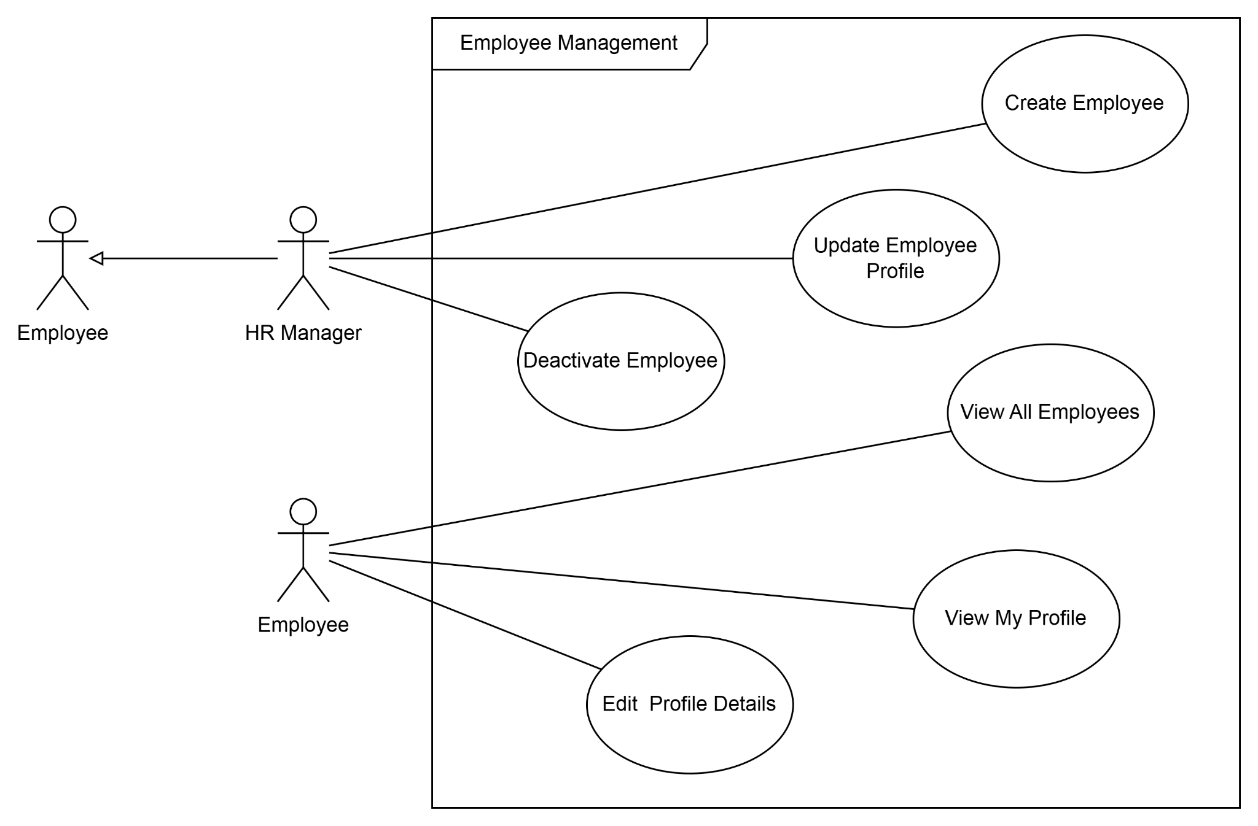
Payroll Management UCD: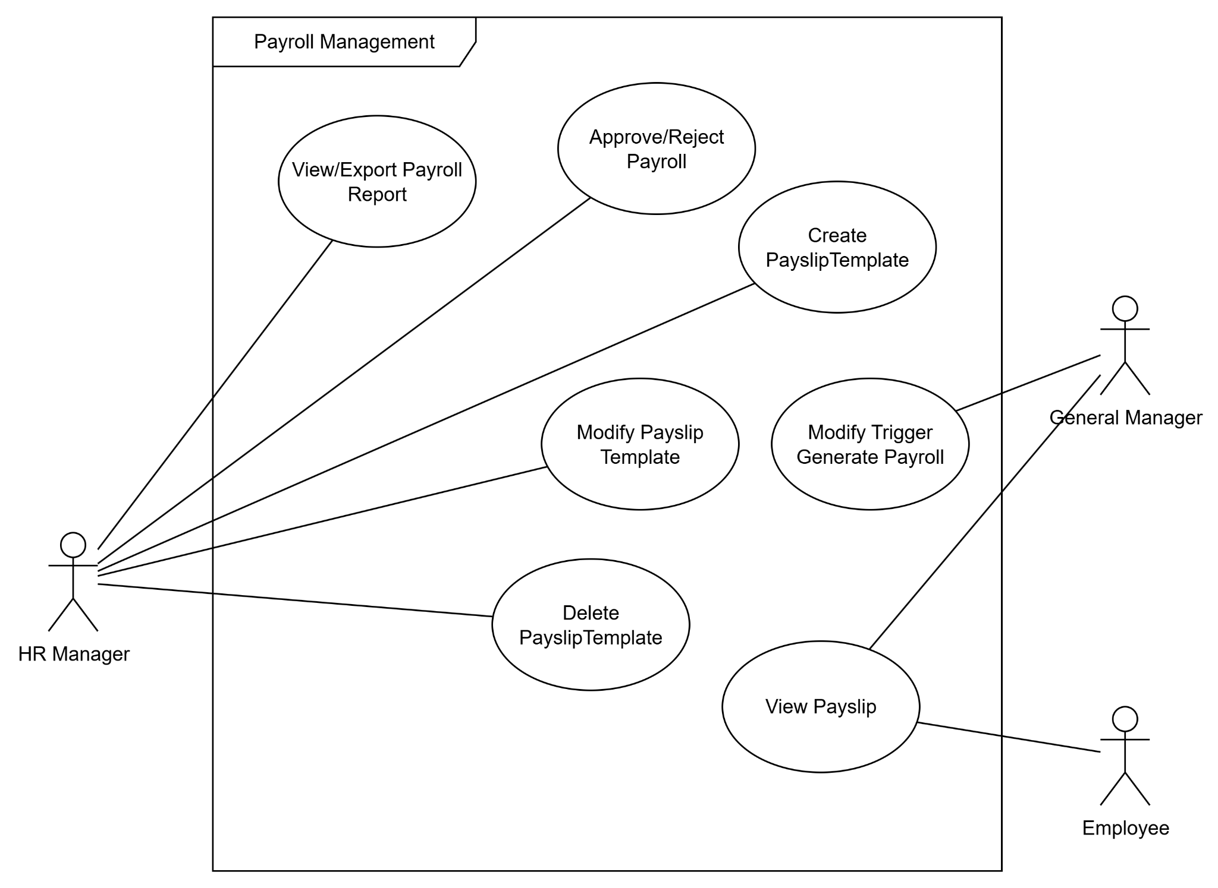

Authentication UCD:
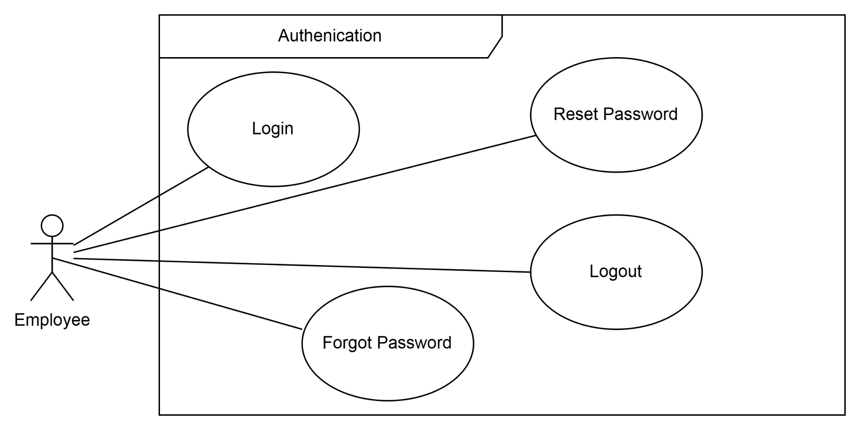

Task Management UCD:
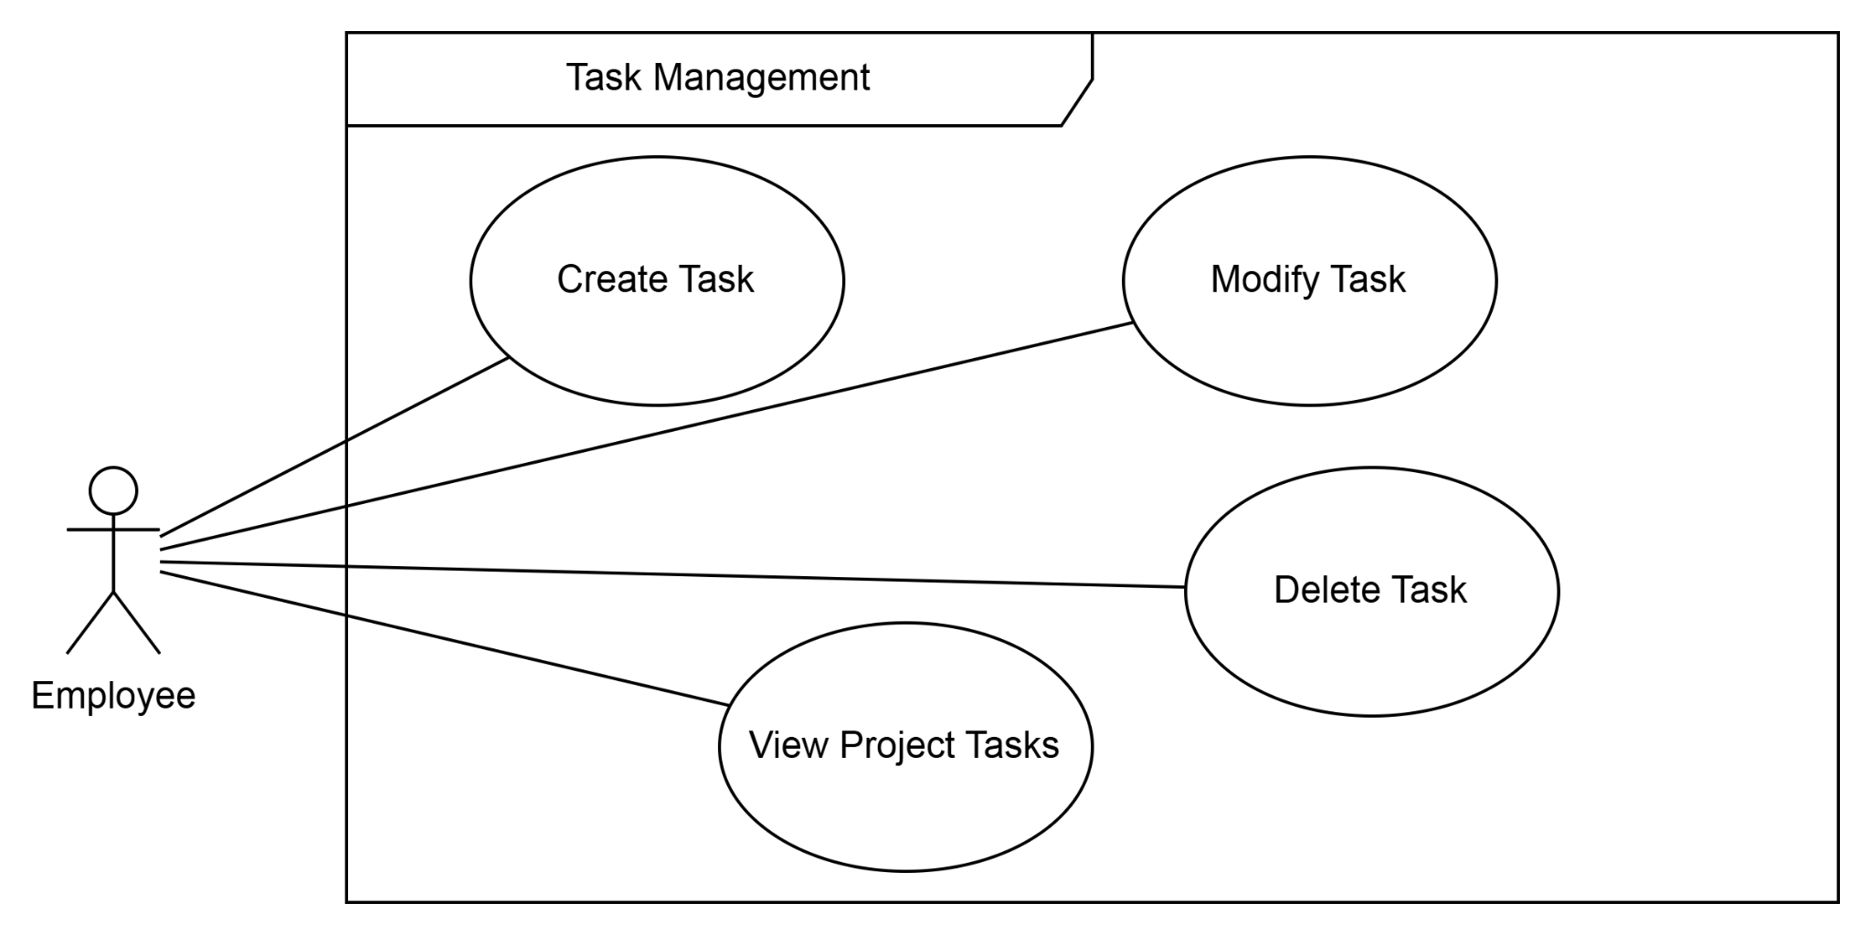

Agent Support UCD:
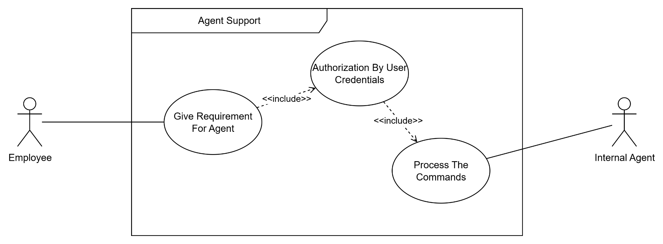

Project Management UCD:
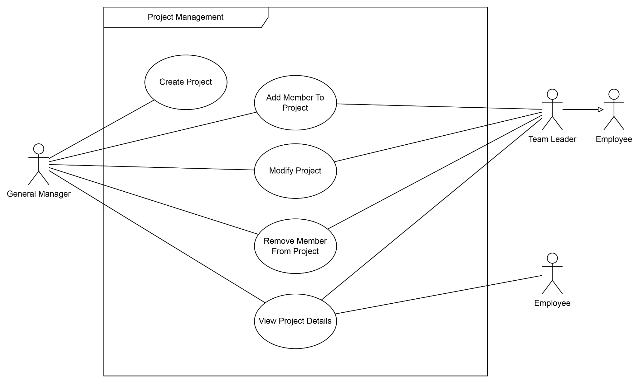

Attendance Management UCD:

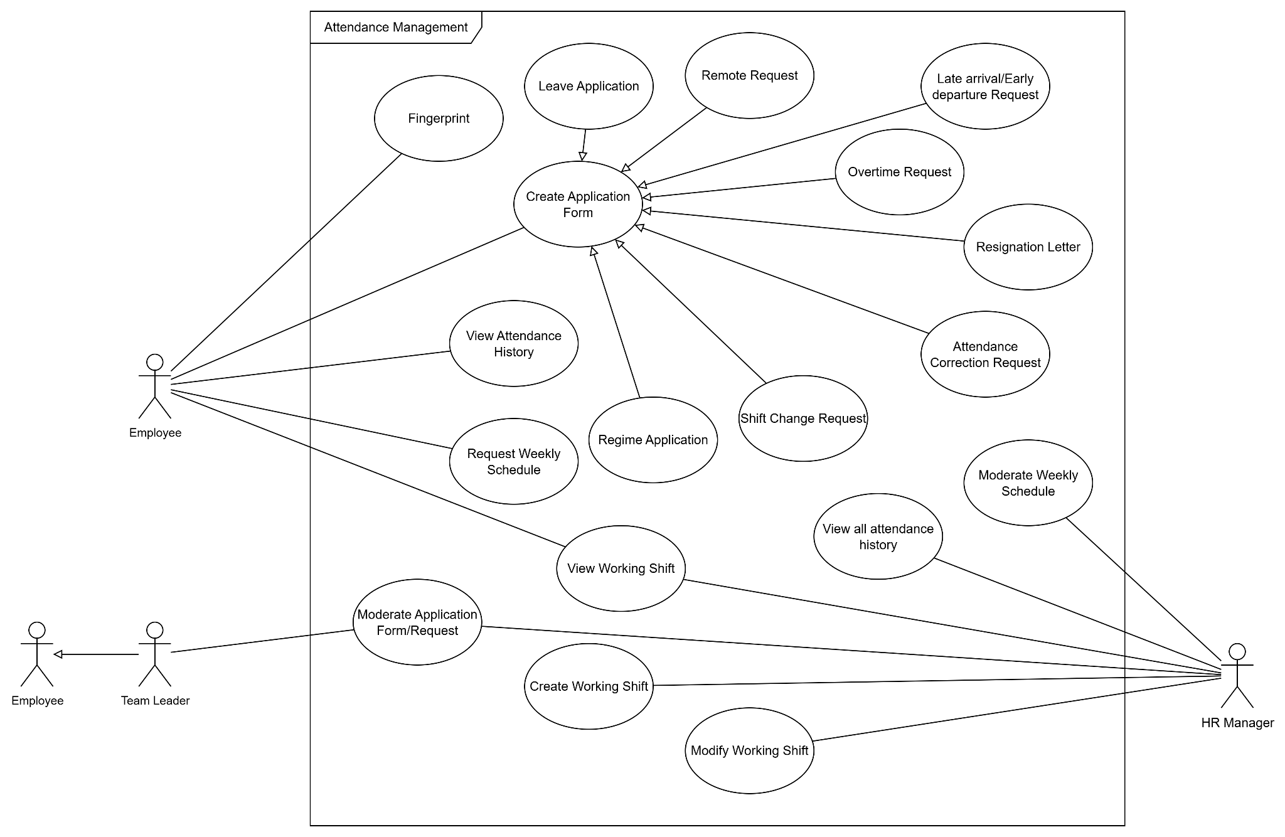
Recruitment Management UCD
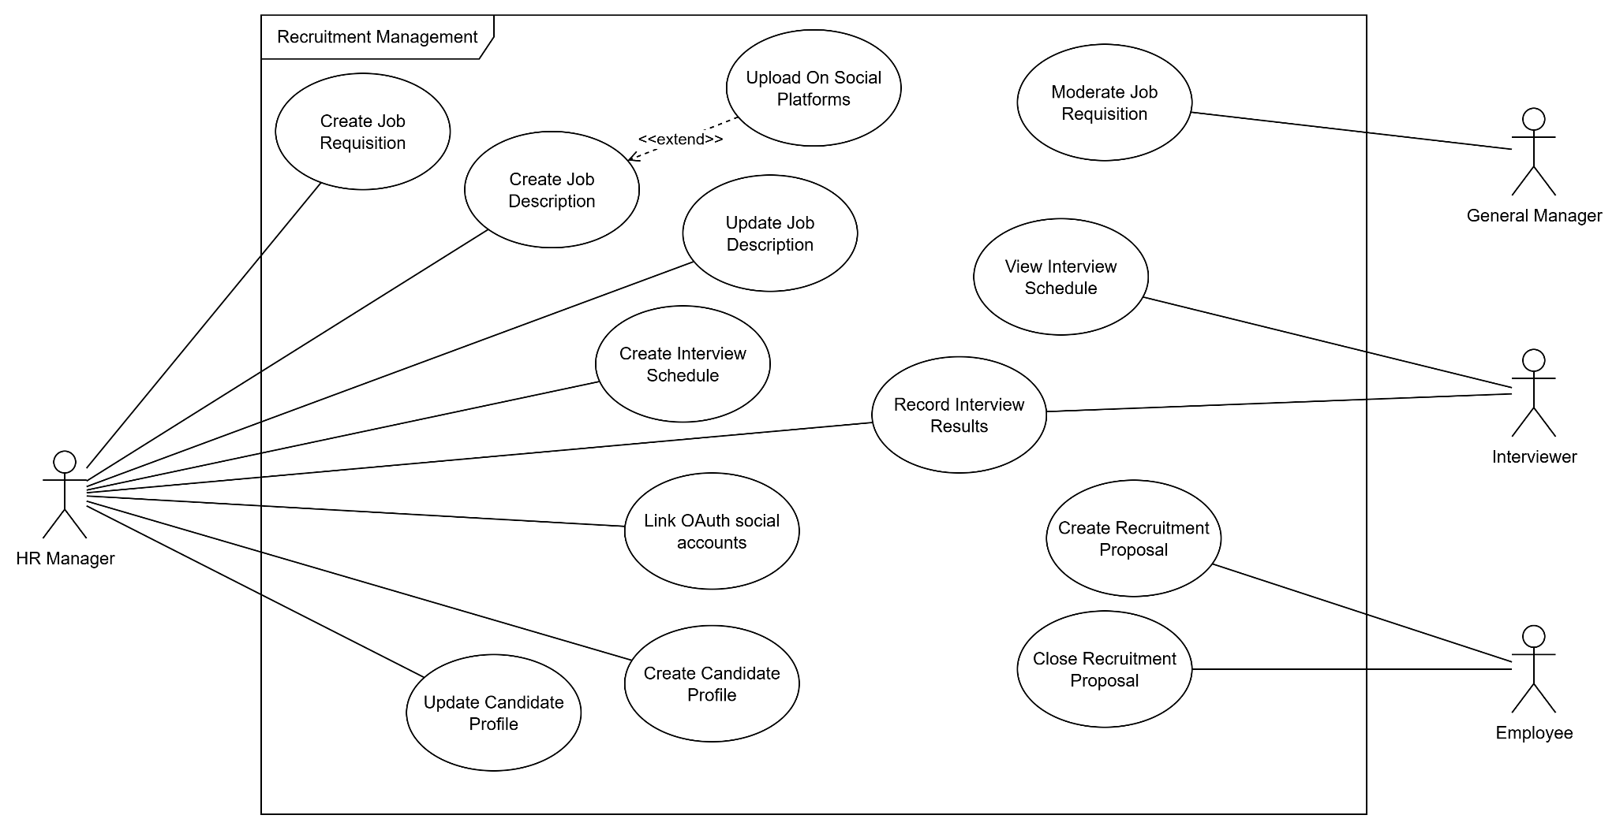
b. Descriptions

# | Feature | Use Case | Use Case Description
01 | Authentication | Login | Employee logs into the system with credentials.
02 | Authentication | Logout | Employee logs out and terminates the current session.
03 | Authentication | Reset Password | Employee resets their password by requesting Admin to reset it, then entering a new password and confirming it.
04 | Authentication | Forgot Password | Employees who cannot access their account initiates a password recovery flow.
05 | Authorization & Security | View Login Activity | Administrator views the login history and activity logs of all users in the system.
06 | Authorization & Security | Detect Suspicious Activity | The system detects abnormal login patterns (e.g., multiple failed attempts). This use case extends View Login Activity when suspicious behavior is identified. (<<extend>>)
07 | Authorization & Security | Assign Role | Administrator assigns a role (e.g., HR Manager, Team Leader, Employee) to a user account, granting the corresponding set of permissions.
08 | Authorization & Security | Revoke Role | Administrator revokes a previously assigned role from a user, removing the associated access rights.
09 | Authorization & Security | Reissue Password | Administrator reissues a temporary password for an employee who has lost access, typically triggered by a Reset Password request.
10 | Employee Management | Create Employee | HR Manager adds a new employee profile to the system.
11 | Employee Management | Update Employee Profile | HR Manager updates personal and professional details of an employee.
12 | Employee Management | Deactivate Employee | HR Manager deactivates an employee account (e.g., upon resignation).
13 | Employee Management | View All Employees | HR Manager views the list of all employees.
14 | Employee Management | View My Profile | Employee views their own profile information.
15 | Employee Management | Edit Profile Details | Employee edits their own editable profile fields such as phone number or address.
16 | Attendance Management | Fingerprint | Employee records their check-in or check-out by scanning their fingerprint. The system automatically logs the timestamp and updates their attendance status.
17 | Attendance Management | View Attendance History | Employee views their own attendance records.
18 | Attendance Management | View All Attendance History | HR Manager views attendance records of all employees.
19 | Attendance Management | Create Application Form | Employee creates an application form (Leave, Overtime, Remote, Shift Change, or Regime).
20 | Attendance Management | Leave Application | Employee submits a leave request (extends Create Application Form).
21 | Attendance Management | Overtime Request | Employee submits an overtime request (extends Create Application Form).
22 | Attendance Management | Remote Request | Employee submits a remote work request  form stating the reason for working  outside the office. By default, employees  work on-site; a Remote Request is  required to be approved before working  remotely.
23 | Attendance Management | Shift Change Request | Employee requests a change to their working shift.
24 | Attendance Management | Regime Application | Employee applies for a special work regime.
25 | Attendance Management | Create Recruitment Proposal | Employee submits a proposal requesting new headcount for their team, including justification and the required position details.
26 | Attendance Management | View Working Shift | Employee views their assigned working shift schedule.
27 | Attendance Management | Create Working Shift | HR Manager creates a new working shift template.
28 | Attendance Management | Modify Working Shift | HR Manager modifies an existing working shift.
29 | Attendance Management | Moderate Application Form | Team Leader or HR Manager reviews submitted application forms and approves or rejects them. The system notifies the employee of the outcome.
30 | Payroll Management | View/Export Payroll Report | HR Manager views and exports payroll reports.
31 | Payroll Management | Modify Salary Template | HR Manager modifies an existing salary template.
32 | Payroll Management | Moderate Payroll | HR Manager submits the generated payroll for review. The General Manager moderates (approves or requests revision of) the payroll before it is finalized.
33 | Payroll Management | View Payslip | Employee views their monthly payslip
34 | Payroll Management | Modify Trigger Generate Payroll | General Manager modifies the schedule/trigger for automatic payroll generation.
35 | Project Management | Create Project | General Manager creates a new project.
36 | Project Management | Modify Project | General Manager or Team Leader modifies project details.
37 | Project Management | Add Member To Project | General Manager or Team Leader adds an employee to a project.
38 | Project Management | Remove Member From Project | General Manager or Team Leader removes a member from a project.
39 | Project Management | View Project Details | General Manager, Team Leader, or Employee views project information.
40 | Task Management | Create Task | Employee creates a new task within a project.
41 | Task Management | Modify Task | Employee modifies an existing task.
42 | Task Management | Delete Task | Employee deletes a task.
43 | Task Management | View Project Tasks | Employee views all tasks associated with a project.
44 | Agent Support | Give Requirement For Agent | Employee provides a natural language command or requirement to the internal AI agent. This use case includes Authorization By User Credentials before any command is executed. (<<include>>) .
45 | Agent Support | Authorization By User Credentials | The agent verifies the employee's identity and permission level before processing the command. Upon successful authorization, it includes Process The Commands. (<<include>>)
46 | Agent Support | Process The Commands | The agent interprets and executes the authorized command, interacting with the relevant system modules to fulfill the employee's request.

2. Overall Functionalities

2.1 Screens Flow
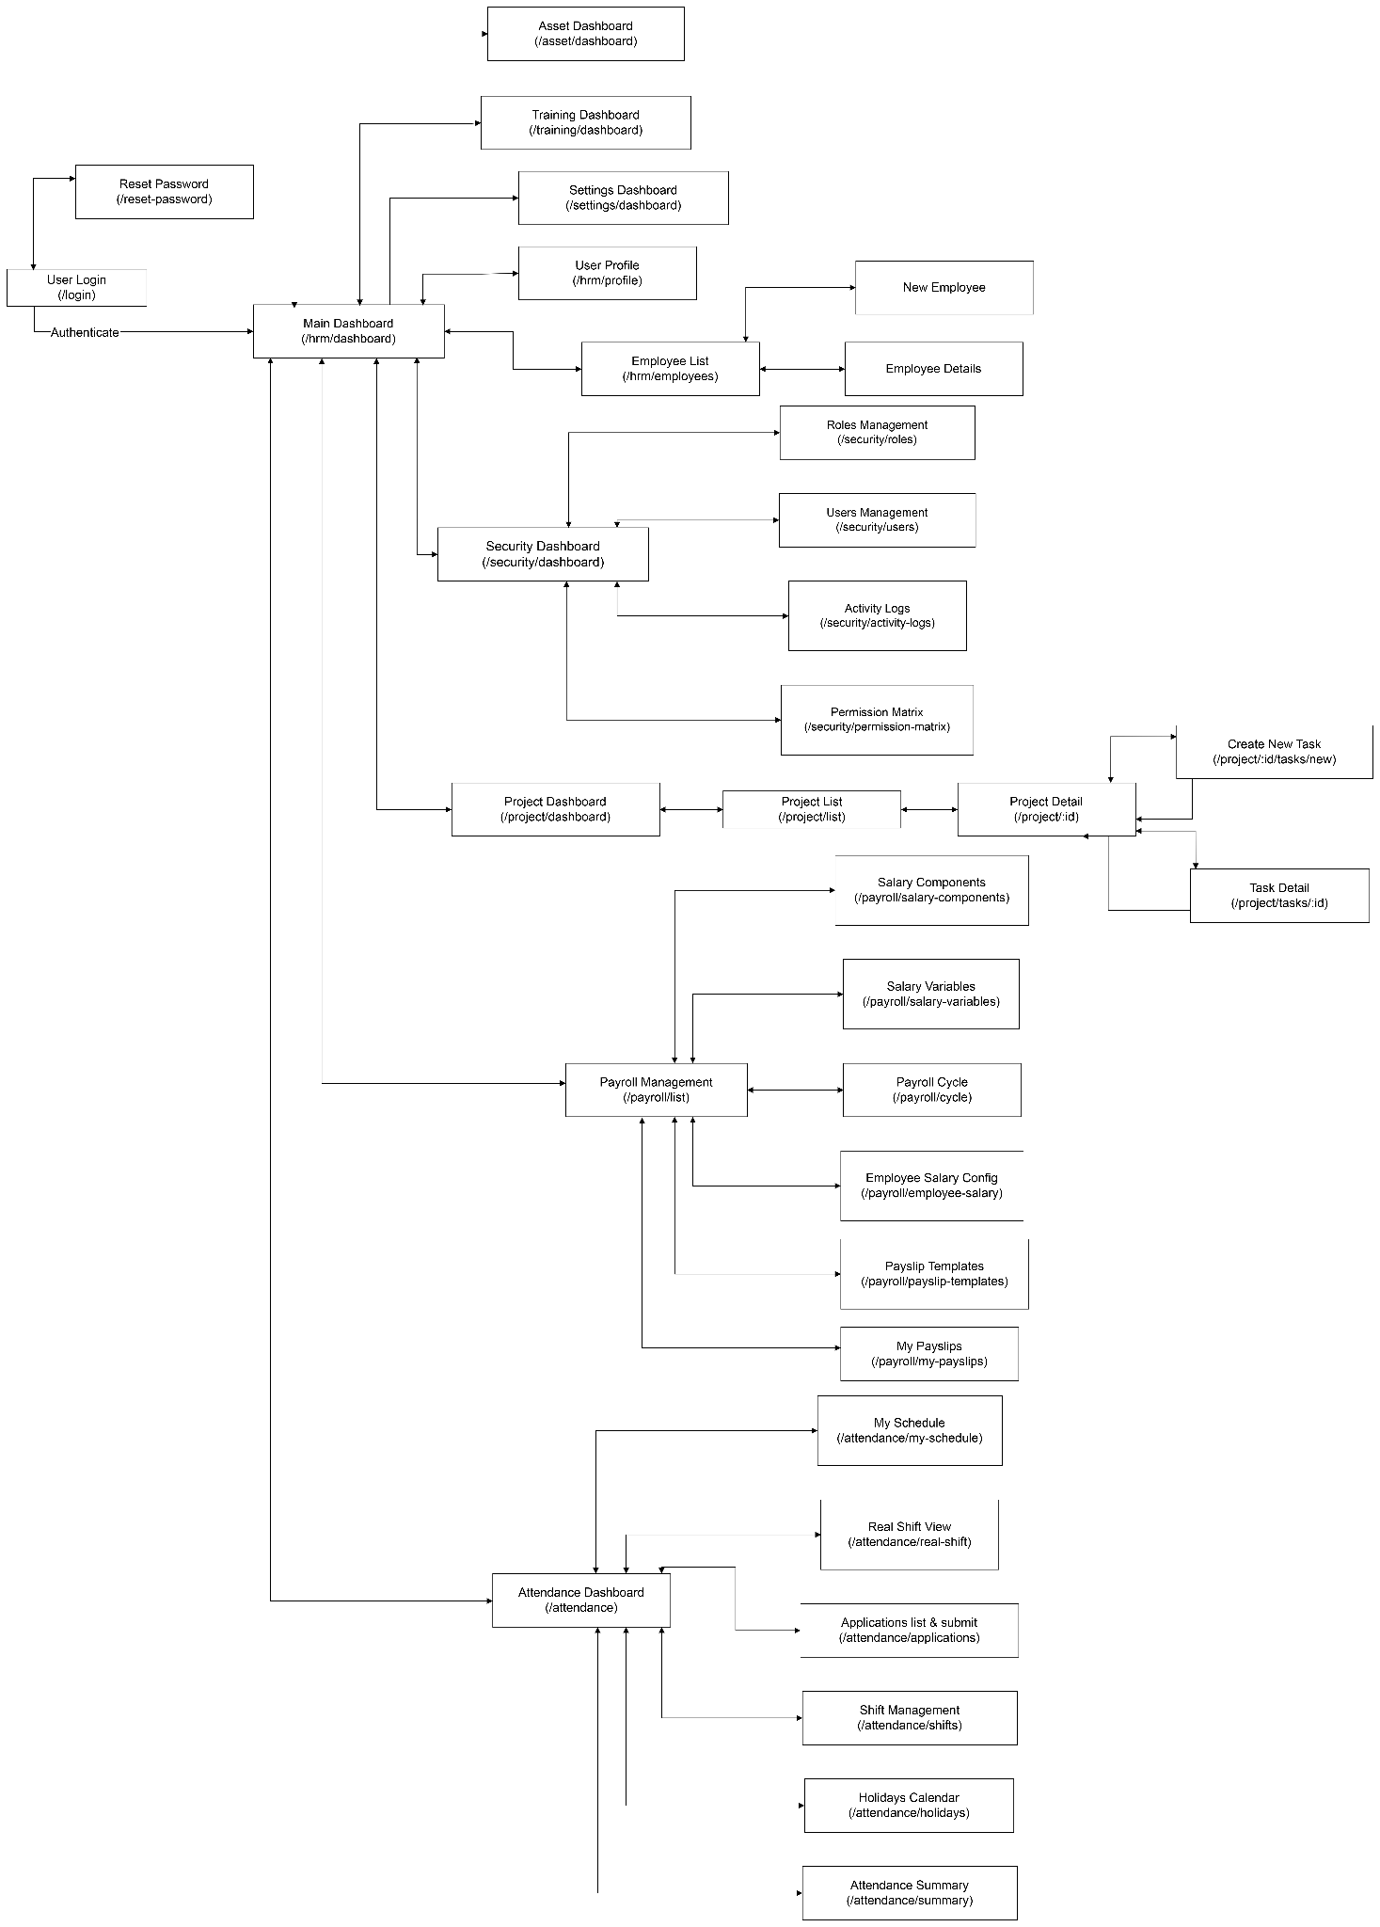

2.2 Screen Descriptions

# | Feature | Screen | Description
1 | Authentication | Login Screen | Screen for employees to enter credentials and log in.
2 | Authentication | Reset Password Screen | Screen for Admin to reset an employee's  password, or for employee to enter and  confirm a new password.
 | Authorization & Security | Role & Security Management Screen | Screen for Administrator to assign/revoke roles, view login activity, and manage suspicious activity alerts.
3 | Employee Management | Employee List | Displays all employee records with search and filter options.
4 | Employee Management | Employee Details | Displays full profile of an individual employee.
5 | Employee Management | Add/Edit Employee | Form screen for creating or updating an employee record.
6 | Attendance Management | Attendance Dashboard | Overview of attendance statistics and quick-access links.
7 | Attendance Management | Attendance History | List of check-in/check-out records for an employee
8 | Attendance Management | Application Form Screen | Form for submitting Leave, Overtime, Remote, Shift Change, or Regime requests.
9 | Attendance Management | Working Shift Management | Screen to create, view, and modify working shifts.
10 | Attendance Management | Recruitment Proposal Screen | Form screen for employees to submit or close a recruitment proposal for new headcount.
11 | Payroll Management | Payroll Dashboard | Summary of payroll status and navigation to sub-features.
12 | Salary Management | Salary Template Management | CRUD screen for salary templates.
13 | Payroll Management | Payroll Report | View and export payroll reports by period.
14 | Payroll Management | Payslip View | Employee's personal payslip screen.
18 | Project Management | Project List | List of all projects with status and key information.
19 | Project Management | Project Details | Detailed view of a project including members and tasks.
20 | Task Management | Task Board/List | Kanban or list view of tasks for a project.
21 | Agent Support | Agent Chat Interface | Chat-based interface for submitting commands to the internal agent.

2.3 Screen Authorization

Screen | Employee | Team Leader | HR Manager | General Manager | Administrator
Login / Logout / Reset Password | X | X | X | X | X
View My Profile | X | X | X | X | X
View Employee Details | X | X | X |  | X
View All Employees |  |  | X | X | X
Add / Update / Deactivate Employee |  |  | X |  | X
View Attendance History (own) | X | X |  |  | X
View All Attendance History |  |  | X |  | X
Submit Application Forms | X | X |  |  | X
Approve/Reject Application Form |  | X | X |  | X
Create / Modify Working Shift |  |  | X |  | X
View Working Shift | X | X | X |  | X
View/Export Payroll Report |  |  | X | X | X
Manage Salary Components & Templates |  |  | X |  | X
Approve/Reject Payroll |  |  | X | X | X
Modify Trigger Generate Payroll |  |  |  | X | X
View Payslip | X | X |  |  | X
Manage Recruitment Postings & Candidates |  |  | X |  | X
Create / Close Recruitment Proposal | X | X |  |  | X
Create / Modify Project |  | X |  | X | X
Add / Remove Project Members |  | X |  | X | X
View Project Details | X | X |  | X | X
Create / Modify / Delete Task | X | X |  |  | X
View Project Tasks | X | X |  | X | X
Agent Support (Give Requirement) | X | X |  |  | X

2.4 Non-UI Functions

# | Feature | System Function | Description
1 | Attendance Management | Fingerprint Sync Service | Background service that synchronizes fingerprint data from hardware devices to the database.
2 | Payroll Management | Auto Payroll Generation (Cron Job) | Scheduled job that automatically generates payroll on a configured trigger date each month.
3 | Authorization & Security | Suspicious Activity Detection | Background service that monitors login patterns and flags anomalies (e.g., multiple failed logins).
4 | Agent Support | Agent Command Processor | Internal service that parses, validates, and executes commands submitted by authorized users.

3. System High Level Design

3.1 Database Design
a. Database Schema
Module 1: Human Resources & Core System Management
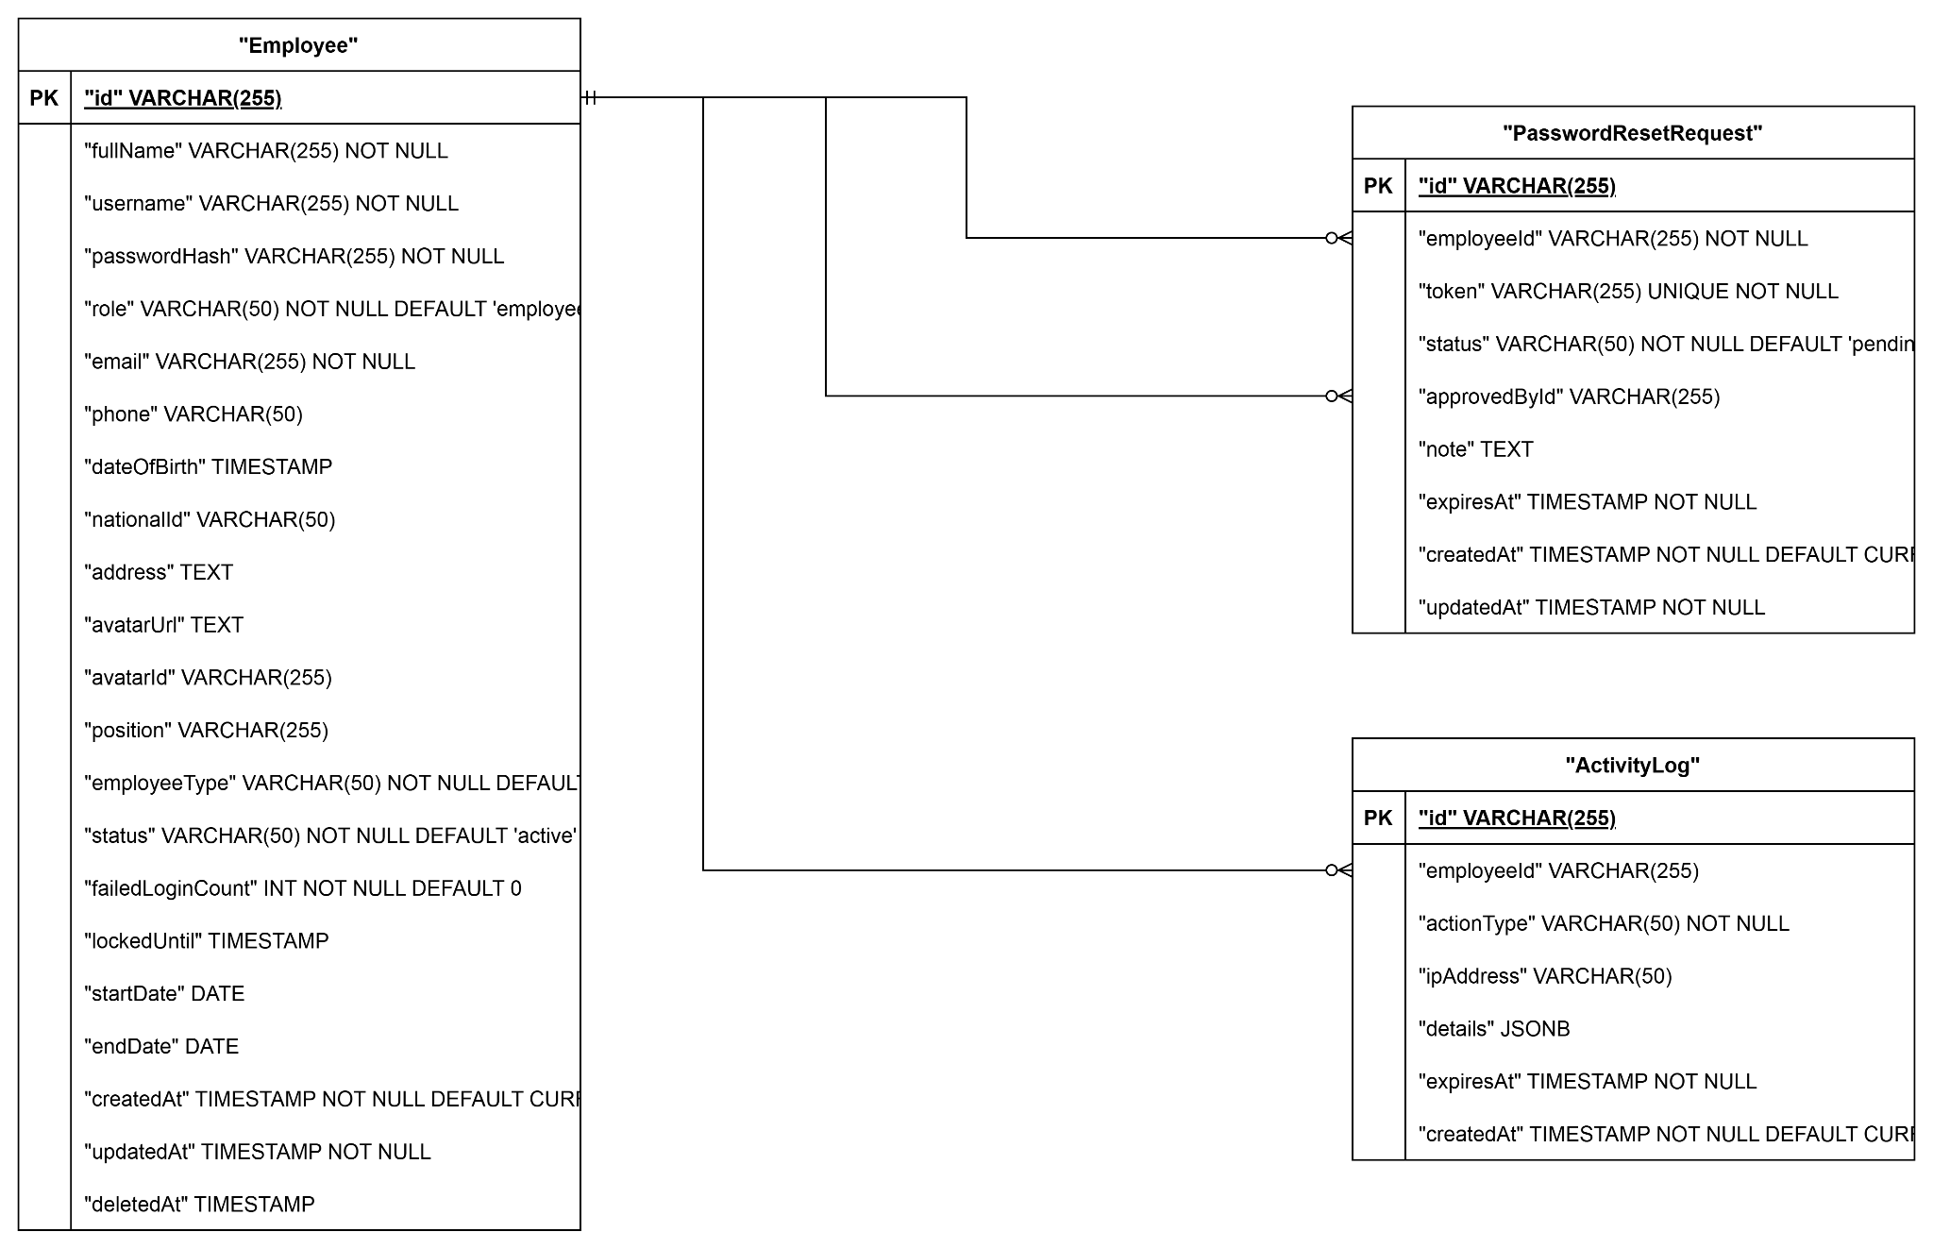

Module 2: Attendance & Shifts
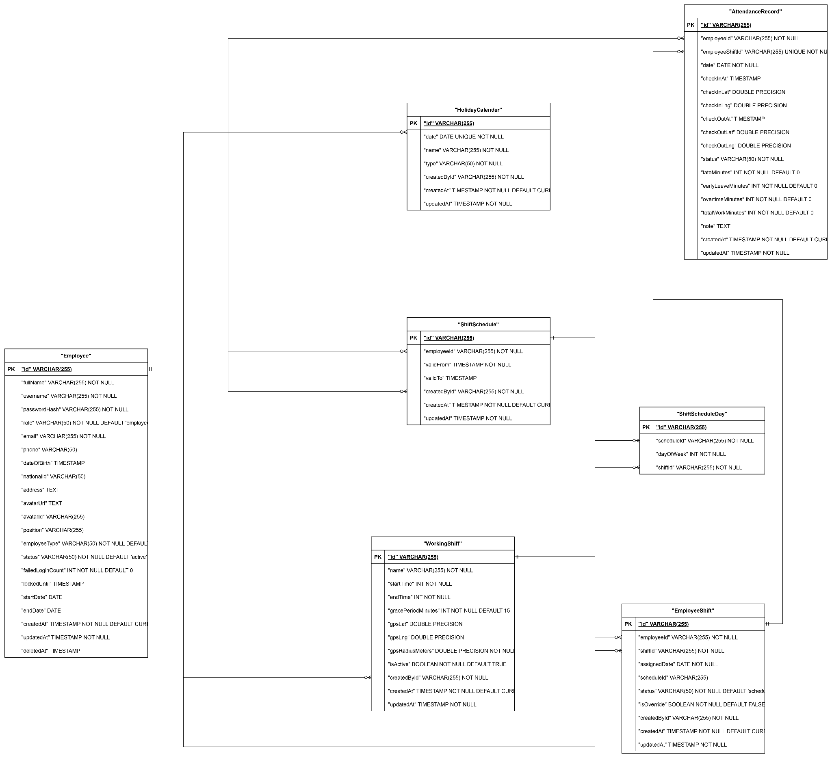

Module 3: Request & Approval Management
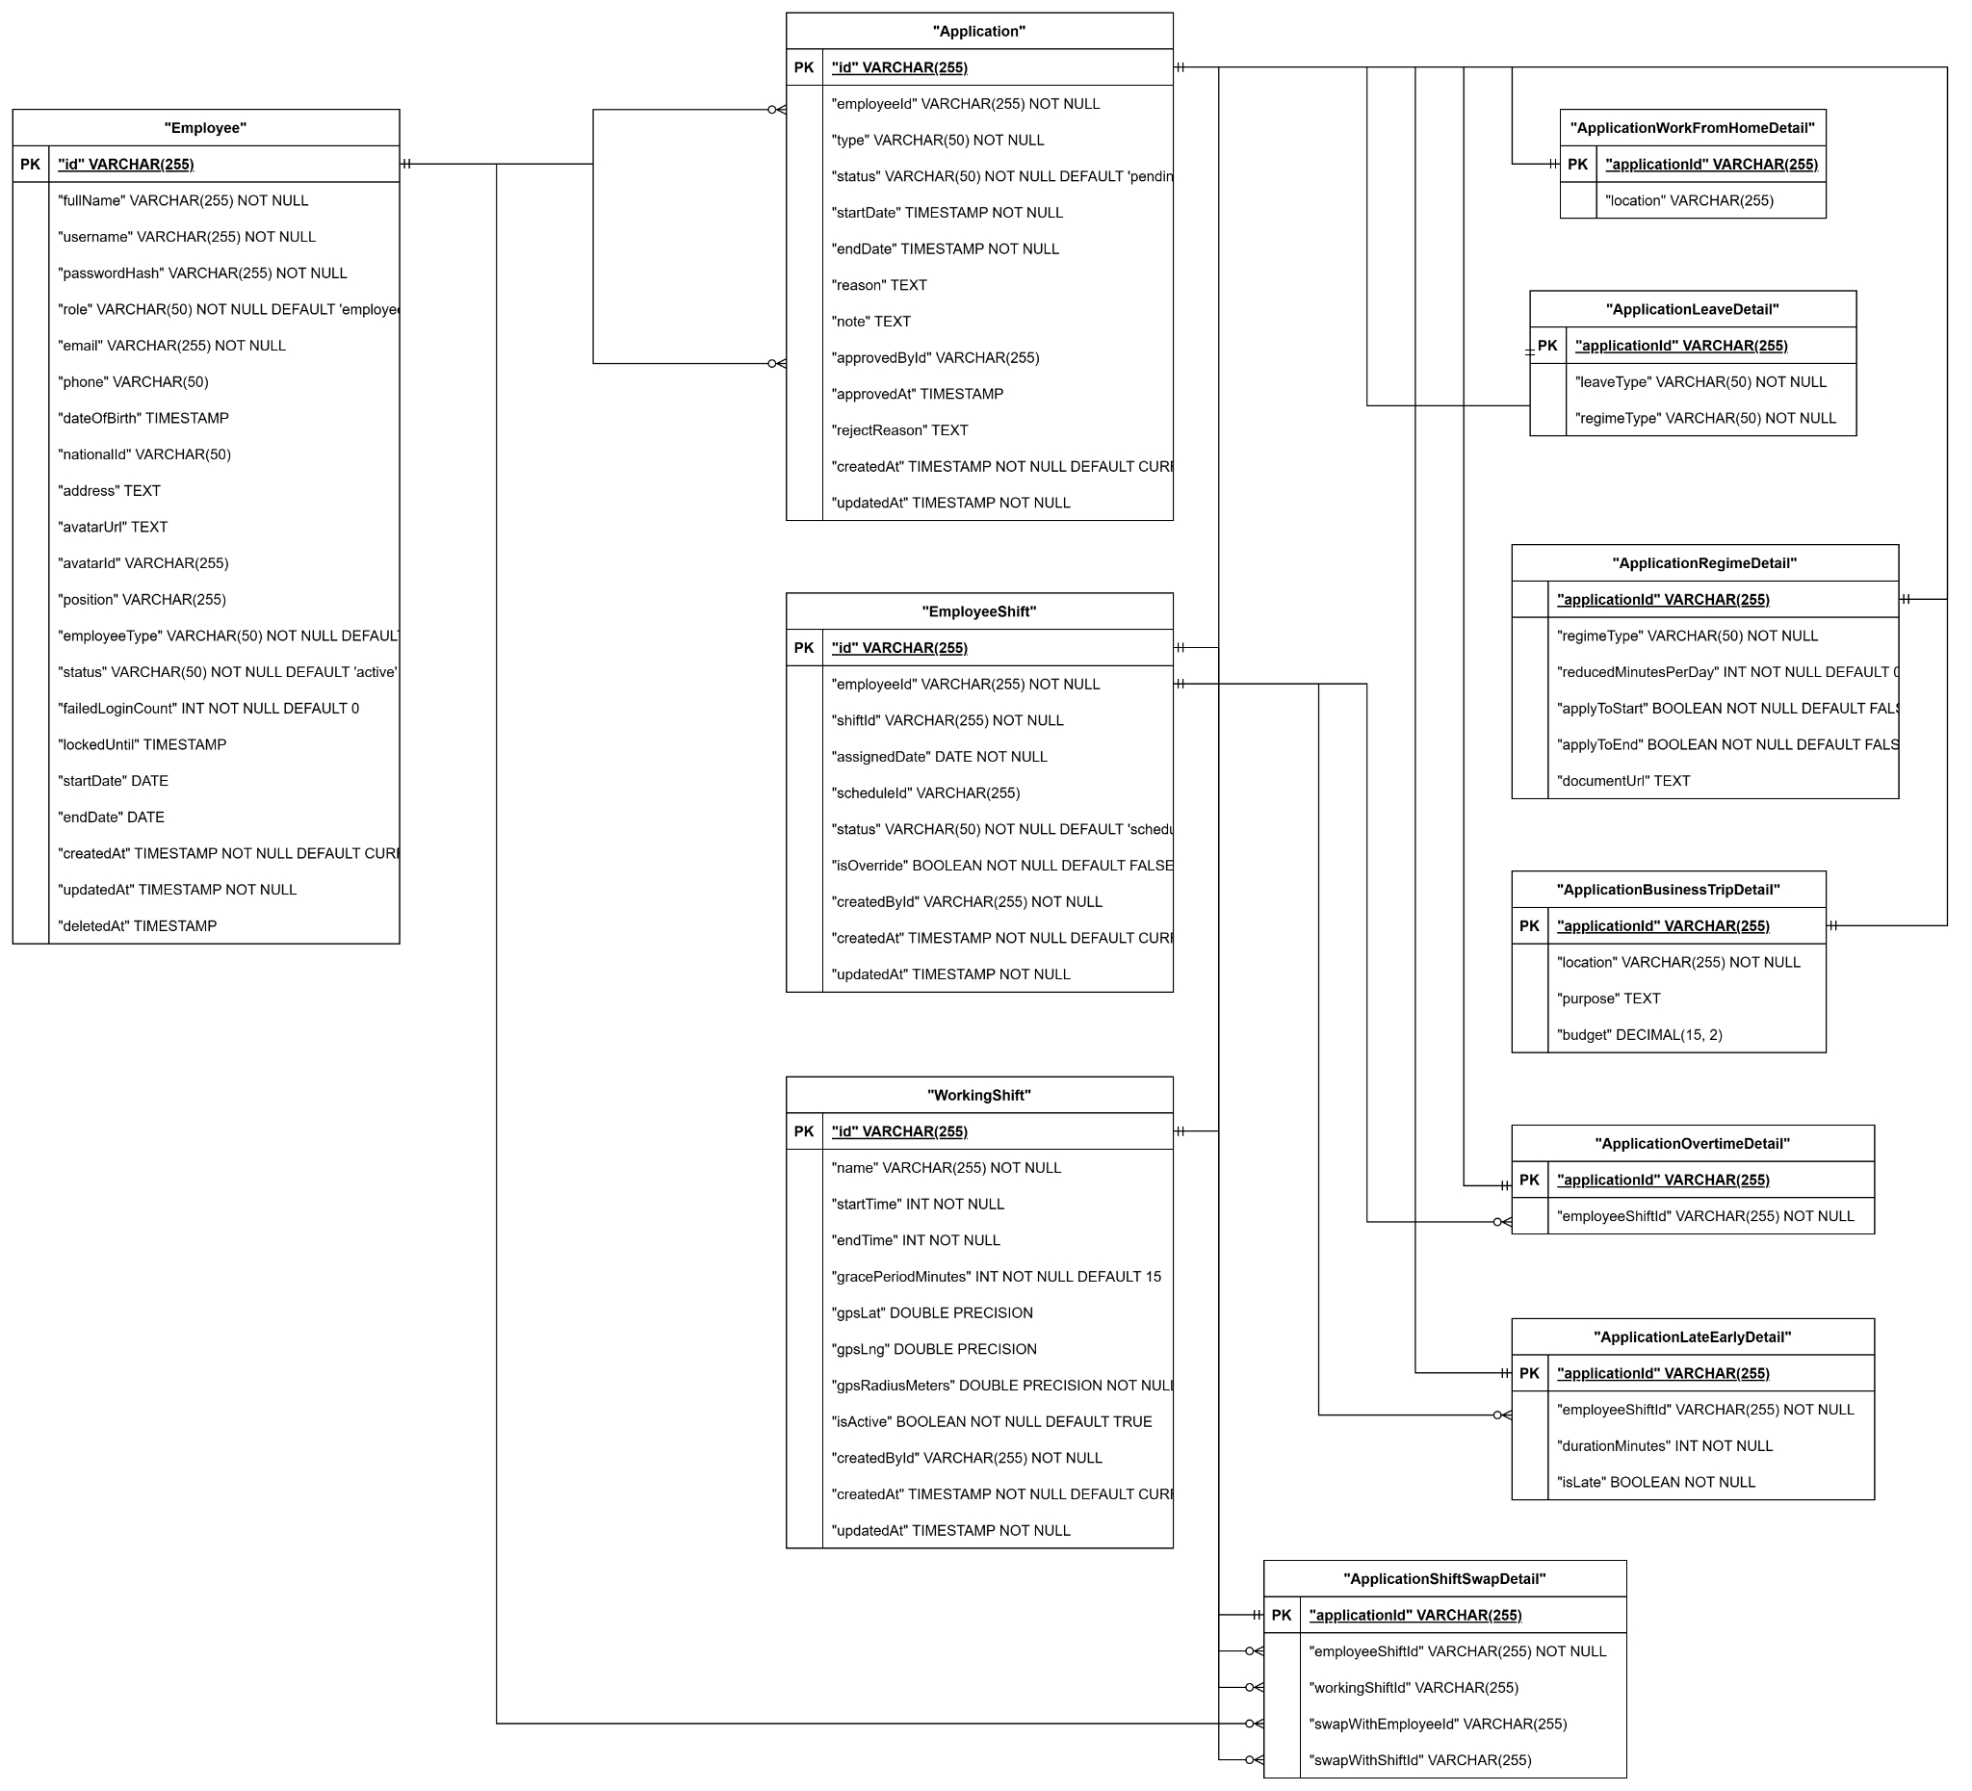

Module 4:Salary Configuration & Payroll Management
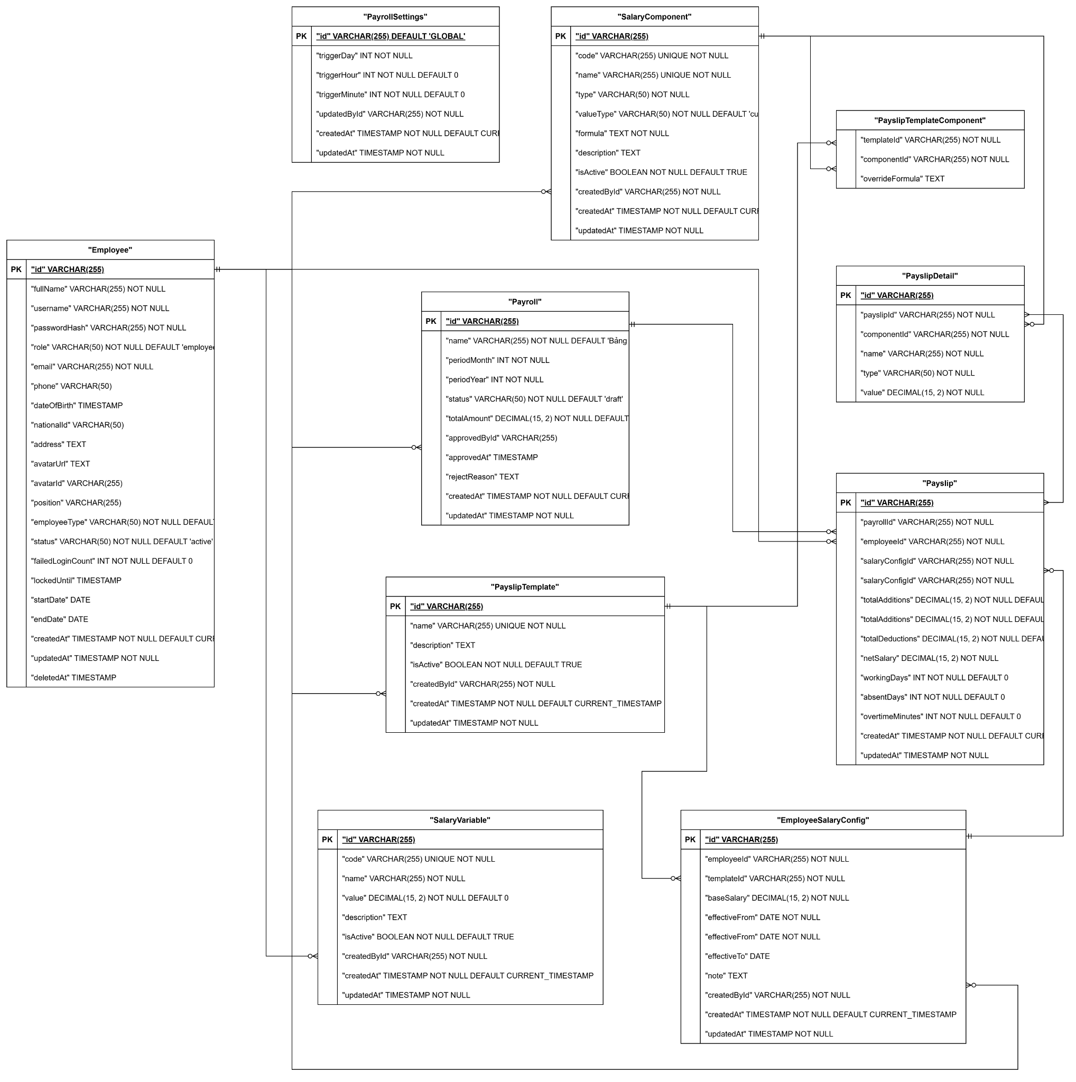

Module 5: Project & Task Management (Projects & Tasks)
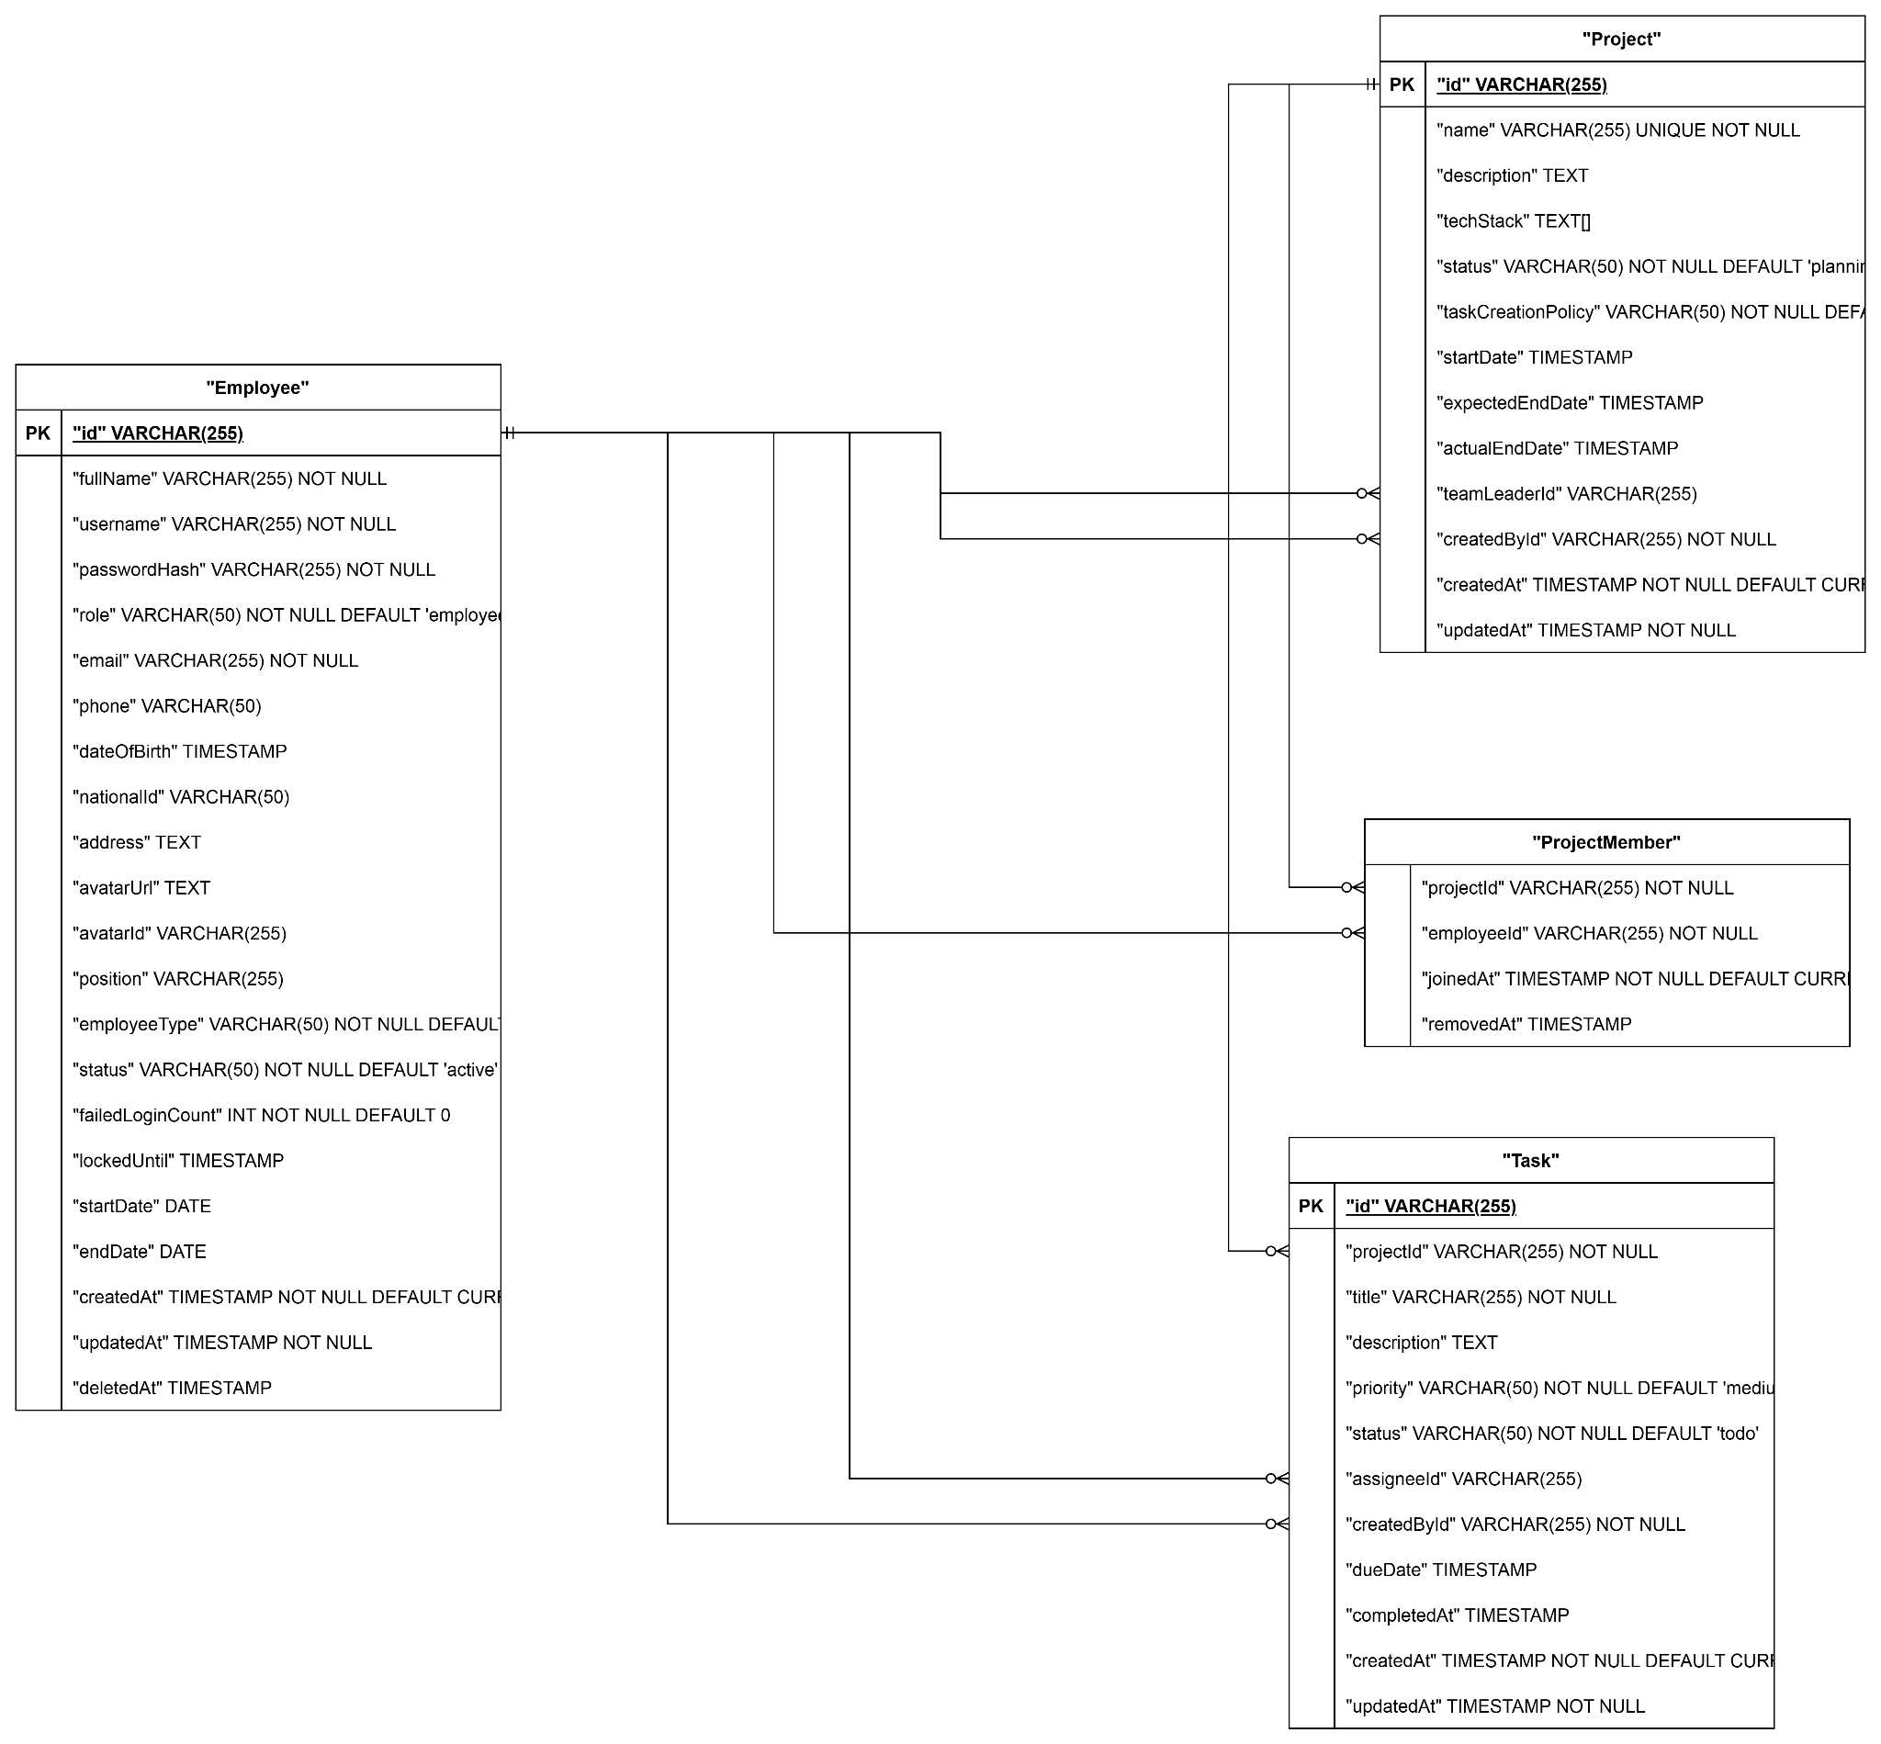

b. Table Descriptions

# | Table | Description
01 | Employee | Stores employee personal and employment information. - Primary keys: employee_id - Foreign keys: role_id (Role)
02 | Role | Defines system roles (Employee, Team Leader, HR Manager, General Manager, Administrator). - Primary keys: role_id
03 | Permission | Defines granular permissions assignable to roles. - Primary keys: permission_id
04 | RolePermission | Junction table mapping roles to permissions. - Primary keys: role_id, permission_id - Foreign keys: role_id, permission_id
05 | Attendance | Records employee check-in/check-out events from fingerprint device. - Primary keys: attendance_id - Foreign keys: employee_id
06 | WorkingShift | Defines working shift schedules. - Primary keys: shift_id
07 | ApplicationForm | Stores leave, overtime, remote, shift change, and regime application forms. - Primary keys: form_id - Foreign keys: employee_id, approver_id
08 | SalaryComponent | Stores salary components such as base pay, bonuses, allowances, deductions. - Primary keys: component_id
09 | SalaryTemplate | Defines salary calculation templates. - Primary keys: template_id
10 | Payroll | Stores generated payroll records per period. - Primary keys: payroll_id - Foreign keys: template_id, approved_by
11 | Payslip | Individual employee payslip for each payroll period. - Primary keys: payslip_id - Foreign keys: payroll_id, employee_id
12 | RecruitmentPosting | Stores job postings for open positions. - Primary keys: posting_id - Foreign keys: created_by (HR Manager)
13 | Candidate | Stores applicant/candidate information. - Primary keys: candidate_id - Foreign keys: posting_id
14 | InterviewSchedule | Tracks scheduled interviews for candidates. - Primary keys: interview_id - Foreign keys: candidate_id, interviewer_id
15 | Project | Stores project information. - Primary keys: project_id - Foreign keys: created_by
16 | ProjectMember | Junction table mapping employees to projects. - Primary keys: project_id, employee_id - Foreign keys: project_id, employee_id
17 | Task | Stores tasks within projects. - Primary keys: task_id - Foreign keys: project_id, assignee_id, created_by
18 | LoginActivity | Logs all login events for audit and security monitoring. - Primary keys: log_id - Foreign keys: employee_id

3.2 Code Packages
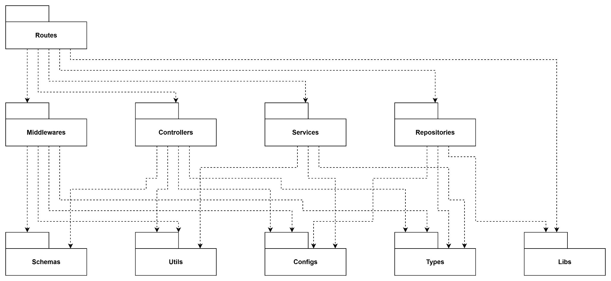
Package descriptions:

# | Package | Description
1 | Routes | The outermost layer and API entry point. Defines URLs, HTTP methods, and routes requests to the appropriate Middlewares and Controllers.
2 | Middlewares | The "checkpoints" intercepting requests before Controllers. Responsible for authentication, authorization, centralized error handling, and calling Schemas for input validation.
3 | Controllers | The HTTP adapter layer. Receives requests, extracts data, calls Services to execute business logic, and formats the HTTP response to return to the client.
4 | Services | The core business logic layer. Executes business rules, calculations, and orchestrates data flow by interacting with Repositories.
5 | Repositories | The data access layer. Responsible for direct communication with the database (via Libs), hiding database implementation details from the Services layer.
6 | Schemas | Defines data validation schemas (e.g., using Zod) to ensure the integrity and validity of incoming and outgoing data.
7 | Utils | Contains shared, independent helper functions (pure functions) such as password hashing, JWT processing, date formatting, and string manipulation.
8 | Configs | Centralized storage for system configurations: environment variables, connection strings, and especially business constants/enums to prevent hardcoding.
9 | Types | Contains static type definitions (TypeScript Interfaces, Types), Data Transfer Objects (DTOs), and Contracts to ensure Type Safety across the entire system.
10 | Libs | Wrapper layer for third-party libraries. Initializes and configures external SDKs (e.g., Database clients) to isolate them from the core application logic.

II. Requirement Specifications

1. Common Functions

1.1. Authentication
- UC01 Login
a. Functional Description

UC ID and Name | UC01 - User Login
Created By | LoanTTB
Date Created | 01/06/2026
Primary Actor | Employee
Secondary Actors | Authentication System
Trigger | Employee submits login form
Description | Employee authenticates to access the HR & Project Management System using valid credentials
Preconditions | PRE-1: Employee account exists  PRE-2: Account is active
Postconditions | POST-1: JWT token generated  POST-2: User redirected to dashboard
Normal Flow | 1.0 Login  - User opens Login page  - User enters username and password  - User clicks Login  - System validates credentials  - System generates JWT token  - System redirects user to Dashboard
Alternative Flows | 1.1 Invalid Credentials  - System detects invalid username or password  - System displays authentication error  - Return to step 2
Exceptions | 1.0.E1 Account Locked  - System detects account is temporarily locked  - System displays lockout message  - Use case terminates  1.0.E2 System Failure  - Authentication service unavailable  - System displays error message  - Use case terminates
Priority | Must Have
Frequency of Use | Very High
Business Rules | BR-AUTH-01, BR-AUTH-02, BR-AUTH-03, BR-AUTH-04
Other Information | None
Assumptions | User has valid credentials

b. Business Rules

ID | Business Rule | Description
BR-AUTH-01 | Active Account Only | Only active employees may log in
BR-AUTH-02 | Password Hashing | Passwords must be stored using bcrypt hashing
BR-AUTH-03 | JWT Authentication | System uses JWT token-based authentication
BR-AUTH-04 | Account Lockout | Account is locked for 5 minutes after 5 consecutive failed login attempts

- UC02 Logout
a. Functional Description

UC ID and Name | UC02 - User Logout
Created By | LoanTTB
Date Created | 01/06/2026
Primary Actor | Employee
Secondary Actors | Authentication System
Trigger | Employee clicks Logout button
Description | Employee terminates the current authenticated session and exits the system securely
Preconditions | PRE-1: Employee is authenticated  PRE-2: Valid JWT session exists
Postconditions | POST-1: JWT token invalidated or removed from client storage  POST-2: Logout activity recorded  POST-3: User redirected to Login page
Normal Flow | 2.0 Logout  - Employee clicks Logout  - System receives logout request  - System records logout activity  - System removes authentication token  - System redirects employee to Login page
Alternative Flows | 2.1 Session Expired  - System detects session already expired  - System clears local authentication data  - System redirects employee to Login page
Exceptions | 2.0.E1 System Failure  - Logging service unavailable  - System completes logout process locally  - User is redirected to Login page
Priority | Must Have
Frequency of Use | Very High
Business Rules | BR-AUTH-05
Other Information | None
Assumptions | User has an active session

b. Business Rules

ID | Business Rule | Description
BR-AUTH-05 | Session Termination | Logout must invalidate current session and remove authentication token

- UC03 Reset Password
a. Functional Description

UC ID and Name | UC03 - Reset Password
Created By | LoanTTB
Date Created | 01/06/2026
Primary Actor | Employee
Secondary Actors | Authentication System
Trigger | Employee submits reset password form using a valid reset token
Description | Employee resets account password using a valid password reset link
Preconditions | PRE-1: Valid reset token exists  PRE-2: Reset request status is Pending
Postconditions | POST-1: Password updated successfully  POST-2: Reset token marked as Used  POST-3: User can log in using the new password
Normal Flow | 3.0 Reset Password  - Employee opens Reset Password page  - System validates reset token  - System displays reset password form  - Employee enters new password  - Employee confirms new password  - Employee submits form  - System validates reset token  - System validates password policy  - System updates password  - System marks reset token as Used  - System displays success message
Alternative Flows | 3.1 Password Validation Failed  - System detects password policy violation  - System displays validation error  - Return to step 2
Exceptions | 3.0.E1 Invalid Token  - System detects invalid token  - System displays error message  - Use case terminates  3.0.E2 Expired Token  - System detects expired token  - System displays expiration message  - Use case terminates
Priority | Must Have
Frequency of Use | Medium
Business Rules | BR-AUTH-06, BR-AUTH-07
Other Information | None
Assumptions | User has received the reset email

b. Business Rules

ID | Business Rule | Description
BR-AUTH-06 | Reset Token Expiration | Password reset token expires after 15 minutes
BR-AUTH-07 | Password Reuse Restriction | New password must be different from the current password

- UC04 Forgot Password
a. Functional Description

UC ID and Name | UC04 - Forgot Password
Created By | LoanTTB
Date Created | 01/06/2026
Primary Actor | Employee
Secondary Actors | Authentication System, Email Service
Trigger | Employee selects "Forgot Password"
Description | Employee requests a password reset link through the registered email address
Preconditions | PRE-1: Employee has access to an email address
Postconditions | POST-1: Reset token is generated  POST-2: Password reset request is stored  POST-3: Reset email is sent
Normal Flow | 4.0 Forgot Password  - Employee clicks Forgot Password  - Employee enters email address  - Employee submits request  - System validates email  - System generates reset token  - System creates password reset request  - System sends reset email  - System displays confirmation message
Alternative Flows | 4.1 Existing Pending Request  - System detects active reset request  - System returns generic confirmation message  - Use case ends
Exceptions | 4.0.E1 Email Service Unavailable  - Email service fails  - System logs error  - Generic response still displayed
Priority | Must Have
Frequency of Use | Medium
Business Rules | BR-AUTH-08, BR-AUTH-09
Other Information | System must not reveal whether the email exists
Assumptions | Employee has access to registered email

b. Business Rules

ID | Business Rule | Description
BR-AUTH-08 | Email Enumeration Protection | System must not reveal whether an email exists
BR-AUTH-09 | Single Active Reset Request | Only one pending password reset request is allowed per employee

- UC05 Change Password
a. Functional Description

UC ID and Name | UC05 - Change Password
Created By | LoanTTB
Date Created | 01/06/2026
Primary Actor | Employee
Secondary Actors | Authentication System
Trigger | Employee submits change password form
Description | Employee changes current account password
Preconditions | PRE-1: Employee is authenticated  PRE-2: Employee account is active
Postconditions | POST-1: Password updated successfully  POST-2: Previous password becomes invalid
Normal Flow | 5.0 Change Password  - Employee opens Change Password page  - Employee enters current password  - Employee enters new password  - Employee confirms new password  - Employee submits form  - System validates current password  - System validates password policy  - System updates password  - System displays success message
Alternative Flows | 5.1 Password Validation Failed  - System detects invalid password format  - System displays validation error  - Return to step 3
Exceptions | 5.0.E1 Incorrect Current Password  - System detects incorrect current password  - System displays error message  - Use case terminates  5.0.E2 Password Reuse Detected  - System detects new password matches current password  - System displays error message  - Use case terminates
Priority | Must Have
Frequency of Use | Medium
Business Rules | BR-AUTH-10, BR-AUTH-11, BR-AUTH-12
Other Information | None
Assumptions | Employee remembers current password

b. Business Rules

ID | Business Rule | Description
BR-AUTH-10 | Password Complexity | Password must satisfy minimum security requirements
BR-AUTH-11 | Password Reuse Prevention | New password must be different from current password
BR-AUTH-12 | Password Hashing | Updated passwords must be stored using bcrypt hashing

1.2. Authorization & Security
- UC06 View Login Activity
a. Functional Description

UC ID and Name | UC06 - View Login Activity
Created By | LoanTTB
Date Created | 01/06/2026
Primary Actor | Employee
Secondary Actors | Activity Logging System
Trigger | Employee requests login activity history
Description | Employee reviews authentication activity associated with their account
Preconditions | PRE-1: Employee is authenticated
Postconditions | POST-1: Login activity records displayed
Normal Flow | 6.0 View Login Activity  - Employee navigates to Login Activity page  - System retrieves activity records  - System displays login history  - Employee reviews activity details
Alternative Flows | 6.1 Apply Filter  - Employee specifies filter criteria  - System filters activity records  - System displays filtered results
Exceptions | 6.0.E1 No Activity Records  - System finds no records  - System displays empty state message
Priority | Should Have
Frequency of Use | Medium
Business Rules | BR-SEC-01
Other Information | Activity records are read-only
Assumptions | Activity logs are stored by the system

b. Business Rules

ID | Business Rule | Description
BR-SEC-01 | Activity Logging | Every authentication attempt must be logged

- UC07 Detect Suspicious Activity
a. Functional Description

UC ID and Name | UC07 - Detect Suspicious Activity
Created By | LoanTTB
Date Created | 01/06/2026
Primary Actor | Authentication System
Secondary Actors | Security Administrator
Trigger | System detects abnormal authentication behavior
Description | System monitors login activities and identifies suspicious behavior
Preconditions | PRE-1: Activity logging is enabled
Postconditions | POST-1: Security event recorded  POST-2: Alert generated if required
Normal Flow | 7.0 Detect Suspicious Activity  - System monitors login attempts  - System evaluates security rules  - System identifies suspicious behavior  - System records security event  - System notifies administrator
Alternative Flows | 7.1 Auto Lock Account  - System detects excessive failed attempts  - System locks account temporarily  - System records security event
Exceptions | 7.0.E1 Monitoring Service Failure  - Monitoring service unavailable  - System records error log  - Use case terminates
Priority | Should Have
Frequency of Use | Medium
Business Rules | BR-SEC-02, BR-SEC-03
Other Information | Detection process runs automatically
Assumptions | Security thresholds are predefined

b. Business Rules

ID | Business Rule | Description
BR-SEC-02 | Failed Login Monitoring | System monitors consecutive failed login attempts
BR-SEC-03 | Security Alert | Suspicious activities must generate alerts

- UC08 Assign Role
a. Functional Description

UC ID and Name | UC08 - Assign Role
Created By | LoanTTB
Date Created | 01/06/2026
Primary Actor | HR Manager
Secondary Actors | Authorization System
Trigger | HR Manager assigns role to employee
Description | HR Manager grants a role to an employee account
Preconditions | PRE-1: HR Manager is authenticated  PRE-2: Employee account exists
Postconditions | POST-1: Role assignment saved  POST-2: Employee permissions updated  POST-3: Audit log created
Normal Flow | 8.0 Assign Role  - HR Manager opens Employee Details page  - HR Manager selects Assign Role  - System displays available roles  - HR Manager selects role  - HR Manager confirms action  - System updates employee role  - System records audit log
Alternative Flows | 8.1 Replace Existing Role  - Employee already has a role  - System requests confirmation  - HR Manager confirms replacement  - Continue at step 6
Exceptions | 8.0.E1 Unauthorized Action  - User lacks permission to assign roles  - System denies access  - Use case terminates
Priority | Must Have
Frequency of Use | Medium
Business Rules | BR-RBAC-01, BR-RBAC-02
Other Information | All role changes must be logged
Assumptions | Roles are predefined by the system

b. Business Rules

ID | Business Rule | Description
BR-RBAC-01 | Authorized Role Assignment | Only authorized users can assign roles
BR-RBAC-02 | Audit Logging | Every role assignment must be logged

- UC09 Revoke Role
a. Functional Description

UC ID and Name | UC09 - Revoke Role
Created By | LoanTTB
Date Created | 01/06/2026
Primary Actor | HR Manager
Secondary Actors | Authorization System
Trigger | HR Manager revokes an employee role
Description | HR Manager removes role permissions from an employee account
Preconditions | PRE-1: HR Manager is authenticated  PRE-2: Employee has assigned role
Postconditions | POST-1: Role revoked  POST-2: Employee permissions updated  POST-3: Audit log created
Normal Flow | 9.0 Revoke Role  - HR Manager opens Employee Details page  - HR Manager selects assigned role  - HR Manager chooses Revoke Role  - System requests confirmation  - HR Manager confirms action  - System removes role assignment  - System records audit log
Alternative Flows | 9.1 Assign Replacement Role  - HR Manager selects replacement role  - System updates role assignment  - System records audit log
Exceptions | 9.0.E1 Unauthorized Action  - User lacks permission to revoke roles  - System denies access  - Use case terminates
Priority | Must Have
Frequency of Use | Medium
Business Rules | BR-RBAC-03, BR-RBAC-04
Other Information | All role removals must be logged
Assumptions | Employee account remains active after role revocation

b. Business Rules

ID | Business Rule | Description
BR-RBAC-03 | Authorized Role Revocation | Only authorized users can revoke roles
BR-RBAC-04 | Permission Update | Permission changes take effect immediately after role revocation

2. Patron Feature

2.1. Employee Management Feature
- UC10 Create Employee

UC ID and Name: | UC10 - Create Employee
Created By: | ThangDX
Date Created: | 01/06/2026
Primary Actor: | HR Manager
Secondary Actors: | Admin, General Manager, System
Trigger: | HR opens Employee List and submits Create Employee form
Description: | Privileged user registers a new employee account with credentials, role, employment type, and personal/employment details.
Preconditions: | PRE-1: Actor authenticated (BR-AUTH-01, BR-AUTH-02)  PRE-2: Actor role is admin, hr_manager, or general_manager (BR-AUTH-04)  PRE-3: Username, email, phone, nationalId not already used (BR-EMP-01)
Postconditions: | POST-1: New Employee record persisted with hashed password  POST-2: Employee available in list and auth system  POST-3: Default status active unless specified
Normal Flow: | 1.0 Create Employee  1. HR opens HRM → Employees  2. HR clicks Create Employee  3. HR enters fullName, username, email, password, role, employeeType, optional personal fields  4. HR clicks Save  5. System validates via createEmployeeSchema  6. POST /api/employees  7. System hashes password and persists record  8. System displays success and refreshes employee list
Alternative Flows: | 1.1 Create with Optional Fields - phone, position, dateOfBirth, nationalId, address, startDate  1.2 Create Intern/Contractor - employeeType set accordingly
Exceptions: | 1.0.E1 Not Authenticated - 401  1.0.E2 Insufficient Permission - 403  1.0.E3 Duplicate Credentials - 409 (username/email/phone/nationalId)  1.0.E4 Invalid Input - 400 (password policy, email format)  1.0.E5 System Failure - service unavailable
Priority: | Must Have
Frequency of Use: | Low
Business Rules: | BR-AUTH-01, BR-AUTH-02, BR-AUTH-03, BR-AUTH-04, BR-EMP-01, BR-EMP-02, BR-EMP-03, BR-EMP-04, BR-EMP-05, BR-EMP-06
Other Information: | API: POST /api/employees. Frontend: EmployeeCreateModal.tsx, EmployeeList.tsx (/hrm/employees). Password min 8 chars with upper/lower/digit/special.
Assumptions: | HR has authority to onboard staff. Initial password communicated securely to employee.

- UC11 Update Employee Profile

UC ID and Name: | UC11 - Update Employee Profile
Created By: | ThangDX
Date Created: | 01/06/2026
Primary Actor: | HR Manager
Secondary Actors: | Admin, General Manager, System
Trigger: | HR selects employee and submits updated profile form
Description: | Privileged user updates any employee's HR-managed profile fields (name, contact, role, type, status, employment dates, password reset).
Preconditions: | PRE-1: Actor authenticated (BR-AUTH-01, BR-AUTH-02)  PRE-2: Privileged role (BR-AUTH-04)  PRE-3: Target employee exists and not soft-deleted  PRE-4: Updated unique fields do not conflict (BR-EMP-01)
Postconditions: | POST-1: Employee record updated with new updatedAt  POST-2: Role change logged to activity audit if role changed (BR-EMP-07)  POST-3: Password re-hashed if password field provided
Normal Flow: | 1.0 Update Employee Profile  1. HR opens Employee List  2. HR selects employee → Edit  3. HR modifies one or more fields in EmployeeEditDrawer  4. HR clicks Save  5. System validates via updateEmployeeSchema  6. PATCH /api/employees/:id  7. System persists changes  8. System displays success and refreshes list/detail
Alternative Flows: | 1.1 Partial Update - only changed fields sent  1.2 Role Change - activity log ROLE_ASSIGNED or ROLE_REVOKED  1.3 Reset Password - HR sets new password, system hashes before save
Exceptions: | 1.0.E1 Not Authenticated - 401  1.0.E2 Insufficient Permission - 403  1.0.E3 Employee Not Found - 404  1.0.E4 Duplicate Credentials - 409  1.0.E5 Invalid Input - 400  1.0.E6 System Failure - service unavailable
Priority: | Must Have
Frequency of Use: | Medium
Business Rules: | BR-AUTH-01, BR-AUTH-02, BR-AUTH-03, BR-AUTH-04, BR-EMP-01, BR-EMP-02, BR-EMP-07, BR-EMP-08, BR-EMP-09, BR-EMP-10
Other Information: | API: PATCH /api/employees/:id. Frontend: EmployeeEditDrawer.tsx.
Assumptions: | HR maintains accurate employment records. Role changes follow company policy.

- UC12 Deactivate Employee

UC ID and Name: | UC12 - Deactivate Employee
Created By: | ThangDX
Date Created: | 01/06/2026
Primary Actor: | HR Manager
Secondary Actors: | Admin, General Manager, System
Trigger: | HR changes employee status to inactive/on_leave/terminated
Description: | Privileged user deactivates an employee by updating employment status. Inactive/on_leave blocks normal use; terminated ends employment (UI: "Cho nhân sự nghỉ việc").
Preconditions: | PRE-1: Actor authenticated (BR-AUTH-01, BR-AUTH-02)  PRE-2: Privileged role (BR-AUTH-04)  PRE-3: Target employee exists  PRE-4: Actor is not deactivating own admin account without policy approval
Postconditions: | POST-1: Employee status updated (inactive, on_leave, or terminated)  POST-2: Inactive/terminated users blocked from login (BR-AUTH-03)  POST-3: Employee remains in database (soft status change, not hard delete)
Normal Flow: | 1.0 Deactivate Employee  1. HR opens Employee List  2. HR selects employee  3. HR sets status to inactive via Edit, OR confirms "Cho nhân sự nghỉ việc" (terminated)  4. System validates status value  5. PATCH /api/employees/:id/status or PATCH /api/employees/:id  6. System persists new status  7. System displays success message
Alternative Flows: | 1.1 Set On Leave - status = on_leave  1.2 Reinstate - terminated → active (handleReinstate)  1.3 Soft Delete API - DELETE /api/employees/:id marks terminated + deletedAt + anonymizes unique fields
Exceptions: | 1.0.E1 Not Authenticated - 401  1.0.E2 Insufficient Permission - 403  1.0.E3 Employee Not Found - 404  1.0.E4 Invalid Status - 400  1.0.E5 System Failure - service unavailable
Priority: | Must Have
Frequency of Use: | Low
Business Rules: | BR-AUTH-01, BR-AUTH-02, BR-AUTH-03, BR-AUTH-04, BR-EMP-11, BR-EMP-12, BR-EMP-13, BR-EMP-14, BR-EMP-15
Other Information: | API: PATCH /api/employees/:id/status, PATCH /api/employees/:id, DELETE /api/employees/:id. Status values: active, inactive, on_leave, terminated.
Assumptions: | HR follows offboarding policy before termination. Terminated employees can be reinstated to active.

- UC13 View All Employees

UC ID and Name: | UC13 - View All Employees
Created By: | ThangDX
Date Created: | 01/06/2026
Primary Actor: | HR Manager
Secondary Actors: | Admin, General Manager, Team Leader, System
Trigger: | User opens Employee List page or applies search/filter
Description: | Authenticated user views paginated company employee directory with search, status/type filters, sorting, and employee detail drawer.
Preconditions: | PRE-1: User authenticated (BR-AUTH-01, BR-AUTH-02)  PRE-2: User account active (BR-AUTH-03)  PRE-3: Employee records exist in system
Postconditions: | POST-1: Paginated employee list displayed read-only  POST-2: No employee data modified by view action
Normal Flow: | 1.0 View All Employees  1. User opens HRM → Employees (/hrm/employees)  2. System calls GET /api/employees with page, limit  3. System retrieves paginated records  4. System displays table: name, email, role, type, status  5. User searches or switches filter tabs (all, full_time, terminated, etc.)  6. User opens employee detail drawer for full profile
Alternative Flows: | 1.1 Search by Name/Email - search query param  1.2 Filter by Status - status=terminated tab  1.3 Filter by Type - type=full_time|part_time|intern|contractor  1.4 Sort - sortBy, sortOrder params  1.5 Export - CSV download from list page
Exceptions: | 1.0.E1 Not Authenticated - 401  1.0.E2 Invalid Query Parameters - 400  1.0.E3 No Results - empty state shown  1.0.E4 System Failure - service unavailable
Priority: | Must Have
Frequency of Use: | High
Business Rules: | BR-AUTH-01, BR-AUTH-02, BR-AUTH-03, BR-EMP-16, BR-EMP-17, BR-EMP-18, BR-EMP-19, BR-EMP-20
Other Information: | API: GET /api/employees, GET /api/employees/:id. Frontend: EmployeeList.tsx, EmployeeDetailsDrawer.tsx.
Assumptions: | All authenticated HRM users may browse directory. HR actions require privileged role.

- UC14 View My Profile

UC ID and Name: | UC14 - View My Profile
Created By: | ThangDX
Date Created: | 01/06/2026
Primary Actor: | Employee
Secondary Actors: | System
Trigger: | User opens My Profile page
Description: | Authenticated user views their own profile: personal info, employment info, avatar, role, status, and linked personal employee record.
Preconditions: | PRE-1: User authenticated (BR-AUTH-01, BR-AUTH-02)  PRE-2: User account active (BR-AUTH-03)  PRE-3: Profile linked to employee record
Postconditions: | POST-1: Profile displayed read-only  POST-2: No profile data modified by view action
Normal Flow: | 1.0 View My Profile  1. User opens HRM → Profile (/hrm/profile)  2. System resolves empId from JWT  3. GET /api/profile/me  4. System retrieves profile DTO  5. System displays personal tab (name, phone, DOB, nationalId, address, avatar)  6. User switches employment tab (role, type, status, position, startDate)
Alternative Flows: | 1.1 View Avatar - displays Cloudinary image or placeholder  1.2 View Linked Employee - personalEmployee section if linked and active  1.3 Password Tab - view change-password form (read-only until submit in UC15)
Exceptions: | 1.0.E1 Not Authenticated - 401  1.0.E2 Profile Not Found - 404  1.0.E3 System Failure - service unavailable
Priority: | Must Have
Frequency of Use: | High
Business Rules: | BR-AUTH-01, BR-AUTH-02, BR-AUTH-03, BR-EMP-21, BR-EMP-22, BR-EMP-23, BR-EMP-24
Other Information: | API: GET /api/profile/me. Frontend: Profile.tsx, useProfileMaster.ts.
Assumptions: | JWT empId maps to valid employee. Employment fields are HR-managed and read-only on profile page.

- UC15 Edit Profile Details

UC ID and Name: | UC15 - Edit Profile Details
Created By: | ThangDX
Date Created: | 01/06/2026
Primary Actor: | Employee
Secondary Actors: | System, Cloudinary (avatar)
Trigger: | User clicks Edit on profile or uploads avatar / changes password
Description: | User updates self-service profile fields (fullName, phone, dateOfBirth, nationalId, address), uploads avatar, or changes own password.
Preconditions: | PRE-1: User authenticated (BR-AUTH-01, BR-AUTH-02)  PRE-2: User account active (BR-AUTH-03)  PRE-3: New password meets policy if changing password (BR-EMP-04)
Postconditions: | POST-1: Editable profile fields updated  POST-2: Avatar URL/ID saved after Cloudinary upload  POST-3: Password hash updated after successful change-password  POST-4: Role/status/employment fields unchanged (HR-only via UC11)
Normal Flow: | 1.0 Edit Profile Details  1. User opens Profile → clicks Edit  2. User modifies allowed fields  3. User clicks Save  4. System validates via updateProfileSchema  5. PATCH /api/profile/me  6. System persists changes  7. System displays updated profile
Alternative Flows: | 1.1 Upload Avatar - POST /api/profile/me/avatar (multipart), Cloudinary webp 400×400  1.2 Change Password - POST /api/profile/me/change-password with oldPassword + newPassword  1.3 Cancel Edit - discards unsaved form state
Exceptions: | 1.0.E1 Not Authenticated - 401  1.0.E2 Invalid Input - 400 (phone, DOB, nationalId, password policy)  1.0.E3 Wrong Old Password - change-password rejected  1.0.E4 Avatar Upload Failed - Cloudinary/network error  1.0.E5 System Failure - service unavailable
Priority: | Must Have
Frequency of Use: | Medium
Business Rules: | BR-AUTH-01, BR-AUTH-02, BR-AUTH-03, BR-EMP-04, BR-EMP-21, BR-EMP-25, BR-EMP-26, BR-EMP-27, BR-EMP-28
Other Information: | API: PATCH /api/profile/me, POST /api/profile/me/avatar, POST /api/profile/me/change-password. Frontend: Profile.tsx.
Assumptions: | User may only edit own profile. HR-managed fields updated via UC11 only.

2.2. Attendance Management Feature
- UC16 Fingerprint

UC ID and Name: | UC16 - Fingerprint
Created By: | ThangDX
Date Created: | 01/06/2026
Primary Actor: | Employee
Secondary Actors: | System, GPS Service
Trigger: | Employee taps the virtual fingerprint scanner to record attendance
Description: | Employee uses the virtual fingerprint scanner to check in or check out. The system captures GPS location, resolves today's shift, validates time window and geofence, then records attendance and calculates work metrics on checkout.
Preconditions: | PRE-1: Employee account exists and is active (BR-AUTH-01, BR-AUTH-03)  PRE-2: Employee is authenticated with a valid JWT (BR-AUTH-01, BR-AUTH-02)  PRE-3: Employee has a shift assigned for today  PRE-4: Device can provide GPS coordinates
Postconditions: | POST-1: On check-in - AttendanceRecord created with checkInAt and GPS  POST-2: On check-out - checkOutAt saved and work metrics calculated  POST-3: Attendance status determined (on_time, late, early_leave, overtime)
Normal Flow: | 1.0 Fingerprint Scan  1. Employee opens Attendance module  2. Employee opens Virtual Scanner  3. Employee taps scan button  4. System captures GPS (lat, lng)  5. System resolves today's shift for employee  6. System validates check-in/check-out time window  7. System validates GPS geofence (if configured)  8. If no check-in today → system records check-in  9. If checked in and within checkout window → system records check-out  10. System displays attendance result to employee
Alternative Flows: | 1.1 Late Check-in  1. Employee checks in after grace period  2. System still records check-in  3. Status set to late at checkout  4. Return to step 10 of 1.0  1.2 Checkout Overwrite  1. Employee scans again during checkout window  2. System overwrites previous checkOutAt  3. System recalculates metrics  4. Return to step 10 of 1.0  1.3 Overnight Shift Carryover  1. System finds open record from previous day  2. System applies overnight carryover rule  3. Continue checkout flow  4. Return to step 9 of 1.0
Exceptions: | 1.0.E1 Not Authenticated - 401 Unauthorized  1.0.E2 Check-in Too Early - "Not yet check-in time"  1.0.E3 Check-in Too Late - "Check-in too late"  1.0.E4 Already Checked In - "Already checked in"  1.0.E5 Outside GPS Radius - "Outside attendance radius"  1.0.E6 No Shift Found - shift-not-found error  1.0.E7 System Failure - service unavailable
Priority: | Must Have
Frequency of Use: | Very High
Business Rules: | BR-AUTH-01, BR-AUTH-02, BR-AUTH-03, BR-AUTH-04, BR-ATT-01, BR-ATT-02, BR-ATT-03, BR-ATT-04, BR-ATT-05, BR-ATT-06, BR-ATT-07, BR-ATT-08, BR-ATT-09, BR-ATT-10
Other Information: | API: POST /api/attendance/scan. Frontend: VirtualScanner.tsx. Default grace period: 15 minutes.
Assumptions: | Virtual scanner simulates fingerprint hardware. GPS available on client. Shift data maintained by HR (UC27/UC28).

- UC17 View Attendance History

UC ID and Name: | UC17 - View Attendance History
Created By: | ThangDX
Date Created: | 01/06/2026
Primary Actor: | Employee
Secondary Actors: | System
Trigger: | Employee opens personal attendance overview page
Description: | Employee views own attendance history: check-in/out, shift, duration, status. Weekly calendar (planned vs actual) and monthly summary.
Preconditions: | PRE-1: Employee account active (BR-AUTH-03)  PRE-2: Employee authenticated (BR-AUTH-01, BR-AUTH-02)  PRE-3: Attendance module accessible to employee role
Postconditions: | POST-1: Read-only records scoped to authenticated employee  POST-2: No data modified
Normal Flow: | 1.0 View Personal Attendance History  1. Employee opens Attendance → My Schedule / Summary  2. System resolves employeeId from JWT  3. Employee selects date range  4. System calls GET /api/attendance (own employeeId)  5. System retrieves records  6. System displays date, shift, check-in/out, minutes, status  7. Employee views weekly calendar tabs
Alternative Flows: | 1.1 No Records - empty state  1.2 Filter by Status - re-query with status param  1.3 Actual vs Planned - overlay real times on grid (green/yellow)
Exceptions: | 1.0.E1 Not Authenticated - 401  1.0.E2 Invalid Query Parameters - 400  1.0.E3 System Failure - service unavailable
Priority: | Must Have
Frequency of Use: | High
Business Rules: | BR-AUTH-01, BR-AUTH-02, BR-AUTH-03, BR-AUTH-04, BR-ATT-11, BR-ATT-12, BR-ATT-13, BR-ATT-14, BR-ATT-15
Other Information: | API: GET /api/attendance. Frontend: MySchedule.tsx, AttendanceSummary.tsx, WeeklyScheduleCalendar.tsx.
Assumptions: | Records created via UC16. Employee–account link exists.

- UC18 View All Attendance History

UC ID and Name: | UC18 - View All Attendance History
Created By: | ThangDX
Date Created: | 01/06/2026
Primary Actor: | HR Manager
Secondary Actors: | Admin, General Manager, System
Trigger: | HR/Admin opens company-wide attendance summary or applies filter
Description: | Privileged users view attendance for all or one employee, with optional CSV export.
Preconditions: | PRE-1: Actor authenticated (BR-AUTH-01, BR-AUTH-02)  PRE-2: Role is admin, hr_manager, or general_manager (BR-AUTH-04)  PRE-3: Attendance data exists
Postconditions: | POST-1: Filtered list for one or all employees  POST-2: Optional CSV downloaded  POST-3: No data modified
Normal Flow: | 1.0 View All Attendance History  1. HR opens Attendance → Summary / Dashboard  2. HR sets startDate, endDate, optional employeeId, status  3. System validates privileged role  4. System calls GET /api/attendance (no employee scope)  5. System retrieves matching records  6. System displays name, email, shift, check-in/out, status  7. HR reviews data
Alternative Flows: | 1.1 Filter by Employee - single employeeId  1.2 Export CSV - GET /api/attendance/export → attendance_report_YYYY-MM-DD.csv  1.3 No Results - empty result set
Exceptions: | 1.0.E1 Not Authenticated - 401  1.0.E2 Insufficient Permission - 403 on export  1.0.E3 Invalid Query Parameters - 400  1.0.E4 System Failure - service unavailable
Priority: | Must Have
Frequency of Use: | High
Business Rules: | BR-AUTH-01, BR-AUTH-02, BR-AUTH-03, BR-AUTH-04, BR-ATT-16, BR-ATT-17, BR-ATT-18, BR-ATT-19, BR-ATT-20
Other Information: | API: GET /api/attendance, GET /api/attendance/export. Frontend: AttendanceSummary.tsx, AttendanceDashboard.tsx.
Assumptions: | UC16 generates source data. HR authorized to monitor attendance.

- UC19 Create Application Form
a. Functional Description

UC ID and Name | UC19 - Create Application Form
Created By | TuyetNA
Date Created | 01/06/2026
Primary Actor | Employee
Secondary Actors | Notification Service, Audit System
Trigger | Employee wants to submit a new application form.
Description | Employee creates and submits an application form for approval. The system validates required information, saves the application, and notifies the appropriate approver.
Preconditions | PRE-1: Employee is authenticated and has permission to create application forms.  PRE-2: Application form type is available and active.
Postconditions | POST-1: Application form is successfully created and saved.  POST-2: Application status is set to 'Pending Approval'.  POST-3: Notification is sent to the designated approver.  POST-4: Creation activity is recorded in the audit trail.
Normal Flow | 19.1 Create Application Form  1. Employee accesses the Application Form module.  2. System displays available application form types.  3. Employee selects a form type.  4. System displays the corresponding application form.  5. Employee enters required information and attachments (if applicable).  6. Employee clicks Submit.  7. System validates all required fields and business rules.  8. System creates the application record.  9. System sets application status to 'Pending Approval'.  10. System sends a notification to the designated approver.  11. System displays a successful submission message.
Alternative Flows | 19.2 Save Draft  1. Employee enters application information.  2. Employee clicks Save Draft.  3. System validates draft requirements.  4. System saves the application with status 'Draft'.  5. Employee may continue editing later.
Exceptions | 19.0.E1 Validation Failure  1. Required fields are missing or invalid.  2. System displays validation error messages.  3. Employee corrects the information and resubmits.  19.0.E2 Notification Service Failure  1. Notification service is unavailable.  2. System successfully creates the application.  3. System queues the notification for retry.
Priority | Must Have
Frequency of Use | High
Business Rules | BR-PAY-01
Other Information | Supporting documents may be attached depending on the application type.
Assumptions | A valid approval workflow has already been configured. The designated approver exists and is active in the system.

.b. Business Rules

ID | Business Rule | Description
BR-APP-01 | Mandatory Fields Validation | All required fields must be completed before an application can be submitted.

- UC20 Leave Application
a. Functional Description

UC ID and Name | UC20 - Create Leave Application
Created By | TuyetNA
Date Created | 01/06/2026
Primary Actor | Employee
Secondary Actors | Leave Approver, Notification Service, Audit System
Trigger | Employee wants to request leave.
Description | Employee creates and submits a leave application. The system validates leave information, checks leave balance and eligibility, then routes the request for approval.
Preconditions | PRE-1: Employee is authenticated.  PRE-2: Employee has permission to submit leave requests.  PRE-3: Leave type is active and available.
Postconditions | POST-1: Leave application is successfully created.  POST-2: Application status is set to 'Pending Approval'.  POST-3: Notification is sent to the designated approver.  POST-4: Leave request is recorded in the audit trail.
Normal Flow | 20.1 Create Leave Application  1. Employee accesses the Leave Application module.  2. System displays the leave request form.  3. Employee selects leave type.  4. Employee enters start date, end date, reason, and supporting documents (if required).  5. Employee clicks Submit.  6. System validates the entered information.  7. System checks leave balance and leave policy rules.  8. System creates the leave application.  9. System sets status to 'Pending Approval'.  10. System sends notification to the designated approver.  11. System displays a successful submission message.
Alternative Flows | 20.2 Save Draft  1. Employee enters leave information.  2. Employee clicks Save Draft.  3. System saves the application with status 'Draft'.  4. Employee may continue editing later.  5. Employee may continue editing later.
Exceptions | 20.0.E1 Insufficient Leave Balance  1. Employee requests more leave days than available.  2. System displays an error message.  3. Leave application is not submitted.  20.0.E2 Validation Failure  1. Required fields are missing or invalid.  2. System displays validation errors.  3. Employee corrects the information and resubmits.  20.0.E3 Notification Service Failure  1. Notification service is unavailable.  2. System successfully creates the leave application.  3. System queues the notification for retry.
Priority | Must Have
Frequency of Use | High
Business Rules | BR-PAY-01
Other Information | Supporting documents may be required for specific leave types such as sick leave or maternity leave.
Assumptions | Leave policies and approval workflow have been configured in the system.

b. Business Rules

ID | Business Rule | Description
BR-LEAVE-01 | Leave Balance Validation | Employees cannot request leave exceeding their available leave balance.

- UC21 Overtime Request
a. Functional Description

UC ID and Name | UC21 - Create Overtime Request
Created By | TuyetNA
Date Created | 01/06/2026
Primary Actor | Employee
Secondary Actors | Manager, Notification Service, Audit System
Trigger | Employee needs to work beyond normal working hours and requests overtime approval.
Description | Employee creates and submits an overtime request. The system validates overtime information and routes the request to the designated approver for review.
Preconditions | PRE-1: Employee is authenticated.  PRE-2: Employee has permission to submit overtime requests.  PRE-3: Overtime request period is within company policy limits.
Postconditions | POST-1: Overtime request is successfully created.  POST-2: Request status is set to 'Pending Approval'.  POST-3: Notification is sent to the designated approver.  POST-4: Request creation is recorded in the audit trail.
Normal Flow | 21.1 Create Overtime Request  1. Employee accesses the Overtime Request module.  2. System displays the overtime request form.  3. Employee enters overtime date, start time, end time, total hours, and reason.  4. Employee uploads supporting documents (if required).  5. Employee clicks Submit.  6. System validates the entered information.  7. System verifies overtime duration against company policy.  8. System creates the overtime request.  9. System sets status to 'Pending Approval'.  10. System sends notification to the designated approver.  11. System displays a successful submission message.
Alternative Flows | 21.2 Save Draft  1. Employee enters overtime information.  2. Employee clicks Save Draft.  3. System saves the request with status 'Draft'.  4. Employee may continue editing later.
Exceptions | 21.0.E1 Invalid Overtime Hours  1. Requested overtime hours exceed company limits or contain invalid time ranges.  2. System displays an error message.  3. Request is not submitted.  21.0.E2 Validation Failure  1. Required fields are missing or invalid.  2. System displays validation errors.  3. Employee corrects the information and resubmits.  21.0.E3 Notification Service Failure  1. Notification service is unavailable.  2. System successfully creates the overtime request.  3. System queues the notification for retry.
Priority | Must Have
Frequency of Use | High
Business Rules | BR-OT-01
Other Information | Supporting documents may be required for special overtime cases.
Assumptions | Overtime policy and approval workflow have been configured in the system.

b. Business Rules

ID | Business Rule | Description
BR-OT-01 | Overtime Hours Validation | Overtime requests must not exceed the maximum overtime hours defined by company policy.

- UC22 Remote Request
a. Functional Description

UC ID and Name | UC22 - Create Remote Work Request
Created By | TuyetNA
Date Created | 01/06/2026
Primary Actor | Employee
Secondary Actors | Manager, Notification Service, Audit System
Trigger | Employee wants to work remotely and submits a remote work request.
Description | Employee creates and submits a remote work request. The system validates request information and routes the request to the designated approver for review.
Preconditions | PRE-1: Employee is authenticated.  PRE-2: Employee has permission to submit remote work requests.  PRE-3: Remote work policy is active and applicable to the employee.
Postconditions | POST-1: Remote work request is successfully created.  POST-2: Request status is set to 'Pending Approval'.  POST-3: Notification is sent to the designated approver.  POST-4: Request creation is recorded in the audit trail.
Normal Flow | 22.1 Create Remote Work Request  1. Employee accesses the Remote Work Request module.  2. System displays the remote work request form.  3. Employee enters remote work date(s), location, and reason.  4. Employee uploads supporting documents (if required).  5. Employee clicks Submit.  6. System validates the entered information.  7. System verifies compliance with remote work policy.  8. System creates the remote work request.  9. System sets status to 'Pending Approval'.  10. System sends notification to the designated approver.  11. System displays a successful submission message.  11. System displays a successful submission message.
Alternative Flows | 22.2 Save Draft  1. Employee enters remote work request information.  2. Employee clicks Save Draft.  3. System saves the request with status 'Draft'.  4. Employee may continue editing later.
Exceptions | 22.0.E1 Policy Violation  1. Requested remote work arrangement violates company policy.  2. System displays an error message.  3. Request is not submitted.  22.0.E2 Validation Failure  1. Required fields are missing or invalid.  2. System displays validation errors.  3. Employee corrects the information and resubmits.  22.0.E3 Notification Service Failure  1. Notification service is unavailable.  2. System successfully creates the remote work request.  3. System queues the notification for retry.
Priority | Must Have
Frequency of Use | High
Business Rules | BR-REMOTE-01
Other Information | Employees may be required to specify their remote working location and availability during working hours.
Assumptions | Remote work policy and approval workflow have been configured in the system.

b. Business Rules

ID | Business Rule | Description
BR-REMOTE-01 | Remote Work Eligibility | Only employees eligible under company policy may submit remote work requests.

- UC23 Shift Change Request
a. Functional Description

UC ID and Name | UC22 - Create ShiftChange Request
Created By | TuyetNA
Date Created | 01/06/2026
Primary Actor | Employee
Secondary Actors | Manager, Notification Service, Audit System
Trigger | Employee wants to change an assigned work shift and submits a shift change request.
Description | Employee creates and submits a shift change request. The system validates the request details and routes it to the designated approver for review.
Preconditions | PRE-1: Employee is authenticated.  PRE-2: Employee has permission to submit shift change requests.  PRE-3: Employee has an assigned shift that is eligible for change.
Postconditions | POST-1: Shift change request is successfully created.  POST-2: Request status is set to 'Pending Approval'.  POST-3: Notification is sent to the designated approver.  POST-4: Request creation is recorded in the audit trail.
Normal Flow | 23.1 Create Shift Change Request  1. Employee accesses the Shift Change Request module.  2. System displays the shift change request form.  3. Employee selects the current shift and requested shift.  4. Employee enters the shift change date and reason.  5. Employee uploads supporting documents (if required).  6. Employee clicks Submit.  7. System validates the entered information.  8. System verifies shift availability and company policies.  9. System creates the shift change request.  10. System sets status to 'Pending Approval'.  11. System sends notification to the designated approver.  12. System displays a successful submission message.  8. System creates the overtime request.  9. System sets status to 'Pending Approval'.  10. System sends notification to the designated approver.  11. System displays a successful submission message.
Alternative Flows | 23.2 Save Draft  1. Employee enters shift change information.  2. Employee clicks Save Draft.  3. System saves the request with status 'Draft'.  4. Employee may continue editing later.
Exceptions | 23.0.E1 Shift Not Available  1. Requested shift is unavailable or exceeds staffing limits.  2. System displays an error message.  3. Request is not submitted.  23.0.E2 Validation Failure  1. Required fields are missing or invalid.  2. System displays validation errors.  3. Employee corrects the information and resubmits.  23.0.E3 Notification Service Failure  1. Notification service is unavailable.  2. System successfully creates the shift change request.  3. System queues the notification for retry.
Priority | Must Have
Frequency of Use | High
Business Rules | BR-SHIFT-01
Other Information | Employees may only request changes for future shifts that have not yet started.
Assumptions | Shift schedules and approval workflows have been configured in the system.

b. Business Rules

ID | Business Rule | Description
BR-SHIFT-01 | Future Shift Restriction | Employees may only request changes for future scheduled shifts.

- UC24 Resignation Request
a. Functional Description

UC ID and Name | UC24 - Create Resignation Request
Created By | TuyetNA
Date Created | 01/06/2026
Primary Actor | Employee
Secondary Actors | Manager, Notification Service, Audit System
Trigger | Employee decides to resign and submits a resignation request.
Description | Employee creates and submits a resignation request. The system validates the resignation information and routes the request to the designated approver for review and processing.
Preconditions | PRE-1: Employee is authenticated.  PRE-2: Employee has permission to submit resignation requests.  PRE-3: Employee is currently active in the organization. .
Postconditions | POST-1: Resignation request is successfully created.  POST-2: Request status is set to 'Pending Approval'.  POST-3: Notification is sent to the designated approver and HR department.  POST-4: Request creation is recorded in the audit trail.
Normal Flow | 24.1 Create Resignation Request  1. Employee accesses the Resignation Request module.  2. System displays the resignation request form.  3. Employee enters resignation date, last working day, and reason for resignation.  4. Employee uploads supporting documents (if required).  5. Employee clicks Submit.  6. System validates the entered information.  7. System verifies compliance with resignation notice period requirements.  8. System creates the resignation request.  9. System sets status to 'Pending Approval'.  10. System sends notification to the designated approver and HR department.  11. System displays a successful submission message.
Alternative Flows | 24.2 Save Draft  1. Employee enters resignation information.  2. Employee clicks Save Draft.  3. System saves the request with status 'Draft'.  4. Employee may continue editing later.
Exceptions | 24.0.E1 Invalid Resignation Date  1. The resignation date does not satisfy the required notice period.  2. System displays an error message.  3. Request is not submitted.  24.0.E2 Validation Failure  1. Required fields are missing or invalid.  2. System displays validation errors.  3. Employee corrects the information and resubmits.  24.0.E3 Notification Service Failure  1. Notification service is unavailable.  2. System successfully creates the resignation request.  3. System queues the notification for retry.
Priority | Must Have
Frequency of Use | High
Business Rules | BR-RES-01
Other Information | Employees may be required to complete an exit process after resignation approval.
Assumptions | Resignation policy, notice period rules, and approval workflow have been configured in the system.

b. Business Rules

ID | Business Rule | Description
BR-RES-01 | Notice Period Requirement | The proposed last working day must satisfy the minimum notice period defined by company policy.

- UC25 Late Arrival / Early Departure Request
a. Functional Description

UC ID and Name | UC25 - Create Late Arrival / Early Departure Request
Created By | TuyetNA
Date Created | 01/06/2026
Primary Actor | Employee
Secondary Actors | Manager, Notification Service, Audit System
Trigger | Employee needs to arrive late or leave work early and submits a request for approval.
Description | Employee creates and submits a late arrival or early departure request. The system validates the request details and routes it to the designated approver for review.
Preconditions | PRE-1: Employee is authenticated.  PRE-2: Employee has permission to submit late arrival/early departure requests.  PRE-3: The requested date is a valid working day.
Postconditions | POST-1: Request is successfully created.  POST-2: Request status is set to 'Pending Approval'.  POST-3: Notification is sent to the designated approver.  POST-4: Request creation is recorded in the audit trail.
Normal Flow | 25.1 Create Late Arrival / Early Departure Request  1. Employee accesses the Late Arrival / Early Departure Request module.  2. System displays the request form.  3. Employee selects request type (Late Arrival or Early Departure).  4. Employee enters request date, expected arrival/departure time, and reason.  5. Employee uploads supporting documents (if required).  6. Employee clicks Submit.  7. System validates the entered information.  8. System creates the request.  9. System sets status to 'Pending Approval'.  10. System sends notification to the designated approver.  11. System displays a successful submission message.
Alternative Flows | 25.2 Save Draft  1. Employee enters request information.  2. Employee clicks Save Draft.  3. System saves the request with status 'Draft'.  4. Employee may continue editing later.
Exceptions | 25.0.E1 Invalid Request Time  1. The requested arrival or departure time is invalid or outside working schedule constraints.  2. System displays an error message.  3. Request is not submitted.  25.0.E2 Validation Failure  1. Required fields are missing or invalid.  2. System displays validation errors.  3. Employee corrects the information and resubmits.  25.0.E3 Notification Service Failure  1. Notification service is unavailable.  2. System successfully creates the request.  3. System queues the notification for retry.
Priority | Must Have
Frequency of Use | High
Business Rules | BR-LAED-01
Other Information | The request may affect attendance records and payroll calculations after approval.
Assumptions | Attendance policies and approval workflows have been configured in the system.

b. Business Rules

ID | Business Rule | Description
BR-LAED-01 | Working Time Validation | Requested arrival or departure time must be within allowable limits defined by company policy.

- UC26 View Working Shift

UC ID and Name: | UC26 - View Working Shift
Created By: | ThangDX
Date Created: | 01/06/2026
Primary Actor: | Employee
Secondary Actors: | HR Manager, Admin, System
Trigger: | User opens schedule or shift view page
Description: | User views shift definitions and personal weekly schedule (name, start/end, assigned days). HR may view company-wide schedules.
Preconditions: | PRE-1: User authenticated (BR-AUTH-01, BR-AUTH-02)  PRE-2: Account active (BR-AUTH-03)  PRE-3: Shift/schedule data exists
Postconditions: | POST-1: Shift/schedule displayed read-only  POST-2: No data modified
Normal Flow: | 1.0 View Working Shift  1. Employee opens Attendance → My Schedule  2. Employee selects week  3. System calls GET /api/schedules/my?date=YYYY-MM-DD  4. System resolves pattern per day  5. System renders weekly grid with shift blocks  6. Employee views assigned shifts
Alternative Flows: | 1.1 No Schedule - "No shift assigned this week"  1.2 Shift Detail - GET /api/shifts/:id  1.3 HR Company Schedules - privileged calendar view  1.4 Rotating Template - resolve week index by cycleWeeks
Exceptions: | 1.0.E1 Not Authenticated - 401  1.0.E2 Shift Not Found - 404  1.0.E3 Invalid Date - 400  1.0.E4 System Failure - service unavailable
Priority: | Must Have
Frequency of Use: | High
Business Rules: | BR-AUTH-01, BR-AUTH-02, BR-AUTH-03, BR-AUTH-04, BR-SHF-01, BR-SHF-02, BR-SHF-03, BR-SHF-04, BR-SHF-05, BR-SHF-06
Other Information: | API: GET /api/shifts, GET /api/shifts/:id, GET /api/schedules/my. Frontend: MySchedule.tsx, WorkSchedules.tsx, WeeklyScheduleCalendar.tsx.
Assumptions: | Shifts from UC27. Schedules assigned by HR via templates or direct assignment.

- UC27 Create Working Shift

UC ID and Name: | UC27 - Create Working Shift
Created By: | ThangDX
Date Created: | 01/06/2026
Primary Actor: | HR Manager
Secondary Actors: | Admin, General Manager, System
Trigger: | HR submits new working shift form
Description: | HR creates reusable shift template (name, hours, grace period, optional GPS, active flag) for scheduling and UC16 validation.
Preconditions: | PRE-1: Actor authenticated (BR-AUTH-01, BR-AUTH-02)  PRE-2: Privileged role (BR-AUTH-04)  PRE-3: Shift name not in use
Postconditions: | POST-1: WorkingShift persisted  POST-2: Available for assignment and UC16  POST-3: createdById recorded
Normal Flow: | 1.0 Create Working Shift  1. HR opens Shifts → Create  2. HR enters name, startTime, endTime (HH:mm)  3. HR optionally sets gracePeriod, GPS, isActive  4. HR clicks Save  5. System validates (Zod)  6. POST /api/shifts  7. System persists record  8. Success message returned
Alternative Flows: | 1.1 With GPS Geofence - UC16 enforces radius  1.2 Overnight Shift - endTime < startTime = next-day boundary
Exceptions: | 1.0.E1 Not Authenticated - 401  1.0.E2 Insufficient Permission - 403  1.0.E3 Duplicate Name - retry form  1.0.E4 Invalid Input - 400  1.0.E5 System Failure - service unavailable
Priority: | Must Have
Frequency of Use: | Low
Business Rules: | BR-AUTH-01, BR-AUTH-02, BR-AUTH-03, BR-AUTH-04, BR-SHF-07, BR-SHF-08, BR-SHF-09, BR-SHF-10, BR-SHF-11, BR-SHF-12, BR-SHF-13
Other Information: | API: POST /api/shifts. Frontend: ShiftManagement.tsx. Schema: createWorkingShiftSchema.
Assumptions: | HR knows shift policy. GPS accurate when geofence enabled.

- UC28 Modify Working Shift

UC ID and Name: | UC28 - Modify Working Shift
Created By: | ThangDX
Date Created: | 01/06/2026
Primary Actor: | HR Manager
Secondary Actors: | Admin, General Manager, System
Trigger: | HR selects existing shift and submits updates
Description: | HR updates shift definition. Changes affect future UC16 validation and schedule display.
Preconditions: | PRE-1: Actor authenticated (BR-AUTH-01, BR-AUTH-02)  PRE-2: Privileged role (BR-AUTH-04)  PRE-3: Target shift exists  PRE-4: New name not duplicated
Postconditions: | POST-1: WorkingShift updated  POST-2: Past attendance unchanged  POST-3: Future scans use new rules
Normal Flow: | 1.0 Modify Working Shift  1. HR opens Shifts  2. HR selects shift to edit  3. HR modifies fields  4. HR clicks Save  5. System validates (updateWorkingShiftSchema)  6. PATCH /api/shifts/:id  7. System persists update  8. Success message returned
Alternative Flows: | 1.1 Partial Update - only changed fields  1.2 Deactivate - isActive=false, history kept  1.3 Delete - DELETE /api/shifts/:id
Exceptions: | 1.0.E1 Not Authenticated - 401  1.0.E2 Insufficient Permission - 403  1.0.E3 Shift Not Found - 404  1.0.E4 Duplicate Name - retry  1.0.E5 Invalid Input - 400  1.0.E6 System Failure - service unavailable
Priority: | Should Have
Frequency of Use: | Low
Business Rules: | BR-AUTH-01, BR-AUTH-02, BR-AUTH-03, BR-AUTH-04, BR-SHF-14, BR-SHF-15, BR-SHF-16, BR-SHF-17, BR-SHF-18, BR-SHF-19, BR-SHF-20
Other Information: | API: PATCH/DELETE /api/shifts/:id. Frontend: ShiftManagement.tsx.
Assumptions: | Shift from UC27. HR notifies employees before major time changes.

- UC29 Moderate Application Form
a. Functional Description

UC ID and Name | UC29- Moderate Application Form
Created By | TuyetNA
Date Created | 01/06/2026
Primary Actor | HR Manager
Secondary Actors | Reporting System, File Export Service
Trigger | HR Manager navigates to the Payroll Report section and selects reporting period
Description | HR Manager or Payroll Admin views payroll summary data for a selected period and optionally exports the report in PDF or Excel format.
Preconditions | PRE-1: User is authenticated and has HR Manager or Payroll Admin role.  PRE-2: At least one payroll cycle has been processed for the selected period.
Postconditions | POST-1: Payroll report is displayed on screen with accurate data.  POST-2: If exported, a file (PDF/Excel) is downloaded to the user's device.  POST-3: Export activity is logged in the audit trail.
Normal Flow | 30.1 View/Export Payroll Report  User navigates to Payroll Report module.  System displays report filter options (period, department, employee group).  User selects reporting period and optional filters.  System retrieves and displays payroll summary data.  User reviews the report.  User clicks Export (PDF/Excel).  System generates the file and initiates download.
Alternative Flows | 30.2 No Data for Selected Period  System finds no payroll data for selected period.  System displays message: 'No payroll records found for this period.'  User may change filter and retry.
Exceptions | 30.0.E1 Export Service Unavailable  File generation service fails.  System notifies user: 'Export failed. Please try again later.'  Report remains visible on screen.
Priority | Must Have
Frequency of Use | High
Business Rules | BR-PAY-01
Other Information | None
Assumptions | Supports PDF and Excel export formats.

b. Business Rules

ID | Business Rule | Description
BR-PAY-01 | Report Access Control | Only HR Manager or Payroll Admin roles may view or export payroll reports.

2.3. Payroll Management Feature
- UC30 View/Export Payroll Report
a. Functional Description
UC ID and Name | UC30 - View/Export Payroll Report
Created By | AnhLD
Date Created | 01/06/2026
Primary Actor | HR Manager
Secondary Actors | Reporting System, File Export Service
Trigger | HR Manager navigates to the Payroll Report section and selects reporting period
Description | HR Manager or Payroll Admin views payroll summary data for a selected period and optionally exports the report in PDF or Excel format.
Preconditions | PRE-1: User is authenticated and has HR Manager or Payroll Admin role.  PRE-2: At least one payroll cycle has been processed for the selected period.
Postconditions | POST-1: Payroll report is displayed on screen with accurate data.  POST-2: If exported, a file (PDF/Excel) is downloaded to the user's device.  POST-3: Export activity is logged in the audit trail.
Normal Flow | 30.1 View/Export Payroll Report  User navigates to Payroll Report module.  System displays report filter options (period, department, employee group).  User selects reporting period and optional filters.  System retrieves and displays payroll summary data.  User reviews the report.  User clicks Export (PDF/Excel).  System generates the file and initiates download.
Alternative Flows | 30.2 No Data for Selected Period  System finds no payroll data for selected period.  System displays message: 'No payroll records found for this period.'  User may change filter and retry.
Exceptions | 30.0.E1 Export Service Unavailable  File generation service fails.  System notifies user: 'Export failed. Please try again later.'  Report remains visible on screen.
Priority | Must Have
Frequency of Use | High
Business Rules | BR-PAY-01
Other Information | None
Assumptions | Supports PDF and Excel export formats.

b. Business Rules

ID | Business Rule | Description
BR-PAY-01 | Report Access Control | Only HR Manager or Payroll Admin roles may view or export payroll reports.

- UC31 Modify Salary Template
a. Functional Description

UC ID and Name | UC31 - Approve/Reject Payroll
Created By | AnhLD
Date Created | 01/06/2026
Primary Actor | HR Manager
Secondary Actors | Notification Service, Audit System
Trigger | Approver receives notification that a payroll cycle is pending approval
Description | An authorized approver reviews a submitted payroll cycle and either approves it for processing or rejects it with a reason, triggering appropriate notifications.
Preconditions | PRE-1: Payroll cycle has been generated and submitted for approval.  PRE-2: User has Approver role with sufficient permissions.
Postconditions | POST-1: Payroll status updated to 'Approved' or 'Rejected'.  POST-2: Notification sent to Payroll Admin with decision.  POST-3: Decision and timestamp recorded in audit trail.
Normal Flow | 31.1 Approve Payroll  - Approver opens pending payroll from notification or dashboard.  - System displays payroll summary with employee breakdown.  - Approver reviews payroll details.  - Approver clicks Approve.  - System prompts for confirmation.  - Approver confirms.  - System updates payroll status to 'Approved'.  - System sends notification to Payroll Admin.
Alternative Flows | 31.2 Reject Payroll  - Approver clicks Reject.  - System prompts Approver to enter rejection reason.  - Approver enters reason and confirms.  - System updates payroll status to 'Rejected'.  - System notifies Payroll Admin with rejection reason.
Exceptions | 31.0.E1 Notification Service Failure  - Notification service unavailable.  - System completes approval/rejection.  - System queues notification for retry.
Priority | Must Have
Frequency of Use | Medium
Business Rules | BR-PAY-02
Other Information | Rejection requires a mandatory reason field.
Assumptions | Only one approval level is required.

b. Business Rules

ID | Business Rule | Description
BR-PAY-02 | Payroll Approval Authority | Only designated Finance Approver or HR Manager may approve or reject payroll cycles.

- UC32 Moderate Payroll
a. Functional Description

UC ID and Name | UC32 - Create Payslip Template
Created By | AnhLD
Date Created | 01/06/2026
Primary Actor | HR Manager
Secondary Actors | Template Engine, Storage Service
Trigger | Payroll Admin clicks 'Create New Template' in the Payslip Template management screen
Description | Payroll Admin defines a new payslip template by configuring layout, salary components, deductions, and formatting rules to be used in future payroll cycles.
Preconditions | PRE-1: User is authenticated with Payroll Admin or HR Manager role.  PRE-2: No duplicate template name exists in the system.
Postconditions | POST-1: New payslip template saved with unique ID.  POST-2: Template available for selection in payroll configuration.  POST-3: Template creation logged in audit trail.
Normal Flow | 32.1 Create Payslip Template  - User navigates to Payslip Template management.  - User clicks 'Create New Template'.  - System displays template configuration form.  - User enters template name and description.  - User configures salary components (basic, allowances, bonuses).  - User configures deduction items (tax, insurance).  - User previews generated payslip layout.  - User clicks Save.  - System validates and saves the template.  - System confirms: 'Template created successfully.'
Alternative Flows | 32.2 Duplicate Template Name  - System detects template name already exists.  - System displays error: 'Template name already in use.'  - User modifies the name and resubmits.
Exceptions | 32.0.E1 Storage Service Failure  - Storage service unavailable during save.  - System displays error: 'Unable to save template. Please try again.'  - Template data retained in form for retry.
Priority | Must Have
Frequency of Use | Low
Business Rules | BR-PAY-03
Other Information | Supports multiple component types: earnings, deductions, employer contributions.
Assumptions | Salary component definitions are already configured in the system.

b. Business Rules

ID | Business Rule | Description
BR-PAY-03 | Unique Template Name | Each payslip template must have a unique name within the organization.

- UC33 View Payslip
a. Functional Description

UC ID and Name | UC33 - Modify Payslip Template
Created By | AnhLD
Date Created | 01/06/2026
Primary Actor | HR Manager
Secondary Actors | Template Engine, Storage Service
Trigger | Payroll Admin selects an existing template and clicks 'Edit'
Description | Payroll Admin modifies an existing payslip template by updating components, layout, or formatting. Changes take effect for future payroll cycles only.
Preconditions | PRE-1: User is authenticated with Payroll Admin or HR Manager role.  PRE-2: The target payslip template exists and is not locked (not in use by an active payroll run).
Postconditions | POST-1: Template updated with new configuration.  POST-2: Version history entry created for the template.  POST-3: Modification logged in audit trail.
Normal Flow | 33.1 Modify Payslip Template  - User navigates to Payslip Template list.  - User selects the target template and clicks Edit.  - System loads current template configuration in editable form.  - User modifies desired fields (components, labels, ordering).  - User previews updated payslip layout.  - User clicks Save Changes.  - System validates changes.  - System saves updated template and creates version snapshot.  - System confirms: 'Template updated successfully.'
Alternative Flows | 33.2 Cancel Modification  - Cancel Modification  - User clicks Cancel before saving.  - System prompts: 'Discard unsaved changes?'  - User confirms discard.  - System returns to template list without changes.
Exceptions | 33.0.E1 Template Locked by Active Payroll  - System detects template is in use by running payroll cycle.  - System displays error: 'Template cannot be edited while a payroll cycle is active.'  - User is returned to template list.
Priority | Must Have
Frequency of Use | Low
Business Rules | BR-PAY-04
Other Information | Changes do not retroactively affect previously generated payslips.
Assumptions | No active payroll cycle is using the template at the time of modification.

b. Business Rules

ID | Business Rule | Description
BR-PAY-04 | Template Modification Lock | A payslip template cannot be modified while it is referenced by an active payroll cycle.

- UC34 Modify Trigger Generate Payroll
a. Functional Description

UC ID and Name | UC34 - Modify Trigger Generate Payroll
Created By | AnhLD
Date Created | 01/06/2026
Primary Actor | Administrator
Secondary Actors | Scheduler Service, Notification Service
Trigger | Payroll Admin navigates to Payroll Trigger settings and selects Edit
Description | Payroll Admin updates the automated payroll generation trigger configuration including schedule (date/time), frequency (monthly/bi-weekly), and associated payslip template.
Preconditions | PRE-1: User is authenticated with Payroll Admin role.  PRE-2: Existing payroll trigger configuration is present in the system.
Postconditions | POST-1: Payroll trigger updated with new schedule/frequency settings.  POST-2: Scheduler service rescheduled with new configuration.  POST-3: Configuration change logged in audit trail.
Normal Flow | 34.1 Modify Trigger Generate Payroll  - User navigates to Payroll Configuration > Trigger Settings.  - System displays current trigger configuration.  - User clicks Edit.  - User modifies trigger parameters (date, frequency, template).  - User clicks Save.  - System validates new schedule (no conflicts, valid date).  - System updates trigger and reschedules in Scheduler Service.  - System confirms: 'Payroll trigger updated successfully.'
Alternative Flows | 34.2 Conflict with Existing Schedule  - System detects the new trigger date conflicts with a pending payroll run.  - System warns: 'Conflict detected with scheduled payroll on [date].'  - User adjusts the date or cancels.
Exceptions | 34.0.E1 Scheduler Service Unavailable  - Scheduler service fails to update.  - System stores configuration change locally.  - System displays warning: 'Schedule saved but may not sync until service is restored.'
Priority | Must Have
Frequency of Use | Low
Business Rules | BR-PAY-05
Other Information | Supports monthly, bi-weekly, and custom cron-based scheduling.
Assumptions | The scheduler service is operational and integrated with the payroll system.

b. Business Rules

ID | Business Rule | Description
BR-PAY-05 | Trigger Schedule Validation | Payroll trigger date must not conflict with an already-queued payroll run for the same period.

2.4. Project Management Feature
- UC35 Create Project
a. Functional Description

UC ID and Name | UC35 – Create Project
Created By | NhatTPD
Date Created | 01/06/2026
Primary Actor | Admin, HR Manager, General Manager
Secondary Actors | Employee (assigned as Team Leader)
Trigger | The actor navigates to the Project Management page and selects "Create Project".
Description | Allows authorized management users to create a new project, define project information, configure task creation policy, and assign a Team Leader.
Preconditions | PRE-1: User is authenticated.  PRE-2: User has one of the following roles: Admin, HR Manager, or General Manager.
Postconditions | POST-1: A new project record is created.  POST-2: Project status is initialized as Planning.  POST-3:Assigned Team Leader is linked to the project.
Normal Flow | - Actor selects Create Project.  - System displays the Project Creation Form.  - Actor enters project information:  - Project Name  - Description  - Tech Stack  - Start Date  - Expected End Date  - Actor selects Task Creation Policy.  - Actor selects a Team Leader.  - Actor submits the form.  - System validates the entered information.  - System creates the project.  - System displays a success message.
Alternative Flows | 1.1 Invalid Credentials  A1. Team Leader is not assigned.  Actor leaves Team Leader empty.  System creates the project with no Team Leader assigned.
Exceptions | E1. Duplicate Project Name  System detects an existing project with the same name.  System displays an error message.  E2. Invalid Date Range  Expected End Date is earlier than Start Date.  System rejects the submission.
Priority | Must Have
Frequency of Use | Medium
Business Rules | - • BR-PROJ-01 (Unique Project Name)  - • BR-PROJ-02 (Valid Team Leader Assignment)  - BR-PROJ-04 (Task Creation Authorization )
Other Information | None
Assumptions | The designated Team Leader is notified of their assignment automatically.

b. Business Rules

ID | Business Rule | Description
BR-AUTH-01 | Unique Project Name | The project name must be unique across the entire system. Duplicate names are not allowed.
BR-AUTH-02 | Password Hashing | Only active employees can be assigned as Project Team Leaders.
BR-AUTH-04 | Task Creation Authorization | Project task creation policy must be defined as either leader_only or all_members.

- UC36 Modify Project
a. Functional Description

UC ID and Name | UC36 – Modify Project
Created By | NhatTPD
Date Created | 01/06/2026
Primary Actor | Admin, HR Manager, General Manager, Project Team Leader
Secondary Actors | None
Trigger | The actor selects "Edit Project" from the Project Details page.
Description | Allows authorized users to update project information including status, dates, technology stack, project policies, and Team Leader assignment.
Preconditions | PRE-1: User is authenticated.  PRE-2: Project exists.  PRE-3: User has project modification permission.
Postconditions | POST-1: Project information is updated.  POST-2: Activity log is recorded.  POST-3: Updated project information is displayed
Normal Flow | 1. Actor selects Edit Project.  2. System displays the Project Edit Form.  3. Actor updates project information.  • Project Name  • Description  • Tech Stack  • Start Date  • End Date  • Project Status  • Task Creation Policy  • Team Leader  4. Actor submits the changes.  5. System validates the entered information.  6. System updates the project record.  7. System records the modification history.  8. System displays a success message.
Alternative Flows | A1. Project Completion  A1.1 Actor changes status to Completed.  A1.2 System automatically records Actual End Date.  A1.3 System saves the project.
Exceptions | E1. Unauthorized User  E1.1 User does not have edit permission.  E1.2 System displays "Access Denied".  E2. Invalid Dates  E2.1 End Date is earlier than Start Date.  E2.2 System displays validation error.
Priority | High / Must Have
Frequency of Use | Medium
Business Rules | - BR-PROJ-01 (Unique Project Name)  - BR-PROJ-02 (Valid Team Leader Assignment)  - BR-PROJ-03 (Project Status Transitions)
Other Information | None
Assumptions | Updating project information does not automatically modify existing tasks.

b. Business Rules

ID | Business Rule | Description
BR-AUTH-01 | Unique Project Name | Updated project name must remain unique within the system.
BR-AUTH-02 | Valid Team Leader Assignment | Only active employees can be assigned as Team Leaders.
BR-PROJ-03 | Project Status Transitions | Project status must follow the defined ProjectStatus values. Completing a project automatically sets Actual End Date.

- UC37 Add Member To Project
a. Functional Description

UC ID and Name | UC37 – Add Member To Project
Created By | NhatTPD
Date Created | 01/06/2026
Primary Actor | Project Team Leader, Admin, HR Manager
Secondary Actors | Employee (being added)
Trigger | The actor selects "Add Member" from the Project Members page.
Description | Allows authorized users to add active employees to a project team so they can participate in project activities and task assignments.
Preconditions | PRE-1: User is authenticated.  PRE-2: Project exists.  PRE-3: Employee exists and is active.  PRE-4: Employee is not already an active member of the project.
Postconditions | POST-1: Employee is added to the project.  POST-2: ProjectMember record is created.  POST-3: Employee gains access to project resources.
Normal Flow | 1. Actor opens Project Members tab.  2. Actor selects Add Member.  3. System displays active employee list.  4. Actor searches and selects an employee.  5. Actor confirms the addition.  6. System verifies membership eligibility.  7. System creates ProjectMember record.  8. System updates member list.  9. System displays success message.
Alternative Flows | A1. Re-Add Previous Member  A1.1 Existing member record has removedAt value.  A1.2 System clears removedAt field.  A1.3 Membership becomes active again
Exceptions | E1. Employee Already Exists  E1.1 Employee is already an active member.  E1.2 System displays error message.
Priority | High / Must Have
Frequency of Use | High
Business Rules | BR-PROJ-05
Other Information | Joined date is automatically generated.
Assumptions | Added members can access project tasks.

b. Business Rules

ID | Business Rule | Description
BR-PROJ-05 | Active Member Eligibility | Only employees with active status can be added to a project.

- UC38 Remove Member From Project
a. Functional Description

UC ID and Name | UC38 – Remove Member From Project
Created By | NhatTPD
Date Created | 01/06/2026
Primary Actor | Project Team Leader, Admin, HR Manager
Secondary Actors | Employee (being removed)
Trigger | The actor clicks Remove beside a project member..
Description | Allows authorized users to remove a member from a project while preserving historical project records.
Preconditions | PRE-1: User is authenticated.  PRE-2: Project exists.  PRE-3: Employee is an active project member.
Postconditions | POST-1: Member is removed from active membership.  POST-2: removedAt timestamp is recorded.
Normal Flow | 1. Actor views member list.  2. Actor selects Remove.  3. System displays confirmation dialog.  4. Actor confirms removal.  5. System updates removedAt field.  6. System refreshes member list.  7. System displays success message.
Alternative Flows | None
Exceptions | E1. Team Leader Removal  E1.1 Selected member is Team Leader.  E1.2 System blocks the action.  E1.3 System requests assignment of a new Team Leader first.
Priority | High / Must Have
Frequency of Use | Low
Business Rules | BR-PROJ-06
Other Information | Soft delete mechanism is used.
Assumptions | Historical records remain unchanged.

b. Business Rules

ID | Business Rule | Description
BR-PROJ-05 | Team Leader Retention | A Project Team Leader cannot be removed until another Team Leader is assigned.

- UC39 View Project Details
a. Functional Description

UC ID and Name | UC39 – View Project Details
Created By | NhatTPD
Date Created | 01/06/2026
Primary Actor | Any Authenticated Employee
Secondary Actors | None
Trigger | User selects a project from the project list.
Description | Allows authorized users to view complete project information, member details, and project statistics.
Preconditions | PRE-1: User is authenticated.  PRE-2: Project exists.  PRE-3: User has access permission.
Postconditions | POST-1: Project details are displayed.
Normal Flow | 1. User selects a project.  2. System verifies access rights.  3. System retrieves project information.  4. System retrieves project members.  5. System retrieves task statistics.  6. System displays project overview page.
Alternative Flows | None
Exceptions | E1. Unauthorized Access  E1.1 User lacks permission.  E1.2 System displays Access Denied message.
Priority | High / Must Have
Frequency of Use | Very High
Business Rules | BR-PROJ-05
Other Information | Includes Overview, Members, Tasks, and Settings tabs.
Assumptions | None

b. Business Rules

ID | Business Rule | Description
BR-PROJ-05 | Project Access Control | Only project members or authorized management roles can view project details.

2.5. Task Management Feature
- UC40 Create Task
a. Functional Description

UC ID and Name | UC40 – Create Task
Created By | NhatTPD
Date Created | 01/06/2026
Primary Actor | Project Team Leader, Task Creator, Admin
Secondary Actors | Employee (Assignee)
Trigger | Actor selects New Task.
Description | Allows authorized users to create a new task within a project and assign it to a project member.
Preconditions | PRE-1: User is authenticated.  PRE-2: Project exists.  PRE-3: User has task creation permission.
Postconditions | POST-1: Task record is created.  POST-2: Task status is initialized as Todo.
Normal Flow | 1. Actor selects New Task.  2. System displays task creation form.  3. Actor enters task information.  • Title  • Description  • Tracker Type  • Priority  • Due Date  • Assignee  • Estimated Time  4. Actor submits the form.  5. System validates information.  6. System creates task.  7. System displays success message.
Alternative Flows | A1. Unassigned Task  A1.1 Actor leaves assignee empty.  A1.2 System creates task without assignee.
Exceptions | E1. Policy Restriction  E1.1 Task creation policy is leader_only.  E1.2 Actor is not Team Leader.  E1.3 System rejects request.
Priority | High / Must Have
Frequency of Use | High
Business Rules | BR-PROJ-04, BR-TASK-01, BR-TASK-05
Other Information | Default status = Todo.
Assumptions | Assignee receives notification.
b. Business Rules

ID | Business Rule | Description
BR-PROJ-04 | Task Creation Authorization | A Project Team Leader cannot be removed until another Team Leader is assigned.
BR-TASK-01 | Assignee Membership Validation | Task assignee must be an active member of the project.
BR-TASK-05 | Valid Tracker and Priority | Tracker type and priority must be valid enum values.

- UC41 Modify Task
a. Functional Description

UC ID and Name | UC41 – Modify Task
Created By | NhatTPD
Date Created | 01/06/2026
Primary Actor | Project Team Leader, Task Assignee, Task Creator, Admin
Secondary Actors | None
Trigger | Actor opens Task Details and edits information.
Description | Allows authorized users to update task information and progress.
Preconditions | PRE-1: Task exists.  PRE-2: User has edit permission.
Postconditions | POST-1: Task information is updated.
Normal Flow | 1. Actor opens task details.  2. Actor updates task information.  3. Actor modifies progress or status.  4. Actor selects Save.  5. System validates data.  6. System updates task.  7. System refreshes task board.
.Alternative Flows | A1. Complete Task  A1.1 Status changed to Done.  A1.2 System sets Progress = 100%.  A1.3 System records completedAt.  A2. Reopen Task  A2.1 Status changed from Done to Reopened.  A2.2 System clears completedAt value.
Exceptions | E1. Unauthorized User  E1.1 User has no edit permission.  E1.2 System blocks update.
Priority | High / Must Have
Frequency of Use | Very High
Business Rules | BR-TASK-02, BR-TASK-03
Other Information | None
Assumptions | Progress is updated regularly.
b. Business Rules

ID | Business Rule | Description
BR-TASK-02 | Task Status Transitions | Task status must follow predefined workflow transitions.
BR-TASK-03 | Progress Range Validation | Progress value must be between 0 and 100 percent.

- UC42 Delete Task
a. Functional Description

UC ID and Name | UC42 – Delete Task
Created By | NhatTPD
Date Created | 01/06/2026
Primary Actor | Project Team Leader, Task Creator, Admin
Secondary Actors | None
Trigger | Actor selects Delete Task.
Description | Allows authorized users to permanently remove a task from the project.
Preconditions | PRE-1: Task exists.  PRE-2: User has delete permission.
Postconditions | POST-1: Task is removed from database.  POST-2: Related records are deleted.
Normal Flow | 1. Actor opens task details.  2. Actor selects Delete Task.  3. System displays confirmation dialog.  4. Actor confirms deletion.  5. System deletes task.  6. System removes related logs.  7. System redirects to task board.
Alternative Flows | None
Exceptions | E1. Unauthorized Deletion  E1.1 User lacks delete permission.  E1.2 System blocks deletion request.
Priority | Medium / Should Have
Frequency of Use | Low
Business Rules | BR-TASK-04
Other Information | Deletion is permanent.
Assumptions | Deleted tasks cannot be recovered.
b. Business Rules

ID | Business Rule | Description
BR-TASK-04 | Cascade Deletion of Time Logs | Deleting a task automatically removes related spent time records.

- UC43 View Project Tasks
a. Functional Description

UC ID and Name | UC43 – View Project Tasks
Created By | NhatTPD
Date Created | 01/06/2026
Primary Actor | Project Member, Team Leader, Admin, HR Manager
Secondary Actors | None
Trigger | Actor opens Tasks tab.
Description | Allows users to view project tasks in list or Kanban board format.
Preconditions | PRE-1: User is authenticated.  PRE-2: User has project access permission.
Postconditions | POST-1: Project tasks are displayed.
Normal Flow | 1. Actor selects Tasks tab.  2. System retrieves project tasks.  3. System retrieves assignees and progress data.  4. System groups tasks by status.  5. System displays Kanban board.
Alternative Flows | A1. Filter Tasks  A1.1 Actor applies filter criteria.  A1.2 System refreshes task list..  A2. Sort Tasks  A2.1 Actor selects sorting option.  A2.2 System rearranges tasks.
Exceptions | None
Priority | High / Must Have
Frequency of Use | Very High
Business Rules | BR-TASK-02
Other Information | Supports drag-and-drop task movement.
Assumptions | Drag-and-drop triggers UC41 Modify Task.
b. Business Rules

ID | Business Rule | Description
BR-TASK-02 | Task Status Transitions | Tasks must be displayed according to their current status.

III. Design Specifications

1. Common Functions

1.1 System Access
a. Login Screen
Related UC:
- UC01 Login
UI Design:
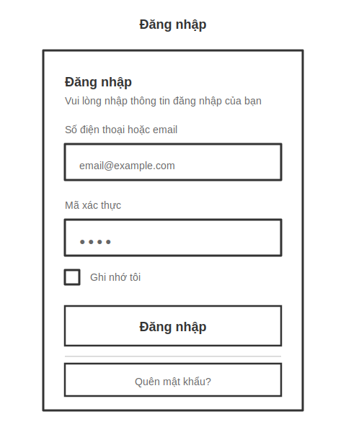

UI Elements:

Field Name | Field Type | Description
Tên đăng nhập hoặc Email* | Text Box | This is for user to input their username for logging in
Mật khẩu* | Password Box | User enters their password to log in to the system.
Hiển thị/Ẩn mật khẩu | Button (Icon Toggle) | User clicks to switch password visibility between plain text and masked characters.
Ghi nhớ tôi | Checkbox | User selects this option to save their login session for future visits.
Đăng nhập | Button | User clicks to authenticate and access the system using the provided username and password.
Quên mật khẩu? | Button | User clicks to button to navigate to the Forgot Password page

Database Access:

Table | CRUD | Description
user | R | Verify UserName & Password information
user_setting | R | Specify the authorizations of the logged-in user

PostgreSQL (Supabase) Commands:
1/ User authentication:
SELECT user_id, username, email, password_hash, is_active
FROM user
WHERE (username = $1 OR email = $1)
AND is_active = TRUE;

2/ Get User Settings:
SELECT user_id, role_id, permissions, theme_preference, language
FROM user_setting
WHERE user_id = $1;

3/ Last login time update:
UPDATE user
SET last_login_at = NOW()
WHERE user_id = $1;

4/ Create a login session:
INSERT INTO login_session (user_id, session_token, login_at, ip_address, device_info)
VALUES ($1, $2, NOW(), $3, $4);

- UC04 Forgot Password
UI Design:
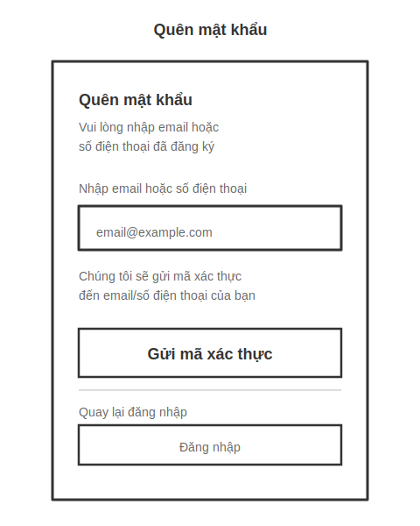
UI Elements:

Field Name | Field Type | Description
Email* | Text Box | Users enter their registered email or phone number to receive a verification code.
Gửi mã xác thực | Button | Button to send verification code to user's email/SMS
Quay lại đăng nhập | Button | Button to return to the Login screen
Gửi lại mã | Button (Timer) | Button to resend code (displayed after the code is sent, with a 60-second timer)

Database Access:

Table | CRUD | Description
user | R | Search for users based on email or phone number
password_reset_token | C | Generate a 24-hour reset token

PostgreSQL (Supabase) Commands:
1/ Search users by email/phone:
SELECT user_id, username, email, phone_number, is_active
FROM user
WHERE (email = $1 OR phone_number = $1)
AND is_active = TRUE;

2/ Generate reset authentication code:
INSERT INTO password_reset_token (user_id, token, created_at, expires_at)
VALUES ($1, $2, NOW(), NOW() + INTERVAL '24 hours')
RETURNING token;

3/ Check out the recently submitted code:
SELECT COUNT(*) FROM password_reset_token
WHERE user_id = $1
AND created_at > NOW() - INTERVAL '5 minutes';

b. Reset Password Screen
Related UC:
- UC03 Reset Password
UI Design:
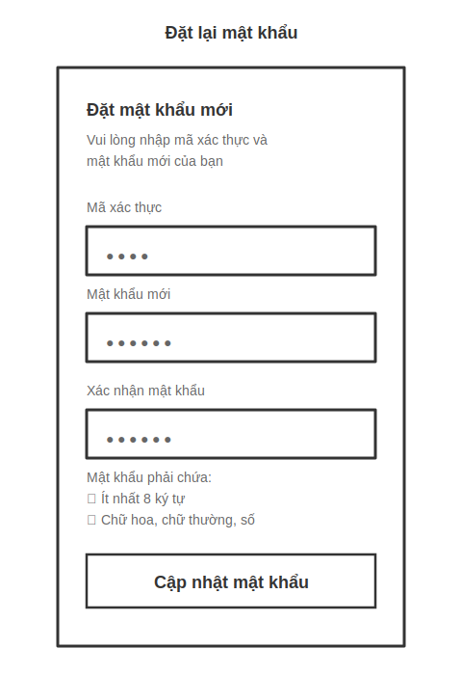
UI Elements:

Field Name | Field Type | Description
Mã xác thực* | Text Box | User enters 6-digit verification code or token from reset email
Mật khẩu mới* | Password Box | User enters new password. Password is masked as dots
Xác nhận mật khẩu* | Password Box | User re-enters new password to confirm. Must match "Mật khẩu mới"
Hiển thị/Ẩn mật khẩu | Button (Icon Toggle) | User clicks to toggle password visibility for both password fields
Yêu cầu mật khẩu | Text Display | Shows password requirements: minimum 8 characters, uppercase, lowercase, numbers, special characters
Cập nhật mật khẩu | Button | User clicks to update password with new credentials

Database Access:

Table | CRUD | Description
password_reset_token | R | Verify reset token is valid and not expired
user | U | Update password hash for user
password_reset_token | U | Mark token as used after successful reset
audit_log | C | Log password change for security audit

PostgreSQL (Supabase) Commands:
1/ Verify reset token validity:
SELECT user_id, expires_at
FROM password_reset_token
WHERE token = $1
AND expires_at > NOW()
AND is_used = FALSE;

2/ Update user password:
UPDATE user
SET password_hash = $1,
updated_at = NOW(),
password_changed_at = NOW()
WHERE user_id = $2;

3/ Mark token as used:
UPDATE password_reset_token
SET is_used = TRUE,
used_at = NOW()
WHERE token = $1;

4/ Log password change:
INSERT INTO audit_log (user_id, action, details, ip_address, created_at)
VALUES ($1, 'PASSWORD_CHANGED', 'Password reset via UC03', $2, NOW());

5/ Check password history:
SELECT password_hash FROM password_history
WHERE user_id = $1
ORDER BY changed_at DESC
LIMIT 5;

c. User Role Management Screen
Related UC:
- UC07 Assign Role
UI Design:
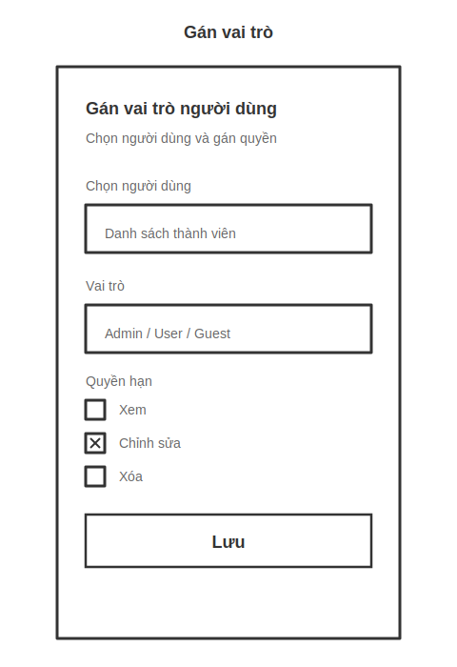
UI Elements:

Field Name | Field Type | Description
Chọn người dùng* | Dropdown/Search Box | Admin selects user from member list. Supports search by name and email
Vai trò* | Dropdown/Radio Button | Admin selects role for user: Admin, Manager, User, Guest
Quyền hạn | Checkbox Group | Permission checkboxes: View, Edit, Delete, Export Reports
Chi tiết quyền hạn | Table/List | Display detailed permissions for each selected role
Lưu | Button | Save role and permission assignments
Hủy | Button | Save role and permission assignments
Xóa quyền hạn | Button (Danger) | Clear all permissions for the selected user

Database Access:

Table | CRUD | Description
user | R | Get list of users for assignment
role | R | Get available roles in system
user_role | C/U | Assign role to user
user_permission | C/U | Assign specific permissions to user
audit_log | C | Log role assignment changes

PostgreSQL (Supabase) Commands:
1/ Get list of active users:
SELECT user_id, username, email, first_name, last_name, is_active
FROM user
WHERE is_active = TRUE
ORDER BY username ASC;

2/ Get available roles:
SELECT role_id, role_name, description
FROM role
WHERE is_active = TRUE
ORDER BY role_id ASC;

3/ Assign role to user:
INSERT INTO user_role (user_id, role_id, assigned_at, assigned_by)
VALUES ($1, $2, NOW(), $3)
ON CONFLICT (user_id)
DO UPDATE SET role_id = $2, assigned_at = NOW();

4/ Assign permissions to user:
INSERT INTO user_permission (user_id, permission_id, is_granted, assigned_at, assigned_by)
VALUES ($1, $2, TRUE, NOW(), $3)
ON CONFLICT (user_id, permission_id)
DO UPDATE SET is_granted = TRUE, assigned_at = NOW();

5/ Log role assignment:
INSERT INTO audit_log (user_id, action, details, changed_by, ip_address, created_at)
VALUES ($1, 'ROLE_ASSIGNED', $2, $3, $4, NOW());

6/ Get current user role:
SELECT ur.user_id, ur.role_id, r.role_name
FROM user_role ur
JOIN role r ON ur.role_id = r.role_id
WHERE ur.user_id = $1 AND ur.is_active = TRUE;

- UC08 Revoke Role
UI Design:
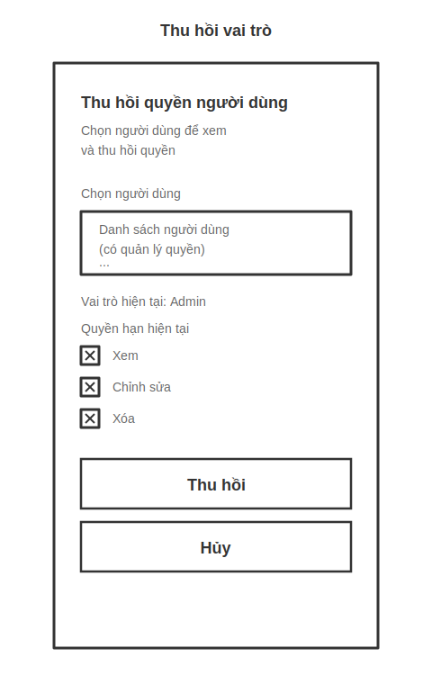
UI Elements:

Field Name | Field Type | Description
Chọn người dùng* | Dropdown/Search Box | Admin selects user to revoke role. Supports search by name and email
Vai trò hiện tại | Display Text | Show current user role (read-only)
Quyền hạn hiện tại | Checkbox Group (Disabled) | List current permissions (view only, cannot edit)
Lý do thu hồi* | Text Area | Admin enters reason for revoking role
Thu hồi | Button (Danger) | Revoke all role and permissions from user
Gửi thông báo | Checkbox | Send email notification to user when role is revoked
Hủy | Button | Cancel and return to previous page

Database Access:

Table | CRUD | Description
user | R | Get list of users with roles
user_role | R/U | View current role and set inactive
user_permission | R/D | View permissions and delete them
audit_log | C | Log role revocation for audit trail

PostgreSQL (Supabase) Commands:
1/ Get users with active roles:
sqlSELECT u.user_id, u.username, u.email, u.first_name, u.last_name, r.role_name
FROM user u
LEFT JOIN user_role ur ON u.user_id = ur.user_id AND ur.is_active = TRUE
LEFT JOIN role r ON ur.role_id = r.role_id
WHERE u.is_active = TRUE AND ur.user_id IS NOT NULL
ORDER BY u.username ASC;

2/ Get current user role:
sqlSELECT ur.user_id, ur.role_id, r.role_name, ur.assigned_at
FROM user_role ur
JOIN role r ON ur.role_id = r.role_id
WHERE ur.user_id = $1 AND ur.is_active = TRUE;

3/ Get current user permissions:
sqlSELECT up.permission_id, p.permission_name, p.description, up.assigned_at
FROM user_permission up
JOIN permission p ON up.permission_id = p.permission_id
WHERE up.user_id = $1 AND up.is_granted = TRUE;

4/ Revoke role (mark as inactive):
sqlUPDATE user_role
SET is_active = FALSE,
revoked_at = NOW(),
revoked_by = $2,
revoke_reason = $3
WHERE user_id = $1;

5/ Revoke all permissions:
sqlUPDATE user_permission
SET is_granted = FALSE,
revoked_at = NOW(),
revoked_by = $2
WHERE user_id = $1;

6/ Log role revocation:
sqlINSERT INTO audit_log (user_id, action, details, changed_by, ip_address, created_at)
VALUES ($1, 'ROLE_REVOKED', $2, $3, $4, NOW());

d. Login Activity Screen
Related UC:
- UC05 View Login Activity
UI Design:
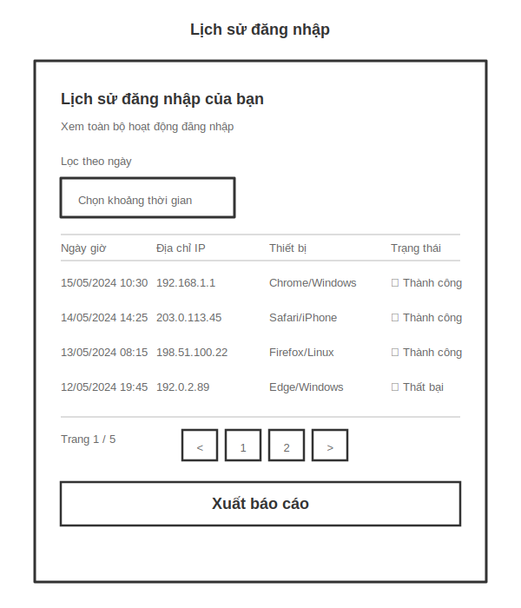
UI Elements:

Field Name | Field Type | Description
Lọc theo thời gian | Date Picker (From-To) | This is for user to input their username for logging in
Lọc theo trạng thái | Dropdown | User enters their password to log in to the system.
Tìm kiếm thiết bị | Text Box | User clicks to switch password visibility between plain text and masked characters.
Bảng lịch sử đăng nhập | Data Table | User selects this option to save their login session for future visits.
Phân trang | Pagination Control | User clicks to authenticate and access the system using the provided username and password.
Xuất báo cáo | Button | User clicks to negative to the Password Reset page in case they forgot their password

Database Access:

Table | CRUD | Description
login_session | R | Get login history for current user
user | R | Get user information

PostgreSQL (Supabase) Commands:
1/ Get user login history
sqlSELECT
ls.session_id,
ls.user_id,
ls.login_at,
ls.logout_at,
ls.ip_address,
ls.device_info,
ls.browser,
ls.os,
ls.location,
ls.country,
ls.city,
ls.is_successful,
ls.failure_reason,
EXTRACT(EPOCH FROM (COALESCE(ls.logout_at, NOW()) - ls.login_at)) as duration_seconds
FROM login_session ls
WHERE ls.user_id = $1
AND ls.login_at BETWEEN $2 AND $3
ORDER BY ls.login_at DESC
LIMIT 20 OFFSET $4;

2/ Filter by status
sqlSELECT *
FROM login_session
WHERE user_id = $1
AND login_at BETWEEN $2 AND $3
AND is_successful = $4
ORDER BY login_at DESC
LIMIT 20 OFFSET $5;

3/ Search by device
sqlSELECT *
FROM login_session
WHERE user_id = $1
AND login_at BETWEEN $2 AND $3
AND (browser ILIKE $4 OR os ILIKE $4 OR device_info ILIKE $4)
ORDER BY login_at DESC
LIMIT 20 OFFSET $5;

4/ Count total login records
sqlSELECT COUNT(*) as total_count
FROM login_session
WHERE user_id = $1
AND login_at BETWEEN $2 AND $3;

2. Employee Management Feature

2.1 Employee List Screen
Related UC:
- UC13 View All Employees
UI Design:
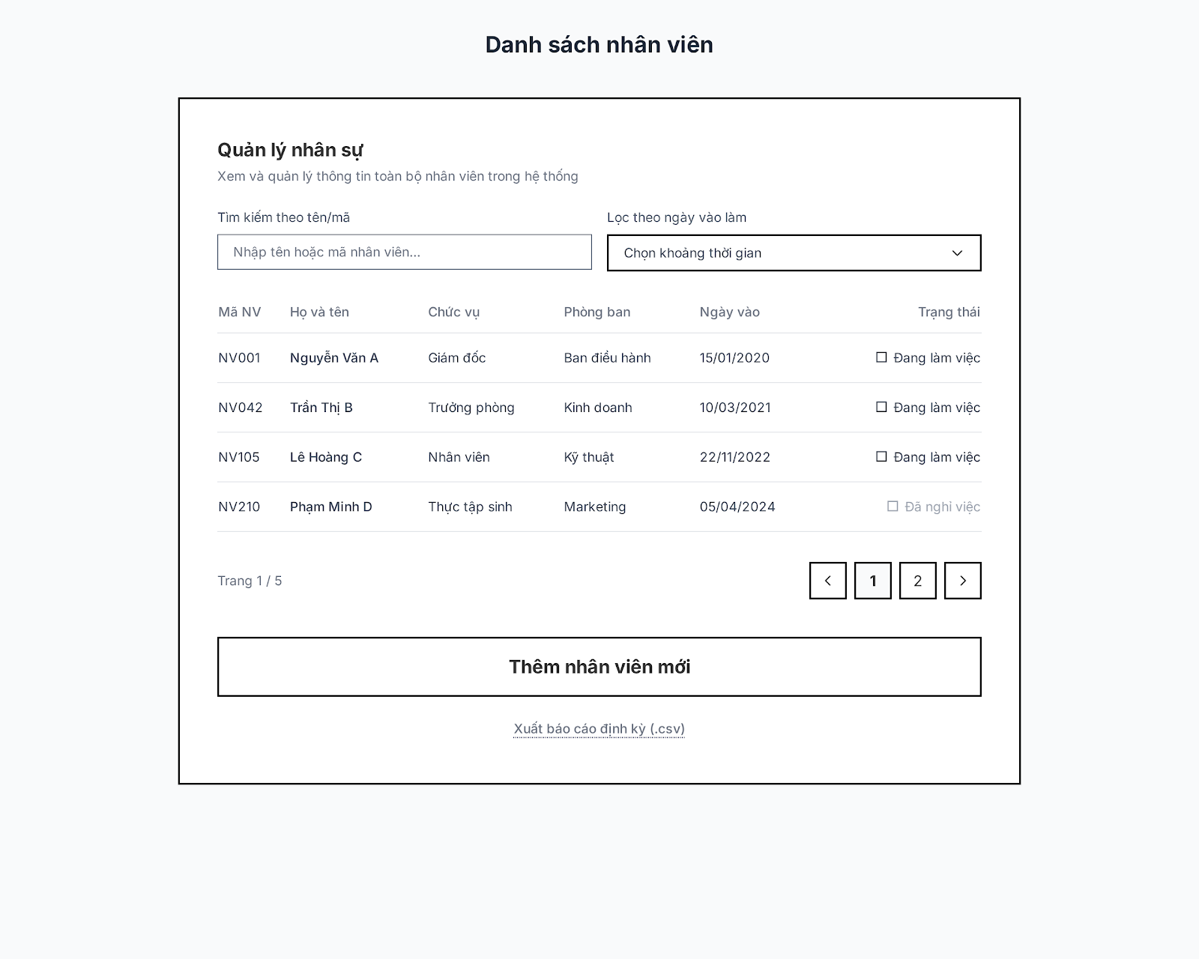
UI Elements:

Field Name | Field Type | Description
Tìm kiếm theo tên/mã | Text Box | User enters employee name or ID to filter search in the list.
Lọc theo ngày vào làm | Date Picker (From-To) | User selects a date range of hiring to filter the employee list.
Bảng danh sách nhân viên | Data Table | Displays employee list information (ID, Full name, Position, Department, Join date, Status).
Phân trang | Pagination Control | Allows user to navigate through employee list pages.
Thêm nhân viên mới | Button | User clicks to open the form or navigate to the page to add a new employee.
Xuất báo cáo định kỳ (.csv) | Button | User clicks to export and download CSV file of employee list by current filters.

Database Access:

Table | CRUD | Description
employee | R, C | Get employee list (Read) and add new employee (Create).
department | R | Get department information to display in the table.
PostgreSQL (Supabase) Commands:
1/ Get employee list:
SELECT
e.employee_id, e.full_name, e.position, d.department_name, e.hire_date, e.status
FROM employee e
LEFT JOIN department d ON e.department_id = d.department_id
ORDER BY e.employee_id ASC
LIMIT 10 OFFSET $1;

2/ Filter by hire date range:
SELECT
e.employee_id, e.full_name, e.position, d.department_name, e.hire_date, e.status
FROM employee e
LEFT JOIN department d ON e.department_id = d.department_id
WHERE e.hire_date BETWEEN $1 AND $2
ORDER BY e.hire_date DESC
LIMIT 10 OFFSET $3;

3/ Search by name or employee ID:
SELECT
e.employee_id, e.full_name, e.position, d.department_name, e.hire_date, e.status
FROM employee e
LEFT JOIN department d ON e.department_id = d.department_id
WHERE (e.full_name ILIKE $1 OR e.employee_id ILIKE $1)
ORDER BY e.employee_id ASC
LIMIT 10 OFFSET $2;

4/ Count total employee records:
SELECT COUNT(*) as total_count
FROM employee
WHERE (full_name ILIKE $1 OR employee_id ILIKE $1)
AND hire_date BETWEEN $2 AND $3;

2.2 Employee Details Screen
Related UC:
- UC14 View My Profile
UI Design:
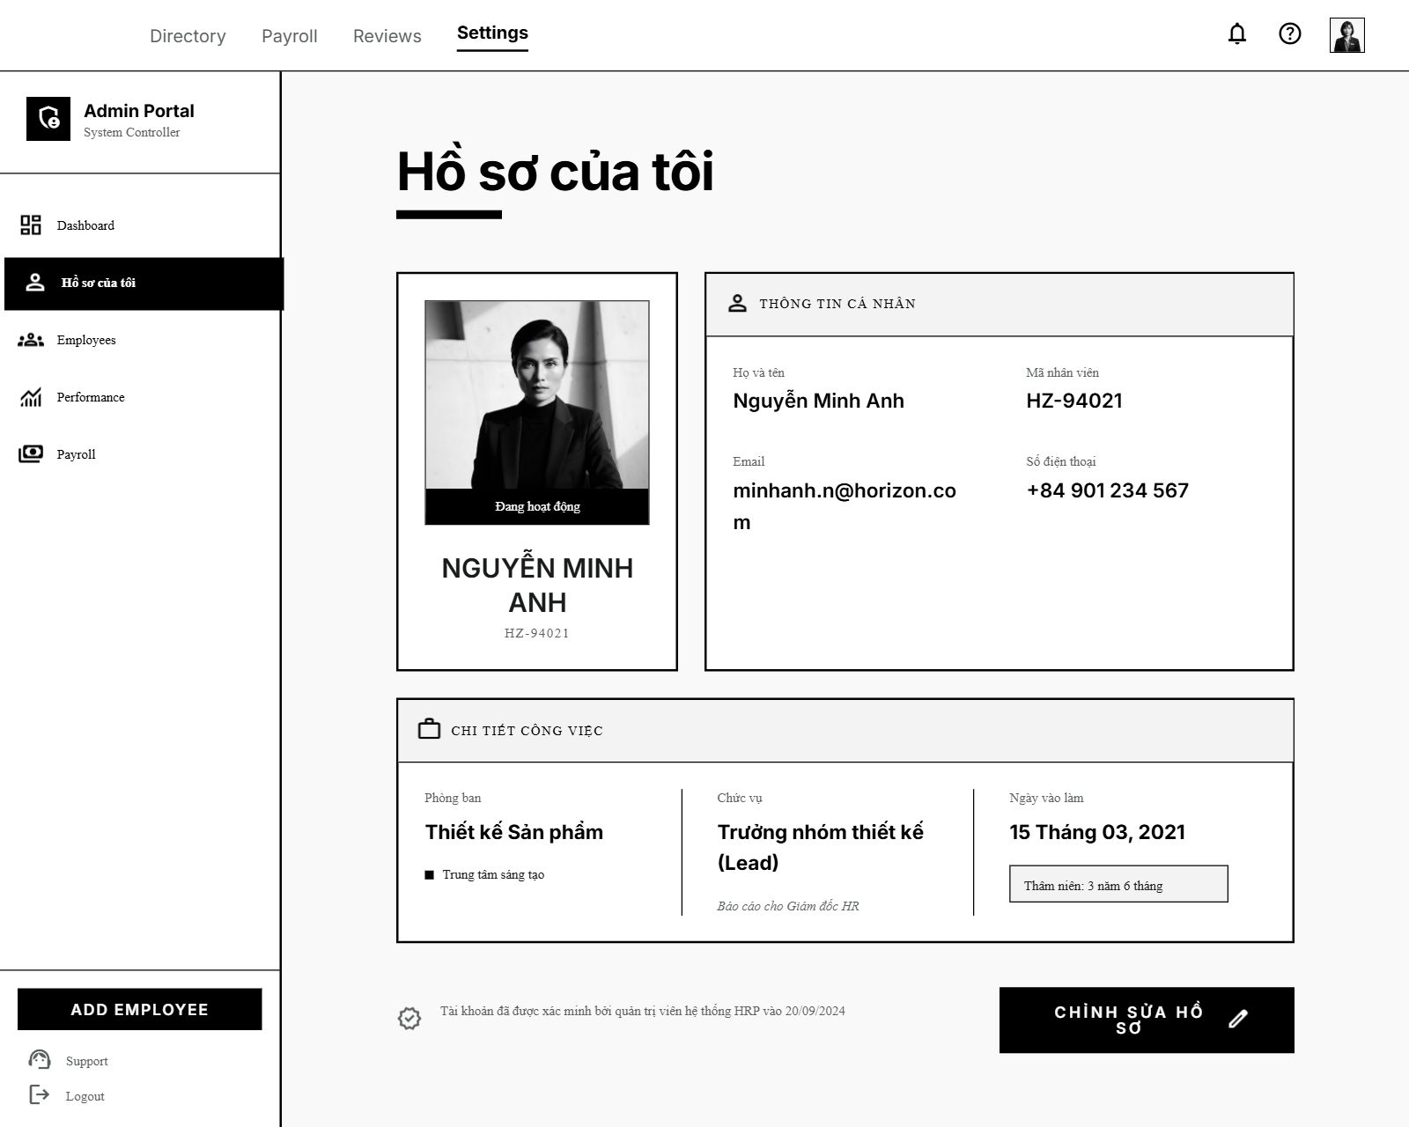
UI Elements:

Field Name | Field Type | Description
Thông tin cá nhân | Card Group | Displays Avatar, Full name, Employee ID, Email, Phone number of current logged in user.
Chi tiết công việc | Card Group | Displays Department, Position, Join date, Tenure.
Chỉnh sửa hồ sơ | Button | User clicks to navigate to the Edit Profile Details page.

Database Access:

Table | CRUD | Description
employee | R | Get personal details and work statistics of logged-in employee.

PostgreSQL (Supabase) Commands:
1/ Get employee details:
SELECT
e.employee_id, e.full_name, e.email, e.phone, e.avatar_url, e.position,
d.department_name, e.hire_date, e.status,
age(now(), e.hire_date) as tenure
FROM employee e
LEFT JOIN department d ON e.department_id = d.department_id
WHERE e.employee_id = $1;
- UC11 Update Employee Profile
UI Design:


UI Elements:

Field Name | Field Type | Description
Tên người dùng | Text Box | User updates the account username for logging into the system.
Email công việc | Text Box | User enters their corporate email address.
Mật khẩu mới | Text Box (Password) | User inputs a new password to update account security.
Trạng thái | Dropdown | User changes the active status of the employee account (e.g. Active, Inactive).
Xác thực 2 yếu tố (2FA) | Switch Control | User toggles to enable or disable two-factor authentication for extra security.
Lưu thay đổi | Button | User clicks to update and save profile changes to the system.
Hủy bỏ | Button | User clicks to discard changes and close the form.
Database Access:

Table | CRUD | Description
employee | U | Update employee profile details and security settings.
PostgreSQL (Supabase) Commands:

1/ Update profile details:
UPDATE employee
SET username = $1,
email = $2,
password_hash = CASE WHEN $3 IS NOT NULL THEN crypt($3, gen_salt('bf')) ELSE password_hash END,
status = $4,
two_factor_enabled = $5,
updated_at = now()
WHERE employee_id = $6;

- UC12 Deactivate Employee
UI Design:
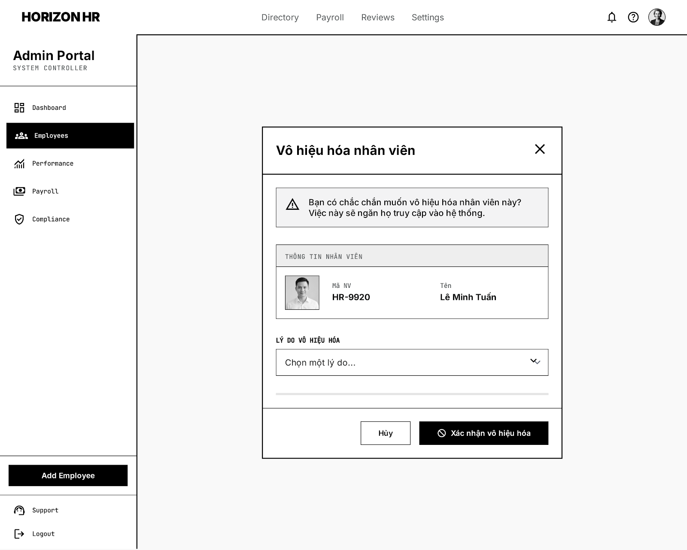

UI Elements:

Field Name | Field Type | Description
Thông tin nhân viên cần vô hiệu hóa | Card | Displays Avatar, ID, Name of the selected employee.
Lý do vô hiệu hóa | Dropdown | User selects a reason (e.g., Resignation, Suspended, Leave of absence...).
Xác nhận vô hiệu hóa | Button | Updates employee status to inactive.
Hủy | Button | Closes modal without saving any changes.
Database Access:

Table | CRUD | Description
employee | U | Updates status to 'Inactive' and records the reason.
PostgreSQL (Supabase) Commands:

1/ Deactivate employee:
UPDATE employee
SET status = 'Inactive',
deactivation_reason = $2,
deactivated_at = now()
WHERE employee_id = $1;

2.3 Create Employee Screen
Related UC:
- UC10 Create Employee
UI Design:
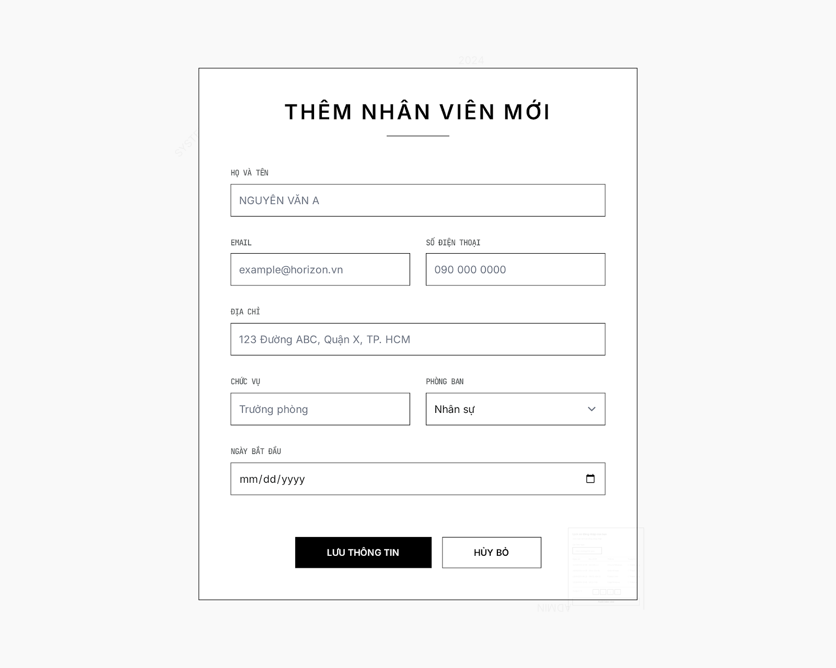
UI Elements:

Field Name | Field Type | Description
Họ và tên | Text Box | User enters employee full name.
Email / Số điện thoại / Địa chỉ | Text Box | User enters contact information.
Chức vụ | Text Box | User enters professional job title.
Phòng ban | Dropdown | User selects working department.
Ngày bắt đầu | Date Picker | User selects hiring / starting date.
Lưu thông tin | Button | User clicks to create a new employee record.
Database Access:

Table | CRUD | Description
employee | C | Create a new employee profile.
PostgreSQL (Supabase) Commands:
1/ Create new employee:
INSERT INTO employee (
full_name, email, phone, address, position, department_id, hire_date, status
) VALUES (
$1, $2, $3, $4, $5, $6, $7, 'Active'
);

2.4 Edit Profile Screen
Related UC:
- UC15 Edit Profile Details
UI Design:
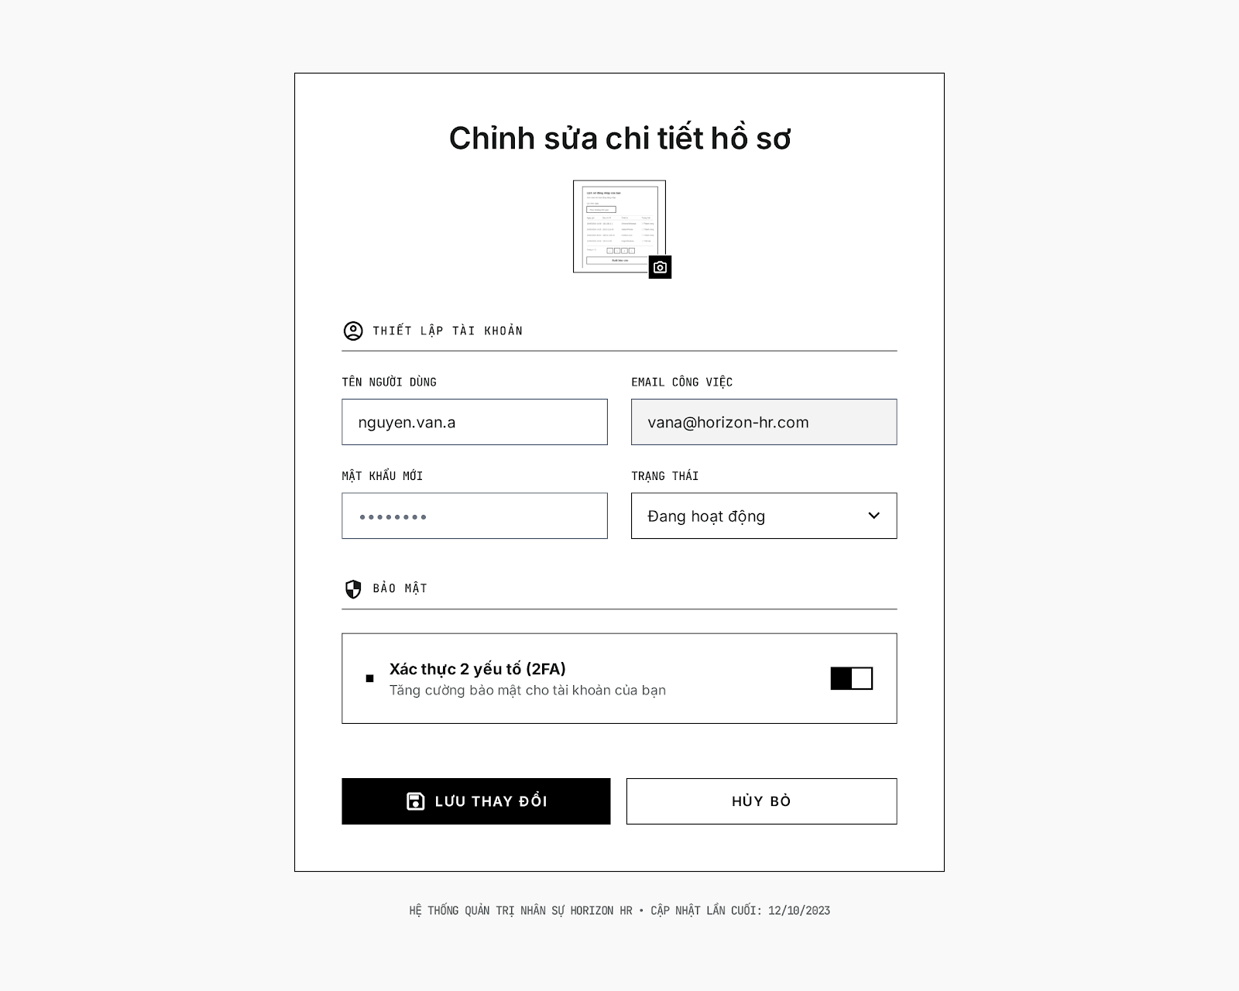

UI Elements:

Field Name | Field Type | Description
Tên người dùng | Text Box | User updates the account username for logging into the system.
Email công việc | Text Box | User enters their corporate email address.
Mật khẩu mới | Text Box (Password) | User inputs a new password to update account security.
Trạng thái | Dropdown | User changes the active status of the employee account (e.g. Active, Inactive).
Xác thực 2 yếu tố (2FA) | Switch Control | User toggles to enable or disable two-factor authentication for extra security.
Lưu thay đổi | Button | User clicks to update and save profile changes to the system.
Hủy bỏ | Button | User clicks to discard changes and close the form.
Database Access:

Table | CRUD | Description
employee | U | Update employee profile details and security settings.
PostgreSQL (Supabase) Commands:
1/ Update profile details:
UPDATE employee
SET username = $1,
email = $2,
password_hash = CASE WHEN $3 IS NOT NULL THEN crypt($3, gen_salt('bf')) ELSE password_hash END,
status = $4,
two_factor_enabled = $5,
updated_at = now()
WHERE employee_id = $6;

3. Attendance Management Feature

3.1 Attendance Dashboard
Related UC:
- UC16 Fingerprint
UI Design:

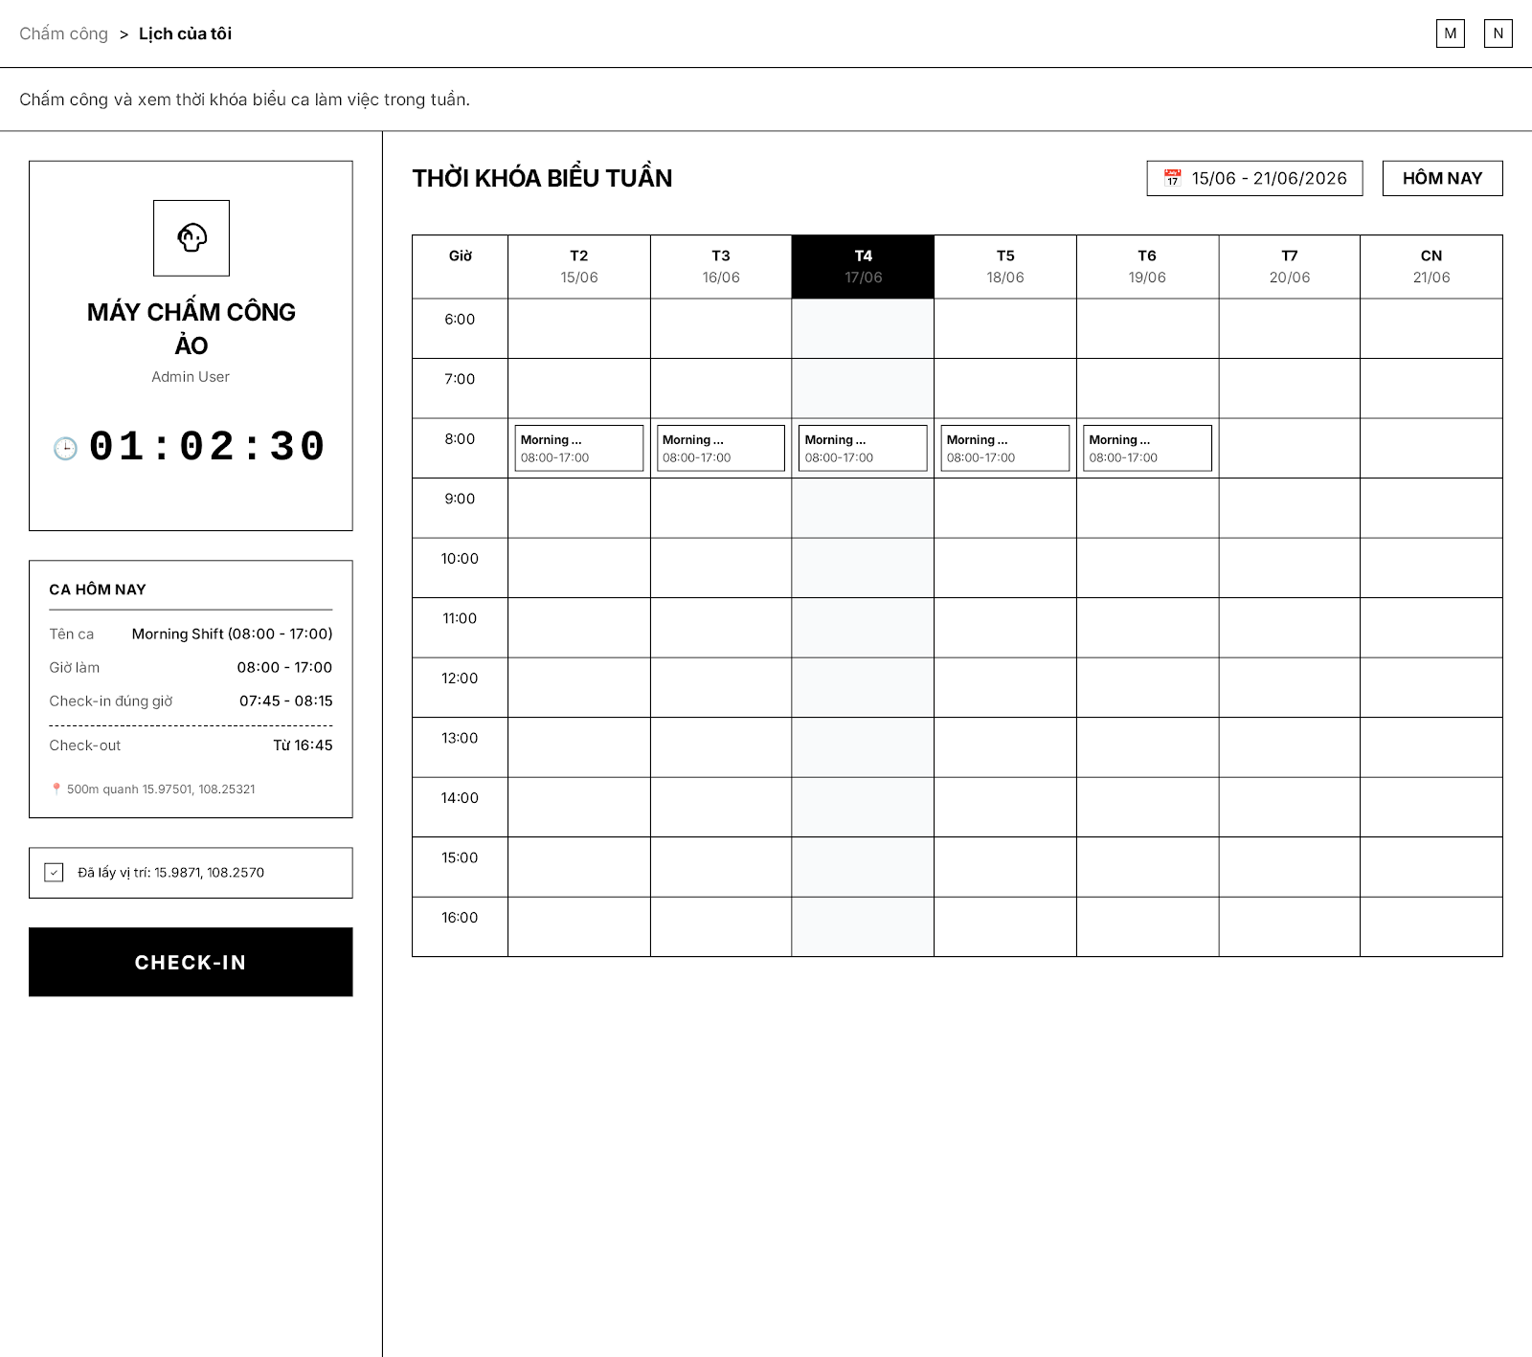
UI Elements:
Field Name | Field Type | Description
Giờ máy chấm công | Text Control (Clock) | Displays current system time for tracking check-in/out.
Ca hôm nay | Card / Text | Displays shift info (Start/End time, valid check-in window).
Nút Check-in / Check-out | Button | User clicks to check-in or check-out based on GPS boundaries.
Thời khóa biểu tuần | Schedule Board | Displays weekly shift planner from Monday to Sunday.
Database Access:
Table | CRUD | Description
attendance_log | C, U, R | Creates check-in log, updates check-out log and fetches log history.
work_shift | R | Get shift configuration to validate the check-in time.
PostgreSQL (Supabase) Commands:

1/ Check-in:
INSERT INTO attendance_log (
employee_id, shift_id, check_in_time, check_in_lat, check_in_long, status
) VALUES (
$1, $2, now(), $3, $4, 'Present'
);

2/ Check-out:
UPDATE attendance_log
SET check_out_time = now(),
check_out_lat = $2,
check_out_long = $3
WHERE employee_id = $1 AND check_out_time IS NULL;

- UC17 View Attendance History
UI Design:

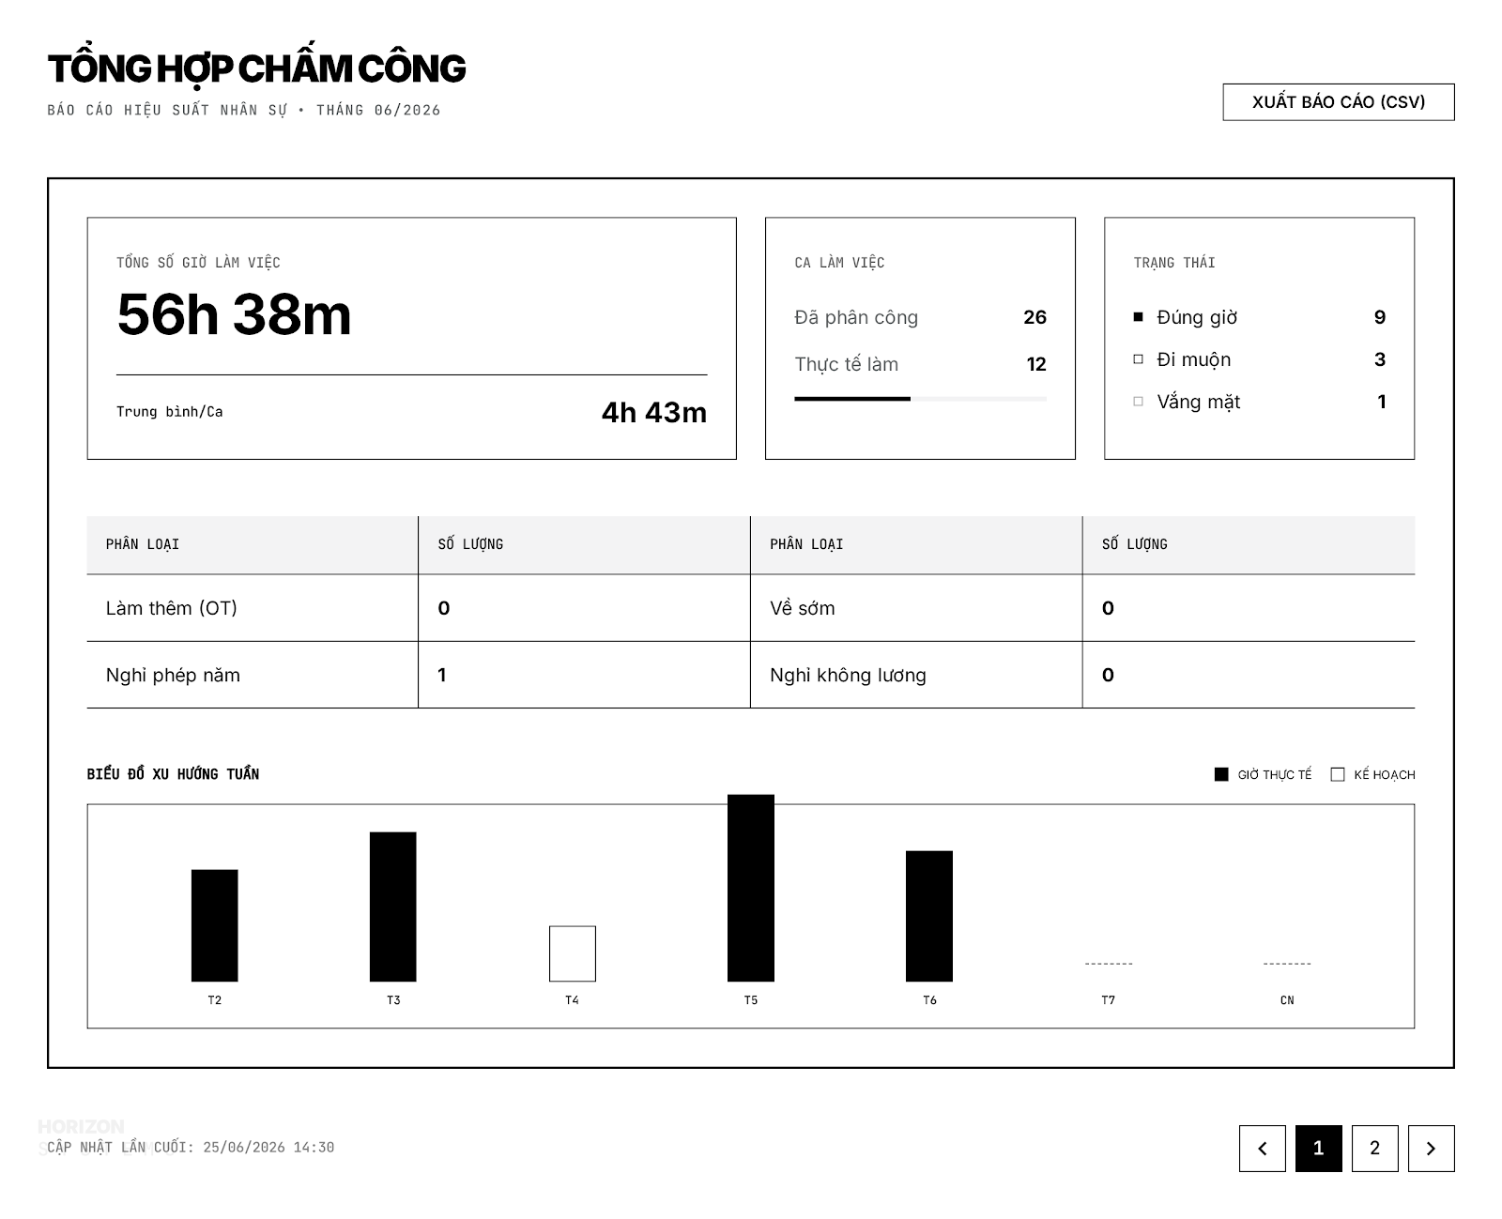
UI Elements:
Field Name | Field Type | Description
Tổng số giờ làm việc / Trung bình ca | KPI Card | Displays total actual working hours and shift average of current month.
Thống kê ca làm việc & Trạng thái | KPI Card / List | Displays assigned vs actual shifts, and counts for On Time, Late, Absent logs.
Biểu đồ xu hướng tuần | Bar Chart | Bar chart comparing estimated hours with actual hours of work per week.
Database Access:
Table | CRUD | Description
attendance_log | R | Aggregates and counts employee attendance states.
PostgreSQL (Supabase) Commands:

1/ Get monthly attendance statistics:
SELECT
COALESCE(SUM(EXTRACT(EPOCH FROM (check_out_time - check_in_time))/3600), 0) as total_hours,
COUNT(CASE WHEN status = 'Present' THEN 1 END) as present_days,
COUNT(CASE WHEN status = 'Late' THEN 1 END) as late_days,
COUNT(CASE WHEN status = 'Absent' THEN 1 END) as absent_days
FROM attendance_log
WHERE employee_id = $1 AND check_in_time BETWEEN $2 AND $3;

- UC18 View All Attendance History
UI Design:

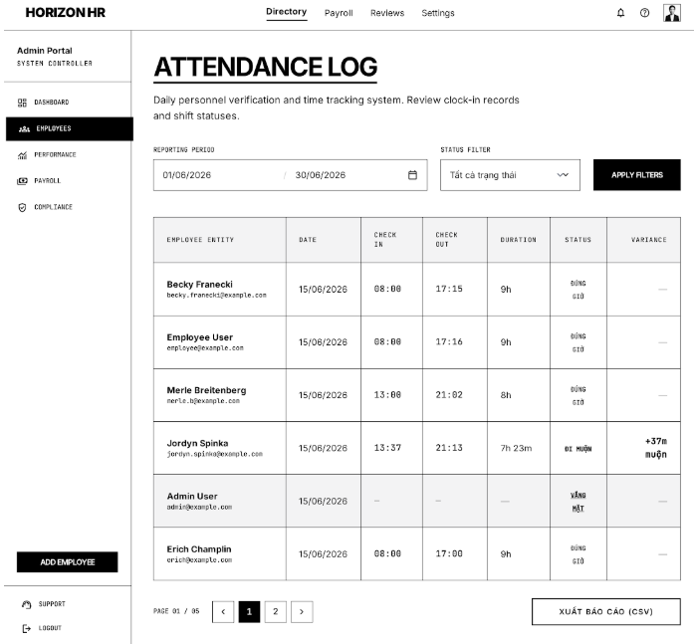
UI Elements:
Field Name | Field Type | Description
Thời gian báo cáo | Date Range Picker | User selects date range to filter the attendance history logs.
Bộ lọc trạng thái | Dropdown | User filters by check-in status (e.g. On time, Late, Absent).
Bảng nhật ký | Data Table | Displays detailed log (Employee, Date, Check-in, Check-out, Duration, Status, Variance).
Database Access:
Table | CRUD | Description
attendance_log | R | Get raw attendance logs of all staff.
employee | R | Get employee information (ID, Email, Name) for table display.
PostgreSQL (Supabase) Commands:

1/ Fetch all logs:
SELECT
e.full_name, e.email, a.check_in_time::date as date,
a.check_in_time::time as check_in, a.check_out_time::time as check_out,
(a.check_out_time - a.check_in_time) as duration,
a.status, a.variance_minutes
FROM attendance_log a
JOIN employee e ON a.employee_id = e.employee_id
WHERE a.check_in_time BETWEEN $1 AND $2
AND ($3 IS NULL OR a.status = $3)
ORDER BY a.check_in_time DESC
LIMIT 10 OFFSET $4;

3.2 Attendance History Screen
Related UC:
- UC17 View Attendance History
UI Design:
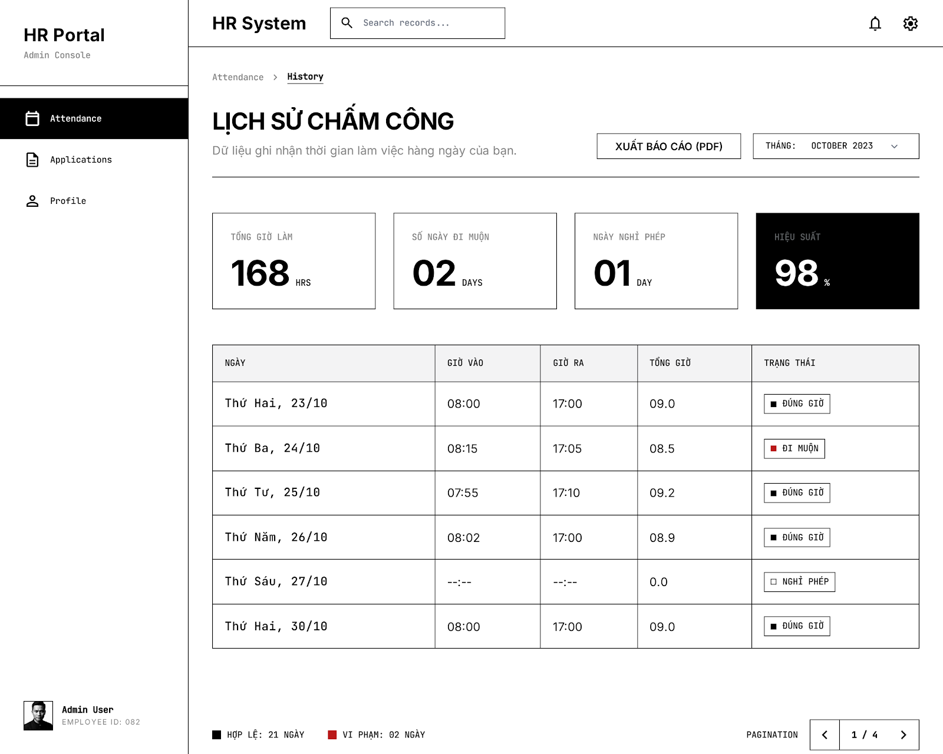
UI Elements:
Field Name | Field Type | Description
Bộ lọc Tháng | Dropdown (Month) | User selects a month to review their personal logs.
Thông số tổng hợp | Cards Group | Displays aggregated KPIs: Total Work Hours (Hrs), Late Days, Leave Days, Efficiency (%).
Bảng lịch sử hàng ngày | Data Table | Displays: Day, Check-in, Check-out, Total Hours, Status (On time / Late / Off).
Database Access:
Table | CRUD | Description
attendance_log | R | Get attendance history of the logged-in employee.
PostgreSQL (Supabase) Commands:

1/ Get employee monthly attendance history:
SELECT
check_in_time::date as work_date,
check_in_time::time as check_in,
check_out_time::time as check_out,
EXTRACT(EPOCH FROM (check_out_time - check_in_time))/3600 as total_hours,
status
FROM attendance_log
WHERE employee_id = $1
AND EXTRACT(MONTH FROM check_in_time) = $2
AND EXTRACT(YEAR FROM check_in_time) = $3
ORDER BY check_in_time ASC;
- UC18 View All Attendance History
UI Design:
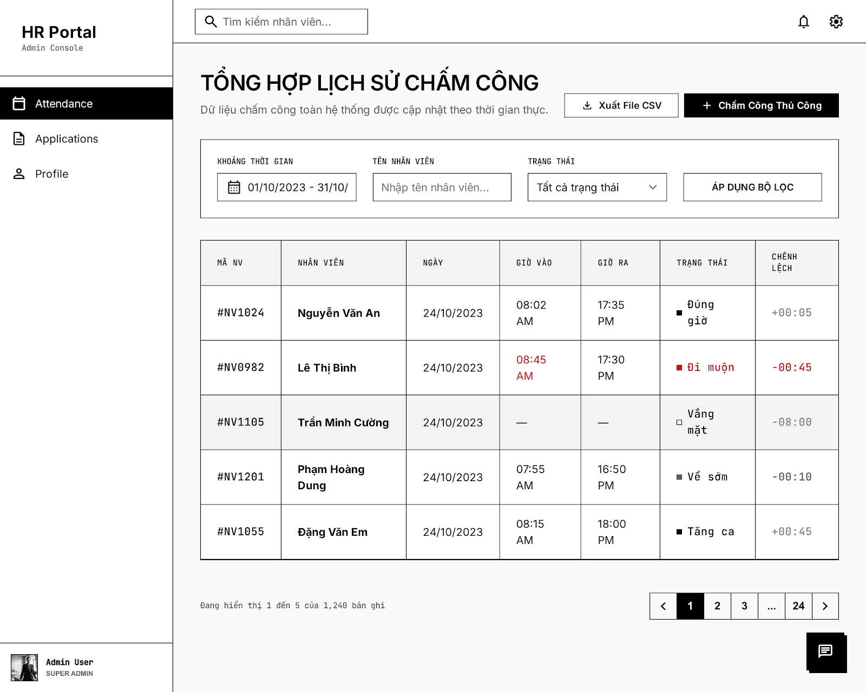
UI Elements:
Field Name | Field Type | Description
Khoảng thời gian / Tên nhân viên / Trạng thái | Filters Group | Allows admin to filter team records by multiple conditions.
Chấm công thủ công | Button | Admin clicks to manually add or edit check-in/out records of any staff.
Bảng tổng hợp | Data Table | Displays list of employee daily attendance along with computed variance (+/- min).
Database Access:
Table | CRUD | Description
attendance_log | R, C, U | Read log, allow admin to insert or override records of attendance.
PostgreSQL (Supabase) Commands:

1/ Admin force edit/insert attendance log:
INSERT INTO attendance_log (
employee_id, check_in_time, check_out_time, status, variance_minutes, edited_by_admin
) VALUES (
$1, $2, $3, $4, $5, TRUE
)
ON CONFLICT (employee_id, check_in_time::date)
DO UPDATE SET
check_in_time = EXCLUDED.check_in_time,
check_out_time = EXCLUDED.check_out_time,
status = EXCLUDED.status,
variance_minutes = EXCLUDED.variance_minutes,
edited_by_admin = TRUE;

3.3 Application Form Screen
Related UC:
- UC19 Create Application Form
UI Design:
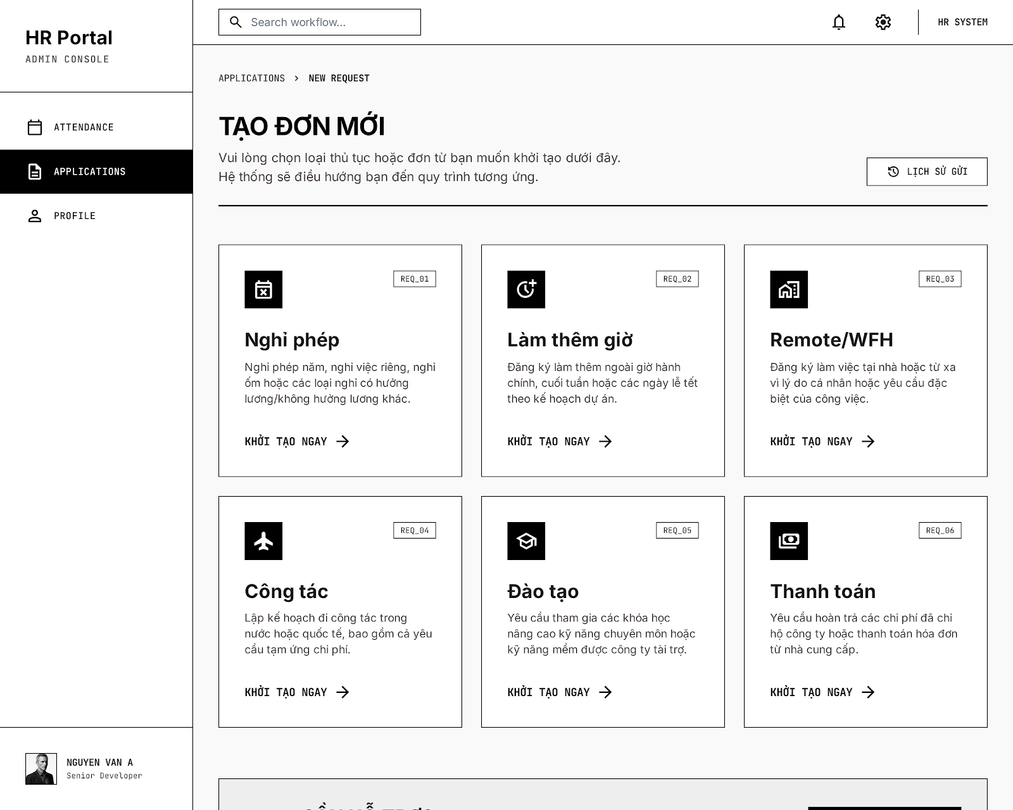
UI Elements:
Field Name | Field Type | Description
Danh sách loại đơn | Cards Grid | Displays cards of requests: Leave, Overtime, Remote/WFH, Business Trip, Training, Reimbursement.
Khởi tạo ngay | Button (Link) | User clicks to open the selected request type entry form.
Lịch sử gửi | Button | User clicks to view the history of submitted requests.
Database Access:
Table | CRUD | Description
request_type | R | Gets request types categories config list in the system.
PostgreSQL (Supabase) Commands:

1/ Fetch all request types:
SELECT request_type_id, code, name, description
FROM request_type
WHERE is_active = TRUE;

- UC20 Leave Application
UI Design:
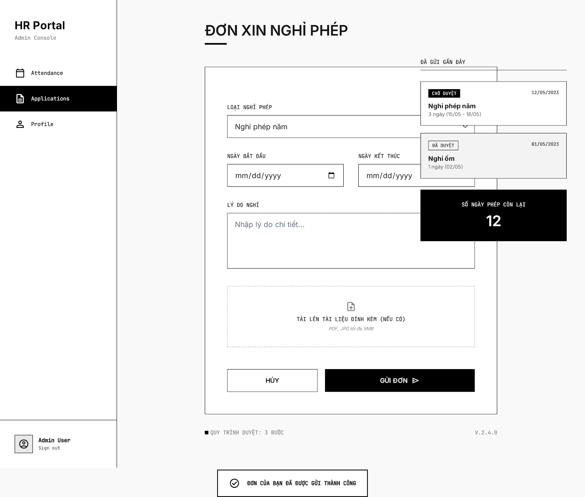
UI Elements:
Field Name | Field Type | Description
Loại nghỉ phép | Dropdown | User selects leave type (e.g. Annual leave, sick leave, unpaid leave).
Ngày bắt đầu / Kết thúc | Date Picker | User selects date range for leave application.
Lý do nghỉ | Text Area | User enters a description/reason for approval.
Số ngày phép còn lại | Badge / Indicator | Displays remaining leave balance of current year for the employee (e.g. 12).
Tải tài liệu đính kèm | Upload Control | User uploads supporting documents (medical certificates, etc.).
Gửi đơn | Button | User clicks to submit the form to their supervisor.
Database Access:
Table | CRUD | Description
leave_request | C, R | Create leave request record and read request parameters.
leave_balance | R, U | Read and deduct annual leave balance after approval.
PostgreSQL (Supabase) Commands:

1/ Submit leave request:
INSERT INTO leave_request (
employee_id, leave_type, start_date, end_date, reason, attachment_url, status
) VALUES (
$1, $2, $3, $4, $5, $6, 'Pending'
);

2/ Check leave balance:
SELECT balance
FROM leave_balance
WHERE employee_id = $1 AND year = EXTRACT(YEAR FROM now());

- UC21 Overtime Request
UI Design:
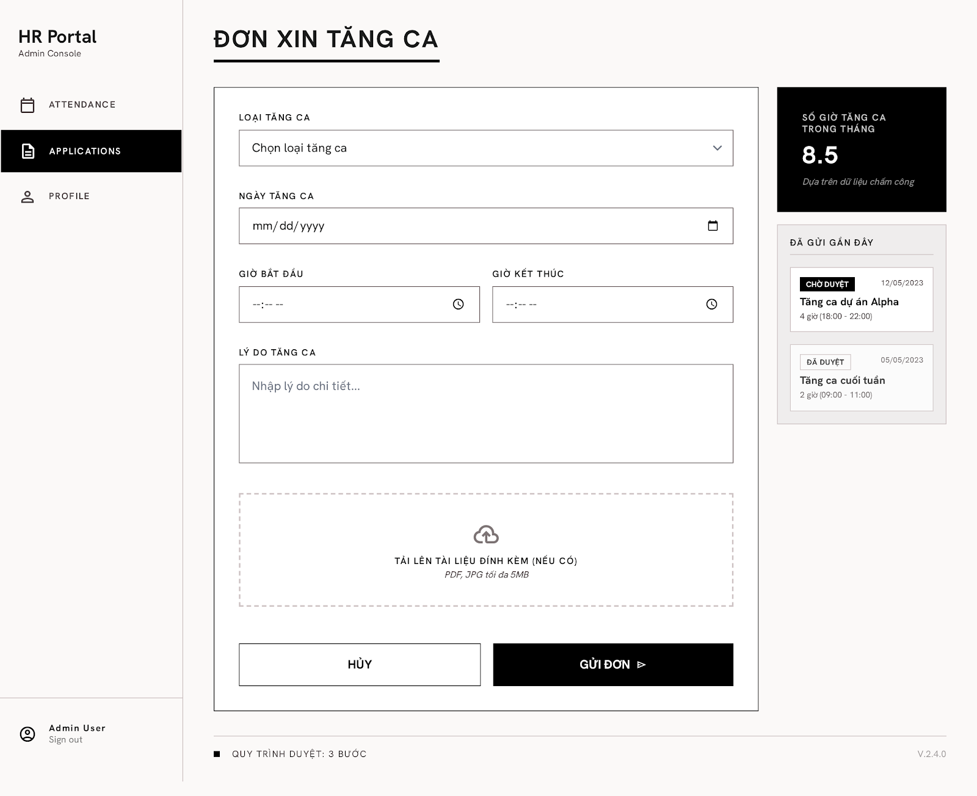
UI Elements:
Field Name | Field Type | Description
Loại tăng ca | Dropdown | User selects overtime category (e.g. Project Overtime, Weekend Overtime).
Ngày tăng ca | Date Picker | User selects the calendar date for the overtime request.
Giờ bắt đầu | Time Picker | User configures the starting time (HH:mm) of overtime.
Giờ kết thúc | Time Picker | User configures the ending time (HH:mm) of overtime.
Lý do tăng ca | Text Area | User enters detailed tasks and purpose of the overtime.
Tải lên tài liệu đính kèm (nếu có) | Upload Control | User uploads attachments (PDF, JPG up to 5MB) as proof.
Số giờ tăng ca trong tháng | KPI Card / Indicator | Displays accumulated monthly overtime hours based on attendance logs (e.g. 8.5 hours).
Đã gửi gần đây | History List | Displays list of recently submitted overtime applications (Status: Pending, Approved, Rejected).
Gửi đơn | Button | User submits the overtime request for approval.
Hủy | Button | User cancels and discards current inputs.
Database Access:
Table | CRUD | Description
overtime_request | C, R | Creates overtime application and fetches recent submission list.
attendance_log | R | Queries monthly approved overtime hours logs to calculate the KPI indicator.
PostgreSQL (Supabase) Commands:

1/ Submit overtime application request:
INSERT INTO overtime_request (
employee_id, overtime_type, work_date, start_time, end_time, reason, attachment_url, status
) VALUES (
$1, $2, $3, $4, $5, $6, $7, 'Pending'
);

2/ Calculate monthly total overtime hours:
SELECT COALESCE(SUM(EXTRACT(EPOCH FROM (check_out_time - check_in_time))/3600), 0) as total_ot_hours
FROM attendance_log
WHERE employee_id = $1
AND status = 'Overtime'
AND EXTRACT(MONTH FROM check_in_time) = EXTRACT(MONTH FROM now())
AND EXTRACT(YEAR FROM check_in_time) = EXTRACT(YEAR FROM now());

- UC22 Remote Request
UI Design:
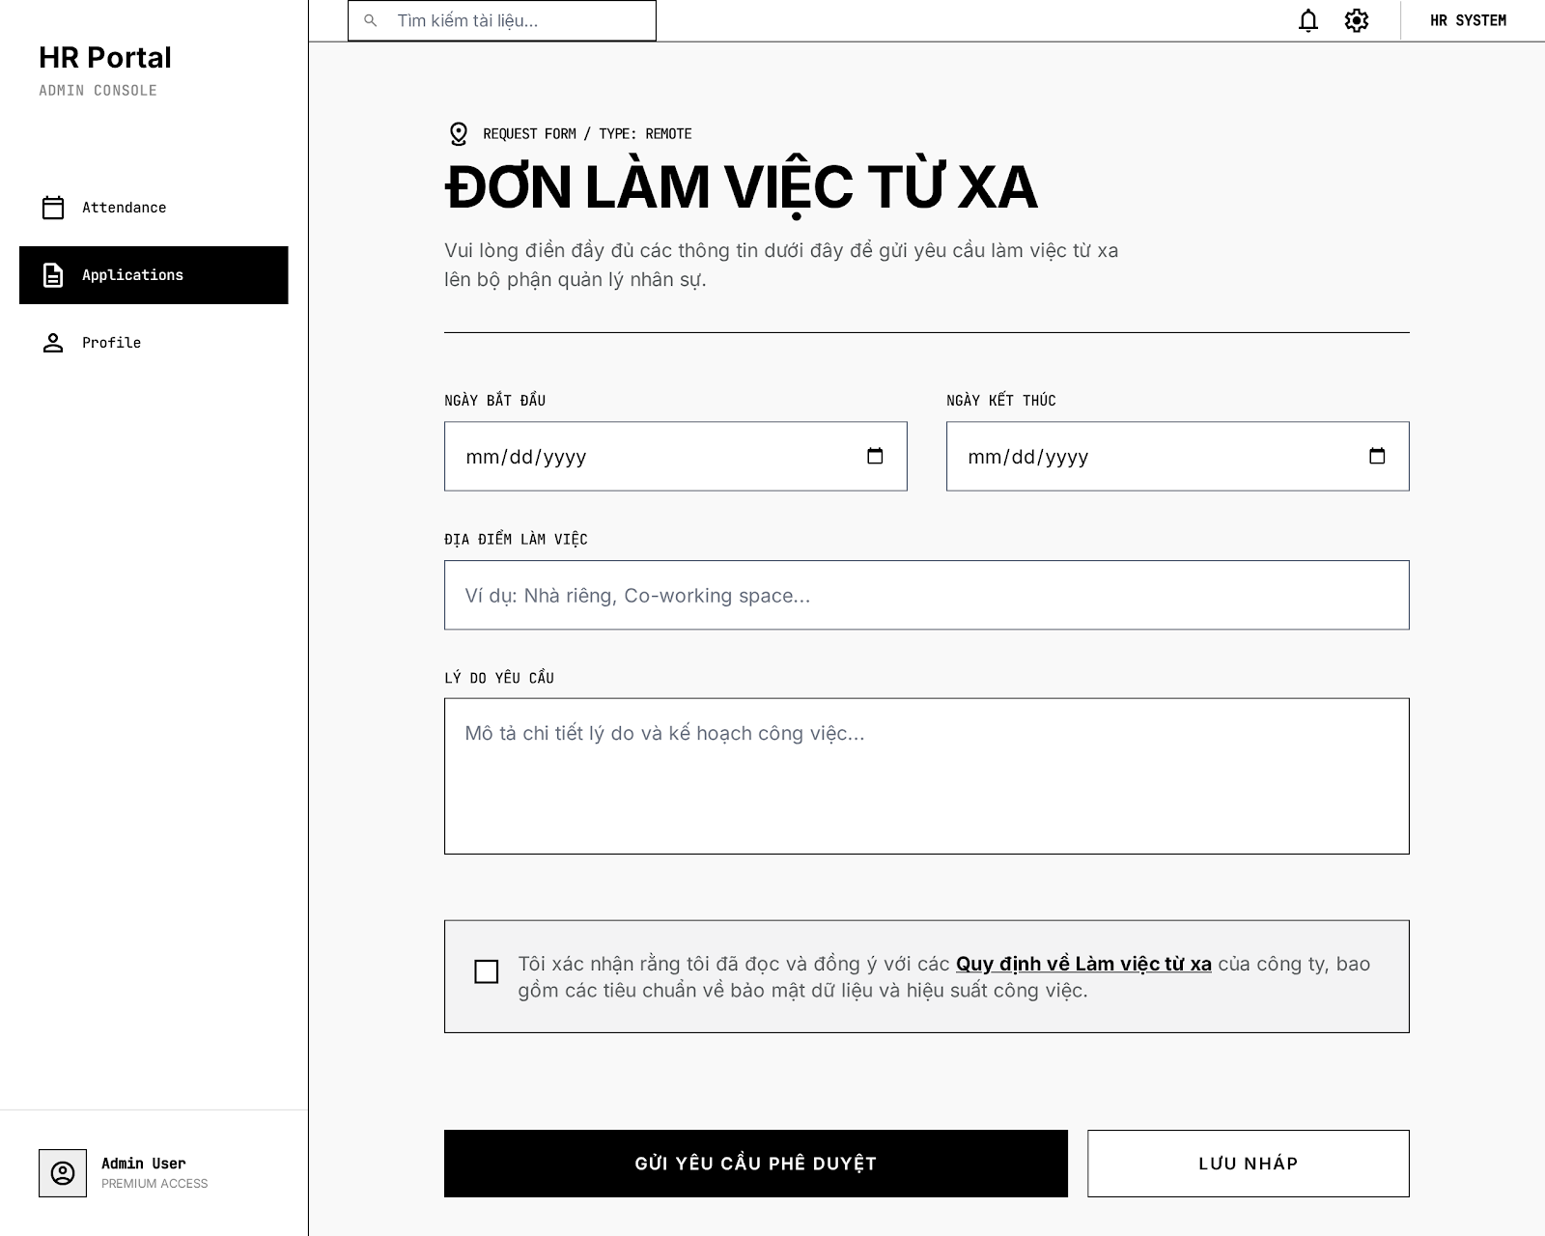
UI Elements:
Field Name | Field Type | Description
Ngày bắt đầu / Ngày kết thúc | Date Picker | User selects date range for remote work application.
Địa điểm làm việc | Text Box | User enters work location (e.g. Home, Co-working space...).
Lý do yêu cầu | Text Area | User enters explanation and work planning details.
Tôi xác nhận đã đọc và đồng ý... | Checkbox | User ticks to agree with company's remote work regulations.
Gửi yêu cầu phê duyệt / Lưu nháp | Button | Buttons to submit the request or save as draft.
Database Access:
Table | CRUD | Description
remote_work_request | C, U | Saves remote work request (Active or Draft).
PostgreSQL (Supabase) Commands:

1/ Submit remote work request:
INSERT INTO remote_work_request (
employee_id, start_date, end_date, work_location, reason, agreement_signed, status
) VALUES (
$1, $2, $3, $4, $5, $6, 'Pending'
);

- UC23 Shift Change Request
UI Design:
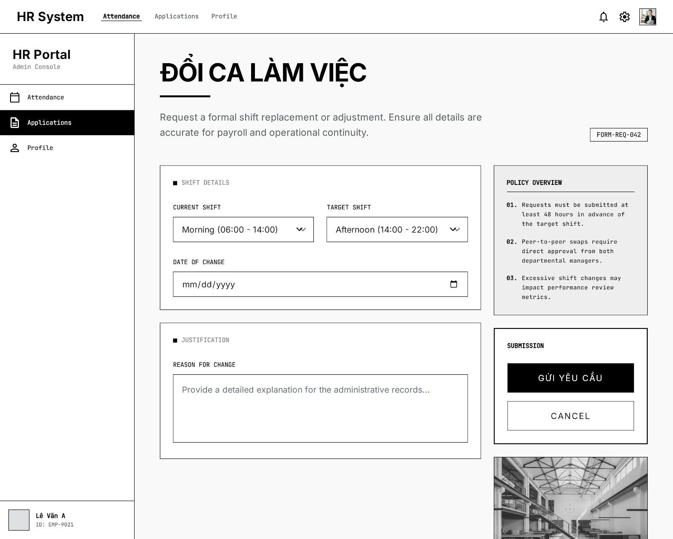
UI Elements:
Field Name | Field Type | Description
Ca hiện tại / Ca muốn đổi | Dropdown | User selects current shift and the target shift to swap with.
Ngày đổi ca | Date Picker | User selects the target date for shift replacement.
Lý do thay đổi | Text Area | User enters justification/reason for administrative records.
Gửi yêu cầu / Hủy | Button | Buttons to submit swap request or cancel input changes.
Database Access:
Table | CRUD | Description
shift_swap_request | C | Create a record for shift swapping application.
PostgreSQL (Supabase) Commands:

1/ Create shift swap request:
INSERT INTO shift_swap_request (
employee_id, current_shift_id, target_shift_id, swap_date, reason, status
) VALUES (
$1, $2, $3, $4, $5, 'Pending'
);

- UC24 Regime Application
UI Design:
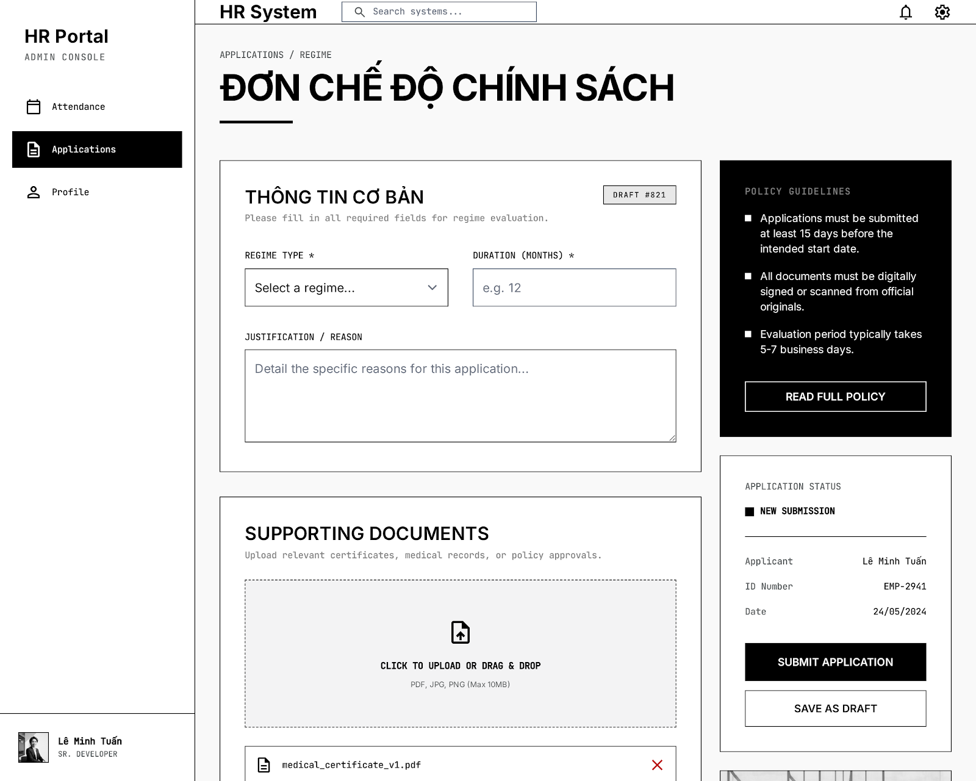
UI Elements:
Field Name | Field Type | Description
Loại chế độ (Regime Type) | Dropdown | User selects regime type (Social insurance, Maternity, Education...).
Thời gian áp dụng (Tháng) | Text Box | User enters duration of coverage (e.g. 12 months).
Tài liệu đính kèm | Upload Control | User uploads certificates, medical records (PDF, JPG, PNG).
Gửi yêu cầu / Lưu nháp | Button | Buttons to submit application or save as draft.
Database Access:
Table | CRUD | Description
policy_request | C, R | Store policy registration data along with uploaded certification link.
PostgreSQL (Supabase) Commands:

1/ Submit policy request:
INSERT INTO policy_request (
employee_id, regime_type, duration_months, justification, attachment_url, status
) VALUES (
$1, $2, $3, $4, $5, 'Pending'
);

3.4 Recruitment Proposal Screen
Related UC:
- UC25 Create Recruitment Proposal
UI Design:
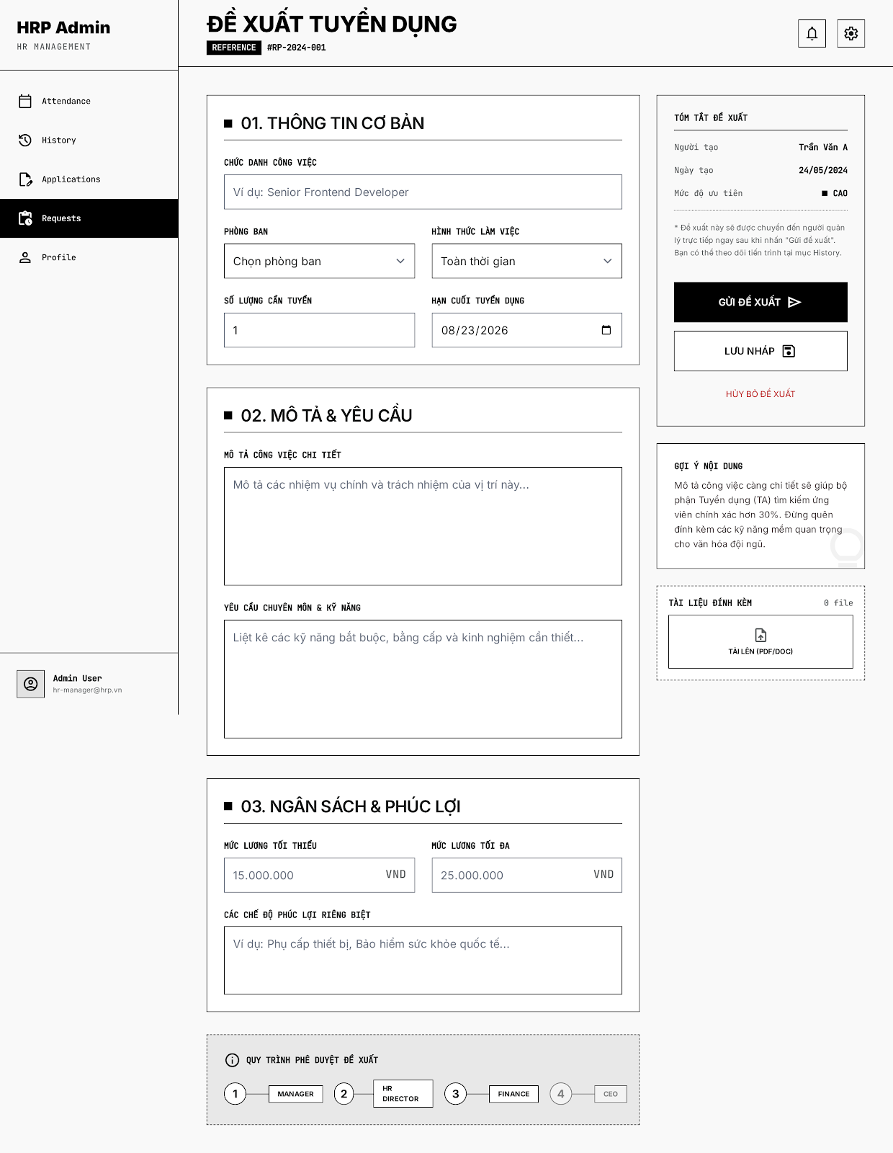

UI Elements:
Field Name | Field Type | Description
Thông tin cơ bản | Form Section | Job title, Department, Employment type, headcount quota, deadline.
Mô tả & Yêu cầu | Form Section | Detailed job description, skills & qualification requirements.
Ngân sách & Phúc lợi | Form Section | Minimum/Maximum base salary, and specific benefits.
Gửi đề xuất / Lưu nháp | Button | Buttons to submit proposal for a 4-step approval flow or save as draft.
Database Access:
Table | CRUD | Description
recruitment_proposal | C, R | Creates or reads recruitment proposals records.
PostgreSQL (Supabase) Commands:
1/ Submit recruitment proposal:
INSERT INTO recruitment_proposal (
proposed_by, job_title, department_id, work_type, quantity, deadline,
job_description, requirements, min_salary, max_salary, benefits, status
) VALUES (
$1, $2, $3, $4, $5, $6, $7, $8, $9, $10, $11, 'Manager_Reviewing'
);

3.5 Working Shift Screen
Related UC:
- UC26 View Working Shift
UI Design:

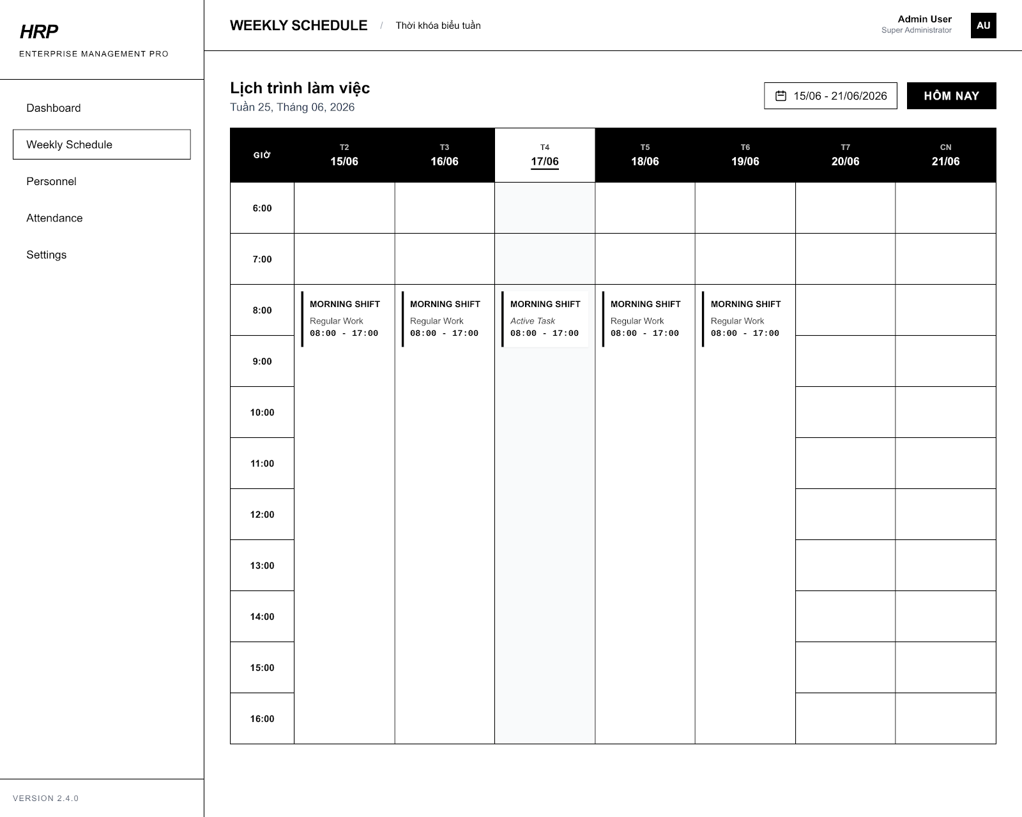
UI Elements:
Field Name | Field Type | Description
Lịch trình làm việc | Calendar / Grid | Displays the weekly work shifts for employees with detailed hours (e.g., Morning Shift 08:00 - 17:00).
Hôm nay | Button | Navigates the schedule grid to the current date.
Tên ca làm việc | Text Input | Name of the shift (e.g., Night Shift (22:00 - 06:00)). Required.
Giờ bắt đầu / Giờ kết thúc | Time Picker | Start and end times of the shift. Required.
Thời gian ân hạn (phút) | Number Input | Grace period in minutes allowed for late check-in.
Kích hoạt ca làm | Toggle / Checkbox | Enables or disables the shift in the system.
GPS Configuration | Form Group / Map | Latitude and longitude coordinate inputs, with option to select current location or pick on map.
Lưu thay đổi | Button | Submits the form to save/update the working shift.
Database Access:
Table | CRUD | Description
working_shift | R, U | Read weekly shifts schedule, and update or create shift settings including times and GPS configuration.
PostgreSQL (Supabase) Commands:
1/ Get weekly schedule / working shifts:
SELECT
shift_id, shift_name, start_time, end_time, grace_period_minutes, is_active, latitude, longitude
FROM working_shift
ORDER BY start_time ASC;
2/ Update working shift details:
UPDATE working_shift
SET
shift_name = $2,
start_time = $3,
end_time = $4,
grace_period_minutes = $5,
is_active = $6,
latitude = $7,
longitude = $8
WHERE shift_id = $1;

- UC27 Create Working Shift
UI Design:

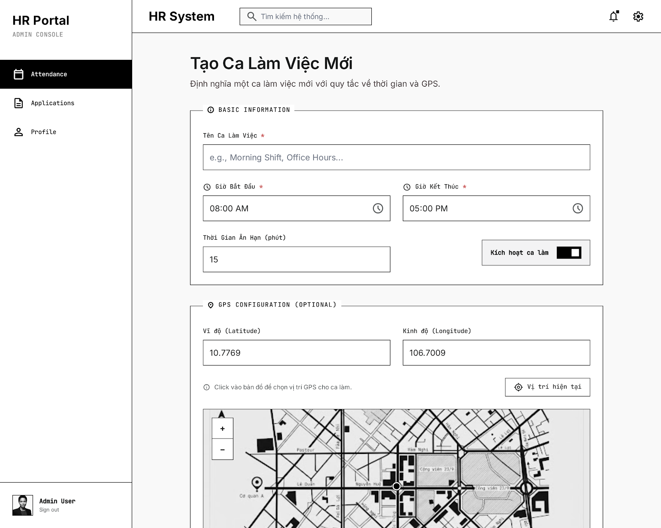
UI Elements:
Field Name | Field Type | Description
Tên Ca Làm Việc | Text Box | User enters work shift name (e.g. Morning Shift, Office Hours...).
Giờ Bắt Đầu / Giờ Kết Thúc | Time Picker | User selects starting and ending hours of the shift.
Thời Gian Ân Hạn (phút) | Text Box / Number | User enters maximum allowance in minutes for late arrivals.
Kích hoạt ca làm | Switch Control | User toggles shift status active / inactive on the system.
Cấu hình định vị GPS (Vĩ độ / Kinh độ / Bản đồ) | Map / Inputs | User configures GPS coordinate bounding boxes to restrict check-in location.
Database Access:
Table | CRUD | Description
work_shift | C, U, R | Create or update work shift settings and GPS coordinates.
PostgreSQL (Supabase) Commands:

1/ Create work shift:
INSERT INTO work_shift (
name, start_time, end_time, grace_period_minutes, is_active, latitude, longitude
) VALUES (
$1, $2, $3, $4, $5, $6, $7
);

2/ Update work shift:
UPDATE work_shift
SET name = $1,
start_time = $2,
end_time = $3,
grace_period_minutes = $4,
is_active = $5,
latitude = $6,
longitude = $7,
updated_at = now()
WHERE shift_id = $8;

- UC28 Modify Working Shift
UI Design:

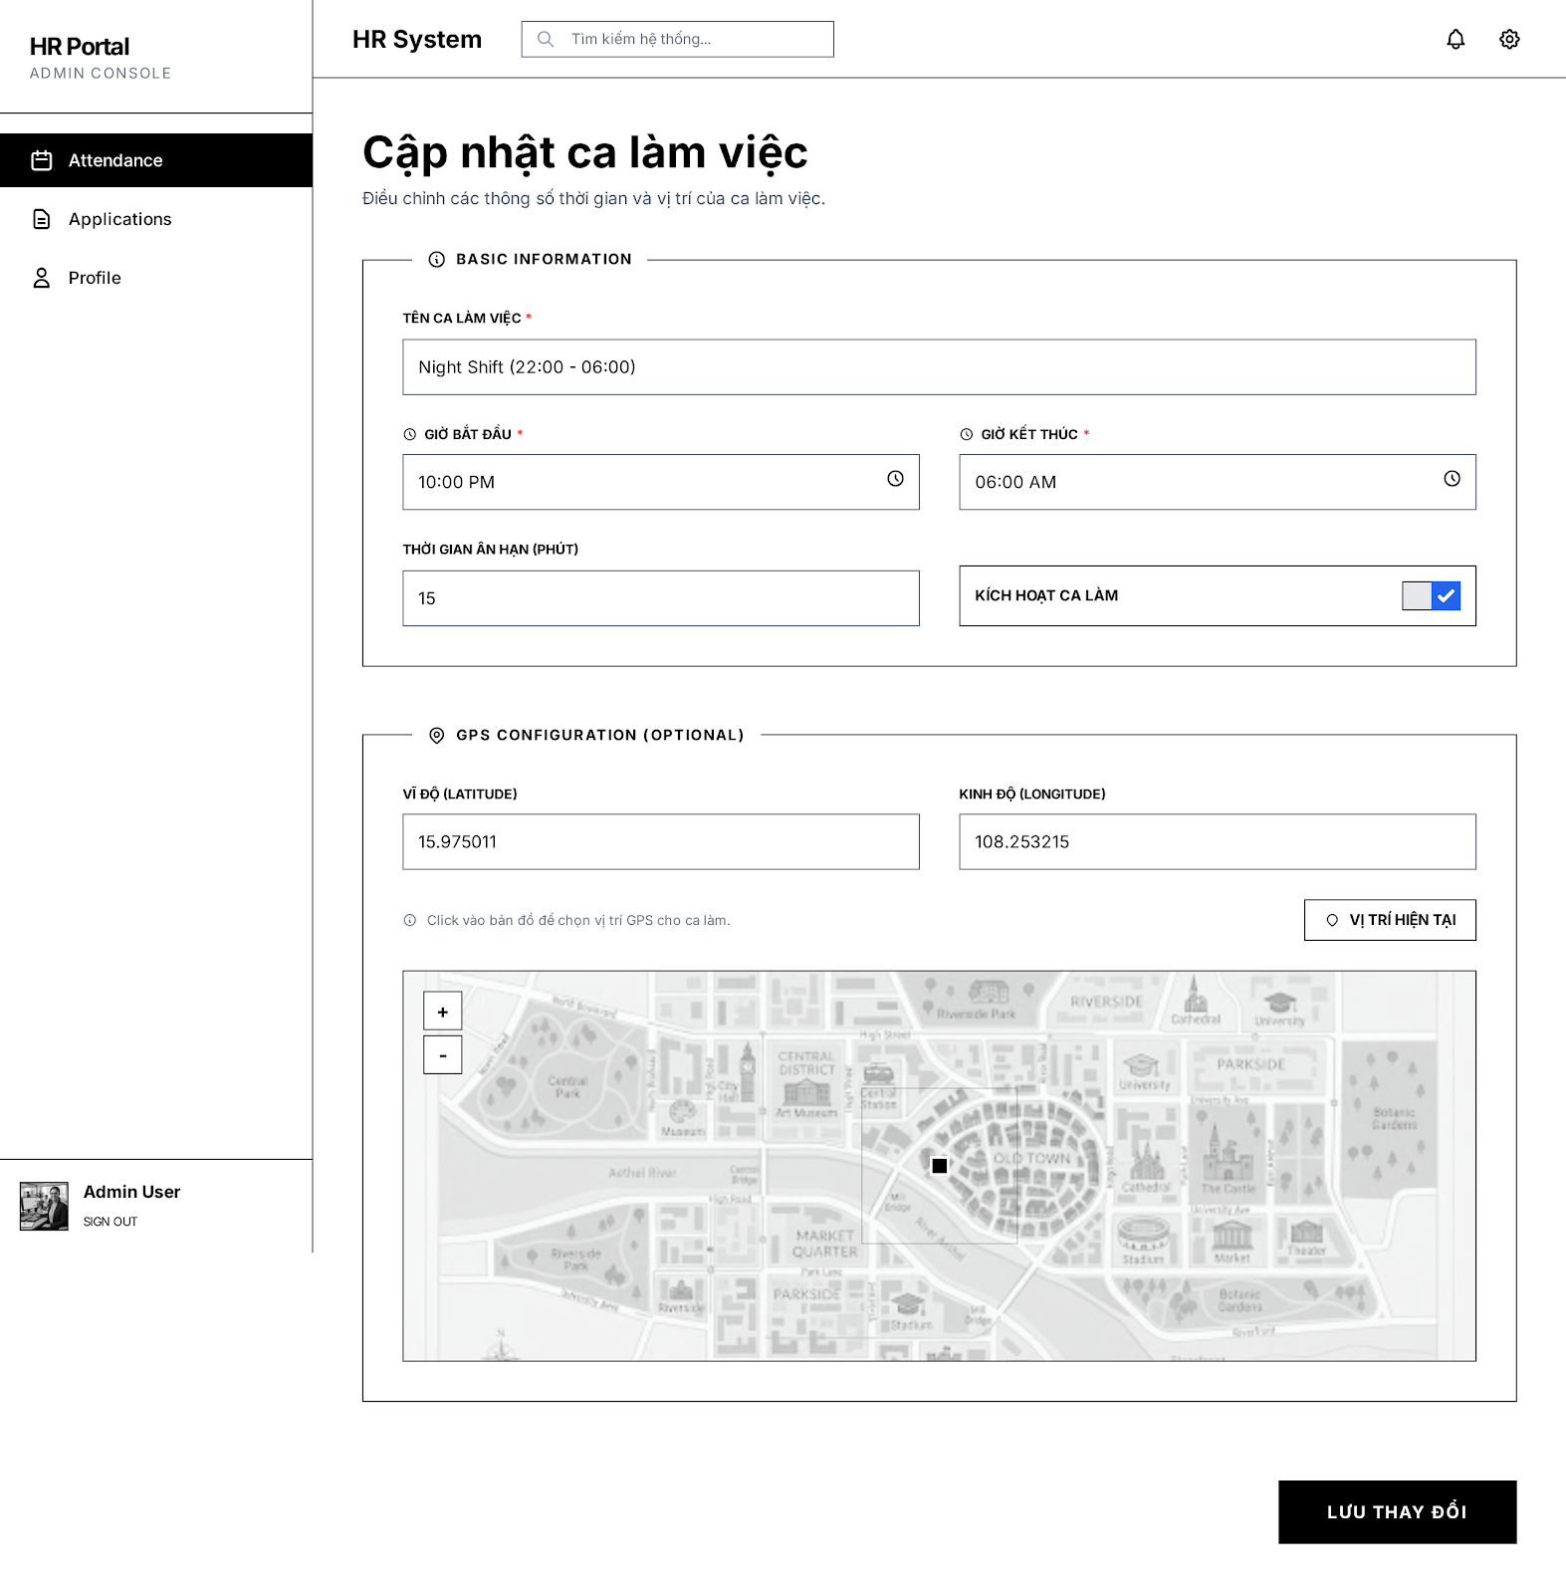
UI Elements:
Field Name | Field Type | Description
Lịch trình làm việc | Calendar / Grid | Displays the weekly work shifts for employees with detailed hours (e.g., Morning Shift 08:00 - 17:00).
Hôm nay | Button | Navigates the schedule grid to the current date.
Tên ca làm việc | Text Input | Name of the shift (e.g., Night Shift (22:00 - 06:00)). Required.
Giờ bắt đầu / Giờ kết thúc | Time Picker | Start and end times of the shift. Required.
Thời gian ân hạn (phút) | Number Input | Grace period in minutes allowed for late check-in.
Kích hoạt ca làm | Toggle / Checkbox | Enables or disables the shift in the system.
GPS Configuration | Form Group / Map | Latitude and longitude coordinate inputs, with option to select current location or pick on map.
Lưu thay đổi | Button | Submits the form to save/update the working shift.
Database Access:
Table | CRUD | Description
working_shift | R, U | Read weekly shifts schedule, and update or create shift settings including times and GPS configuration.
PostgreSQL (Supabase) Commands:
1/ Get weekly schedule / working shifts:
SELECT
shift_id, shift_name, start_time, end_time, grace_period_minutes, is_active, latitude, longitude
FROM working_shift
ORDER BY start_time ASC;
2/ Update working shift details:
UPDATE working_shift
SET
shift_name = $2,
start_time = $3,
end_time = $4,
grace_period_minutes = $5,
is_active = $6,
latitude = $7,
longitude = $8
WHERE shift_id = $1;

3.6 Application Approval Screen
Related UC:
- UC29 Moderate Application Form
UI Design:
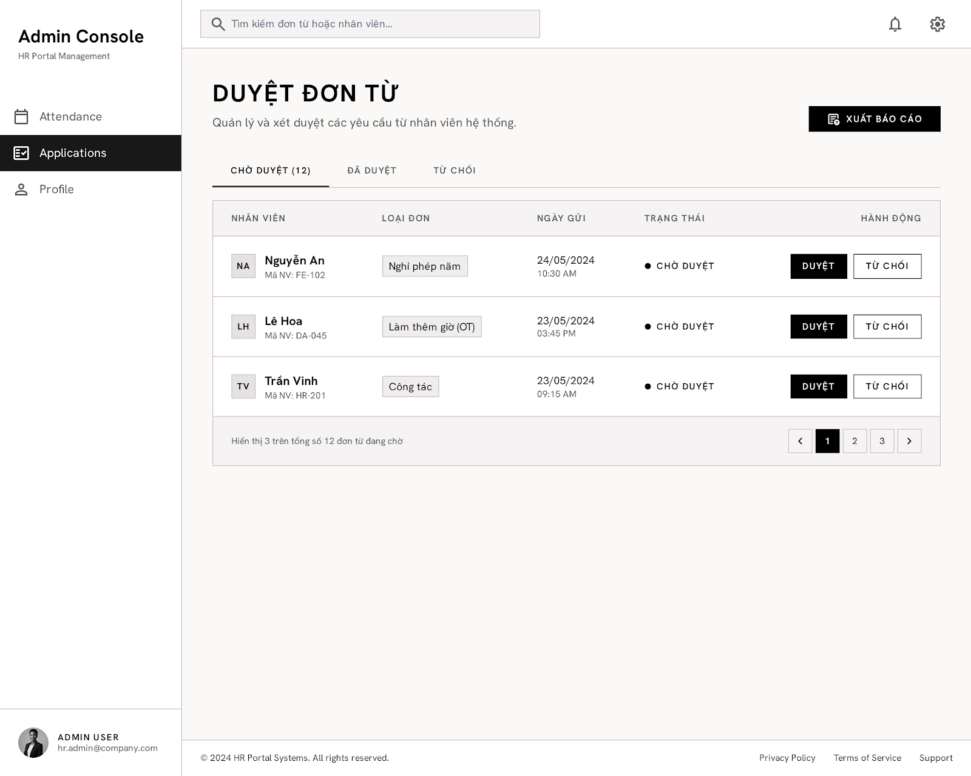

UI Elements:
Field Name | Field Type | Description
Tabs trạng thái | Tab Control | Filters list of applications by status: "Chờ duyệt", "Đã duyệt", "Từ chối". Displays count of pending applications.
Xuất báo cáo | Button | Allows HR Manager to export application list/reports.
Danh sách Đơn từ | Table | Displays employee details (Name, Code), Type of Application (e.g., Nghỉ phép năm, Làm thêm giờ, Công tác), Submission Date, Status, and Action buttons.
Duyệt | Button | Approves the selected application. Changes status to "Đã duyệt".
Từ chối | Button | Rejects the selected application. Changes status to "Từ chối".
Phân trang | Pagination | Navigates between pages of the application list.
Database Access:
Table | CRUD | Description
application_form | R, U | List submitted applications and update their status (approved/rejected) by HR Manager.
employee | R | Read applicant employee details (name, code).
PostgreSQL (Supabase) Commands:
1/ Get applications list with employee details (Pending status):
SELECT
af.application_id,
e.full_name,
e.employee_code,
af.application_type,
af.created_at,
af.status
FROM application_form af
JOIN employee e ON af.employee_id = e.employee_id
WHERE af.status = 'PENDING'
ORDER BY af.created_at DESC;
2/ Moderate (Approve/Reject) application status:
UPDATE application_form
SET
status = $2, -- 'APPROVED' or 'REJECTED'
moderated_by = $3,
moderated_at = NOW()
WHERE application_id = $1;

4. Payroll Management Feature

4.1 Payroll Dashboard
Related UC:
- UC30 View/Export Payroll Report
UI Design:
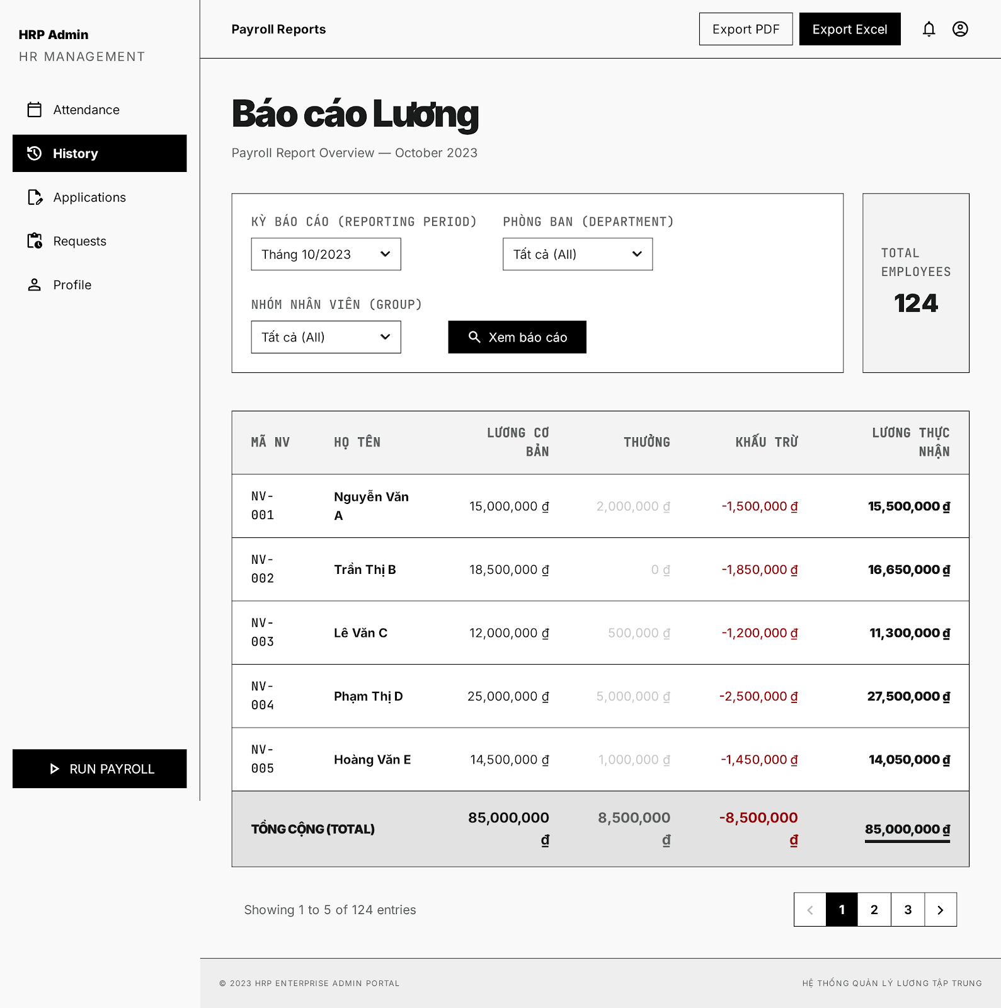
UI Elements:
Field Name | Field Type | Description
Export PDF / Export Excel | Button Group | Allows exporting the payroll report to PDF or Excel formats.
Kỳ báo cáo (Reporting Period) | Dropdown | Filters payroll data by specific month/year (e.g., Tháng 10/2023).
Phòng ban (Department) | Dropdown | Filters payroll data by department.
Nhóm nhân viên (Group) | Dropdown | Filters payroll by staff groups.
Xem báo cáo | Button | Queries and updates the data table based on selected filters.
Total Employees | Stat Box | Displays the total number of employees in the selected filters (e.g., 124).
Bảng Lương (Payroll Table) | Table | Lists employees with columns: Mã NV, Họ Tên, Lương Cơ Bản, Thưởng, Khấu Trừ, Lương Thực Nhận, and a Total row at the bottom.
Phân trang | Pagination | Controls list navigation (e.g., Showing 1 to 5 of 124 entries).
Database Access:
Table | CRUD | Description
payroll_report | R | Query payroll records, salary breakdowns, deductions, and bonuses for reports.
employee | R | Get employee name and employee code.
PostgreSQL (Supabase) Commands:
1/ Query payroll list with filters & calculations:
SELECT
e.employee_code,
e.full_name,
pr.base_salary,
pr.bonus,
pr.deductions,
(pr.base_salary + pr.bonus - pr.deductions) as net_salary
FROM payroll_report pr
JOIN employee e ON pr.employee_id = e.employee_id
WHERE pr.period = $1 -- e.g., '2023-10'
AND ($2 IS NULL OR e.department_id = $2)
ORDER BY e.employee_code ASC;
2/ Get payroll summary stats:
SELECT
COUNT(DISTINCT pr.employee_id) as total_employees,
SUM(pr.base_salary) as total_base,
SUM(pr.bonus) as total_bonus,
SUM(pr.deductions) as total_deductions,
SUM(pr.base_salary + pr.bonus - pr.deductions) as total_net
FROM payroll_report pr
JOIN employee e ON pr.employee_id = e.employee_id
WHERE pr.period = $1
AND ($2 IS NULL OR e.department_id = $2);

4.2 Payroll Template Screen
Related UC:
- UC31 Modify Payroll Template
UI Design:
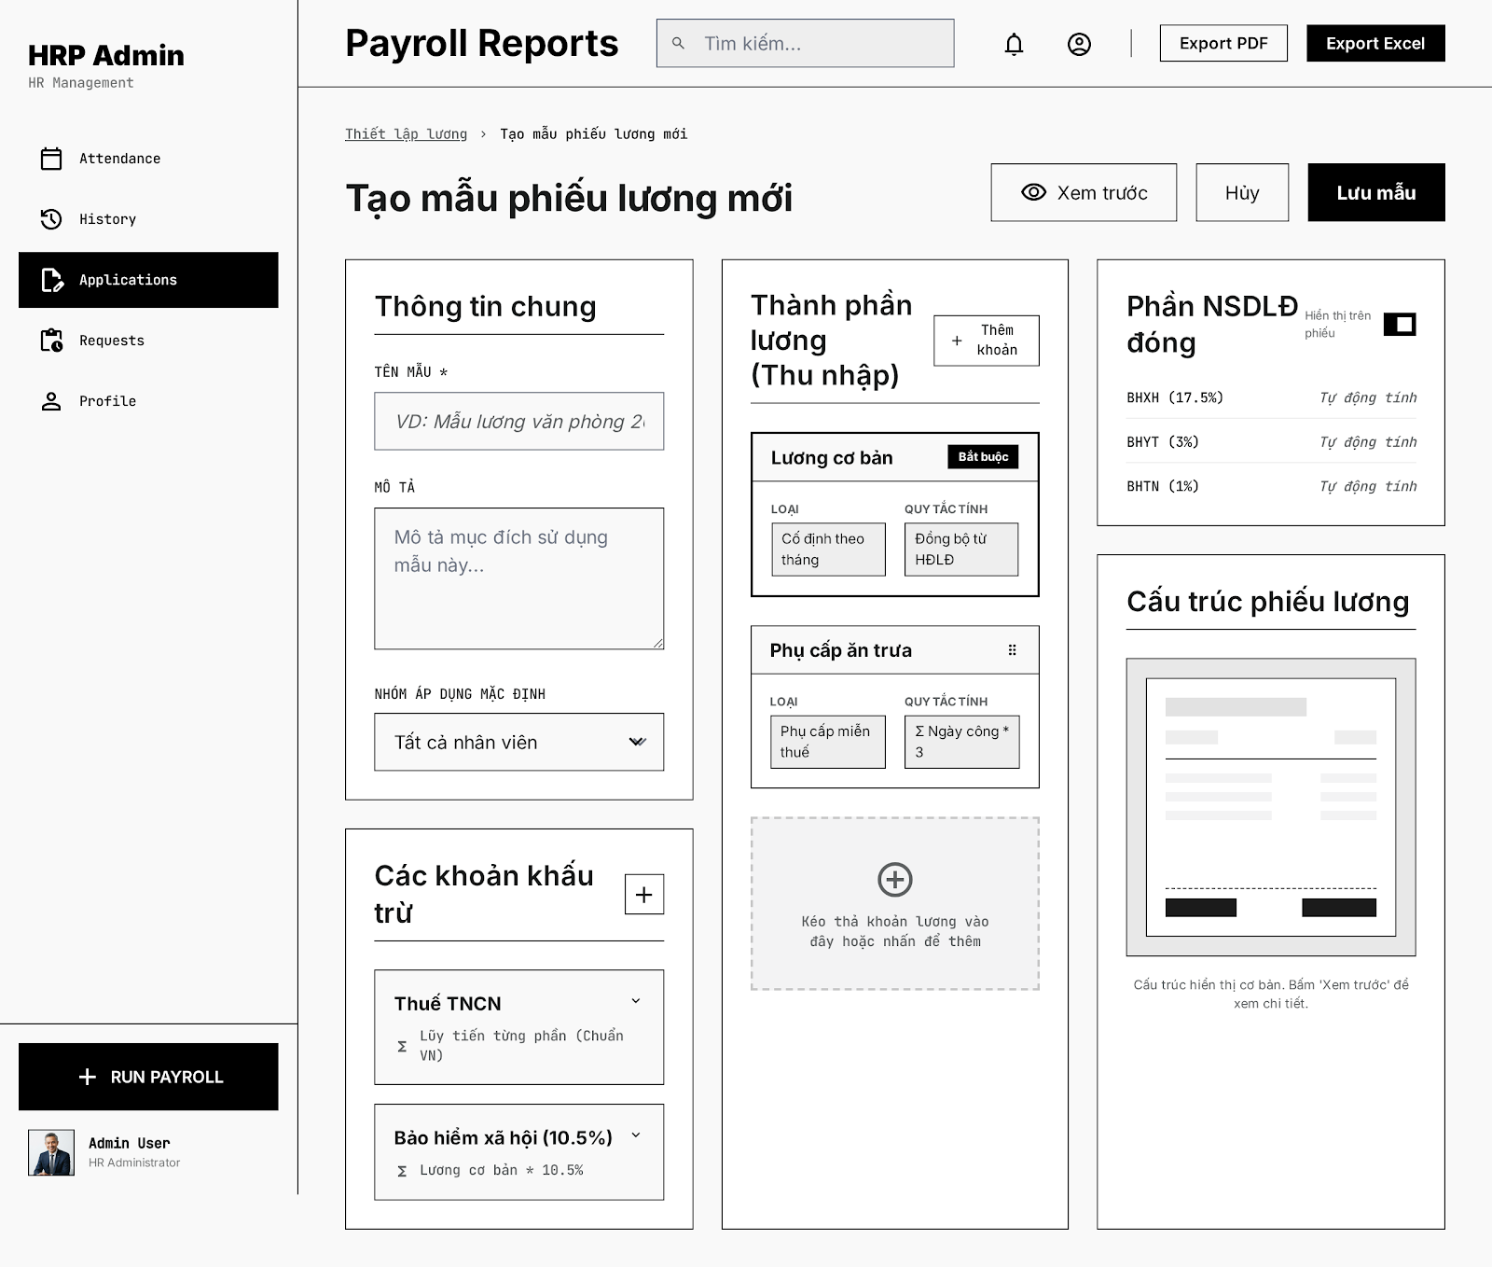
UI Elements:
Field Name | Field Type | Description
Xem trước | Button | Allows viewing a preview draft of the payslip based on the template.
Lưu mẫu | Button | Saves the newly created or modified payroll template structure.
Thông tin chung | Form Section | Contains: Tên mẫu (Text Input), Mô tả (Text Area), Nhóm áp dụng mặc định (Dropdown).
Thành phần lương (Thu nhập) | Form Section / List | Add and configure income elements: Lương cơ bản, Phụ cấp ăn trưa, etc. with calculation rules. Includes "Thêm khoản" button.
Các khoản khấu trừ | Form Section / List | Configure deductions: Thuế TNCN (Lũy tiến từng phần), Bảo hiểm xã hội (10.5%), etc. Includes "Thêm" button.
Phần NSDLĐ đóng | Form Section | Insurance percentages contributed by the employer: BHXH (17.5%), BHYT (3%), BHTN (1%). Toggle switch to hide/show on payslip.
Cấu trúc phiếu lương | Visual Diagram | Illustrates the template layout visual representation.
Database Access:
Table | CRUD | Description
payroll_template | C, R, U | Create, read, and update payroll templates configuration and formula components.
PostgreSQL (Supabase) Commands:
1/ Save/Create new payroll template:
INSERT INTO payroll_template (
template_name, description, default_group,
income_components, deduction_components, employer_contributions,
created_at, updated_at
) VALUES (
$1, $2, $3,
$4::jsonb, -- e.g., [{"name": "Lương cơ bản", "type": "fixed", "rules": "..."}]
$5::jsonb, -- e.g., [{"name": "Thuế TNCN", "type": "progressive"}]
$6::jsonb, -- e.g., {"bhxh": 17.5, "bhyt": 3.0, "bhtn": 1.0}
NOW(), NOW()
) RETURNING template_id;
2/ Update existing payroll template:
UPDATE payroll_template
SET
template_name = $2,
description = $3,
default_group = $4,
income_components = $5::jsonb,
deduction_components = $6::jsonb,
employer_contributions = $7::jsonb,
updated_at = NOW()
WHERE template_id = $1;

4.3 Payroll Approval Screen
Related UC:
- UC32 Moderate Payroll
UI Design:
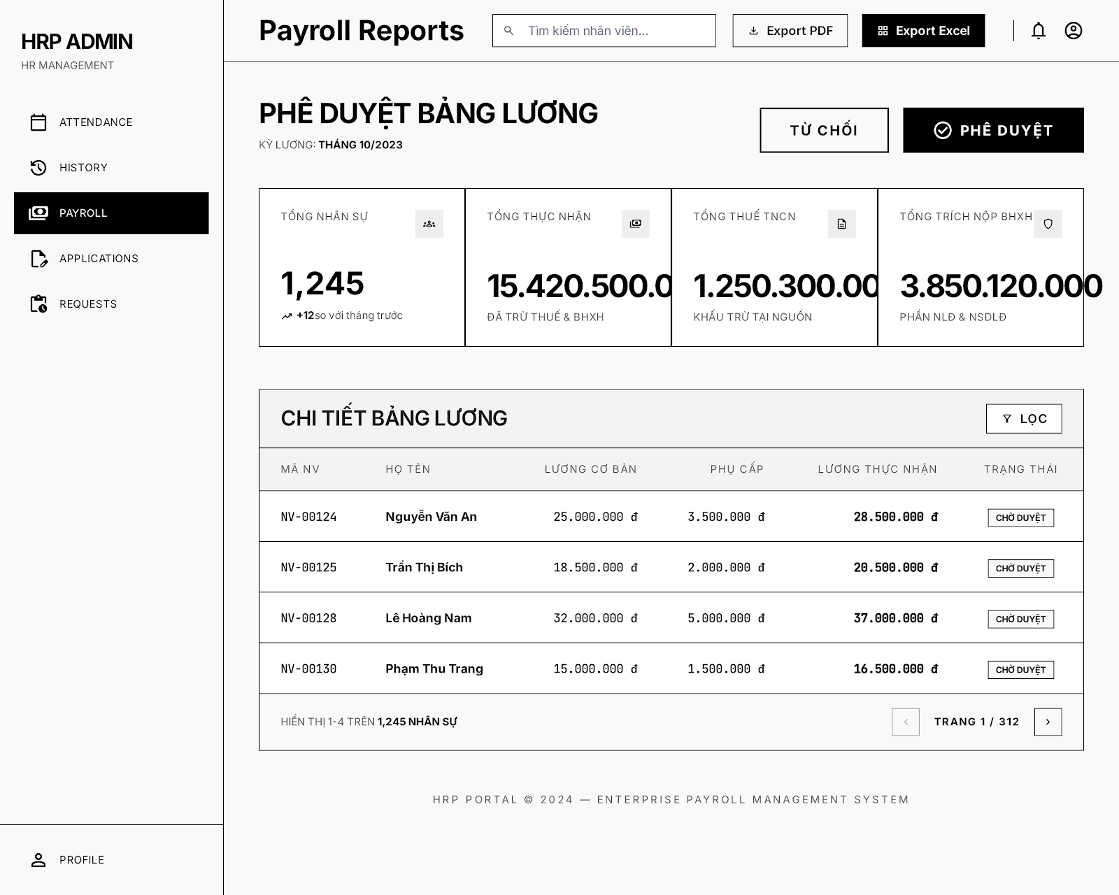
UI Elements:
Field Name | Field Type | Description
Từ chối / Phê duyệt | Button Group | Allows approving or rejecting the entire monthly payroll sheet.
KPI Stats Row | Metrics Grid | Shows summary info:  - Tổng nhân sự (e.g. 1,245)  - Tổng thực nhận (e.g. 15.420.500.000 đ)  - Tổng thuế TNCN (e.g. 1.250.300.000 đ)  - Tổng trích nộp BHXH (e.g. 3.850.120.000 đ)
Lọc | Button | Filters details inside the payroll sheet list.
Chi tiết bảng lương | Table | Lists employee line-items: Mã NV, Họ Tên, Lương Cơ Bản, Phụ Cấp, Lương Thực Nhận, Trạng Thái.
Phân trang | Pagination | Controls list navigation (e.g., Trang 1 / 312).
Database Access:
Table | CRUD | Description
payroll_run | R, U | Query total monthly payroll metrics and update approval status (APPROVED / REJECTED).
payroll_detail | R | Read individuals salary details within the run.
PostgreSQL (Supabase) Commands:
1/ Query payroll run general stats (e.g., for Period '2023-10'):
SELECT
run_id, period, status,
total_employees, total_net_salary, total_tax, total_insurance
FROM payroll_run
WHERE period = $1;
2/ Moderate entire payroll sheet:
UPDATE payroll_run
SET
status = $2, -- 'APPROVED' or 'REJECTED'
approved_by = $3,
approved_at = NOW()
WHERE run_id = $1;

4.4 Payslip Screen
Related UC:
- UC33 View Payslip
UI Design:
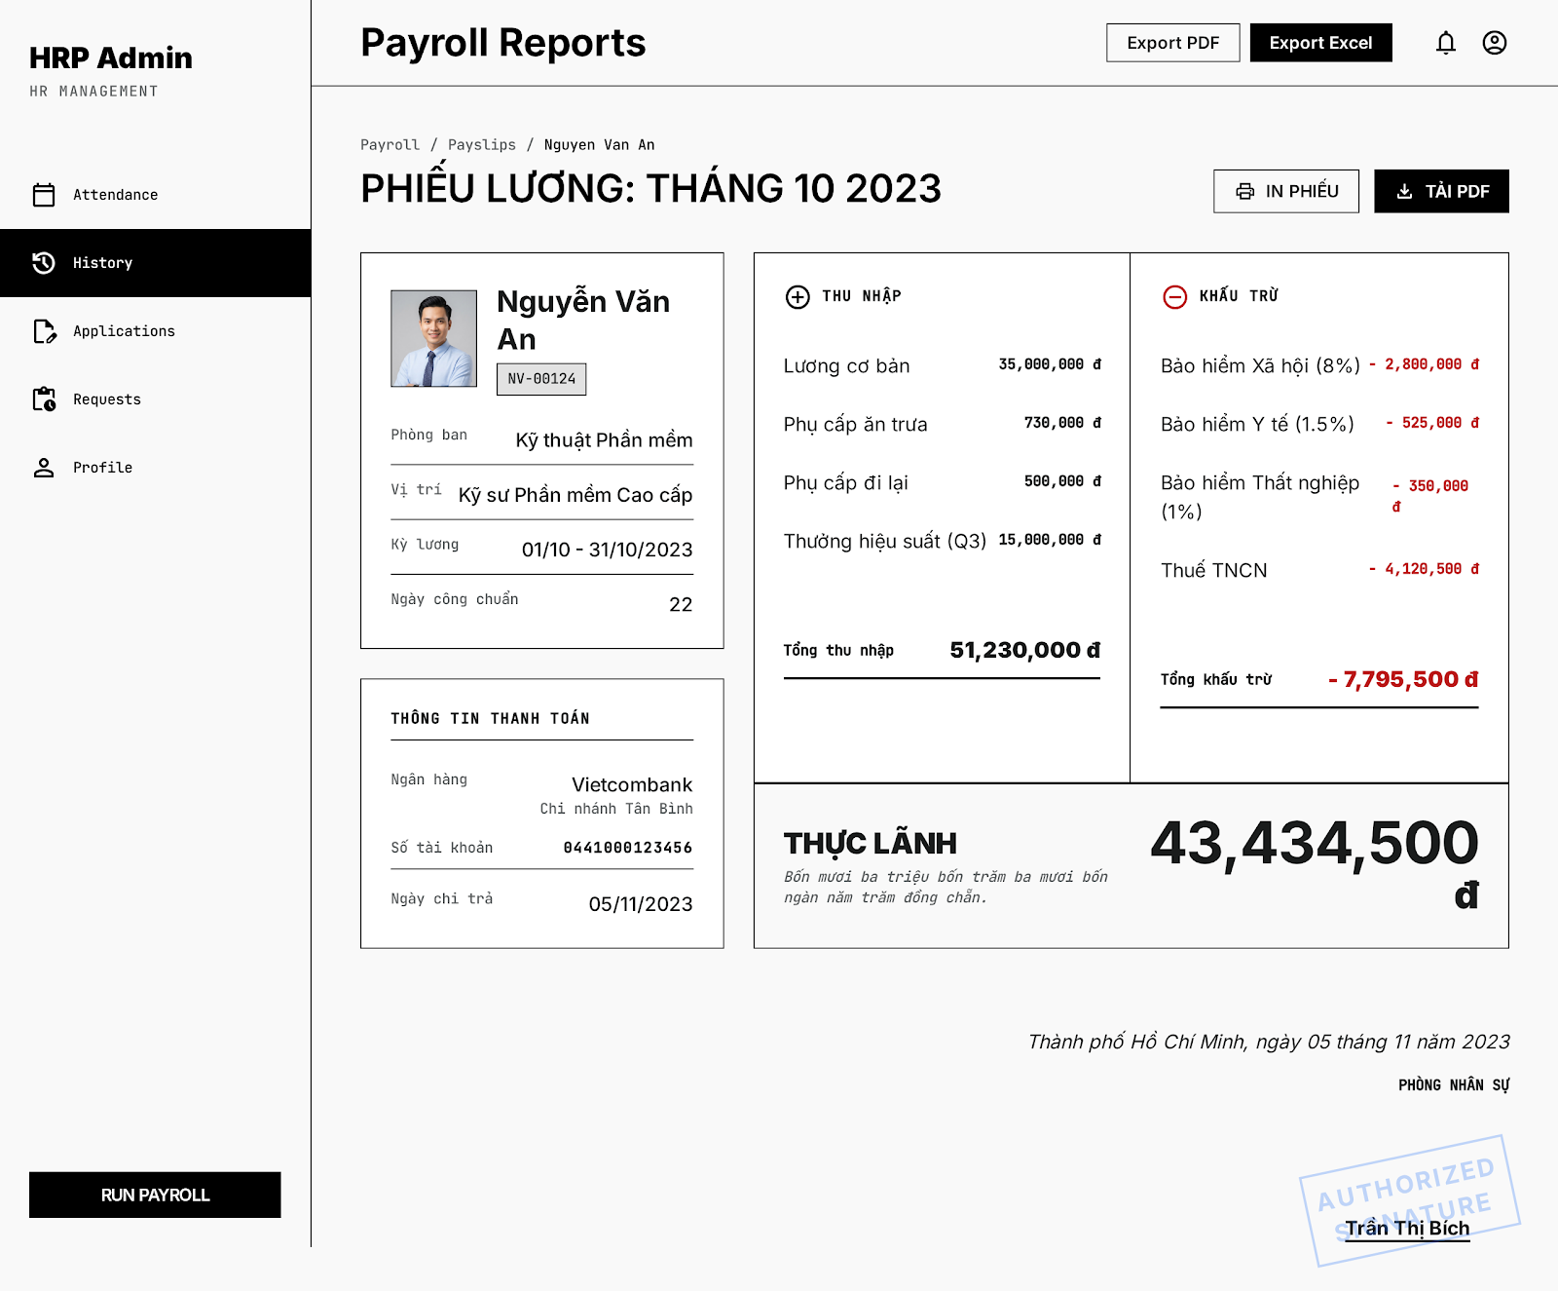
UI Elements:
Field Name | Field Type | Description
In phiếu / Tải PDF | Button Group | Prints the payslip or downloads it in PDF format.
Thông tin nhân viên | Card / Layout | Shows Avatar, Full name, Employee Code (NV-00124), Department, Position, Pay Period (01/10 - 31/10/2023), and Standard working days (22).
Thông tin thanh toán | Card / Layout | Shows bank account info (Ngân hàng, Số tài khoản, Ngày chi trả).
Thu nhập (Earnings) | List / Column | Breakdown of earnings: Lương cơ bản, Phụ cấp ăn trưa, Phụ cấp đi lại, Thưởng hiệu suất (Q3) and Tong thu nhap (e.g. 51,230,000 đ).
Khấu trừ (Deductions) | List / Column | Breakdown of deductions: BHXH (8%), BHYT (1.5%), BHTN (1%), Thuế TNCN and Tong khau tru (e.g. -7,795,500 đ).
Thực Lãnh (Net Pay) | Highlight Banner | Final net pay amount (e.g. 43,434,500 đ) and text summary of the amount.
Database Access:
Table | CRUD | Description
payslip | R | Read personal monthly payslip detail, bank payment status, and breakdown elements.
employee | R | Read employee bank details and active position profile details.
PostgreSQL (Supabase) Commands:
1/ Query payslip breakdown for employee (e.g., ID 124, Period '2023-10'):
SELECT
p.payslip_id, p.period_start, p.period_end, p.working_days,
p.earnings, -- JSONB object containing earnings list
p.deductions, -- JSONB object containing deductions list
p.net_salary, p.payment_date,
e.full_name, e.employee_code, e.department_id, e.position,
e.bank_name, e.bank_account_number
FROM payslip p
JOIN employee e ON p.employee_id = e.employee_id
WHERE p.employee_id = $1 AND p.period = $2;

4.5 Payroll Scheduler Screen
Related UC:
- UC34 Modify Trigger Generate Payroll
UI Design:
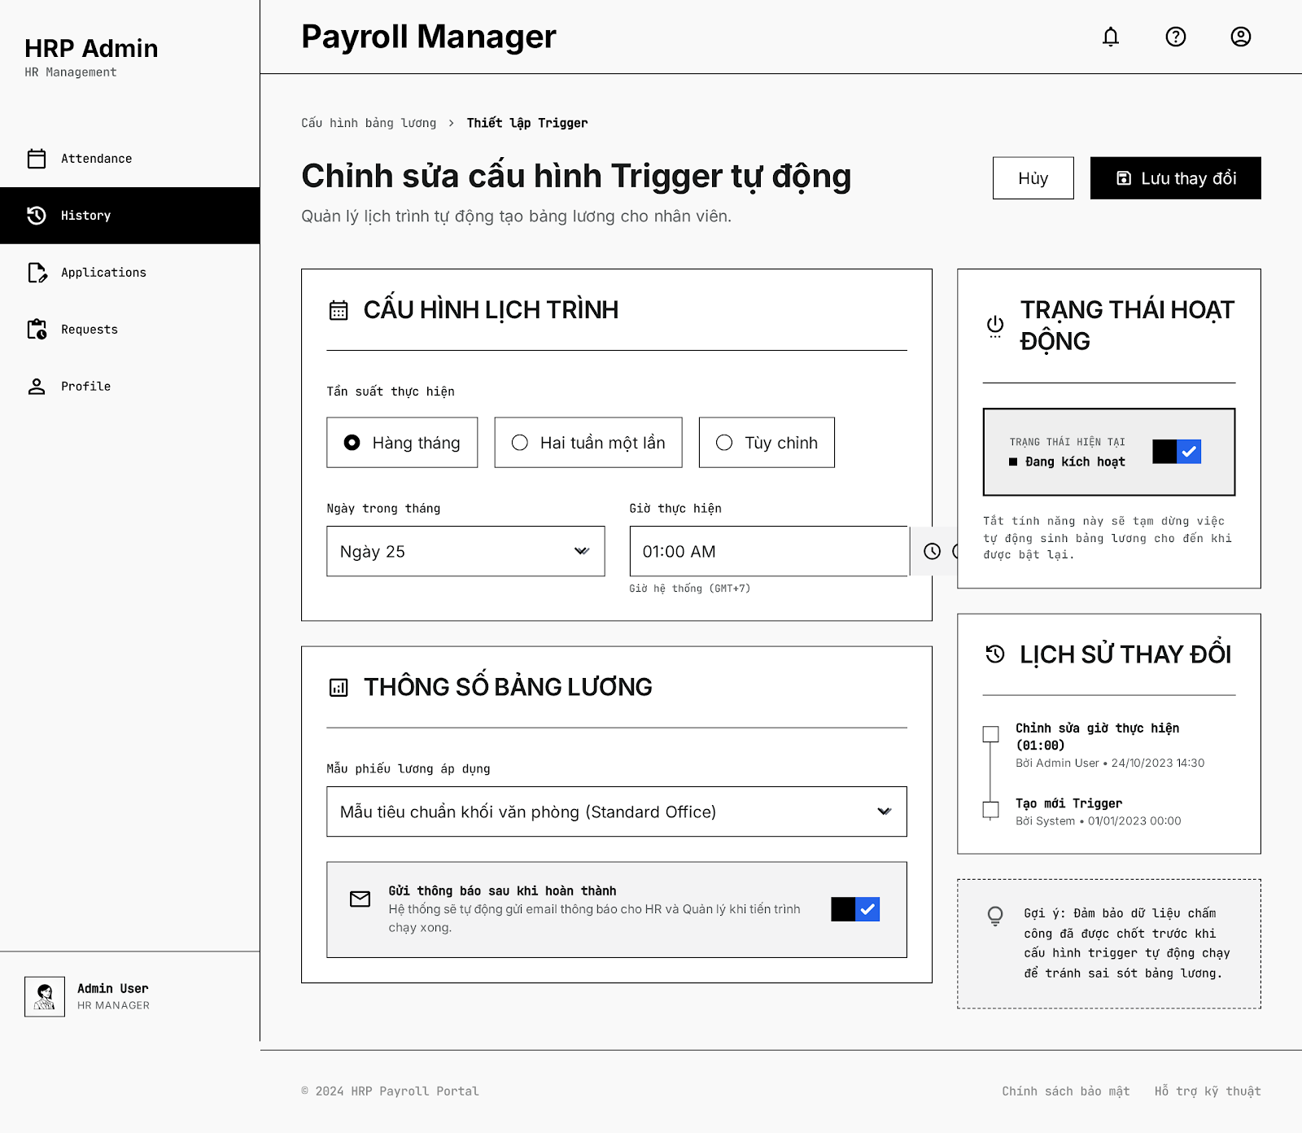
UI Elements:
Field Name | Field Type | Description
Hủy / Lưu thay đổi | Button Group | Allows canceling edits or saving scheduler modifications.
Tần suất thực hiện | Radio Group | Options: "Hàng tháng", "Hai tuần một lần", "Tùy chỉnh".
Ngày trong tháng | Dropdown | Selects the day of the month to trigger execution (e.g. Ngày 25).
Giờ thực hiện | Time Input | Selects triggering time (e.g. 01:00 AM).
Mẫu phiếu lương áp dụng | Dropdown | Selects the default template (e.g. Mẫu tiêu chuẩn khối văn phòng).
Gửi thông báo sau khi hoàn thành | Checkbox / Toggle | Enables automated email reports to HR when execution finishes.
Trạng thái hoạt động | Toggle Switch | Activates or deactivates the scheduler trigger rule.
Lịch sử thay đổi | Log Timeline | Displays historical change log records of the schedule.
Database Access:
Table | CRUD | Description
payroll_trigger_config | R, U | Manage scheduler frequency, target dates, times, default template selection, and status toggle.
payroll_trigger_log | R | View change history log list of scheduler configurations.
PostgreSQL (Supabase) Commands:
1/ Query active scheduler config:
SELECT
config_id, frequency, execution_day, execution_time,
template_id, send_email_notification, is_active
FROM payroll_trigger_config
LIMIT 1;
2/ Update scheduler configurations:
UPDATE payroll_trigger_config
SET
frequency = $2,
execution_day = $3,
execution_time = $4,
template_id = $5,
send_email_notification = $6,
is_active = $7,
updated_at = NOW()
WHERE config_id = $1;
3/ Insert action log record (History):
INSERT INTO payroll_trigger_log (
action_type, details, performed_by
) VALUES (
'UPDATE_CONFIG', $1, $2
);

5. Project Management Feature

5.1 Project List Screen
Related UC:
- UC35 Create Project
UI Design:
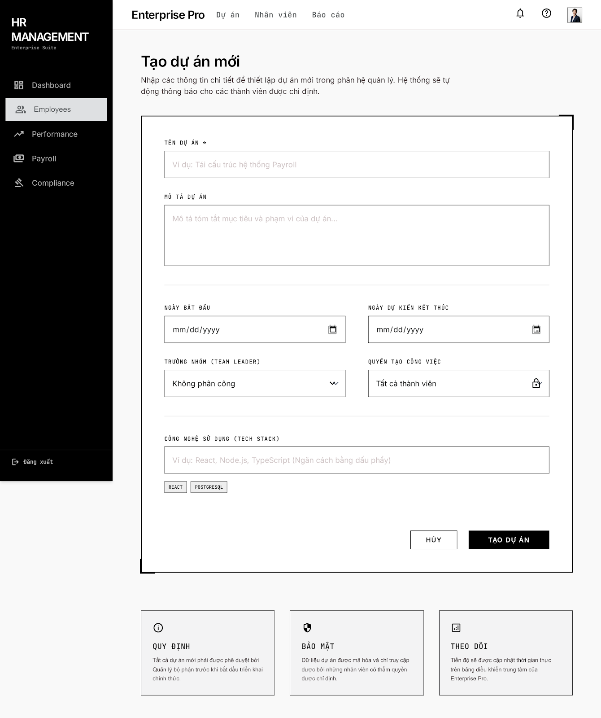

UI Elements:
Field Name | Field Type | Description
Tên dự án * | Text Box | Validates and inputs the unique project name.
Mô tả dự án | Text Area | Optional textual description of the project scope.
Ngày bắt đầu | Date Picker | Sets the initial date of the project.
Ngày dự kiến kết thúc | Date Picker | Sets the target deadline of the project.
Trưởng nhóm (Team Leader) | Dropdown Select | Selects an active employee to lead the project. Defaults to "Không phân công"
Quyền tạo công việc | Dropdown Select | Selects task creation policy: "Tất cả thành viên" (all_members) or "Chỉ trưởng nhóm" (leader_only).
Công nghệ sử dụng (Tech Stack) | Text Box | Input list of technologies separated by commas.
Tạo dự án | Button | Triggers input validation and saves the project record.
Hủy | Button | Discards inputs and redirects to the Project List page.

Database Access:
Table | CRUD | Description
Project | C | Create a new project row with the form parameters.
Employee | R | Query active employees to populate the Team Leader dropdown.
PostgreSQL (Supabase) Commands:
1/ Populate Team Leader Dropdown:
SELECT "id", "fullName", "email"
FROM "Employee"
WHERE "status" = 'active' AND "deletedAt" IS NULL
ORDER BY "fullName" ASC;

2/ Create New Project:
INSERT INTO "Project" (
"id", "name", "description", "techStack", "status",
"taskCreationPolicy", "startDate", "expectedEndDate",
"teamLeaderId", "createdById", "createdAt", "updatedAt"
) VALUES (
'project_target_uuid_123', 'Data Warehouse Integration', 'Set up Snowflake and ETL pipelines',
ARRAY['React', 'Node.js', 'TypeScript'], 'planning',
'all_members', '2026-06-16 00:00:00', '2026-12-31 00:00:00',
'emp_leader_id_123', 'emp_creator_id_456', NOW(), NOW()
);

- UC39 View Project Details
UI Design:
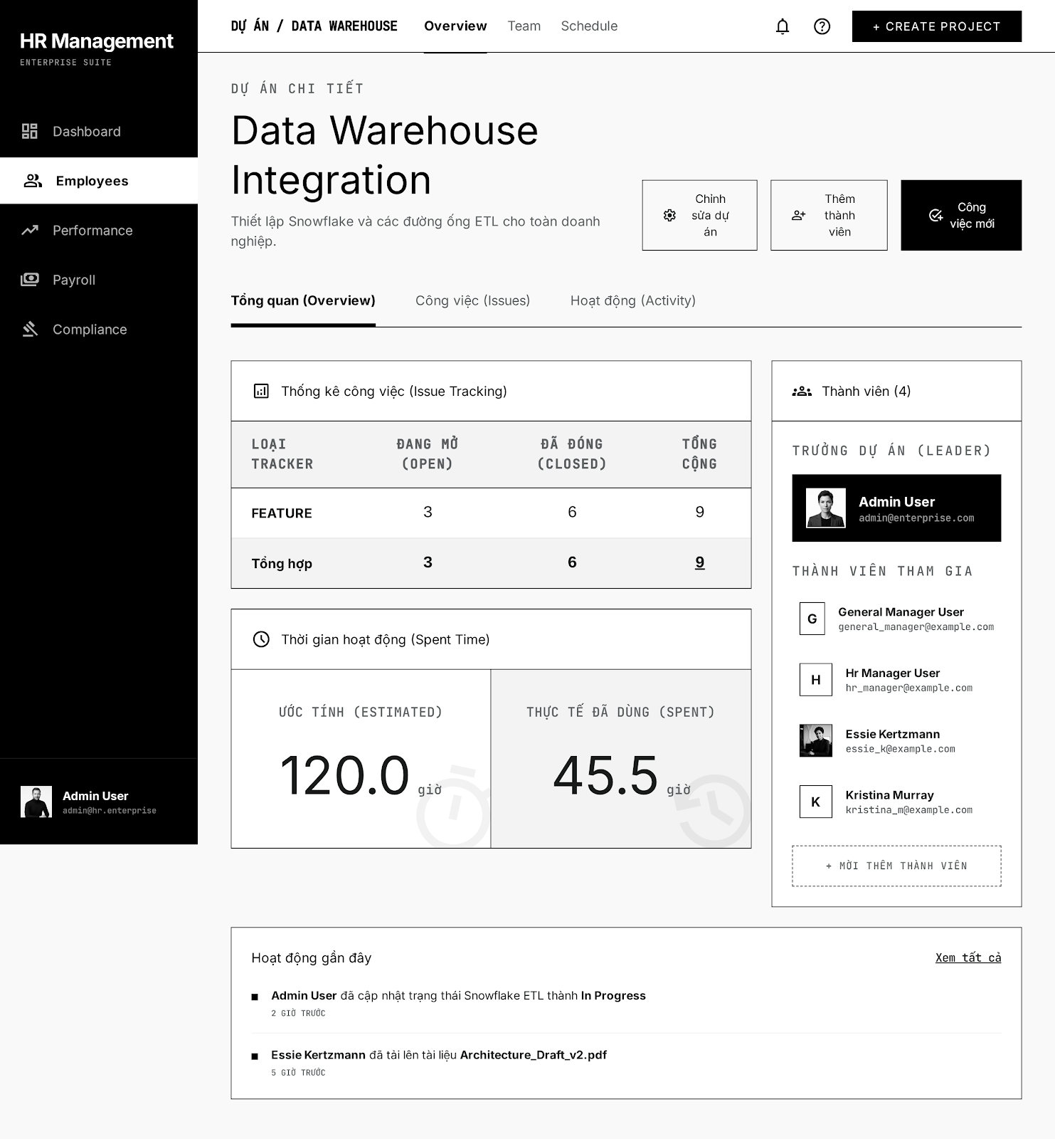

UI Elements:
Field Name | Field Type | Description
Chỉnh sửa dự án | Button | Opens the "Chỉnh sửa dự án" (Modify Project) Modal dialog.
Thêm thành viên | Password Box | Opens the "Thêm thành viên dự án" (Add Member) Modal dialog.
Công việc mới | Button | Redirects the user to the Create Task Screen.
Tổng quan (Overview) | Tab | Displays the spent time charts and tracker statistics widgets.
Công việc (Issues) | Tab | Navigates to the active Kanban board/tasks list of the project.
Hoạt động (Activity) | Tab | Navigates to the active Kanban board/tasks list of the project.
Thống kê công việc (Issue Tracking) | Table Widget | Shows active tasks count grouped by tracker type (feature, bug, etc.) and status.
Thời gian hoạt động (Spent Time) | Card Widget | Displays total estimates vs total actual spent hours.
Thành viên (4) | Sidebar Widget | Displays the project leader and list of active members.

Database Access:
Table | CRUD | Description
Project | R | Query metadata of the project.
ProjectMember | R | Query active members in the project.
Task | R | Retrieve tasks count grouped by status and tracker type.
SpentTime | R | Sum up logged hours vs task estimated times.

PostgreSQL (Supabase) Commands:
1/ Fetch Project Metadata & Lead Details:
SELECT p.*, e."fullName" AS "teamLeaderName", e."email" AS "teamLeaderEmail"
FROM "Project" p
LEFT JOIN "Employee" e ON p."teamLeaderId" = e."id"
WHERE p."id" = 'project_target_uuid_123';

2/ Fetch Active Project Members list:
SELECT pm.*, e."fullName", e."email", e."position", e."avatarUrl"
FROM "ProjectMember" pm
INNER JOIN "Employee" e ON pm."employeeId" = e."id"
WHERE pm."projectId" = 'project_target_uuid_123'
AND pm."removedAt" IS NULL;

3/ Aggregate Task Counts by Status & Tracker:
SELECT "tracker", "status", COUNT(*) as "count"
FROM "Task"
WHERE "projectId" = 'project_target_uuid_123'
GROUP BY "tracker", "status";

4/ Sum Task Estimates and Logged Hours:
SELECT
COALESCE(SUM(t."estimatedTime"), 0) AS "totalEstimated",
COALESCE(SUM(s."hours"), 0) AS "totalSpent"
FROM "Task" t
LEFT JOIN "SpentTime" s ON t."id" = s."taskId"
WHERE t."projectId" = 'project_target_uuid_123';

5.2 Project Details Screen
Related UC:
- UC36 Modify Project
UI Design:
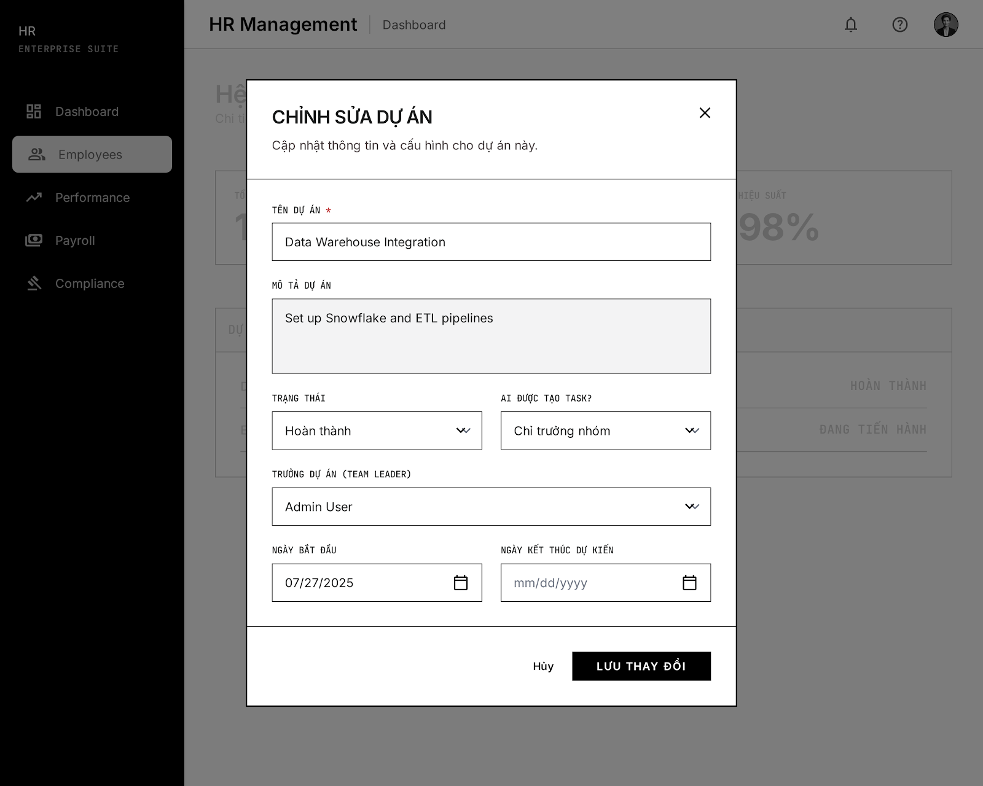

UI Elements:
Field Name | Field Type | Description
Tên dự án * | Text Box | Modifies the unique project name.
Mô tả dự án | Text Area | Modifies the description.
Trạng thái | Dropdown Select | Selects status: planning, active, on_hold, completed (translates to "Hoàn thành"), cancelled.
Ai được tạo task? | Dropdown Select | Maps to taskCreationPolicy: "Tất cả thành viên" (all_members) or "Chỉ trưởng nhóm" (leader_only).
Trưởng dự án (Team Leader) | Dropdown Select | Re-assigns the project's Team Leader.
Ngày bắt đầu | Date Picker | Modifies start date.
Ngày kết thúc dự kiến | Date Picker | Modifies expected end date.
Lưu thay đổi | Button | Triggers validation and saves changes to the database.
Hủy | Button | Discards updates and closes the modal dialog.

Database Access:
Table | CRUD | Description
Project | U | Update fields of the target project record.
Employee | R | Query active employees to populate the Team Leader dropdown list.

UI Elements:
Field Name | Field Type | Description
Tên dự án * | Text Box | Modifies the unique project name.
Mô tả dự án | Password Box | Modifies the description.
Trạng thái | Dropdown Select | Selects status: planning, active, on_hold, completed (translates to "Hoàn thành"), cancelled.
Ai được tạo task? | Tab | Displays the spent time charts and tracker statistics widgets.
Công việc (Issues) | Tab | Navigates to the active Kanban board/tasks list of the project.
Hoạt động (Activity) | Tab | Navigates to the active Kanban board/tasks list of the project.
Thống kê công việc (Issue Tracking) | Table Widget | Shows active tasks count grouped by tracker type (feature, bug, etc.) and status.
Thời gian hoạt động (Spent Time) | Card Widget | Displays total estimates vs total actual spent hours.
Thành viên (4) | Sidebar Widget | Displays the project leader and list of active members.

Database Access:
Table | CRUD | Description
Project | R | Query metadata of the project.
ProjectMember | R | Query active members in the project.
Task | R | Retrieve tasks count grouped by status and tracker type.
SpentTime | R | Sum up logged hours vs task estimated times.

PostgreSQL (Supabase) Commands:
1/ Update Project Details:
SQL
UPDATE "Project"
SET
"name" = 'Data Warehouse Integration',
"description" = 'Set up Snowflake and ETL pipelines',
"status" = 'completed',
"taskCreationPolicy" = 'leader_only',
"startDate" = '2025-07-27 00:00:00',
"expectedEndDate" = NULL, -- Or specific updated expected end date
"actualEndDate" = NOW(), -- Because status is set to Completed/Hoàn thành
"teamLeaderId" = 'emp_admin_user_uuid',
"updatedAt" = NOW()
WHERE "id" = 'project_target_uuid_123';

- UC37 Add Member To Project
UI Design:
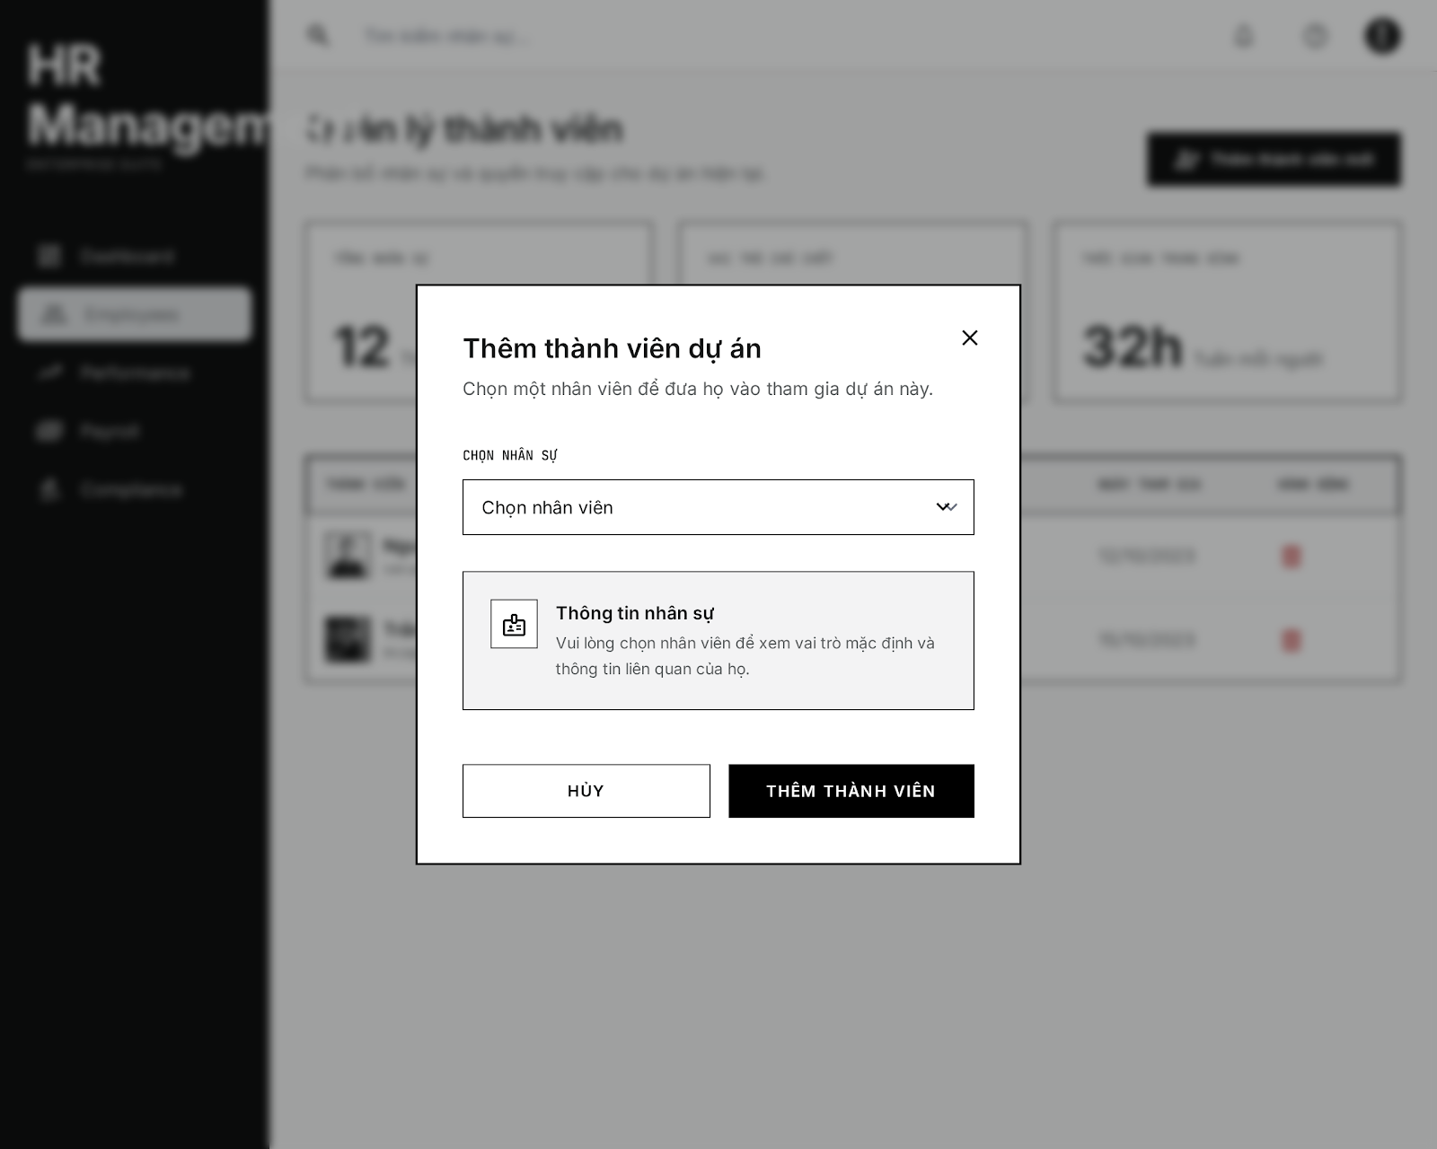

UI Elements:
Field Name | Field Type | Description
Chọn nhân sự | Dropdown Select | Search and select an active employee not currently in the project.
Thông tin nhân sự | Info Box panel | Displays context role information dynamically once a member is selected.
Thêm thành viên | Button | Triggers validation and registers project membership in database.
Hủy | Button | Closes the modal dialog without saving.

Database Access:
Table | CRUD | Description
ProjectMember | C / U | Upsert member link. Re-enables membership if removedAt was set.
Employee | R | Query active employees who are not already active members of the project.

PostgreSQL (Supabase) Commands:
1/ Fetch Non-Member Active Employees:
SQL
SELECT "id", "fullName", "email", "position"
FROM "Employee"
WHERE "status" = 'active'
AND "deletedAt" IS NULL
AND "id" NOT IN (
SELECT "employeeId"
FROM "ProjectMember"
WHERE "projectId" = 'project_target_uuid_123'
AND "removedAt" IS NULL
)
ORDER BY "fullName" ASC;

2/ Add Member (Upsert Query):
SQL
INSERT INTO "ProjectMember" ("projectId", "employeeId", "joinedAt", "removedAt")
VALUES ('project_target_uuid_123', 'emp_selected_uuid_777', NOW(), NULL)
ON CONFLICT ("projectId", "employeeId")
DO UPDATE SET "removedAt" = NULL, "joinedAt" = NOW();

- UC38 Remove Member From Project
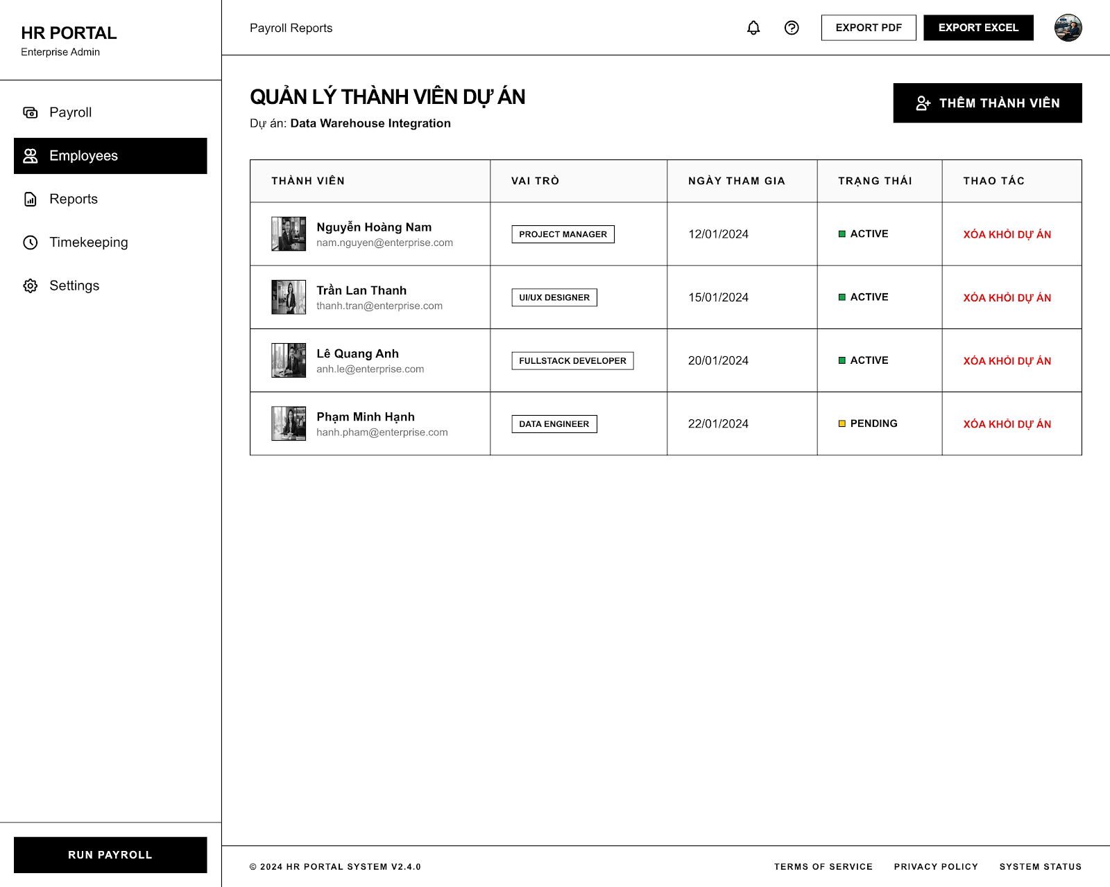

UI Elements:
Field Name | Field Type | Description
Thêm thành viên | Button | Opens the Add Member pop-up modal.
Xóa khỏi dự án (Xóa) | Link / Button | Triggers member removal confirmation dialog for the selected employee row.

Database Access:
Table | CRUD | Description
ProjectMember | R / U | Retrieve all project members and soft-delete selected memberships.
Employee | R | Retrieve employee names, emails, avatars, and default roles.

PostgreSQL (Supabase) Commands:
1/ Fetch Project Members with Roles and Status:
SELECT pm."joinedAt", pm."removedAt", e."id", e."fullName", e."email", e."position", e."status"
FROM "ProjectMember" pm
INNER JOIN "Employee" e ON pm."employeeId" = e."id"
WHERE pm."projectId" = 'project_target_uuid_123'
AND pm."removedAt" IS NULL;

2/ Soft Delete Member:
UPDATE "ProjectMember"
SET "removedAt" = NOW()
WHERE "projectId" = 'project_target_uuid_123'
AND "employeeId" = 'emp_target_uuid_to_remove';

6. Task Management Feature

6.1 Task Board Screen
Related UC:
- UC40 Create Task
UI Design:
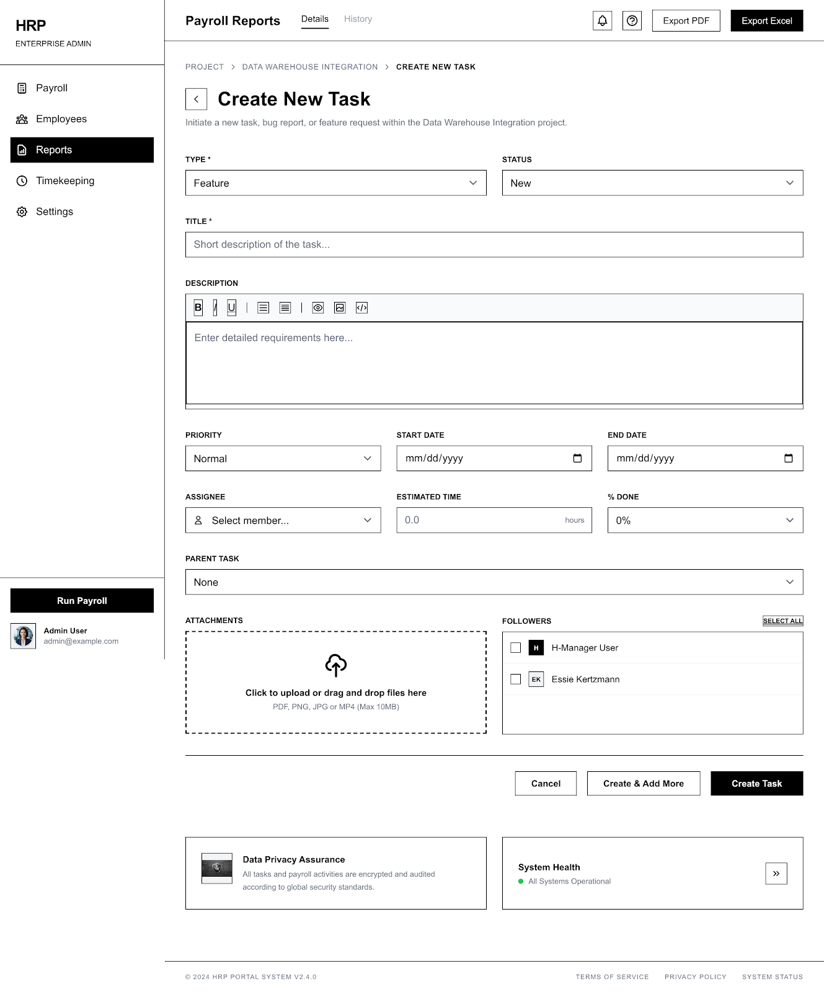

UI Elements:
Field Name | Field Type | Description
LOẠI YÊU CẦU * | Dropdown Select | Selects Tracker: feature ("Tính năng"), bug, etc.
TRẠNG THÁI | Dropdown Select | Selects TaskStatus: todo ("Đang mở"), etc.
TIÊU ĐỀ * | Text Box | Input task name title.
MÔ TẢ | Rich Text Editor | Inputs detailed task descriptions.
ĐỘ ƯU TIÊN | Dropdown Select | Selects Priority: low, medium ("Bình thường"), high, urgent.
NGÀY BẮT ĐẦU | Date Picker | Sets task start date.
HẠN HOÀN THÀNH | Date Picker | Sets task due date.
NGƯỜI THỰC HIỆN | Dropdown Select | Assigns a member from the project.
THỜI GIAN ƯỚC TÍNH | Number Box | Estimated hours (e.g. 0.0).
% HOÀN THÀNH | Dropdown Select | Progress indicator (defaults to 0 %).
CÔNG VIỆC CHA | Dropdown Select | Links a parent task if creating a subtask.
TÀI LIỆU ĐÍNH KÈM | File Upload Zone | Upload files up to 10MB.
Tạo công việc (Tạo) | Button | Saves the task and returns to the board.
Tạo và thêm tiếp | Button | Saves the task and clears inputs to allow creating another task.
Hủy | Button | Discards inputs and closes form.

Database Access:
Table | CRUD | Description
Task | C | Insert new task row.
ProjectMember | R | Fetch members for assignee selection list.

PostgreSQL (Supabase) Commands:
1/ Save Task:
INSERT INTO "Task" (
"id", "projectId", "title", "description", "tracker",
"priority", "status", "assigneeId", "createdById",
"dueDate", "estimatedTime", "progress", "createdAt", "updatedAt"
) VALUES (
'cuid_task_uuid_101', 'project_target_uuid_123', 'Implement Auth Middleware',
'Secure the routing with JWT token checks', 'feature',
'medium', 'todo', 'emp_developer_id_888', 'emp_creator_id_456',
'2026-06-30 23:59:59', 8.0, 0, NOW(), NOW()
);

- UC41 Modify Task
UI Design:
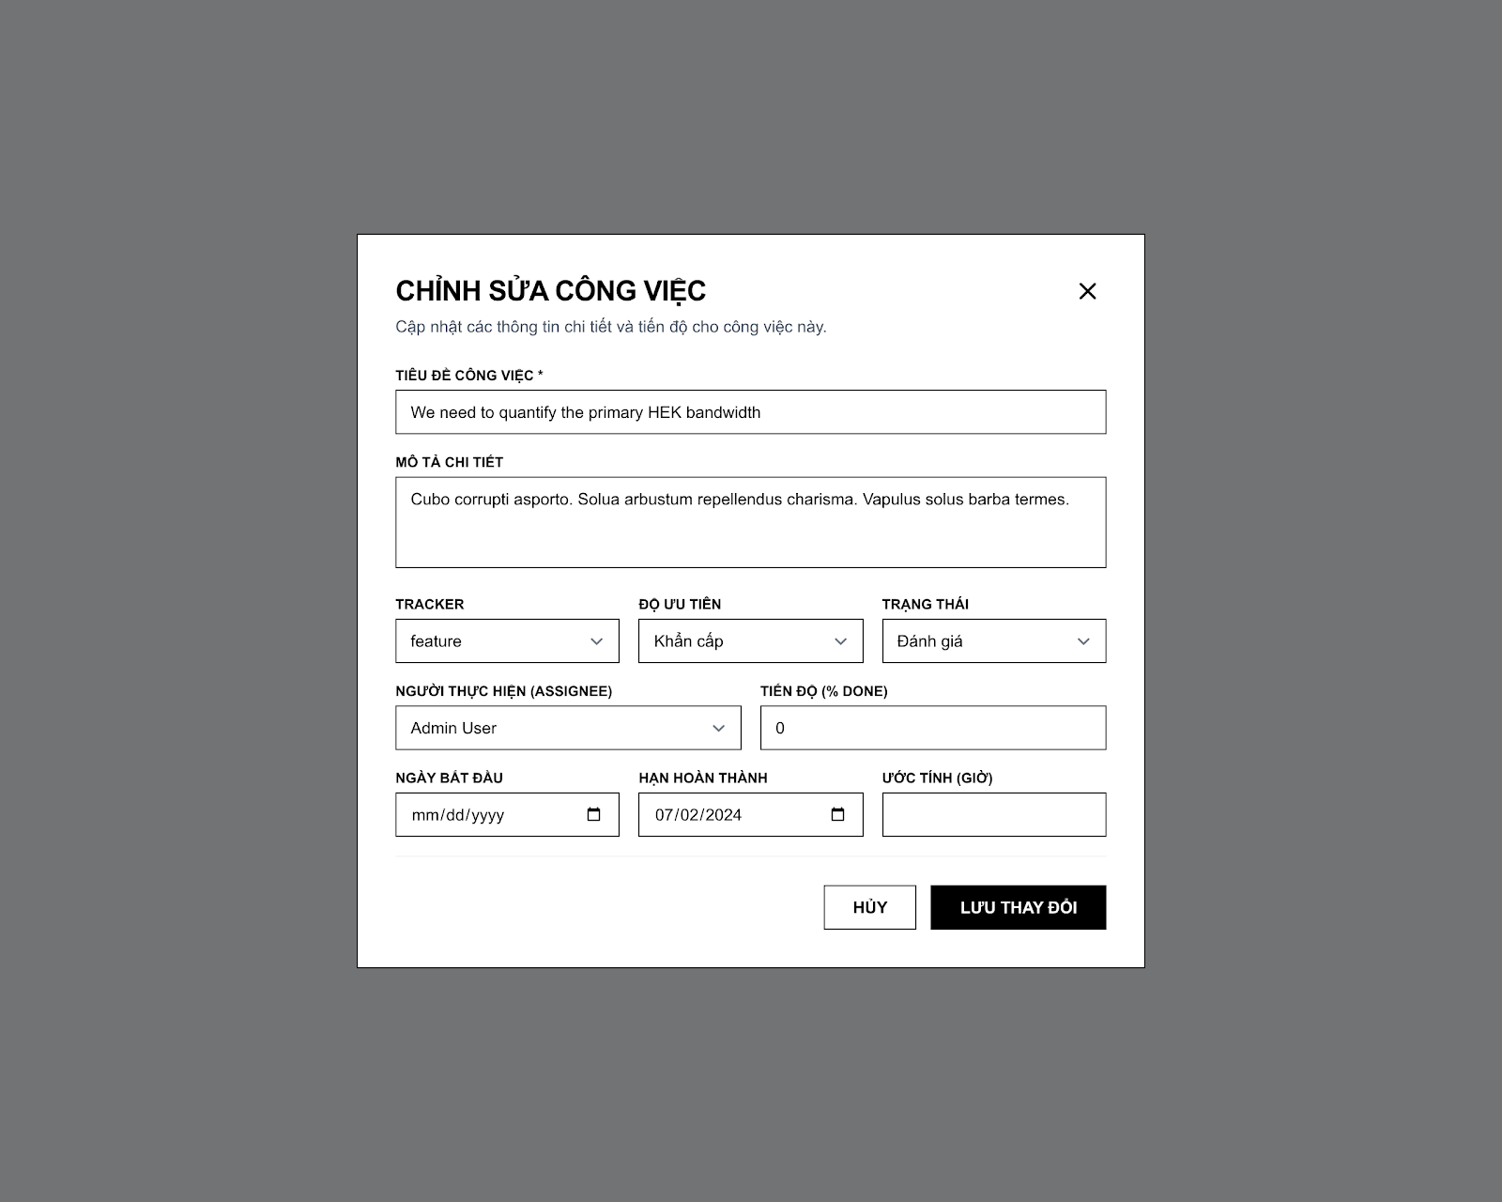

UI Elements:
Field Name | Field Type | Description
Tiêu đề công việc * | Text Box | Edits task title.
Mô tả chi tiết | Text Area | Edits task description.
Tracker | Dropdown Select | Selects category: feature, bug, etc.
Độ ưu tiên | Dropdown Select | Selects priority: low, medium, high, urgent ("Khẩn cấp").
Trạng thái | Dropdown Select | Selects status: todo, in_progress ("Đang làm"), in_review ("Đánh giá"), done ("Hoàn thành"), etc.
Người thực hiện (Assignee) | Dropdown Select | Selects assignee.
Tiến độ (% Done) | Number Input | Input progress value (0 to 100).
Ngày bắt đầu | Date Picker | Edits start date.
Hạn hoàn thành | Date Picker | Edits due date.
Ước tính (Giờ) | Number Input | Edits estimate.
Lưu thay đổi | Button | Saves updates and registers activity.
Hủy | Button | Closes modal discarding changes.

Database Access:
Table | CRUD | Description
Task | U | Update target task row attributes.

PostgreSQL (Supabase) Commands:
1/ Save Updated Task Details:
SQL
UPDATE "Task"
SET
"title" = 'We need to quantify the primary HEX bandwidth!',
"description" = 'Cubo corrupti asporto. Solus arbustum repellendus charisma...',
"tracker" = 'feature',
"priority" = 'urgent',
"status" = 'in_review',
"assigneeId" = 'emp_admin_user_uuid',
"progress" = 0,
"dueDate" = '2026-07-02 00:00:00',
"estimatedTime" = NULL,
"updatedAt" = NOW()
WHERE "id" = 'cuid_task_uuid_101';

- UC42 Delete Task
UI Design:

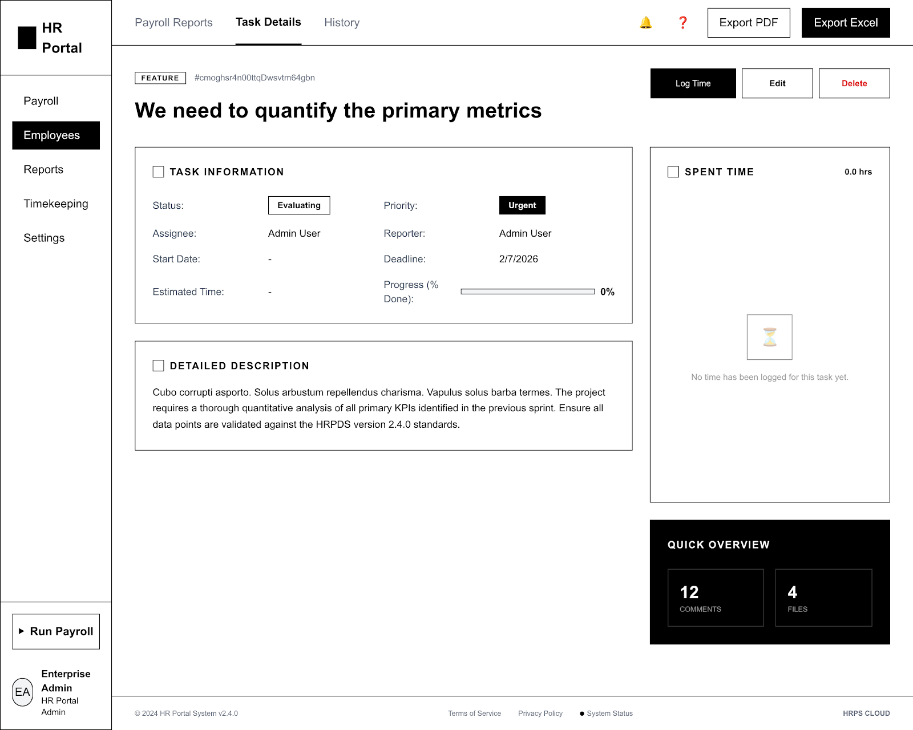

UI Elements:
Field Name | Field Type | Description
Ghi nhận thời gian | Button | Opens Log Time modal popup dialog.
Chỉnh sửa | Button | Opens Modify Task Modal.
Xóa công việc | Button | Triggers confirmation dialog to permanently delete the task.
Confirm Delete | Button | Deletes task from database permanently.
Cancel | Button | Closes dialog without deletion.

Database Access:
Table | CRUD | Description
Task | R / D | Query task details or delete task record.
SpentTime | R / D | Retrieve time logs or cascade-delete time logs when task is deleted.

PostgreSQL (Supabase) Commands:
1/ Delete Task from Database (Cascades SpentTime deletion):
DELETE FROM "Task"
WHERE "id" = 'cuid_task_uuid_101';

- UC43 View Project Tasks
UI Design:
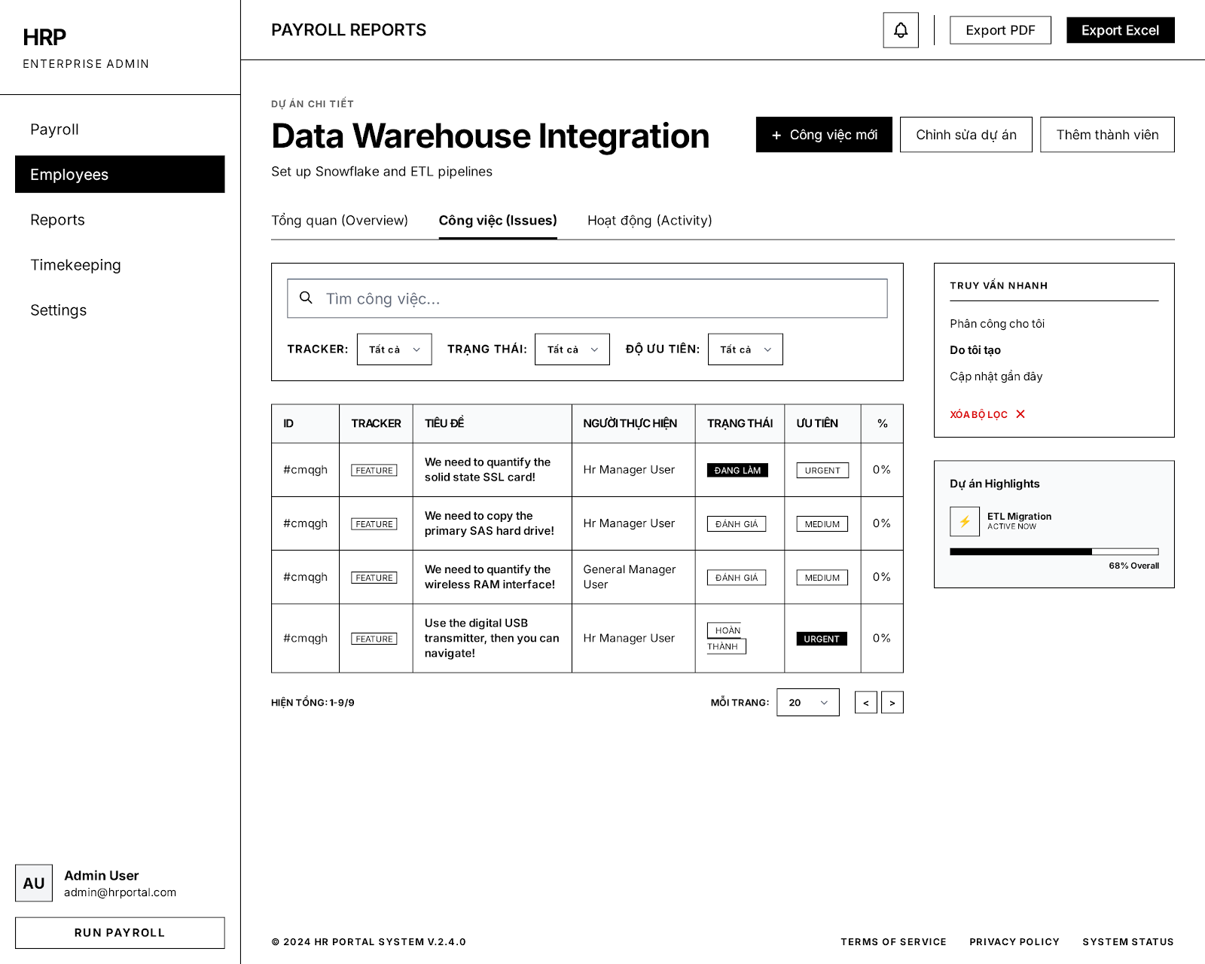

UI Elements:
Field Name | Field Type | Description
Tìm công việc... | Text Box | Filters tasks dynamically by search keywords matched against titles/descriptions.
Tracker | Dropdown Filter | Filters list by task category (feature, bug, etc.).
Trạng thái | Dropdown Filter | Filters list by status (todo, in_progress, etc.).
Độ ưu tiên | Dropdown Filter | Filters list by priority (low, medium, high, urgent).
ID / Tracker / Tiêu đề | Table Columns | Double-click or click a row to view task details.
Công việc mới | Button | Navigates the user to the Create Task Screen.

Database Access:
Table | CRUD | Description
Task | R | Retrieve all tasks linked to the project ID.
Employee | R | Join employee table to display assignee name and avatar.

PostgreSQL (Supabase) Commands:
1/ Fetch Project Tasks with Filtering:
SQL
SELECT t.*, e."fullName" AS "assigneeName", e."avatarUrl" AS "assigneeAvatar"
FROM "Task" t
LEFT JOIN "Employee" e ON t."assigneeId" = e."id"
WHERE t."projectId" = 'project_target_uuid_123'
AND t."title" ILIKE '%search_term%'
AND t."tracker" = 'feature' -- Optional filters
AND t."status" = 'in_progress'
ORDER BY t."createdAt" DESC
LIMIT 25 OFFSET 0;

IV. Appendix

1. Assumptions & Dependencies
Assumptions (AS):
AS-1 (User Session Security): Users have valid credentials and their active sessions are maintained securely by the React frontend via HTTP-only cookies containing JWT tokens.
AS-2 (GPS Accuracy & Geofencing): Employees checking in/out have mobile or browser GPS active, and the coordinates are accurate within a 500-meter radius around the geofence center (FPT University Da Nang campus).
AS-3 (Initial Credentials Delivery): When a new employee account is registered, their initial temporary password is communicated securely via an offline channel.
AS-4 (Email Delivery Service): The external SMTP/email relay service is operational, enabling password reset requests to deliver valid 15-minute tokens securely.
AS-5 (Preconfigured Policies): Attendance shift templates, leave quotas, overtime policies, and approval workflows are preconfigured in the database before employees submit forms.
AS-6 (AI Model Availability): The TaskEstimateAI functionality has continuous local access to the 9Router proxy at http://localhost:20128/v1 or online access to the Google Gemini API.
AS-7 (Project Team Membership): Tasks in a project can only be assigned to employees who are active members of that project. Removing a member does not purge historical work logs but prevents future assignments.
Dependencies (DE):
DE-1 (Vite & React 19 Frontend): The frontend relies on React 19, Vite 8, Zustand/React Query state management, and the router-navigator singleton for smooth navigation.
DE-2 (Express 5 & Bun Backend): The backend requires the Bun runtime environment and Express 5 for executing business logic and handling HTTP endpoints.
DE-3 (Supabase / PostgreSQL Database): Relies on a PostgreSQL database instance hosted on Supabase, which must maintain high availability for CRUD transactions.
DE-4 (9Router / Gemini API): The AI matchmaking algorithm and project task generation rely on external LLM availability (9Router proxy or Google Gemini API).
DE-5 (Cloudinary Storage): Employee profile avatar uploads are dependent on the Cloudinary API.

2. Limitations & Exclusions
LE-1 (Virtual Biometrics): The fingerprint check-in feature (UC16 Fingerprint) does not connect to physical biometric hardware. Check-in is simulated via software buttons on the virtual fingerprint scanner screen.
LE-2 (No Bank Gateway Integration): Payroll calculations and payslips are generated within the app, but no direct integration with banks (e.g., NAPAS, bank APIs) exists to automate money transfers. Payments must be processed manually.
LE-3 (Static Geofencing Configuration): The geofence coordinates and radius (500m) are defined as constants in the backend codebase (attendance.config.ts) and cannot be modified dynamically through the UI.
LE-4 (Manual Kanban Synchronization): The Kanban task board does not support real-time WebSocket pushes. Updates made by other users are reflected upon page reload or route transition.
LE-5 (Static Compensation Multipliers): Overtime multipliers (1.5x) and monthly work hour divisors (176h) are defined in backend config files (project.config.ts) rather than through a dynamic policy builder UI.
LE-6 (No Government Tax API Integration): Tax calculations (PIT, social insurance, etc.) are computed using basic static formulas in code rather than syncing with national tax department APIs.

3. Business Rules

ID | Category | Rule Definition
BR-AUTH-01 | Authentication | Active Account Only: Only employees with active status are permitted to log in. Inactive or deactivated accounts must be blocked.
BR-AUTH-02 | Security | Password Hashing: Passwords must be securely stored in the database using the bcrypt hashing algorithm on the backend.
BR-AUTH-03 | Authentication | JWT Token-based Auth: Authentication relies on Access Tokens (15-min TTL) and Refresh Tokens (7-day TTL) transported securely in HTTP-only cookies.
BR-AUTH-04 | Security | Account Lockout: Accounts are locked for 5 minutes after 5 consecutive failed login attempts to prevent brute-force attacks.
BR-AUTH-05 | Session | Session Termination: Logging out must invalidate the current session, clear tokens from cookies, and blacklist the active JWT.
BR-AUTH-06 | Security | Reset Token Expiration: Password reset tokens sent to registered emails expire exactly after 15 minutes.
BR-AUTH-07 | Security | Password Reuse Restriction: A newly reset password must be different from the employee's current password.
BR-AUTH-08 | Security | Email Enumeration Protection: During password recovery, the system must not reveal whether the entered email address exists in the system.
BR-AUTH-09 | Security | Single Active Reset Request: Only one pending password reset request is allowed per employee at any given time.
BR-AUTH-10 | Security | Password Complexity: Passwords must satisfy minimum security requirements (minimum 8 characters, containing uppercase, lowercase, digits, and special characters).
BR-AUTH-11 | Authorization | Authorized Role Assignment: Only users with the Administrator role can assign roles (HR Manager, Team Leader, Employee) to accounts.
BR-AUTH-12 | Security | Audit Logging: Every role assignment and revocation must be logged in the security audit database with details.
BR-AUTH-13 | Authorization | Authorized Role Revocation: Only users with the Administrator role can revoke roles from user accounts.
BR-AUTH-14 | Authorization | Permission Update Propagation: Revoking or changing a role must invalidate active sessions and take effect immediately.
BR-SEC-01 | Security | Activity Logging: Every authentication attempt (successful or failed) must be logged with timestamp, IP, and user agent.
BR-SEC-02 | Security | Suspicious Activity Alerts: Consecutive failed login attempts or access from unusual patterns must generate security alerts for Administrators.
BR-EMP-01 | Constraints | Unique Credentials: Fields like username, email, phone number, and national ID must be unique across all active and inactive employees.
BR-EMP-02 | Audit | Profile Change Logs: Role changes and critical field modifications in an employee's profile must be recorded in the audit trail.
BR-EMP-03 | Constraints | Offboarding Policy: Employees cannot be deactivated (soft deleted) if they have unresolved assets or are currently assigned as the sole Team Leader of an active project.
BR-EMP-04 | Constraints | Resignation Notice Period: The proposed last working day for a resignation request must satisfy the minimum notice period (e.g., 30 or 45 days) based on employment contract type.
BR-ATT-01 | Constraints | Mandatory GPS Check-in: To register check-in/out, employees must be within the geofence range of 500 meters from the FPT University Da Nang campus (Latitude: 15.96751, Longitude: 108.26052).
BR-ATT-02 | Constraints | Check-in Grace Period: A grace period of 5 minutes is allowed for shifts (e.g. check-in up to 5 minutes late without penalty).
BR-ATT-03 | Constraints | Leave Balance Limit: Employees cannot submit leave requests that exceed their remaining accrued leave balance.
BR-ATT-04 | Constraints | Overtime Hours Cap: Overtime requests must not exceed the daily and monthly overtime hour limits defined by company policy.
BR-ATT-05 | Constraints | Remote Work Eligibility: Remote work requests are subject to approval. By default, employees work onsite; remote work requires approved remote forms.
BR-ATT-06 | Constraints | Future Shift Change Restrictions: Shift change requests must be submitted only for future scheduled shifts.
BR-ATT-07 | Constraints | Late Arrival / Early Departure Limits: Arrival/departure adjustments must fall within company limits (e.g. max 120 minutes from shift start/end).
BR-APP-01 | Validation | Form Completion: All required fields (dates, reasons, types) must be filled before submitting leave, overtime, or shift requests.
BR-PAY-01 | Authorization | Payroll Access Control: Only the HR Manager or Payroll Admin roles can view, calculate, or export monthly payroll reports.
BR-PAY-02 | Authorization | Payroll Approval Authority: The generated payroll must be approved by the General Manager before finalizing and issuing payslips.
BR-PAY-03 | Constraints | Unique Template Name: Salary template names must be unique within the system to avoid calculation confusion.
BR-PAY-04 | Constraints | Template Modification Lock: A salary template cannot be edited if it is referenced by an active, unfinalized payroll cycle.
BR-PAY-05 | Constraints | Trigger Schedule Conflict: Payroll execution cannot be scheduled if there is already an active run queued for the same period.
BR-PAY-06 | Computations | Standard Salary Base: The default monthly working hours divisor is 176 hours for standard salary calculations.
BR-PAY-07 | Computations | Overtime Multiplier: Overtime hours are compensated at a rate of 1.5x the standard hourly salary.
BR-PROJ-01 | Constraints | Unique Project Name: Project names must be unique within the system.
BR-PROJ-02 | Constraints | Valid Team Leader: Only active employees can be assigned as the Team Leader of a project.
BR-PROJ-03 | Constraints | Project Status Transition: Project statuses must follow standard flows. Completing a project auto-sets the Actual End Date.
BR-PROJ-04 | Constraints | Team Leader Retention: A Project Team Leader cannot be removed from an active project unless another active Team Leader is assigned.
BR-PROJ-05 | Authorization | Project Access Restriction: Only assigned project members or management roles (General Manager, Admin) can view project details and tasks.
BR-TASK-01 | Constraints | Assignee Membership: A task can only be assigned to active employees who are members of that specific project.
BR-TASK-02 | Constraints | Task Status Transitions: Tasks must follow standard Kanban column flows (To Do -> In Progress -> In Review -> Done).
BR-TASK-03 | Validation | Progress Percentage: Task progress values must strictly fall between 0% and 100%.
BR-TASK-04 | Constraints | Time Log Cascade Delete: Deleting a task will automatically cascade delete all associated spent time logs.
BR-TASK-05 | Validation | Tracker & Priority Enums: Tasks must map to valid tracker enums (feature, task, support, test) and priority levels (low, medium, high, urgent).
BR-TASK-06 | Constraints | Enforce Estimate Cap: Logged spent hours on a task cannot exceed the initial estimated time.

