

Software Design Specification
Integrated HR and Project Management System
(HRP Management System)
Version: 1.0

– 16 July, 2026 –
Table of Contents
I. Overview 4
1. Code Packages 4
2. Database Design 5
a. Database Schema 5
b. Table Description 10
II. Code Designs 12
1. Personal Module 12
1.1 Feature Personal Work Schedule 12
1.2 Feature Part-time Availability Registration 14
1.3 Feature Personal Payslip 16
1.4 Feature Personal Projects 18
1.5 Feature Personal Applications 24
2. Human Resource Management Module 26
2.1 Feature Employee Profile Management 26
2.2 Feature Personal Profile Information 29
2.3 Feature System Activity Logs 38
2.4 Feature System Security Overview 39
2.5 Feature Login History 43
3. Application Module 47
3.1 Feature Application Approval and Management 47
3.2 Feature Create New Application 49
4. Attendance Module 51
4.1 Feature Attendance Dashboard 51
4.2 Feature Attendance Summary 53
4.3 Feature General Work Schedule 54
4.4 Feature Part-time Availability Shift Scheduling 57
4.5 Feature Weekly Shift Schedule 59
4.6 Feature Weekly Default Shift Configuration 60
4.7 Feature Actual Work Shifts 62
4.8 Feature Shift List Management 64
4.9 Feature Holiday Management 66
5. Payroll Module 68
5.1 Feature Payroll Period Management 68
5.2 Feature Salary Component Management 70
5.3 Feature Payroll Variable Management 72
5.4 Feature Payslip Template Management 74
5.5 Feature Payroll Cycle Management 76
5.6 Feature Employee Salary Management 78
6. Project Module 80
6.1 Feature Project List 80
6.2 Feature Project Details 89
6.3 Feature Create New Task 98
6.4 Feature Task Details 104
7. Settings and Authorization Module 110
7.1 Feature System Configuration Overview 110
7.2 Feature Role Management 114
7.3 Feature Role Permission Configuration 122
7.4 Feature Permission Matrix 129
7.5 Feature Project Position Management 135
7.6 Feature User Management 139
8. Recruitment Module 144
8.1 Feature: Job Requisition & Approval 144
8.2 Feature Job Postings & Candidate Intake 147
8.3 Feature Candidate Application & Kanban Tracking 151
8.4 Feature Interview Scheduling & Evaluation 155
8.5 Feature Interview Scheduling & Evaluation 158
9. Authentication and System Module 162
9.1 Feature Login 162
9.2 Feature Password Reset 171
9.3 Feature 404 Error Page (Page Not Found) 181

I. Overview

1. Code Packages
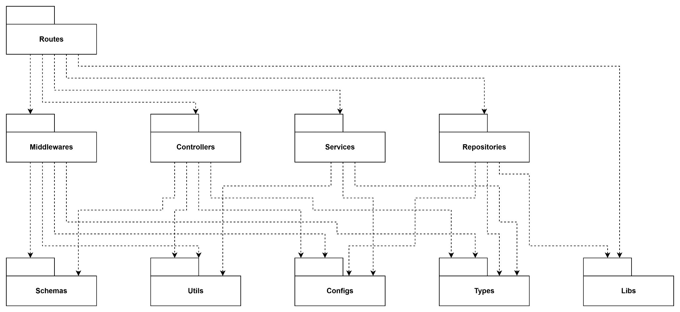

Package descriptions
# | Package | Description
1 | Routes | The outermost layer and API entry point. Defines URLs, HTTP methods, and routes requests to the appropriate Middlewares and Controllers.
2 | Middlewares | The "checkpoints" intercepting requests before Controllers. Responsible for authentication, authorization, centralized error handling, and calling Schemas for input validation.
3 | Controllers | The HTTP adapter layer. Receives requests, extracts data, calls Services to execute business logic, and formats the HTTP response to return to the client.
4 | Services | The core business logic layer. Executes business rules, calculations, and orchestrates data flow by interacting with Repositories.
5 | Repositories | The data access layer. Responsible for direct communication with the database (via Libs), hiding database implementation details from the Services layer.
6 | Schemas | Defines data validation schemas (e.g., using Zod) to ensure the integrity and validity of incoming and outgoing data.
7 | Utils | Contains shared, independent helper functions (pure functions) such as password hashing, JWT processing, date formatting, and string manipulation.
8 | Configs | Centralized storage for system configurations: environment variables, connection strings, and especially business constants/enums to prevent hardcoding.
9 | Types | Contains static type definitions (TypeScript Interfaces, Types), Data Transfer Objects (DTOs), and Contracts to ensure Type Safety across the entire system.
10 | Libs | Wrapper layer for third-party libraries. Initializes and configures external SDKs (e.g., Database clients) to isolate them from the core application logic.

2. Database Design

a. Database Schema

Module 1: Human Resources & Core System Management
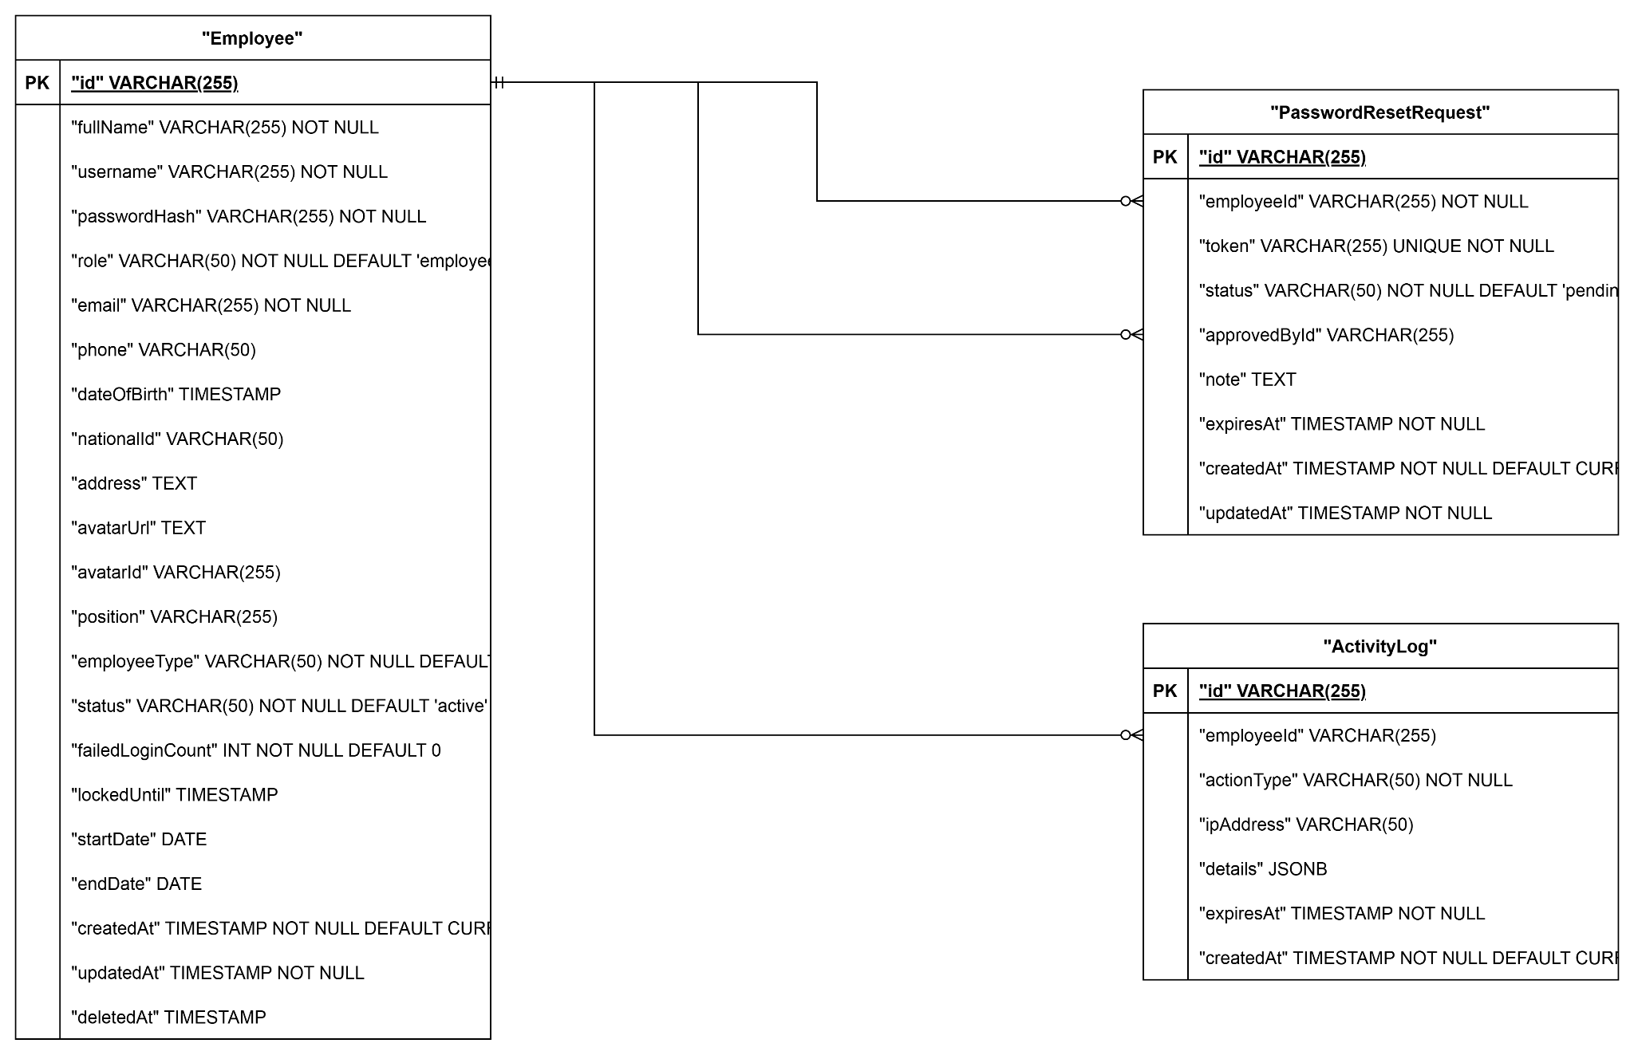

Module 2: Attendance & Shifts
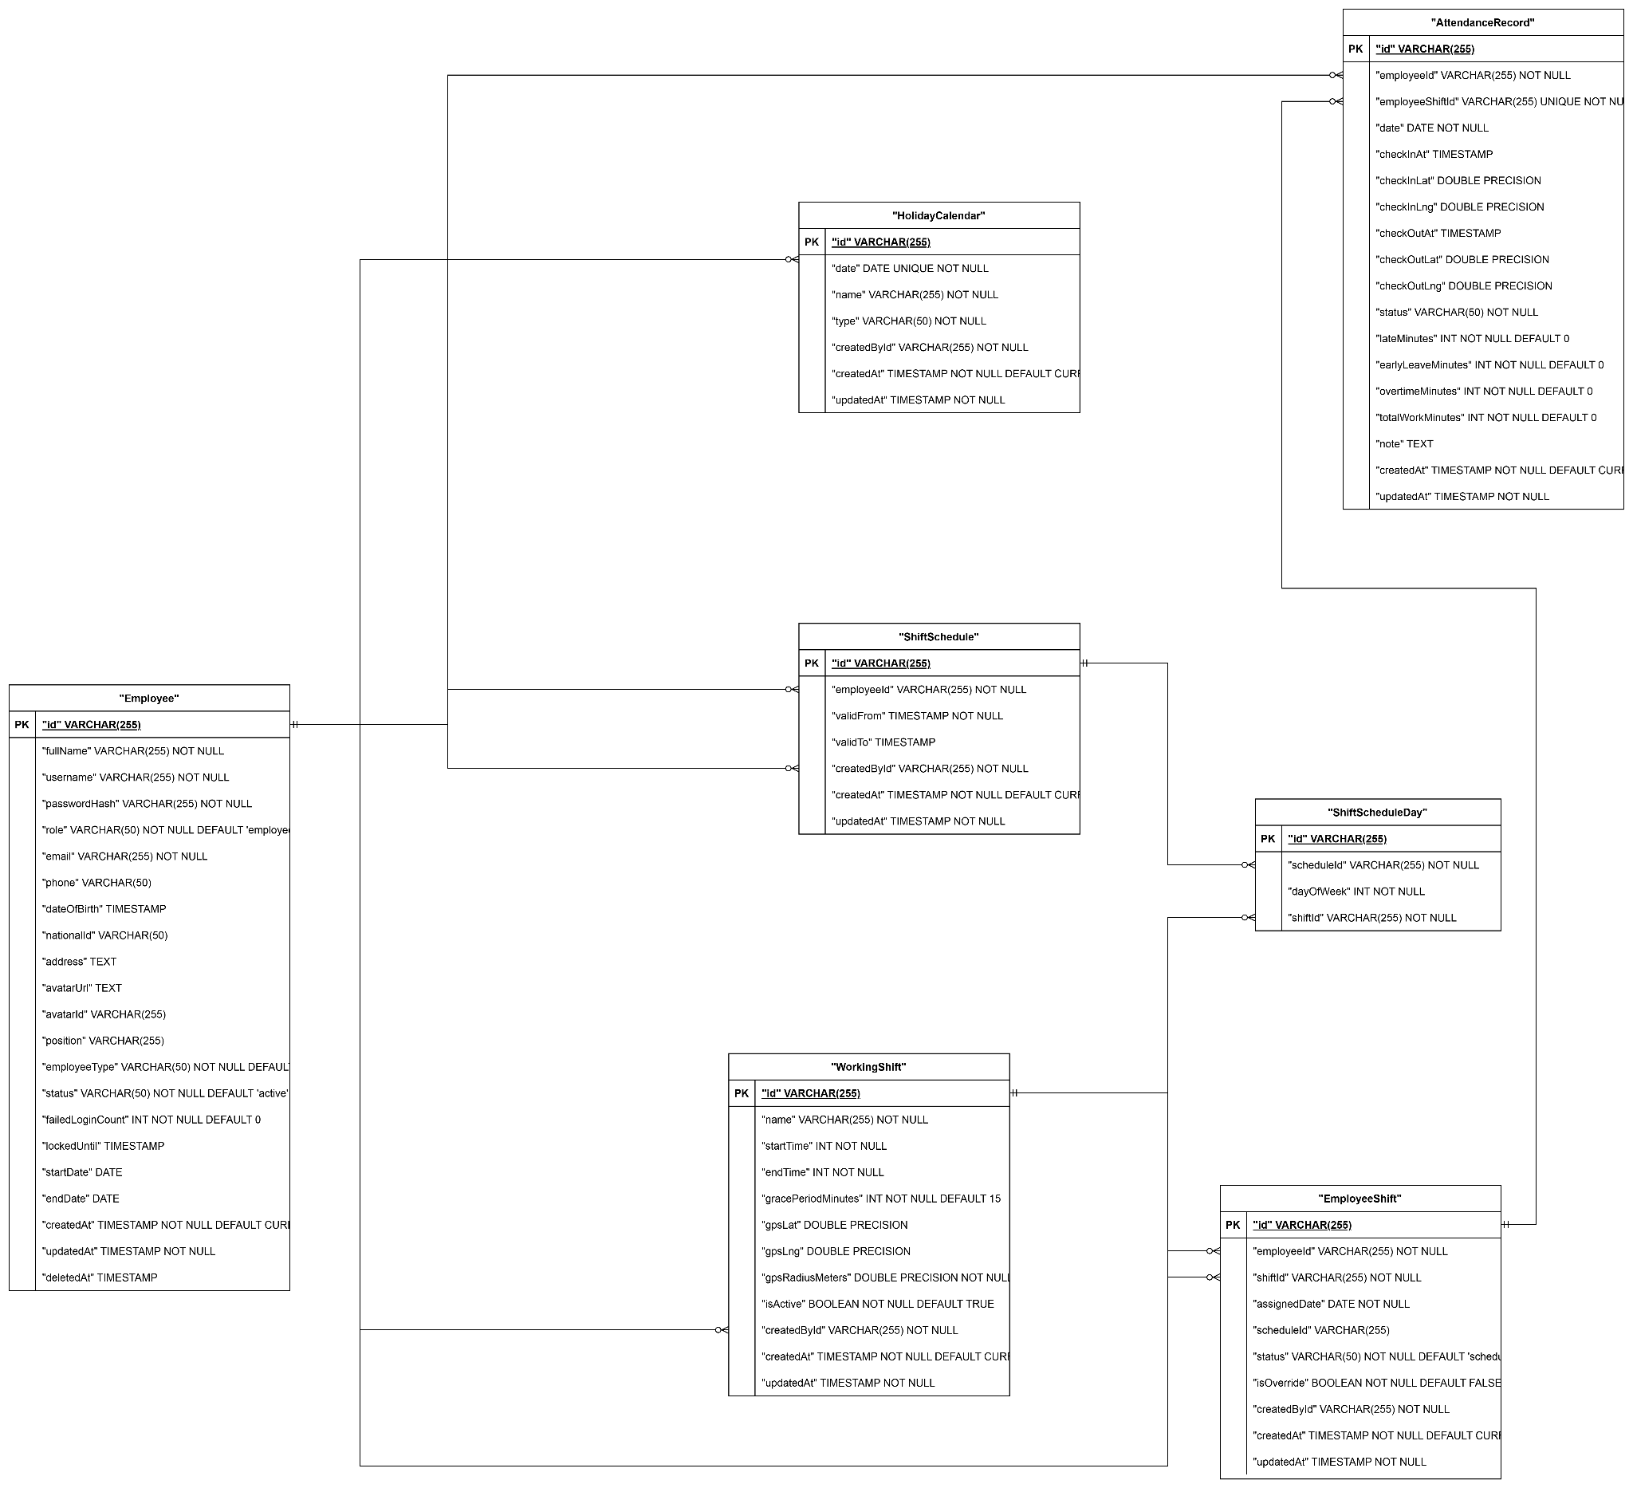

Module 3: Request & Approval Management
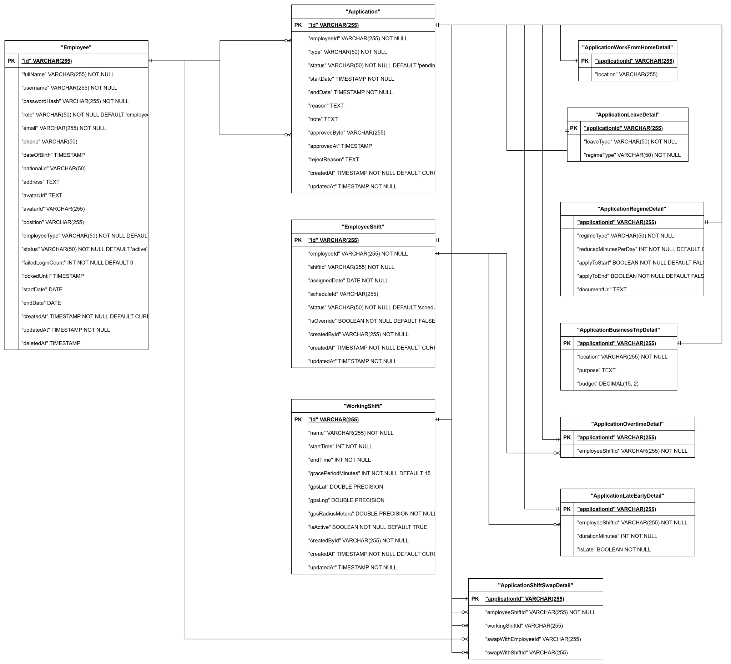

Module 4:Salary Configuration & Payroll Management

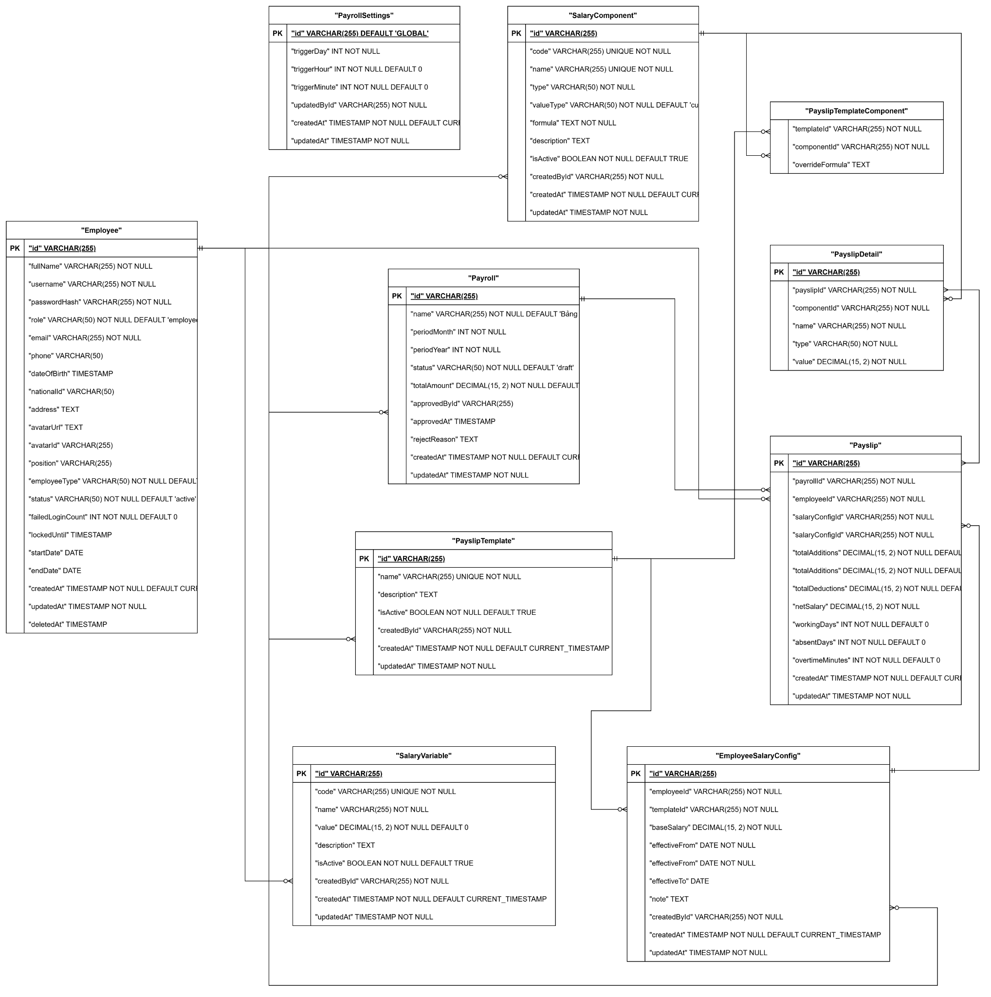

Module 5: Project & Task Management (Projects & Tasks)
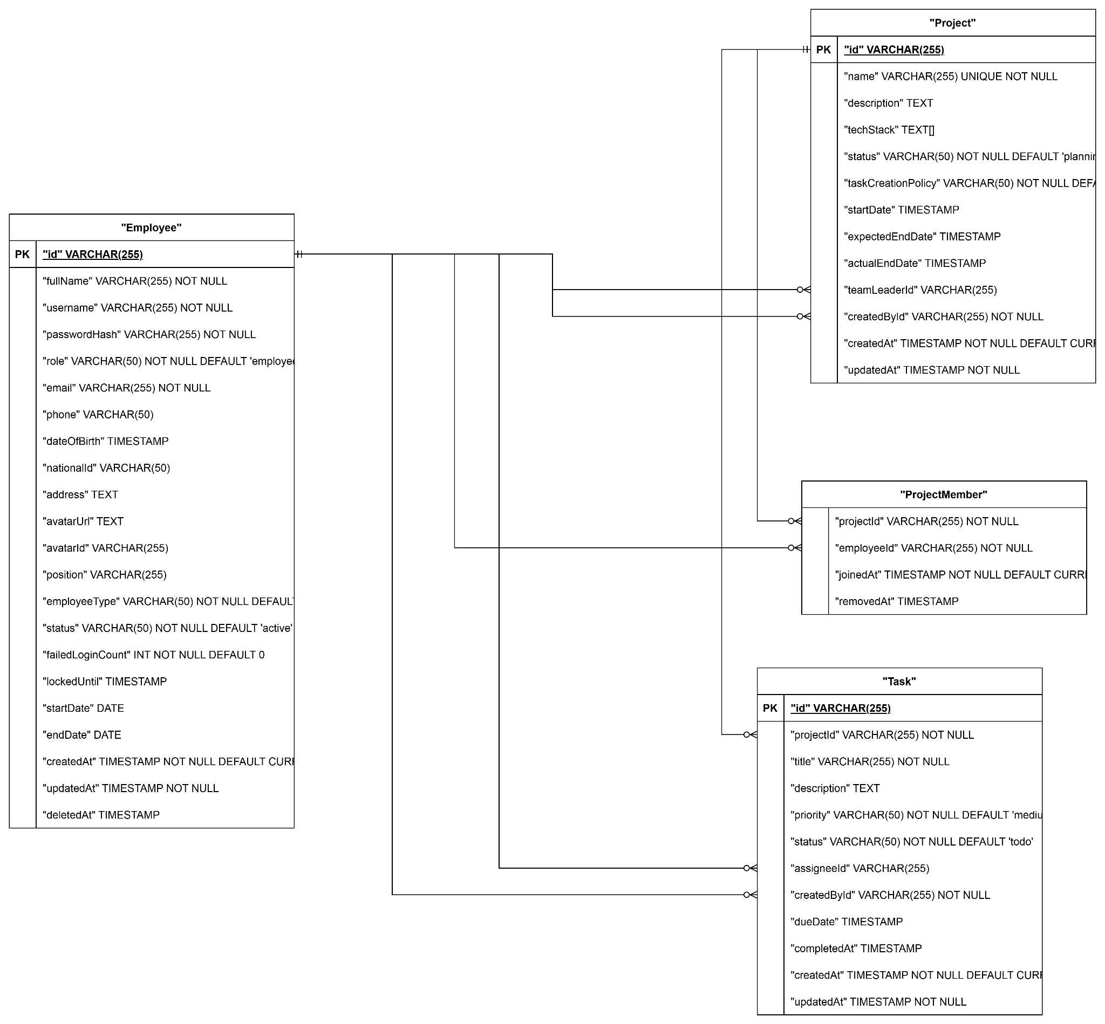

b. Table Description
# | Table | Description
01 | Employee | Stores employee personal and employment information. - Primary keys: employee_id - Foreign keys: role_id (Role)
02 | Role | Defines system roles (Employee, Team Leader, HR Manager, General Manager, Administrator). - Primary keys: role_id
03 | Permission | Defines granular permissions assignable to roles. - Primary keys: permission_id
04 | RolePermission | Junction table mapping roles to permissions. - Primary keys: role_id, permission_id - Foreign keys: role_id, permission_id
05 | Attendance | Records employee check-in/check-out events from fingerprint device. - Primary keys: attendance_id - Foreign keys: employee_id
06 | WorkingShift | Defines working shift schedules. - Primary keys: shift_id
07 | ApplicationForm | Stores leave, overtime, remote, shift change, and regime application forms. - Primary keys: form_id - Foreign keys: employee_id, approver_id
08 | SalaryComponent | Stores salary components such as base pay, bonuses, allowances, deductions. - Primary keys: component_id
09 | SalaryTemplate | Defines salary calculation templates. - Primary keys: template_id
10 | Payroll | Stores generated payroll records per period. - Primary keys: payroll_id - Foreign keys: template_id, approved_by
11 | Payslip | Individual employee payslip for each payroll period. - Primary keys: payslip_id - Foreign keys: payroll_id, employee_id
12 | RecruitmentPosting | Stores job postings for open positions. - Primary keys: posting_id - Foreign keys: created_by (HR Manager)
13 | Candidate | Stores applicant/candidate information. - Primary keys: candidate_id - Foreign keys: posting_id
14 | InterviewSchedule | Tracks scheduled interviews for candidates. - Primary keys: interview_id - Foreign keys: candidate_id, interviewer_id
15 | Project | Stores project information. - Primary keys: project_id - Foreign keys: created_by
16 | ProjectMember | Junction table mapping employees to projects. - Primary keys: project_id, employee_id - Foreign keys: project_id, employee_id
17 | Task | Stores tasks within projects. - Primary keys: task_id - Foreign keys: project_id, assignee_id, created_by
18 | LoginActivity | Logs all login events for audit and security monitoring. - Primary keys: log_id - Foreign keys: employee_id

II. Code Designs

1. Personal Module

1.1 Feature Personal Work Schedule

a. Class Diagram
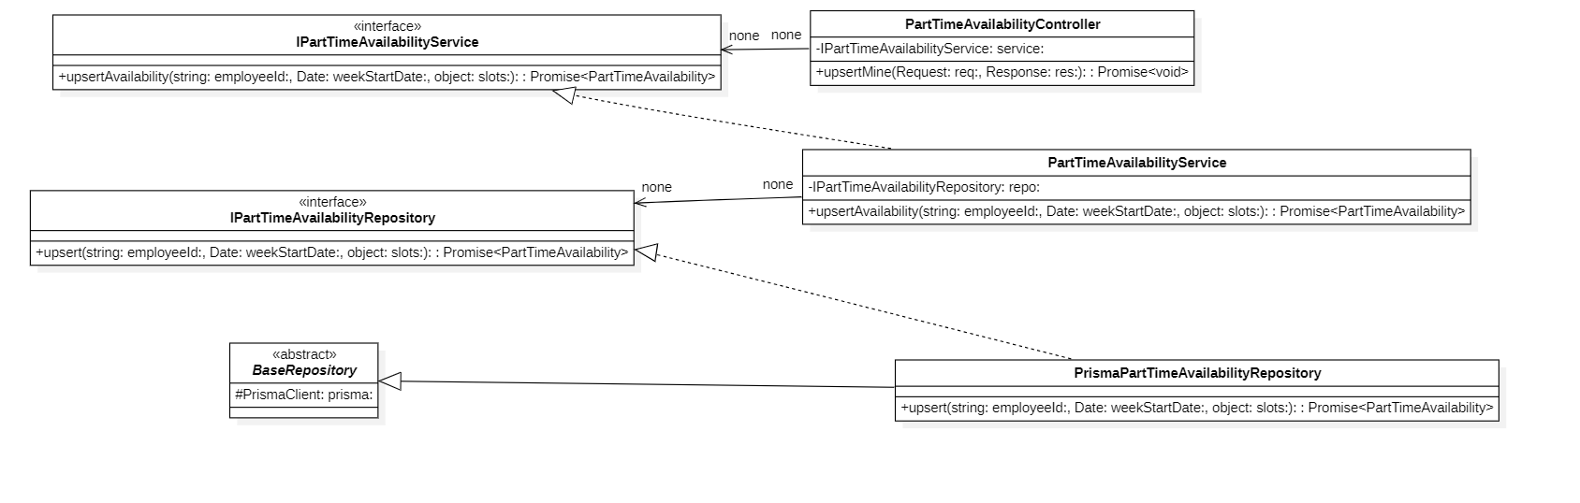

b. Class Specifications
ShiftController Class
No | Method | Description
01 | constructor(service: IShiftService) : void | Inputs: Input parameters: service: IShiftService.  Outputs: Output: void.  Processing: Initializes a new instance of the ShiftController class and injects required dependencies.

ShiftService Class
No | Method | Description
01 | constructor(shiftRepo: IWorkingShiftRepository) : void | Inputs: Input parameters: shiftRepo: IWorkingShiftRepository.  Outputs: Output: void.  Processing: Initializes a new instance of the ShiftService class and injects required dependencies.

PrismaWorkingShiftRepository Class
No | Method | Description
01 | constructor(prisma: PrismaClient) : void | Inputs: Input parameters: prisma: PrismaClient.  Outputs: Output: void.  Processing: Initializes a new instance of the PrismaWorkingShiftRepository class and injects required dependencies.

c. Sequence Diagram(s)
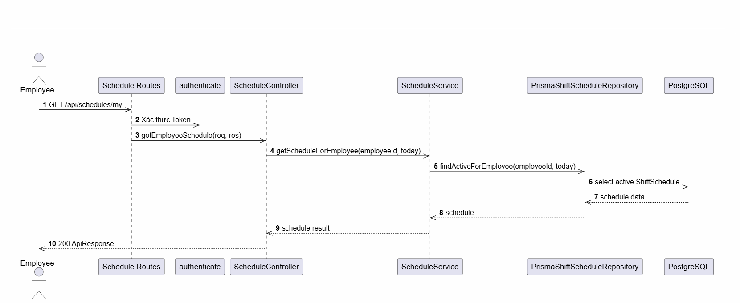

d. Database Queries
Retrieve the active recurring schedule template for an employee:
SELECT ss.*, ssd.*
FROM shift_schedules ss
LEFT JOIN shift_schedule_days ssd ON ss.id = ssd.shift_schedule_id
WHERE ss.employee_id = :employeeId
AND ss.valid_from <= :targetDate
AND (ss.valid_to IS NULL OR ss.valid_to >= :targetDate)
ORDER BY ss.valid_from DESC;
Get actual daily shift assignments or admin overrides for a specific date:
SELECT es.*, ws.*
FROM employee_shifts es
LEFT JOIN working_shifts ws ON es.shift_id = ws.id
WHERE es.employee_id = :employeeId
AND es.assigned_date = DATE(:targetDate)
ORDER BY es.is_override DESC, es.created_at ASC;

1.2 Feature Part-time Availability Registration

a. Class Diagram
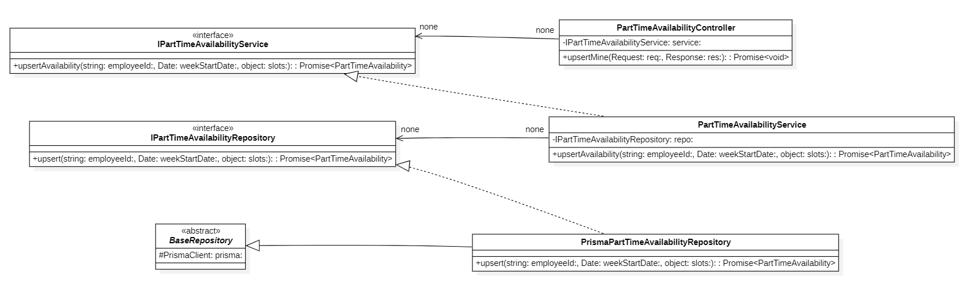

b. Class Specifications
ShiftController Class
No | Method | Description
01 | constructor(service: IShiftService) : void | Inputs: Input parameters: service: IShiftService.  Outputs: Output: void.  Processing: Initializes a new instance of the ShiftController class and injects required dependencies.

ShiftService Class
No | Method | Description
01 | constructor(shiftRepo: IWorkingShiftRepository) : void | Inputs: Input parameters: shiftRepo: IWorkingShiftRepository.  Outputs: Output: void.  Processing: Initializes a new instance of the ShiftService class and injects required dependencies.

PrismaWorkingShiftRepository Class
No | Method | Description
01 | constructor(prisma: PrismaClient) : void | Inputs: Input parameters: prisma: PrismaClient.  Outputs: Output: void.  Processing: Initializes a new instance of the PrismaWorkingShiftRepository class and injects required dependencies.

c. Sequence Diagram(s)
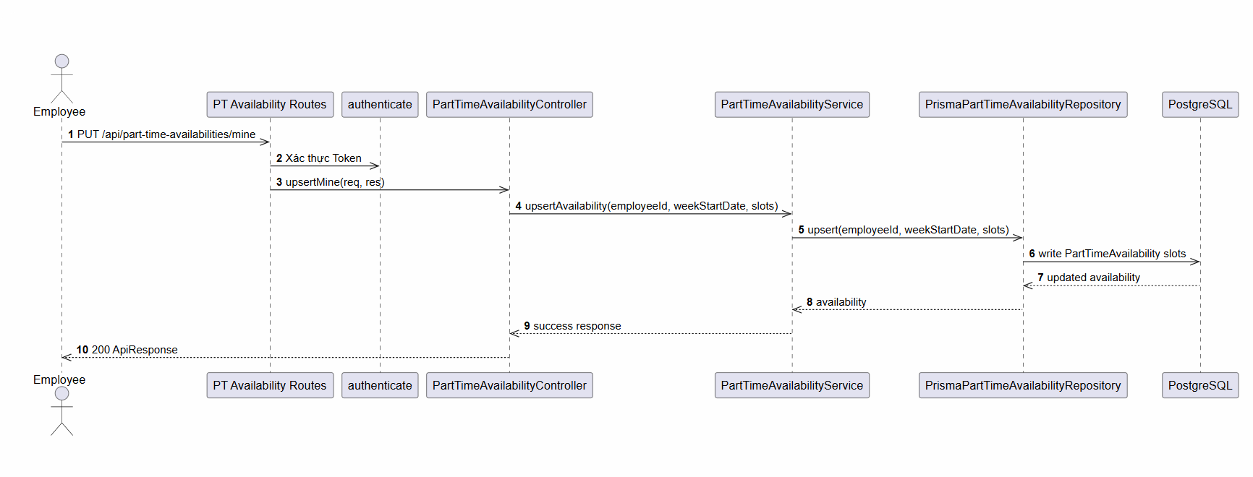

d. Database Queries
Find part-time availability registration header, days, and slots for an employee by week start (Monday):
SELECT wa.*, wad.*, was.*
FROM part_time_weekly_availabilities wa
LEFT JOIN part_time_availability_days wad ON wa.id = wad.availability_id
LEFT JOIN part_time_availability_slots was ON wad.id = was.day_id
WHERE wa.employee_id = :employeeId
AND wa.week_start = DATE(:weekStart);
Submit/upsert part-time availability (transaction flow equivalent):
-- 1. Upsert availability week header
INSERT INTO part_time_weekly_availabilities (employee_id, week_start, status, note, submitted_at)
VALUES (:employeeId, DATE(:weekStart), :status, :note, :submittedAt)
ON CONFLICT (employee_id, week_start)
DO UPDATE SET
status = EXCLUDED.status,
note = EXCLUDED.note,
submitted_at = EXCLUDED.submitted_at,
reviewed_by_id = NULL,
reviewed_at = NULL,
reject_reason = NULL
RETURNING id;

-- 2. Clear out existing days and slots for the week header ID
DELETE FROM part_time_availability_days WHERE availability_id = :availabilityId;

-- 3. Insert newly submitted availability days
INSERT INTO part_time_availability_days (availability_id, day_of_week, is_busy_all_day)
VALUES (:availabilityId, :dayOfWeek, :isBusyAllDay)
RETURNING id, day_of_week;

-- 4. Insert corresponding hours (slots) for non-busy days
INSERT INTO part_time_availability_slots (day_id, start_time, end_time, sort_order)
VALUES (:dayId, :startTime, :endTime, :sortOrder);

1.3 Feature Personal Payslip

a. Class Diagram
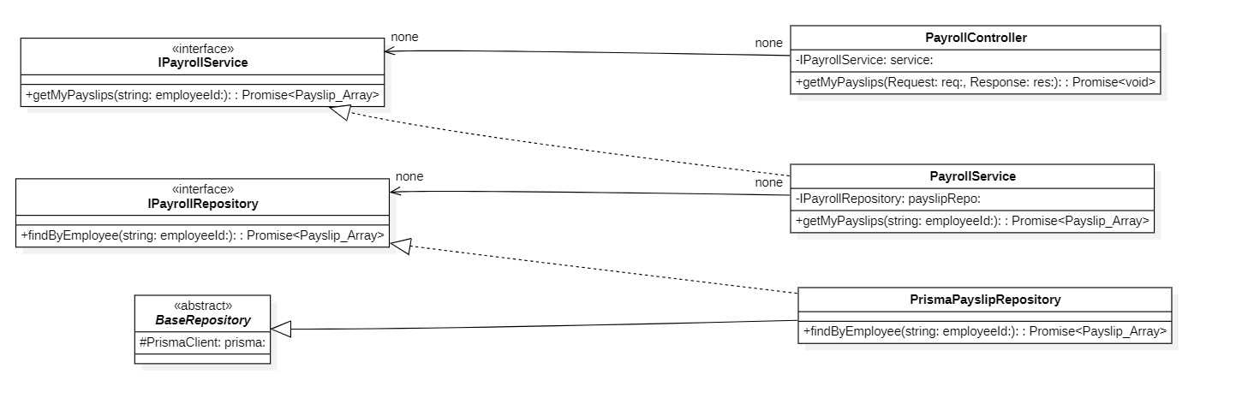

b. Class Specifications
PayrollController Class
No | Method | Description
01 | constructor(service: IPayrollService) : void | Inputs: Input parameters: service: IPayrollService.  Outputs: Output: void.  Processing: Initializes a new instance of the PayrollController class and injects required dependencies.

PayrollService Class
No | Method | Description
01 | constructor(service: IPayrollService) : void | Inputs: Input parameters: payrollRepo: IPayrollRepository, payslipRepo: IPayslipRepository, salaryConfigRepo: IEmployeeSalaryConfigRepository.  Outputs: Output: void.  Processing: Initializes a new instance of the PayrollService class and injects required dependencies.

PrismaPayslipRepository Class
No | Method | Description
01 | constructor(prisma: PrismaClient) : void | Inputs: Input parameters: prisma: PrismaClient.  Outputs: Output: void.  Processing: Initializes a new instance of the PrismaPayslipRepository class and injects required dependencies.

c. Sequence Diagram(s)
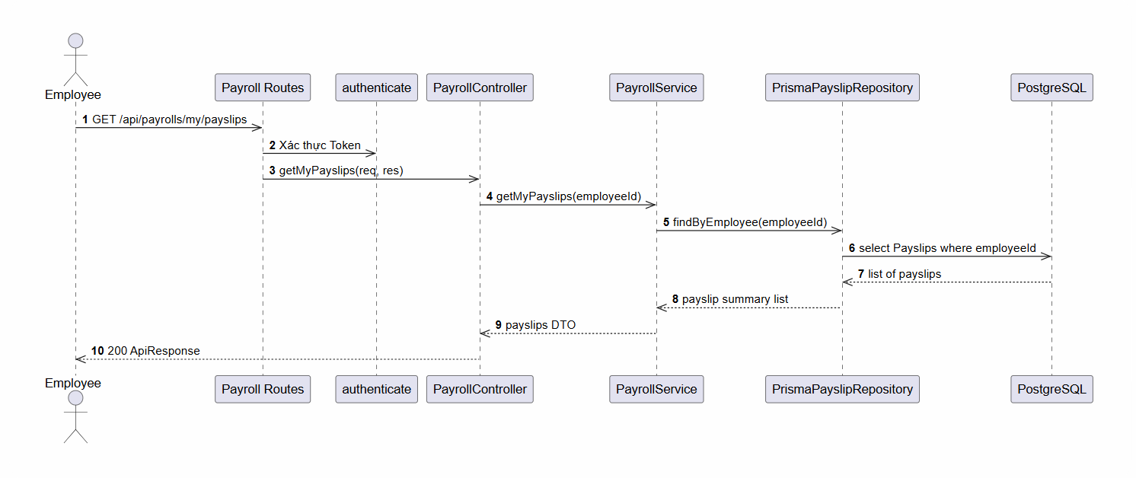

d. Database Queries
Fetch all payslips belonging to a specific employee:
SELECT p.*, pd.*, pr.*
FROM payslips p
LEFT JOIN payslip_details pd ON p.id = pd.payslip_id
LEFT JOIN payrolls pr ON p.payroll_id = pr.id
WHERE p.employee_id = :employeeId
ORDER BY p.created_at DESC;
Fetch detailed component breakdown of a specific payslip:
SELECT p.*, pd.*
FROM payslips p
LEFT JOIN payslip_details pd ON p.id = pd.payslip_id
WHERE p.payroll_id = :payrollId
AND p.employee_id = :employeeId;

1.4 Feature Personal Projects

a. Class Diagram
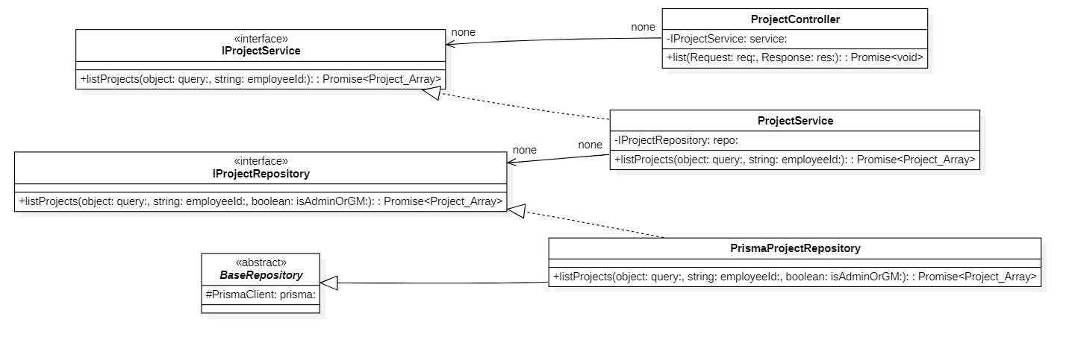

b. Class Specifications
ProjectController Class
No | Method | Description
01 | constructor(service: IProjectService) : void | Inputs: Input parameters: service: IProjectService.  Outputs: Output: void.  Processing: Initializes a new instance of the ProjectController class and injects required dependencies.
02 | list(req: AuthRequest, res: Response) : Promise | Inputs: Input parameters: req: AuthRequest, res: Response.  Outputs: Output: Promise.  Processing: Queries the database or processes business logic to retrieve/find data based on the specified input criteria.
03 | getOne(req: AuthRequest, res: Response) : Promise | Inputs: Input parameters: req: AuthRequest, res: Response.  Outputs: Output: Promise.  Processing: Queries the database or processes business logic to retrieve/find data based on the specified input criteria.
04 | create(req: AuthRequest, res: Response) : Promise | Inputs: Input parameters: req: AuthRequest, res: Response.  Outputs: Output: Promise.  Processing: Validates the input data and inserts a new record into the database.
05 | update(req: AuthRequest, res: Response) : Promise | Inputs: Input parameters: req: AuthRequest, res: Response.  Outputs: Output: Promise.  Processing: Verifies existence, validates new input data, and updates the record in the database.
06 | delete(req: AuthRequest, res: Response) : Promise | Inputs: Input parameters: req: AuthRequest, res: Response.  Outputs: Output: Promise.  Processing: Performs a deletion (either soft or hard delete) of the record from the database.
07 | addMember(req: AuthRequest, res: Response) : Promise | Inputs: Input parameters: req: AuthRequest, res: Response.  Outputs: Output: Promise.  Processing: Validates the input data and inserts a new record into the database.
08 | removeMember(req: AuthRequest, res: Response) : Promise | Inputs: Input parameters: req: AuthRequest, res: Response.  Outputs: Output: Promise.  Processing: Performs a deletion (either soft or hard delete) of the record from the database.
09 | getMembers(req: AuthRequest, res: Response) : Promise | Inputs: Input parameters: req: AuthRequest, res: Response.  Outputs: Output: Promise.  Processing: Queries the database or processes business logic to retrieve/find data based on the specified input criteria.
10 | getGanttData(req: AuthRequest, res: Response) : Promise | Inputs: Input parameters: req: AuthRequest, res: Response.  Outputs: Output: Promise.  Processing: Queries the database or processes business logic to retrieve/find data based on the specified input criteria.
11 | updateMember(req: AuthRequest, res: Response) : Promise | Inputs: Input parameters: req: AuthRequest, res: Response.  Outputs: Output: Promise.  Processing: Verifies existence, validates new input data, and updates the record in the database.

ProjectService Class
No | Method | Description
01 | constructor(repository: IProjectRepository, employeeRepository: IEmployeeRepository, prisma: PrismaClient, statusService?: IProjectTaskStatusService) : void | Inputs: Input parameters: repository: IProjectRepository, employeeRepository: IEmployeeRepository, prisma: PrismaClient, statusService?: IProjectTaskStatusService.  Outputs: Output: void.  Processing: Initializes a new instance of the ProjectService class and injects required dependencies.
02 | getProject(id: string, userId: string) : Promise | Inputs: Input parameters: id: string, userId: string.  Outputs: Output: Promise.  Processing: Queries the database or processes business logic to retrieve/find data based on the specified input criteria.
03 | listProjects(query: ProjectListQuery, userId: string) : Promise | Inputs: Input parameters: query: ProjectListQuery, userId: string.  Outputs: Output: Promise.  Processing: Queries the database or processes business logic to retrieve/find data based on the specified input criteria.
04 | createProject(data: CreateProjectDto, userId: string) : Promise | Inputs: Input parameters: data: CreateProjectDto, userId: string.  Outputs: Output: Promise.  Processing: Validates the input data and inserts a new record into the database.
05 | updateProject(id: string, data: UpdateProjectDto, userId: string) : Promise | Inputs: Input parameters: id: string, data: UpdateProjectDto, userId: string.  Outputs: Output: Promise.  Processing: Verifies existence, validates new input data, and updates the record in the database.
06 | deleteProject(id: string, userId: string) : Promise | Inputs: Input parameters: id: string, userId: string.  Outputs: Output: Promise.  Processing: Performs a deletion (either soft or hard delete) of the record from the database.
07 | addMember(projectId: string, employeeId: string, userId: string, options?: object) : Promise | Inputs: Input parameters: projectId: string, employeeId: string, userId: string, options?: object.  Outputs: Output: Promise.  Processing: Validates the input data and inserts a new record into the database.
08 | removeMember(projectId: string, employeeId: string, userId: string) : Promise | Inputs: Input parameters: projectId: string, employeeId: string, userId: string.  Outputs: Output: Promise.  Processing: Performs a deletion (either soft or hard delete) of the record from the database
09 | getMembers(projectId: string, userId: string) : Promise | Inputs: Input parameters: projectId: string, userId: string.  Outputs: Output: Promise.  Processing: Queries the database or processes business logic to retrieve/find data based on the specified input criteria.
10 | getGanttData(projectId: string, userId: string) : Promise | Inputs: Input parameters: projectId: string, userId: string.  Outputs: Output: Promise.  Processing: Queries the database or processes business logic to retrieve/find data based on the specified input criteria.
11 | updateMember(projectId: string, employeeId: string, userId: string, data: object) : Promise | Inputs: Input parameters: projectId: string, employeeId: string, userId: string, data: object.  Outputs: Output: Promise.  Processing: Verifies existence, validates new input data, and updates the record in the database.
12 | checkIsAdminOrGM(userId: string) : Promise | Inputs: Input parameters: userId: string.  Outputs: Output: Promise.  Processing: Executes internal business logic for this function according to the system workflow requirements.

PrismaProjectRepository Class
No | Method | Description
01 | constructor(prisma: PrismaClient) : void | Inputs: Input parameters: prisma: PrismaClient.  Outputs: Output: void.  Processing: Initializes a new instance of the PrismaProjectRepository class and injects required dependencies. .
02 | findById(id: string) : Promise | Inputs: Input parameters: id: string.  Outputs: Output: Promise.  Processing: Queries the database or processes business logic to retrieve/find data based on the specified input criteria.
03 | findByName(name: string) : Promise | Inputs: Input parameters: name: string.  Outputs: Output: Promise.  Processing: Queries the database or processes business logic to retrieve/find data based on the specified input criteria.
04 | listProjects(query: ProjectListQuery, userId: string, isAdminOrGM: boolean) : Promise | Inputs: Input parameters: query: ProjectListQuery, userId: string, isAdminOrGM: boolean.  Outputs: Output: Promise.  Processing: Queries the database or processes business logic to retrieve/find data based on the specified input criteria.
05 | createProject(data: object) : Promise | Inputs: Input parameters: data: object.  Outputs: Output: Promise.  Processing: Validates the input data and inserts a new record into the database.
06 | updateProject(id: string, data: UpdateProjectDto) : Promise | Inputs: Input parameters: id: string, data: UpdateProjectDto.  Outputs: Output: Promise.  Processing: Verifies existence, validates new input data, and updates the record in the database.
07 | deleteProject(id: string) : Promise | Inputs: Input parameters: id: string.  Outputs: Output: Promise.  Processing: Performs a deletion (either soft or hard delete) of the record from the database.
08 | addMember(projectId: string, employeeId: string, options?: object) : Promise | Inputs: Input parameters: projectId: string, employeeId: string, options?: object.  Outputs: Output: Promise.  Processing: Validates the input data and inserts a new record into the database.
09 | removeMember(projectId: string, employeeId: string) : Promise | Inputs: Input parameters: projectId: string, employeeId: string.  Outputs: Output: Promise.  Processing: Performs a deletion (either soft or hard delete) of the record from the database.
10 | isMember(projectId: string, employeeId: string) : Promise | Inputs: Input parameters: projectId: string, employeeId: string.  Outputs: Output: Promise.  Processing: Executes internal business logic for this function according to the system workflow requirements.
11 | getMember(projectId: string, employeeId: string) : Promise | Inputs: Input parameters: projectId: string, employeeId: string.  Outputs: Output: Promise.  Processing: Queries the database or processes business logic to retrieve/find data based on the specified input criteria.
12 | getMembers(projectId: string) : Promise | Inputs: Input parameters: projectId: string.  Outputs: Output: Promise.  Processing: Queries the database or processes business logic to retrieve/find data based on the specified input criteria.
13 | getGanttData(projectId: string) : Promise | Inputs: Input parameters: projectId: string.  Outputs: Output: Promise.  Processing: Queries the database or processes business logic to retrieve/find data based on the specified input criteria.
14 | hasActiveOnsiteMembership(employeeId: string) : Promise | Inputs: Input parameters: employeeId: string.  Outputs: Output: Promise.  Processing: Executes internal business logic for this function according to the system workflow requirements
15 | updateMember(projectId: string, employeeId: string, data: object) : Promise | Inputs: Input parameters: projectId: string, employeeId: string, data: object.  Outputs: Output: Promise.  Processing: Verifies existence, validates new input data, and updates the record in the database.
16 | mapToDomain(project: PrismaProjectWithRelations) : Project | Inputs: Input parameters: project: PrismaProjectWithRelations.  Outputs: Output: Project.  Processing: Executes internal business logic for this function according to the system workflow requirements.

c. Sequence Diagram(s)

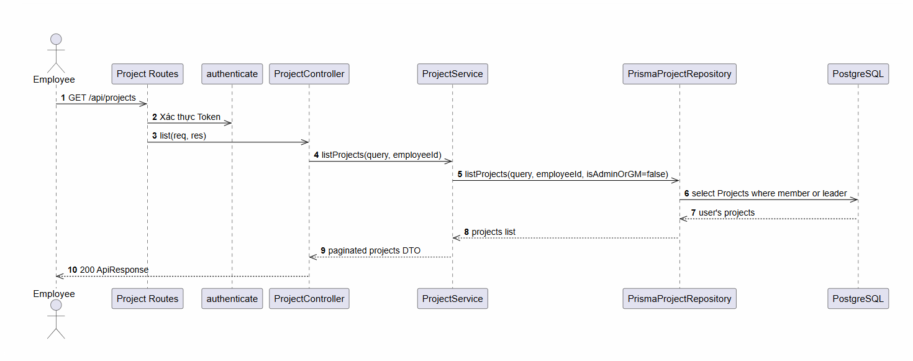

d. Database Queries
Fetch projects where the employee is either a team leader or active member:
SELECT DISTINCT p.*, tl.full_name AS team_leader_name
FROM projects p
LEFT JOIN employees tl ON p.team_leader_id = tl.id
LEFT JOIN project_members pm ON p.id = pm.project_id
WHERE p.team_leader_id = :userId
OR (pm.employee_id = :userId AND pm.removed_at IS NULL);

1.5 Feature Personal Applications

a. Class Diagram
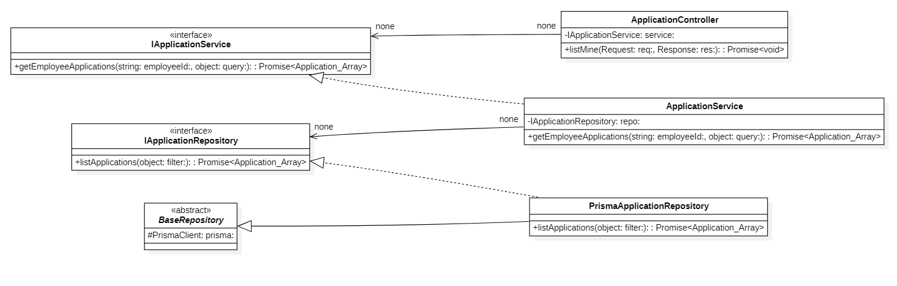

b. Class Specifications
ApplicationController Class
No | Method | Description
01 | constructor(service: IApplicationService) : void | Inputs: Input parameters: service: IApplicationService.  Outputs: Output: void.  Processing: Initializes a new instance of the ApplicationController class and injects required dependencies.

ApplicationService Class
No | Method | Description
01 | constructor(applicationRepo: IApplicationRepository, employeeShiftRepo: IEmployeeShiftRepository, workingShiftRepo: IWorkingShiftRepository, attendanceRepo: IAttendanceRepository) : void | Inputs: Input parameters: applicationRepo: IApplicationRepository, employeeShiftRepo: IEmployeeShiftRepository, workingShiftRepo: IWorkingShiftRepository, attendanceRepo: IAttendanceRepository.  Outputs: Output: void.  Processing: Initializes a new instance of the ApplicationService class and injects required dependencies.

PrismaApplicationRepository Class
No | Method | Description
01 | constructor(prisma: PrismaClient) : void | Inputs: Input parameters: prisma: PrismaClient.  Outputs: Output: void.  Processing: Initializes a new instance of the PrismaApplicationRepository class and injects required dependencies.

c. Sequence Diagram(s)
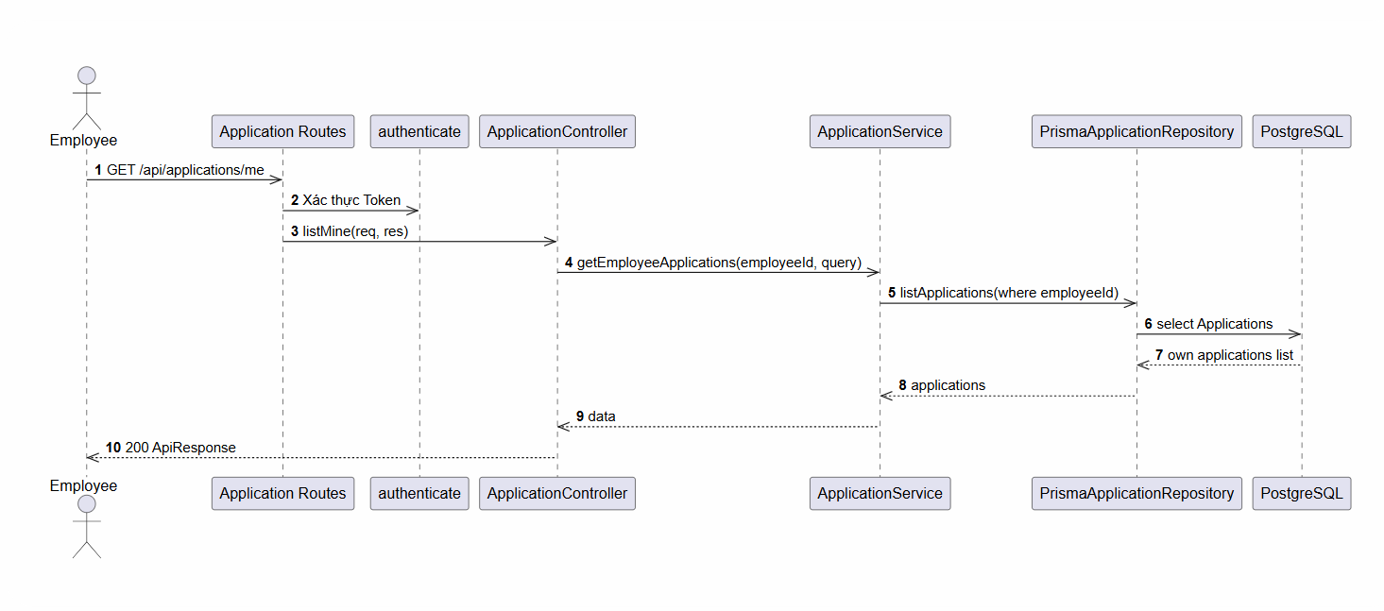

d. Database Queries
List all requests/applications (leave, OT, shift swap, WFH...) submitted by the employee:
SELECT a.*, e.full_name AS employee_name
FROM applications a
LEFT JOIN employees e ON a.employee_id = e.id
WHERE a.employee_id = :employeeId
AND (:type IS NULL OR a.type = :type)
AND (:status IS NULL OR a.status = :status)
ORDER BY a.created_at DESC
LIMIT :limit OFFSET :offset;
Cancel a pending application
UPDATE applications
SET status = 'cancelled'
WHERE id = :id AND employee_id = :employeeId;

2. Human Resource Management Module

2.1 Feature Employee Profile Management

a. Class Diagram
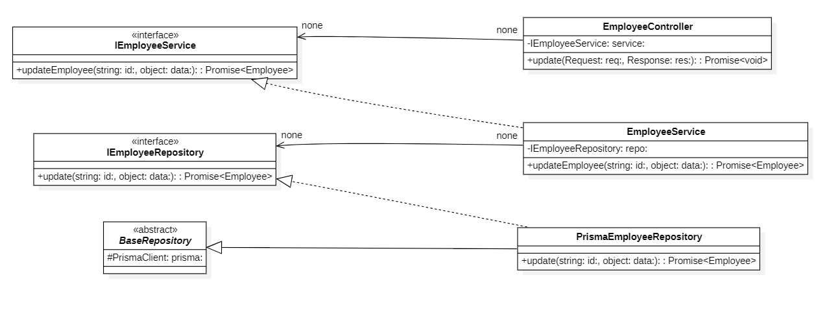

b. Class Specifications
EmployeeController Class
No | Method | Description
01 | constructor(prisma: PrismaClient) : void | Inputs: Input parameters: service: IEmployeeService.  Outputs: Output: void.  Processing: Initializes a new instance of the EmployeeController class and injects required dependencies.
02 | list(req: AuthRequest, res: Response) : Promise | Inputs: Input parameters: req: AuthRequest, res: Response.  Outputs: Output: Promise.  Processing: Queries the database or processes business logic to retrieve/find data based on the specified input criteria.
03 | listApprovers(req: AuthRequest, res: Response) : Promise | Inputs: Input parameters: req: AuthRequest, res: Response.  Outputs: Output: Promise.  Processing: Queries the database or processes business logic to retrieve/find data based on the specified input criteria.
04 | getOne(req: AuthRequest, res: Response) : Promise | Inputs: Input parameters: req: AuthRequest, res: Response.  Outputs: Output: Promise.  Processing: Queries the database or processes business logic to retrieve/find data based on the specified input criteria.
05 | create(req: AuthRequest, res: Response) : Promise | Inputs: Input parameters: req: AuthRequest, res: Response.  Outputs: Output: Promise.  Processing: Validates the input data and inserts a new record into the database.
06 | update(req: AuthRequest, res: Response) : Promise | Inputs: Input parameters: req: AuthRequest, res: Response.  Outputs: Output: Promise.  Processing: Verifies existence, validates new input data, and updates the record in the database.
07 | updateStatus(req: AuthRequest, res: Response) : Promise | Inputs: Input parameters: req: AuthRequest, res: Response.  Outputs: Output: Promise.  Processing: Verifies existence, validates new input data, and updates the record in the database.
08 | delete(req: AuthRequest, res: Response) : Promise | Inputs: Input parameters: req: AuthRequest, res: Response.  Outputs: Output: Promise.  Processing: Performs a deletion (either soft or hard delete) of the record from the database.

c. Sequence Diagram(s)
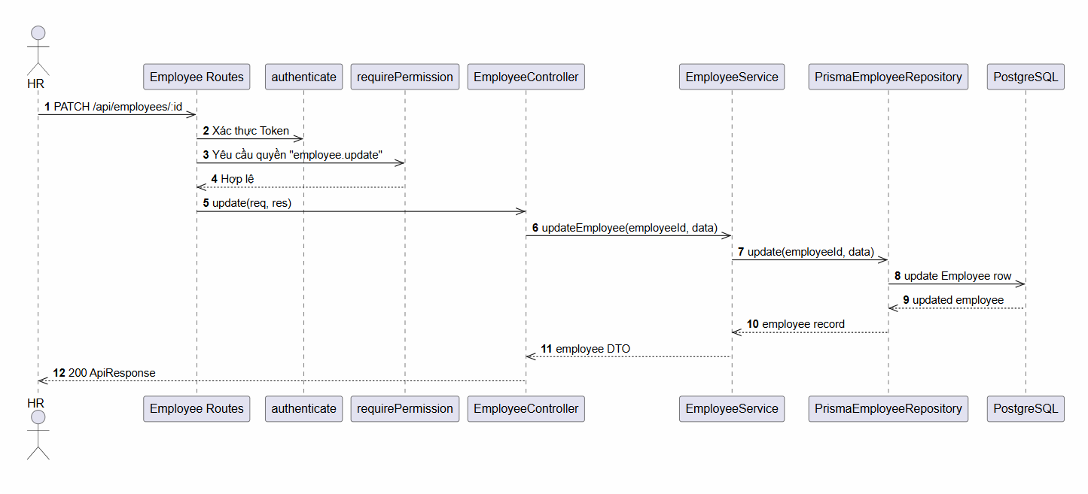

d. Database Queries
Retrieve paginated and filtered list of employee profiles (excluding soft-deleted ones)
SELECT e.*, array_agg(r.name) AS roles
FROM employees e
LEFT JOIN employee_roles er ON e.id = er.employee_id
LEFT JOIN roles r ON er.role_id = r.id
WHERE e.deleted_at IS NULL
AND (:status IS NULL OR e.status = :status)
AND (:employeeType IS NULL OR e.employee_type = :employeeType)
GROUP BY e.id
ORDER BY e.created_at DESC
LIMIT :limit OFFSET :offset;
Create, update, or soft-delete an employee:
-- Create employee
INSERT INTO employees (full_name, username, email, phone, position_id, status)
VALUES (:fullName, :username, :email, :phone, :positionId, :status);

-- Update employee
UPDATE employees SET full_name = :fullName, status = :status WHERE id = :id;

-- Soft delete
UPDATE employees SET deleted_at = NOW() WHERE id = :id;

2.2 Feature Personal Profile Information

a. Class Diagram
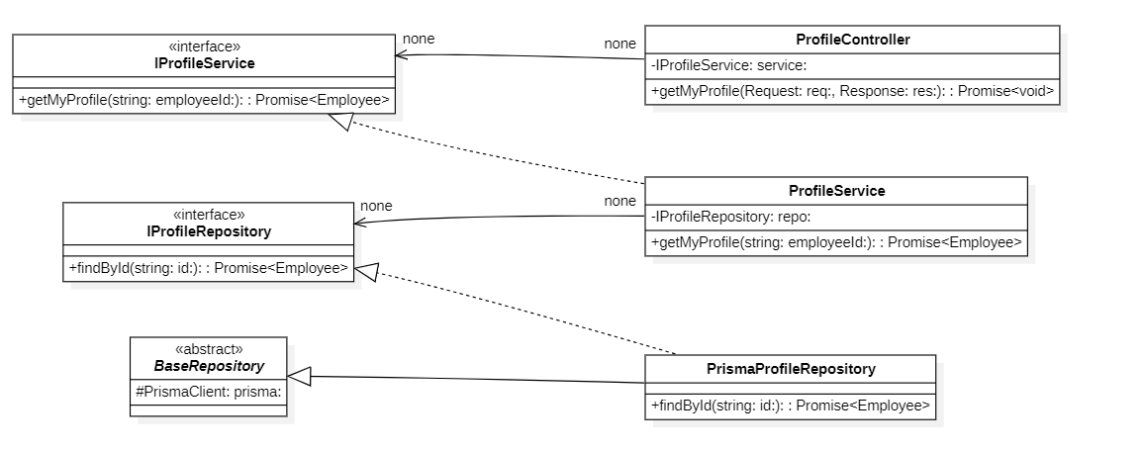

b. Class Specifications
EmployeeController Class
No | Method | Description
01 | constructor(repository: IEmployeeRepository, authRepository?: IAuthRepository) : void | Inputs: Input parameters: repository: IEmployeeRepository, authRepository?: IAuthRepository.  Outputs: Output: void.  Processing: Initializes a new instance of the EmployeeService class and injects required dependencies.
02 | listEmployees(query: EmployeeListQuery) : Promise | Inputs: Input parameters: query: EmployeeListQuery.  Outputs: Output: Promise.  Processing: Queries the database or processes business logic to retrieve/find data based on the specified input criteria
03 | getEmployee(id: string) : Promise | Inputs: Input parameters: id: string.  Outputs: Output: Promise.  Processing: Queries the database or processes business logic to retrieve/find data based on the specified input criteria.
04 | createEmployee(data: CreateEmployeeDto) : Promise | nputs: Input parameters: data: CreateEmployeeDto.  Outputs: Output: Promise.  Processing: Validates the input data and inserts a new record into the database.
05 | updateEmployee(id: string, data: UpdateEmployeeDto, actorId?: string, ipAddress?: string) : Promise | Inputs: Input parameters: id: string, data: UpdateEmployeeDto, actorId?: string, ipAddress?: string.  Outputs: Output: Promise.  Processing: Verifies existence, validates new input data, and updates the record in the database.
06 | updateStatus(id: string, status: EmployeeStatus, actorId?: string, ipAddress?: string) : Promise | Inputs: Input parameters: id: string, status: EmployeeStatus, actorId?: string, ipAddress?: string.  Outputs: Output: Promise.  Processing: Verifies existence, validates new input data, and updates the record in the database.
07 | deleteEmployee(id: string, actorId?: string) : Promise | Inputs: Input parameters: id: string, actorId?: string.  Outputs: Output: Promise.  Processing: Performs a deletion (either soft or hard delete) of the record from the database.
08 | listApprovers() : Promise | Inputs: Input parameters: None.  Outputs: Output: Promise.  Processing: Queries the database or processes business logic to retrieve/find data based on the specified input criteria.
09 | getEmployeeRoles(employeeId: string) : Promise | Inputs: Input parameters: employeeId: string.  Outputs: Output: Promise.  Processing: Queries the database or processes business logic to retrieve/find data based on the specified input criteria.
10 | assignRole(employeeId: string, roleId: string, actorId?: string) : Promise | Inputs: Input parameters: employeeId: string, roleId: string, actorId?: string.  Outputs: Output: Promise.  Processing: Creates an association/assignment between two entities (e.g., assigning a role to an employee or permissions to a role).
11 | revokeRole(employeeId: string, roleId: string, actorId?: string) : Promise | Inputs: Input parameters: employeeId: string, roleId: string, actorId?: string.  Outputs: Output: Promise.  Processing: Removes the association/assignment between two entities.
12 | updateRoles(employeeId: string, roleIds: string[], version: number, actorId?: string) : Promise | Inputs: Input parameters: employeeId: string, roleIds: string[], version: number, actorId?: string.  Outputs: Output: Promise.  Processing: Verifies existence, validates new input data, and updates the record in the database.

PrismaEmployeeRepository Class
No | Method | Description
01 | constructor(prisma: PrismaClient) : void | Inputs: Input parameters: prisma: PrismaClient.  Outputs: Output: void.  Processing: Initializes a new instance of the PrismaEmployeeRepository class and injects required dependencies.
02 | listEmployeesPaginated(query: EmployeeListQuery) : Promise | Inputs: Input parameters: query: EmployeeListQuery.  Outputs: Output: Promise.  Processing: Queries the database or processes business logic to retrieve/find data based on the specified input criteria.
03 | findById(id: string) : Promise | Inputs: Input parameters: id: string.  Outputs: Output: Promise.  Processing: Queries the database or processes business logic to retrieve/find data based on the specified input criteria.
04 | createEmployee(data: CreateEmployeeDto) : Promise | Inputs: Input parameters: data: CreateEmployeeDto.  Outputs: Output: Promise.  Processing: Validates the input data and inserts a new record into the database.
05 | updateEmployee(id: string, data: object) : Promise | Inputs: Input parameters: id: string, data: object.  Outputs: Output: Promise.  Processing: Verifies existence, validates new input data, and updates the record in the database.
06 | updateStatus(id: string, status: EmployeeStatus) : Promise | Inputs: Input parameters: id: string, status: EmployeeStatus.  Outputs: Output: Promise.  Processing: Verifies existence, validates new input data, and updates the record in the database.
07 | deleteEmployee(id: string) : Promise | Inputs: Input parameters: id: string.  Outputs: Output: Promise.  Processing: Performs a deletion (either soft or hard delete) of the record from the database.
08 | findRolesByEmployeeId(employeeId: string) : Promise | Inputs: Input parameters: employeeId: string.  Outputs: Output: Promise.  Processing: Queries the database or processes business logic to retrieve/find data based on the specified input criteria.
09 | assignRole(employeeId: string, roleId: string, actorId?: string) : Promise | Inputs: Input parameters: employeeId: string, roleId: string, actorId?: string.  Outputs: Output: Promise.  Processing: Creates an association/assignment between two entities (e.g., assigning a role to an employee or permissions to a role).
10 | revokeRole(employeeId: string, roleId: string) : Promise | Inputs: Input parameters: employeeId: string, roleId: string.  Outputs: Output: Promise.  Processing: Removes the association/assignment between two entities.
11 | updateRoles(employeeId: string, roleIds: string[], version: number, actorId?: string) : Promise | Inputs: Input parameters: employeeId: string, roleIds: string[], version: number, actorId?: string.  Outputs: Output: Promise.  Processing: Verifies existence, validates new input data, and updates the record in the database.
12 | countActiveAdmins(tx?: object) : Promise | Inputs: Input parameters: tx?: object.  Outputs: Output: Promise.  Processing: Executes internal business logic for this function according to the system workflow requirements.
13 | mapToDomain(employee: EmployeeWithRoles) : Employee | Inputs: Input parameters: employee: EmployeeWithRoles.  Outputs: Output: Employee.  Processing: Executes internal business logic for this function according to the system workflow requirements.

EmployeeController Class
No | Method | Description
01 | constructor(service: IEmployeeService) : void | Inputs: Input parameters: service: IEmployeeService.  Outputs: Output: void.  Processing: Initializes a new instance of the EmployeeController class and injects required dependencies.
02 | list(req: AuthRequest, res: Response) : Promise | Inputs: Input parameters: req: AuthRequest, res: Response.  Outputs: Output: Promise.  Processing: Queries the database or processes business logic to retrieve/find data based on the specified input criteria.
03 | listApprovers(req: AuthRequest, res: Response) : Promise | Inputs: Input parameters: req: AuthRequest, res: Response.  Outputs: Output: Promise.  Processing: Queries the database or processes business logic to retrieve/find data based on the specified input criteria.
04 | getOne(req: AuthRequest, res: Response) : Promise | Inputs: Input parameters: req: AuthRequest, res: Response.  Outputs: Output: Promise.  Processing: Queries the database or processes business logic to retrieve/find data based on the specified input criteria.
05 | create(req: AuthRequest, res: Response) : Promise | Inputs: Input parameters: req: AuthRequest, res: Response.  Outputs: Output: Promise.  Processing: Validates the input data and inserts a new record into the database.
06 | update(req: AuthRequest, res: Response) : Promise | Inputs: Input parameters: req: AuthRequest, res: Response.  Outputs: Output: Promise.  Processing: Verifies existence, validates new input data, and updates the record in the database.
07 | updateStatus(req: AuthRequest, res: Response) : Promise | Inputs: Input parameters: req: AuthRequest, res: Response.  Outputs: Output: Promise.  Processing: Verifies existence, validates new input data, and updates the record in the database.
08 | delete(req: AuthRequest, res: Response) : Promise | Inputs: Input parameters: req: AuthRequest, res: Response.  Outputs: Output: Promise.  Processing: Performs a deletion (either soft or hard delete) of the record from the database.

EmployeeService Class
No | Method | Description
01 | constructor(repository: IEmployeeRepository, authRepository?: IAuthRepository) : void | Inputs: Input parameters: repository: IEmployeeRepository, authRepository?: IAuthRepository.  Outputs: Output: void.  Processing: Initializes a new instance of the EmployeeService class and injects required dependencies.
02 | listEmployees(query: EmployeeListQuery) : Promise | Inputs: Input parameters: query: EmployeeListQuery.  Outputs: Output: Promise.  Processing: Queries the database or processes business logic to retrieve/find data based on the specified input criteria.
03 | getEmployee(id: string) : Promise | Inputs: Input parameters: id: string.  Outputs: Output: Promise.  Processing: Queries the database or processes business logic to retrieve/find data based on the specified input criteria.
04 | createEmployee(data: CreateEmployeeDto) : Promise | Inputs: Input parameters: data: CreateEmployeeDto.  Outputs: Output: Promise.  Processing: Validates the input data and inserts a new record into the database.
05 | updateEmployee(id: string, data: UpdateEmployeeDto, actorId?: string, ipAddress?: string) : Promise | Inputs: Input parameters: id: string, data: UpdateEmployeeDto, actorId?: string, ipAddress?: string.  Outputs: Output: Promise.  Processing: Verifies existence, validates new input data, and updates the record in the database.
06 | updateStatus(id: string, status: EmployeeStatus, actorId?: string, ipAddress?: string) : Promise | Inputs: Input parameters: id: string, status: EmployeeStatus, actorId?: string, ipAddress?: string.  Outputs: Output: Promise.  Processing: Verifies existence, validates new input data, and updates the record in the database.
07 | deleteEmployee(id: string, actorId?: string) : Promise | Inputs: Input parameters: id: string, actorId?: string.  Outputs: Output: Promise.  Processing: Performs a deletion (either soft or hard delete) of the record from the database.
08 | listApprovers() : Promise | Inputs: Input parameters: None.  Outputs: Output: Promise.  Processing: Queries the database or processes business logic to retrieve/find data based on the specified input criteria.
09 | getEmployeeRoles(employeeId: string) : Promise | Inputs: Input parameters: employeeId: string.  Outputs: Output: Promise.  Processing: Queries the database or processes business logic to retrieve/find data based on the specified input criteria.
10 | assignRole(employeeId: string, roleId: string, actorId?: string) : Promise | Inputs: Input parameters: employeeId: string, roleId: string, actorId?: string.  Outputs: Output: Promise.  Processing: Creates an association/assignment between two entities (e.g., assigning a role to an employee or permissions to a role)
11 | revokeRole(employeeId: string, roleId: string, actorId?: string) : Promise | Inputs: Input parameters: employeeId: string, roleId: string, actorId?: string.  Outputs: Output: Promise.  Processing: Removes the association/assignment between two entities.
12 | updateRoles(employeeId: string, roleIds: string[], version: number, actorId?: string) : Promise | Inputs: Input parameters: employeeId: string, roleIds: string[], version: number, actorId?: string.  Outputs: Output: Promise.  Processing: Verifies existence, validates new input data, and updates the record in the database.

PrismaEmployeeRepository Class
No | Method | Description
01 | constructor(prisma: PrismaClient) : void | Inputs: Input parameters: prisma: PrismaClient.  Outputs: Output: void.  Processing: Initializes a new instance of the PrismaEmployeeRepository class and injects required dependencies.
02 | listEmployeesPaginated(query: EmployeeListQuery) : Promise | Inputs: Input parameters: query: EmployeeListQuery.  Outputs: Output: Promise.  Processing: Queries the database or processes business logic to retrieve/find data based on the specified input criteria.
03 | findById(id: string) : Promise | Inputs: Input parameters: id: string.  Outputs: Output: Promise.  Processing: Queries the database or processes business logic to retrieve/find data based on the specified input criteria.
04 | createEmployee(data: CreateEmployeeDto) : Promise | Inputs: Input parameters: data: CreateEmployeeDto.  Outputs: Output: Promise.  Processing: Validates the input data and inserts a new record into the database.
05 | updateEmployee(id: string, data: object) : Promise | Inputs: Input parameters: id: string, data: object.  Outputs: Output: Promise.  Processing: Verifies existence, validates new input data, and updates the record in the database.
06 | updateStatus(id: string, status: EmployeeStatus) : Promise | Inputs: Input parameters: id: string, status: EmployeeStatus.  Outputs: Output: Promise.  Processing: Verifies existence, validates new input data, and updates the record in the database.
07 | deleteEmployee(id: string) : Promise | Inputs: Input parameters: id: string.  Outputs: Output: Promise.  Processing: Performs a deletion (either soft or hard delete) of the record from the database.
08 | findRolesByEmployeeId(employeeId: string) : Promise | Inputs: Input parameters: employeeId: string.  Outputs: Output: Promise.  Processing: Queries the database or processes business logic to retrieve/find data based on the specified input criteria.
09 | assignRole(employeeId: string, roleId: string, actorId?: string) : Promise | Inputs: Input parameters: employeeId: string, roleId: string, actorId?: string.  Outputs: Output: Promise.  Processing: Creates an association/assignment between two entities (e.g., assigning a role to an employee or permissions to a role).
10 | revokeRole(employeeId: string, roleId: string) : Promise | Inputs: Input parameters: employeeId: string, roleId: string.  Outputs: Output: Promise.  Processing: Removes the association/assignment between two entities.
11 | updateRoles(employeeId: string, roleIds: string[], version: number, actorId?: string) : Promise | Inputs: Input parameters: employeeId: string, roleIds: string[], version: number, actorId?: string.  Outputs: Output: Promise.  Processing: Verifies existence, validates new input data, and updates the record in the database.
12 | countActiveAdmins(tx?: object) : Promise | Inputs: Input parameters: tx?: object.  Outputs: Output: Promise.  Processing: Executes internal business logic for this function according to the system workflow requirements.
13 | mapToDomain(employee: EmployeeWithRoles) : Employee | Inputs: Input parameters: employee: EmployeeWithRoles.  Outputs: Output: Employee.  Processing: Executes internal business logic for this function according to the system workflow requirements.

c. Sequence Diagram(s)
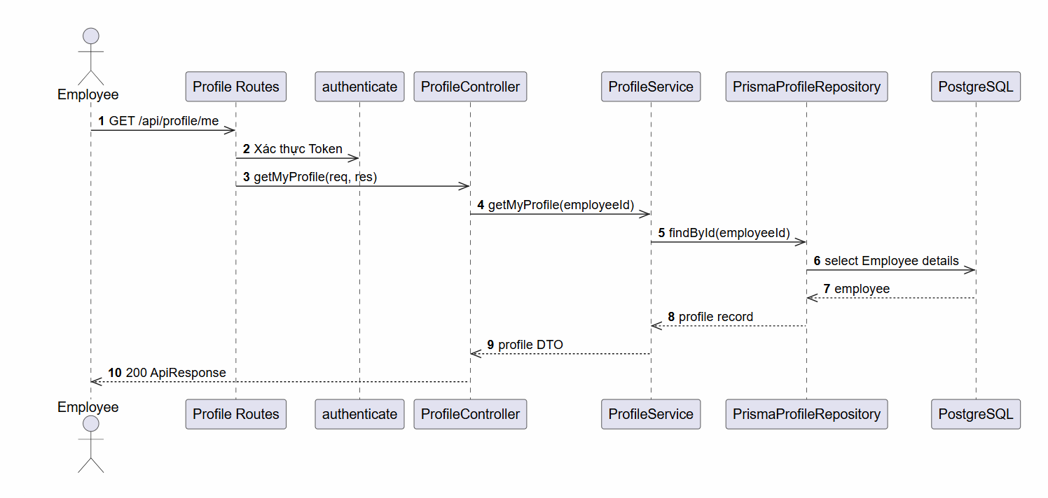

d. Database Queries
Get employee personal profile:
SELECT e.*, pe.full_name AS personal_employee_name
FROM employees e
LEFT JOIN employees pe ON e.personal_employee_id = pe.id
WHERE e.id = :empId AND e.deleted_at IS NULL;
Update contact fields and avatar info:
UPDATE employees
SET full_name = :fullName, phone = :phone, address = :address, date_of_birth = :dateOfBirth
WHERE id = :empId;

UPDATE employees
SET avatar_url = :avatarUrl, avatar_id = :avatarId
WHERE id = :empId;

2.3 Feature System Activity Logs

a. Class Diagram
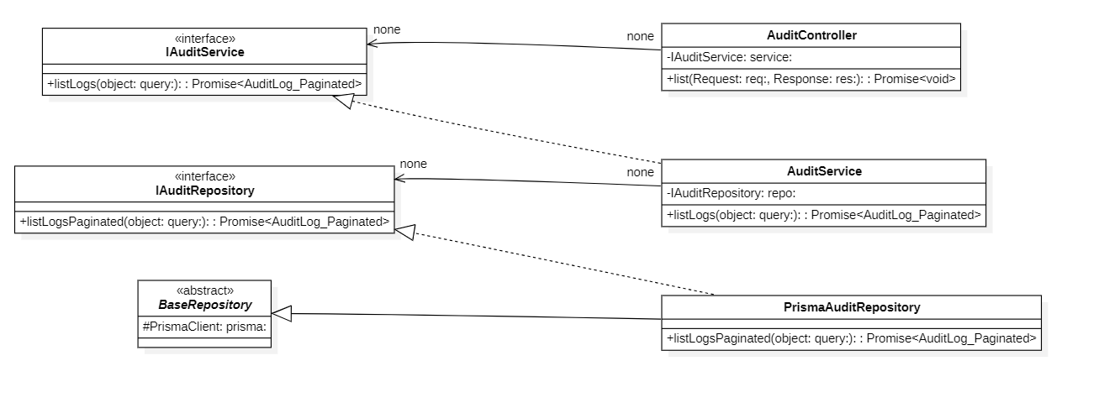

c. Sequence Diagram(s)

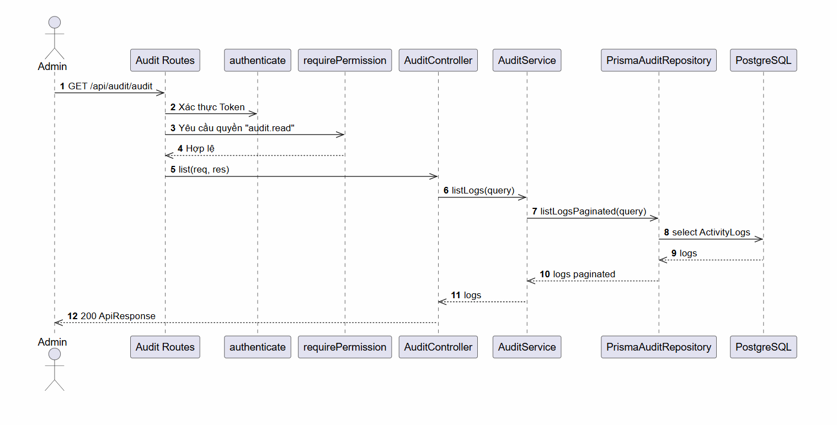

d. Database Queries
List all role/permission modification logs (admin auditing view):
SELECT al.*, actor.full_name AS actor_name, target.full_name AS target_name
FROM authorization_audit_logs al
LEFT JOIN employees actor ON al.actor_id = actor.id
LEFT JOIN employees target ON al.target_employee_id = target.id
WHERE (:actorId IS NULL OR al.actor_id = :actorId)
AND (:action IS NULL OR al.action = :action)
ORDER BY al.created_at DESC
LIMIT :limit OFFSET :offset;

2.4 Feature System Security Overview

a. Class Diagram
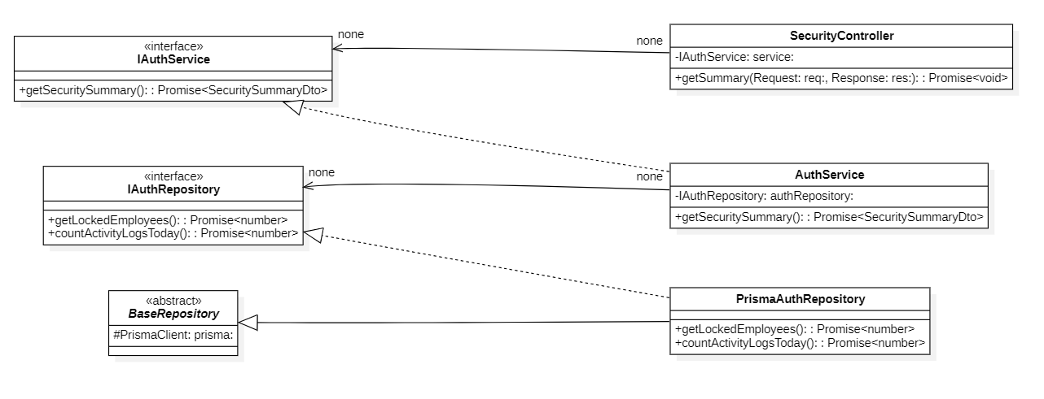

b. Class Specifications
AuthorizationService Class
No | Method | Description
01 | constructor(cache: ICacheService) : void | Inputs: Input parameters: cache: ICacheService.  Outputs: Output: void.  Processing: Initializes a new instance of the AuthorizationService class and injects required dependencies.
02 | getAuthorizationContext(employeeId: string, options?: object) : Promise | Inputs: Input parameters: employeeId: string, options?: object.  Outputs: Output: Promise.  Processing: Queries the database or processes business logic to retrieve/find data based on the specified input criteria.
03 | invalidateUserCache(employeeId: string) : Promise | Inputs: Input parameters: employeeId: string.  Outputs: Output: Promise.  Processing: Executes internal business logic for this function according to the system workflow requirements.
04 | invalidateGlobalVersion() : Promise | Inputs: Input parameters: None.  Outputs: Output: Promise.  Processing: Executes internal business logic for this function according to the system workflow requirements.
05 | invalidateRoleCache(roleId: string) : Promise | Inputs: Input parameters: roleId: string.  Outputs: Output: Promise.  Processing: Executes internal business logic for this function according to the system workflow requirements
06 | invalidatePermissionCache(permissionId: string) : Promise | Inputs: Input parameters: permissionId: string.  Outputs: Output: Promise.  Processing: Executes internal business logic for this function according to the system workflow requirements.
07 | incrementMetric(metric: string) : void | Inputs: Input parameters: metric: string.  Outputs: Output: void.  Processing: Executes internal business logic for this function according to the system workflow requirements.
08 | getMetrics() : Record | Inputs: Input parameters: None.  Outputs: Output: Record.  Processing: Queries the database or processes business logic to retrieve/find data based on the specified input criteria.
09 | logDecision(employeeId: string, permission: string, allowed: boolean, source: string) : void | Inputs: Input parameters: employeeId: string, permission: string, allowed: boolean, source: string.  Outputs: Output: void.  Processing: Executes internal business logic for this function according to the system workflow requirements.
10 | getGlobalVersion() : Promise | Inputs: Input parameters: None.  Outputs: Output: Promise.  Processing: Queries the database or processes business logic to retrieve/find data based on the specified input criteria.
11 | fetchAndCacheContext(employeeId: string, snapshotVersion: number, cacheKey: string) : Promise | Inputs: Input parameters: employeeId: string, snapshotVersion: number, cacheKey: string.  Outputs: Output: Promise.  Processing: Executes internal business logic for this function according to the system workflow requirements.

ICacheService Interface
No | Method | Description
01 | get~T~(key: string) : Promise | Inputs: Input parameters: key: string.  Outputs: Output: Promise.  Processing: Queries the database or processes business logic to retrieve/find data based on the specified input criteria.
02 | set~T~(key: string, value: T, ttlSeconds?: number) : Promise | Inputs: Input parameters: key: string, value: T, ttlSeconds?: number.  Outputs: Output: Promise.  Processing: Executes internal business logic for this function according to the system workflow requirements.
03 | del(key: string) : Promise | Inputs: Input parameters: key: string.  Outputs: Output: Promise.  Processing: Executes internal business logic for this function according to the system workflow requirements.
04 | clear() : Promise | Inputs: Input parameters: None.  Outputs: Output: Promise.  Processing: Executes internal business logic for this function according to the system workflow requirements.
05 | subscribe(channel: string, callback: (message: string) => void) : Promise | Inputs: Input parameters: channel: string, callback: (message: string) => void.  Outputs: Output: Promise.  Processing: Executes internal business logic for this function according to the system workflow requirements.
06 | publish(channel: string, message: string) : Promise | Inputs: Input parameters: channel: string, message: string.  Outputs: Output: Promise.  Processing: Executes internal business logic for this function according to the system workflow requirements.

c. Sequence Diagram(s)

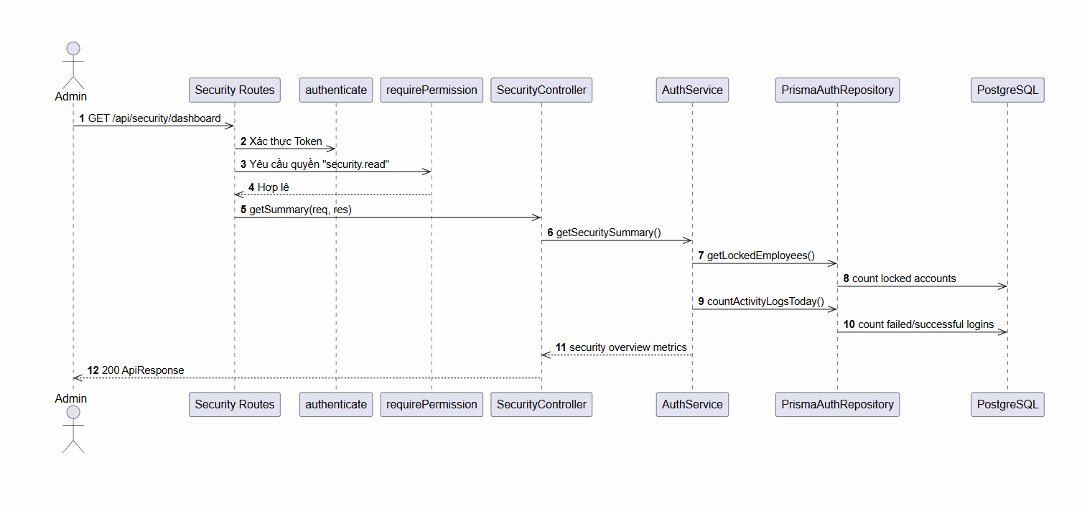

d. Database Queries
Find all locked or failed-login-blocked accounts:
SELECT id, full_name, email, failed_login_count, locked_until
FROM employees
WHERE (locked_until > NOW() OR failed_login_count >= 5)
AND deleted_at IS NULL;
Unlock a locked account:
UPDATE employees
SET failed_login_count = 0, locked_until = NULL
WHERE id = :empId;

2.5 Feature Login History

a. Class Diagram
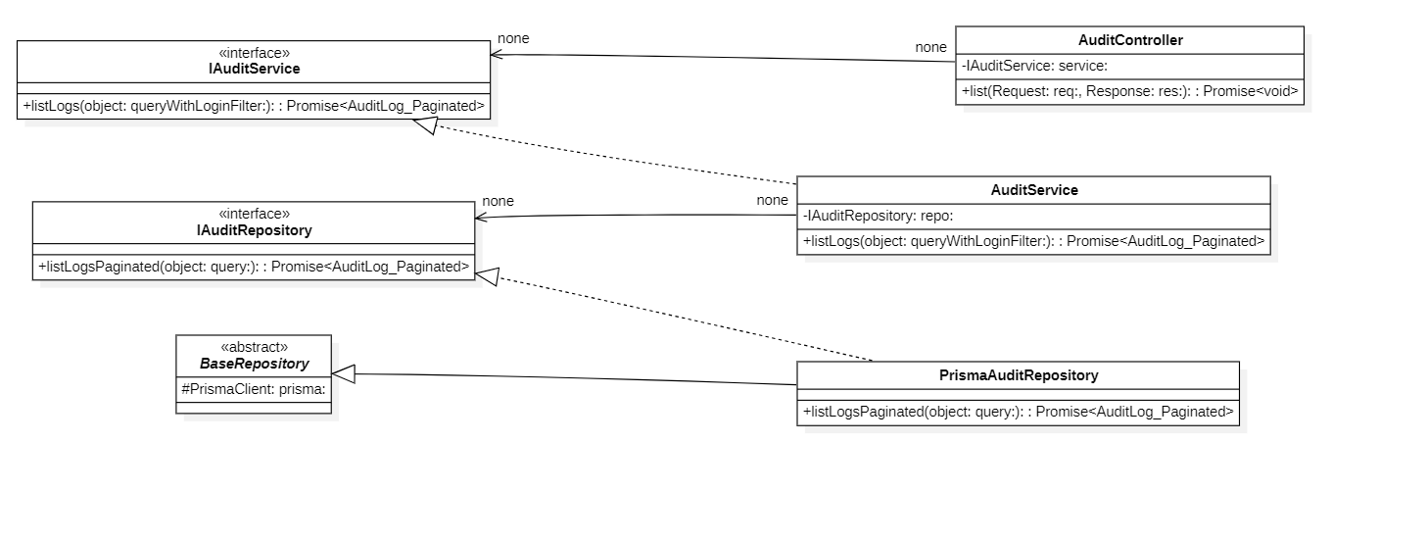

b. Class Specifications
EmployeeController Class
No | Method | Description
01 | constructor(service: IEmployeeService) : void | Inputs: Input parameters: service: IEmployeeService.  Outputs: Output: void.  Processing: Initializes a new instance of the EmployeeController class and injects required dependencies.
02 | list(req: AuthRequest, res: Response) : Promise | Inputs: Input parameters: req: AuthRequest, res: Response.  Outputs: Output: Promise.  Processing: Queries the database or processes business logic to retrieve/find data based on the specified input criteria.
03 | listApprovers(req: AuthRequest, res: Response) : Promise | Inputs: Input parameters: req: AuthRequest, res: Response.  Outputs: Output: Promise.  Processing: Queries the database or processes business logic to retrieve/find data based on the specified input criteria.
04 | getOne(req: AuthRequest, res: Response) : Promise | Inputs: Input parameters: req: AuthRequest, res: Response.  Outputs: Output: Promise.  Processing: Queries the database or processes business logic to retrieve/find data based on the specified input criteria.
05 | create(req: AuthRequest, res: Response) : Promise | Inputs: Input parameters: req: AuthRequest, res: Response.  Outputs: Output: Promise.  Processing: Validates the input data and inserts a new record into the database.
06 | update(req: AuthRequest, res: Response) : Promise | Inputs: Input parameters: req: AuthRequest, res: Response.  Outputs: Output: Promise.  Processing: Verifies existence, validates new input data, and updates the record in the database.
07 | updateStatus(req: AuthRequest, res: Response) : Promise | Inputs: Input parameters: req: AuthRequest, res: Response.  Outputs: Output: Promise.  Processing: Verifies existence, validates new input data, and updates the record in the database.
08 | delete(req: AuthRequest, res: Response) : Promise | Inputs: Input parameters: req: AuthRequest, res: Response.  Outputs: Output: Promise.  Processing: Performs a deletion (either soft or hard delete) of the record from the database.

EmployeeService Class
No | Method | Description
01 | constructor(repository: IEmployeeRepository, authRepository?: IAuthRepository) : void | Inputs: Input parameters: repository: IEmployeeRepository, authRepository?: IAuthRepository.  Outputs: Output: void.  Processing: Initializes a new instance of the EmployeeService class and injects required dependencies.
02 | listEmployees(query: EmployeeListQuery) : Promise | Inputs: Input parameters: query: EmployeeListQuery.  Outputs: Output: Promise.  Processing: Queries the database or processes business logic to retrieve/find data based on the specified input criteria.
03 | getEmployee(id: string) : Promise | Inputs: Input parameters: data: CreateEmployeeDto.  Outputs: Output: Promise.  Processing: Validates the input data and inserts a new record into the database.
04 | createEmployee(data: CreateEmployeeDto) : Promise | Inputs: Input parameters: id: string, data: UpdateEmployeeDto, actorId?: string, ipAddress?: string.  Outputs: Output: Promise.  Processing: Verifies existence, validates new input data, and updates the record in the database.
05 | updateEmployee(id: string, data: UpdateEmployeeDto, actorId?: string, ipAddress?: string) : Promise | Inputs: Input parameters: id: string, status: EmployeeStatus, actorId?: string, ipAddress?: string.  Outputs: Output: Promise.  Processing: Verifies existence, validates new input data, and updates the record in the database.
06 | updateStatus(id: string, status: EmployeeStatus, actorId?: string, ipAddress?: string) : Promise | Inputs: Input parameters: id: string, actorId?: string.  Outputs: Output: Promise.  Processing: Performs a deletion (either soft or hard delete) of the record from the database.
07 | deleteEmployee(id: string, actorId?: string) : Promise | Inputs: Input parameters: None.  Outputs: Output: Promise.  Processing: Queries the database or processes business logic to retrieve/find data based on the specified input criteria.
08 | listApprovers() : Promise | Inputs: Input parameters: employeeId: string.  Outputs: Output: Promise.  Processing: Queries the database or processes business logic to retrieve/find data based on the specified input criteria.
09 | getEmployeeRoles(employeeId: string) : Promise | Inputs: Input parameters: employeeId: string.  Outputs: Output: Promise.  Processing: Queries the database or processes business logic to retrieve/find data based on the specified input criteria.
10 | assignRole(employeeId: string, roleId: string, actorId?: string) : Promise | Inputs: Input parameters: employeeId: string, roleId: string, actorId?: string.  Outputs: Output: Promise.  Processing: Creates an association/assignment between two entities (e.g., assigning a role to an employee or permissions to a role).
11 | revokeRole(employeeId: string, roleId: string, actorId?: string) : Promise | Inputs: Input parameters: employeeId: string, roleId: string, actorId?: string.  Outputs: Output: Promise.  Processing: Removes the association/assignment between two entities.
12 | updateRoles(employeeId: string, roleIds: string[], version: number, actorId?: string) : Promise | Inputs: Input parameters: employeeId: string, roleIds: string[], version: number, actorId?: string.  Outputs: Output: Promise.  Processing: Verifies existence, validates new input data, and updates the record in the database.

c. Sequence Diagram(s)
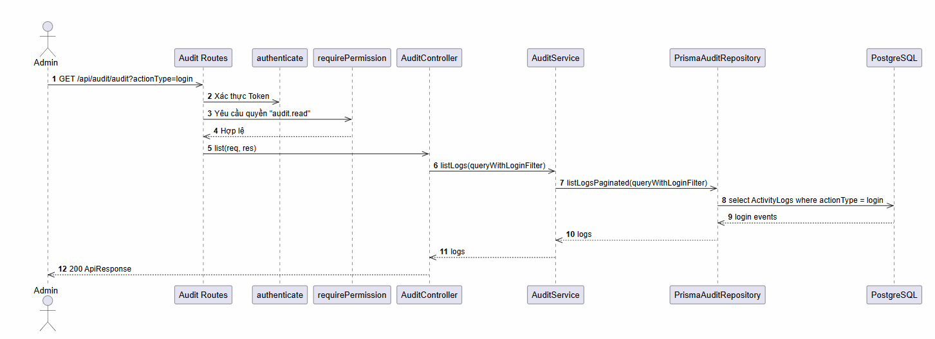

d. Database Queries
Fetch login/logout events for security auditing
SELECT id, employee_id, category, action_type, ip_address, details, created_at
FROM activity_logs
WHERE employee_id = :employeeId
AND category = 'auth'
ORDER BY created_at DESC
LIMIT :limit OFFSET :offset;

3. Application Module

3.1 Feature Application Approval and Management

a. Class Diagram
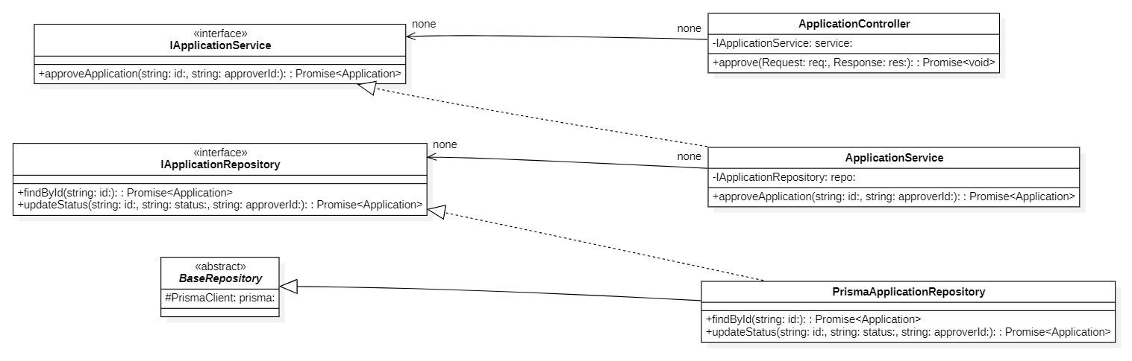

b. Class Specifications
ApplicationController Class
No | Method | Description
01 | constructor(service: IApplicationService) : void | Inputs: Input parameters: service: IApplicationService.  Outputs: Output: void.  Processing: Initializes a new instance of the ApplicationController class and injects required dependencies.

ApplicationService
No | Method | Description
01 | constructor(applicationRepo: IApplicationRepository, employeeShiftRepo: IEmployeeShiftRepository, workingShiftRepo: IWorkingShiftRepository, attendanceRepo: IAttendanceRepository) : void | Inputs: Input parameters: applicationRepo: IApplicationRepository, employeeShiftRepo: IEmployeeShiftRepository, workingShiftRepo: IWorkingShiftRepository, attendanceRepo: IAttendanceRepository.  Outputs: Output: void.  Processing: Initializes a new instance of the ApplicationService class and injects required dependencies.

PrismaApplicationRepository Class
No | Method | Description
01 | constructor(prisma: PrismaClient) : void | Inputs: Input parameters: prisma: PrismaClient.  Outputs: Output: void.  Processing: Initializes a new instance of the PrismaApplicationRepository class and injects required dependencies.

c. Sequence Diagram(s)

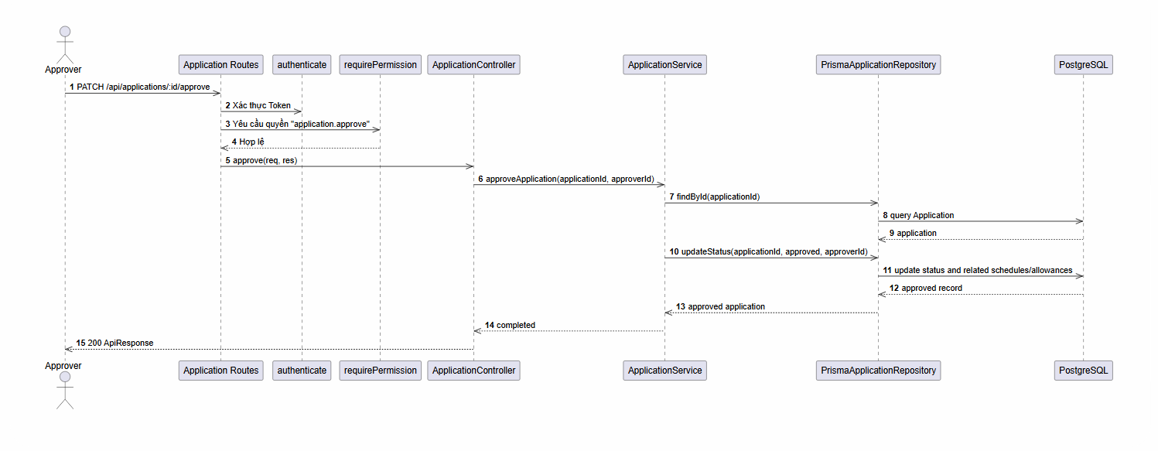

d. Database Queries
List pending applications assigned to an approver or managed team:
SELECT a.*, e.full_name AS employee_name
FROM applications a
LEFT JOIN employees e ON a.employee_id = e.id
WHERE a.status = 'pending'
AND (a.assigned_to_id = :approverId OR a.employee_id IN (:managedEmployeeIds));
Approve request:
UPDATE applications
SET status = 'approved', approved_by_id = :approvedById, approved_at = NOW()
WHERE id = :id;

3.2 Feature Create New Application

a. Class Diagram
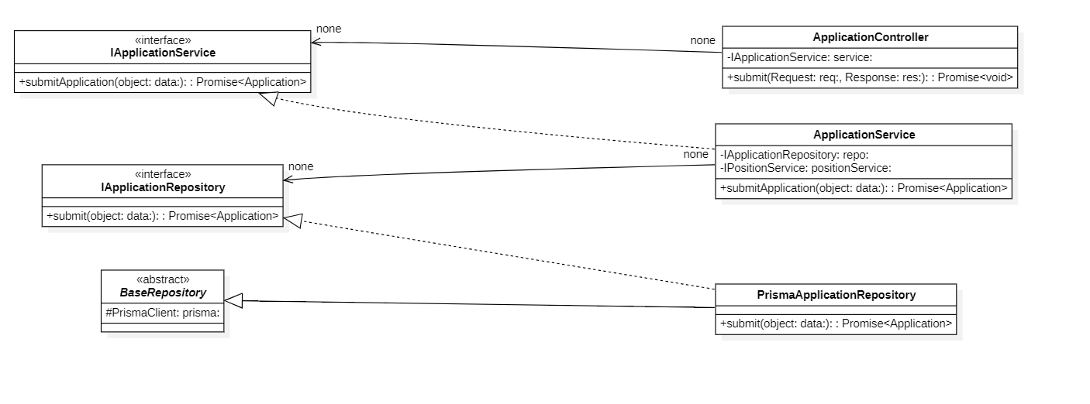

b. Class Specifications
ApplicationController Class
No | Method | Description
01 | constructor(service: IApplicationService) : void | Inputs: Input parameters: service: IApplicationService.  Outputs: Output: void.  Processing: Initializes a new instance of the ApplicationController class and injects required dependencies.

ApplicationService Class
No | Method | Description
01 | constructor(applicationRepo: IApplicationRepository, employeeShiftRepo: IEmployeeShiftRepository, workingShiftRepo: IWorkingShiftRepository, attendanceRepo: IAttendanceRepository) : void | Inputs: Input parameters: applicationRepo: IApplicationRepository, employeeShiftRepo: IEmployeeShiftRepository, workingShiftRepo: IWorkingShiftRepository, attendanceRepo: IAttendanceRepository.  Outputs: Output: void.  Processing: Initializes a new instance of the ApplicationService class and injects required dependencies.

PrismaApplicationRepository Class
No | Method | Description
01 | constructor(prisma: PrismaClient) : void | Inputs: Input parameters: prisma: PrismaClient.  Outputs: Output: void.  Processing: Initializes a new instance of the PrismaApplicationRepository class and injects required dependencies.

c. Sequence Diagram(s)
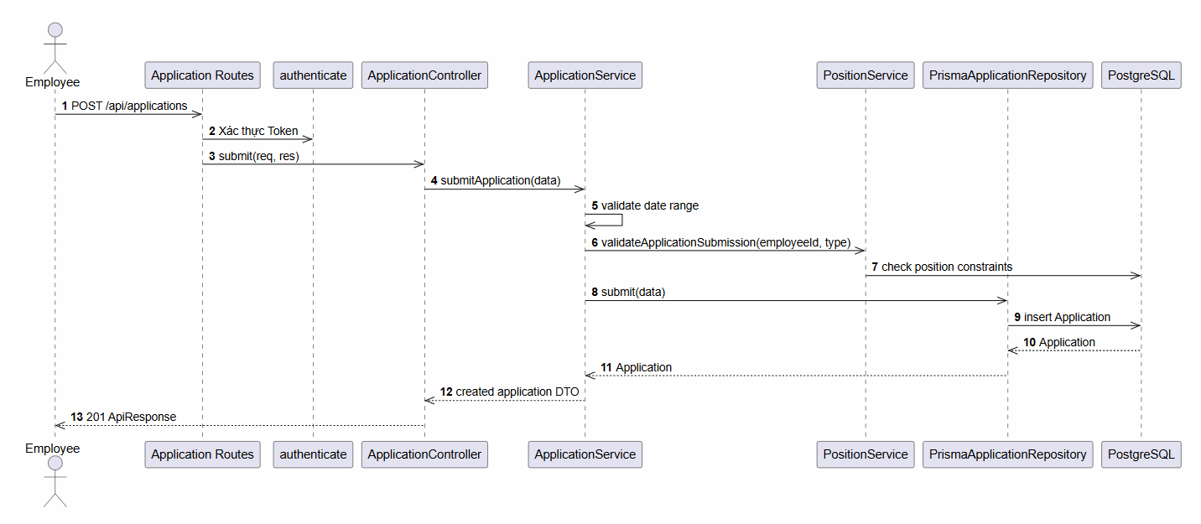

d. Database Queries
Insert a new application request:
INSERT INTO applications (employee_id, type, status, start_date, end_date, reason, note, assigned_to_id)
VALUES (:employeeId, :type, 'pending', :startDate, :endDate, :reason, :note, :assignedToId)
RETURNING id;
Verify date overlap before submission:
SELECT id
FROM applications
WHERE employee_id = :employeeId
AND status IN ('pending', 'approved')
AND type = 'leave'
AND start_date <= DATE(:endDate)
AND end_date >= DATE(:startDate)
LIMIT 1;

4. Attendance Module

4.1 Feature Attendance Dashboard

a. Class Diagram
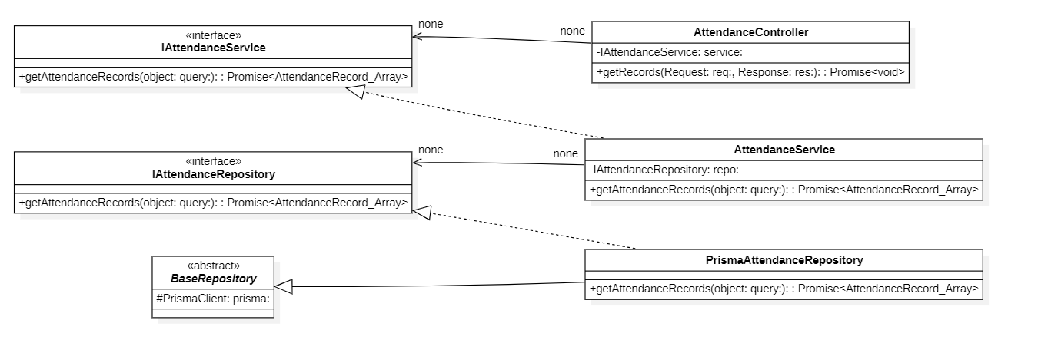

b. Class Specifications
AttendanceController Class
No | Method | Description
01 | constructor(service: IAttendanceService) : void | Inputs: Input parameters: service: IAttendanceService.  Outputs: Output: void.  Processing: Initializes a new instance of the AttendanceController class and injects required dependencies.

AttendanceService Class
No | Method | Description
01 | constructor(attendanceRepo: IAttendanceRepository, employeeShiftRepo: IEmployeeShiftRepository, scheduleRepo: IShiftScheduleRepository, holidayRepo: IHolidayRepository, workingShiftRepo: IWorkingShiftRepository, employeeRepo: IEmployeeRepository) : void | Inputs: Input parameters: attendanceRepo: IAttendanceRepository, employeeShiftRepo: IEmployeeShiftRepository, scheduleRepo: IShiftScheduleRepository, holidayRepo: IHolidayRepository, workingShiftRepo: IWorkingShiftRepository, employeeRepo: IEmployeeRepository.  Outputs: Output: void.  Processing: Initializes a new instance of the AttendanceService class and injects required dependencies.

PrismaAttendanceRepository Class
No | Method | Description
01 | constructor(prisma: PrismaClient) : void | Inputs: Input parameters: prisma: PrismaClient.  Outputs: Output: void.  Processing: Initializes a new instance of the PrismaAttendanceRepository class and injects required dependencies.

c. Sequence Diagram(s)
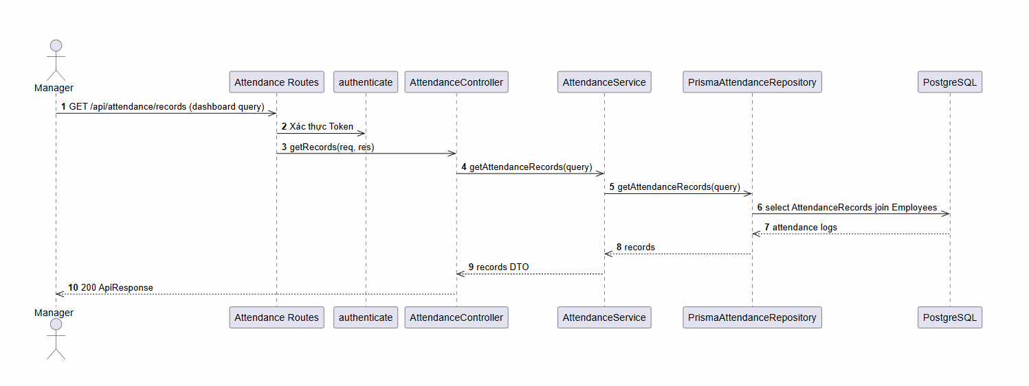

d. Database Queries
Check-in GPS coordinate scanning and record registration:
INSERT INTO attendance_records (employee_id, employee_shift_id, date, check_in_at, check_in_lat, check_in_lng, status)
VALUES (:employeeId, :employeeShiftId, CURRENT_DATE, NOW(), :lat, :lng, 'absent')
ON CONFLICT (employee_shift_id)
DO UPDATE SET
check_in_at = EXCLUDED.check_in_at,
check_in_lat = EXCLUDED.check_in_lat,
check_in_lng = EXCLUDED.check_in_lng;

4.2 Feature Attendance Summary

a. Class Diagram
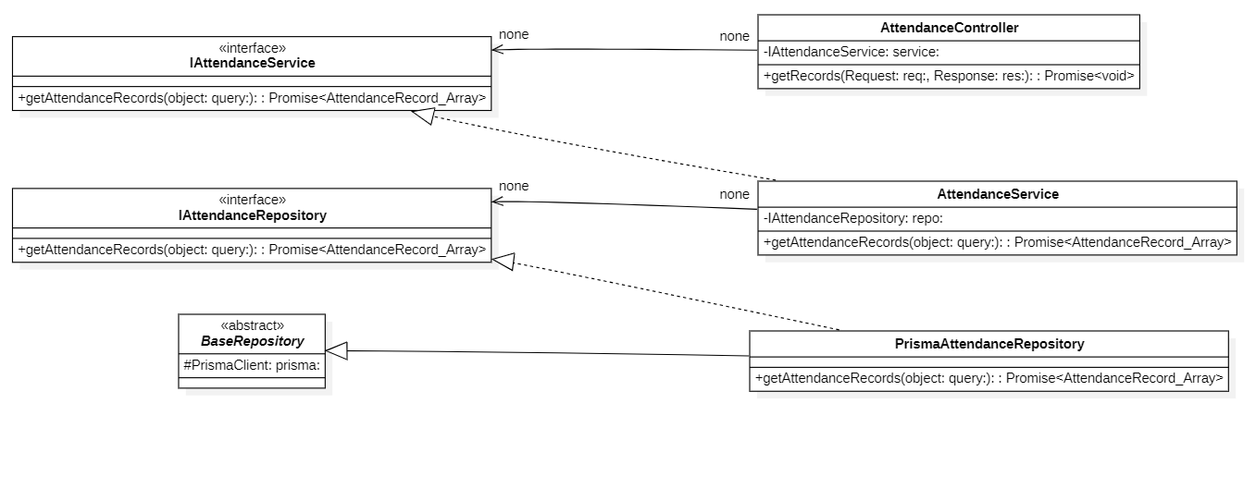

b. Class Specifications
AttendanceController Class
No | Method | Description
01 | constructor(service: IAttendanceService) : void | Inputs: Input parameters: service: IAttendanceService.  Outputs: Output: void.  Processing: Initializes a new instance of the AttendanceController class and injects required dependencies.

c. Sequence Diagram(s)
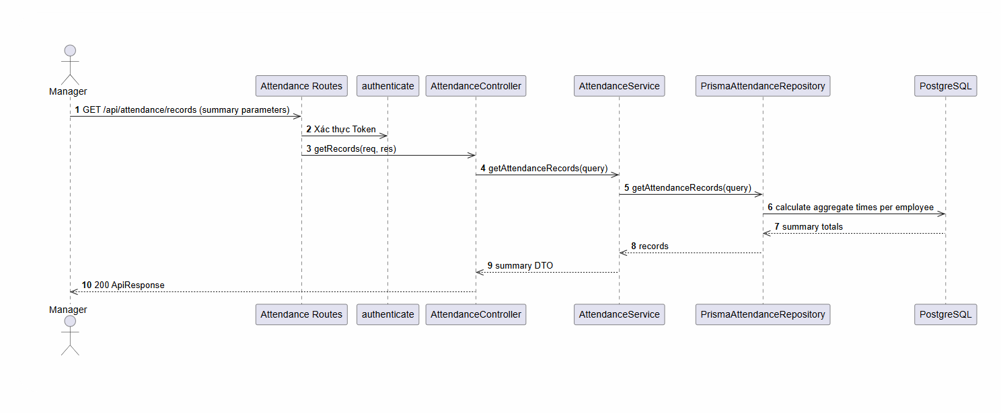

d. Database Queries
Retrieve employee monthly attendance record aggregate:
SELECT ar.*, es.shift_id, ws.name AS shift_name, rs.actual_start_time, rs.actual_end_time
FROM attendance_records ar
LEFT JOIN employee_shifts es ON ar.employee_shift_id = es.id
LEFT JOIN working_shifts ws ON es.shift_id = ws.id
LEFT JOIN real_shifts rs ON ar.id = rs.attendance_record_id
WHERE ar.employee_id = :employeeId
AND ar.date BETWEEN DATE(:startDate) AND DATE(:endDate)
ORDER BY ar.date DESC;

4.3 Feature General Work Schedule

a. Class Diagram
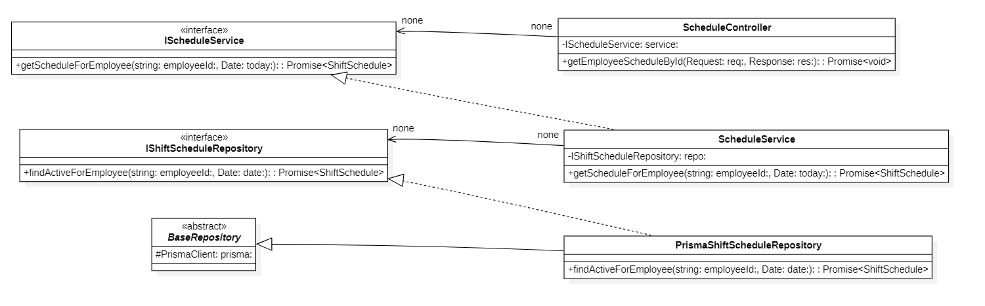

b. Class Specifications
AttendanceService Class
No | Method | Description
01 | constructor(attendanceRepo: IAttendanceRepository, employeeShiftRepo: IEmployeeShiftRepository, scheduleRepo: IShiftScheduleRepository, holidayRepo: IHolidayRepository, workingShiftRepo: IWorkingShiftRepository, employeeRepo: IEmployeeRepository) : void | Inputs: Input parameters: attendanceRepo: IAttendanceRepository, employeeShiftRepo: IEmployeeShiftRepository, scheduleRepo: IShiftScheduleRepository, holidayRepo: IHolidayRepository, workingShiftRepo: IWorkingShiftRepository, employeeRepo: IEmployeeRepository.  Outputs: Output: void.  Processing: Initializes a new instance of the AttendanceService class and injects required dependencies.

PrismaAttendanceRepository Class
No | Method | Description
01 | constructor(prisma: PrismaClient) : void | Inputs: Input parameters: prisma: PrismaClient.  Outputs: Output: void.  Processing: Initializes a new instance of the PrismaAttendanceRepository class and injects required dependencies.

ShiftController Class
No | Method | Description
01 | constructor(service: IShiftService) : void | Inputs: Input parameters: service: IShiftService.  Outputs: Output: void.  Processing: Initializes a new instance of the ShiftController class and injects required dependencies.

ShiftService Class
No | Method | Description
01 | constructor(shiftRepo: IWorkingShiftRepository) : void | Inputs: Input parameters: shiftRepo: IWorkingShiftRepository.  Outputs: Output: void.  Processing: Initializes a new instance of the ShiftService class and injects required dependencies.

PrismaWorkingShiftRepository Class
No | Method | Description
01 | constructor(prisma: PrismaClient) : void | Inputs: Input parameters: prisma: PrismaClient.  Outputs: Output: void.  Processing: Initializes a new instance of the PrismaWorkingShiftRepository class and injects required dependencies.

c. Sequence Diagram(s)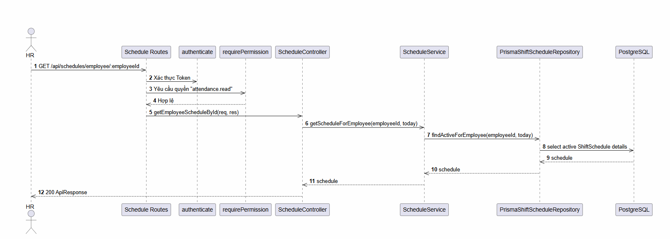

d. Database QueriesFind the current active schedule template for an employee:
SELECT *
FROM shift_schedules
WHERE employee_id = :employeeId
AND valid_from <= DATE(:targetDate)
AND (valid_to IS NULL OR valid_to >= DATE(:targetDate))
ORDER BY valid_from DESC
LIMIT 1;

4.4 Feature Part-time Availability Shift Scheduling

a. Class Diagram
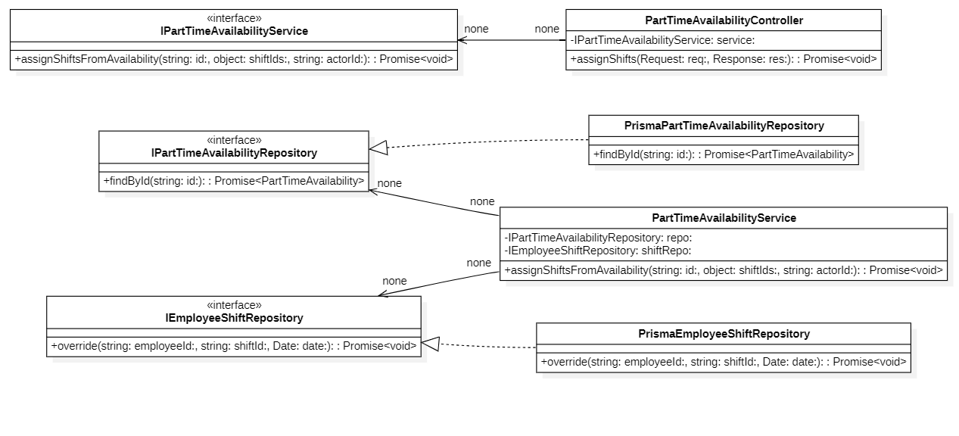

b. Class Specifications
ShiftController Class
No | Method | Description
01 | constructor(service: IShiftService) : void | Inputs: Input parameters: service: IShiftService.  Outputs: Output: void.  Processing: Initializes a new instance of the ShiftController class and injects required dependencies

ShiftService Class
No | Method | Description
01 | constructor(shiftRepo: IWorkingShiftRepository) : void | Inputs: Input parameters: shiftRepo: IWorkingShiftRepository.  Outputs: Output: void.  Processing: Initializes a new instance of the ShiftService class and injects required dependencies.

PrismaWorkingShiftRepository Class
No | Method | Description
01 | constructor(prisma: PrismaClient) : void | Inputs: Input parameters: prisma: PrismaClient.  Outputs: Output: void.  Processing: Initializes a new instance of the PrismaWorkingShiftRepository class and injects required dependencies.

c. Sequence Diagram(s)

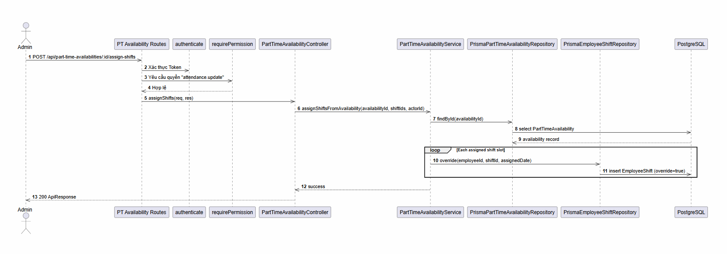

d. Database Queries
Override part-time shifts based on registered availability:
-- Clear out prior overrides for scheduled dates
DELETE FROM employee_shifts
WHERE employee_id = :employeeId
AND assigned_date IN (:dates)
AND is_override = TRUE;

-- Batch insert newly assigned shifts
INSERT INTO employee_shifts (employee_id, assigned_date, shift_id, is_override, status, created_by_id)
VALUES (:employeeId, DATE(:assignedDate), :shiftId, TRUE, 'scheduled', :createdById);

4.5 Feature Weekly Shift Schedule

a. Class Diagram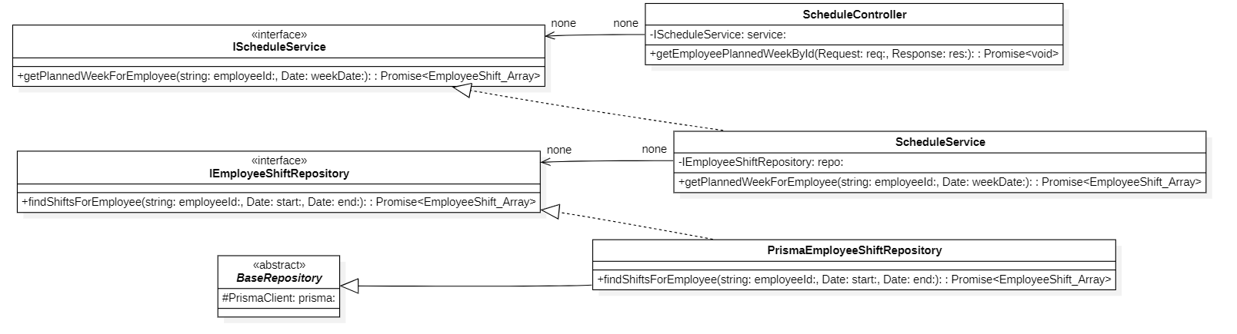

b. Class Specifications
ShiftController Class
No | Method | Description
01 | constructor(service: IShiftService) : void | Inputs: Input parameters: service: IShiftService.  Outputs: Output: void.  Processing: Initializes a new instance of the ShiftController class and injects required dependencies.

ShiftService Class
No | Method | Description
01 | constructor(shiftRepo: IWorkingShiftRepository) : void | Inputs: Input parameters: shiftRepo: IWorkingShiftRepository.  Outputs: Output: void.  Processing: Initializes a new instance of the ShiftService class and injects required dependencies.

PrismaWorkingShiftRepository Class
No | Method | Description
01 | constructor(prisma: PrismaClient) : void | Inputs: Input parameters: prisma: PrismaClient.  Outputs: Output: void.  Processing: Initializes a new instance of the PrismaWorkingShiftRepository class and injects required dependencies.

c. Sequence Diagram(s)

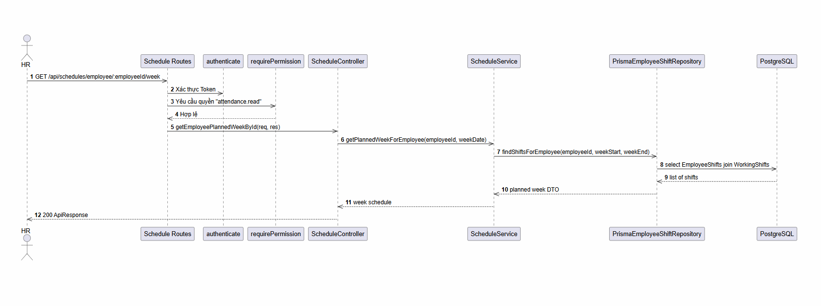

d. Database Queries
List all weekly shift templates
SELECT *
FROM weekly_schedule_templates
ORDER BY created_at DESC;

4.6 Feature Weekly Default Shift Configuration

a. Class Diagram
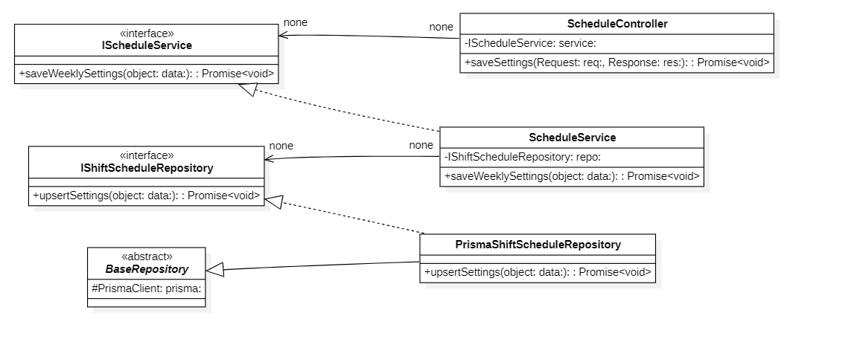

b. Class Specifications
ShiftController Class
No | Method | Description
01 | constructor(service: IShiftService) : void | Inputs: Input parameters: service: IShiftService.  Outputs: Output: void.  Processing: Initializes a new instance of the ShiftController class and injects required dependencies

ShiftService Class
No | Method | Description
01 | constructor(shiftRepo: IWorkingShiftRepository) : void | Inputs: Input parameters: shiftRepo: IWorkingShiftRepository.  Outputs: Output: void.  Processing: Initializes a new instance of the ShiftService class and injects required dependencies.

PrismaWorkingShiftRepository Class
No | Method | Description
01 | constructor(prisma: PrismaClient) : void | Inputs: Input parameters: prisma: PrismaClient.  Outputs: Output: void.  Processing: Initializes a new instance of the PrismaWorkingShiftRepository class and injects required dependencies.

c. Sequence Diagram(s)

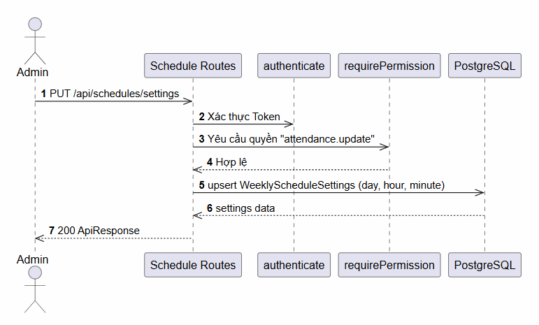

d. Database Queries
Insert a new rotating weekly schedule template
INSERT INTO weekly_schedule_templates (name, description, cycle_weeks, is_active, created_by_id)
VALUES (:name, :description, :cycleWeeks, :isActive, :createdById)
RETURNING id;

4.7 Feature Actual Work Shifts

a. Class Diagram
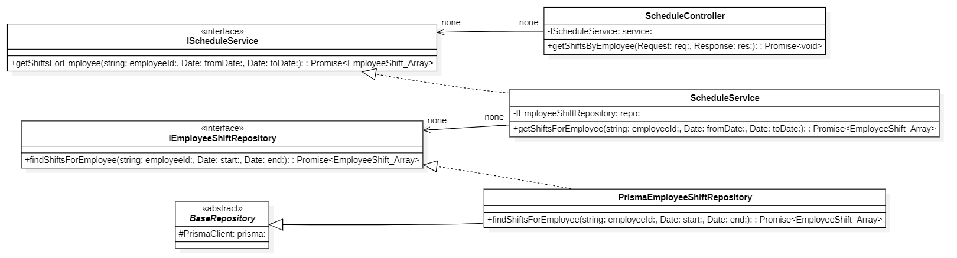

b. Class Specifications
ShiftController Class
No | Method | Description
01 | constructor(service: IShiftService) : void | Inputs: Input parameters: service: IShiftService.  Outputs: Output: void.  Processing: Initializes a new instance of the ShiftController class and injects required dependencies.

ShiftService Class
No | Method | Description
01 | constructor(shiftRepo: IWorkingShiftRepository) : void | Inputs: Input parameters: shiftRepo: IWorkingShiftRepository.  Outputs: Output: void.  Processing: Initializes a new instance of the ShiftService class and injects required dependencies.

PrismaWorkingShiftRepository Class
No | Method | Description
01 | constructor(prisma: PrismaClient) : void | Inputs: Input parameters: prisma: PrismaClient.  Outputs: Output: void.  Processing: Initializes a new instance of the PrismaWorkingShiftRepository class and injects required dependencies.

c. Sequence Diagram(s)

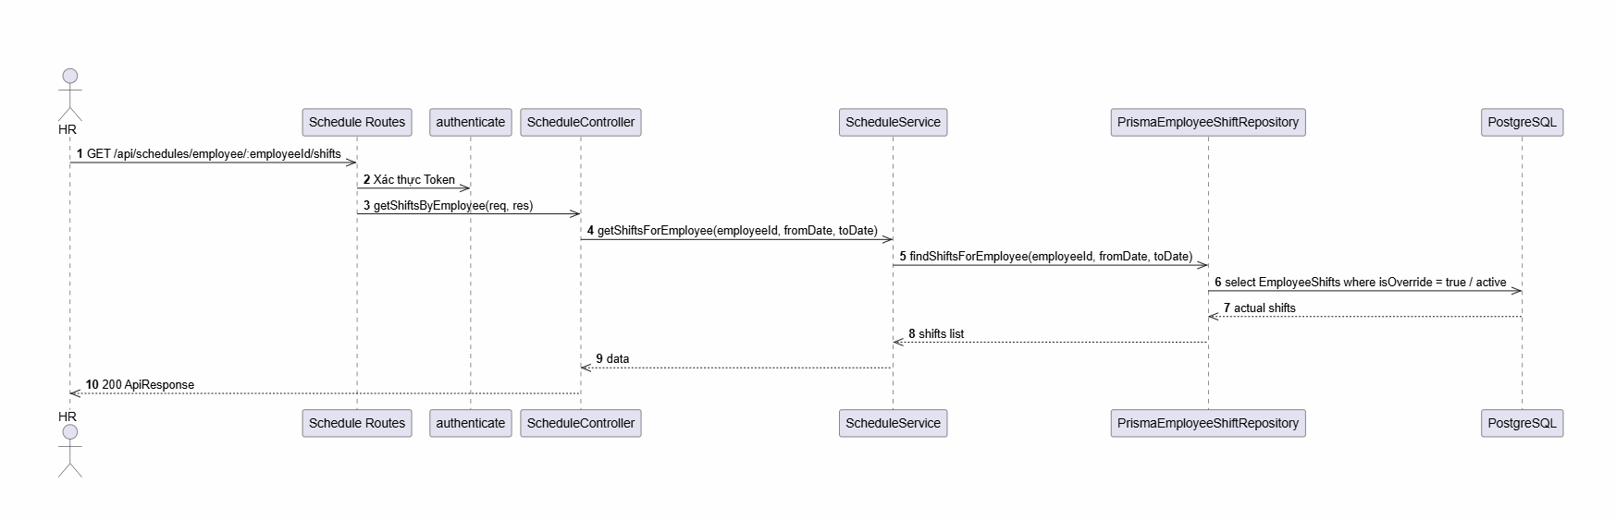

d. Database Queries
Upsert actual worked hours (real shift durations) on Check-out
INSERT INTO real_shifts (employee_id, attendance_record_id, date, actual_start_time, actual_end_time, is_matched)
VALUES (:employeeId, :attendanceRecordId, CURRENT_DATE, :startTime, :endTime, :isMatched)
ON CONFLICT (attendance_record_id)
DO UPDATE SET
actual_end_time = EXCLUDED.actual_end_time,
is_matched = EXCLUDED.is_matched;

4.8 Feature Shift List Management

a. Class Diagram
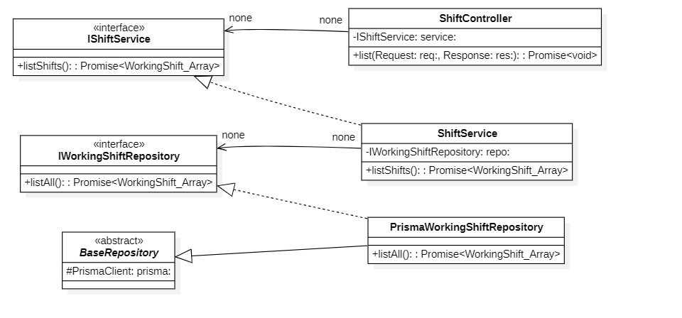

b. Class Specifications
ShiftController Class
No | Method | Description
01 | constructor(service: IShiftService) : void | Inputs: Input parameters: service: IShiftService.  Outputs: Output: void.  Processing: Initializes a new instance of the ShiftController class and injects required dependencies. .

ShiftService Class
No | Method | Description
01 | constructor(shiftRepo: IWorkingShiftRepository) : void | Inputs: Input parameters: shiftRepo: IWorkingShiftRepository.  Outputs: Output: void.  Processing: Initializes a new instance of the ShiftService class and injects required dependencies.

PrismaWorkingShiftRepository Class
No | Method | Description
01 | constructor(prisma: PrismaClient) : void | Inputs: Input parameters: prisma: PrismaClient.  Outputs: Output: void.  Processing: Initializes a new instance of the PrismaWorkingShiftRepository class and injects required dependencies.

c. Sequence Diagram(s)

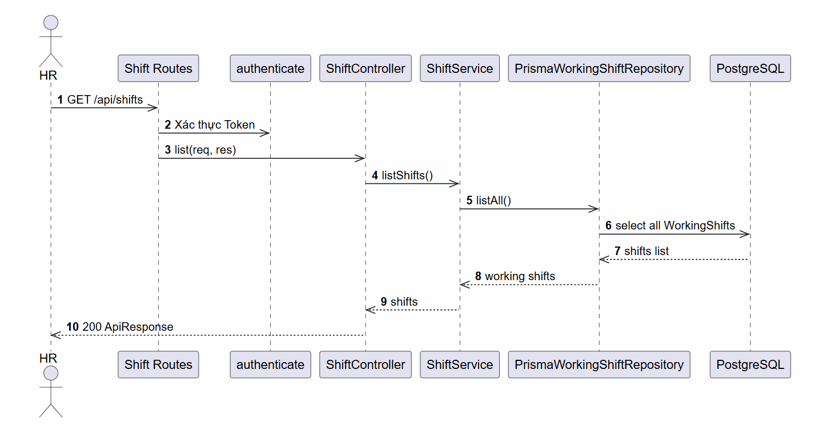

d. Database Queries
Add, update, or remove working shifts (shift master data)
-- Insert new shift configuration
INSERT INTO working_shifts (name, start_time, end_time, break_start_time, break_end_time, gps_lat, gps_lng, gps_radius_meters)
VALUES (:name, :startTime, :endTime, :breakStartTime, :breakEndTime, :gpsLat, :gpsLng, :gpsRadiusMeters);

-- Delete shift
DELETE FROM working_shifts WHERE id = :id;

4.9 Feature Holiday Management

a. Class Diagram
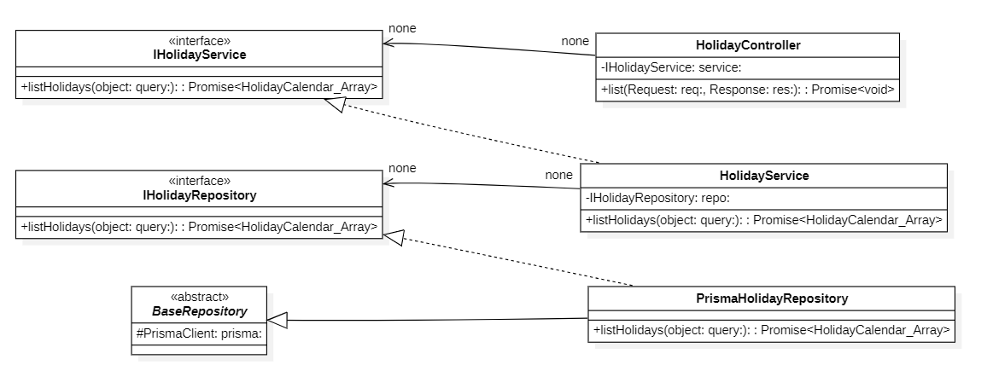

b. Class Specifications
HolidayController Class
No | Method | Description
01 | constructor(service: IHolidayService) : void | Inputs: Input parameters: service: IHolidayService.  Outputs: Output: void.  Processing: Initializes a new instance of the HolidayController class and injects required dependencies.

HolidayService Class
No | Method | Description
01 | constructor(holidayRepo: IHolidayRepository) : void | Inputs: Input parameters: holidayRepo: IHolidayRepository.  Outputs: Output: void.  Processing: Initializes a new instance of the HolidayService class and injects required dependencies.

PrismaWorkingShiftRepository Class
No | Method | Description
01 | constructor(prisma: PrismaClient) : void | Inputs: Input parameters: prisma: PrismaClient.  Outputs: Output: void.  Processing: Initializes a new instance of the PrismaHolidayRepository class and injects required dependencies.

c. Sequence Diagram(s)
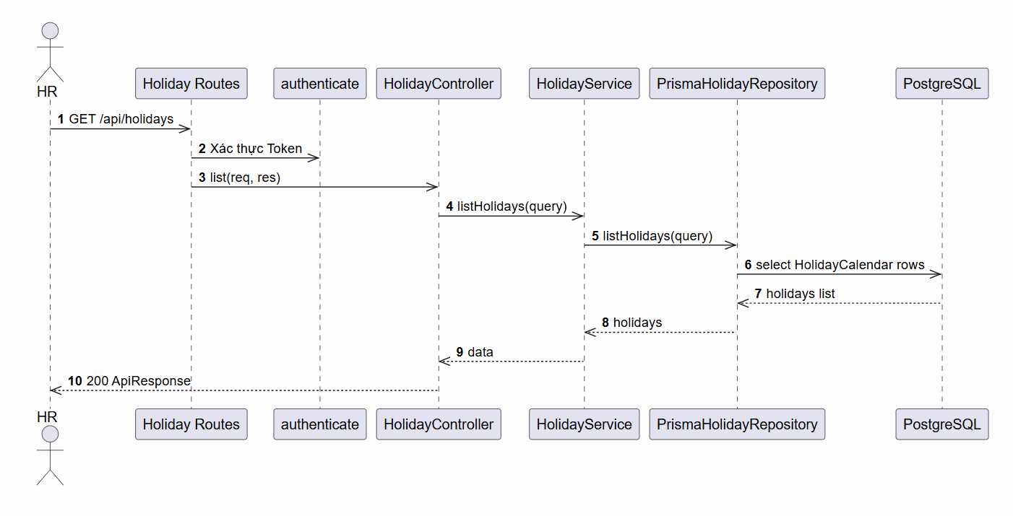

d. Database Queries
Mark affected employee shifts as holiday pending:
UPDATE employee_shifts
SET status = 'holiday_pending'
WHERE assigned_date BETWEEN DATE(:start) AND DATE(:end)
AND status = 'scheduled'
AND (:employeeIds IS NULL OR employee_id IN (:employeeIds));

5. Payroll Module

5.1 Feature Payroll Period Management

a. Class Diagram
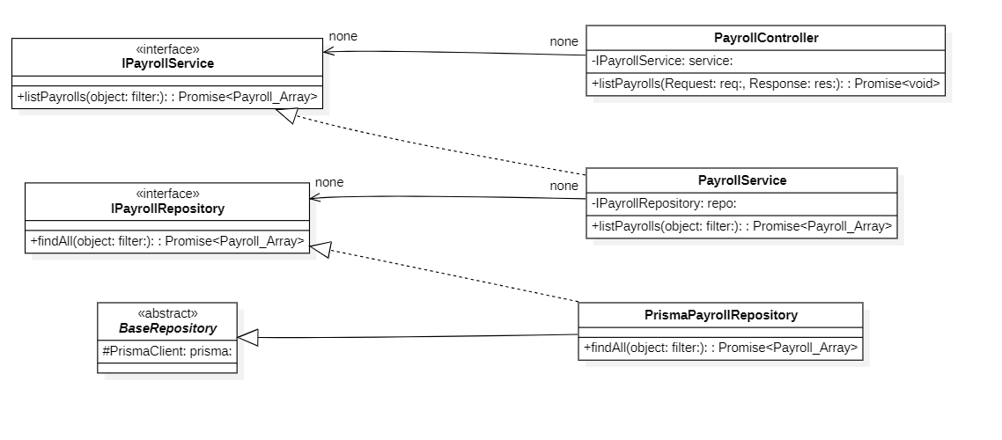

b. Class Specifications
PayrollController Class

No | Method | Description
01 | constructor(service: IPayrollService) : void | Inputs: Input parameters: service: IPayrollService.  Outputs: Output: void.  Processing: Initializes a new instance of the PayrollController class and injects required dependencies.

PayrollService Class

No | Method | Description
01 | constructor(payrollRepo: IPayrollRepository, payslipRepo: IPayslipRepository, salaryConfigRepo: IEmployeeSalaryConfigRepository) : void | Inputs: Input parameters: payrollRepo: IPayrollRepository, payslipRepo: IPayslipRepository, salaryConfigRepo: IEmployeeSalaryConfigRepository.  Outputs: Output: void.  Processing: Initializes a new instance of the PayrollService class and injects required dependencies.

PrismaPayrollRepository Class

No | Method | Description
01 | constructor(prisma: PrismaClient) : void | Inputs: Input parameters: prisma: PrismaClient.  Outputs: Output: void.  Processing: Initializes a new instance of the PrismaPayrollRepository class and injects required dependencies.

c. Sequence Diagram(s)
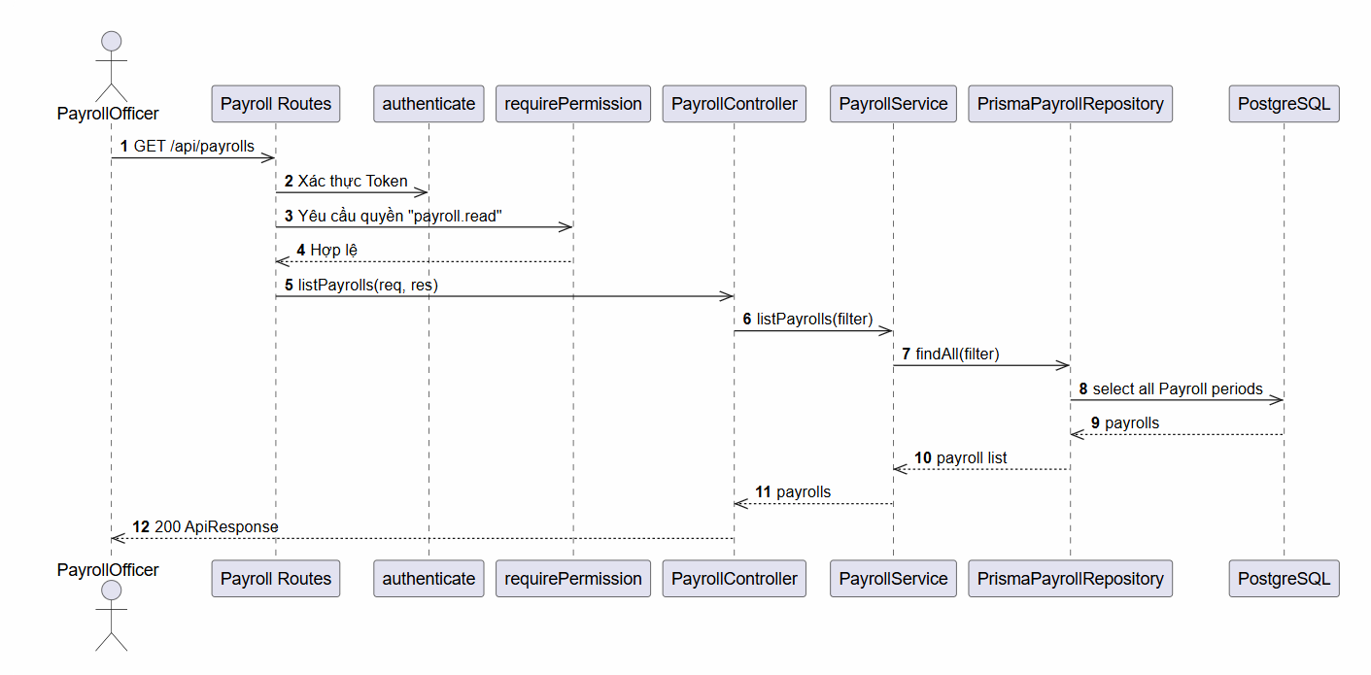

d. Database Queries
Look up payroll period metadata
SELECT *
FROM payrolls
WHERE period_month = :month
AND period_year = :year
AND name = :name;

5.2 Feature Salary Component Management

a. Class Diagram
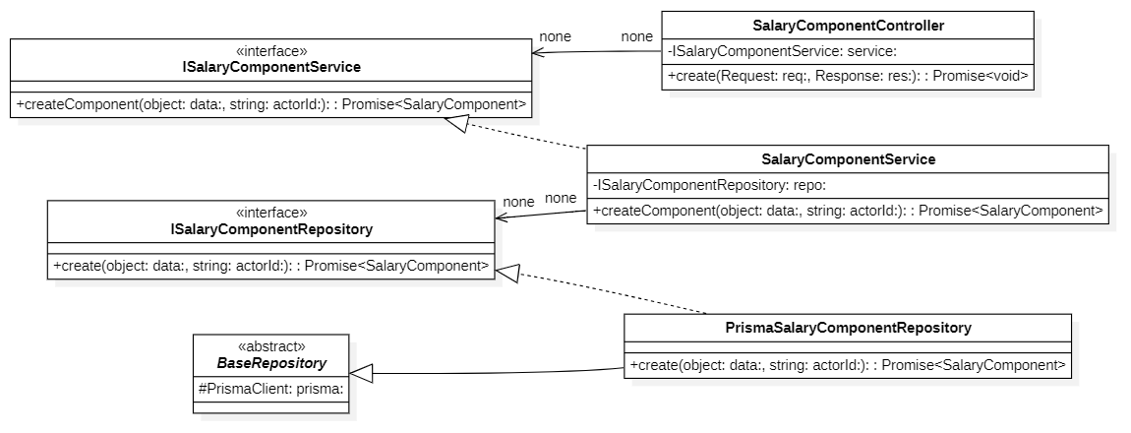

b. Class Specifications
SalaryComponentController Class

No | Method | Description
01 | constructor(service: ISalaryComponentService) : void | Inputs: Input parameters: service: ISalaryComponentService.  Outputs: Output: void.  Processing: Initializes a new instance of the SalaryComponentController class and injects required dependencies.

SalaryComponentService Class

No | Method | Description
01 | constructor(repo: ISalaryComponentRepository) : void | Inputs: Input parameters: repo: ISalaryComponentRepository.  Outputs: Output: void.  Processing: Initializes a new instance of the SalaryComponentService class and injects required dependencies.

PrismaSalaryComponentRepository Class

No | Method | Description
01 | constructor(prisma: PrismaClient) : void | Inputs: Input parameters: prisma: PrismaClient.  Outputs: Output: void.  Processing: Initializes a new instance of the PrismaSalaryComponentRepository class and injects required dependencies.

c. Sequence Diagram(s)
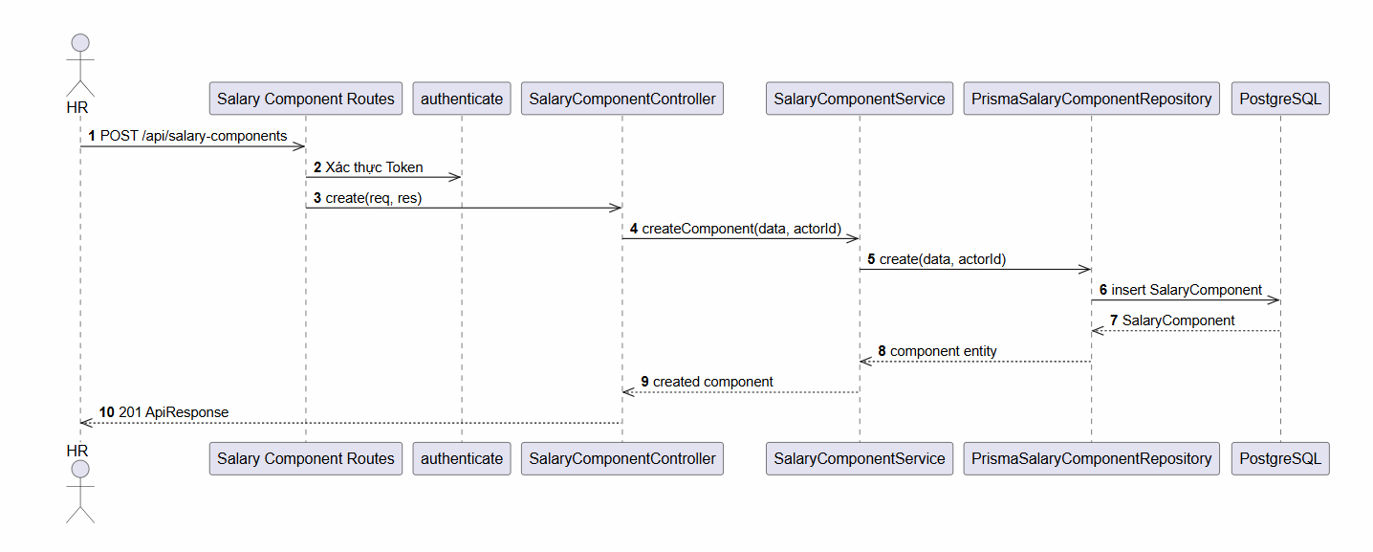

d. Database Queries
Add or deactivate formula components
INSERT INTO salary_components (name, type, formula, description, created_by_id)
VALUES (:name, :type, :formula, :description, :createdById);

UPDATE salary_components SET is_active = FALSE WHERE id = :id;

5.3 Feature Payroll Variable Management

a. Class Diagram
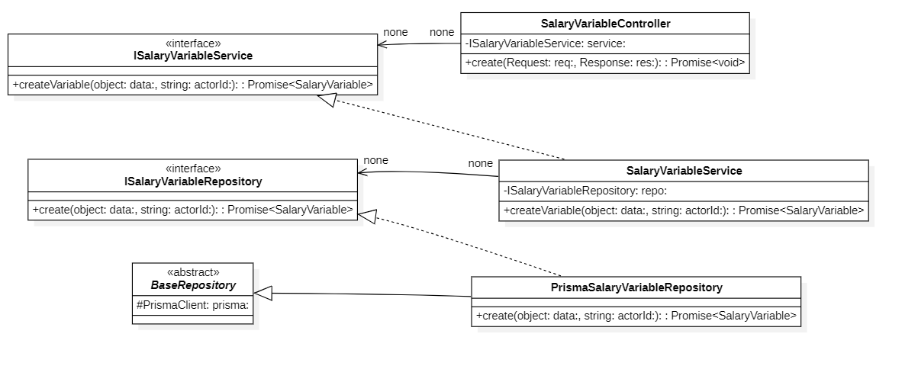

b. Class Specifications
SalaryVariableController Class

No | Method | Description
01 | constructor(service: ISalaryVariableService) : void | Inputs: Input parameters: service: ISalaryVariableService.  Outputs: Output: void.  Processing: Initializes a new instance of the SalaryVariableController class and injects required dependencies.

SalaryVariableService Class

No | Method | Description
01 | constructor(repo: ISalaryVariableRepository) : void | Inputs: Input parameters: repo: ISalaryVariableRepository.  Outputs: Output: void.  Processing: Initializes a new instance of the SalaryVariableService class and injects required dependencies.

PrismaSalaryVariableRepository Class

No | Method | Description
01 | constructor(prisma: PrismaClient) : void | Inputs: Input parameters: prisma: PrismaClient.  Outputs: Output: void.  Processing: Initializes a new instance of the PrismaSalaryVariableRepository class and injects required dependencies. .

c. Sequence Diagram(s)

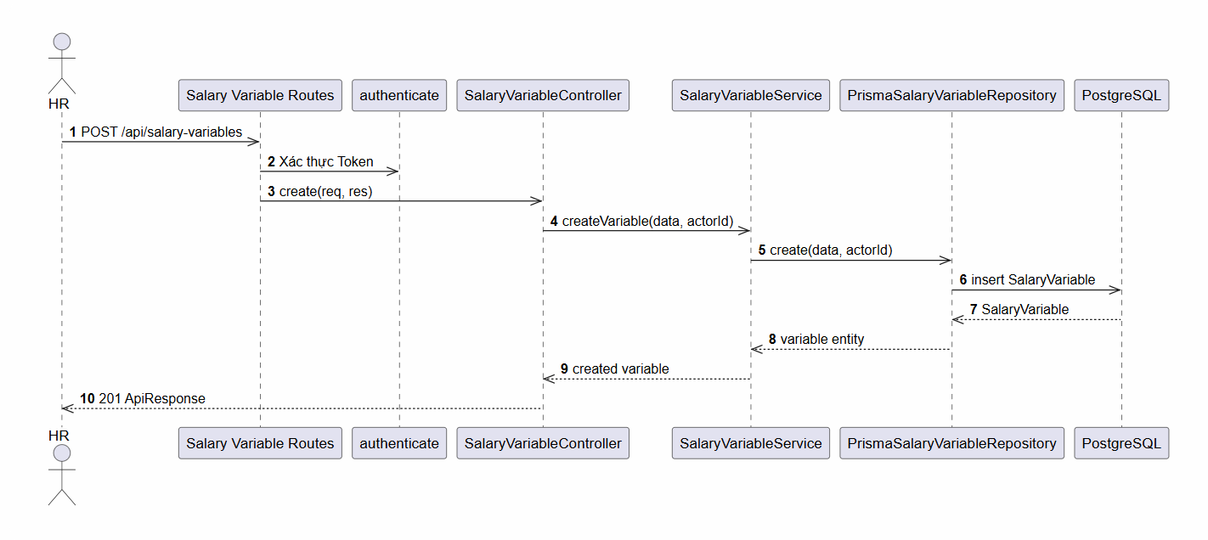

d. Database Queries
Manage global values/rules driving salary calculations:
INSERT INTO salary_variables (code, name, value, description, created_by_id)
VALUES (:code, :name, :value, :description, :createdById);

5.4 Feature Payslip Template Management

a. Class Diagram
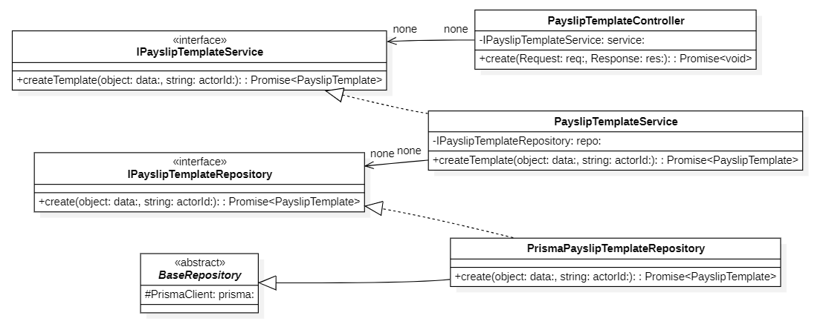

b. Class Specifications
PayslipTemplateController Class

No | Method | Description
01 | constructor(service: IPayslipTemplateService) : void | Inputs: Input parameters: service: IPayslipTemplateService.  Outputs: Output: void.  Processing: Initializes a new instance of the PayslipTemplateController class and injects required dependencies.

PayslipTemplateService Class

No | Method | Description
01 | constructor(repo: IPayslipTemplateRepository) : void | Inputs: Input parameters: repo: IPayslipTemplateRepository.  Outputs: Output: void.  Processing: Initializes a new instance of the PayslipTemplateService class and injects required dependencies.

PrismaPayslipTemplateRepository Class

No | Method | Description
01 | constructor(prisma: PrismaClient) : void | Inputs: Input parameters: prisma: PrismaClient.  Outputs: Output: void.  Processing: Initializes a new instance of the PrismaPayslipTemplateRepository class and injects required dependencies.

c. Sequence Diagram(s)

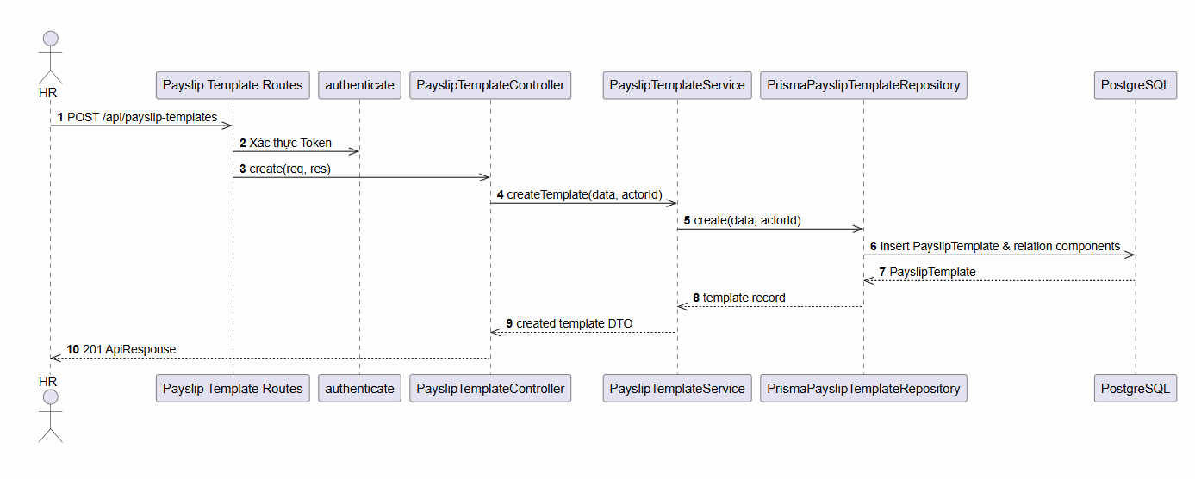

d. Database Queries
Define and assign components to payslip layouts
INSERT INTO payslip_templates (name, description, created_by_id)
VALUES (:name, :description, :createdById) RETURNING id;

INSERT INTO payslip_template_components (template_id, component_id, override_formula)
VALUES (:templateId, :componentId, :overrideFormula);

5.5 Feature Payroll Cycle Management

a. Class Diagram
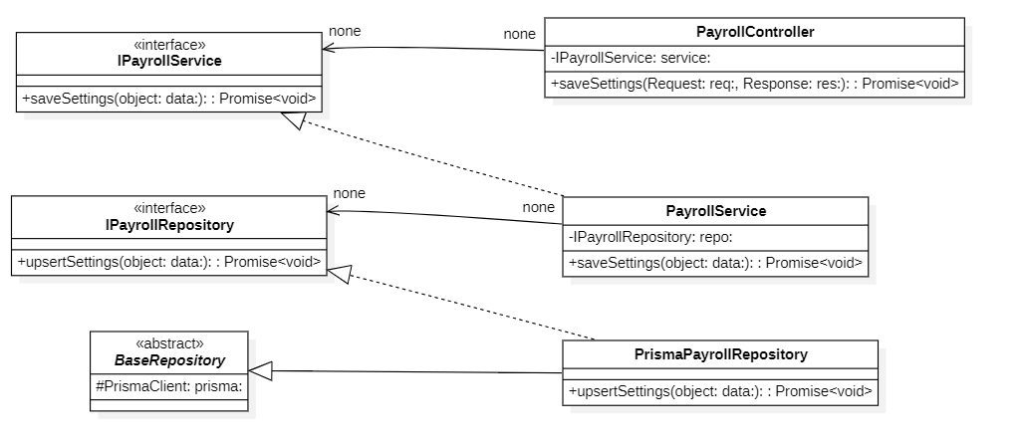

b. Class Specifications
PayrollController Class

No | Method | Description
01 | constructor(service: IPayrollService) : void | Inputs: Input parameters: service: IPayrollService.  Outputs: Output: void.  Processing: Initializes a new instance of the PayrollController class and injects required dependencies.

PayrollService Class

No | Method | Description
01 | constructor(payrollRepo: IPayrollRepository, payslipRepo: IPayslipRepository, salaryConfigRepo: IEmployeeSalaryConfigRepository) : void | Inputs: Input parameters: payrollRepo: IPayrollRepository, payslipRepo: IPayslipRepository, salaryConfigRepo: IEmployeeSalaryConfigRepository.  Outputs: Output: void.  Processing: Initializes a new instance of the PayrollService class and injects required dependencies.

PrismaPayrollRepository Class

No | Method | Description
01 | constructor(prisma: PrismaClient) : void | Inputs: Input parameters: prisma: PrismaClient.  Outputs: Output: void.  Processing: Initializes a new instance of the PrismaPayrollRepository class and injects required dependencies.

c. Sequence Diagram(s)

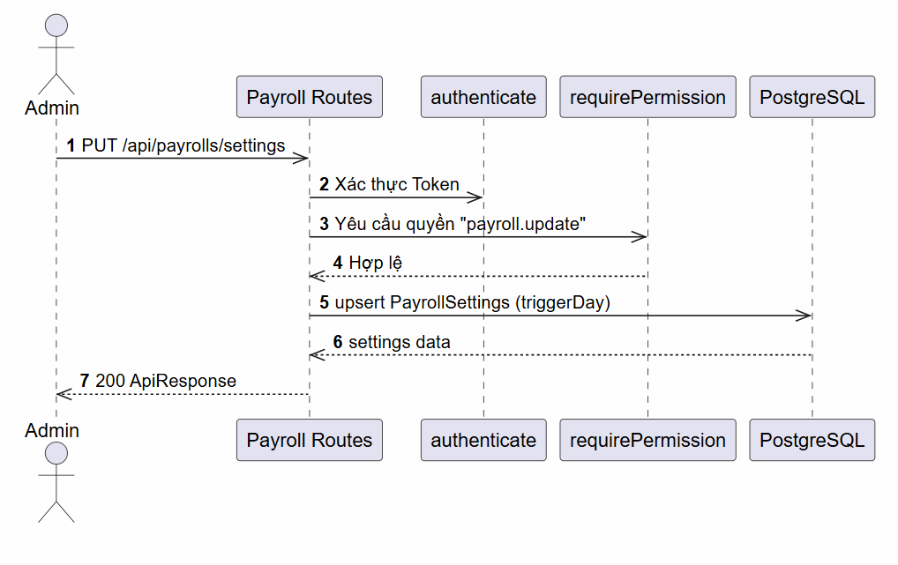

d. Database Queries
Bulk generate payslips during a calculation run:
INSERT INTO payslips (payroll_id, employee_id, salary_config_id, total_additions, total_deductions, net_salary, working_days, absent_days, overtime_minutes)
VALUES (:payrollId, :employeeId, :salaryConfigId, :totalAdditions, :totalDeductions, :netSalary, :workingDays, :absentDays, :overtimeMinutes);

5.6 Feature Employee Salary Management

a. Class Diagram
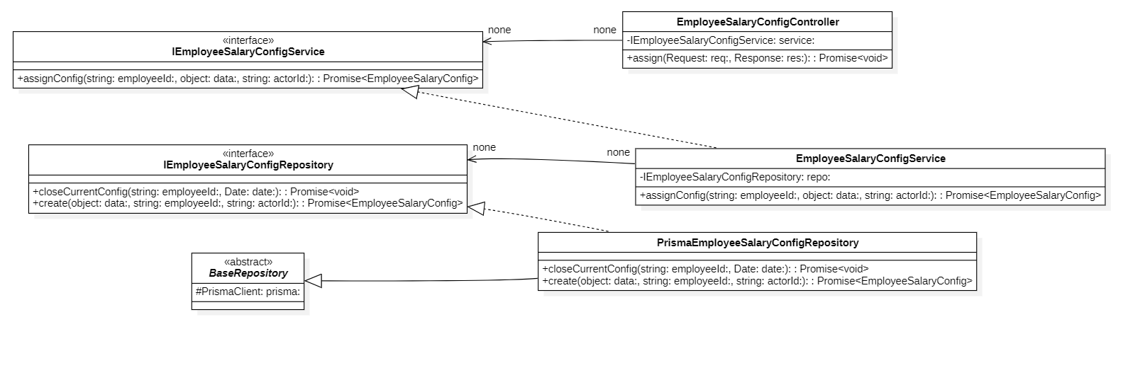

b. Class Specifications
EmployeeSalaryConfigController Class

No | Method | Description
01 | constructor(service: IEmployeeSalaryConfigService) : void | Inputs: Input parameters: service: IEmployeeSalaryConfigService.  Outputs: Output: void.  Processing: Initializes a new instance of the EmployeeSalaryConfigController class and injects required dependencies.

EmployeeSalaryConfigService Class

No | Method | Description
01 | constructor(repo: IEmployeeSalaryConfigRepository) : void | Inputs: Input parameters: repo: IEmployeeSalaryConfigRepository.  Outputs: Output: void.  Processing: Initializes a new instance of the EmployeeSalaryConfigService class and injects required dependencies.

PrismaEmployeeSalaryConfigRepository Class

No | Method | Description
01 | constructor(prisma: PrismaClient) : void | Inputs: Input parameters: prisma: PrismaClient.  Outputs: Output: void.  Processing: Initializes a new instance of the PrismaEmployeeSalaryConfigRepository class and injects required dependencies.

c. Sequence Diagram(s)
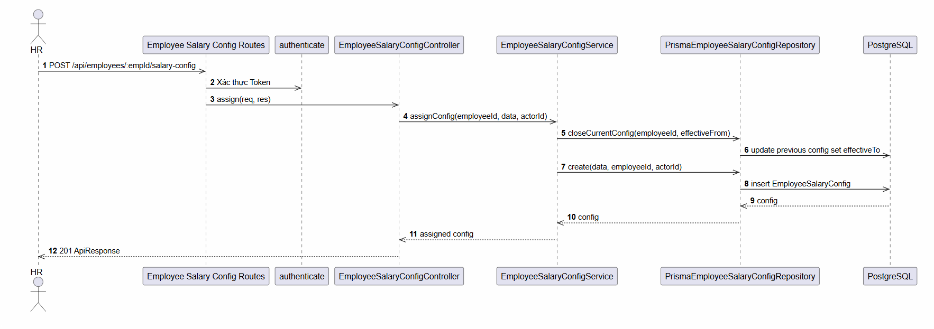

d. Database Queries
Fetch currently active salary configuration for an employee:
SELECT *
FROM employee_salary_configs
WHERE employee_id = :employeeId
AND effective_from <= :atDate
AND (effective_to IS NULL OR effective_to >= :atDate)
ORDER BY effective_from DESC
LIMIT 1;

6. Project Module

6.1 Feature Project List

a. Class Diagram
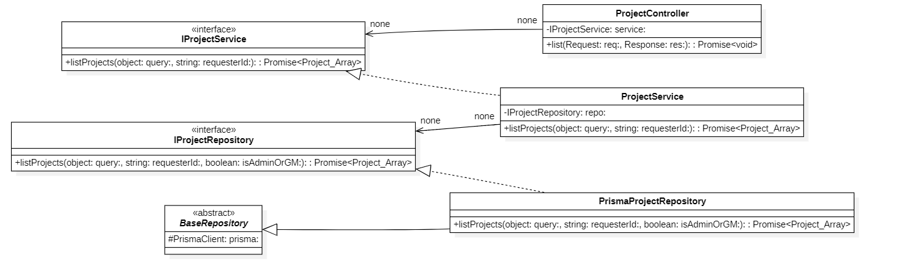

b. Class Specifications
ProjectController Class

No | Method | Description
01 | constructor(service: IProjectService) : void | Inputs: Input parameters: service: IProjectService.  Outputs: Output: void.  Processing: Initializes a new instance of the ProjectController class and injects required dependencies.
02 | list(req: AuthRequest, res: Response) : Promise | Inputs: Input parameters: req: AuthRequest, res: Response.  Outputs: Output: Promise.  Processing: Queries the database or processes business logic to retrieve/find data based on the specified input criteria.
03 | getOne(req: AuthRequest, res: Response) : Promise | Inputs: Input parameters: req: AuthRequest, res: Response.  Outputs: Output: Promise.  Processing: Queries the database or processes business logic to retrieve/find data based on the specified input criteria.
04 | create(req: AuthRequest, res: Response) : Promise | Inputs: Input parameters: req: AuthRequest, res: Response.  Outputs: Output: Promise.  Processing: Validates the input data and inserts a new record into the database.
05 | update(req: AuthRequest, res: Response) : Promise | Inputs: Input parameters: req: AuthRequest, res: Response.  Outputs: Output: Promise.  Processing: Verifies existence, validates new input data, and updates the record in the database.
06 | delete(req: AuthRequest, res: Response) : Promise | Inputs: Input parameters: req: AuthRequest, res: Response.  Outputs: Output: Promise.  Processing: Performs a deletion (either soft or hard delete) of the record from the database.
07 | addMember(req: AuthRequest, res: Response) : Promise | Inputs: Input parameters: req: AuthRequest, res: Response.  Outputs: Output: Promise.  Processing: Validates the input data and inserts a new record into the database.
08 | removeMember(req: AuthRequest, res: Response) : Promise | Inputs: Input parameters: req: AuthRequest, res: Response.  Outputs: Output: Promise.  Processing: Performs a deletion (either soft or hard delete) of the record from the database.
09 | getMembers(req: AuthRequest, res: Response) : Promise | Inputs: Input parameters: req: AuthRequest, res: Response.  Outputs: Output: Promise.  Processing: Queries the database or processes business logic to retrieve/find data based on the specified input criteria.
10 | getGanttData(req: AuthRequest, res: Response) : Promise | Inputs: Input parameters: req: AuthRequest, res: Response.  Outputs: Output: Promise.  Processing: Queries the database or processes business logic to retrieve/find data based on the specified input criteria.
11 | updateMember(req: AuthRequest, res: Response) : Promise | Inputs: Input parameters: req: AuthRequest, res: Response.  Outputs: Output: Promise.  Processing: Verifies existence, validates new input data, and updates the record in the database
ProjectService Class

No | Method | Description
01 | constructor(repository: IProjectRepository, employeeRepository: IEmployeeRepository, prisma: PrismaClient, statusService?: IProjectTaskStatusService) : void | Inputs: Input parameters: repository: IProjectRepository, employeeRepository: IEmployeeRepository, prisma: PrismaClient, statusService?: IProjectTaskStatusService.  Outputs: Output: void.  Processing: Initializes a new instance of the ProjectService class and injects required dependencies.
02 | getProject(id: string, userId: string) : Promise | Inputs: Input parameters: id: string, userId: string.  Outputs: Output: Promise.  Processing: Queries the database or processes business logic to retrieve/find data based on the specified input criteria.
03 | listProjects(query: ProjectListQuery, userId: string) : Promise | Inputs: Input parameters: query: ProjectListQuery, userId: string.  Outputs: Output: Promise.  Processing: Queries the database or processes business logic to retrieve/find data based on the specified input criteria.
04 | createProject(data: CreateProjectDto, userId: string) : Promise | Inputs: Input parameters: data: CreateProjectDto, userId: string.  Outputs: Output: Promise.  Processing: Validates the input data and inserts a new record into the database.
05 | updateProject(id: string, data: UpdateProjectDto, userId: string) : Promise | Inputs: Input parameters: id: string, data: UpdateProjectDto, userId: string.  Outputs: Output: Promise.  Processing: Verifies existence, validates new input data, and updates the record in the database.
06 | deleteProject(id: string, userId: string) : Promise | Inputs: Input parameters: id: string, userId: string.  Outputs: Output: Promise.  Processing: Performs a deletion (either soft or hard delete) of the record from the database.
07 | addMember(projectId: string, employeeId: string, userId: string, options?: object) : Promise | Inputs: Input parameters: projectId: string, employeeId: string, userId: string, options?: object.  Outputs: Output: Promise.  Processing: Validates the input data and inserts a new record into the database.
08 | removeMember(projectId: string, employeeId: string, userId: string) : Promise | Inputs: Input parameters: projectId: string, employeeId: string, userId: string.  Outputs: Output: Promise.  Processing: Performs a deletion (either soft or hard delete) of the record from the database.
09 | getMembers(projectId: string, userId: string) : Promise | Inputs: Input parameters: projectId: string, userId: string.  Outputs: Output: Promise.  Processing: Queries the database or processes business logic to retrieve/find data based on the specified input criteria.
10 | getGanttData(projectId: string, userId: string) : Promise | Inputs: Input parameters: projectId: string, userId: string.  Outputs: Output: Promise.  Processing: Queries the database or processes business logic to retrieve/find data based on the specified input criteria.
11 | updateMember(projectId: string, employeeId: string, userId: string, data: object) : Promise | Inputs: Input parameters: projectId: string, employeeId: string, userId: string, data: object.  Outputs: Output: Promise.  Processing: Verifies existence, validates new input data, and updates the record in the database.
12 | checkIsAdminOrGM(userId: string) : Promise | Inputs: Input parameters: userId: string.  Outputs: Output: Promise.  Processing: Executes internal business logic for this function according to the system workflow requirements.
PrismaProjectRepository Class

No | Method | Description
01 | constructor(prisma: PrismaClient) : void | Inputs: Input parameters: prisma: PrismaClient.  Outputs: Output: void.  Processing: Initializes a new instance of the PrismaProjectRepository class and injects required dependencies.
02 | findById(id: string) : Promise | Inputs: Input parameters: id: string.  Outputs: Output: Promise.  Processing: Queries the database or processes business logic to retrieve/find data based on the specified input criteria.
03 | findByName(name: string) : Promise | Inputs: Input parameters: name: string.  Outputs: Output: Promise.  Processing: Queries the database or processes business logic to retrieve/find data based on the specified input criteria.
04 | listProjects(query: ProjectListQuery, userId: string, isAdminOrGM: boolean) : Promise | Inputs: Input parameters: query: ProjectListQuery, userId: string, isAdminOrGM: boolean.  Outputs: Output: Promise.  Processing: Queries the database or processes business logic to retrieve/find data based on the specified input criteria.
05 | createProject(data: object) : Promise | Inputs: Input parameters: data: object.  Outputs: Output: Promise.  Processing: Validates the input data and inserts a new record into the database.
06 | updateProject(id: string, data: UpdateProjectDto) : Promise | Inputs: Input parameters: id: string, data: UpdateProjectDto.  Outputs: Output: Promise.  Processing: Verifies existence, validates new input data, and updates the record in the database.
07 | deleteProject(id: string) : Promise | Inputs: Input parameters: id: string.  Outputs: Output: Promise.  Processing: Performs a deletion (either soft or hard delete) of the record from the database.
08 | addMember(projectId: string, employeeId: string, options?: object) : Promise | Inputs: Input parameters: projectId: string, employeeId: string, options?: object.  Outputs: Output: Promise.  Processing: Validates the input data and inserts a new record into the database.
09 | removeMember(projectId: string, employeeId: string) : Promise | Inputs: Input parameters: projectId: string, employeeId: string.  Outputs: Output: Promise.  Processing: Performs a deletion (either soft or hard delete) of the record from the database.
10 | isMember(projectId: string, employeeId: string) : Promise | Inputs: Input parameters: projectId: string, employeeId: string.  Outputs: Output: Promise.  Processing: Executes internal business logic for this function according to the system workflow requirements.
11 | getMember(projectId: string, employeeId: string) : Promise | Inputs: Input parameters: projectId: string, employeeId: string.  Outputs: Output: Promise.  Processing: Queries the database or processes business logic to retrieve/find data based on the specified input criteria.
12 | getMembers(projectId: string) : Promise | Inputs: Input parameters: projectId: string.  Outputs: Output: Promise.  Processing: Queries the database or processes business logic to retrieve/find data based on the specified input criteria.
13 | getGanttData(projectId: string) : Promise | Inputs: Input parameters: projectId: string.  Outputs: Output: Promise.  Processing: Queries the database or processes business logic to retrieve/find data based on the specified input criteria.
14 | hasActiveOnsiteMembership(employeeId: string) : Promise | Inputs: Input parameters: employeeId: string.  Outputs: Output: Promise.  Processing: Executes internal business logic for this function according to the system workflow requirements.
15 | updateMember(projectId: string, employeeId: string, data: object) : Promise | Inputs: Input parameters: projectId: string, employeeId: string, data: object.  Outputs: Output: Promise.  Processing: Verifies existence, validates new input data, and updates the record in the database.
16 | mapToDomain(project: PrismaProjectWithRelations) : Project | Inputs: Input parameters: project: PrismaProjectWithRelations.  Outputs: Output: Project.  Processing: Executes internal business logic for this function according to the system workflow requirements.

Project Class

No | Method | Description
01 | (No methods) | Entity class holding data structure.

c. Sequence Diagram(s)
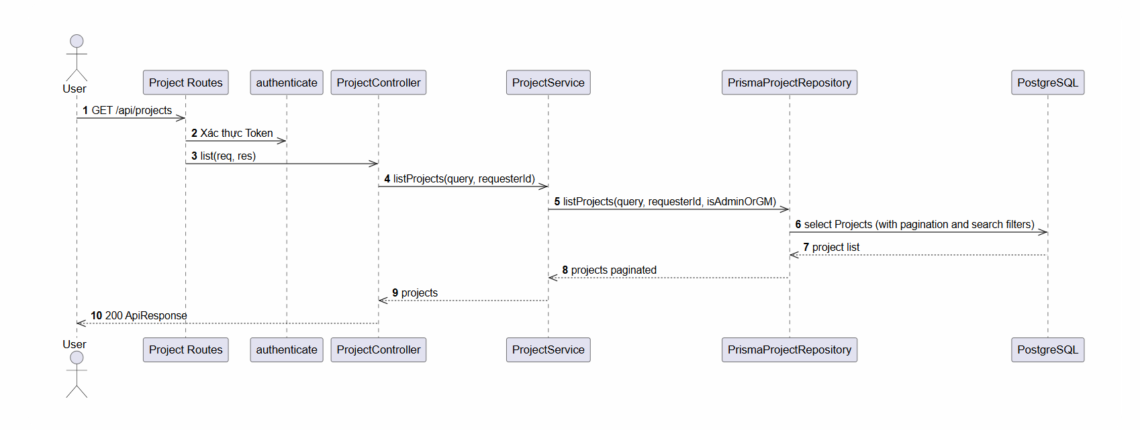

d. Database Queries
Get list of projects (Authorized: Admin/GM views all, Team Leaders/Members view assigned):
SELECT DISTINCT p.*
FROM projects p
LEFT JOIN project_members pm ON p.id = pm.project_id
WHERE (:isAdminOrGM = TRUE)
OR (p.team_leader_id = :userId)
OR (pm.employee_id = :userId AND pm.removed_at IS NULL)
ORDER BY p.created_at DESC
LIMIT :limit OFFSET :offset;

6.2 Feature Project Details

a. Class Diagram
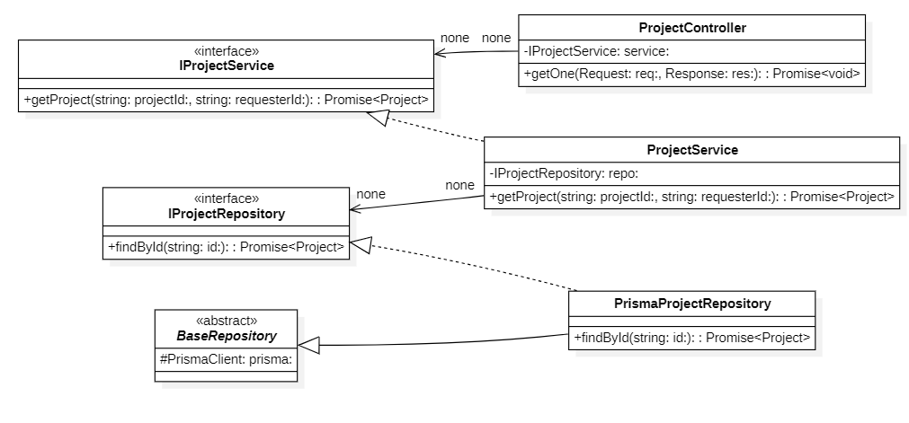

b. Class Specifications
ProjectController Class

No | Method | Description
01 | constructor(service: IProjectService) : void | Inputs: Input parameters: service: IProjectService.  Outputs: Output: void.  Processing: Initializes a new instance of the ProjectController class and injects required dependencies.
02 | list(req: AuthRequest, res: Response) : Promise | Inputs: Input parameters: req: AuthRequest, res: Response.  Outputs: Output: Promise.  Processing: Queries the database or processes business logic to retrieve/find data based on the specified input criteria.
03 | getOne(req: AuthRequest, res: Response) : Promise | Inputs: Input parameters: req: AuthRequest, res: Response.  Outputs: Output: Promise.  Processing: Queries the database or processes business logic to retrieve/find data based on the specified input criteria.
04 | create(req: AuthRequest, res: Response) : Promise | Inputs: Input parameters: req: AuthRequest, res: Response.  Outputs: Output: Promise.  Processing: Validates the input data and inserts a new record into the database.
05 | update(req: AuthRequest, res: Response) : Promise | Inputs: Input parameters: req: AuthRequest, res: Response.  Outputs: Output: Promise.  Processing: Verifies existence, validates new input data, and updates the record in the database.
06 | delete(req: AuthRequest, res: Response) : Promise | Inputs: Input parameters: req: AuthRequest, res: Response.  Outputs: Output: Promise.  Processing: Performs a deletion (either soft or hard delete) of the record from the database.
07 | addMember(req: AuthRequest, res: Response) : Promise | Inputs: Input parameters: req: AuthRequest, res: Response.  Outputs: Output: Promise.  Processing: Validates the input data and inserts a new record into the database.
08 | removeMember(req: AuthRequest, res: Response) : Promise | Inputs: Input parameters: req: AuthRequest, res: Response.  Outputs: Output: Promise.  Processing: Performs a deletion (either soft or hard delete) of the record from the database.
09 | getMembers(req: AuthRequest, res: Response) : Promise | Inputs: Input parameters: req: AuthRequest, res: Response.  Outputs: Output: Promise.  Processing: Queries the database or processes business logic to retrieve/find data based on the specified input criteria.
10 | getGanttData(req: AuthRequest, res: Response) : Promise | Inputs: Input parameters: req: AuthRequest, res: Response.  Outputs: Output: Promise.  Processing: Queries the database or processes business logic to retrieve/find data based on the specified input criteria.
11 | updateMember(req: AuthRequest, res: Response) : Promise | Inputs: Input parameters: req: AuthRequest, res: Response.  Outputs: Output: Promise.  Processing: Verifies existence, validates new input data, and updates the record in the database.
ProjectService Class

No | Method | Description
01 | constructor(repository: IProjectRepository, employeeRepository: IEmployeeRepository, prisma: PrismaClient, statusService?: IProjectTaskStatusService) : void | Inputs: Input parameters: repository: IProjectRepository, employeeRepository: IEmployeeRepository, prisma: PrismaClient, statusService?: IProjectTaskStatusService.  Outputs: Output: void.  Processing: Initializes a new instance of the ProjectService class and injects required dependencies.
02 | getProject(id: string, userId: string) : Promise | Inputs: Input parameters: id: string, userId: string.  Outputs: Output: Promise.  Processing: Queries the database or processes business logic to retrieve/find data based on the specified input criteria.
03 | listProjects(query: ProjectListQuery, userId: string) : Promise | Inputs: Input parameters: query: ProjectListQuery, userId: string.  Outputs: Output: Promise.  Processing: Queries the database or processes business logic to retrieve/find data based on the specified input criteria.
04 | createProject(data: CreateProjectDto, userId: string) : Promise | Inputs: Input parameters: data: CreateProjectDto, userId: string.  Outputs: Output: Promise.  Processing: Validates the input data and inserts a new record into the database.
05 | updateProject(id: string, data: UpdateProjectDto, userId: string) : Promise | Inputs: Input parameters: id: string, data: UpdateProjectDto, userId: string.  Outputs: Output: Promise.  Processing: Verifies existence, validates new input data, and updates the record in the database.
06 | deleteProject(id: string, userId: string) : Promise | Inputs: Input parameters: id: string, userId: string.  Outputs: Output: Promise.  Processing: Performs a deletion (either soft or hard delete) of the record from the database.
07 | addMember(projectId: string, employeeId: string, userId: string, options?: object) : Promise | Inputs: Input parameters: projectId: string, employeeId: string, userId: string, options?: object.  Outputs: Output: Promise.  Processing: Validates the input data and inserts a new record into the database.
08 | removeMember(projectId: string, employeeId: string, userId: string) : Promise | Inputs: Input parameters: projectId: string, employeeId: string, userId: string.  Outputs: Output: Promise.  Processing: Performs a deletion (either soft or hard delete) of the record from the database.
09 | getMembers(projectId: string, userId: string) : Promise | Inputs: Input parameters: projectId: string, userId: string.  Outputs: Output: Promise.  Processing: Queries the database or processes business logic to retrieve/find data based on the specified input criteria.
10 | getGanttData(projectId: string, userId: string) : Promise | Inputs: Input parameters: projectId: string, userId: string.  Outputs: Output: Promise.  Processing: Queries the database or processes business logic to retrieve/find data based on the specified input criteria.
11 | updateMember(projectId: string, employeeId: string, userId: string, data: object) : Promise | Inputs: Input parameters: projectId: string, employeeId: string, userId: string, data: object.  Outputs: Output: Promise.  Processing: Verifies existence, validates new input data, and updates the record in the database.
12 | checkIsAdminOrGM(userId: string) : Promise | Inputs: Input parameters: userId: string.  Outputs: Output: Promise.  Processing: Executes internal business logic for this function according to the system workflow requirements.

PrismaProjectRepository Class

No | Method | Description
01 | constructor(prisma: PrismaClient) : void | Inputs: Input parameters: prisma: PrismaClient.  Outputs: Output: void.  Processing: Initializes a new instance of the PrismaProjectRepository class and injects required dependencies.
02 | findById(id: string) : Promise | Inputs: Input parameters: id: string.  Outputs: Output: Promise.  Processing: Queries the database or processes business logic to retrieve/find data based on the specified input criteria.
03 | findByName(name: string) : Promise | Inputs: Input parameters: name: string.  Outputs: Output: Promise.  Processing: Queries the database or processes business logic to retrieve/find data based on the specified input criteria.
04 | listProjects(query: ProjectListQuery, userId: string, isAdminOrGM: boolean) : Promise | Inputs: Input parameters: query: ProjectListQuery, userId: string, isAdminOrGM: boolean.  Outputs: Output: Promise.  Processing: Queries the database or processes business logic to retrieve/find data based on the specified input criteria.
05 | createProject(data: object) : Promise | Inputs: Input parameters: data: object.  Outputs: Output: Promise.  Processing: Validates the input data and inserts a new record into the database.
06 | updateProject(id: string, data: UpdateProjectDto) : Promise | Inputs: Input parameters: id: string, data: UpdateProjectDto.  Outputs: Output: Promise.  Processing: Verifies existence, validates new input data, and updates the record in the database.
07 | deleteProject(id: string) : Promise | Inputs: Input parameters: id: string.  Outputs: Output: Promise.  Processing: Performs a deletion (either soft or hard delete) of the record from the database.
08 | addMember(projectId: string, employeeId: string, options?: object) : Promise | Inputs: Input parameters: projectId: string, employeeId: string, options?: object.  Outputs: Output: Promise.  Processing: Validates the input data and inserts a new record into the database.
09 | removeMember(projectId: string, employeeId: string) : Promise | Inputs: Input parameters: projectId: string, employeeId: string.  Outputs: Output: Promise.  Processing: Performs a deletion (either soft or hard delete) of the record from the database.
10 | isMember(projectId: string, employeeId: string) : Promise | Inputs: Input parameters: projectId: string, employeeId: string.  Outputs: Output: Promise.  Processing: Executes internal business logic for this function according to the system workflow requirements.
11 | getMember(projectId: string, employeeId: string) : Promise | Inputs: Input parameters: projectId: string, employeeId: string.  Outputs: Output: Promise.  Processing: Queries the database or processes business logic to retrieve/find data based on the specified input criteria.
12 | getMembers(projectId: string) : Promise | Inputs: Input parameters: projectId: string.  Outputs: Output: Promise.  Processing: Queries the database or processes business logic to retrieve/find data based on the specified input criteria.
13 | getGanttData(projectId: string) : Promise | Inputs: Input parameters: projectId: string.  Outputs: Output: Promise.  Processing: Queries the database or processes business logic to retrieve/find data based on the specified input criteria.
14 | hasActiveOnsiteMembership(employeeId: string) : Promise | Inputs: Input parameters: employeeId: string.  Outputs: Output: Promise.  Processing: Executes internal business logic for this function according to the system workflow requirements.
15 | updateMember(projectId: string, employeeId: string, data: object) : Promise | Inputs: Input parameters: projectId: string, employeeId: string, data: object.  Outputs: Output: Promise.  Processing: Verifies existence, validates new input data, and updates the record in the database.
16 | mapToDomain(project: PrismaProjectWithRelations) : Project | Inputs: Input parameters: project: PrismaProjectWithRelations.  Outputs: Output: Project.  Processing: Executes internal business logic for this function according to the system workflow requirements.

c. Sequence Diagram(s)

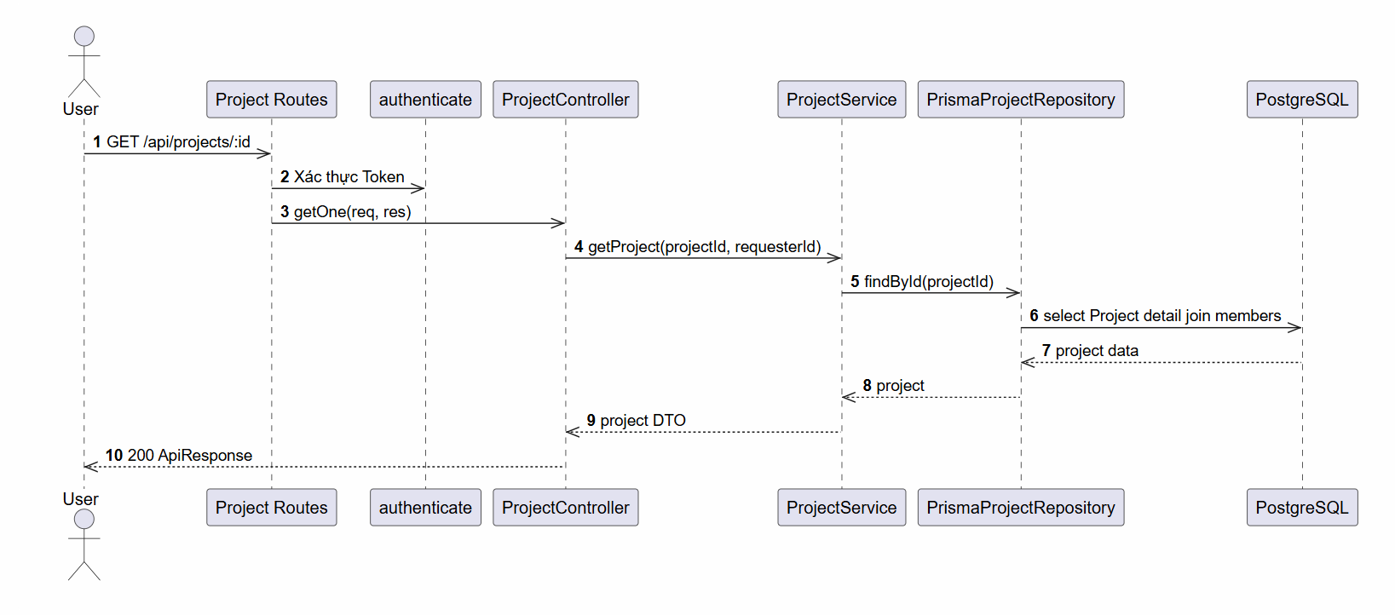

d. Database Queries
Retrieve project profile details, member roster, and Gantt tasks:
-- Fetch active members
SELECT pm.*, e.full_name, e.email
FROM project_members pm
LEFT JOIN employees e ON pm.employee_id = e.id
WHERE pm.project_id = :projectId AND pm.removed_at IS NULL;

-- Fetch tasks
SELECT * FROM tasks WHERE project_id = :projectId ORDER BY created_at ASC;

6.3 Feature Create New Task

a. Class Diagram
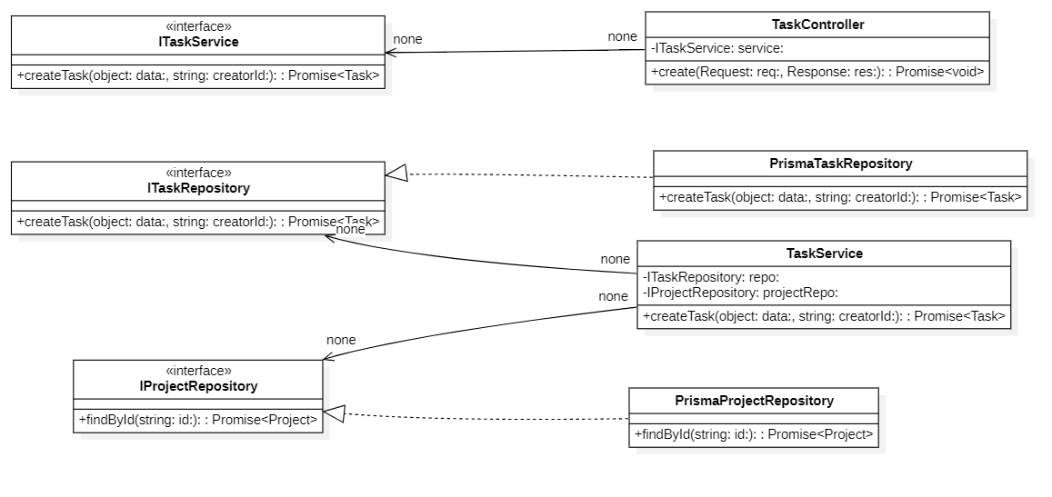

b. Class Specifications
TaskController Class

No | Method | Description
01 | constructor(service: ITaskService) : void | Inputs: Input parameters: service: ITaskService.  Outputs: Output: void.  Processing: Initializes a new instance of the TaskController class and injects required dependencies.
02 | list(req: AuthRequest, res: Response) : Promise | Inputs: Input parameters: req: AuthRequest, res: Response.  Outputs: Output: Promise.  Processing: Queries the database or processes business logic to retrieve/find data based on the specified input criteria.
03 | getOne(req: AuthRequest, res: Response) : Promise | Inputs: Input parameters: req: AuthRequest, res: Response.  Outputs: Output: Promise.  Processing: Queries the database or processes business logic to retrieve/find data based on the specified input criteria.
04 | create(req: AuthRequest, res: Response) : Promise | Inputs: Input parameters: req: AuthRequest, res: Response.  Outputs: Output: Promise.  Processing: Validates the input data and inserts a new record into the database.
05 | update(req: AuthRequest, res: Response) : Promise | Inputs: Input parameters: req: AuthRequest, res: Response.  Outputs: Output: Promise.  Processing: Verifies existence, validates new input data, and updates the record in the database.
06 | delete(req: AuthRequest, res: Response) : Promise | Inputs: Input parameters: req: AuthRequest, res: Response.  Outputs: Output: Promise.  Processing: Performs a deletion (either soft or hard delete) of the record from the database.
TaskService Class

No | Method | Description
01 | constructor(repository: ITaskRepository, projectRepository: IProjectRepository, employeeRepository: IEmployeeRepository, statusRepository?: IProjectTaskStatusRepository, positionService?: IPositionService) : void | Inputs: Input parameters: repository: ITaskRepository, projectRepository: IProjectRepository, employeeRepository: IEmployeeRepository, statusRepository?: IProjectTaskStatusRepository, positionService?: IPositionService.  Outputs: Output: void.  Processing: Initializes a new instance of the TaskService class and injects required dependencies.
02 | getTask(id: string, userId: string) : Promise | Inputs: Input parameters: id: string, userId: string.  Outputs: Output: Promise.  Processing: Queries the database or processes business logic to retrieve/find data based on the specified input criteria.
03 | listTasks(query: TaskListQuery, userId: string) : Promise | Inputs: Input parameters: query: TaskListQuery, userId: string.  Outputs: Output: Promise.  Processing: Queries the database or processes business logic to retrieve/find data based on the specified input criteria.
04 | createTask(data: CreateTaskDto, userId: string) : Promise | Inputs: Input parameters: data: CreateTaskDto, userId: string.  Outputs: Output: Promise.  Processing: Validates the input data and inserts a new record into the database.
05 | updateTask(id: string, data: UpdateTaskDto, userId: string) : Promise | Inputs: Input parameters: id: string, data: UpdateTaskDto, userId: string.  Outputs: Output: Promise.  Processing: Verifies existence, validates new input data, and updates the record in the database.
06 | deleteTask(id: string, userId: string) : Promise | Inputs: Input parameters: id: string, userId: string.  Outputs: Output: Promise.  Processing: Performs a deletion (either soft or hard delete) of the record from the database.
07 | isAuthorizedAdminOrGM(userId: string) : Promise | Inputs: Input parameters: userId: string.  Outputs: Output: Promise.  Processing: Executes internal business logic for this function according to the system workflow requirement
PrismaTaskRepository Class

No | Method | Description
01 | constructor(prisma: PrismaClient) : void | Inputs: Input parameters: prisma: PrismaClient.  Outputs: Output: void.  Processing: Initializes a new instance of the PrismaTaskRepository class and injects required dependencies.
02 | findById(id: string) : Promise | Inputs: Input parameters: id: string.  Outputs: Output: Promise.  Processing: Queries the database or processes business logic to retrieve/find data based on the specified input criteria.
03 | listTasks(query: TaskListQuery) : Promise | Inputs: Input parameters: query: TaskListQuery.  Outputs: Output: Promise.  Processing: Queries the database or processes business logic to retrieve/find data based on the specified input criteria.
04 | createTask(data: object) : Promise | Inputs: Input parameters: data: object.  Outputs: Output: Promise.  Processing: Validates the input data and inserts a new record into the database.
05 | updateTask(id: string, data: UpdateTaskDto) : Promise | Inputs: Input parameters: id: string, data: UpdateTaskDto.  Outputs: Output: Promise.  Processing: Verifies existence, validates new input data, and updates the record in the database.
06 | deleteTask(id: string) : Promise | Inputs: Input parameters: id: string.  Outputs: Output: Promise.  Processing: Performs a deletion (either soft or hard delete) of the record from the database.
07 | updateTasksStatusId(projectId: string, fromStatusId: string, toStatusId: string) : Promise | Inputs: Input parameters: projectId: string, fromStatusId: string, toStatusId: string.  Outputs: Output: Promise.  Processing: Verifies existence, validates new input data, and updates the record in the database.
08 | syncLegacyStatus(statusId: string, legacyStatus: TaskStatus) : Promise | Inputs: Input parameters: statusId: string, legacyStatus: TaskStatus.  Outputs: Output: Promise.  Processing: Executes internal business logic for this function according to the system workflow requirements.
09 | mapToDomain(task: PrismaTaskWithRelations) : Task | Inputs: Input parameters: task: PrismaTaskWithRelations.  Outputs: Output: Task.  Processing: Executes internal business logic for this function according to the system workflow requirements.

c. Sequence Diagram(s)

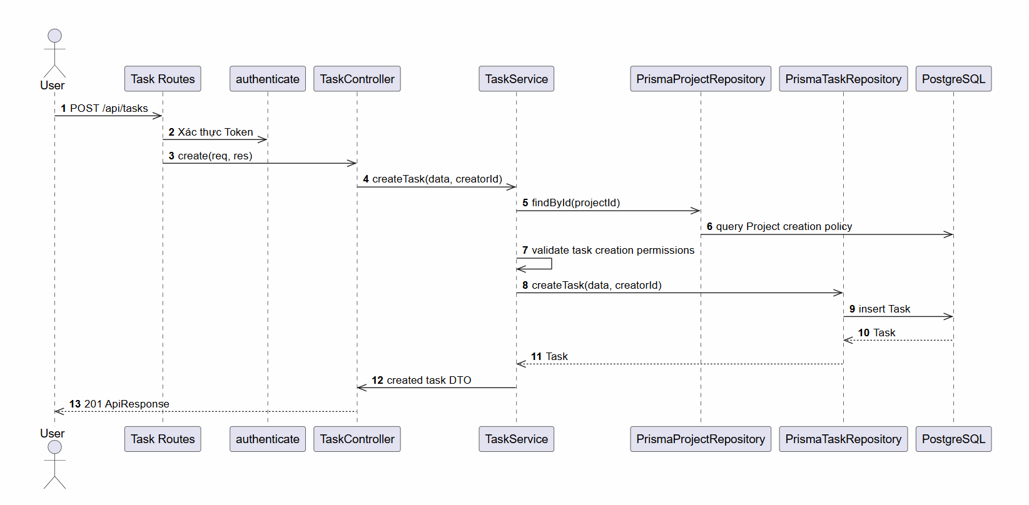

d. Database Queries
Create a project task
INSERT INTO tasks (project_id, title, description, tracker, priority, status, assignee_id, created_by_id, start_date, due_date)
VALUES (:projectId, :title, :description, :tracker, :priority, :status, :assigneeId, :createdById, :startDate, :dueDate);

6.4 Feature Task Details

a. Class Diagram
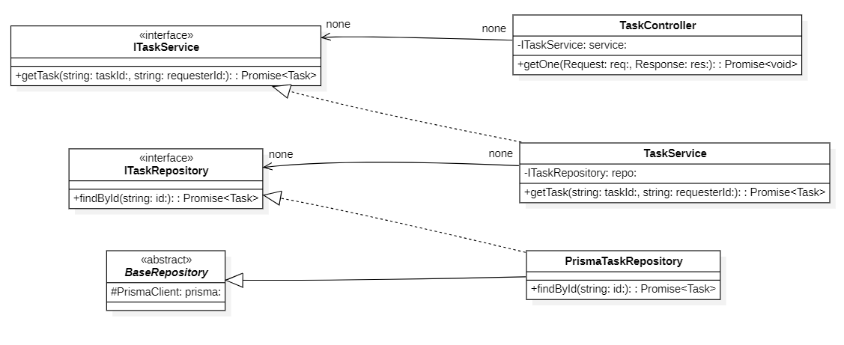

b. Class Specifications
TaskController Class

No | Method | Description
01 | constructor(service: ITaskService) : void | Inputs: Input parameters: service: ITaskService.  Outputs: Output: void.  Processing: Initializes a new instance of the TaskController class and injects required dependencies.
02 | list(req: AuthRequest, res: Response) : Promise | Inputs: Input parameters: req: AuthRequest, res: Response.  Outputs: Output: Promise.  Processing: Queries the database or processes business logic to retrieve/find data based on the specified input criteria.
03 | getOne(req: AuthRequest, res: Response) : Promise | Inputs: Input parameters: req: AuthRequest, res: Response.  Outputs: Output: Promise.  Processing: Queries the database or processes business logic to retrieve/find data based on the specified input criteria.
04 | create(req: AuthRequest, res: Response) : Promise | Inputs: Input parameters: req: AuthRequest, res: Response.  Outputs: Output: Promise.  Processing: Validates the input data and inserts a new record into the database.
05 | update(req: AuthRequest, res: Response) : Promise | Inputs: Input parameters: req: AuthRequest, res: Response.  Outputs: Output: Promise.  Processing: Verifies existence, validates new input data, and updates the record in the database.
06 | delete(req: AuthRequest, res: Response) : Promise | Inputs: Input parameters: req: AuthRequest, res: Response.  Outputs: Output: Promise.  Processing: Performs a deletion (either soft or hard delete) of the record from the database.

TaskService Class

No | Method | Description
01 | constructor(repository: ITaskRepository, projectRepository: IProjectRepository, employeeRepository: IEmployeeRepository, statusRepository?: IProjectTaskStatusRepository, positionService?: IPositionService) : void | Inputs: Input parameters: repository: ITaskRepository, projectRepository: IProjectRepository, employeeRepository: IEmployeeRepository, statusRepository?: IProjectTaskStatusRepository, positionService?: IPositionService.  Outputs: Output: void.  Processing: Initializes a new instance of the TaskService class and injects required dependencies.
02 | getTask(id: string, userId: string) : Promise | Inputs: Input parameters: id: string, userId: string.  Outputs: Output: Promise.  Processing: Queries the database or processes business logic to retrieve/find data based on the specified input criteria.
03 | listTasks(query: TaskListQuery, userId: string) : Promise | Inputs: Input parameters: query: TaskListQuery, userId: string.  Outputs: Output: Promise.  Processing: Queries the database or processes business logic to retrieve/find data based on the specified input criteria.
04 | createTask(data: CreateTaskDto, userId: string) : Promise | Inputs: Input parameters: data: CreateTaskDto, userId: string.  Outputs: Output: Promise.  Processing: Validates the input data and inserts a new record into the database.
05 | updateTask(id: string, data: UpdateTaskDto, userId: string) : Promise | Inputs: Input parameters: id: string, data: UpdateTaskDto, userId: string.  Outputs: Output: Promise.  Processing: Verifies existence, validates new input data, and updates the record in the database.
06 | deleteTask(id: string, userId: string) : Promise | Inputs: Input parameters: id: string, userId: string.  Outputs: Output: Promise.  Processing: Performs a deletion (either soft or hard delete) of the record from the database.
07 | isAuthorizedAdminOrGM(userId: string) : Promise | Inputs: Input parameters: userId: string.  Outputs: Output: Promise.  Processing: Executes internal business logic for this function according to the system workflow requirements.
PrismaTaskRepository Class

No | Method | Description
01 | constructor(prisma: PrismaClient) : void | Inputs: Input parameters: prisma: PrismaClient.  Outputs: Output: void.  Processing: Initializes a new instance of the PrismaTaskRepository class and injects required dependencies.
02 | findById(id: string) : Promise | Inputs: Input parameters: id: string.  Outputs: Output: Promise.  Processing: Queries the database or processes business logic to retrieve/find data based on the specified input criteria.
03 | listTasks(query: TaskListQuery) : Promise | Inputs: Input parameters: query: TaskListQuery.  Outputs: Output: Promise.  Processing: Queries the database or processes business logic to retrieve/find data based on the specified input criteria.
04 | createTask(data: object) : Promise | Inputs: Input parameters: data: object.  Outputs: Output: Promise.  Processing: Validates the input data and inserts a new record into the database.
05 | updateTask(id: string, data: UpdateTaskDto) : Promise | Inputs: Input parameters: id: string, data: UpdateTaskDto.  Outputs: Output: Promise.  Processing: Verifies existence, validates new input data, and updates the record in the database.
06 | deleteTask(id: string) : Promise | Inputs: Input parameters: id: string.  Outputs: Output: Promise.  Processing: Performs a deletion (either soft or hard delete) of the record from the database.
07 | updateTasksStatusId(projectId: string, fromStatusId: string, toStatusId: string) : Promise | Inputs: Input parameters: projectId: string, fromStatusId: string, toStatusId: string.  Outputs: Output: Promise.  Processing: Verifies existence, validates new input data, and updates the record in the database.
08 | syncLegacyStatus(statusId: string, legacyStatus: TaskStatus) : Promise | Inputs: Input parameters: statusId: string, legacyStatus: TaskStatus.  Outputs: Output: Promise.  Processing: Executes internal business logic for this function according to the system workflow requirements.
09 | mapToDomain(task: PrismaTaskWithRelations) : Task | Inputs: Input parameters: task: PrismaTaskWithRelations.  Outputs: Output: Task.  Processing: Executes internal business logic for this function according to the system workflow requirements.

c. Sequence Diagram(s)
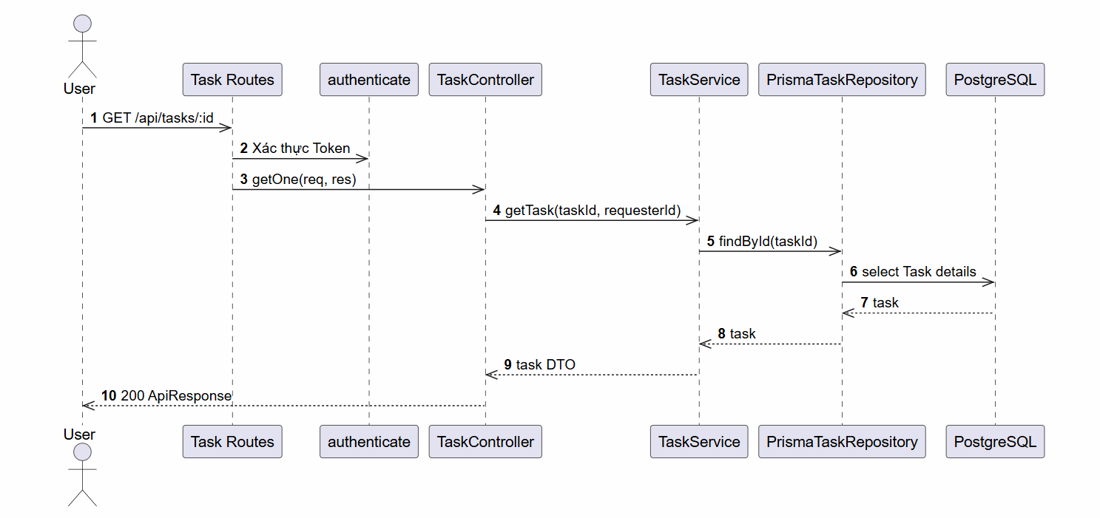

d. Database Queries
Query detailed single task card
SELECT t.*, p.name AS project_name, e.full_name AS assignee_name
FROM tasks t
LEFT JOIN projects p ON t.project_id = p.id
LEFT JOIN employees e ON t.assignee_id = e.id
WHERE t.id = :id;

7. Settings and Authorization Module

7.1 Feature System Configuration Overview

a. Class Diagram
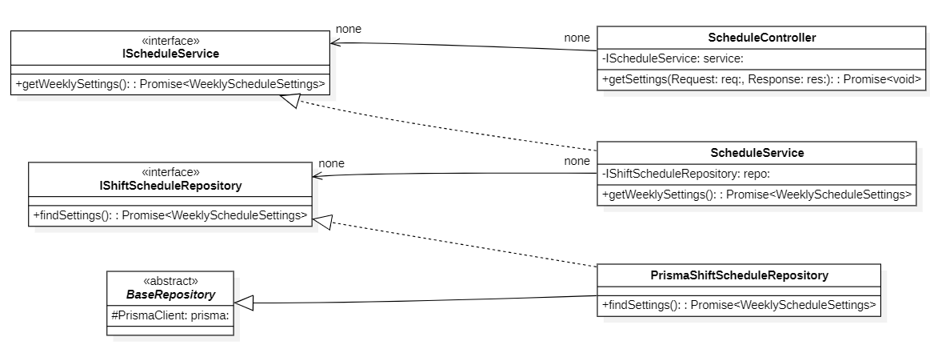

b. Class Specifications
AuthorizationService Class

No | Method | Description
01 | constructor(cache: ICacheService) : void | Inputs: Input parameters: cache: ICacheService.  Outputs: Output: void.  Processing: Initializes a new instance of the AuthorizationService class and injects required dependencies.
02 | getAuthorizationContext(employeeId: string, options?: object) : Promise | Inputs: Input parameters: employeeId: string, options?: object.  Outputs: Output: Promise.  Processing: Queries the database or processes business logic to retrieve/find data based on the specified input criteria.
03 | invalidateUserCache(employeeId: string) : Promise | Inputs: Input parameters: employeeId: string.  Outputs: Output: Promise.  Processing: Executes internal business logic for this function according to the system workflow requirements.
04 | invalidateGlobalVersion() : Promise | Inputs: Input parameters: None.  Outputs: Output: Promise.  Processing: Executes internal business logic for this function according to the system workflow requirements.
05 | invalidateRoleCache(roleId: string) : Promise | Inputs: Input parameters: roleId: string.  Outputs: Output: Promise.  Processing: Executes internal business logic for this function according to the system workflow requirements.
06 | invalidatePermissionCache(permissionId: string) : Promise | Inputs: Input parameters: permissionId: string.  Outputs: Output: Promise.  Processing: Executes internal business logic for this function according to the system workflow requirements.
07 | incrementMetric(metric: string) : void | Inputs: Input parameters: metric: string.  Outputs: Output: void.  Processing: Executes internal business logic for this function according to the system workflow requirements.
08 | getMetrics() : Record | Inputs: Input parameters: None.  Outputs: Output: Record.  Processing: Queries the database or processes business logic to retrieve/find data based on the specified input criteria.
09 | logDecision(employeeId: string, permission: string, allowed: boolean, source: string) : void | Inputs: Input parameters: employeeId: string, permission: string, allowed: boolean, source: string.  Outputs: Output: void.  Processing: Executes internal business logic for this function according to the system workflow requirements.
10 | getGlobalVersion() : Promise | Inputs: Input parameters: None.  Outputs: Output: Promise.  Processing: Queries the database or processes business logic to retrieve/find data based on the specified input criteria.
11 | fetchAndCacheContext(employeeId: string, snapshotVersion: number, cacheKey: string) : Promise | Inputs: Input parameters: employeeId: string, snapshotVersion: number, cacheKey: string.  Outputs: Output: Promise.  Processing: Executes internal business logic for this function according to the system workflow requirements.
ICacheService Interface

No | Method | Description
01 | get~T~(key: string) : Promise | Inputs: Input parameters: key: string.  Outputs: Output: Promise.  Processing: Queries the database or processes business logic to retrieve/find data based on the specified input criteria.
02 | set~T~(key: string, value: T, ttlSeconds?: number) : Promise | Inputs: Input parameters: key: string, value: T, ttlSeconds?: number.  Outputs: Output: Promise.  Processing: Executes internal business logic for this function according to the system workflow requirements.
03 | del(key: string) : Promise | Inputs: Input parameters: key: string.  Outputs: Output: Promise.  Processing: Executes internal business logic for this function according to the system workflow requirements.
04 | clear() : Promise | Inputs: Input parameters: None.  Outputs: Output: Promise.  Processing: Executes internal business logic for this function according to the system workflow requirements.
05 | subscribe(channel: string, callback: (message: string) => void) : Promise | Inputs: Input parameters: channel: string, callback: (message: string) => void.  Outputs: Output: Promise.  Processing: Executes internal business logic for this function according to the system workflow requirements.
06 | publish(channel: string, message: string) : Promise | Inputs: Input parameters: channel: string, message: string.  Outputs: Output: Promise.  Processing: Executes internal business logic for this function according to the system workflow requirements.

c. Sequence Diagram(s)

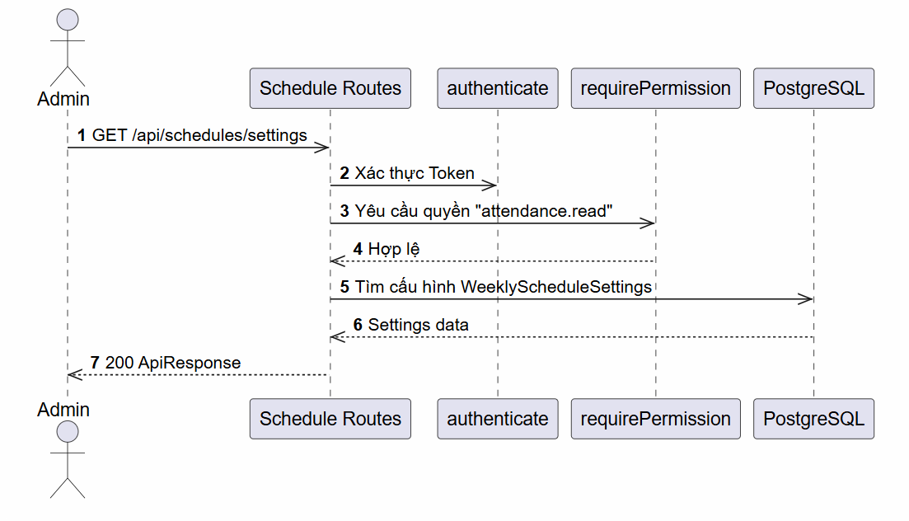

d. Database Queries
Find saved custom UI board/Gantt query views:
SELECT * FROM custom_queries WHERE employee_id = :employeeId AND project_id = :projectId;

7.2 Feature Role Management

a. Class Diagram
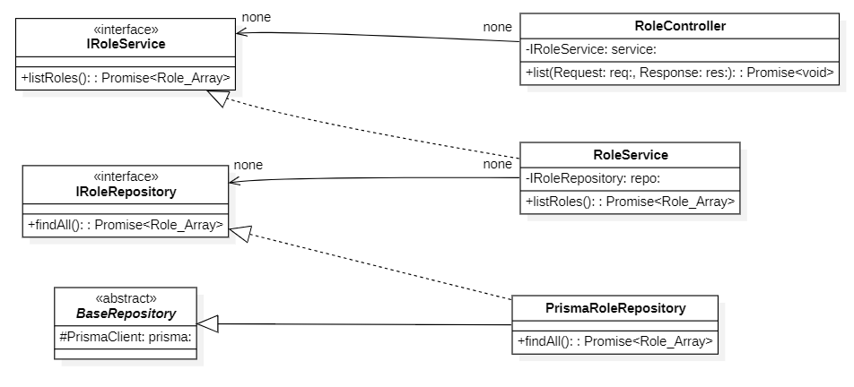

b. Class Specifications
RoleController Class

No | Method | Description
01 | constructor(service: IRoleService) : void | Inputs: Input parameters: service: IRoleService.  Outputs: Output: void.  Processing: Initializes a new instance of the RoleController class and injects required dependencies.
02 | list(req: AuthRequest, res: Response) : Promise | Inputs: Input parameters: req: AuthRequest, res: Response.  Outputs: Output: Promise.  Processing: Queries the database or processes business logic to retrieve/find data based on the specified input criteria.
03 | getOne(req: AuthRequest, res: Response) : Promise | Inputs: Input parameters: req: AuthRequest, res: Response.  Outputs: Output: Promise.  Processing: Queries the database or processes business logic to retrieve/find data based on the specified input criteria.
04 | create(req: AuthRequest, res: Response) : Promise | Inputs: Input parameters: req: AuthRequest, res: Response.  Outputs: Output: Promise.  Processing: Validates the input data and inserts a new record into the database.
05 | update(req: AuthRequest, res: Response) : Promise | Inputs: Input parameters: req: AuthRequest, res: Response.  Outputs: Output: Promise.  Processing: Verifies existence, validates new input data, and updates the record in the database.
06 | delete(req: AuthRequest, res: Response) : Promise | Inputs: Input parameters: req: AuthRequest, res: Response.  Outputs: Output: Promise.  Processing: Performs a deletion (either soft or hard delete) of the record from the database.
RoleService

No | Method | Description
01 | constructor(repository: IRoleRepository) : void | Inputs: Input parameters: repository: IRoleRepository.  Outputs: Output: void.  Processing: Initializes a new instance of the RoleService class and injects required dependencies.
02 | listRoles(query: RoleListQuery) : Promise | Inputs: Input parameters: query: RoleListQuery.  Outputs: Output: Promise.  Processing: Queries the database or processes business logic to retrieve/find data based on the specified input criteria.
03 | getRole(id: string) : Promise | Inputs: Input parameters: id: string.  Outputs: Output: Promise.  Processing: Queries the database or processes business logic to retrieve/find data based on the specified input criteria.
04 | createRole(data: CreateRoleDto) : Promise | Inputs: Input parameters: data: CreateRoleDto.  Outputs: Output: Promise.  Processing: Validates the input data and inserts a new record into the database.
05 | updateRole(id: string, data: UpdateRoleDto) : Promise | Inputs: Input parameters: id: string, data: UpdateRoleDto.  Outputs: Output: Promise.  Processing: Verifies existence, validates new input data, and updates the record in the database.
06 | deleteRole(id: string, actorId: string) : Promise | Inputs: Input parameters: id: string, actorId: string.  Outputs: Output: Promise.  Processing: Performs a deletion (either soft or hard delete) of the record from the database.
07 | getRolePermissions(roleId: string) : Promise | Inputs: Input parameters: roleId: string.  Outputs: Output: Promise.  Processing: Queries the database or processes business logic to retrieve/find data based on the specified input criteria.
08 | assignPermission(roleId: string, permissionId: string, actorId?: string) : Promise | Inputs: Input parameters: roleId: string, permissionId: string, actorId?: string.  Outputs: Output: Promise.  Processing: Creates an association/assignment between two entities (e.g., assigning a role to an employee or permissions to a role).
09 | revokePermission(roleId: string, permissionId: string, actorId?: string) : Promise | Inputs: Input parameters: roleId: string, permissionId: string, actorId?: string.  Outputs: Output: Promise.  Processing: Removes the association/assignment between two entities.
10 | updatePermissions(roleId: string, permissionIds: string[], actorId?: string) : Promise | Inputs: Input parameters: roleId: string, permissionIds: string[], actorId?: string.  Outputs: Output: Promise.  Processing: Verifies existence, validates new input data, and updates the record in the database.

PrismaRoleRepository Class

No | Method | Description
01 | constructor(prisma: PrismaClient) : void | Inputs: Input parameters: prisma: PrismaClient.  Outputs: Output: void.  Processing: Initializes a new instance of the PrismaRoleRepository class and injects required dependencies.
02 | listRolesPaginated(query: RoleListQuery) : Promise | Inputs: Input parameters: query: RoleListQuery.  Outputs: Output: Promise.  Processing: Queries the database or processes business logic to retrieve/find data based on the specified input criteria.
03 | findById(id: string) : Promise | Inputs: Input parameters: id: string.  Outputs: Output: Promise.  Processing: Queries the database or processes business logic to retrieve/find data based on the specified input criteria.
04 | findActiveByIds(ids: string[]) : Promise | Inputs: Input parameters: ids: string[].  Outputs: Output: Promise.  Processing: Queries the database or processes business logic to retrieve/find data based on the specified input criteria.
05 | findByName(name: string, includeSoftDeleted?: boolean) : Promise | Inputs: Input parameters: name: string, includeSoftDeleted?: boolean.  Outputs: Output: Promise.  Processing: Queries the database or processes business logic to retrieve/find data based on the specified input criteria.
06 | createRole(data: CreateRoleDto) : Promise | Inputs: Input parameters: data: CreateRoleDto.  Outputs: Output: Promise.  Processing: Validates the input data and inserts a new record into the database.
07 | updateRole(id: string, data: UpdateRoleDto) : Promise | Inputs: Input parameters: id: string, data: UpdateRoleDto.  Outputs: Output: Promise.  Processing: Verifies existence, validates new input data, and updates the record in the database.
08 | deleteRole(id: string, actorId: string) : Promise | Inputs: Input parameters: id: string, actorId: string.  Outputs: Output: Promise.  Processing: Performs a deletion (either soft or hard delete) of the record from the database.
09 | countEmployeeAssignments(id: string) : Promise | Inputs: Input parameters: id: string.  Outputs: Output: Promise.  Processing: Executes internal business logic for this function according to the system workflow requirements.
10 | countPermissionAssignments(id: string) : Promise | Inputs: Input parameters: id: string.  Outputs: Output: Promise.  Processing: Executes internal business logic for this function according to the system workflow requirements.
11 | countRemainingAdminUsers(roleId: string, tx?: Prisma.TransactionClient) : Promise | Inputs: Input parameters: roleId: string, tx?: Prisma.TransactionClient.  Outputs: Output: Promise.  Processing: Executes internal business logic for this function according to the system workflow requirements.
12 | findPermissionsByRoleId(roleId: string) : Promise | Inputs: Input parameters: roleId: string.  Outputs: Output: Promise.  Processing: Queries the database or processes business logic to retrieve/find data based on the specified input criteria.
13 | assignPermission(roleId: string, permissionId: string, actorId?: string) : Promise | Inputs: Input parameters: roleId: string, permissionId: string, actorId?: string.  Outputs: Output: Promise.  Processing: Creates an association/assignment between two entities (e.g., assigning a role to an employee or permissions to a role).
14 | revokePermission(roleId: string, permissionId: string) : Promise | Inputs: Input parameters: roleId: string, permissionId: string.  Outputs: Output: Promise.  Processing: Removes the association/assignment between two entities.
15 | updatePermissions(roleId: string, permissionIds: string[], actorId?: string) : Promise | Inputs: Input parameters: roleId: string, permissionIds: string[], actorId?: string.  Outputs: Output: Promise.  Processing: Verifies existence, validates new input data, and updates the record in the database.
16 | mapToDomain(role: PrismaAppRole) : AppRole | Inputs: Input parameters: role: PrismaAppRole.  Outputs: Output: AppRole.  Processing: Executes internal business logic for this function according to the system workflow requirements.

c. Sequence Diagram(s)

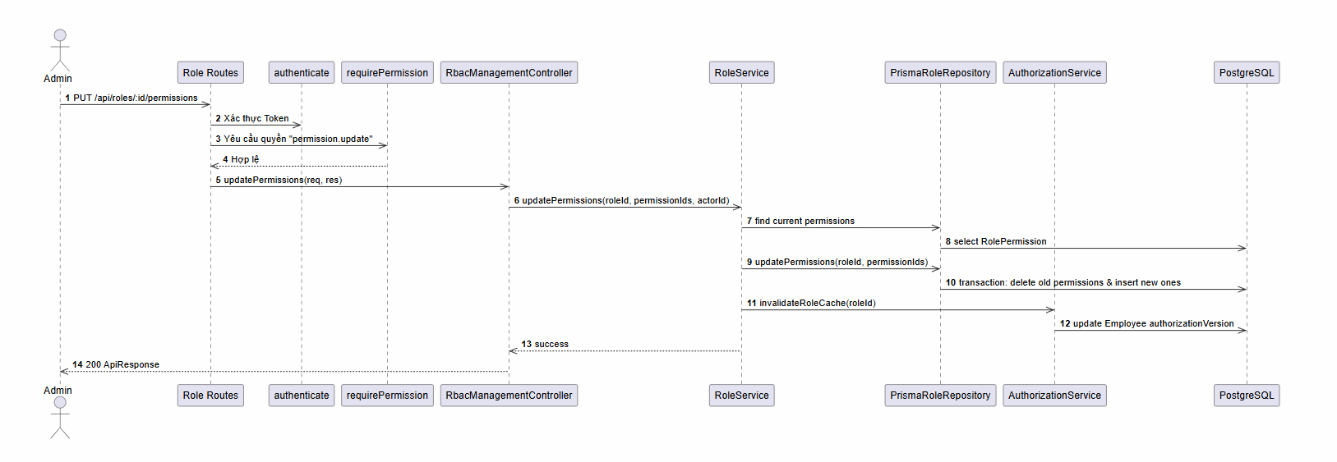

d. Database Queries
List security roles and count user assignments
SELECT r.*, COUNT(ur.employee_id) as employees_count
FROM roles r
LEFT JOIN employee_roles ur ON r.id = ur.role_id
WHERE r.deleted_at IS NULL
GROUP BY r.id;

7.3 Feature Role Permission Configuration

a. Class Diagram
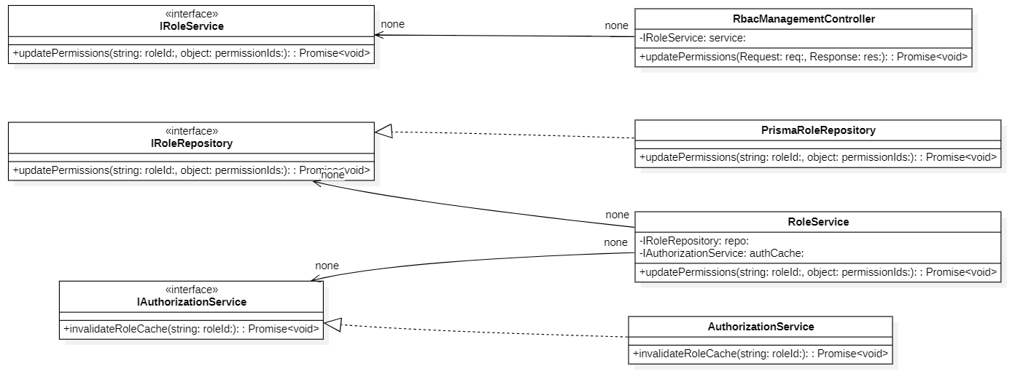

b. Class Specifications
PermissionController Class

No | Method | Description
01 | constructor(service: IPermissionService) : void | Inputs: Input parameters: service: IPermissionService.  Outputs: Output: void.  Processing: Initializes a new instance of the PermissionController class and injects required dependencies.
02 | list(req: AuthRequest, res: Response) : Promise | Inputs: Input parameters: req: AuthRequest, res: Response.  Outputs: Output: Promise.  Processing: Queries the database or processes business logic to retrieve/find data based on the specified input criteria.
03 | getOne(req: AuthRequest, res: Response) : Promise | Inputs: Input parameters: req: AuthRequest, res: Response.  Outputs: Output: Promise.  Processing: Queries the database or processes business logic to retrieve/find data based on the specified input criteria.
04 | create(req: AuthRequest, res: Response) : Promise | Inputs: Input parameters: req: AuthRequest, res: Response.  Outputs: Output: Promise.  Processing: Validates the input data and inserts a new record into the database.
05 | update(req: AuthRequest, res: Response) : Promise | Inputs: Input parameters: req: AuthRequest, res: Response.  Outputs: Output: Promise.  Processing: Verifies existence, validates new input data, and updates the record in the database.
06 | delete(req: AuthRequest, res: Response) : Promise | Inputs: Input parameters: req: AuthRequest, res: Response.  Outputs: Output: Promise.  Processing: Performs a deletion (either soft or hard delete) of the record from the database.

PermissionService Class

No | Method | Description
01 | constructor(repository: IPermissionRepository) : void | Inputs: Input parameters: repository: IPermissionRepository.  Outputs: Output: void.  Processing: Initializes a new instance of the PermissionService class and injects required dependencies.
02 | listPermissions(query: PermissionListQuery) : Promise | Inputs: Input parameters: query: PermissionListQuery.  Outputs: Output: Promise.  Processing: Queries the database or processes business logic to retrieve/find data based on the specified input criteria.
03 | getPermission(id: string) : Promise | Inputs: Input parameters: id: string.  Outputs: Output: Promise.  Processing: Queries the database or processes business logic to retrieve/find data based on the specified input criteria.
04 | createPermission(data: CreatePermissionDto) : Promise | Inputs: Input parameters: data: CreatePermissionDto.  Outputs: Output: Promise.  Processing: Validates the input data and inserts a new record into the database.
05 | updatePermission(id: string, data: UpdatePermissionDto) : Promise | Inputs: Input parameters: id: string, data: UpdatePermissionDto.  Outputs: Output: Promise.  Processing: Verifies existence, validates new input data, and updates the record in the database.
06 | deletePermission(id: string, actorId: string) : Promise | Inputs: Input parameters: id: string, actorId: string.  Outputs: Output: Promise.  Processing: Performs a deletion (either soft or hard delete) of the record from the database.

PrismaPermissionRepository Class

No | Method | Description
01 | constructor(prisma: PrismaClient) : void | Inputs: Input parameters: prisma: PrismaClient.  Outputs: Output: void.  Processing: Initializes a new instance of the PrismaPermissionRepository class and injects required dependencies.
02 | listPermissionsPaginated(query: PermissionListQuery) : Promise | Inputs: Input parameters: query: PermissionListQuery.  Outputs: Output: Promise.  Processing: Queries the database or processes business logic to retrieve/find data based on the specified input criteria.
03 | findById(id: string) : Promise | Inputs: Input parameters: id: string.  Outputs: Output: Promise.  Processing: Queries the database or processes business logic to retrieve/find data based on the specified input criteria.
04 | findByCode(code: string, includeSoftDeleted?: boolean) : Promise | Inputs: Input parameters: code: string, includeSoftDeleted?: boolean.  Outputs: Output: Promise.  Processing: Queries the database or processes business logic to retrieve/find data based on the specified input criteria.
05 | createPermission(data: CreatePermissionDto) : Promise | Inputs: Input parameters: data: CreatePermissionDto.  Outputs: Output: Promise.  Processing: Validates the input data and inserts a new record into the database.
06 | updatePermission(id: string, data: UpdatePermissionDto) : Promise | Inputs: Input parameters: id: string, data: UpdatePermissionDto.  Outputs: Output: Promise.  Processing: Verifies existence, validates new input data, and updates the record in the database.
07 | deletePermission(id: string, actorId: string) : Promise | Inputs: Input parameters: id: string, actorId: string.  Outputs: Output: Promise.  Processing: Performs a deletion (either soft or hard delete) of the record from the database.
08 | countRoleAssignments(id: string) : Promise | Inputs: Input parameters: id: string.  Outputs: Output: Promise.  Processing: Executes internal business logic for this function according to the system workflow requirements.
09 | mapToDomain(permission: PrismaPermission) : Permission | Inputs: Input parameters: permission: PrismaPermission.  Outputs: Output: Permission.  Processing: Executes internal business logic for this function according to the system workflow requirements.

RbacManagementController Class

No | Method | Description
01 | constructor(employeeService: IEmployeeService, roleService: IRoleService) : void | Inputs: Input parameters: employeeService: IEmployeeService, roleService: IRoleService.  Outputs: Output: void.  Processing: Initializes a new instance of the RbacManagementController class and injects required dependencies.
02 | getEmployeeRoles(req: AuthRequest, res: Response) : Promise | Inputs: Input parameters: req: AuthRequest, res: Response.  Outputs: Output: Promise.  Processing: Queries the database or processes business logic to retrieve/find data based on the specified input criteria.
03 | assignRole(req: AuthRequest, res: Response) : Promise | Inputs: Input parameters: req: AuthRequest, res: Response.  Outputs: Output: Promise.  Processing: Creates an association/assignment between two entities (e.g., assigning a role to an employee or permissions to a role).
04 | revokeRole(req: AuthRequest, res: Response) : Promise | Inputs: Input parameters: req: AuthRequest, res: Response.  Outputs: Output: Promise.  Processing: Removes the association/assignment between two entities.
05 | updateRoles(req: AuthRequest, res: Response) : Promise | Inputs: Input parameters: req: AuthRequest, res: Response.  Outputs: Output: Promise.  Processing: Verifies existence, validates new input data, and updates the record in the database.
06 | getRolePermissions(req: AuthRequest, res: Response) : Promise | Inputs: Input parameters: req: AuthRequest, res: Response.  Outputs: Output: Promise.  Processing: Queries the database or processes business logic to retrieve/find data based on the specified input criteria.
07 | assignPermission(req: AuthRequest, res: Response) : Promise | Inputs: Input parameters: req: AuthRequest, res: Response.  Outputs: Output: Promise.  Processing: Creates an association/assignment between two entities (e.g., assigning a role to an employee or permissions to a role).
08 | revokePermission(req: AuthRequest, res: Response) : Promise | Inputs: Input parameters: req: AuthRequest, res: Response.  Outputs: Output: Promise.  Processing: Removes the association/assignment between two entities.
09 | updatePermissions(req: AuthRequest, res: Response) : Promise | Inputs: Input parameters: req: AuthRequest, res: Response.  Outputs: Output: Promise.  Processing: Verifies existence, validates new input data, and updates the record in the database.

c. Sequence Diagram(s)

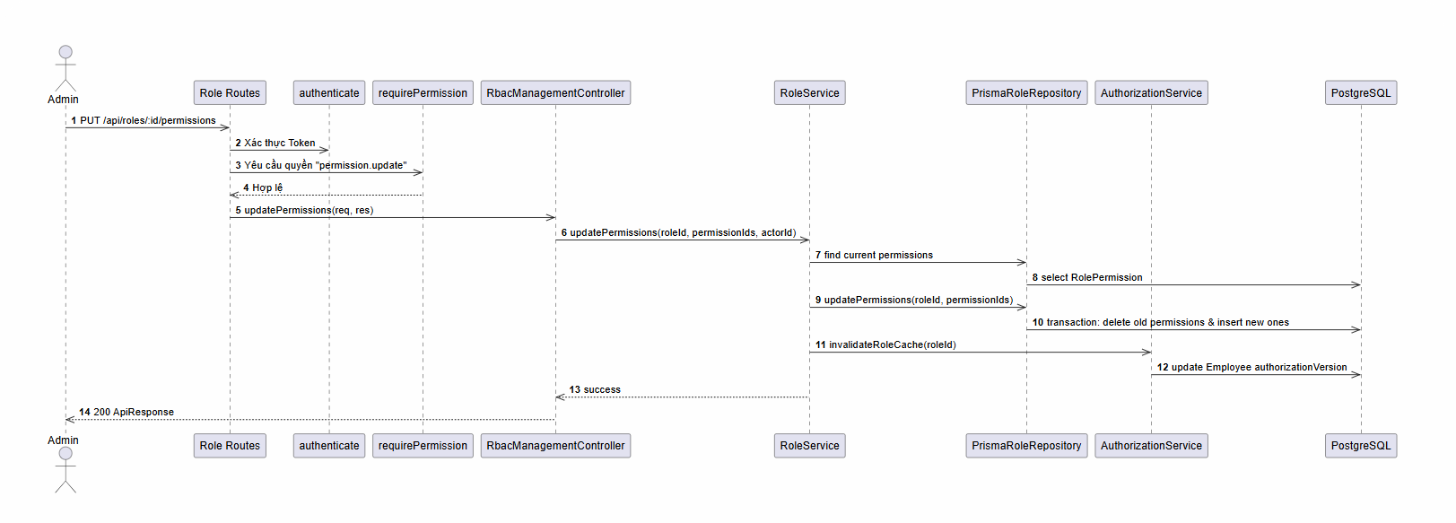

d. Database Queries
Count existing assignments for a specific privilege (checking soft constraints):
SELECT COUNT(*) FROM role_permissions WHERE permission_id = :permissionId;

7.4 Feature Permission Matrix

a. Class Diagram
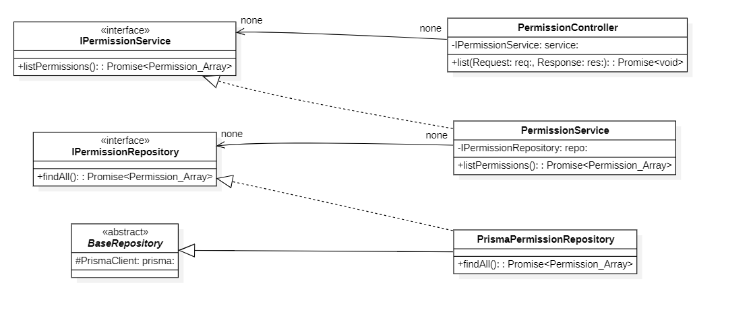

b. Class Specifications
PermissionController Class

No | Method | Description
01 | constructor(service: IPermissionService) : void | Inputs: Input parameters: service: IPermissionService.  Outputs: Output: void.  Processing: Initializes a new instance of the PermissionController class and injects required dependencies.
02 | list(req: AuthRequest, res: Response) : Promise | Inputs: Input parameters: req: AuthRequest, res: Response.  Outputs: Output: Promise.  Processing: Queries the database or processes business logic to retrieve/find data based on the specified input criteria.
03 | getOne(req: AuthRequest, res: Response) : Promise | Inputs: Input parameters: req: AuthRequest, res: Response.  Outputs: Output: Promise.  Processing: Queries the database or processes business logic to retrieve/find data based on the specified input criteria.
04 | create(req: AuthRequest, res: Response) : Promise | Inputs: Input parameters: req: AuthRequest, res: Response.  Outputs: Output: Promise.  Processing: Validates the input data and inserts a new record into the database.
05 | update(req: AuthRequest, res: Response) : Promise | Inputs: Input parameters: req: AuthRequest, res: Response.  Outputs: Output: Promise.  Processing: Verifies existence, validates new input data, and updates the record in the database.
06 | delete(req: AuthRequest, res: Response) : Promise | Inputs: Input parameters: req: AuthRequest, res: Response.  Outputs: Output: Promise.  Processing: Performs a deletion (either soft or hard delete) of the record from the database.

PermissionService Class

No | Method | Description
01 | constructor(repository: IPermissionRepository) : void | Inputs: Input parameters: repository: IPermissionRepository.  Outputs: Output: void.  Processing: Initializes a new instance of the PermissionService class and injects required dependencies.
02 | listPermissions(query: PermissionListQuery) : Promise | Inputs: Input parameters: query: PermissionListQuery.  Outputs: Output: Promise.  Processing: Queries the database or processes business logic to retrieve/find data based on the specified input criteria.
03 | getPermission(id: string) : Promise | Inputs: Input parameters: id: string.  Outputs: Output: Promise.  Processing: Queries the database or processes business logic to retrieve/find data based on the specified input criteria.
04 | createPermission(data: CreatePermissionDto) : Promise | Inputs: Input parameters: data: CreatePermissionDto.  Outputs: Output: Promise.  Processing: Validates the input data and inserts a new record into the database.
05 | updatePermission(id: string, data: UpdatePermissionDto) : Promise | Inputs: Input parameters: id: string, data: UpdatePermissionDto.  Outputs: Output: Promise.  Processing: Verifies existence, validates new input data, and updates the record in the database.
06 | deletePermission(id: string, actorId: string) : Promise | Inputs: Input parameters: id: string, actorId: string.  Outputs: Output: Promise.  Processing: Performs a deletion (either soft or hard delete) of the record from the database.

PrismaPermissionRepository Class

No | Method | Description
01 | constructor(prisma: PrismaClient) : void | Inputs: Input parameters: prisma: PrismaClient.  Outputs: Output: void.  Processing: Initializes a new instance of the PrismaPermissionRepository class and injects required dependencies.
02 | listPermissionsPaginated(query: PermissionListQuery) : Promise | Inputs: Input parameters: query: PermissionListQuery.  Outputs: Output: Promise.  Processing: Queries the database or processes business logic to retrieve/find data based on the specified input criteria.
03 | findById(id: string) : Promise | Inputs: Input parameters: id: string.  Outputs: Output: Promise.  Processing: Queries the database or processes business logic to retrieve/find data based on the specified input criteria.
04 | findByCode(code: string, includeSoftDeleted?: boolean) : Promise | Inputs: Input parameters: code: string, includeSoftDeleted?: boolean.  Outputs: Output: Promise.  Processing: Queries the database or processes business logic to retrieve/find data based on the specified input criteria.
05 | createPermission(data: CreatePermissionDto) : Promise | Inputs: Input parameters: data: CreatePermissionDto.  Outputs: Output: Promise.  Processing: Validates the input data and inserts a new record into the database.
06 | updatePermission(id: string, data: UpdatePermissionDto) : Promise | Inputs: Input parameters: id: string, data: UpdatePermissionDto.  Outputs: Output: Promise.  Processing: Verifies existence, validates new input data, and updates the record in the database.
07 | deletePermission(id: string, actorId: string) : Promise | Inputs: Input parameters: id: string, actorId: string.  Outputs: Output: Promise.  Processing: Performs a deletion (either soft or hard delete) of the record from the database.
08 | countRoleAssignments(id: string) : Promise | Inputs: Input parameters: id: string.  Outputs: Output: Promise.  Processing: Executes internal business logic for this function according to the system workflow requirements.
09 | mapToDomain(permission: PrismaPermission) : Permission | Inputs: Input parameters: permission: PrismaPermission.  Outputs: Output: Permission.  Processing: Executes internal business logic for this function according to the system workflow requirements.

c. Sequence Diagram(s)

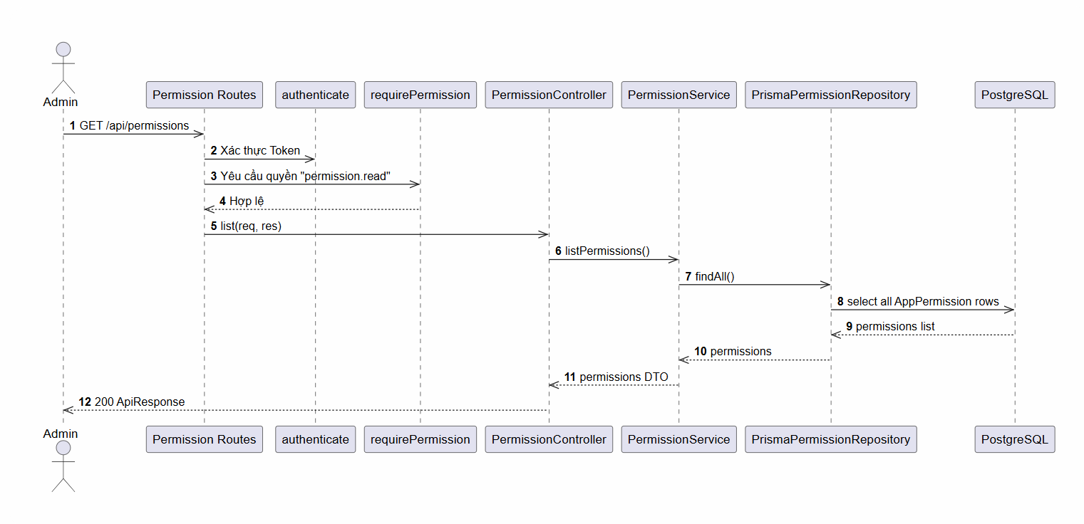

d. Database Queries
List all system permissions:
SELECT * FROM permissions WHERE deleted_at IS NULL;

7.5 Feature Project Position Management

a. Class Diagram
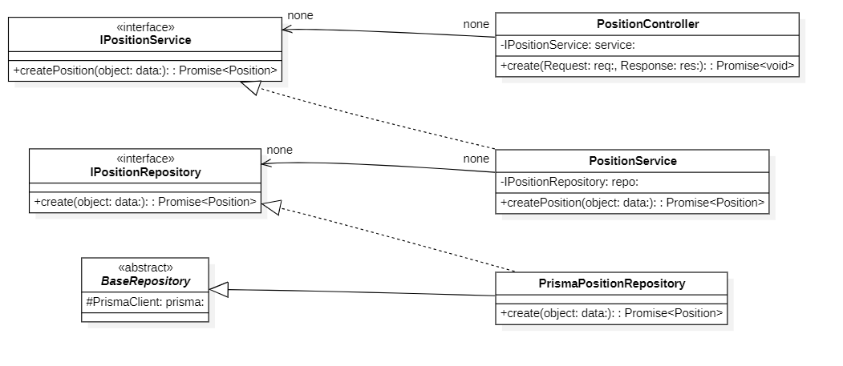

b. Class Specifications
TaskController Class

No | Method | Description
01 | constructor(service: ITaskService) : void | Inputs: Input parameters: service: ITaskService.  Outputs: Output: void.  Processing: Initializes a new instance of the TaskController class and injects required dependencies.
02 | list(req: AuthRequest, res: Response) : Promise | Inputs: Input parameters: req: AuthRequest, res: Response.  Outputs: Output: Promise.  Processing: Queries the database or processes business logic to retrieve/find data based on the specified input criteria.
03 | getOne(req: AuthRequest, res: Response) : Promise | Inputs: Input parameters: req: AuthRequest, res: Response.  Outputs: Output: Promise.  Processing: Queries the database or processes business logic to retrieve/find data based on the specified input criteria.
04 | create(req: AuthRequest, res: Response) : Promise | Inputs: Input parameters: req: AuthRequest, res: Response.  Outputs: Output: Promise.  Processing: Validates the input data and inserts a new record into the database.
05 | update(req: AuthRequest, res: Response) : Promise | Inputs: Input parameters: req: AuthRequest, res: Response.  Outputs: Output: Promise.  Processing: Verifies existence, validates new input data, and updates the record in the database.
06 | delete(req: AuthRequest, res: Response) : Promise | Inputs: Input parameters: req: AuthRequest, res: Response.  Outputs: Output: Promise.  Processing: Performs a deletion (either soft or hard delete) of the record from the database.
TaskService Class

No | Method | Description
01 | constructor(repository: ITaskRepository, projectRepository: IProjectRepository, employeeRepository: IEmployeeRepository, statusRepository?: IProjectTaskStatusRepository, positionService?: IPositionService) : void | Inputs: Input parameters: repository: ITaskRepository, projectRepository: IProjectRepository, employeeRepository: IEmployeeRepository, statusRepository?: IProjectTaskStatusRepository, positionService?: IPositionService.  Outputs: Output: void.  Processing: Initializes a new instance of the TaskService class and injects required dependencies.
02 | getTask(id: string, userId: string) : Promise | Inputs: Input parameters: id: string, userId: string.  Outputs: Output: Promise.  Processing: Queries the database or processes business logic to retrieve/find data based on the specified input criteria.
03 | listTasks(query: TaskListQuery, userId: string) : Promise | Inputs: Input parameters: query: TaskListQuery, userId: string.  Outputs: Output: Promise.  Processing: Queries the database or processes business logic to retrieve/find data based on the specified input criteria.
04 | createTask(data: CreateTaskDto, userId: string) : Promise | Inputs: Input parameters: data: CreateTaskDto, userId: string.  Outputs: Output: Promise.  Processing: Validates the input data and inserts a new record into the database.
05 | updateTask(id: string, data: UpdateTaskDto, userId: string) : Promise | Inputs: Input parameters: id: string, data: UpdateTaskDto, userId: string.  Outputs: Output: Promise.  Processing: Verifies existence, validates new input data, and updates the record in the database.
06 | deleteTask(id: string, userId: string) : Promise | Inputs: Input parameters: id: string, userId: string.  Outputs: Output: Promise.  Processing: Performs a deletion (either soft or hard delete) of the record from the database.
07 | isAuthorizedAdminOrGM(userId: string) : Promise | Inputs: Input parameters: userId: string.  Outputs: Output: Promise.  Processing: Executes internal business logic for this function according to the system workflow requirements.

c. Sequence Diagram(s)

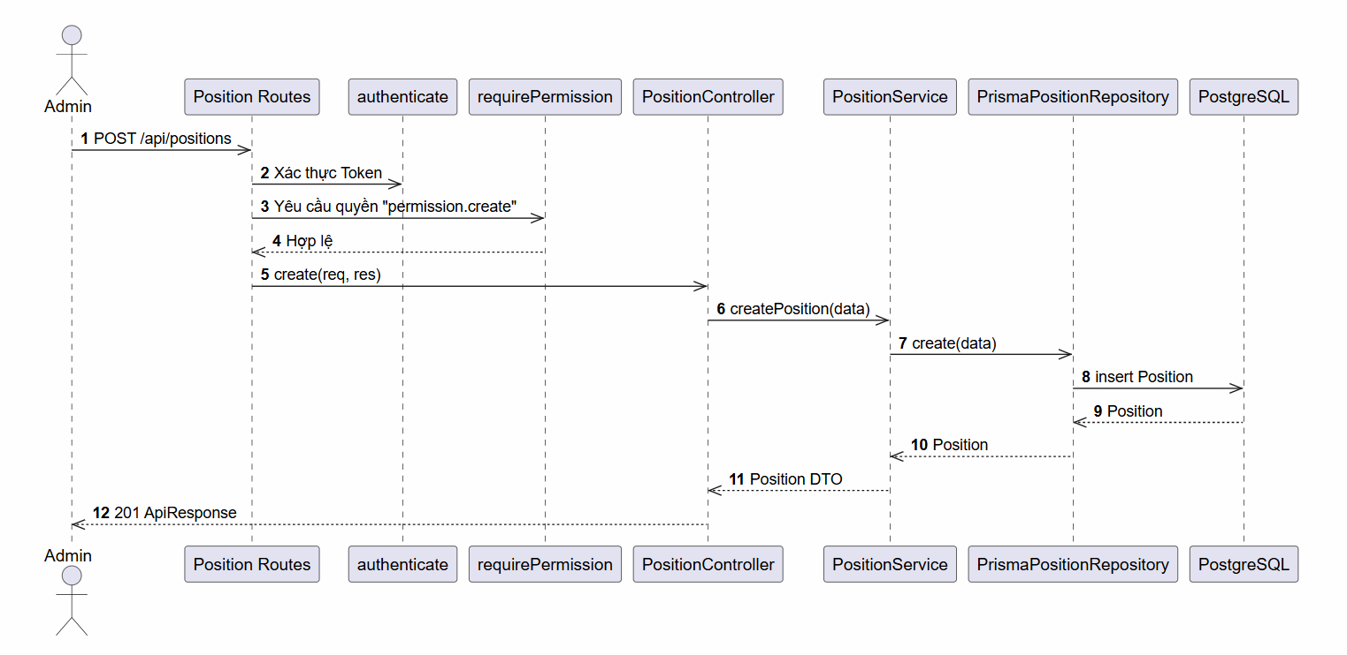

d. Database Queries
Fetch corporate designations and roles allowed within project spaces:
SELECT * FROM positions WHERE deleted_at IS NULL;
SELECT * FROM project_roles WHERE project_id = :projectId;

7.6 Feature User Management

a. Class Diagram
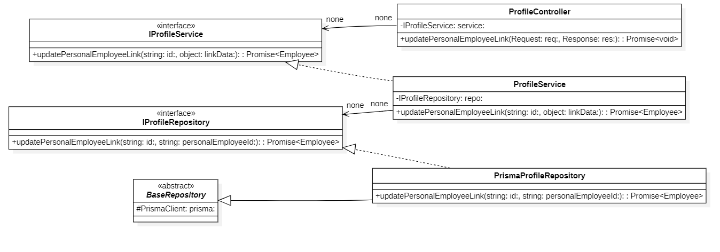

b. Class Specifications
EmployeeController Class

No | Method | Description
01 | constructor(service: IEmployeeService) : void | Inputs: Input parameters: service: IEmployeeService.  Outputs: Output: void.  Processing: Initializes a new instance of the EmployeeController class and injects required dependencies.
02 | list(req: AuthRequest, res: Response) : Promise | Inputs: Input parameters: req: AuthRequest, res: Response.  Outputs: Output: Promise.  Processing: Queries the database or processes business logic to retrieve/find data based on the specified input criteria.
03 | listApprovers(req: AuthRequest, res: Response) : Promise | Inputs: Input parameters: req: AuthRequest, res: Response.  Outputs: Output: Promise.  Processing: Queries the database or processes business logic to retrieve/find data based on the specified input criteria.
04 | getOne(req: AuthRequest, res: Response) : Promise | Inputs: Input parameters: req: AuthRequest, res: Response.  Outputs: Output: Promise.  Processing: Queries the database or processes business logic to retrieve/find data based on the specified input criteria.
05 | create(req: AuthRequest, res: Response) : Promise | Inputs: Input parameters: req: AuthRequest, res: Response.  Outputs: Output: Promise.  Processing: Validates the input data and inserts a new record into the database.
06 | update(req: AuthRequest, res: Response) : Promise | Inputs: Input parameters: req: AuthRequest, res: Response.  Outputs: Output: Promise.  Processing: Verifies existence, validates new input data, and updates the record in the database.
07 | updateStatus(req: AuthRequest, res: Response) : Promise | Inputs: Input parameters: req: AuthRequest, res: Response.  Outputs: Output: Promise.  Processing: Verifies existence, validates new input data, and updates the record in the database.
08 | delete(req: AuthRequest, res: Response) : Promise | Inputs: Input parameters: req: AuthRequest, res: Response.  Outputs: Output: Promise.  Processing: Performs a deletion (either soft or hard delete) of the record from the database.

EmployeeService Class

No | Method | Description
01 | constructor(repository: IEmployeeRepository, authRepository?: IAuthRepository) : void | Inputs: Input parameters: repository: IEmployeeRepository, authRepository?: IAuthRepository.  Outputs: Output: void.  Processing: Initializes a new instance of the EmployeeService class and injects required dependencies.
02 | listEmployees(query: EmployeeListQuery) : Promise | Inputs: Input parameters: query: EmployeeListQuery.  Outputs: Output: Promise.  Processing: Queries the database or processes business logic to retrieve/find data based on the specified input criteria.
03 | getEmployee(id: string) : Promise | Inputs: Input parameters: id: string.  Outputs: Output: Promise.  Processing: Queries the database or processes business logic to retrieve/find data based on the specified input criteria.
04 | createEmployee(data: CreateEmployeeDto) : Promise | Inputs: Input parameters: data: CreateEmployeeDto.  Outputs: Output: Promise.  Processing: Validates the input data and inserts a new record into the database.
05 | updateEmployee(id: string, data: UpdateEmployeeDto, actorId?: string, ipAddress?: string) : Promise | Inputs: Input parameters: id: string, data: UpdateEmployeeDto, actorId?: string, ipAddress?: string.  Outputs: Output: Promise.  Processing: Verifies existence, validates new input data, and updates the record in the database.
06 | updateStatus(id: string, status: EmployeeStatus, actorId?: string, ipAddress?: string) : Promise | Inputs: Input parameters: id: string, status: EmployeeStatus, actorId?: string, ipAddress?: string.  Outputs: Output: Promise.  Processing: Verifies existence, validates new input data, and updates the record in the database.
07 | deleteEmployee(id: string, actorId?: string) : Promise | Inputs: Input parameters: id: string, actorId?: string.  Outputs: Output: Promise.  Processing: Performs a deletion (either soft or hard delete) of the record from the database.
08 | listApprovers() : Promise | Inputs: Input parameters: None.  Outputs: Output: Promise.  Processing: Queries the database or processes business logic to retrieve/find data based on the specified input criteria.
09 | getEmployeeRoles(employeeId: string) : Promise | Inputs: Input parameters: employeeId: string.  Outputs: Output: Promise.  Processing: Queries the database or processes business logic to retrieve/find data based on the specified input criteria.
10 | assignRole(employeeId: string, roleId: string, actorId?: string) : Promise | Inputs: Input parameters: employeeId: string, roleId: string, actorId?: string.  Outputs: Output: Promise.  Processing: Creates an association/assignment between two entities (e.g., assigning a role to an employee or permissions to a role).
11 | revokeRole(employeeId: string, roleId: string, actorId?: string) : Promise | Inputs: Input parameters: employeeId: string, roleId: string, actorId?: string.  Outputs: Output: Promise.  Processing: Removes the association/assignment between two entities.
12 | updateRoles(employeeId: string, roleIds: string[], version: number, actorId?: string) : Promise | Inputs: Input parameters: employeeId: string, roleIds: string[], version: number, actorId?: string.  Outputs: Output: Promise.  Processing: Verifies existence, validates new input data, and updates the record in the database

c. Sequence Diagram(s)
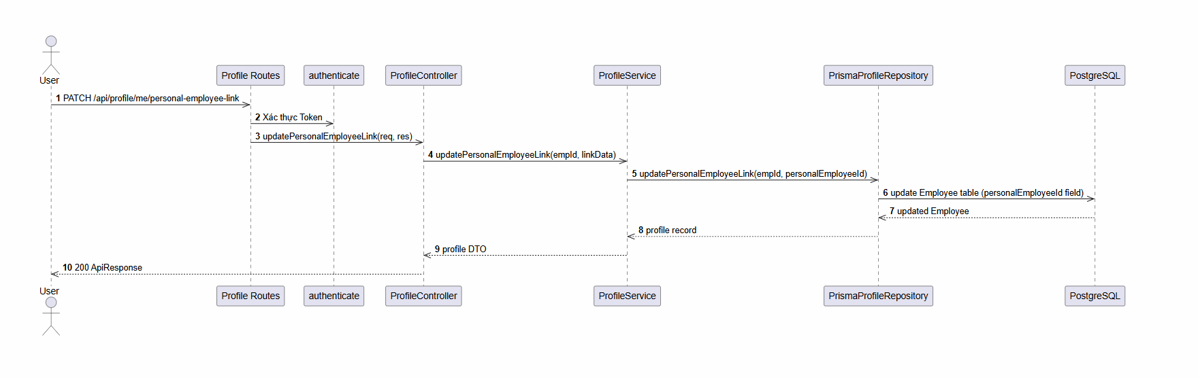

8. Recruitment Module

8.1 Feature: Job Requisition & Approval

a. Class Diagram
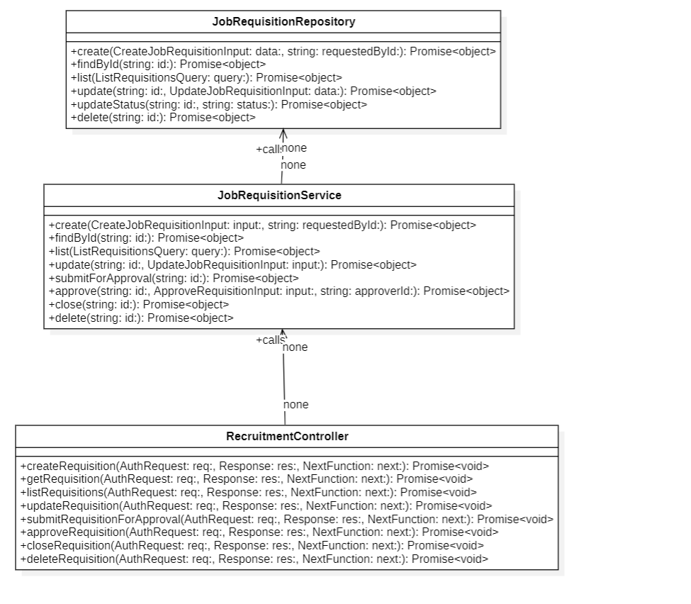

b. Class Specifications
RecruitmentController Class

No | Method | Description
01 | createRequisition(req, res, next) | Inputs: Request, Response, NextFunction.  Outputs: Promise<void> (Returns JSON ApiResponse containing created Requisition ID).  Processing: Parses and validates the request body via createJobRequisitionSchema, passes the data and the logged-in user ID to JobRequisitionService.create, and sends back HTTP 201.
02 | approveRequisition(req, res, next) | Inputs: Request, Response, NextFunction.  Outputs: Promise<void> (Returns JSON status message).  Processing: Extracts the requisition ID from parameters and approval status/reasons from body, invokes JobRequisitionService.approve, and sends success response.

JobRequisitionService Class

No | Method | Description
01 | create(input, requestedById) | Inputs: input: CreateJobRequisitionInput, requestedById: string.  Outputs: Promise<object>.  Processing: Validates salary range bounds (salaryMin <= salaryMax), asserts that the designated approver is eligible, and calls JobRequisitionRepository.create.
02 | approve(id, input, approverId) | Inputs: id: string, input: ApproveRequisitionInput, approverId: string.  Outputs: Promise<object>.  Processing: Checks if the requisition exists and is in the pending approval state. Verifies that the approving user matches the designated approver, updates status to approved/rejected, and logs the workflow action.

JobRequisitionRepository Class

No | Method | Description
01 | create(data, requestedById) | Inputs: data: CreateJobRequisitionInput, requestedById: string.  Outputs: Promise<{ id: string }>.  Processing: Generates a unique sequential code for the requisition (e.g. REQ-YYYY-XXXX), inserts the requisition record into the database, and returns the ID.
02 | findById(id) | Inputs: id: string.  Outputs: Promise<object | null>.  Processing: Queries the JobRequisition table using a unique ID filter, including relations for requestedBy, approver, approvedBy, and positions.

c. Sequence Diagram(s)
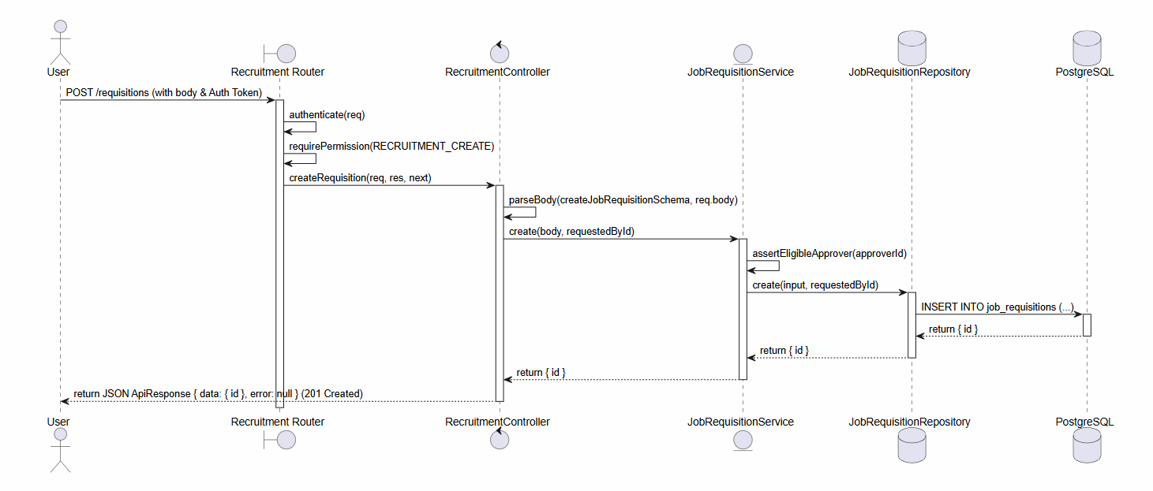

d. Database Queries
-- YYYY represents the current year and XXXX represents a 4-digit sequential padded count
INSERT INTO "job_requisitions" (
"id", "code", "title", "department", "position_level", "currency",
"priority", "reason", "requested_by_id", "approver_id", "position_id",
"salary_min", "salary_max", "headcount", "employment_type",
"target_hire_date", "target_close_date", "status", "created_at", "updated_at"
) VALUES (
gen_random_uuid(), :code, :title, :department, :positionLevel, :currency,
:priority, :reason, :requestedById, :approverId, :positionId,
:salaryMin, :salaryMax, :headcount, :employmentType,
:targetHireDate, :targetCloseDate, 'draft', CURRENT_TIMESTAMP, CURRENT_TIMESTAMP
);

8.2 Feature Job Postings & Candidate Intake

a. Class Diagram
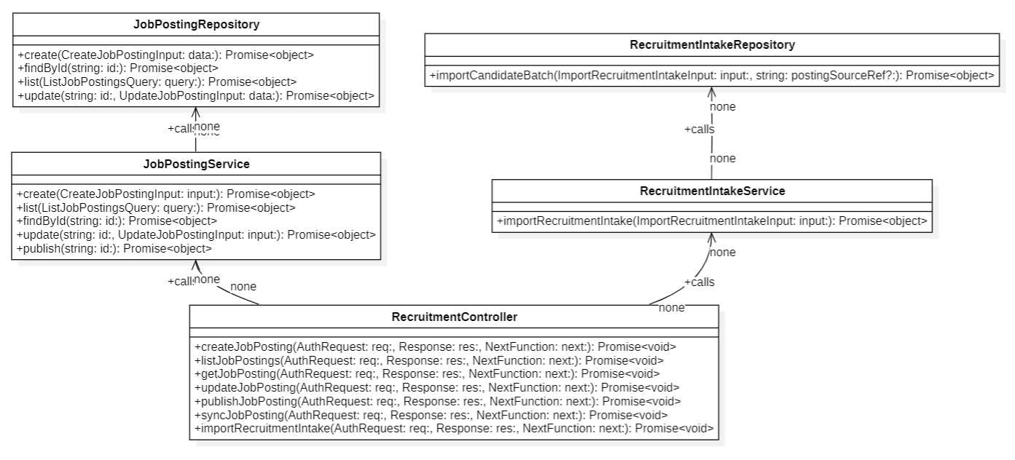

b. Class Specifications
RecruitmentController Class (Posting & Intake APIs)

No | Method | Description
01 | createJobPosting(req, res, next) | Inputs: Request, Response, NextFunction.  Outputs: Promise<void>.  Processing: Validates request body with createJobPostingSchema, calls JobPostingService.create, and returns 201 Created status.
02 | importRecruitmentIntake(req, res, next) | Inputs: Request, Response, NextFunction.  Outputs: Promise<void>.  Processing: Parses and validates intake records body via importRecruitmentIntakeSchema, passes data to RecruitmentIntakeService.importRecruitmentIntake, and returns

JobPostingService Class

No | Method | Description
01 | create(input) | Inputs: input: CreateJobPostingInput.  Outputs: Promise<object>.  Processing: Calls JobPostingRepository.create to create a draft posting tied to an approved Requisition.
02 | publish(id) | Inputs: id: string.  Outputs: Promise<object>.  Processing: Finds the posting, changes its status to active/published, and sets the publish date.

RecruitmentIntakeRepository Class

No | Method | Description
01 | importCandidateBatch(input, postingSourceRef) | Inputs: input: ImportRecruitmentIntakeInput, postingSourceRef: string.  Outputs: Promise<object>.  Processing: Wraps batch creation of candidates and associated recruitment applications in a database Transaction. Skips existing exact Google Form responses, creates missing candidates, validates active duplication constraints, and records Google Form connectors' responses.

c. Sequence Diagram(s)
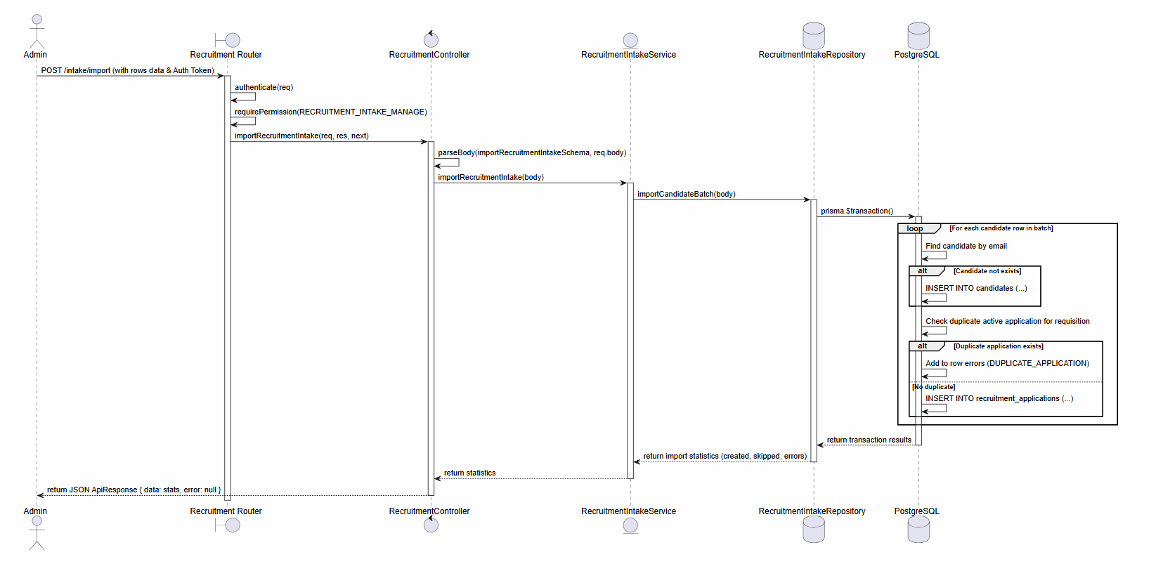

d. Database Queries
1. Insert candidate (If not exists)
INSERT INTO "candidates" (
"id", "full_name", "email", "phone", "cv_url", "notes", "source", "created_at", "updated_at"
) VALUES (
gen_random_uuid(), :fullName, :email, :phone, :cvUrl, :notes, :source, CURRENT_TIMESTAMP, CURRENT_TIMESTAMP
)
ON CONFLICT ("email") DO UPDATE
SET "updated_at" = CURRENT_TIMESTAMP;

2. Create Job Posting linked to Requisition
INSERT INTO "job_postings" (
"id", "requisition_id", "title", "description", "requirements",
"status", "published_at", "created_at", "updated_at"
) VALUES (
gen_random_uuid(), :requisitionId, :title, :description, :requirements,
'draft', NULL, CURRENT_TIMESTAMP, CURRENT_TIMESTAMP
);
3. Check for existing active application for candidate
SELECT id
FROM "recruitment_applications"
WHERE "requisition_id" = :requisitionId
AND "candidate_id" = :candidateId
AND "status" NOT IN ('hired', 'rejected', 'withdrawn');

8.3 Feature Candidate Application & Kanban Tracking

a. Class Diagram
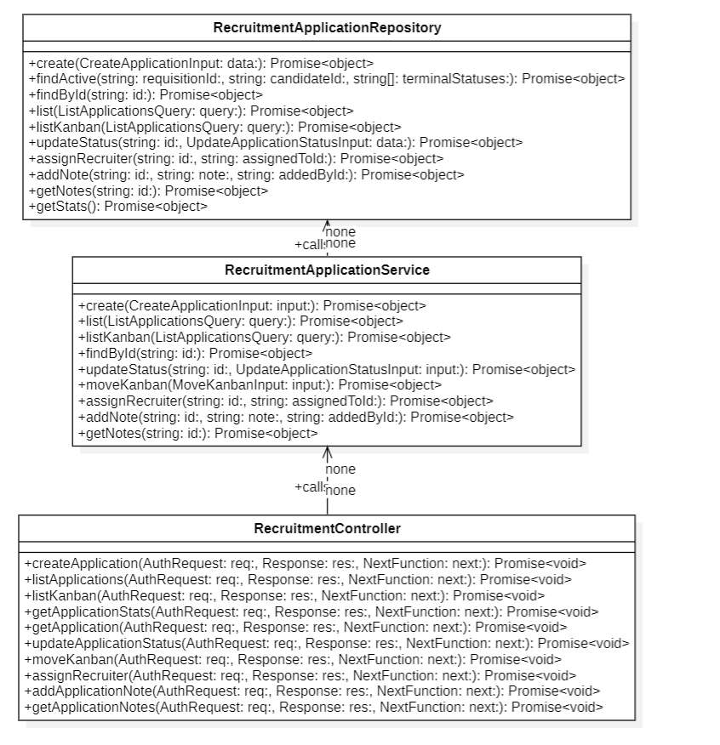

b. Class Specifications
RecruitmentController Class (Application & Kanban APIs)

No | Method | Description
01 | listKanban(req, res, next) | Inputs: Request, Response, NextFunction.  Outputs: Promise<void>.  Processing: Parses list queries using listApplicationsQuerySchema, retrieves applications grouped/ordered for Kanban display via RecruitmentApplicationService.listKanban, and returns them in JSON envelope.
02 | moveKanban(req, res, next) | Inputs: Request, Response, NextFunction.  Outputs: Promise<void>.  Processing: Validates input data with moveKanbanSchema (id, targetStatus), executes position movement using RecruitmentApplicationService.moveKanban, and returns HTTP 200.

RecruitmentApplicationService Class

No | Method | Description
01 | moveKanban(input) | Inputs: input: MoveKanbanInput.  Outputs: Promise<object>.  Processing: Asserts that the transition from current status to target status is valid under recruitment workflow constraints (e.g. cannot transition directly from new to offer_accepted without interviews), then delegates update to RecruitmentApplicationRepository.updateStatus.
02 | assignRecruiter(id, assignedToId) | Inputs: id: string, assignedToId: string.  Outputs: Promise<object>.  Processing: Calls repository to bind the application to a specific HR staff member (recruiter).

RecruitmentApplicationRepository Class

No | Method | Description
01 | listKanban(query) | Inputs: query: ListApplicationsQuery.  Outputs: Promise<{ items: any[], total: number }>.  Processing: Queries the recruitmentApplication table for non-terminal statuses ('new', 'reviewing', 'shortlisted', 'interviewing', 'final_review', 'offer_sent', 'offer_accepted'), including candidate profiles and active interview rounds.
02 | updateStatus(id, data) | Inputs: id: string, data: UpdateApplicationStatusInput.  Outputs: Promise<object>.  Processing: Updates the status column of the specified application, storing rejectReason or withdrawReason if applicable, and returning the updated record.

c. Sequence Diagram(s)

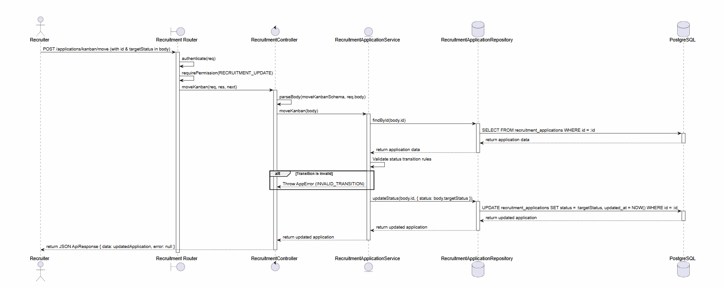

d. Database Queries
1. List Kanban Applications
SELECT ra.*,
c.full_name AS candidate_name,
c.email AS candidate_email,
c.avatar_url AS candidate_avatar,
jr.title AS requisition_title,
jr.department AS requisition_department
FROM "recruitment_applications" ra
INNER JOIN "candidates" c ON ra.candidate_id = c.id
INNER JOIN "job_requisitions" jr ON ra.requisition_id = jr.id
WHERE ra.status IN ('new', 'reviewing', 'shortlisted', 'interviewing', 'final_review', 'offer_sent', 'offer_accepted')
AND ra.requisition_id = :requisitionId
ORDER BY ra.updated_at DESC
LIMIT :limit OFFSET :offset;
2. Move Kanban Status (Update application status)
UPDATE "recruitment_applications"
SET "status" = :status,
"reject_reason" = :rejectReason,
"withdraw_reason" = :withdrawReason,
"updated_at" = CURRENT_TIMESTAMP
WHERE "id" = :id;

3. Assign Recruiter to Application
UPDATE "recruitment_applications"
SET "assigned_to_id" = :assignedToId,
"updated_at" = CURRENT_TIMESTAMP
WHERE "id" = :id;

8.4 Feature Interview Scheduling & Evaluation

a. Class Diagram
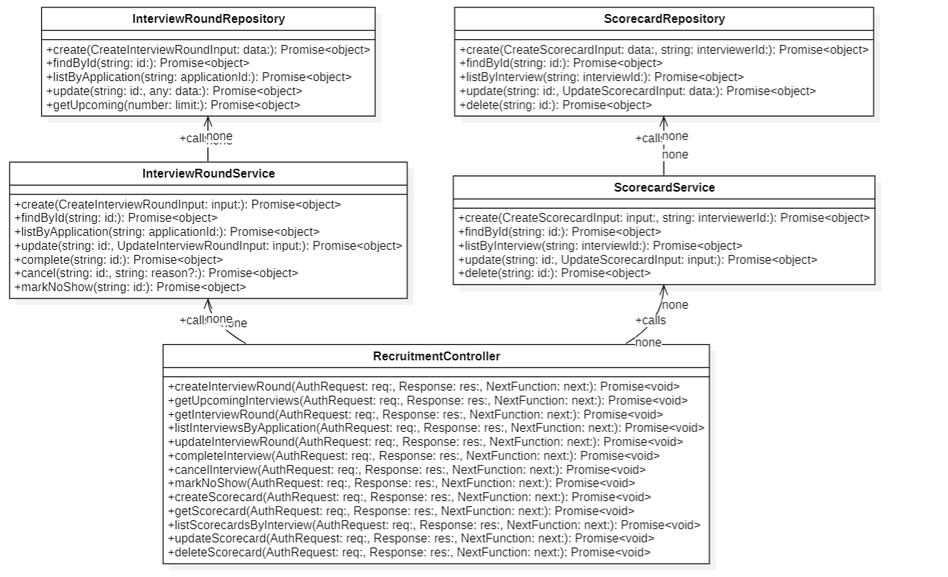

b. Class Specifications
RecruitmentController Class (Interview & Scorecard APIs)

No | Method | Description
01 | createInterviewRound(req, res, next) | Inputs: Request, Response, NextFunction.  Outputs: Promise<void>.  Processing: Validates input via createInterviewRoundSchema, calls InterviewRoundService.create, and sends 201 response.
02 | createScorecard(req, res, next) | Inputs: Request, Response, NextFunction.  Outputs: Promise<void>.  Processing: Validates body with createScorecardSchema, passes values and interviewer employee ID to ScorecardService.create, and returns 201 Created.

InterviewRoundService Class

No | Method | Description
01 | create(input) | Inputs: input: CreateInterviewRoundInput.  Outputs: Promise<object>.  Processing: Validates that the application exists and is in the 'interviewing' or transitionable state, schedules the round parameters (roundNumber, scheduleTime), and calls repository.
02 | complete(id) | Inputs: id: string.  Outputs: Promise<object>.  Processing: Marks the interview round as 'completed', checks if overall feedback and scores from scorecard are registered.

ScorecardRepository Class

No | Method | Description
01 | create(data, interviewerId) | Inputs: data: CreateScorecardInput, interviewerId: string.  Outputs: Promise<{ id: string }>.  Processing: Saves ratings, overall recommendation (e.g. hire, hold, strong_hire, reject) and evaluation remarks into database.

c. Sequence Diagram(s)

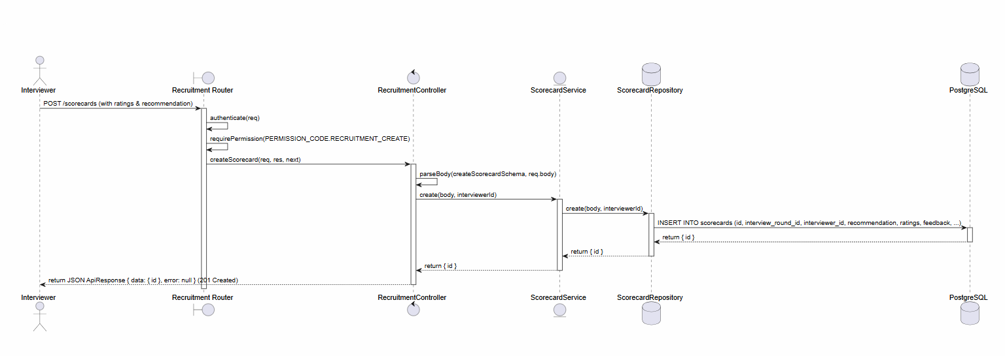

d. Database Queries
1. Schedule Interview Round
INSERT INTO "interview_rounds" (
"id", "application_id", "round_number", "title", "interviewer_ids",
"scheduled_at", "status", "created_at", "updated_at"
) VALUES (
gen_random_uuid(), :applicationId, :roundNumber, :title, :interviewerIds,
:scheduledAt, 'scheduled', CURRENT_TIMESTAMP, CURRENT_TIMESTAMP
);

2. Create Scorecard
INSERT INTO "scorecards" (
"id", "interview_round_id", "interviewer_id", "recommendation",
"ratings", "feedback", "created_at", "updated_at"
) VALUES (
gen_random_uuid(), :interviewRoundId, :interviewerId, :recommendation,
:ratings::jsonb, :feedback, CURRENT_TIMESTAMP, CURRENT_TIMESTAMP
);

3. Query upcoming interviews with candidate info
SELECT ir.*,
c.full_name AS candidate_name,
jr.title AS job_title
FROM "interview_rounds" ir
INNER JOIN "recruitment_applications" ra ON ir.application_id = ra.id
INNER JOIN "candidates" c ON ra.candidate_id = c.id
INNER JOIN "job_requisitions" jr ON ra.requisition_id = jr.id
WHERE ir.status = 'scheduled'
AND ir.scheduled_at >= CURRENT_TIMESTAMP
ORDER BY ir.scheduled_at ASC;

8.5 Feature Interview Scheduling & Evaluation

a. Class Diagram
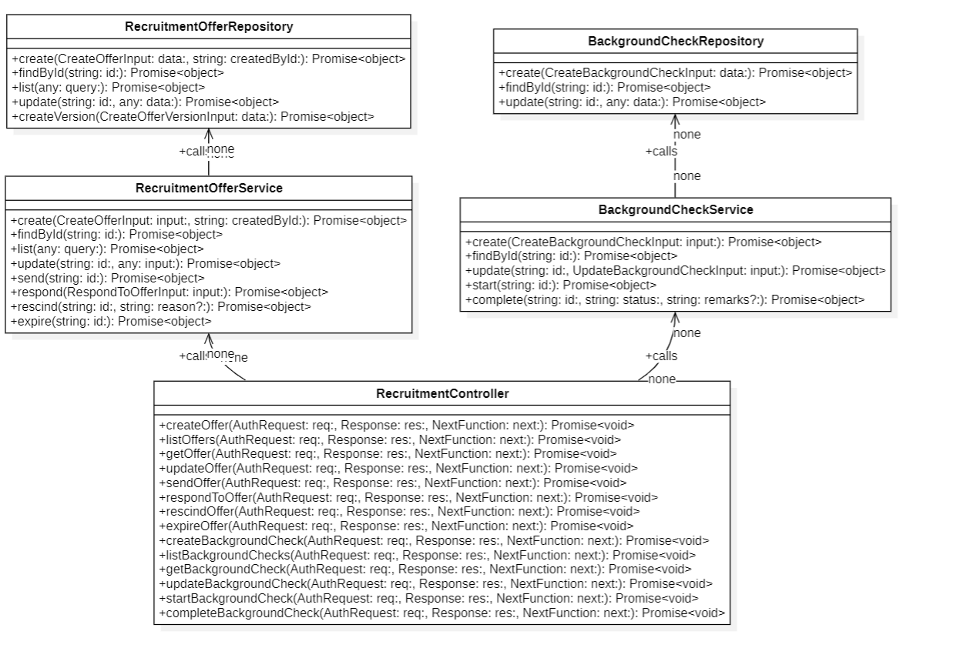

b. Class Specifications
RecruitmentOfferService Class

No | Method | Description
01 | create(input, createdById) | Inputs: input: CreateOfferInput, createdById: string.  Outputs: Promise<object>.  Processing: Checks that the corresponding Application is in the 'final_review' state, sets up salary and benefit details, and inserts a draft offer into the database.
02 | respond(input) | Inputs: input: RespondToOfferInput.  Outputs: Promise<object>.  Processing: Registers candidate response ('accepted' or 'declined'). If accepted, automatically initiates background check workflow and updates Application status to 'offer_accepted'.

BackgroundCheckService Class

No | Method | Description
01 | start(id) | Inputs: id: string.  Outputs: Promise<object>.  Processing: Advances background check state from 'draft' to 'in_progress' and records check start timestamp.
02 | complete(id, status, remarks) | Inputs: id: string, status: string, remarks?: string.  Outputs: Promise<object>.  Processing: Completes check as 'passed' or 'failed', logs notes, and prepares candidate record for onboarding.

c. Sequence Diagram(s)

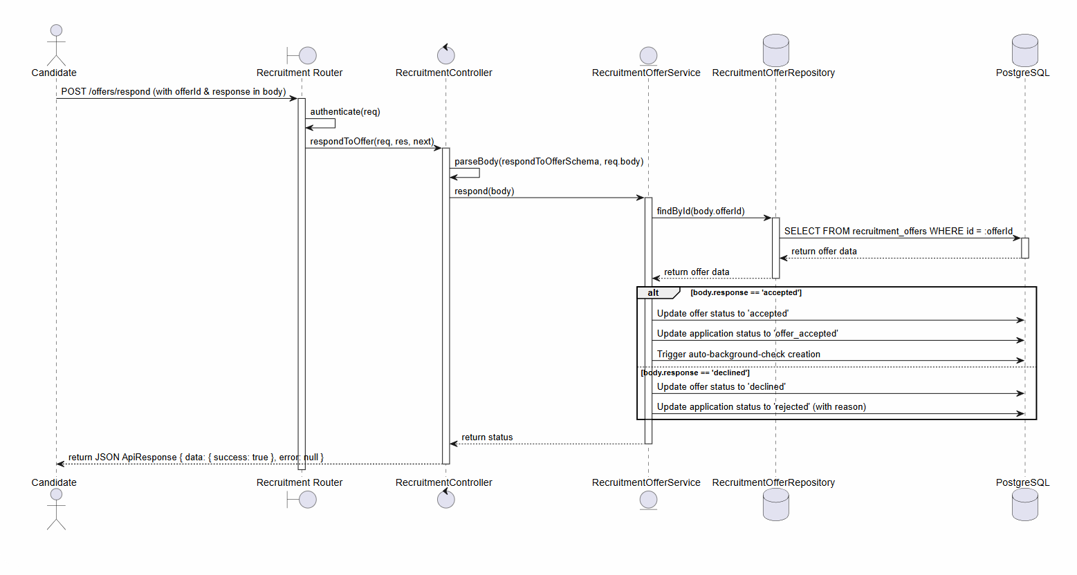

d. Database Queries
1. Create Offer Draft
INSERT INTO "recruitment_offers" (
"id", "application_id", "candidate_id", "offered_salary", "currency",
"start_date", "end_date", "trial_end_date", "job_title", "department",
"employment_type", "benefits", "notes", "created_by_id", "status", "current_version",
"created_at", "updated_at"
) VALUES (
gen_random_uuid(), :applicationId, :candidateId, :offeredSalary, :currency,
:startDate, :endDate, :trialEndDate, :jobTitle, :department,
:employmentType, :benefits::jsonb, :notes, :createdById, 'draft', 1,
CURRENT_TIMESTAMP, CURRENT_TIMESTAMP
);

2. Create Background Check Record
INSERT INTO "background_checks" (
"id", "offer_id", "candidate_id", "status", "provider",
"check_type", "started_at", "completed_at", "remarks",
"created_at", "updated_at"
) VALUES (
gen_random_uuid(), :offerId, :candidateId, 'draft', :provider,
:checkType, NULL, NULL, NULL,
CURRENT_TIMESTAMP, CURRENT_TIMESTAMP
);

3. Update Offer Response
UPDATE "recruitment_offers"
SET "status" = :status,
"updated_at" = CURRENT_TIMESTAMP
WHERE "id" = :id;

9. Authentication and System Module

9.1 Feature Login

a. Class Diagram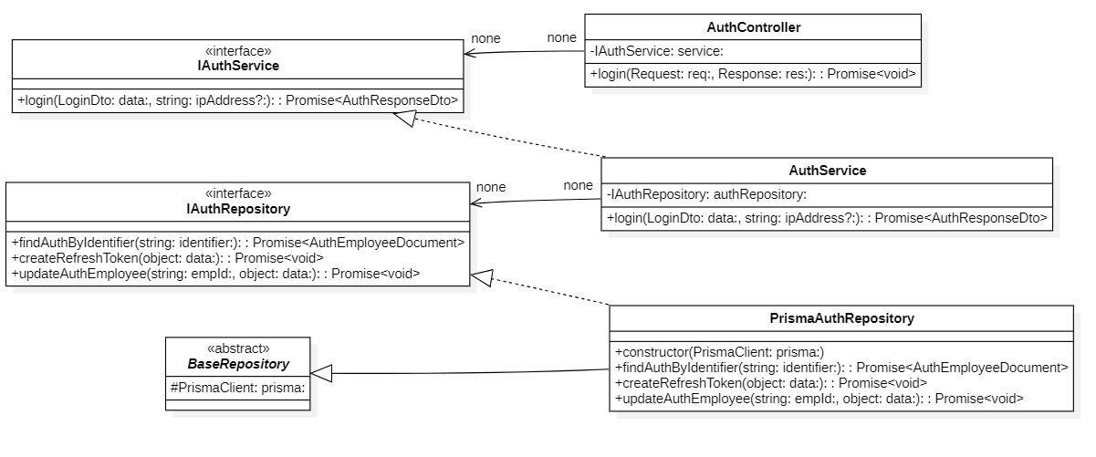

b. Class Specifications
AuthController Class

No | Method | Description
01 | constructor(service: IAuthService) : void | Inputs: Input parameters: service: IAuthService.  Outputs: Output: void.  Processing: Initializes a new instance of the AuthController class and injects required dependencies.
02 | login(req: Request, res: Response) : Promise | Inputs: Input parameters: req: Request, res: Response.  Outputs: Output: Promise.  Processing: Executes internal business logic for this function according to the system workflow requirements.
03 | logout(req: AuthRequest, res: Response) : Promise | Inputs: Input parameters: req: AuthRequest, res: Response.  Outputs: Output: Promise.  Processing: Executes internal business logic for this function according to the system workflow requirements.
04 | refresh(req: Request, res: Response) : Promise | Inputs: Input parameters: req: Request, res: Response.  Outputs: Output: Promise.  Processing: Executes internal business logic for this function according to the system workflow requirements.
05 | getMe(req: AuthRequest, res: Response) : Promise | Inputs: Input parameters: req: AuthRequest, res: Response.  Outputs: Output: Promise.  Processing: Queries the database or processes business logic to retrieve/find data based on the specified input criteria.
06 | forgotPassword(req: Request, res: Response) : Promise | Inputs: Input parameters: req: Request, res: Response.  Outputs: Output: Promise.  Processing: Executes internal business logic for this function according to the system workflow requirements.
07 | changePassword(req: AuthRequest, res: Response) : Promise | Inputs: Input parameters: req: AuthRequest, res: Response.  Outputs: Output: Promise.  Processing: Executes internal business logic for this function according to the system workflow requirements.
08 | validateResetToken(req: Request, res: Response) : Promise | Inputs: Input parameters: req: Request, res: Response.  Outputs: Output: Promise.  Processing: Executes internal business logic for this function according to the system workflow requirements.
09 | resetPassword(req: Request, res: Response) : Promise | Inputs: Input parameters: req: Request, res: Response.  Outputs: Output: Promise.  Processing: Executes internal business logic for this function according to the system workflow requirements.
10 | listMyActivityLogs(req: AuthRequest, res: Response) : Promise | Inputs: Input parameters: req: AuthRequest, res: Response.  Outputs: Output: Promise.  Processing: Queries the database or processes business logic to retrieve/find data based on the specified input criteria.
11 | getMyActivityLogDetail(req: AuthRequest, res: Response) : Promise | Inputs: Input parameters: req: AuthRequest, res: Response.  Outputs: Output: Promise.  Processing: Queries the database or processes business logic to retrieve/find data based on the specified input criteria.
12 | listActivityLogs(req: AuthRequest, res: Response) : Promise | Inputs: Input parameters: req: AuthRequest, res: Response.  Outputs: Output: Promise.  Processing: Queries the database or processes business logic to retrieve/find data based on the specified input criteria.
13 | getActivityLogDetail(req: AuthRequest, res: Response) : Promise | Inputs: Input parameters: req: AuthRequest, res: Response.  Outputs: Output: Promise.  Processing: Queries the database or processes business logic to retrieve/find data based on the specified input criteria.
AuthService Class

No | Method | Description
01 | constructor(repo: IAuthRepository) : void | Inputs: Input parameters: repo: IAuthRepository.  Outputs: Output: void.  Processing: Initializes a new instance of the AuthService class and injects required dependencies.
02 | login(data: LoginDto, ip: string) : Promise | Inputs: Input parameters: data: LoginDto, ip: string.  Outputs: Output: Promise.  Processing: Executes internal business logic for this function according to the system workflow requirements.
03 | logout(employeeId: string, refreshToken: string, ip: string) : Promise | Inputs: Input parameters: employeeId: string, refreshToken: string, ip: string.  Outputs: Output: Promise.  Processing: Executes internal business logic for this function according to the system workflow requirements.
04 | refresh(refreshToken: string) : Promise | Inputs: Input parameters: refreshToken: string.  Outputs: Output: Promise.  Processing: Executes internal business logic for this function according to the system workflow requirements.
05 | getMe(employeeId: string) : Promise | Inputs: Input parameters: employeeId: string.  Outputs: Output: Promise.  Processing: Queries the database or processes business logic to retrieve/find data based on the specified input criteria.
06 | forgotPassword(data: ForgotPasswordDto) : Promise | Inputs: Input parameters: data: ForgotPasswordDto.  Outputs: Output: Promise.  Processing: Executes internal business logic for this function according to the system workflow requirements.
07 | changePassword(employeeId: string, data: ChangePasswordDto) : Promise | Inputs: Input parameters: employeeId: string, data: ChangePasswordDto.  Outputs: Output: Promise.  Processing: Executes internal business logic for this function according to the system workflow requirements.
08 | validateResetToken(data: ValidateResetTokenDto) : Promise | Inputs: Input parameters: data: ValidateResetTokenDto.  Outputs: Output: Promise.  Processing: Executes internal business logic for this function according to the system workflow requirements.
09 | resetPassword(data: ResetPasswordDto) : Promise | Inputs: Input parameters: data: ResetPasswordDto.  Outputs: Output: Promise.  Processing: Executes internal business logic for this function according to the system workflow requirements.
10 | getMyActivityLogs(employeeId: string, query: ActivityLogQuery) : Promise | Inputs: Input parameters: employeeId: string, query: ActivityLogQuery.  Outputs: Output: Promise.  Processing: Queries the database or processes business logic to retrieve/find data based on the specified input criteria.
11 | getMyActivityLogDetail(employeeId: string, id: string) : Promise | Inputs: Input parameters: employeeId: string, id: string.  Outputs: Output: Promise.  Processing: Queries the database or processes business logic to retrieve/find data based on the specified input criteria.
12 | getActivityLogs(query: ActivityLogQuery) : Promise | Inputs: Input parameters: query: ActivityLogQuery.  Outputs: Output: Promise.  Processing: Queries the database or processes business logic to retrieve/find data based on the specified input criteria.
13 | getActivityLogDetail(id: string) : Promise | Inputs: Input parameters: id: string.  Outputs: Output: Promise.  Processing: Queries the database or processes business logic to retrieve/find data based on the specified input criteria.

IAuthService Interface

No | Method | Description
01 | login(data: LoginDto, ip: string) : Promise | Inputs: Input parameters: data: LoginDto, ip: string.  Outputs: Output: Promise.  Processing: Executes internal business logic for this function according to the system workflow requirements.
02 | logout(employeeId: string, refreshToken: string, ip: string) : Promise | Inputs: Input parameters: employeeId: string, refreshToken: string, ip: string.  Outputs: Output: Promise.  Processing: Executes internal business logic for this function according to the system workflow requirements.
03 | refresh(refreshToken: string) : Promise | Inputs: Input parameters: refreshToken: string.  Outputs: Output: Promise.  Processing: Executes internal business logic for this function according to the system workflow requirements.
04 | getMe(employeeId: string) : Promise | Inputs: Input parameters: employeeId: string.  Outputs: Output: Promise.  Processing: Queries the database or processes business logic to retrieve/find data based on the specified input criteria.
05 | forgotPassword(data: ForgotPasswordDto) : Promise | Inputs: Input parameters: data: ForgotPasswordDto.  Outputs: Output: Promise.  Processing: Executes internal business logic for this function according to the system workflow requirements.
06 | changePassword(employeeId: string, data: ChangePasswordDto) : Promise | Inputs: Input parameters: employeeId: string, data: ChangePasswordDto.  Outputs: Output: Promise.  Processing: Executes internal business logic for this function according to the system workflow requirements.
07 | validateResetToken(data: ValidateResetTokenDto) : Promise | Inputs: Input parameters: data: ValidateResetTokenDto.  Outputs: Output: Promise.  Processing: Executes internal business logic for this function according to the system workflow requirements.
08 | resetPassword(data: ResetPasswordDto) : Promise | Inputs: Input parameters: data: ResetPasswordDto.  Outputs: Output: Promise.  Processing: Executes internal business logic for this function according to the system workflow requirements.
09 | getMyActivityLogs(employeeId: string, query: ActivityLogQuery) : Promise | Inputs: Input parameters: employeeId: string, query: ActivityLogQuery.  Outputs: Output: Promise.  Processing: Queries the database or processes business logic to retrieve/find data based on the specified input criteria.
10 | getMyActivityLogDetail(employeeId: string, id: string) : Promise | Inputs: Input parameters: employeeId: string, id: string.  Outputs: Output: Promise.  Processing: Queries the database or processes business logic to retrieve/find data based on the specified input criteria.
11 | getActivityLogs(query: ActivityLogQuery) : Promise | Inputs: Input parameters: query: ActivityLogQuery.  Outputs: Output: Promise.  Processing: Queries the database or processes business logic to retrieve/find data based on the specified input criteria.
12 | getActivityLogDetail(id: string) : Promise | Inputs: Input parameters: id: string.  Outputs: Output: Promise.  Processing: Queries the database or processes business logic to retrieve/find data based on the specified input criteria.
PrismaAuthRepository Class

No | Method | Description
01 | constructor(prisma: PrismaClient) : void | Inputs: Input parameters: prisma: PrismaClient.  Outputs: Output: void.  Processing: Initializes a new instance of the PrismaAuthRepository class and injects required dependencies.
02 | findById(id: string) : Promise | Inputs: Input parameters: id: string.  Outputs: Output: Promise.  Processing: Queries the database or processes business logic to retrieve/find data based on the specified input criteria.
03 | findAuthByIdentifier(identifier: string) : Promise | Inputs: Input parameters: identifier: string.  Outputs: Output: Promise.  Processing: Queries the database or processes business logic to retrieve/find data based on the specified input criteria.
04 | findAuthByEmail(email: string) : Promise | Inputs: Input parameters: email: string.  Outputs: Output: Promise.  Processing: Queries the database or processes business logic to retrieve/find data based on the specified input criteria.

c. Sequence Diagram(s)

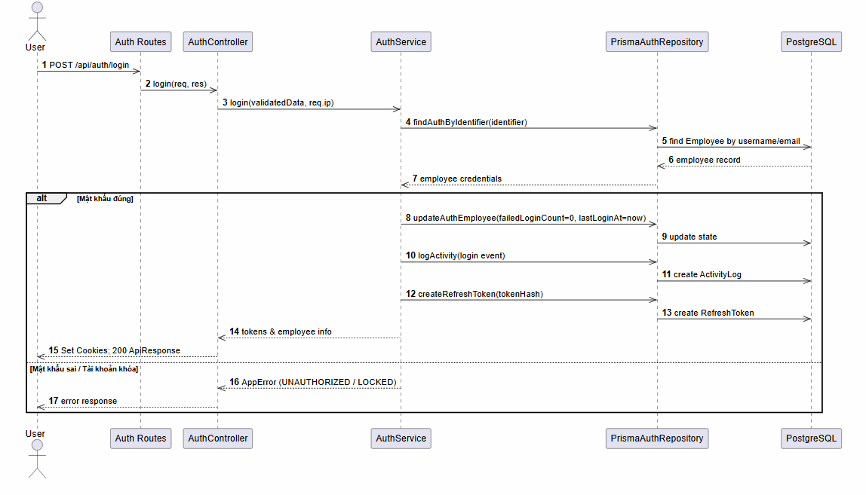

d. Database Queries
Lookup user identification
SELECT *
FROM employees
WHERE (email = :identifier OR username = :identifier)
AND deleted_at IS NULL;
Create refresh session token
INSERT INTO refresh_tokens (employee_id, token_hash, expires_at)
VALUES (:employeeId, :tokenHash, :expiresAt);

9.2 Feature Password Reset

a. Class Diagram
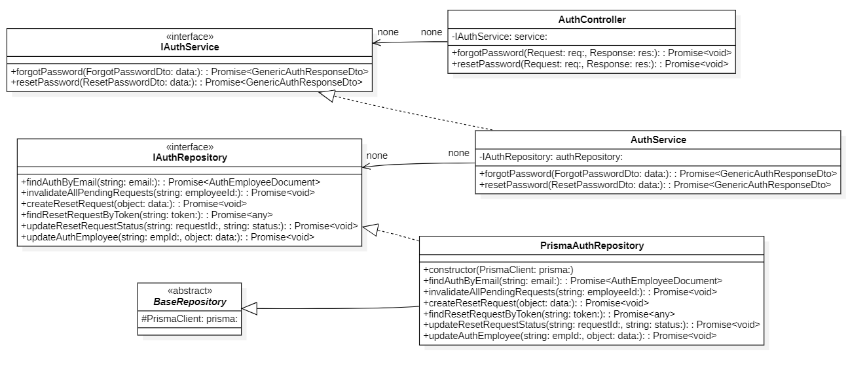

b. Class Specifications
AuthController Class

No | Method | Description
01 | constructor(service: IAuthService) : void | Inputs: Input parameters: service: IAuthService.  Outputs: Output: void.  Processing: Initializes a new instance of the AuthController class and injects required dependencies.
02 | login(req: Request, res: Response) : Promise | Inputs: Input parameters: req: Request, res: Response.  Outputs: Output: Promise.  Processing: Executes internal business logic for this function according to the system workflow requirements.
03 | logout(req: AuthRequest, res: Response) : Promise | Inputs: Input parameters: req: AuthRequest, res: Response.  Outputs: Output: Promise.  Processing: Executes internal business logic for this function according to the system workflow requirements.
04 | refresh(req: Request, res: Response) : Promise | Inputs: Input parameters: req: Request, res: Response.  Outputs: Output: Promise.  Processing: Executes internal business logic for this function according to the system workflow requirements.
05 | getMe(req: AuthRequest, res: Response) : Promise | Inputs: Input parameters: req: AuthRequest, res: Response.  Outputs: Output: Promise.  Processing: Queries the database or processes business logic to retrieve/find data based on the specified input criteria.
06 | forgotPassword(req: Request, res: Response) : Promise | Inputs: Input parameters: req: Request, res: Response.  Outputs: Output: Promise.  Processing: Executes internal business logic for this function according to the system workflow requirements.
07 | changePassword(req: AuthRequest, res: Response) : Promise | Inputs: Input parameters: req: AuthRequest, res: Response.  Outputs: Output: Promise.  Processing: Executes internal business logic for this function according to the system workflow requirements.
08 | validateResetToken(req: Request, res: Response) : Promise | Inputs: Input parameters: req: Request, res: Response.  Outputs: Output: Promise.  Processing: Executes internal business logic for this function according to the system workflow requirements.
09 | resetPassword(req: Request, res: Response) : Promise | Inputs: Input parameters: req: Request, res: Response.  Outputs: Output: Promise.  Processing: Executes internal business logic for this function according to the system workflow requirements.
10 | listMyActivityLogs(req: AuthRequest, res: Response) : Promise | Inputs: Input parameters: req: AuthRequest, res: Response.  Outputs: Output: Promise.  Processing: Queries the database or processes business logic to retrieve/find data based on the specified input criteria.
11 | getMyActivityLogDetail(req: AuthRequest, res: Response) : Promise | Inputs: Input parameters: req: AuthRequest, res: Response.  Outputs: Output: Promise.  Processing: Queries the database or processes business logic to retrieve/find data based on the specified input criteria.
12 | listActivityLogs(req: AuthRequest, res: Response) : Promise | Inputs: Input parameters: req: AuthRequest, res: Response.  Outputs: Output: Promise.  Processing: Queries the database or processes business logic to retrieve/find data based on the specified input criteria.
13 | getActivityLogDetail(req: AuthRequest, res: Response) : Promise | Inputs: Input parameters: req: AuthRequest, res: Response.  Outputs: Output: Promise.  Processing: Queries the database or processes business logic to retrieve/find data based on the specified input criteria.

AuthService Class

No | Method | Description
01 | constructor(repo: IAuthRepository) : void | Inputs: Input parameters: repo: IAuthRepository.  Outputs: Output: void.  Processing: Initializes a new instance of the AuthService class and injects required dependencies.
02 | login(data: LoginDto, ip: string) : Promise | Inputs: Input parameters: data: LoginDto, ip: string.  Outputs: Output: Promise.  Processing: Executes internal business logic for this function according to the system workflow requirements.
03 | logout(employeeId: string, refreshToken: string, ip: string) : Promise | Inputs: Input parameters: employeeId: string, refreshToken: string, ip: string.  Outputs: Output: Promise.  Processing: Executes internal business logic for this function according to the system workflow requirements.
04 | refresh(refreshToken: string) : Promise | Inputs: Input parameters: refreshToken: string.  Outputs: Output: Promise.  Processing: Executes internal business logic for this function according to the system workflow requirements.
05 | getMe(employeeId: string) : Promise | Inputs: Input parameters: employeeId: string.  Outputs: Output: Promise.  Processing: Queries the database or processes business logic to retrieve/find data based on the specified input criteria.
06 | forgotPassword(data: ForgotPasswordDto) : Promise | Inputs: Input parameters: data: ForgotPasswordDto.  Outputs: Output: Promise.  Processing: Executes internal business logic for this function according to the system workflow requirements.
07 | changePassword(employeeId: string, data: ChangePasswordDto) : Promise | Inputs: Input parameters: employeeId: string, data: ChangePasswordDto.  Outputs: Output: Promise.  Processing: Executes internal business logic for this function according to the system workflow requirements.
08 | validateResetToken(data: ValidateResetTokenDto) : Promise | Inputs: Input parameters: data: ValidateResetTokenDto.  Outputs: Output: Promise.  Processing: Executes internal business logic for this function according to the system workflow requirements.
09 | resetPassword(data: ResetPasswordDto) : Promise | Inputs: Input parameters: data: ResetPasswordDto.  Outputs: Output: Promise.  Processing: Executes internal business logic for this function according to the system workflow requirements.
10 | getMyActivityLogs(employeeId: string, query: ActivityLogQuery) : Promise | Inputs: Input parameters: employeeId: string, query: ActivityLogQuery.  Outputs: Output: Promise.  Processing: Queries the database or processes business logic to retrieve/find data based on the specified input criteria.
11 | getMyActivityLogDetail(employeeId: string, id: string) : Promise | Inputs: Input parameters: employeeId: string, id: string.  Outputs: Output: Promise.  Processing: Queries the database or processes business logic to retrieve/find data based on the specified input criteria.
12 | getActivityLogs(query: ActivityLogQuery) : Promise | Inputs: Input parameters: query: ActivityLogQuery.  Outputs: Output: Promise.  Processing: Queries the database or processes business logic to retrieve/find data based on the specified input criteria.
13 | getActivityLogDetail(id: string) : Promise | Inputs: Input parameters: id: string.  Outputs: Output: Promise.  Processing: Queries the database or processes business logic to retrieve/find data based on the specified input criteria.

IAuthService Interface

No | Method | Description
01 | login(data: LoginDto, ip: string) : Promise | Inputs: Input parameters: data: LoginDto, ip: string.  Outputs: Output: Promise.  Processing: Executes internal business logic for this function according to the system workflow requirements.
02 | logout(employeeId: string, refreshToken: string, ip: string) : Promise | Inputs: Input parameters: employeeId: string, refreshToken: string, ip: string.  Outputs: Output: Promise.  Processing: Executes internal business logic for this function according to the system workflow requirements.
03 | refresh(refreshToken: string) : Promise | Inputs: Input parameters: refreshToken: string.  Outputs: Output: Promise.  Processing: Executes internal business logic for this function according to the system workflow requirements.
04 | getMe(employeeId: string) : Promise | Inputs: Input parameters: employeeId: string.  Outputs: Output: Promise.  Processing: Queries the database or processes business logic to retrieve/find data based on the specified input criteria.
05 | forgotPassword(data: ForgotPasswordDto) : Promise | Inputs: Input parameters: data: ForgotPasswordDto.  Outputs: Output: Promise.  Processing: Executes internal business logic for this function according to the system workflow requirements.
06 | changePassword(employeeId: string, data: ChangePasswordDto) : Promise | Inputs: Input parameters: employeeId: string, data: ChangePasswordDto.  Outputs: Output: Promise.  Processing: Executes internal business logic for this function according to the system workflow requirements.
07 | validateResetToken(data: ValidateResetTokenDto) : Promise | Inputs: Input parameters: data: ValidateResetTokenDto.  Outputs: Output: Promise.  Processing: Executes internal business logic for this function according to the system workflow requirements.
08 | resetPassword(data: ResetPasswordDto) : Promise | Inputs: Input parameters: data: ResetPasswordDto.  Outputs: Output: Promise.  Processing: Executes internal business logic for this function according to the system workflow requirements.
09 | getMyActivityLogs(employeeId: string, query: ActivityLogQuery) : Promise | Inputs: Input parameters: employeeId: string, query: ActivityLogQuery.  Outputs: Output: Promise.  Processing: Queries the database or processes business logic to retrieve/find data based on the specified input criteria.
10 | getMyActivityLogDetail(employeeId: string, id: string) : Promise | Inputs: Input parameters: employeeId: string, id: string.  Outputs: Output: Promise.  Processing: Queries the database or processes business logic to retrieve/find data based on the specified input criteria.
11 | getActivityLogs(query: ActivityLogQuery) : Promise | Inputs: Input parameters: query: ActivityLogQuery.  Outputs: Output: Promise.  Processing: Queries the database or processes business logic to retrieve/find data based on the specified input criteria.
12 | getActivityLogDetail(id: string) : Promise | Inputs: Input parameters: id: string.  Outputs: Output: Promise.  Processing: Queries the database or processes business logic to retrieve/find data based on the specified input criteria.
PrismaAuthRepository Class

No | Method | Description
01 | constructor(prisma: PrismaClient) : void | Inputs: Input parameters: prisma: PrismaClient.  Outputs: Output: void.  Processing: Initializes a new instance of the PrismaAuthRepository class and injects required dependencies.
02 | findById(id: string) : Promise | Inputs: Input parameters: id: string.  Outputs: Output: Promise.  Processing: Queries the database or processes business logic to retrieve/find data based on the specified input criteria.
03 | findAuthByIdentifier(identifier: string) : Promise | Inputs: Input parameters: identifier: string.  Outputs: Output: Promise.  Processing: Queries the database or processes business logic to retrieve/find data based on the specified input criteria.
04 | findAuthByEmail(email: string) : Promise | Inputs: Input parameters: email: string.  Outputs: Output: Promise.  Processing: Queries the database or processes business logic to retrieve/find data based on the specified input criteria.

c. Sequence Diagram(s)

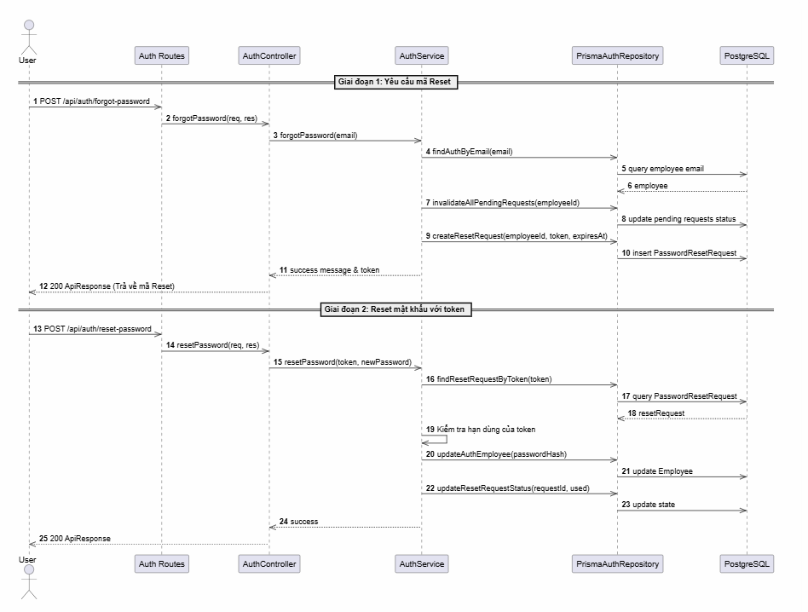

d. Database Queries
Find pending reset token:
SELECT *
FROM reset_requests
WHERE token = :token
AND status = 'pending'
AND expires_at > NOW();

9.3 Feature 404 Error Page (Page Not Found)

a. Class Diagram
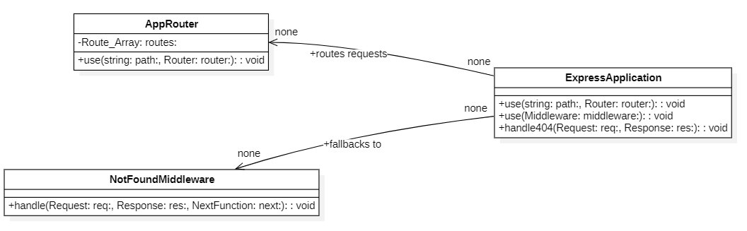

c. Sequence Diagram(s)
