Datos espaciales y mapeo en R.

Luis Daniel Ríos Díaz

27/2/2020

#Establecer directorio  
setwd("C:/Users/ldani/OneDrive/Escritorio/R/Siste/DATA _ R SISTES")  
  
#Paquetes  
library(ggplot2) # ggplot() fortify()  
library(dplyr) # %>% select() filter() bind_rows()

##   
## Attaching package: 'dplyr'

## The following objects are masked from 'package:stats':  
##   
## filter, lag

## The following objects are masked from 'package:base':  
##   
## intersect, setdiff, setequal, union

library(rgdal) # readOGR() spTransform()

## Loading required package: sp

## rgdal: version: 1.4-8, (SVN revision 845)  
## Geospatial Data Abstraction Library extensions to R successfully loaded  
## Loaded GDAL runtime: GDAL 2.2.3, released 2017/11/20  
## Path to GDAL shared files: C:/Users/ldani/OneDrive/Documentos/R/win-library/3.6/rgdal/gdal  
## GDAL binary built with GEOS: TRUE   
## Loaded PROJ.4 runtime: Rel. 4.9.3, 15 August 2016, [PJ_VERSION: 493]  
## Path to PROJ.4 shared files: C:/Users/ldani/OneDrive/Documentos/R/win-library/3.6/rgdal/proj  
## Linking to sp version: 1.3-2

library(raster) # intersect()

##   
## Attaching package: 'raster'

## The following object is masked from 'package:dplyr':  
##   
## select

library(ggsn) # north2() scalebar()

## Loading required package: grid

##   
## Attaching package: 'ggsn'

## The following object is masked from 'package:raster':  
##   
## scalebar

library(rworldmap) # getMap()

## ### Welcome to rworldmap ###

## For a short introduction type : vignette('rworldmap')

#Datos por especie  
Fpendul <- read.csv("F.pendul.csv", sep = ",",row.names = NULL)  
Pcarinat <- read.csv("P.carinat.csv", sep = ",")  
Pfelic <- read.csv("P.felic.csv", sep = ",")  
vars <- c("scientificName", "decimalLongitude",  
 "decimalLatitude")  
Pcarinat_trim <- Pcarinat %>% dplyr::select(one_of(vars))  
Pfelic_trim <- Pfelic %>% dplyr::select(one_of(vars))  
Fpendul_trim <- Fpendul %>% dplyr::select(one_of(vars))  
  
#Archivos shape por países.   
Bra_shp <- shapefile("C:/Users/ldani/OneDrive/Escritorio/R/Siste/DATA _ R SISTES/BRA_adm1.shp")  
Bol_shp <- shapefile("C:/Users/ldani/OneDrive/Escritorio/R/Siste/DATA _ R SISTES/BOL_adm1.shp")  
  
  
#Mapa con archivos shape y ocurrencia de especies.   
(sp_map <- ggplot() +   
 geom_polygon(data = Bra_shp,  
 aes(x = long, y = lat, group = group),  
 fill = NA, colour = "black") +  
 geom_polygon(data = Bol_shp,  
 aes(x = long, y = lat, group = group),  
 fill = NA, colour = "black") +  
 geom_point(colour = "blue", alpha = 0.5,  
 aes(x = decimalLongitude, y = decimalLatitude),  
 data = Fpendul_trim) +  
 geom_point(colour = "red", alpha = 0.5,  
 aes(x = decimalLongitude, y = decimalLatitude),  
 data = Pcarinat_trim) +  
 theme_bw() +  
 xlab("Longitude") +  
 ylab("Latitude") +   
 coord_quickmap())

## Regions defined for each Polygons

## Regions defined for each Polygons

## Warning: Removed 1 rows containing missing values (geom_point).

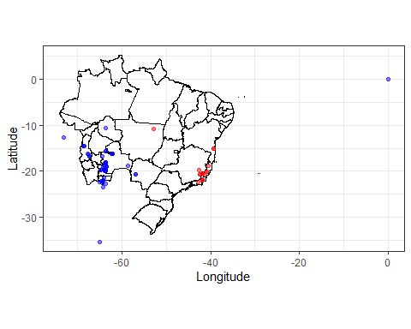

#Mapa generado en R con ocurrencia de especies.  
world <- getMap(resolution = "low")  
saf_countries <- c("Brazil","Bolivia")  
world_saf <- world[world@data$ADMIN %in% saf_countries, ]  
(sp_map <- ggplot() +   
 geom_polygon(data = world_saf,  
 aes(x = long, y = lat, group = group),  
 fill = NA, colour = "black") +   
 geom_point(colour = "blue", alpha = 0.5,  
 aes(x = decimalLongitude, y = decimalLatitude),  
 data = Fpendul_trim) +  
 geom_point(colour = "red", alpha = 0.5,  
 aes(x = decimalLongitude, y = decimalLatitude),  
 data = Pcarinat_trim) +  
 theme_bw() +  
 xlab("Longitude") +  
 ylab("Latitude") +   
 coord_quickmap())

## Regions defined for each Polygons

## Warning: Removed 1 rows containing missing values (geom_point).

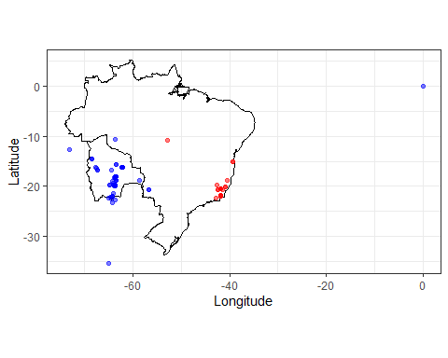

#Mapa a partir de archivo shape con ecoregiones de Morroney ocurrencia de especies.  
Morrone_shp <- shapefile("C:/Users/ldani/OneDrive/Escritorio/R/Siste/DATA _ R SISTES/Lowenberg_Neto_2014.shp")  
Morrone <- fortify(Morrone_shp, region = "Subregio_1")  
(map_Morrone <- ggplot() +  
 geom_polygon(data = Morrone,  
 aes(x = long, y = lat, group = group, fill = id),  
 color = "black", size = 0.5) +  
 geom_point(colour = "blue", alpha = 0.5,  
 aes(x = decimalLongitude, y = decimalLatitude),  
 data = Fpendul_trim) +  
 geom_point(colour = "red", alpha = 0.5,  
 aes(x = decimalLongitude, y = decimalLatitude),  
 data = Pcarinat_trim) +  
 theme_classic() +  
 theme(legend.position="bottom") +  
 theme(legend.title=element_blank()) +   
 xlab("Longitude") +  
 ylab("Latitude") +   
 coord_quickmap())

## Warning: Removed 1 rows containing missing values (geom_point).

