

Contingency Management System

Interim Report

DT228

BSc in Computer Science

Leslie Ducray

C10327999

Supervisor: Richard Lawlor



# Abstract

The purpose of this report is to document the research, design and development involved in the implementation of a contingency management web application. Though the application is developed to target the correction of drug misuse, the fundamentals behind the development could be used by other forms of behavioural economic systems. Contingency Management is a highly recommended and effective approach of physiological incentive based treatment. The approach aims to strategically treat alcohol and other drug addiction through offering tangible rewards. While the Contingency Management approach is clinically very effective and has proved valuable to many service users, the adaption to an automated web application will enable a quicker determination of the applied complex criteria and improve communication between treatment staff. The proposed System aims to automate a current paper-based system, removing the tedious and laborious act of processing a service user’s progression and providing a more ‘real time’ view of progression. This system aims to target two behavioural aspects; engagement and substance test results.

A main objective behind this system is to create a more automated approach to recording and calculating the service user's 'real time' reward status and entitlements (e.g. the voucher value of points accrued, "take away" medication privileges) in a far less laborious user interface than the paper based system which is currently employed in many treatment facilities.

Such facilities could include outpatient drug treatment centres, residential centres, prisons, the military, juvenile detention centres etc.

# Table of Contents

Abstract 2

Table of Contents 3

Table of Tables 4

Table of Figures 5

Chapter 1 Introduction and Background 6

Chapter 2 Research 8

Contingency Management 8

Application Medium and Platform Research 10

Database 11

Web Technology 12

Rule Engine 13

Chapter 3 Design Methodologies 14

Chapter 4 Architecture & Development 24

Current Progress 27

Chapter 5 Challenges, future Work & Project Plan 28

Challenges 28

Testing 30

Evaluation 30

Future Plans 30

Bibliography 31

# Table of Tables

Table 1: Comparison of web development platforms 12

# Table of Figures

Figure 1: First Implementation 15

Figure 2: Full representation of associations between entities 18

Figure 3: The current database schema. 19

Figure 4: High level Use Case of system 21

Figure 5: Front End Horizontal prototype 22

Figure 6: System architecture. 24

Figure 7: Class Diagram of current progress 28

Figure 8: CM process for rewarding/resetting service user's tested samples for substance abuse 29

# Chapter 1 Introduction and Background

According to The European Monitoring Centre for Drugs and Drug Addiction, in 2012 there were at least 1.2 million people in Europe receiving treatment for illicit drug use, of which the majority (630 000) receive treatment for opioid abuse. Cecilia Malmström, The European Commissioner for Home Affairs speaks out about the supply and use of illicit drugs in Europe,

“*We are faced with an ever more complex stimulant market and a relentless supply of new drugs which are increasingly diverse. The fact that over 70 new drugs have been detected in the last year is proof in itself that drug policies need to stay on target*” [1].

In Ireland, the Health Research Board (HRB) report that clients receiving treatment for cannabis was 1,893 and 4,930 for Opioids of which was mainly heroin in 2010.

The HRB also report that 2.8% of young adults between 15 and 34 had confirmed using cocaine as their primary drug in a survey conducted for 2010/2011 [1].

The Drug Treatment Centre Board, based in Dublin, Ireland identified in their 2011 annual report that there 864 individuals receiving treatment for drug addiction of which 68% were male [2]. The report also identified the growing homeless population receiving treatment for substance dependencies which had risen to 233 in 2011 from 181 in 2007. The DTCB report that the (Irish) National Drug Analysis Laboratory conducted 1,187,926 tests in 2011 via urine, blood and oral fluids.

Further statistics attained from Merchants Quay Ireland, a non-profit drug service provider in Ireland, stated in their annual report (2012) they received 20,847 visits from 3,634 clients to make use of their needle exchange service. This is an increase of over 2,000 visits from 2011. Tony Geoghegan, the Chief Executive for Merchants Quay Ireland writes in the annual report "Demand for our homeless and drugs services is growing, yet finances are contracting" [3].

The National Institute for Health and Care Excellence, a public non-departmental body of the Department of health in the United Kingdom published a document in 2007 expressing their recommended approaches for drug treatment, in particular the Contingency Management approach of psychosocially intervening drug misuse [4].

Contingency Management is considered a psychosocial treatment system with a very high degree of evidence base [5] [6] [7] [4].

The approach aims to treat patients/service users by offering incentives to reward various types of behaviours. An incentive to incorporate the CM approach is that it gives the service users the motivation to work towards something other than just a sober and clean living; it can be very beneficial to a population living extreme circumstance (e.g. the homeless, pregnant woman, people with mental illness).

The system will allow users (professional treatment staff/key workers) of specific centers (drug treatment, residential, prisons, the military, juvenile detention centres etc.) to add/edit clients/patients (service users) to the system. Chapter two will uncover more research into Contingency management, the background of the approach and previous automated adaptions.

The motivation is to create an automated generic web application for staff working at a drug treatment facility which will allow them to admit, manage and monitor the progress of service users within a CM program and automatically apply applicable reward and reset rules based on a defined criteria. The primary function of the system will be to apply a reward (Contingency) process to service users based on their drug use, behavior, conduct, attendance and other criteria. The criteria applies logic based on objectively verifiable results from a clients' laboratory test data, behavior, meeting attendance etc. This particular implementation of a contingency management system will group service users of the treatment-based center into two different progress streams, based on predetermined criteria (stability, behavior, extent of drug use). The two streams are ‘High Support’ and ‘Progression’. The reward protocol of each stream is governed by different criteria. Service Users can also be penalized for breaches of the agreed treatment contract including drug use, failure to attend meetings and other regressive behavior. As the system is based on the systematic application of earned incentives, service users will naturally accumulate these rewards. A large part of the application will be to record the transactions of service users. The transactions functionality will feature a balance of the clients earned rewards and eligibilities, ‘sanctions’ (loss of credits and ‘resets’) and a history of credits earned and withdrawn. This particular approach will only monitor two types of behaviours as too avoid re-enforcing behaviours that to not comply with Contingency management behavioural principles.

The system will need to attain and store information on each service user regarding

* Meetings attended / general attendance
* Drug screening tests for various categories of drug use (e.g. Opiate, benzodiazepine, stimulant, cannabis, alcohol etc.)
* “Take Away medication” and other treatment privileges/ eligibilities
* Service User’s Treatment Stream
* Record History
* Rewards/Credit account – balance, history and transactions.
* Notes from staff

The web application will be developed in Java, JSP, JavaScript and SQL primarily and will rely upon a rule based expert system (Drools) to govern the underlying CM criteria.

The primary objective of this application is to provide a web application user interface for staff of a treatment center employing the CM approach. The Web application will be required to correctly manage data requests and response from Client to server. The system functionality will need to correctly calculate the outcomes of the rule based system based on user input from attendance meetings and tested samples. Chapter 4 will cover the architecture and implementation process of the full system scope.

# Chapter 2 Research

### Contingency Management

Research into the proposed project begun by studying and understanding the principles of Contingency Management, its application and its target environment. Contingency management is a psycho-social approach of managing a person’s consequences for their actions by rewarding or depriving them of incentives based on their behaviour [8] [7]. The CM process has a set of defined rules which govern the reward process. Contingency management is a form of drug and alcohol misuse treatment, but its logic abstracted from content could be applied to many other behaviour economic purposes.   
Contingency Management for substance and alcohol abuse is mostly administered in treatment centres (drug treatment centres, prisons, juvenile detention centres etc.).

The rules and logic to follow are adapted from an existing paper based implementation of the CM approach. CM is applied to each new transaction of

* The service user’s attendance (attended, missed or missed with valid reason)
* The result of their substance tests (negative or positive for the presence of the tested substances).

These outcomes determine

1. The amount of points a service user earns which is added to their balance.
2. Their eligibilities earned/lost.
3. Their stream progression/regression.
4. Their date to be clean by (‘Date to Clean’).

For a service user to withdraw their earned credits they need to have at least a certain amount accumulated (in this instance €20), they also need to have tested negative in their most recent substance tests for a ‘Financial’ user to approve the withdrawal of their earned credits, the aforementioned requirements must be true.

Through communication with a clinical psychologist of a Dublin drug treatment centre, which employs a paper based implementation of the CM approach, the following flow of process was elicited and discussed.  
When a service user (client/patient) is first admitted into the CM program, they are assigned to an agreed upon treatment stream. Initially the treatment stream is the lowest level of progression, in this instance, the ‘High Support’ stream. Each stream offers a different magnitude of rewards and likewise a different magnitude of penalty for misbehaviour. The service user’s details are elicited and recorded.

Service users of the system are critiqued on two different behaviors, the explicitly mentioned two behaviors I will be mentioning and including in the development of the CM system is Attendance (to arranged meetings) and the service user’s results to substances tests. It is the results from these substance tests which progress and regress service users through the two streams. If a Service user consecutively tests negative on their substance tests, they will progress from ‘High Support’ stream to ‘Progression’ stream. With each negative test the service user’s point accumulator increments which results in them being rewarded more. In situations where service users are testing positively for tested substances, there points accumulator is reset to its reset value (0). Users do not loose points earned, but they will need to re-build their accumulators to be rewarded more. Likewise if a service user consecutively tests positive they will regress back to ‘High Support’ stream and/or be issued deadlines to test negative (date to clean). These dates are issued to give one weeks’ notice of the testing, extensions can be given. If the service user fails their ‘Date to Clean’ test, they are issued another date in a weeks’ time. These ‘Date to Clean’ dates are issued as cards ‘Green’, ‘Yellow’, ‘Red’ and ‘Black’, Once the black card is issued The Service User will need to re-assess their desire and motivation to continue within the CM program.

Attending meetings earns the service user the eligibility to ‘take away’ or ‘take out’ medication for self-administering out of center. Missing attendance does not affect a service users standing in the program (i.e. they will not regress back into the ‘High Support’ stream).

Through personal correspondence with Dr. Nancy Petry, leading authority in contingency management and the developer of the low-cost contingency management treatment approach [7]; the project proposal was discussed.  
In regards to previous implementation attempts, Dr. Petry had this to say “Several groups have attempted to develop automated CM programs, but none have been widely implemented in practice.” Dr. Petry went on to discuss the previous short falls of previous implementations she has been exposed to and explained corrective measures at trying to better ensure a correct implementation.

“Some of the problems have been that each clinic seems to want to implement CM in its own way, and the programs developed thus far have not been able to accommodate issues such as different reinforcement magnitudes and types (vouchers vs. prizes vs. stars exchangeable for items), different attendance structures (which is less of an issue for opioid replacement treatments relative to outpatient care), different durations of CM interventions, and excused absences.” Many of these issues had been taken into consideration in the initial proposed approach, but the comments stated offered more definition and confirmation for the planned implementation. Dr. Petry continued on to state issues regarding valid reasons for being absent from arranged meetings and sample taking, “Because the evidence-based CM programs have escalating re-enforcers for sustained abstinence, the programs developed to date have not been able to incorporate this feature appropriately given the real world issues that arise (e.g., in terms of missed samples for legitimate reasons etc.).”. Previous implementations have enforced the CM criteria too rigidly without offering an override or exception to legitimate reasons of absence, thus penalizing the service user ‘unfairly’.

### Application Medium and Platform Research

The decision to implement a web application opposed to a native application or an application for a mobile device was decided based on the following considerations:

* **Where will the users use the application?**

Typically users of the system will be based in offices, laboratory environments or mobile around the treatment centre where they can record test results/notes/attendance. The interactions between service user and treatment staff will more often than not require a level of privacy.

* **Who will the typical users be?**

Typically the users of the system will be physiologists/professional treatment staff /key workers who interact directly with the service users or process their test results.

* **What medium/technology will the users have?**

In a treatment centre or correctional facility, typically the administration staff would have a personal computer/laptop for keeping records. In many cases, due to the one-on-one nature of the interaction between a service user and a member of treatment centre staff, information would be taken down during the meeting and this could be via a paper notes, tablet or other mobile devices.

* **What will be the most accessible means of distributing the system?**

Due to the nature of the confidential and sensitive information stored, the system will need to be securely and safely distributed. A web application hosted on a local and secure network would appropriately cater for this requirement. Web applications can be run and rendered on almost every platform that has a web browser installed, this includes smartphones and tablets. The user interface can be easily and efficiently designed using HTML5 and can be enriched with native client side technologies. Disadvantages of developing the application for a specific platform such as IOS or Android mobile devices would render a large portion of the target platforms incompatible, as these technologies are specific to their applicable devices. IOS applications require an Apple Mac device to be developed on with XCode and IOS SDK installed and an Apple device to be run [9], this is not a feasible option for the development of this application, as this system is intended for health services where a financial budget is restricted.  
Publishing any developed applications to the Apple Store also requires developer’s fee and restrictive licencing. While Google Android mobile devices demand no developer’s fees for publishing to their App Store, making them financially more appealing, they are still restrictive to the compatibility of the devices which can run the applications. Web applications designed to be received and rendered through the users bowser is the most feasible option for this particular application as where the user primarily works from their own office with their desktop/ laptop or need to enter in the information from their mobile device, the web application can be accessible regardless of their device and/or platform. As with web applications the application is deployed to a host; there is no need for it to be published to application stores, which will enhance re-deployment time for updates, changes or bug fixes. Should there be changes made, the users will not need to download or install new versions. As the system will be hosted on a local area network, there is no hosting costs.  
HTML5, JavaScript and CSS technologies can be employed by the application to enhance the user’s view of the application on mobile devices using adaptive or responsive web design techniques of displaying and sizing the web page content.  
Disadvantages of developing a web application could include the browser’s performance due to requests and response wait times. The nature of this application does not require an intense low latency interactivity so the user should not be noticeably affected or disadvantaged by delays. Another issue that can arise with a web application is the desire or need to continue working off-line or due to a lack of connection. As mentioned previously, the access and use of the web application will be limited to the confines of the local network which ensure a more secure and deliberate limited external access. As the objective hosting of this application is intended to be hosted on a local area network, an external internet connection (to the World Wide Web) is not necessary requirement.

* **How will this application help?** If implemented correctly, this application will serve a great help to staff of a treatment centre, aiding them by bypassing the act of having to manually apply the CM criteria and provide feedback in near real time. It will provide with them with a much more efficient record keeping facilities. In an economic climate where Health care funding comes with budget constraints, a system that will enhance productivity of staff could prove very beneficial. “A program that was flexible but consistent with CM principles could be very useful.” – Dr. Nancy Petry.

### Database

As the system will rely quite heavily on data storage, a reliable and efficient database management system is needed. The design and implementation of the database is required to be quite sophisticated in its associations. As the business logic of the web application is firmly based on the governing rules of Contingency management, implementing the database to dynamically aid the rule based system will greatly improve the maintainability, consistency and dependency of the system.

The structure and nature of the data storage required for the proposed CM system is relatively rigid and tabular in format. The associations between table entities will serve the database systems primary function for storing and retrieving data. Any change or volatility of the data model/schema is unlikely expected, as the associations between table entities will be closely based on the principles of CM and information required, and the entity attributes will be designed to allow a certain degree of dynamics.

With this statement in mind, the need for the likes of a NoSQL database such as Mongo DB would serve little benefit. NoSQL databases employ a less constrained data model that allows for retrieval and storage of data in a more flexible manner. Where relational models separate data into various associated tables joined by identifiable keys, document orientated NoSQL databases such as Mongo DB aggregate the data into one particular record for storage, thus removing the need for entity relationships [10].

A relational database such as MySQL would suit the nature of a CM system, offering a simple and set approach for storing, querying and retrieving data. MySQL has the power to employ the option of data warehousing which could be an expansion of analytical and report generations for the application in the future. MySQL is one of the leading popular open source relational database managers, offering in addition a MySQL server and the workbench development kit for design and implementation. As the scope of the application by design will be limited to the local network of treatment facility, where the amount of traffic to and from the database will remain relatively low and the expected wish to scale the database is non-existing, a MySQL database is ideally suited.

### Web Technology

Sun’s J2EE, Microsoft ASP.NET and Linux/Apache/MySQL/PHP (LAMP) are the three leading and most popular Web development platforms. When comparing these three platforms to decide on the most suitable and applicable, it is very plain to see the similarities and competing functionalities at a high level.

Table 1: Comparison of web development platforms [11]

|  |  |  |  |
| --- | --- | --- | --- |
| Criteria | J2EE | ASP.NET | LAMP |
| Database Compatibility | Multiple | Multiple | Multiple |
| Accepted Platforms | Multiple | Windows only | Multiple |
| Server Compatibility | Multiple | Windows Server only | Multiple |
| Frameworks | Many to choose from | Many to choose from | Many to choose from |
| Licensing cost | Free | Free | Free |
| Support, Documentation and online resources | Yes | Yes | Yes |

Deciding on a web technology platform required that the platform could integrate correctly and reliably with the chosen database server which is a MySQL server. Java Database Connector (JDBC) forms a framework for communicating between the Java application and the MySQL server. These technologies are all open source and widely used and well documented.

Java Enterprise Edition (J2EE), an expansion of the standard Java platform allows for the inclusions of many pre-existing libraries, these are a large attraction as they have under gone thorough and various testing through various implementations, these library’s will offer more reliability and productivity than having to re-develop the existing functionality [12]. J2EE by default includes many APIs which are necessary for developing a web application such as the JDBC. J2EE also comes pre-set with the various associated file types such as Java Beans, Java Servlets and Java Servlet pages to be included in the developed application. J2EE was developed to aid developers in the design of large multi-tiered applications for reliable and secure distribution over a network.

Spring is a framework designed to architecturally structure the entire scope of the web application [13].

### Rule Engine

Deciding on a rule based expert system to incorporate into the system was dependant on a few factors

* **Will it integrate well with the existing chosen technologies?**  
  As the current web application technologies and languages decided are Java and MySQL, the middle wear needs to be able to interact with the select rules engine.
* **Is the software open source or is purchased licence required?**

Initially JESS (Java expert system shell) was going to be the preferred option to incorporate into the system, until Licensing was looked into. A personal enquiry was made to the Software Licensing Administrator at Sandia National Laboratories requesting information on obtaining a licence for this particular project.

An academic licence was attained under strict terms and conditions that the academic licence is restricted to only using JESS on a project specific basis for academic and non-proprietary and/or commercial research or development.

Open source and Java compatible rule based engines were researched and compared. 'Drools' is an open source forward chaining inference based rule management system that was decided on.

* **Is a Rule engine necessary?** As the primary business logic of the system is focussed on applying criteria to know facts, a rule engine could be very effective in structuring and optimizing the calculation process. Using the rule base will be an optimal means of organizing the CM criteria.

Drools employ an enhanced version of the rete algorithm and can easily be incorporated with in a java application [14]. In addition to the rule engine, the Drools software also includes visual aids which illustrate the flow of the rules which will aid in the development.

# Chapter 3 Design Methodologies

The design and implementation of this project began at a database level. The system is very dependent on the structure of the database entities and their associations. The database is firmly based around a Contingency management paper-based system. There were multiple implementations of the database before further web application development would begin.

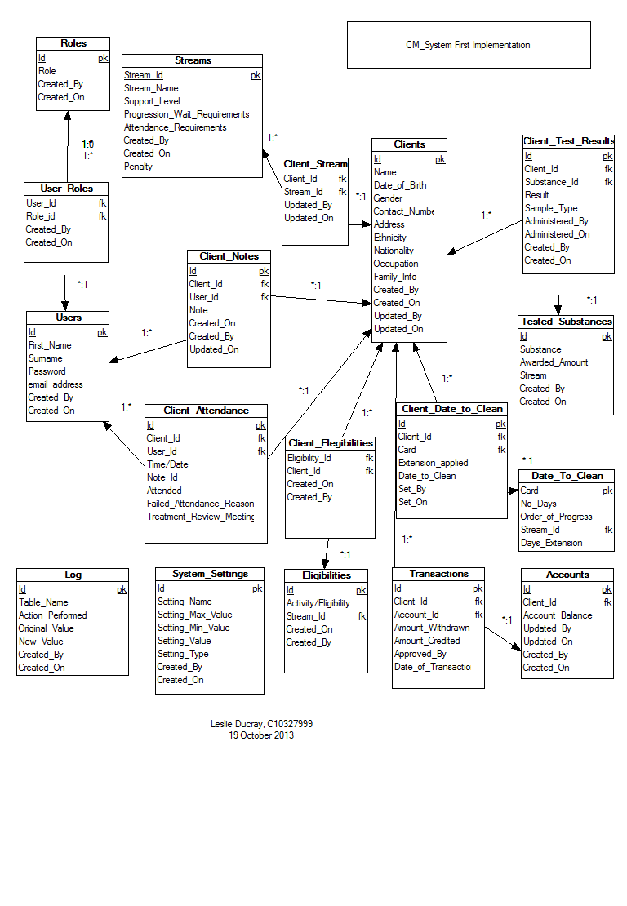

Figure 1: First Implementation

The first implementation of the database was a rough design model recording all the necessary attributes, keys required and the relationships between entities. The first implementation included a full schema logging table, this is removed in later implementations, instead each table record will store the user key and the date associated with its creation and this can alternatively be used as a log. All associations to the ‘User’ table are not recorded in the above diagram as the many associations with the ‘User’ table impairs the readability of the diagram. Figure 2, illustrates the associations between each entity more explicitly. Figure 3 expands on Figure 2, illustrating each entity’s attributes. The design of the database schema is normalized to ensure the schema is more maintainable and the degree of dependency between entities is minimalized.

The database schema is composed of sixteen tables catering for storage of all relative information. A summary of each table is as follows:

* User – The User table stores all static general information related to a member of staff of the treatment facility.
* Role – The Roles are permission statuses for the system.
* User Role – the joining association assigning a role to a user.
* Service User/ clients – This table represented as Service user or Clients stores all general and static information regarding a service user.
* Service User notes – this association table joins a service user and user where the user has recorded a note on the service user.
* Service User attendance – records a service users meeting with a user. This table records if a service user fails to make an arranged meeting and whether they have a legitimate excuse (which will spare them penalization when CM rules are applied).
* Substance – recorded information regarding substances and their effect on the CM criteria.
* Service User Substance Result – This table forms an associative history for each service user and their substance tests, storing the result, date administered, points earned etc.
* Stream – this table stores general information regarding the CM streams- different levels of progression within the CM process.
* Service User Stream – The stream associated with a service user. Their current level of progression.
* Account – A service user’s account stores the balance of their earning.
* Transactions – the records of all rewards earned/credits and withdrawals/debits made to a service user’s account.
* Eligibility – the information regarding all Eligibilities – such as ‘eligible to with draw’ , ‘outings/visits’ , ‘take outs’.
* Service User eligibility – an association of which service users have which eligibilities.
* Date to clean – this table stores the information regarding date to clean rules. ‘Date to Clean’ is a date set by a user of the system assigned to a service user to test negative in a substance test.
* Service user date to clean – A recorded history of service users and their assigned dates to be clean, if extensions were given, consecutive failures.

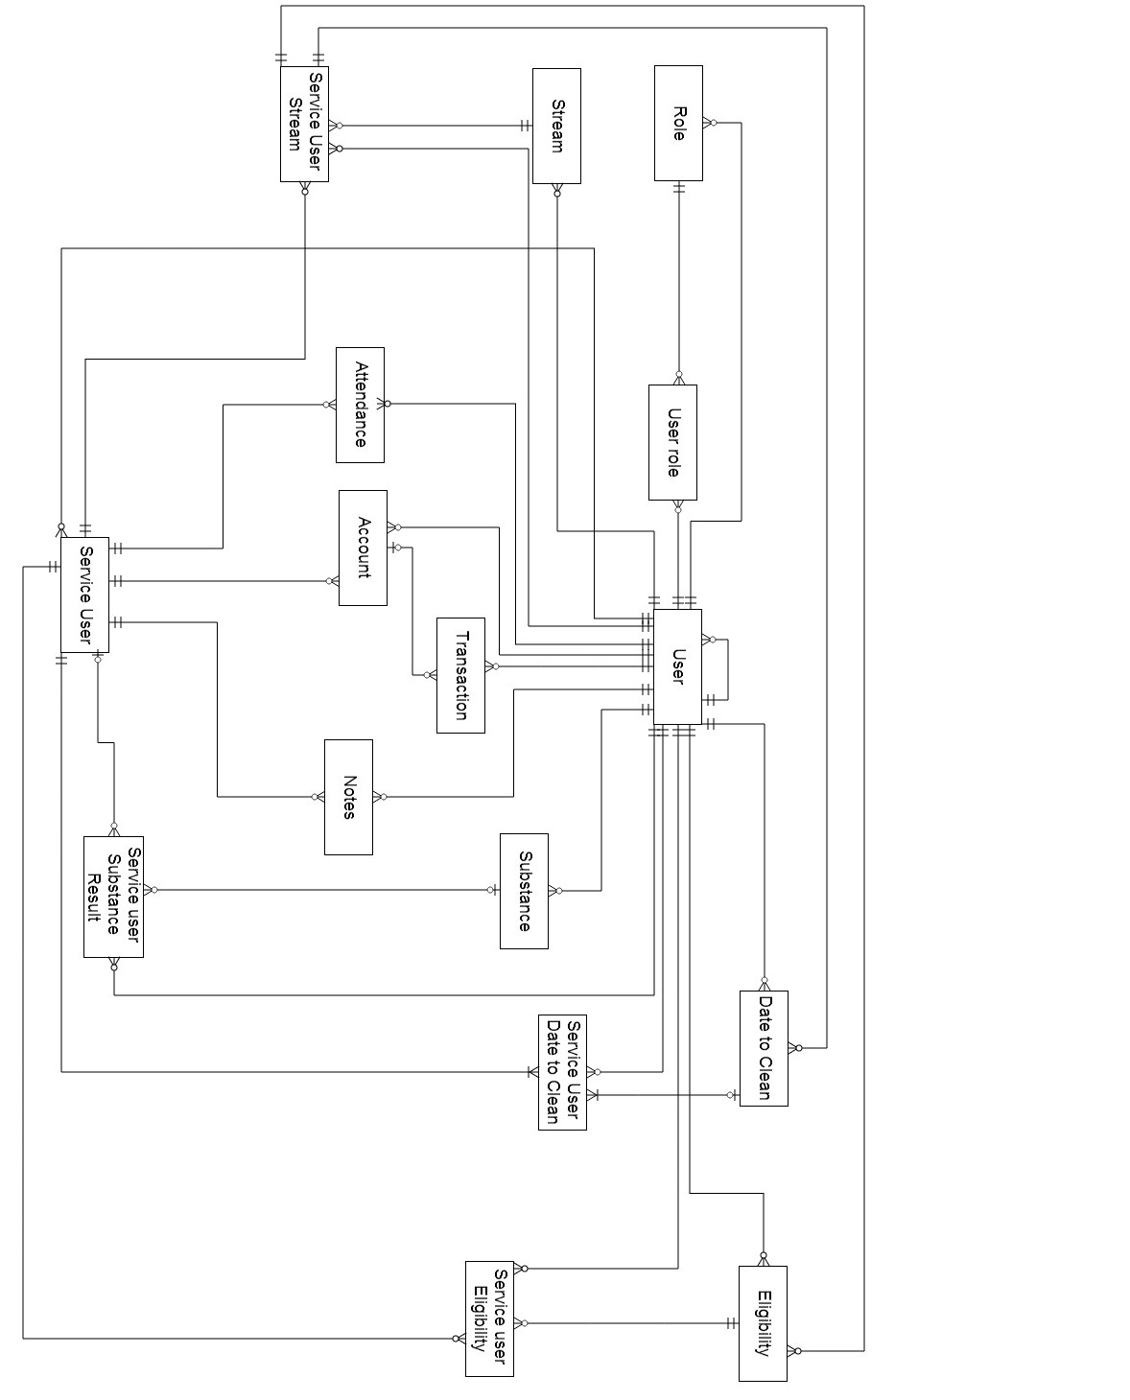

Figure 2: Full representation of associations between entities

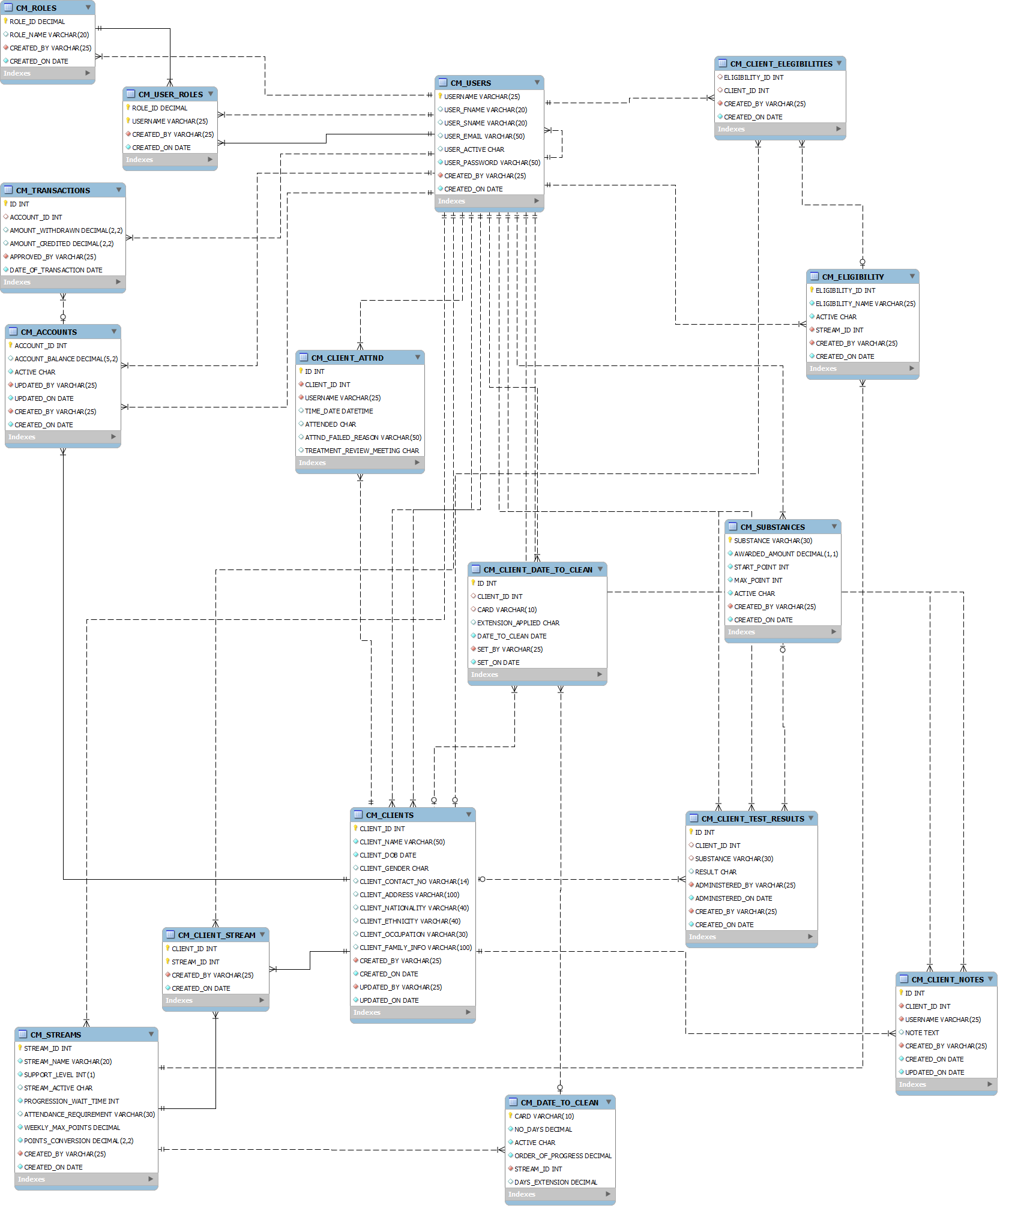

Figure 3: The current database schema.

Figure 3 has been reverse engineered using the SQL script files and MySQL Workbench Modelling tool.

Once the underlying database structure was of confident design, the design and planning began on the expectations of the web application. These expectations are represented in the use case featured in Figure 4. Figure 4 defines the three user (actor) roles of the system:

1. User, the default role of any active user of the system. This role permits a user to add new clients/service users, edit existing ones, record test results and attendance which in turn applies the contingency management criteria.
2. Financial User, a role assigned to a user permitting them to view the account of a service user and approve the withdrawal and/or assignment of rewards to a service user.
3. Admin is the administration role. This role permits a user to add/edit users of the system.

Users of the 'Financial' and 'Admin' role are permitted to all actions of the default user role.

The system actor forms the business logic and control of the application. The system will be required to:

* Establish a connection with the database.
* Respond to user requests.
* Validate user login and assign roles.
* Manage the user session.
* Process queries/updates/transaction statements to the database.
* Calculate and apply the Contingency management rule criteria.

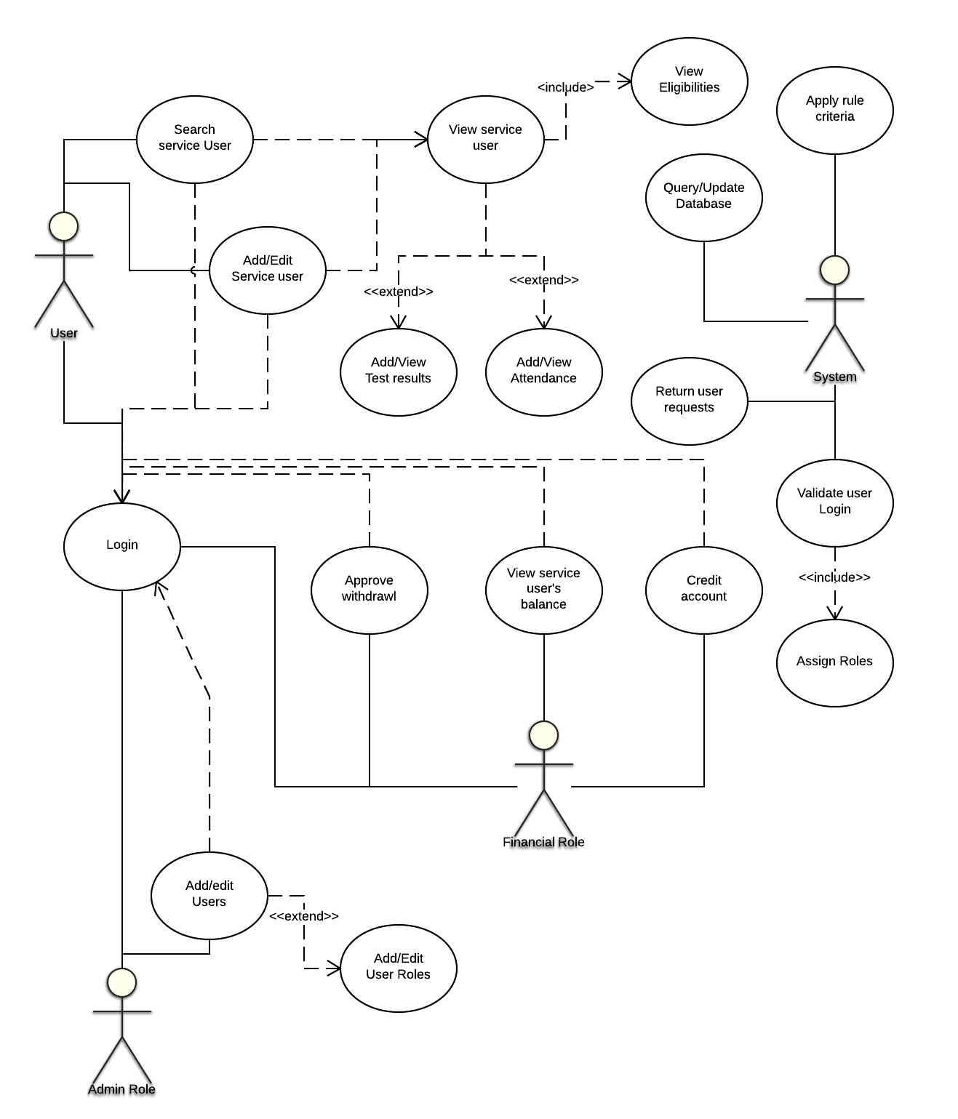

Figure 4: High level Use Case of system

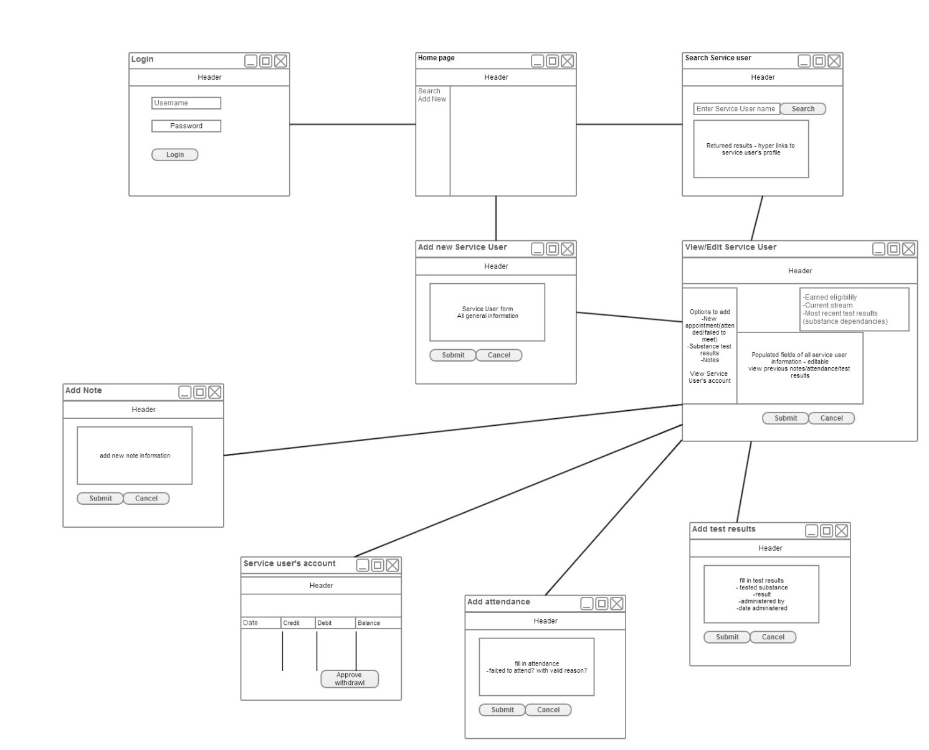

Figure 5: Front End Horizontal prototype

Figure 5 illustrates the conceptual layout of the web application and the flow between pages as presented to the user.

The design methodology chosen to guide the implementation of this application is aspects of the Agile design methodology and Scrum applicable to a single person development team. This methodology feels most suitable to the application, allowing the user to plan sprints/iterations (an independent aspect/module of the system to be developed), design and analyse, implement, test and evaluate [15]. The full system plan is divided up into independent sprints or iterations.

This allows an assessment to be performed at each iteration of a particular aspect of the system to review progress and priorities and to test and evaluate current implementations. The Agile and Scrum methodology encourages an incrementing implementation design and development process [15]. Using this methodology, the progress and implementation of the application can consistently be assessed, and each aspect of the system will be concluded instead of developing multiple incomplete aspects. Having a complete system sprint fully functioning will aid in testing and evaluation, allowing target users to review and provide feedback on a module for consideration, improvement and rectification.

With the general required functionality of the system established, the web application was divided into multiple independent sprints for design and development. These sprints will be discussed further in Chapter 4 Architecture & Development.

# Chapter 4 Architecture & Development

The application is developed using Java technologies. J2EE is an enterprise expansion of the standard java platform. Java technologies incorporate both the running platform/environment (which consists of a Java virtual machine) and the application programming interface [12].

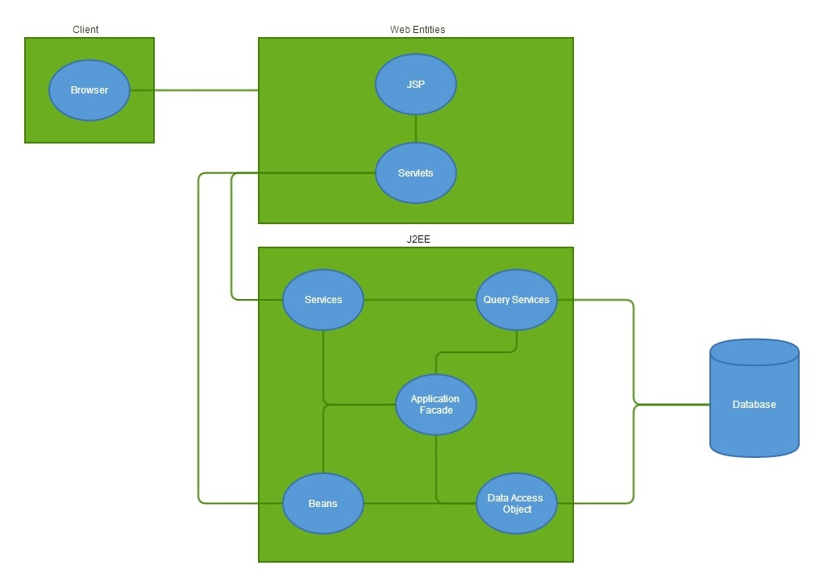

Figure 6: System architecture.

Figure 6 illustrates the technical architecture structuring the web application. The primary component is the J2EE component, which is Java Enterprise Edition. “The Java EE platform provides an API and runtime environment for developing and running large-scale, multi-tiered, scalable, reliable, and secure network applications.”[4]. J2EE is an expansion of the standard edition. In figure 6 the multi-tiered structure is illustrated displaying the division of web components, J2EE components and the database. The full system scope is divided into different tiers or levels. The first tier of the web application is the ‘web components', these consist of the Java servlet pages, the java servlets. The web components tier is only means of the client requesting information from the system and is the only means of receiving a response. The database is hosted on a MySQL server and is connected using a Java Database Connector (JDBC). The Interactions between these components is further document through the discussion of the current progress later in this chapter.

The application is being implemented using Java developed on Java Enterprise Edition Eclipse SDK. The application connects to a MySQL server. The MySQL workbench IDE has been used for design and development of the SQL statements forming the database schema. MySQL Work Bench also includes a modelling tool which has been used to reverse engineer the schema script to confirm the model meets the conceptual idea.

Xampp has been used for hosting the MySQL server and the application locally. Xampp is a cross platform web server package consisting of Apache, Tomcat, PHP and MySQL services.

The Drools workbench can be installed as a plugin for Eclipse enabling immediate project association within the Eclipse work space. Drools knowledge and rule files are designed and developed then as part of the java application.

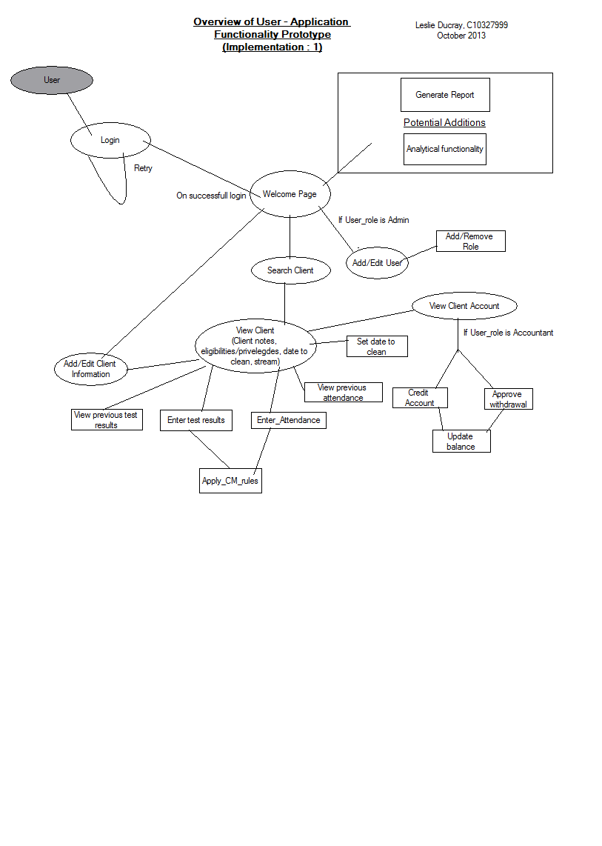

Figure 7: High level flow of the application front end.

### Current Progress

The First Sprint involved the planning and development of ‘Login’ functionality. This begun by firstly by setting up the development environment and integrating the various technologies. The database schema had previously been implemented. A connection is made to the database using the JDBC and the database connection information is stored in a ‘context.xml’ file within the application files. This information includes the database name, its IP address and port, the username, password and the JDBC required. The data source information is stored as a bean in the ‘context.xml’ file, other beans are also stored in this file [16]. This abstraction of database information is achieved using the Spring Framework. The Spring framework uses the JDBC to establish and manage a connection to the data source and to pass statements and the returned record sets across the connection. As the system is dependent on Java servlets and java beans, each instance of both needs to be declared and stored as XML in the ‘web.xml’ file. This XML structured document acts as a deployment descriptor; it determines how URLs will be mapped to the servlets [17].   
Now that the servlet required for the login has been declared, it can now be defined. The ‘UserServlet.java’ will be requested for all actions involving queries, updates or processes involving user information. Using J2EE through Eclipse offers template files for Servlets, JavaBeans and JSP. Initializing a new servlet page declares the template of typical requirements such as the methods ‘doGet’ and ‘doPost’ which accept the HTTP request and response as parameters. As the Servlets will be required to process multiple actions, a list of valid actions are declared using Java enum class type which serves as a specific defined data constants. The list of valid actions will be actions required from the Java servlets pages (JSP). The first sprint will require a login form from a JSP to be submitted and ‘posted’ to the ‘UserServlet’ with the action of ‘Login’ which is a defined enum item. Within the servlet code is a ‘switch’ statement to catch the valid actions and execute the required code for each.

A Façade Interface can be used in an application as a ‘remote’ access layer to prevent revealing business components of the application to the client [18]. They encapsulate the components of the application’s business model, which the clients can then access.

A ‘UserFacade’ class is implemented with a method ‘authenticateUser’ which takes the ‘username’ and ‘password’ fields of the form submitted from the Login page. The ‘AuthenticateUser’ method is called from the servlet with the applicable parameters passed. The implementation of the façade method progressed by declaring a data Access Object (DAO), UserDao. A data access object is an attempt of creating an intermediate layer between the application and the database, whereby information from the data source is stored in an object of the application [18]. Using Java beans designed to store the values of the retrieved attributes from the data source are an implementation of a DAO. Using a DAO keeps the data source hidden from the client. The application can then access and manipulate the values of the Java bean. Two java beans are used for the login process, ‘UserBean’ and ‘UserRoleBean’. Firstly a query is made to the database to validate whether the logging in user exists and that the password matches. If the user is accepted, the ‘UserBean’ is populated with the user information from the database and a second query is performed to request what roles the particular user has, these values then populate a list of ‘UserRoleBean’s which is an attribute of the ‘UserBean’ class.

Java servlets can import various functionalities for dealing with HTTP requests, responses and sessions. If the user’s details are valid, the http session storage structure is populated by the user’s details and role permissions which will be used throughout the application for access and security. The ‘UserServlet’ then directs and dispatches the browser to a login confirmation page.

The second sprint implemented is to search for service users of the system. Currently the implementation is a basic search function to return any service uses matching part of or in full the service user’s name entered in by the user. In this instance we have ‘ServiceUserServlet’ which instantiates a list of ‘ServiceUserBeans’. These Beans are populated by the returned record set from a query made to the database. The Servlet initiates the method ‘SearchServiceUsers’ of the class ‘cmsQueryServiceUser’, a class which will be used for all general database queries in relation to service users.

The list of the service users returned is set to a variable of the JSP where it can be viewed by the user (system client).

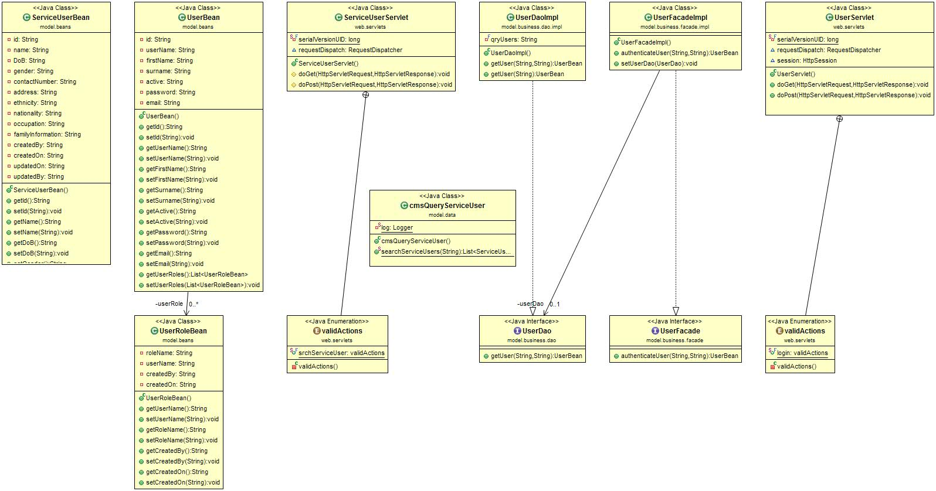

Figure 8: Class Diagram of current progress

# Chapter 5 Challenges, future Work & Project Plan

### Challenges

The largest foreseen challenge in the future of the application will be implementing and correctly evaluating the CM rules within the system and applying them to the application. Flow charts and decision diagrams displaying the reward criteria have been designed to aid this development process and the Drools language and model are being studied.

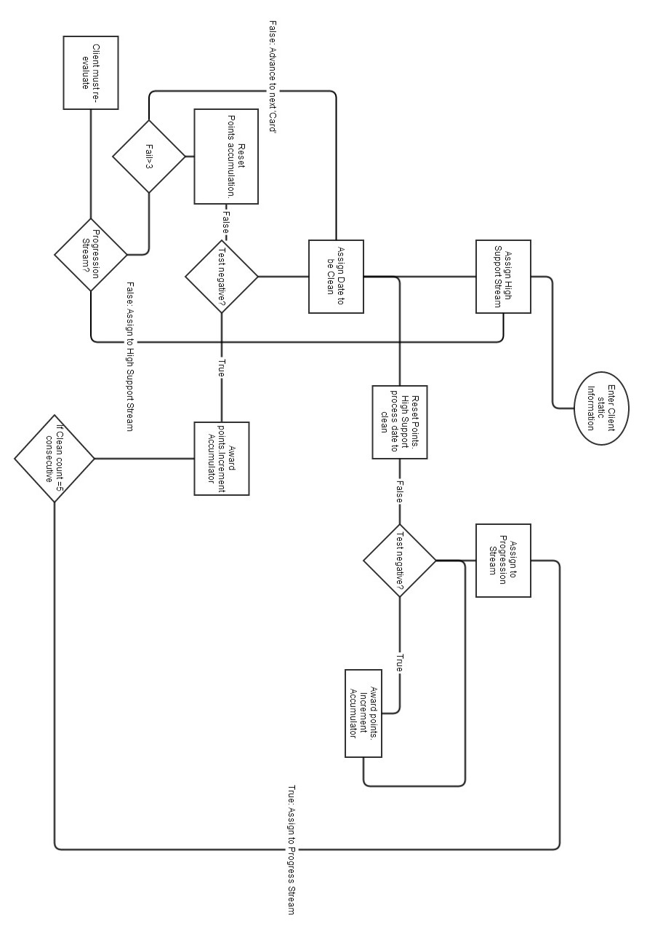

Figure 9: CM process for rewarding/resetting service user's tested samples for substance abuse

In the coming months, priority is placed on the continual iteration of the devised system sprints to continue developing the system modules and ensuring they are thoroughly tested and meet the required specifications.

### Testing

Primary testing will take place during each sprint iteration as with the process of the Agile design methodology. Following pre-written test cases, each aspect of the system will be thoroughly tested based on expected outcomes and intended design. These test cases will be passed or failed depending on the systems outputs. Each Implementation will undergo a full UAT (User Acceptability testing) ensuring the required system requirements are met and correctly implemented. Testing will be performed on the front end based on expected flow/directing of pages, form fields displayed, appearance, validation and client side functionality. The most crucial aspect of the system is the calculation and application of the CM rule criteria. These calculations will be performed by a following a pre-calculated route of actions for various permutations of the applicable scenarios and ensuring the system outputs match that of the pre-calculated test case.

### Evaluation

Evaluation will be primarily based on the accuracy and correctness of the CM rules applied to the events of the system and how they improve the users experience and productivity in helping treat service users of the system. It will take time for solid feedback and evaluations of this system as is with the nature of the Contingency management system. If it improves the work load, productivity and attitude towards work of the staff of a treatment facility and provides accurate and reliable results, this implementation may be considered a success.

### Future Plans

December: To continue systematically designing, developing and testing independent modules of the system, and with each iteration incorporating them into the growing development. It is expected to have the majority of the system middle wear developed by the end of the year. This will include all non-rule based system functionality (e.g. Interactions with database, queries, inserts, updates, form processes, responses to client requests). Documenting all work as progression occurs.

January: Implementation of the Rule based system using Drools and applying it to the functioning system. This process will documented and explained in the Final report. The CM rule base will be applied and associated with the existing Java application classes. Rules of this knowledge base will be called on the update of each CM applicable change in the system.

February: Full system tests and user accessibility testing. Evaluate with real users of a CM paper system, gain and document feedback. Document preliminary evaluations of the system.

March: Will be focussed on polishing off and improving the front end user interface, purely design and layout focussing on the heuristics and HCI properties.  
The Final report will take priority at this stage of the development life cycle and any remaining conclusions of the application. Ensuring the web application is concluded and deployed, ready for the Projects Fair in April.

# Bibliography

|  |  |
| --- | --- |
| [1] | B. Cummins, “ADRU press release story,” Health Research Board, 2013. |
| [2] | “Drug Treatment Centre Board Annual Report 2011,” 2011. |
| [3] | T. Geoghegan, “Merchants Quay Ireland Homeless and Drug Services Annual Report 2012,” 2012. |
| [4] | S. Pilling, J. Strang and C. Gerada, “Psychosocial interventions and opioid detoxification for drug misuse: summary of NICE guidance,” 28 July 2007. [Online]. Available: http://www.ncbi.nlm.nih.gov/pmc/articles/PMC1934496/. [Accessed 3 December 2013]. |
| [5] | S. T. Higgins and N. M. Petry, “Contingency Management: Incentives for Sobriety,” vol. 23, no. 2, pp. 122-127, 1999. |
| [6] | S. T. Higgins, K. Silverman and S. H. Heil, Contingency Management in Substance Abuse Treatment, Guilford Press, 2007. |
| [7] | N. M. Petry, B. Martin, J. L. Cooney and H. R. Kranzler, “Give them prizes and they will come: Contingency management for treatment of alcohol dependence.,” *Journal of Consulting and Clinical Psychology, Vol 68(2),* p. 334, 2000. |
| [8] | N. M. Petry, Contingency Management for Substance Abuse Treatment: A Guide to Implementing This Evidence-Based Practice, Routledge, 2013. |
| [9] | “Start Developing iOS Apps Today,” Apple Developer, 22 November 2013. [Online]. Available: https://developer.apple.com/library/ios/referencelibrary/GettingStarted/RoadMapiOS/index.html. [Accessed 29 November 2013]. |
| [10] | “The MongoDB 2.4 Manual,” [Online]. Available: http://docs.mongodb.org/manual/. [Accessed 3 December 2013]. |
| [11] | “.NET Framework System Requirements,” [Online]. Available: http://msdn.microsoft.com/en-us/library/8z6watww(v=vs.110).aspx. [Accessed 3 December 2013]. |
| [12] | I. Evans, “Your First Cup: An Introduction to the Java EE Platform,” [Online]. Available: http://docs.oracle.com/javaee/7/firstcup/doc/home.htm. [Accessed 10 October 2013]. |
| [13] | R. Johnson, J. Hoeller, A. Arendsen, C. Sampaleanu, R. Harrop, T. Risberg, D. Davison, D. Kopylenko, M. Pollack and E. Vervaet, “Spring - Java/J2EE Application Framework Reference Document,” [Online]. Available: http://docs.spring.io/spring-framework/docs/1.2.8/reference/introduction.html. [Accessed 3 December 2013]. |
| [14] | T. J. D. team, “Drools Expert User Guide,” [Online]. Available: http://docs.jboss.org/drools/release/5.2.0.Final/drools-expert-docs/html/. [Accessed 10 October 2013]. |
| [15] | S. Ambler, “Iteration Modeling: An Agile Best Practice,” [Online]. Available: http://www.agilemodeling.com/essays/iterationModeling.htm. [Accessed 3 December 2013]. |
| [16] | “The Apache Tomcat 5.5 Servlet/JSP Container,” The Apache Software Foundation, [Online]. Available: http://tomcat.apache.org/tomcat-5.5-doc/index.html. [Accessed 9 November 2013]. |
| [17] | “The Deployment Descriptor: web.xml,” Google, 9 September 2013. [Online]. Available: https://developers.google.com/appengine/docs/java/config/webxml. [Accessed 9 November 2013]. |
| [18] | D. Alur, Core J2EE Patterns: Best Practices and Design Strategies, Prentice Hall Professional, 2003. |