

Contingency Management System
Final Year Project Report

DT228
BSc in Computer Science

Leslie Ducray
Richard Lawlor
Dr. Brian Mac Namee

School of Computing
Dublin Institute of Technology

6 April 2014



Abstract

The purpose of this report is to document the processes underpinning the research, design, development and implementation of a Contingency Management web application. Though the application is developed to modify drug misuse, the fundamental activities behind this application could be used to promote many other forms of behaviour change, via the underlying principles of operant reinforcement and behavioural economics. Contingency Management is a highly effective, evidence based, incentive centred treatment for problem behaviours. This approach is most commonly used to strategically treat drug and alcohol addiction through offering tangible and meaningful rewards that are contingent upon agreed and targeted behaviour change. Whilst the Contingency Management approach is clinically highly effective the adoption of an automated web application will enable a determination of complex applied reinforcement criteria in ‘real time’ and improve communication between treatment staff and service users. The proposed system aims to automate a current paper-based system, removing the tedious and laborious act of manually processing a service user’s treatment progression. As per international best practice advice this system aims to target two objective behavioural aspects: engagement in clinical activities and drug use.
A major benefit of this system is the ability to minimise human error and bias in creating an automated approach to recording and calculating the patient’s 'real time' reward status and entitlements (normally vouchers to a calculated monetary value and/ or "take away" medication privileges) in a far less laborious fashion than which is currently employed in many treatment facilities. This approach will be aided by the assistance of a rules engine which will apply the contingency management knowledge. This application could be employed in a range of facilities including but not limited to outpatient drug treatment centres, residential programme, prisons, the military and juvenile detention centres etc.

Declaration

I hereby declare that the work described in this dissertation is, except where otherwise stated, entirely my own work and has not been submitted as an exercise for a degree at this or any other university.

Signed:

_________________________
Leslie Ducray

6 April 2014

Acknowledgements

I would like to thank my supervisor Richard Lawlor for his help and advice over this period, and my second reader Dr. Brian Mac Namee.
My father, Kevin Ducray for the idea and being my domain expert through the full process. Special thanks also to Dr. Nancy Petry for offering early advice on the proposed idea.

Table of Contents

Table of Tables

Table 1: Comparison of web development platforms (13) 17
Table 2: Login Test Cases 62
Table 3: Add/Edit Service User- Test cases 63
Table 4: Add/View Toxicology History - Test cases 64
Table 5: Add/View Meeting Attendance- Test cases 65
Table 6: View Account- Test cases 67
Table 7: View Notes- Test cases 68
Table 8: System Administration- Test cases 68
Table 9: User Management- Test cases 70

Table of Figures

Figure 1: Typical rule-based system architecture. 20
Figure 2: First database schema implementation 25
Figure 3: Full representation of associations between entities 28
Figure 4: The final schema. 29
Figure 5: High level Use Case of the system 31
Figure 6: Front End Horizontal prototype 32
Figure 7: System architecture. 34
Figure 8: High level flow of the application front end. 36
Figure 9: Contingency Management process for rewarding/resetting service user's tested samples for substance abuse. 38
Figure 10: The dataSource bean 39
Figure 11: Sample Servlet declaration in web.xml 39
Figure 12: 'UserServlet' class diagram 40
Figure 13: Login screen 41
Figure 14: User facade interface - DAO class association diagram 42
Figure 15: Search Service User screen 43
Figure 16: User Management screen 44
Figure 17: ServiceUserServlet class diagram 45
Figure 18: Add Service User 46
Figure 19: Class diagram for ServiceUserService and ServiceUserBean 47
Figure 20: Service user facade interface - DAO class association diagram 49
Figure 21: Service user summary 50
Figure 22: Service user's account and previous transaction 51
Figure 23: Service user's notes and correspondences. 53
Figure 24: Add/View substance results 54
Figure 25: Add/View Attendance. 58
Figure 26: System Administration page 59
Figure 27: SystemServlet class diagram 61
Figure 28: ServiceUserBean class attributes 77

Chapter 1 Introduction and Background

According to The European Monitoring Centre for Drugs and Drug Addiction (EMCDDA) in 2012 there were at least 1.2 million people in Europe receiving treatment for illicit drug use, of which the majority (630 000) receive treatment for opioid abuse (2).

With regards to the supply and use of illicit drugs in Europe Cecilia Malmström, the European Commissioner for Home Affairs declared,
“We are faced with an ever more complex stimulant market and a relentless supply of new drugs which are increasingly diverse. The fact that over 70 new drugs have been detected in the last year is proof in itself that drug policies need to stay on target” (2).

In Ireland, the Health Research Board (HRB) reported that in 2010 4,930 patients entered into treatment for opioid dependence, mainly heroin and that 1,893 received treatment for cannabis use.
(2).

The Drug Treatment Centre Board (DTCB) , Ireland’s oldest opiate addiction treatment centre based in Dublin, reported in their 2011 annual report that they treated 864 individuals for drug addiction, of which 68% were male (3). This report also noted the homeless population receiving treatment for addiction had risen to 233 in 2011 from 181 in 2007. This agency also advised that the (Irish) National Drug Analysis Laboratory conducted 1,187,926 drug screening tests in 2011 via urine, blood and oral fluids.

Further statistics furnished by Merchants Quay Ireland, a non-profit drug service provider in Ireland, indicated this body received 20,847 visits from 3,634 service user to make use of their needle exchange service in 2012 (4). This was an increase of over 2,000 visits from 2011. Tony Geoghegan, the Chief Executive for Merchants Quay Ireland, declared in their annual report "Demand for our homeless and drugs services is growing, yet finances are contracting" (4).

The National Institute for Health and Care Excellence (NICE), a highly influential body within the Department of Health in the United Kingdom published a document in 2007 outlining their recommended approaches for drug treatment. In particular the Contingency Management approach was highly endorsed as a psycho-social intervention for drug misuse (5).

According to the prestigious NICE Guidelines and other authorities Contingency Management is considered a psychosocial treatment system with a very high degree of scientific evidence base (6) (7) (8) (5).This approach aims to treat patients by offering incentives to reward or reinforce various types of behaviour change. Contingency Management, In particular this approach has been shown to be very beneficial to a population living extreme circumstance (e.g. the homeless, pregnant woman, people with mental illness) (7).
Chapter two will highlight more research into Contingency Management, the background of the approach and previous automated adaptions.

The motivation for this project is to create an automated generic web application for staff working at a drug treatment facility which will allow them to admit, manage and monitor the progress of service users engaged within a Contingency Management program and automatically apply applicable rewards and reset rules based on a defined criteria. The primary function of the system will be to apply a reinforcement or reward (Contingency) process to service users based on attainment of negotiated or agreed targeted behavior change (i.e. drug use, attendance, participation in therapeutic activities offered etc.). The criteria applies logic based on objectively verifiable results from a clients' laboratory test data or behaviors such as clinic or meeting attendance etc. This particular implementation of a contingency management system will group service users of the treatment-based center into two different progress streams, based on predetermined criteria (stability, behavior, extent of drug use). The two streams are identified for convenience as a ‘Preliminary’ stream and an ‘Advanced’ stream. The reward protocol of each stream is governed by different criteria. Service users can also be penalized for breaches of their agreed treatment contract including drug use, failure to attend agreed meetings without good cause and other relapsing behavior via a loss of opportunity to receive certain credits and /or a ‘reset’ to a less ‘valuable’ reward schedule or protocol. As the system is based on the systematic and structured application of earned incentives, service users will accumulate these rewards. A large part of the application will be to record the transactions of service users. The transactions functionality will feature a balance of the clients earned rewards and eligibilities, ‘sanctions’ (loss of credits and ‘resets’) and a history of credits earned and withdrawn. This particular approach will only monitor two predetermined types of behaviours as per international best practice.

The system will need to attain and store information on each service user including
- Appropriate identifying and demographic data
- Meetings attended / general attendance
- Engagement in target therapeutic activities
- Drug screening tests for various categories of drug use (e.g. Opiate, benzodiazepine, stimulant, cannabis, alcohol etc.)
- “Take Away medication” and other treatment privileges/ eligibilities
- Service User’s Treatment Stream
- Reward history
- Rewards/Credit account – balance, history and transactions.
- Notes from staff
In addition, permitted system users will have access to a system administration module through the web application. Through this module, a user can add and edit ‘substance use’ related target behaviours, specifically what clinically relevant behaviours are to be targeted and how many points a service user can accumulate per attainment of these target behaviour (substance or attendance related); the “reset value” or consequences of a positive drug test result and how the substance use affects the user's status/ progression on their ‘stream’ or ‘level’. The streams or levels are hierarchical, differential levels of reward and are contingent on meeting clinical engagement and drug use target behaviours. Importantly this module will allow the clinic/drug centre management or service providers great flexibility in effecting decisions regarding what combination of target features (behaviours) are tested and how and to what weight they are rewarded. For some organisations, for example opiate use may be a priority whereas for others this behaviour is not an issue for their service users but alcohol use is their major clinical focus. The user can also amend the contingency criteria and values for different streams, in this instance the monetary value for conversion of earned points (per stream or level status) and to what maximum level a service user can be rewarded each week. Permitted system user’s will also have access to a “User management” module, in which the user can also edit data regarding new and existing users or add new staff users to the system.

The web application will be developed in Java, JSP, JavaScript and SQL primarily and will rely upon a rule based expert system (Drools) to govern the underlying Contingency Management criteria.

The primary objective of this application is to provide a web application user interface for staff of a treatment center employing the Contingency Management approach. The web application will be required to correctly and quickly manage data requests and responses between client (browser) and server. The system functionality will need to correctly calculate the outcomes of the rule based system based on user input from attendance meetings and tested samples. Chapter 4 will cover the architecture and implementation process of the full system scope.

Chapter 2 Research

Contingency Management

Research into the proposed project begun by studying and understanding the principles of Contingency Management, its application and its target environment. Contingency Management is a psycho-social treatment approach which focusses on the consequences of a person’s actions by rewarding or depriving them of incentives, based on their behaviour (9) (8) (6) (7). The Contingency Management process has a set of defined rules which govern the reward process. Contingency Management is a form of drug and alcohol misuse treatment, but its logic abstracted from content could be applied to many other behavioural economic. The Contingency management approach reflects the behavioural economics theory as by offering incentives, the abuse of substances will decline, becoming less attractive as abstaining becomes more attractive (10).

Contingency Management for substance and alcohol abuse is mostly administered in treatment centres (drug treatment centres, prisons, juvenile detention centres etc.).

The rules (‘knowledge’) and logic to follow are adapted from existing paper based implementations of the Contingency Management approach. Contingency Management is applied to each new transaction of
- The service user’s attendance (attended, meaningful participated, missed or missed with valid reason)
- The result of their substance tests (negative or positive for the presence of the tested substances).

These outcomes determine
- The amount of points or credits a service user earns which is added to their balance. This balance can be converted to shopping centre vouchers which have a monetary value, personal to holder and which can be redeemed for goods excluding tobacco and alcohol.
- Their eligibilities earned/lost.
- Their stream progression/regression.
- Their date to be clean by (‘Date to Clean’).

For a service user to withdraw their earned credits they need to have a certain pre- agreed minimum amount accumulated (in this instance €20). They also need to have tested negative (i.e. no opiates or cocaine) in their most recent substance tests for a staff user to approve the withdrawal of their earned credits.

Through communication with a clinical psychologist working at a Dublin drug treatment centre which employs a paper based implementation of the Contingency Management approach, the following flow of process was elicited and discussed. This system is based on the scientific literature outlining those features or principles considered to be core to an effective Contingency Management scheme which include:
- Immediacy
- An increasing or escalating schedule of reinforcers
- Progression or regression between ‘streams’ or ‘levels’
- A “reset function”
- Receipt of contingencies (or rewards) which are personally meaningful or rewarding to the participant.
When a service user (client/patient) is first admitted into the Contingency Management program, they are assigned to an agreed upon treatment stream. Generally the initial treatment stream is the foundation or entry level stream, in this instance termed the ‘Preliminary’’ stream. Ideally when the patient progresses in their treatment and stability is established they progress upwards to the next ‘level’ or ‘stream’. Each stream offers a different magnitude of rewards and likewise a different magnitude of penalty for misbehaviour. The service user’s identifying and general details are elicited and recorded.

Service users are ideally critiqued on no more than two different target behaviors. The two explicitly targeted behaviors that will be addressed in the development of this Contingency Management system is 1) Engagement (participation in arranged meetings and therapeutic activities) and 2) Drug Use (as measured by the service user’s regular drug screening tests).

The results of these drug tests impact upon the progression and regression of service users through the two streams. If a service user consecutively tests drug negative (no drugs) they will progress from the ‘Preliminary’ stream to ‘Advanced’ stream. Also with each drug negative test provided per schedule, the service user incrementally acquires more reward points, which results in them receiving a reward of a higher total magnitude. This is termed as an escalating schedule of reinforcers, as the incentives become more attractive. In situations where service users again test positive for drugs after periods of abstinence their incrementally increased ‘reward point accumulator’ is reset to its reset value (usually 0). Users do not lose points earned, but they will need to re-build their accumulators to be rewarded more. Likewise if a service user consecutively tests positive or lapses after a period of abstinence they will regress back to ‘Preliminary’ stream and/or be issued deadlines to test negative (”Target date to be clear”). These dates are issued to give one weeks’ notice of the testing expectation. If the service user fails to meet their ‘Target date to be clear” test, they are issued another date in a weeks’ time. These date targets are progressively issued as a card system (for example progressing through ‘yellow’, ‘orange’ and ‘red’ caution cards. Once the ‘Date to be clear’ associated with the ‘red’ card has failed to be met the patient will be invited to re-assess their desire and motivation to continue within the Contingency Management program.

Attending specific treatment meetings (e.g. Key Worker, Counsellor, Social Worker meetings etc.) also allows the service user to earn a capped number of reward points. The system will be implemented to award a service user up to and including three attended and meaningfully participated engagements per week.

Through personal correspondence with Dr. Nancy Petry, leading international authority in contingency management and the developer of the low-cost contingency management treatment approach (8); the project proposal was discussed.
With reference to previous attempts to develop automated Contingency Management systems, Dr. Petry had this to say “Several groups have attempted to develop automated CM programs, but none have been widely implemented in practice.” Dr. Petry went on to discuss the previous short falls of previous implementations she has been exposed to and explained corrective measures at trying to better ensure a correct implementation.
“Some of the problems have been that each clinic seems to want to implement CM in its own way, and the programs developed thus far have not been able to accommodate issues such as different reinforcement magnitudes and types (vouchers vs. prizes vs. stars exchangeable for items), different attendance structures (which is less of an issue for opioid replacement treatments relative to outpatient care), different durations of CM interventions, and excused absences.” Many of these issues had been taken into consideration in the initial proposed approach, but the comments stated offered more definition and confirmation for the planned implementation. Dr. Petry continued on to state issues regarding valid reasons for being absent from arranged meetings and sample taking, “Because the evidence-based CM programs have escalating reinforcers for sustained abstinence, the programs developed to date have not been able to incorporate this feature appropriately given the real world issues that arise (e.g., in terms of missed samples for legitimate reasons etc.).”. Previous implementations have enforced the Contingency Management criteria too rigidly without offering an override or exception to legitimate reasons of absence, thus penalizing the service user ‘unfairly’.

Application Medium and Platform Research

The decision to implement a web application opposed to a native application or an application for a mobile device was decided based on the following considerations:

- Where will the users use the application?
Typically users of the system will be based in clinic offices, laboratory environments, research centres or even mobile treatment centres (modified treatment busses) where dedicated staff members can record test results/notes/attendances. The interactions between service user and treatment staff will require a level of privacy.

- Who will the typical users be?
Typically the users of the system will be members of a clinical team such as doctors, psychologists, counsellors, or key workers who interact directly with the service users or process their test results.
- What medium/technology will the users typically have?
In a treatment centre or correctional facility, typically the administration staff would have a personal computer/laptop for keeping records. In many cases, due to the one-on-one nature of the interaction between a service user and a member of treatment centre staff, information would be taken down during the meeting and this could be via a paper notes, tablet or other mobile devices.
- What will be the most accessible means of distributing the system?
Due to the nature of the confidential and sensitive information stored, the system will need to be totally secure and meet all data protection and other legislative requirements. A web application hosted on a local and secure network would appropriately cater for this requirement. Web applications can be run and rendered on almost every platform that has a ‘modern’ web browser installed, this includes smartphones and tablets. The user interface can be easily and efficiently designed using HTML5 and can be enriched with native client side technologies. User sessions and login times can be configured to maintain secure access. There is no need for the software to be installed or updated on any of the user’s machines. As the scope of the system is mostly down to the middle and backend functionality, the user interface could be implemented as a Java GUI frontend, but as stated, an instance of the software would need to be installed and running on each user’s native machine for them to have access, more disadvantages arise when the software needs updating for each independent machine.
Disadvantages of developing the application for a specific platform such as IOS or Android mobile devices would render a large portion of the target platforms incompatible, as these technologies are specific to their applicable devices. IOS applications require an Apple Mac device to be developed on with XCode and IOS SDK installed and an Apple device to be run (11), this is not a feasible option for the development of this application, as this system is intended for health services where a financial budget is restricted.
Publishing any developed applications to the Apple Store also requires developer’s fee and restrictive licencing. While Google Android mobile devices demand no developer’s fees for publishing to their App Store, making them financially more appealing, they are still restrictive to the compatibility of the devices which can run the applications. Web applications designed to be received and rendered through the users browser is the most feasible option for this particular application as where the user primarily works from their own office with their desktop/ laptop or need to enter in the information from their mobile device, the web application can be accessible regardless of their device and/or platform. As with web applications the application is deployed to a host; there is no need for it to be published to application stores, which will enhance re-deployment time for updates, changes or bug fixes. Should there be changes made, the users will not need to download or install new versions. As the system will be hosted on a local area network, there are no hosting costs.
HTML5, JavaScript and CSS technologies can be employed by the application to greatly enhance the user’s view of the application on mobile devices and computers alike using adaptive or responsive web design techniques of displaying and sizing the web page content. These technologies can be used to greatly improve the user’s experience.
Disadvantages of developing a web application could include compromising the browser’s performance due to requests and response wait times. The nature of this application does not require an intense low latency interactivity so the user should not be noticeably affected or disadvantaged by delays. Another issue that can arise with a web application is the desire or need to continue working off-line or due to a lack of connection. As mentioned previously, the access and use of the web application will be limited to the confines of the local network which ensure a more secure and deliberate limited external access. As the objective hosting of this application is intended to be hosted on a local area network, an external internet connection (to the World Wide Web) is not a necessary requirement.

- How will this application help? If implemented correctly, this application will provide enhanced efficiency, accuracy and labour saving to clinical staff of a treatment centres, aiding them by bypassing the act of having to manually apply the Contingency Management criteria and also allowing the provision of feedback as to “rewards or credit balance accrued” in near real time. It will provide treatment providers with a much more efficient record keeping facilities and a wealth of data for scientific and peer reviewed research. In an economic climate where Health care funding comes with budget constraints, a system that will enhance productivity of staff could prove very beneficial.

Database

As the system will rely quite heavily on data storage, a reliable and efficient database management system is needed. The design and implementation of the database is required to be quite sophisticated in its associations. As the business logic of the web application is firmly based on the governing rules of Contingency Management, implementing the database to dynamically aid the rule based system will greatly improve the maintainability, consistency and dependency of the system.

The structure and nature of the data storage required for the proposed Contingency Management system is relatively rigid and tabular in format. The associations between table entities will serve the database systems primary function for storing and retrieving data. Any change or volatility of the data model/schema is unlikely expected, as the associations between table entities will be closely based on the principles of Contingency Management and information required, and the entity attributes will be designed to allow a certain degree of dynamics.

With this statement in mind, the need for the likes of a NoSQL database such as Mongo DB would serve little benefit. NoSQL databases employ a less constrained data model that allows for retrieval and storage of data in a more flexible manner. Where relational models separate data into various associated tables joined by identifiable keys, document orientated NoSQL databases such as Mongo DB aggregate the data into one particular record for storage, thus removing the need for entity relationships (12). This tuple like structure, though very powerful and easy to implement would not serve this application.

A relational database such as MySQL would suit the nature of a Contingency Management system, offering a simple and set approach for storing, querying and manipulating data. MySQL has the power to employ the option of data warehousing which could be an expansion of analytical and report generations for the application in the future. MySQL is one of the leading popular open source relational database managers, offering in addition a MySQL server and the workbench development kit for design and implementation. As the scope of the application by design will be limited to the local network of treatment facility, where the amount of traffic to and from the database will remain relatively low and the expected wish to scale the database is non-existing, a MySQL database is ideally suited.

Web Technology

Sun’s J2EE, Microsoft ASP.NET and Linux/Apache/MySQL/PHP (LAMP) are the three leading and most popular Web development platforms. When comparing these three platforms to decide on the most suitable and applicable, it is very plain to see the similarities and competing functionalities at a high level.

Table 1: Comparison of web development platforms (13)
Criteria | J2EE | ASP.NET | LAMP
Database Compatibility | Multiple | Multiple | Multiple
Accepted Platforms | Multiple | Windows only (13) | Multiple
Server Compatibility | Multiple | Windows Server only (13) | Multiple
Frameworks | Many to choose from | Many to choose from | Many to choose from
Licensing cost | Free | Free | Free
Support, Documentation and online resources | Yes | Yes | Yes

The above mentioned are only three of the plethora of different web technologies and frame works. All offering to some degree the required support and functionality required.
Deciding on a web technology platform required that the platform could integrate correctly and reliably with the chosen database server which is a MySQL server. Java Database Connector (JDBC) forms a framework for communicating between the Java application and the MySQL server. These technologies are all open source and widely used and well documented.
Java Enterprise Edition (J2EE), an expansion of the standard Java platform allows for the inclusions of many pre-existing libraries. These are a large attraction as they have under gone thorough and various testing through various implementations. Such libraries will offer more reliability and productivity than having to re-develop the existing functionality (14). J2EE by default includes many APIs which are necessary for developing a web application such as the JDBC. J2EE also comes pre-set with the various associated file types such as Java Beans, Java Servlets and Java Servlet pages through Eclipse to be included in the developed application. J2EE was developed to aid developers in the design of large multi-tiered applications for reliable and secure distribution over a network (14).
The Spring Framework is a specific MVC framework for web applications and RESTful webs services. The Spring framework is designed to architecturally structure the entire scope of the web application (15). The Spring Framework will aid in organizing the structure, abstraction and dependencies of the enterprise application’s many components and Java classes. It also comes with fundamental support for Java Database Connectivity.

J2EE, uses servlets which are used to extend the capabilities of application host servers through a request-response model. Apache Tomcat is a free servlet container server host which is an open source software.

Rule Based Expert System

An expert system is a rule based computer system which is implemented to emulate the decision making process of a human expert in a specific domain or field of expertise. The system relies on ‘knowledge’, which is the understanding of a specific domain. Knowledge is represented as conditional statements (IF-THEN) implemented as rules. Knowledge is elicited from the domain experts on the specific subject and is translated into the rules. Rules are constructed as two parts, firstly the condition represented as an ‘IF’ or ‘WHEN’ antecedent statement, and a ‘THEN’ consequential part, which is fired if the ‘IF’ clause is matched.
The general structure of a rule is as such:
IF <antecedent>
THEN <consequent>
The antecedent is the condition which must be met for the consequent to occur. Antecedents usually involve an object which is matched against a value under a particular mathematical operation. Each rule forms part of the rule base forming the ‘knowledge’.

A typical rule engine is composed of three main components, an inference engine, a rule base and the working memory. As discussed, the rule base are the rules of the system that represent the domain-specific knowledge. The working memory of a rule engine is a database collection of stored facts, these facts with in the working memory are analysed by the inference engine. The inference engine is the aspect of the rule engine which decides what rules are satisfied by the present facts in working memory. There are two techniques which rule based systems can use to infer or reason knowledge, forward chaining and backward chaining inference. Forward chaining is a data-driven means of reasoning, forward chaining works from known facts to produce a conclusion. Backward chaining employs an opposite approach of reasoning from the conclusion or hypothesis and works back to produce which facts that support the hypothesis. The inference technique depends on the type of problem and what is known. The Inference Engine consists of a pattern matcher, an agenda and an execution engine. This architecture is represented in Figure 1.
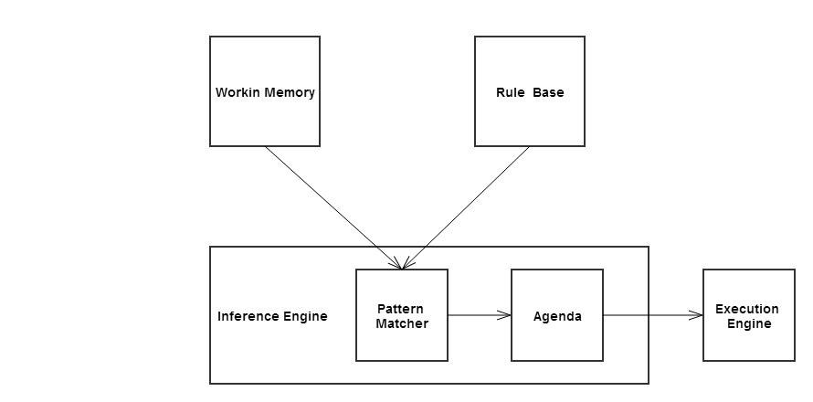
Figure 1: Typical rule-based system architecture.
As stated, the inference system controls the full process of applying the rule base rules to the working memory facts to determine the correct outputs. Determining which rules are satisfied and should be fired is decided by the pattern matcher. The pattern matcher decides which rules apply based on the facts in current working memory. As the inference engine is often required to fire rules based on priority or in a particular order, an agenda is used. The agenda stores a list of all rules which could potentially fire. Once the inference engine has decide on a rule from the agenda to fire, the execution engine fires the rule’s action, the consequent.

For a rule-based expert system to perform in a responsible and reasonable manner, the issue of conflict resolution must be handled. A conflict is an occurrence between two or more similar rules where each of their antecedents are satisfied and thus the rule is activated, these can however contradict or output an incorrect outcome. A Conflict resolution prioritize the order in which these conflicts are fired. A conflict resolution strategy is used to achieve this.
Deciding on a rule based expert system to incorporate into the system was dependant on a few factors

- Will it integrate well with the existing chosen technologies?
As the current web application technologies and languages decided are Java and MySQL, the middle wear needs to be able to interact with the select rules engine.
- Is the software open source or is purchased licence required?
There are many open source rule engines that can easily be integrated into a Java project. These open source and Java compatible rule based engines were also researched and compared. 'Drools' is an open source forward chaining inference based rule management system that was decided on.
- Is a rule engine necessary/ Advantages of using a rule-based system? As the primary business logic of the system is focussed on applying criteria to known facts, a forward chaining inference rule engine could be very effective in structuring and optimizing the calculation process. Rule engines use declarative programming therefor implementing a rule-based expert system diminishes the complexity of attempting to cater for the many business rules through procedural conditional statements. As the data is centralized within the rule base, there is a single means of access and truth which reduces redundancy and dependency of methods. Using the rule base will be an optimal means of organizing the Contingency Management criteria, keeping business logic and data separated. Rule engines offer loose coupling, which allows for flexible rules which can be added, removed or changed without a chain reaction of issues arisen from these alterations.
As the rule/knowledge base is an independent aspect of the proposed system, any changes to the business rules can be edited and saved without any need to re-build or re-deploy the application.

Rule-Based Expert System Considerations

Jess
Jess is a rule engine and scripting language written in Java, allowing full use of Java’s many APIs, making it ideal for integration into a Java based system.
Initially JESS (Java Expert System Shell) was going to be the preferred option to incorporate into the system until licensing was looked into. A personal enquiry was made to the Software Licensing Administrator at Sandia National Laboratories requesting information on obtaining a licence for this particular project.
An academic licence was attained under strict terms and conditions that the academic licence is restricted to only using JESS on a project specific basis for academic and non-proprietary and/or commercial research or development.

Drools
Drools is an object orientated rule engine developed for Java projects. Drools employ an enhanced and augmented implementation of the Forgy Rete algorithm. The Rete Algorithm was written by Dr. Charles Forgy in the late 1970s. The algorithm was inspired a network of nodes like a fishing net. The algorithm can be separated into two key parts, first the rule compilation and secondly the runtime execution. Drools enhances the Rete algorithm to be able to apply it to multiple and combinations of Object types. Drools and can easily be incorporated with in a Java application (16).
In addition to the rule engine, the Drools software also includes visual aids which illustrate the flow of the rules, a visual representation of the Rete ‘net’ created from the rules which will aid in the development. The Drools software can be a ‘plug-in’ for the Eclipse SDK. The RHS of a Drools rule can be written in pure plain old Java.
Allows for Language expression to rule language expression mapping, which can greatly improve the readability of rules for non-technical domain experts.
For example:
Language expression:
Service user has more than {requiredCredit} and card issued is {issuedCard}
Is mapped onto the original rule language expression:
$result: ServiceUserBean( accountDetails.Account_Balance >= {requiredCredit} , dateToClean.card == "{issuedCard}")
Rules allow for variable binding (‘$result’, is the declared variable for the binding, the ‘$’ symbol is purely a naming convention), allowing the fact objects matching the conditions to be bound to a declared variable, this helps for when necessary to refer to the matched object(s) in the RHS.
Drools parses the rule base file and attempts to match rule language expression with an existing rule. The values which are present in the rule that corresponds with the {placeholder} are substituted in.

The Drools rule engine was selected as it appeared to offer the most support and implementation efficiency for matching and firing rules where the working memory and the facts are Java objects in particular complex Java beans. Creating a knowledgebase session, inserting facts and firing the rules are all easily implanted from a Java class, and well documented in the Drools manual (15).

Chapter 3 Design Methodologies

The design and implementation of this project began at a database level. The system is very dependent on the structure of the database entities and their associations. The database is firmly based around a Contingency Management paper-based system. There were multiple implementations of the database before further web application development would begin.

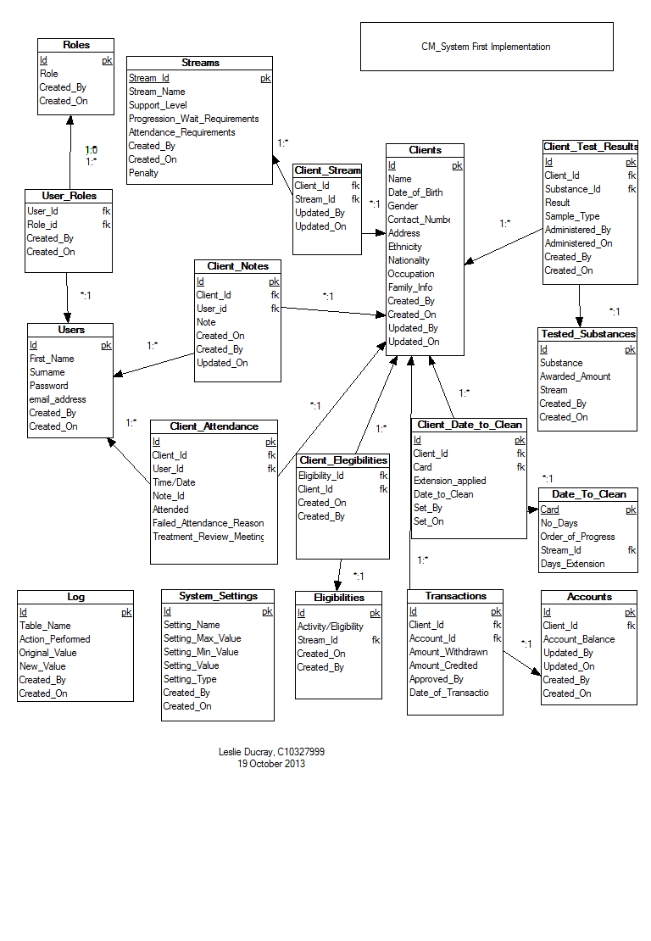
Figure 2: First database schema implementation
The first implementation of the conceptual ERD (Entity-relational database) was a rough design model recording all the necessary attributes, keys required, and the relationships between entities. The first implementation included a full schema logging table. This was removed in later implementations. Instead each table record will store the user key and the date associated with its creation and further latest update and this can alternatively be used as a log. All associations to the ‘User’ table are not recorded in Figure 2 as the many associations with the ‘User’ table impairs the readability of the diagram. Figure 3, illustrates the associations between each entity more explicitly. Figure 3 Expands on Figure 3, illustrating each entity’s attributes, Figure 4 represents the final design. The design of the database schema is normalized to ensure the schema is more maintainable and the degree of dependency between entities is minimised.
The database schema is composed of sixteen tables catering for storage of all relative information. A summary of each table is as follows:
- User – The User table stores all static general information related to a member of staff of the treatment facility.
- Role – The Roles are permission statuses for the system.
- User Role – the joining association assigning a role to a user.
- Service User/ clients – This table represented as Service user or Clients stores all general and static information regarding a service user.
- Service User notes – this association table joins a service user and user where the user has recorded a note on the service user.
- Service User attendance – records a service user’s meeting with a user (i.e. clinician). This table records if a service user fails to make an arranged meeting and whether they have a legitimate excuse (which will spare them penalization when Contingency Management rules are applied).
- Substance – recorded information regarding substances and their effect on the Contingency Management criteria.
- Service User Substance Result – This table forms an associative history for each service user and the results of their regular drug use screening tests storing their urinalysis result, date administered, associated points earned etc.
- Stream – this table stores general information regarding the Contingency Management streams- different levels of progression within the Contingency Management process.
- Service User Stream – The stream associated with a service user. Their current level of progression.
- Account – A service user’s account stores the balance of their earning.
- Transactions – the records of all rewards earned/credits and withdrawals/debits made to a service user’s account.
- Eligibility – the information regarding all Eligibilities – such as ‘eligible to with draw’ , ‘outings/visits’ , ‘take outs’.
- Service User eligibility – an association of which service users have which eligibilities.
- Date to clean – this table stores the information regarding date to clean rules. ‘Date to Clean’ is a date set by a user of the system assigned to a service user to test negative in a substance test.
- Service user date to clean – A recorded history of service users and their assigned dates to be clean, if extensions were given, consecutive failures.
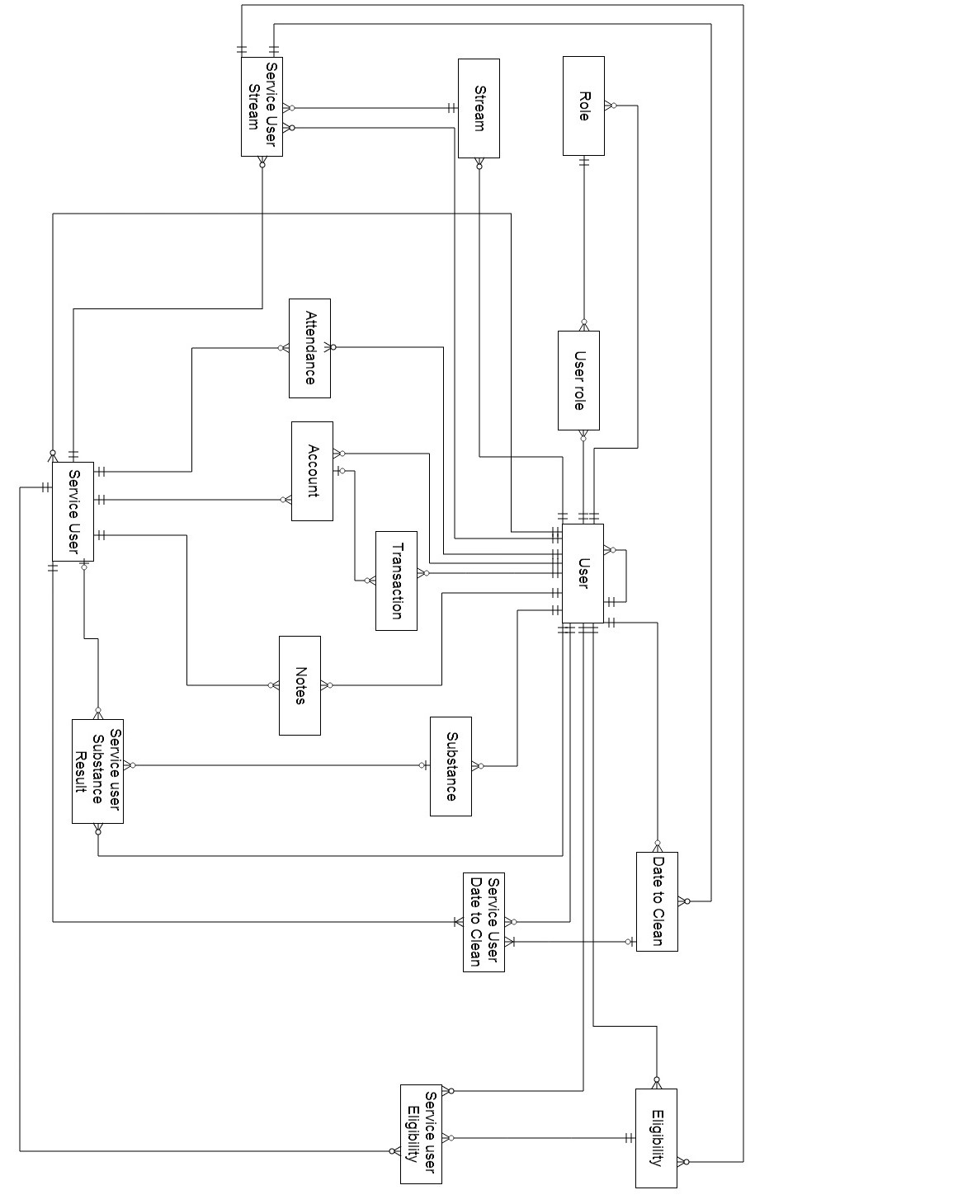
Figure 3: Full representation of associations between entities
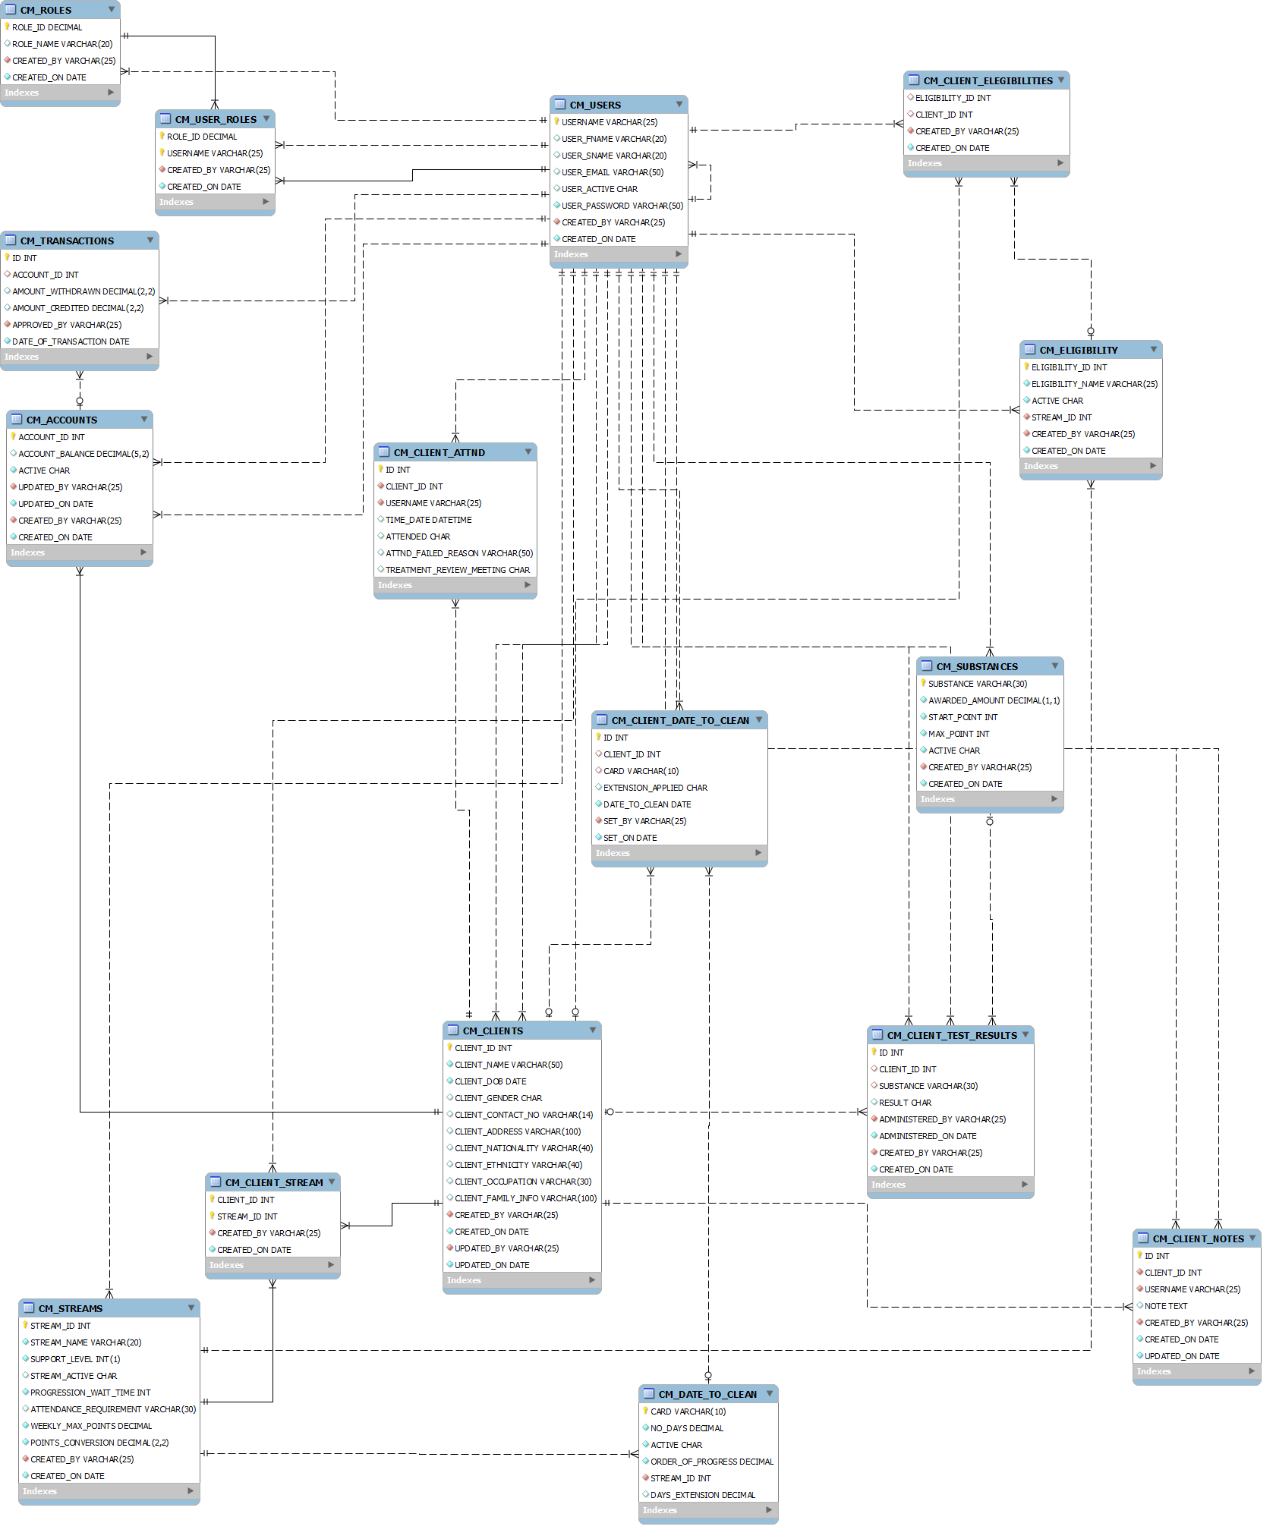
Figure 4: The final schema.
Figure 4 has been reverse engineered using the SQL creates script files and MySQL Workbench Modelling tool.
Once the underlying database structure was of confident design, the design and planning began on the expectations of the web application. These expectations are represented in the use case featured in Figure 4. Figure 4 defines the three user (actor) roles of the system:
- User, the default role of any active user of the system. This role permits a user to add new clients/service users, edit existing ones, record test results and attendance which in turn applies the contingency management criteria.
- Financial User, a role assigned to a user permitting them to view the account of a service user and approve the withdrawal and/or assignment of rewards to a service user.
- Admin is the administration role. This role permits a user to add/edit users of the system, add new substances, edit existing substances or update stream attribute values.
Users of the 'Financial' and 'Admin' role are permitted to all actions of the default user role.

The system actor forms the business logic and control of the application. The system will be required to:
- Establish a connection with the database.
- Respond to user requests.
- Validate user login and assign roles.
- Manage the user session.
- Process queries/updates/transaction statements to the database.
- Calculate and apply the Contingency Management rule criteria.

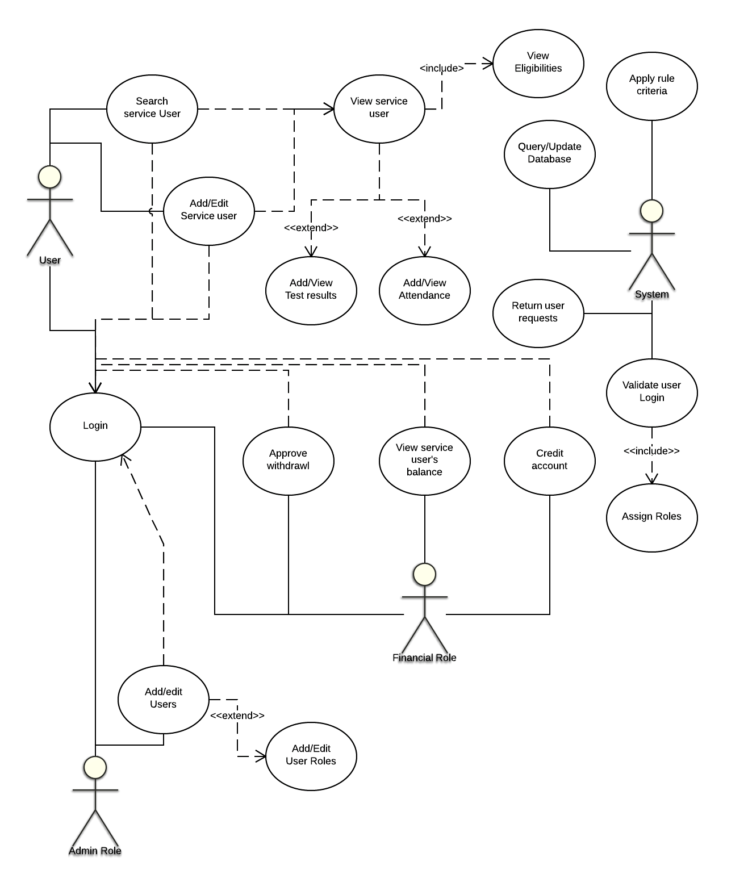
Figure 5: High level Use Case of the system

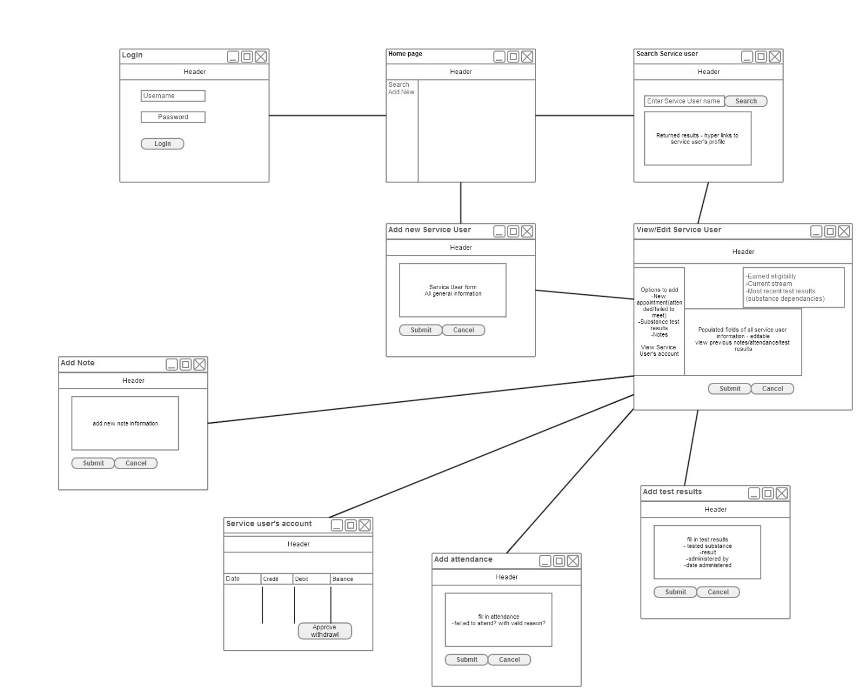
Figure 6: Front End Horizontal prototype

Figure 6 illustrates the conceptual layout of the web application and the flow between pages as presented to the user.
The design methodology chosen to guide the implementation of this application is aspects of the Agile design methodology and Scrum applicable to a single person development team. This methodology feels most suitable to the application, allowing the user to plan sprints/iterations (an independent aspect/module of the system to be developed), design and analyse, implement, test and evaluate (17). The full system plan is divided up into independent sprints or iterations. This allows an assessment to be performed at each iteration of a particular aspect of the system to review progress and prioritise, to test and evaluate current implementations. The Agile and Scrum methodology encourages an incrementing implementation design and development process (17). Using this methodology, the progress and implementation of the application can consistently be assessed, and each aspect of the system will be concluded instead of developing multiple incomplete aspects. Having a complete system sprint fully functioning will aid in testing and evaluation, allowing target users to review and provide feedback on a module for consideration, improvement and rectification.

With the general required functionality of the system established, the web application was divided into multiple independent sprints for design and development. These sprints will be discussed further in Chapter 4 Architecture & Development.

Chapter 4 Architecture & Development

The application is developed using Java technologies. J2EE is an enterprise expansion of the standard Java platform. Java technologies incorporate both the running platform/environment (which consists of a Java virtual machine) and the application programming interface (14).
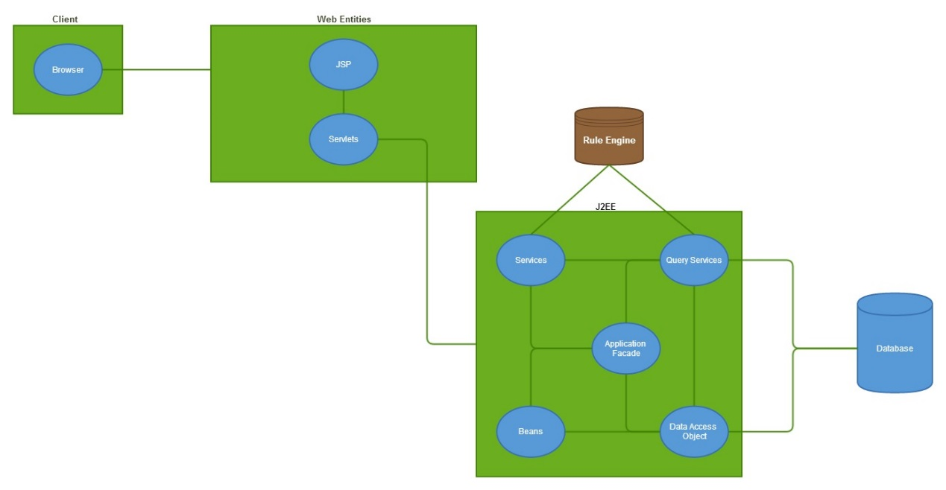
Figure 7: System architecture.

Figure 7 illustrates the technical architecture structuring the web application. The primary component is the J2EE component, which is Java Enterprise Edition. “The Java EE platform provides an API and runtime environment for developing and running large-scale, multi-tiered, scalable, reliable, and secure network applications.”[4]. In Figure 7 the multi-tiered structure is illustrated displaying the division of web components, J2EE components Drools knowledge base and the database. The full system scope is divided into different tiers or levels. The first tier of the web application is the ‘web components', this consist of the Java servlet pages (JSP) and the Java servlets. This division will allow a contained implementation of the Model View Controller (MVC) design pattern of the web components. The web components tier is the only means of the client requesting information from the system and is the only means of receiving a response. The database is hosted on a MySQL server and is connected using a MySQL Java Database Connector (JDBC). The Interactions between these components is further documented through the Implementation discussion.
The application is implemented using Java developed on Java Enterprise Edition Eclipse SDK. The application connects to a MySQL server. The MySQL workbench IDE has been used for design and development of the SQL statements forming the database schema, and testing composed queries and data manipulation statements. MySQL Work Bench also includes a modelling tool which has been used to reverse engineer the schema script to confirm the model meets the conceptual idea.

The Java application can create a new stateless knowledge session to a Drools knowledge base based on the implemented ‘knowledge’ rules. The rules are individual .drl files, which are parsed and used to create the knowledge base. Within the Java application, facts can be inserted into the running memory of the Inference engine. When invoked, the rules will fire, matching the facts against the knowledge base. The stateless session automatically terminates when complete, it can be considered as using a sophisticate calculation function.
Xampp has been used for hosting the MySQL server and the application locally. Xampp is a cross platform web server package consisting of Apache, Tomcat, PHP and MySQL services. Xampp is a handy, convenient and very easy to use application, however, not entirely needed as the only services used are the MySQL server and Tomcat server. Xampp offers a user friendly interface and is informative to system statuses, and allows for services administration.
The Drools workbench can be installed as a plugin for Eclipse enabling immediate project association within the Eclipse work space. Drools knowledge and rule files (.drl) are designed and developed then as part of the Java application.

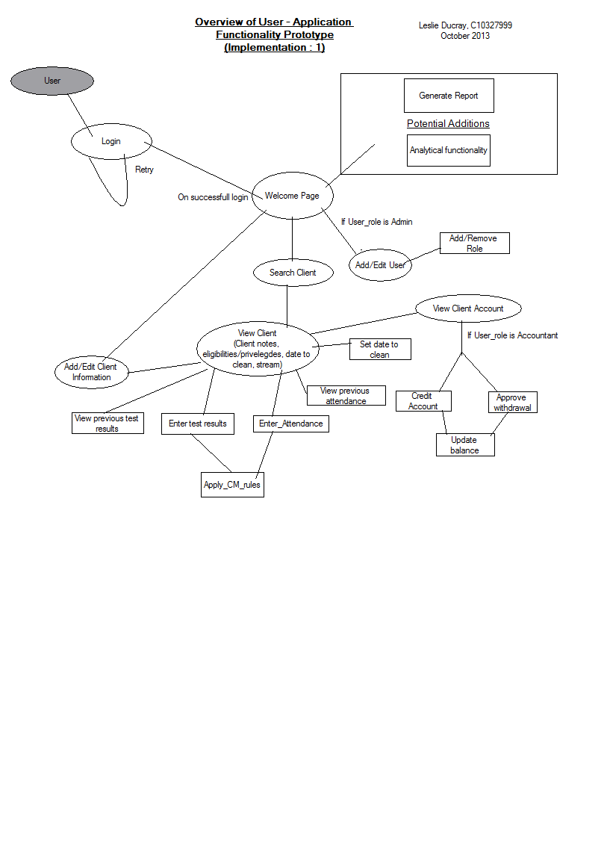
Figure 8: High level flow of the application front end.

Development

As core of this project was to implement a rule based expert system to aid the system with its ‘contingency management’ application, eliciting and engineering the knowledge was a vital stage.

When it came to developing the rule-based system, there are key steps to its implementation: Knowledge engineering, deciding on data structures, testing, building an interface, constructing and writing rules. This is a standard iterative approach to developing a rule-based expert system. As this rule system is to be integrated into a Java web application, the user interface will be developed using the selected web technologies and the data structures will be the java beans which have been implemented to map the database entity structures.
Knowledge engineering is the collection of data from which the system rules will be derived from. This vital stage of system’s development involved eliciting domain specific information for domain experts. Information was gathered from staff of a drug treatment system employing a paper-based system to fill full the criteria of the contingency management approach. Full understanding of the conditions and rules were collected and recorded. This elicited information and understanding is needed to construct the rules for which the knowledge is represented.
Implementation begun initially from developing on the proposed ERD database design structure (Figure 4), based on the elicited information from the domain expert. This would assist in future developments as the various Java classes and Java beans (Class objects to map the table entities) would be implemented to map the required data. Knowing the data entities, their attributes and their associations aided the system development, as each application module could be developed based on the database structure and independently constructed.
To visually comprehend the flow and overview of the rules, decision trees and flow charts were drawn to aid development. Figure 9 demonstrates the understanding of stream/level progression for service user’s based on their substance test results. The flow illustrates an overview of the stages and conditions required for a service user to progress/regress through the two streams.

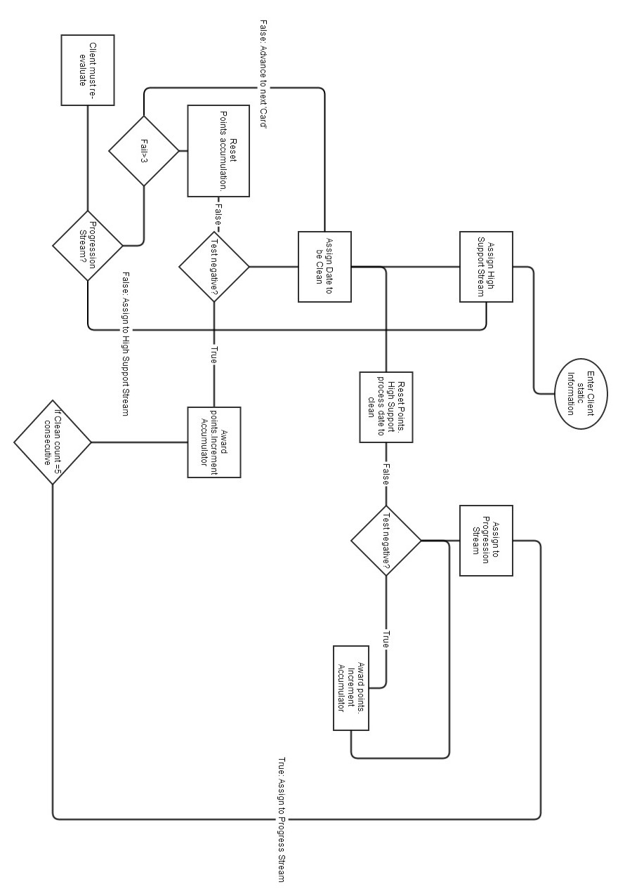
Figure 9: Contingency Management process for rewarding/resetting service user's tested samples for substance abuse.

Once a sound understanding of the knowledge was attained, the rule system implementation was left until the user interface and data structures have been developed.

The system application was divided into multiple independent sprints, which could be developed and integrated into the complete system.
The First Sprint involved the planning and development of ‘Login’ functionality. This begun firstly by setting up the development and testing environment and integrating the various technologies. The Database schema is created and running on a MySQL server.
A connection is made to the database using JDBC (Java Database Connectivity). The JDBC is an API which simply allows for a connection to be established between the Java application and the database for query, insert, update or delete statements. The database connectivity information is stored in a ‘web.xml’ file within the application files. This information includes the database name, its IP address and port to be accessed, the username and password required to gain access and the JDBC is required. This approach is standard, the code used was adjusted to meet the systems correct settings and requirements.
<bean id="dataSource"
class="org.apache.commons.dbcp.BasicDataSource"
destroy-method="close">
<property name="driverClassName" value="com.mysql.jdbc.Driver"/>
<property name="url" value="jdbc:mysql://localhost:3306/cm_system"/>
<property name="username" value="root"/>
<property name="password" value=""/>
<property name="maxWait" value="30000"/>
<property name="removeAbandoned" value="true"/>
<property name="removeAbandonedTimeout" value="30"/>
<property name="logAbandoned" value="true"/>
<property name="validationQuery" value="select 1 from dual"/>
</bean>
Figure 10: The “dataSource” bean
The data source information is stored as a bean (Figure 10) in the ‘context.xml’ file, this bean is referenced to by a “dataSourceManager” class. Other data abstraction objects stored as Beans are also included in the web.xml file, as is the practice and purpose of using a deployment descriptor (17). This abstraction of database information is achieved using the Spring Framework. The Spring framework uses the JDBC to establish and manage a connection to the data source and to pass statements and the returned record sets across the connection. As the system is dependent on Java Servlets to handle requests and responses from the application over the HTTP connection, each Servlet needs to be declared, defined and stored as XML in the ‘context.xml’ file (Figure 11). The servlets URL can be mapped to be more informative to the user.
<servlet>
<servlet-name>UserServlet</servlet-name>
<servlet-class>web.servlets.UserServlet</servlet-class>
</servlet>
Figure 11: Sample Servlet declaration in web.xml

This XML structured document acts as a deployment descriptor; it determines how URLs will be mapped to the servlets (17).
Using J2EE through Eclipse offers template files for Servlets, JavaBeans and JSP. Initializing a new servlet page declares the template of typical requirements such as the methods ‘doGet’ and ‘doPost’ which accept the HTTP request and response as parameters.
A ‘UserServlet’ was developed to be responsible for all requests and responses operations related to the staff users of the system, most importantly for logging in, creating the user's session, assigning users roles and logging out. The user servlet is also called to edit and update new and existing system users.
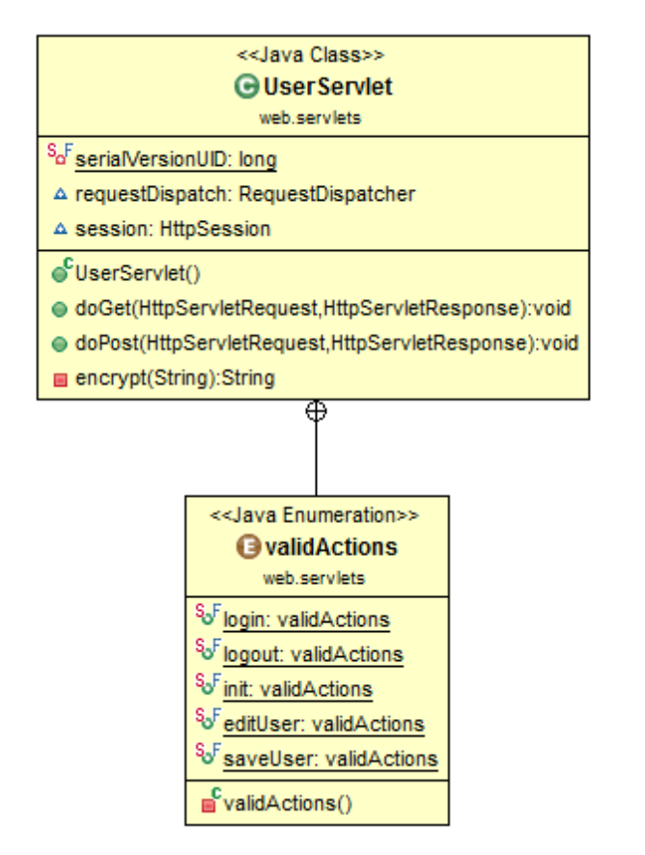
Figure 12: 'UserServlet' class diagram
Figure 12 illustrates the class diagram for the ‘UserServlet’, specifying the actions that can be requested of it represented as a set of enumeration values. Enumeration values are a set of (non-duplicated) predefined constants, that restrict the action requested from the client to be only one of the defined actions (23). As the Servlets will be required to process multiple actions, the list of valid enumeration actions are declared using the Java enum class type which serve as the specific defined data constants. The list of valid actions will be actions requested from the Java servlets pages (JSP).

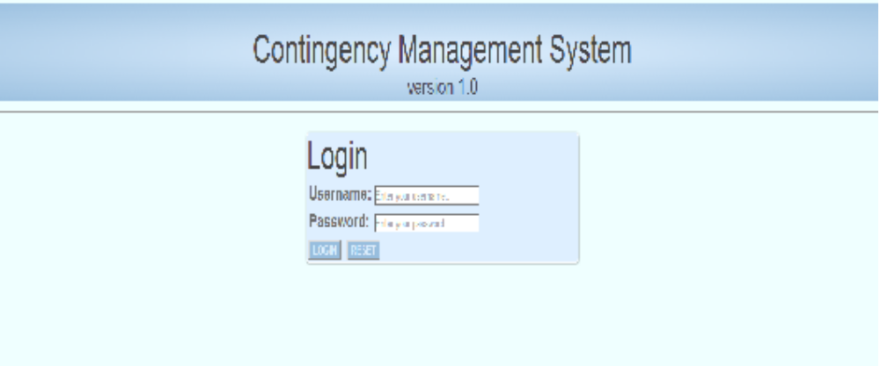
The login page (Index.jsp, Figure 13) is displayed to the user under three circumstances, initially when the user attempts to access the system, when they are re-directed after their logged in session times out or when they have logged out from their session. This page acts as the login page to the system. The user is prompted to enter their username and password.
Figure 13: Login screen
This ‘login’ action is one of the “UserServlet” class’s valid enum actions, when the login form is posted the ‘login’ process begins. Within the servlet code is a ‘switch’ statement to catch the valid actions and execute the set code block/action for each.
The servlet retrieves the entered username and password from the form request. The password is encrypted using MD5 (message-digest algorithm). A Façade Interface can be used in an application as a ‘remote’ access layer to prevent revealing business components of the application to the client (24). They encapsulate the components of the application’s business model, which the clients can then access.
A “UserFacade” class is implemented with a method “authenticateUser” which takes the username and the encrypted password. The ‘authenticateUser’ method is called from the servlet with the applicable parameters passed in. The implementation of the façade method is progressed by declaring a Data Access Object (DAO), “UserDao”. The association between the User façade interface and the data abstract object is illustrated in Figure 14. A data access object is an attempt of creating an intermediate layer between the application and the database, whereby information from the data source is stored in an object of the application (20). Using Java beans designed to store the values of the retrieved attributes from the data source are an implementation of a DAO. Using a DAO keeps the data source hidden from the client. The application can then access and manipulate the values of the Java bean. Two Java beans are used for the login process, “UserBean” and “UserRoleBean”. The user’s credentials are authenticated by querying the database to confirm there is a valid user whose username matches the entered username and password matches the encrypted password. If there is no match, a message is returned to client’s browser alerting them that no valid user matched the entered details. If successful, a ‘UserBean’ is populated by all the user details and a list of “UserRoleBean” objects are populated by the user’s roles. The “UserBean” class has an attribute for a list of “UserRoleBeans”. These values are populated from the returned dataset from querying the database.

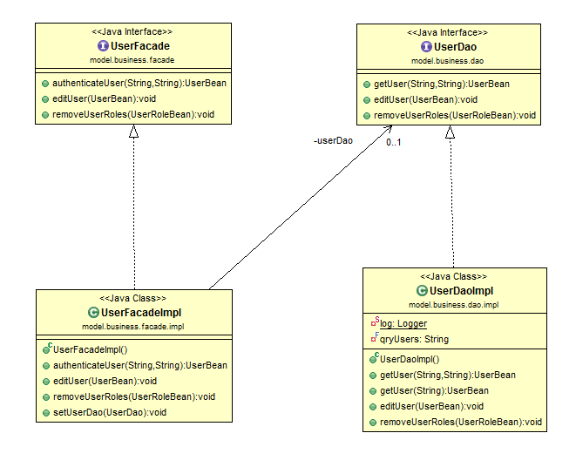
Figure 14: User facade interface - DAO class association diagram
Java servlets can import various functionalities for dealing with HTTP requests, responses and sessions. If the user’s details are valid, the HTTP session storage structure is populated by the user’s details and role permissions which will be used throughout the application for access and security.

The only system role implemented was ‘admin’ which permits the user to additional modules and system actions. The user has gained access into the web application. If the user allows their session to time out, due to thirty minutes of inactivity, any further actions in the system will result in them being returned to the login page, their attempted action is not fulfilled. The system user can choose to log out, doing so will send a ‘logout’ request to the ‘UserServlet’, this is a defined valid action and results in the session being terminated, all session attributes are removed and the user is returned to the login page. The message “Logged out” is displayed.

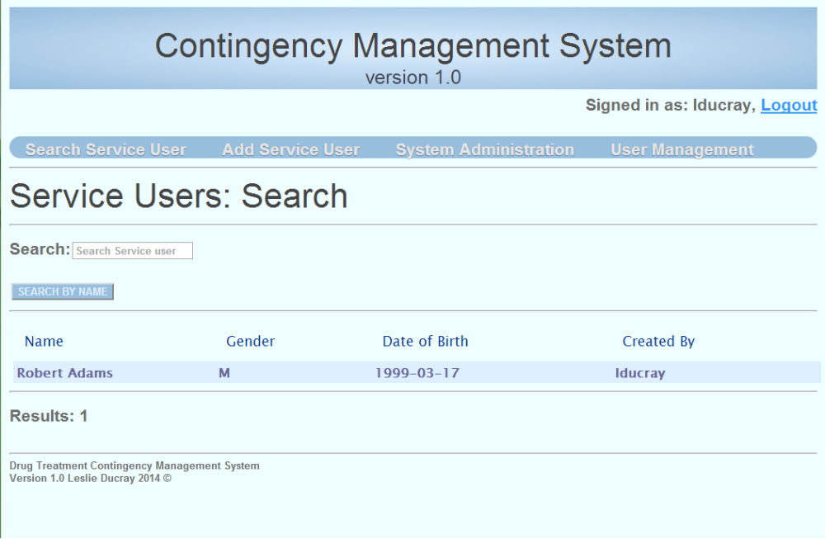
Figure 15: Search Service User screen
Once the user has logged in, they are directed to the page displayed in Figure 15, which allows them to search for a service user.
In continuation on the services provided by “UserServlet” “User Management” is an option which can be selected by top navigation bar.
Selecting “User Management” option from the navigation requests an “init” action from the ‘UserServlet’, this action populates the page with:
- All the existing users by querying the database to return all users stored.
- All the available user roles by querying all roles stored in the database.
The ‘User Management’ is a module for adding and editing existing staff users as displayed in Figure 16 . Users can reset their passwords, have their activity status changed and be de/assigned certain roles. User management’s requests and actions are processed through UserServlet.java.
Selecting an existing user sends a request to the servlet with the selected user’s id. The requested action, “editUser”, queries the database, selecting the user details which match the selected user id. The result set is used to populate a “userBean” which in turn is used to populate the user details on the web form.

The system user can edit or add a new user to the system, both result in the same action request from the servlet. When the user submits the form containing the entered user values, the form is posted to the servlet with the request action “saveUser”. Within this process, it determines whether the operation is an update of an existing user or the adding of a new user. The entered values are retrieved from the request parameters and are used to populate a ‘UserBean’ object instance. If a user role has been removed a delete statement is executed to remove the association between the user and system role. If the user has been assigned a new role, it is applied to the UserBean object instance. The User details, now contained within a UserBean instance are passed through the UserFacade and to the “UserDAOImpl”, which is the implementation of the data access object. A connection to the database is initiated and either an update or an insert into the ‘cm_users’ table is preformed based on whether the user is already in existence on the system. An insert is executed into ‘cm_user_roles’ if the user is assigned a new role.
The retained values are displayed on the web page after the process is complete.

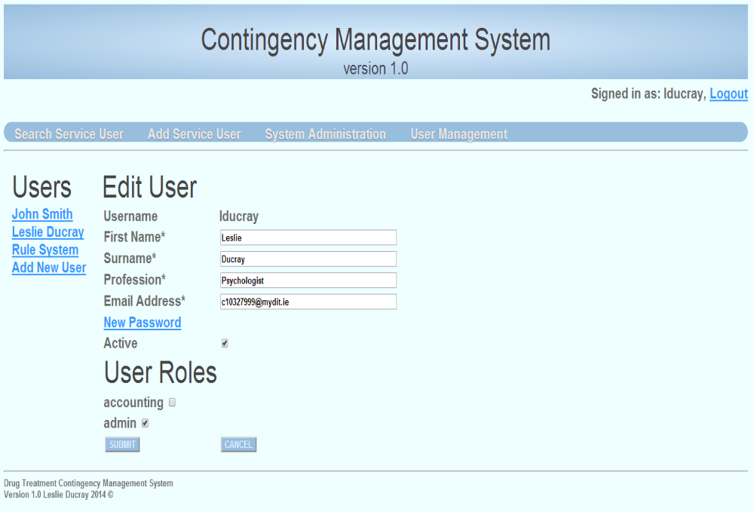
Figure 16: User Management screen
That concludes the responsibilities of the ‘UserServlet’. As it was explained how the ‘UserServlet’ was responsible for all requests, actions and processes related to the staff system users, the ‘ServiceUserServlet’ manages the requests and responses related to the service users. Where the users are the staff accessing the system, the service users are the clients of the drug treatment centre.

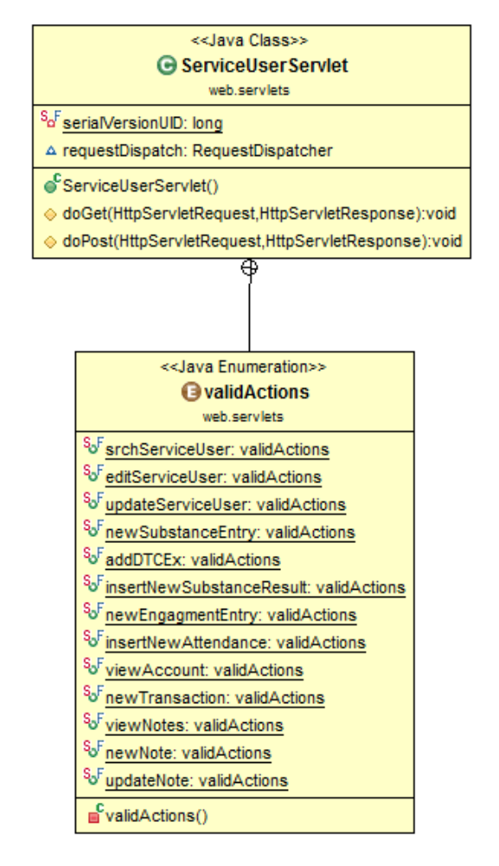
Figure 17: ServiceUserServlet class diagram
The “ServiceUserServlet” is a servlet class (represented in Figure 17) which handles all action requests related to service users. Throughout the application there are many different types of actions which require this servlets request and response processing. This ServiceUserServlet has been implemented to:
- Search for service users
- Add/Edit service user
- Add/View substances results
- Add a target date to test negative
- Add/View meeting attendances
- View service user account
- Apply a transaction
- Add/Edit/View service user notes
Each implementation calls upon various other classes and methods to fulfil the correct action (read, write, update and delete), retrieve newly entered information, query specific records, and display the new results.

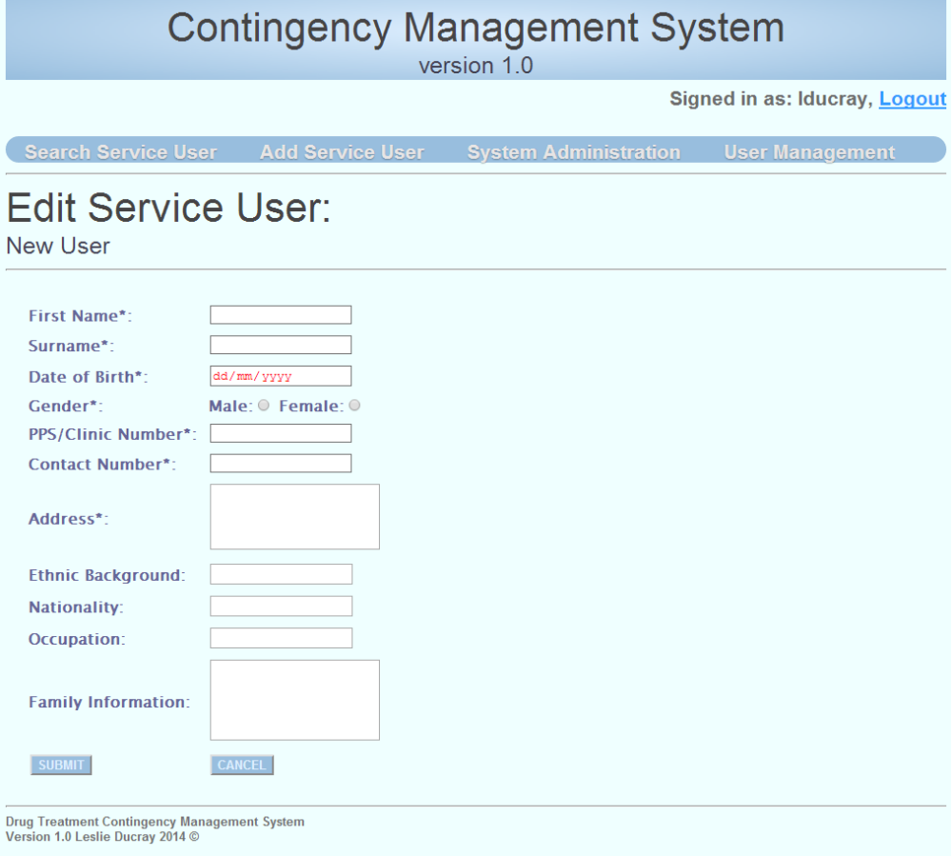
To add a new service user to the system, the user select “Add Service User” from the top navigation bar.
When initially adding a new service user to the system, the user is presented with a blank form (Figure 18) requiring identifying and geographic information to serve as general information on the service user. Once the service user's details have been entered correctly and client side validation succeeds, the user can submit the form. When the form is submitted, it is directed to the “ServiceUserServlet” to be handled.
Figure 18: Add Service User
The “ServiceUserServlet” receives the request action “updatedServiceUser”, which has a condition to determine whether the action is adding a new service user or editing and existing service user. Both actions require a services class called “ServiceUserService”, which are a collection of commonly used methods related to the service user. Either adding a new service user or updating an existing one employ the “ServiceUserService” class and many of its methods (which are illustrated in Figure 19). 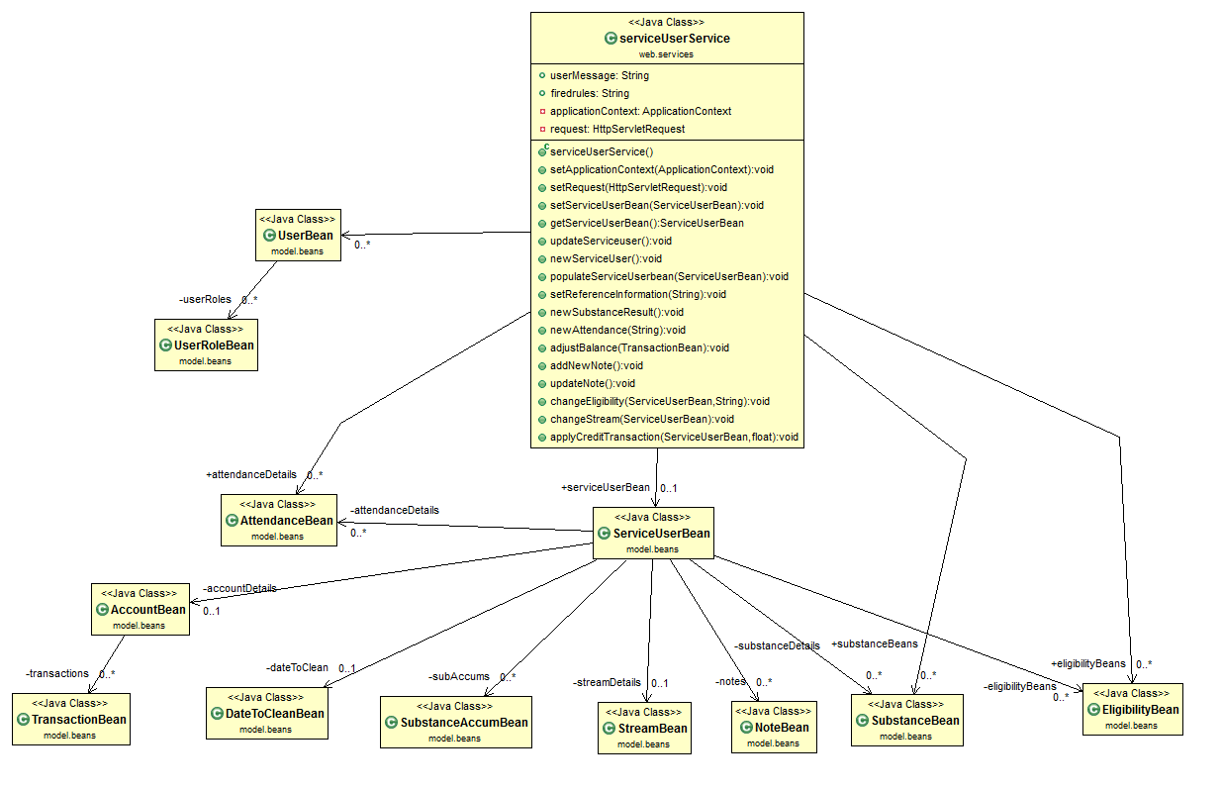
Figure 19: Class diagram for ServiceUserService and ServiceUserBean

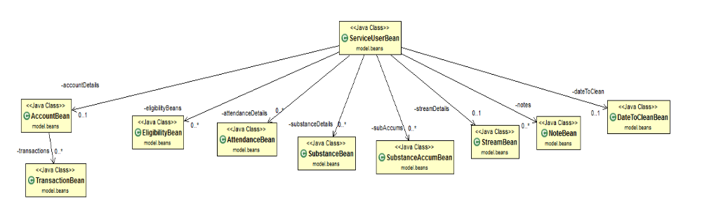
Figure 20: ServiceUserBean class attributes
When adding a new service user, the method “newServiceUser” is called, this method creates a new “ServiceUserBean” (see class attribute associations Figure 20, Figure 20) object which will hold the information. Another method is invoked, “populateServiceUserBean”, which attains the parameter values sent from the HTML form, and extracts them into the specified bean attributes. Once the “ServiceUserBean” is populated with the user entered information, the “ServiceUserBean” object is returned. The bean is then passed through to the “ServiceUserFacade” calling the ”addServiceUser” functionality, which in turn passes the bean through to the “ServiceUserDaoImpl”, where the data access object implementation occurs (Figure 21). A connection and callable statement are initialized. The statement calls a stored procedure from the MySQL database, ‘add_service_user’ which has three parameters, an in parameter for passing a XML string of all the service user’s information and two out parameters which return a success flag and the service user’s assigned id. The XML string of the service user’s details is composed by calling the method “ConvertToXML” which accepts the “ServiceUserBean” object and returns a string. The “ConvertToXML” method creates a new “Document” object, which XML Node elements can be added to. Each “Node” object matches a column of the database table the values will be entered into. When the Nodes are created, children nodes are added to each node to represent the actual data value being assigned to the attributes. This constructed document is passed to an implemented utilities class which handles XML functions, the method “xmlToString” is invoked. The conversion code which is standard was taken from a Stackoverflow user, WhiteFang34, answered on 28 March 2011 (http://stackoverflow.com/questions/5456680/xml-document-to-string).
The now XML string is suitable as a parameter for the store procedure call.

The ‘add_service_user’ stored procedure is a vital process, as it establishes the service user on the system. Each of the service user’s details are extracted from the XML string and are used to insert into the ‘cm_clients’ table. This table has an auto-incrementing primary key, which generates and assigns the service user’s id. The generated service user ID is then used to assign a substance accumulator for each substance to the service user. An association is inserted into the ‘cm_client_substance_accum’ table which stores the associations between the service user and each substance.
Likewise, the service user is also associated with all the available eligibilities and privileges, though they may not yet be entitled. Two MySQL cursors are used to assign the service user substance accumulators and eligibilities. The substance accumulators are employed to track the service user’s running record of “clean”, toxicology screen results for a particular substance (where the user has tested negative for the substance being present). The service user is assigned to the first stream/level of the system, this stream is the ‘Preliminary’ stream. Streams are used to track the service user’s level of support progression.
On success, a success flag “OK” is returned with the service user’s now assigned id.
Back in the “serviceUserDAOImpl”, the returned parameters are extracted, if the success flag is detected true (OK), a service user query is performed on the new service user’s id. The returned result set populates a service user bean which is then returned to the servlet which populates the response to the directed JSP.

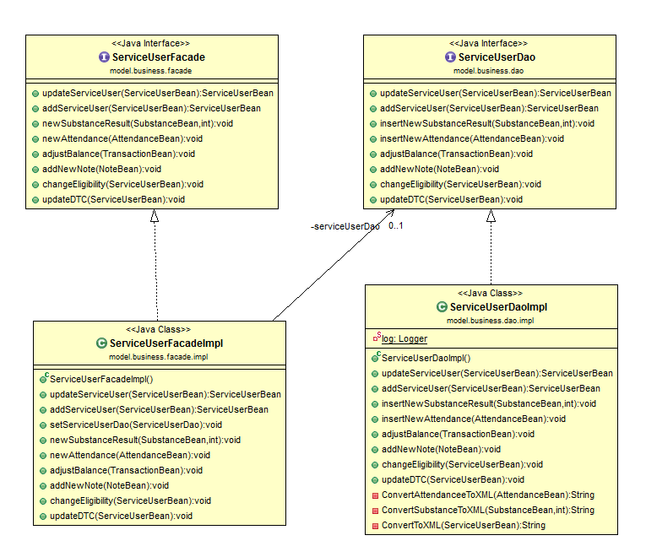
Figure 21: Service user facade interface - DAO class association diagram

Once the add new service user process has been fully completed, the user is presented with the submitted information, the service user's contingency management profile containing summarised information and current statuses ( Figure 22).
Included in the new information is the service user's:

    - The service user’s identifying, geographic and general information.
    - Stream details which display the service user's current stream/level of progress and the date they attained that stream.
    - Eligibilities, a list of all the eligibilities and the service user's current entitlement to them, these are displayed as a green tick for eligible or a red cross for ineligible.
    - Substance accumulations, a list of all active substances and the service user's accumulation of pass results (where there has been a negative detection of the substance in the toxicology screen).
    - Target date for a negative toxicology screen, is a date and caution issued to a service user after a positive/fail test result on any of the stream affecting substances. Within this section, the service user can apply for an extension, which will apply a predefined number of days extra to their current target date.
In addition to the extra service user information, there are service user specific options now available:
    - Add/View Toxicology History, which allows the user to view existing substance test results or add new results from recent toxicology screening.
    - Add/View Meeting Attendance, allows the user to record new meeting attendance and view previous attendances.
    - View Account, allows the user to see all previous transactions where the service user has been awarded credits or where they have withdrawn their credits.
    - View Notes, allows the user to enter in a new note on the service user, edit or view existing notes.
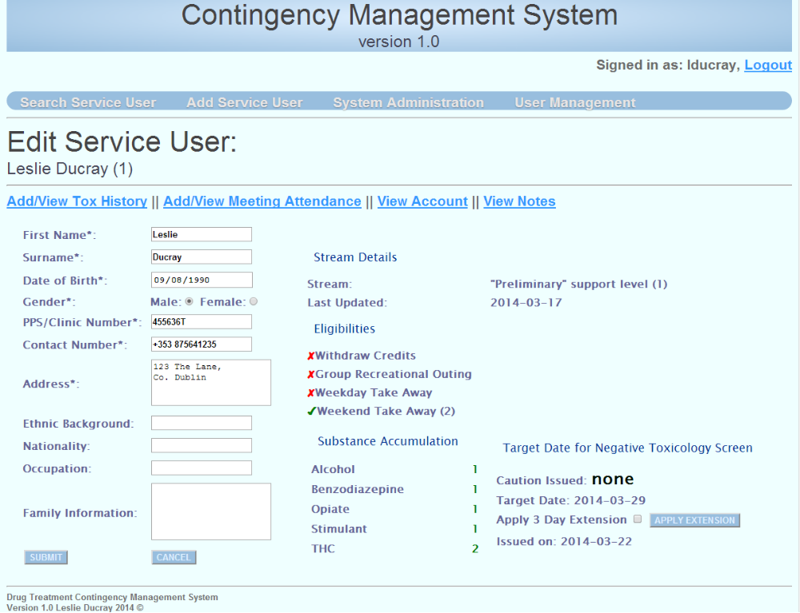
Likewise, when editing an existing service user, the system handles the request very similarly to when adding a new service user. The ‘updateServiceuser’ enumerator action request detects that the update is for an existing user and requests the method “updateServiceUser” from the “ServiceUserService” class as addressed previously when adding a new user. The “updateServiceuser” method behaves very similarly to the “addServiceuser” method also offered by the “ServiceUserService” class – a “ServiceUserBean” is populated from the form request parameters, and this bean is passed through to the “ServiceUserfacade” and to the “ServiceUserDaoImpl” imploring the “updateServiceuser” method. This method takes the same action of converting the service user bean attributes to and XML document and then to an XML string. The XML string, a return success flag and a returned service user id are declared as parameters for a prepared procedure call to the database. The ‘update_service_user’ stored procedure extracts the data attributes and places them in their corresponding position in an update statement. The update is executed. A success flag value and the service user’s id are returned.
Figure 22: Service user summary

The edit service user page is also accessible from the main application navigation as “Search Service User”. The user is presented with a single search entry field for which they can enter either part of or in full, the service user's first name or surname. The application will attempt to match and return all matches where the entered string is like the beginning of either the service user's first name or surname. The results are returned with other general identifying attributes such as the service user’s gender and their date of birth (Figure 15). The user is able to select one of the returned results to enter their profile. Both searching and selecting a service user requests post forms to the “ServiceUserServlet” to be handled. The implementation is a basic search function to return any service users fully or partially matching the service user’s name or surname entered in by the staff user. In this instance we have ‘ServiceUserServlet’ which instantiates a list of ‘ServiceUserBean’ objects. These Beans are populated by the returned record set from a query made to the database. The Servlet initiates a method of the class ‘cmsQueryServiceUser’, a class which will be used for all general database queries in relation to service users.
The list of the service users returned is bound to a variable of the JSP where it can be listed and viewed by the user (system client/ browser).

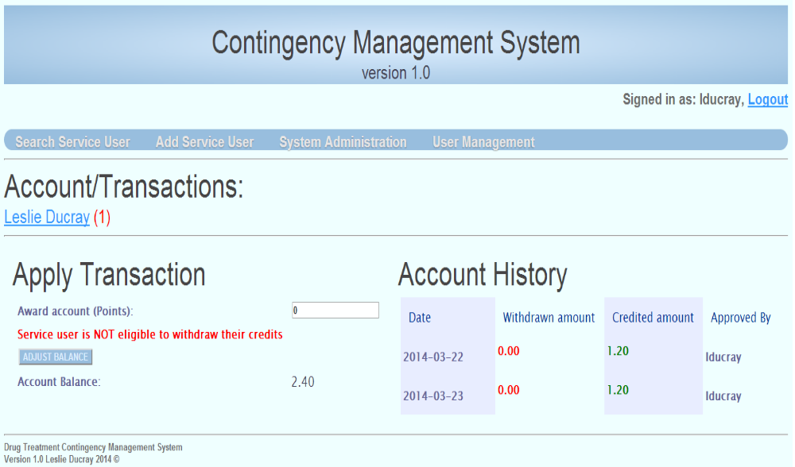
The user can select the “View Accounts” module of the service user's options. The staff user can view all previous transactions related to the service user (as shown in Figure 23). Monetary rewards from the rule system are displayed here as a single row credit transaction. From this page, if the service user is eligible to withdraw based on required criteria (which will be discussed under rules later on), their credits can be withdrawn. Staff can also manually award a service user points which can be converted to currency based on the service user's stream. The service user's current account balance is displayed. When the staff user selects the “View Accounts” module, a request (enumerator action “viewAccount”) is sent to the “ServiceUserServlet”. The servlet populates an “AccountBean” which has a list of “TransactionBeans” as an attribute by querying the service user’s account from the database. The user is directed to the accounts and transactions page and the returned dataset used by JSP to create a table with each row representing a single account transaction, and displays the service user’s account balance.
Figure 23: Service user's account and previous transaction
The user has the option to either award points to the service user or withdraw credits. These actions have client side validation, to enhance user experience, which prevents the entry of non-numeric/float formatted values, the user is also prevented from awarding the service user more than the service user’s stream’s weekly maximum and withdrawing more than the service user has. Both of these actions send a “newTransaction” request to the “ServiceUserServlet”, where a new “TransactionBean” is created and populated with the requested credit and withdraw values. Server side validation is enforced, and the values are converted to a “BigDecimal” objects. “BigDecimal” has proven the recommended approach when dealing with currency, as data types such as double or float have small rounding differences which would lead to incorrect and inconsistent values when manipulating the floating point value. The user entered vales, now in “BigDecimal” format are set to their “TransactionBean” attributes, and the system employs the “ServiceUserService” class’s method “adjustBalance”. The “AdjustBalance” method accepts a transaction bean as a parameter. Within the method, constraints are enforced on how much the service user is awarded, ensuring they do not succeed the weekly maximum. A query is performed on their account to calculate how much they have already been awarded in the last seven days, this value is added to what they are to be awarded, if this results in a value greater than the weekly maximum, the service user is either awarded the difference to meet the maximum value, else they are not awarded anything. The process progresses by initialising a stored procedure callable statement, ‘adjust_balance’ which four parameters:
- The service user’s id, for which the transaction is being applied.
- The amount to be credited.
- The amount to be withdrawn.
- The staff user who has approved the transaction.
Within the stored procedure, an insert statement is executed inserting the above values into the ‘cm_transactions’ table. An update is then executed on the ‘cm_accounts’ table to update the service user’s current balance, and the date the account was last updated.

A call to the rule engine occurs after the transaction has succeed, this will be discussed later. The user is displayed the service user’s account and transaction history, the new transaction is present and the account balance has been updated.

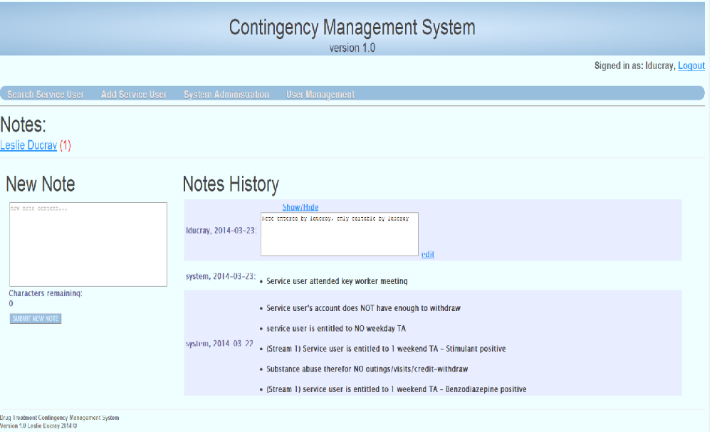
Likewise, from the service user's title page, the staff user can choose to enter in new notes on the service user. Staff can also view previous notes from other staff and update their own history of notes. A staff user can only edit a note they composed. When rules from the rule engine fire based on the service user substance results and attendance, the rules that fire (are matched) are recorded amongst the notes to give record of their occurrence. Selecting to view the service user’s notes requests the action “viewNotes” from the list of valid enumerators. This request is posted to the “ServiceUserServlet”, a query is executed to the database to return all notes for the given service user. The notes populate a list of “NoteBean” objects, which are included in the response to the user, as the page is direct to the “Notes” page. The returned notes populate a table called “Notes History”, where each row is a previous note, the notes are ordered by date updated (updated date is automatically the creation date for new notes) descending. A check is performed on each note, if the note compose is the same as the current user, the user is able to edit the text, otherwise the note appears as read-only text. The user has the option to enter in a new note or edit one of their existing notes, either action results in the request being sent to the “ServiceUserServlet”, which implores the service methods of “ServiceUserService”, the note attributes are retrieved from the request parameters and are used to populate a “NoteBean”. The populated “NoteBean” is passed as parameter to the “ServiceUserFacade” class’s method “addNewNote”, which calls the method “addNewNote” from the “ServiceUserDao” class. Within this method, it is determined where the note is a new note or the update of an existing note, based on whether it has an id. A flag is set depending on the outcome, and the note attribute values are set as parameters for a called store procedure. The stored procedure ‘newNote’, updates or inserts the note values based on the previously set flag. The user’s page is refreshed and the updated/new note fields are displayed.
Figure 24: Service user's notes and correspondences.
The Contingency Management rules may be applied to combinations of different target behaviours (the service user's engagement and attendance at meetings and their substance use test results).
The contingency management reward and reset criteria are applied and calculated ‘in real time’ whenever a service user’s new toxicology screen result or their meeting attendance is entered. For these rules to be applied, the user interface must allow the entry of new data.

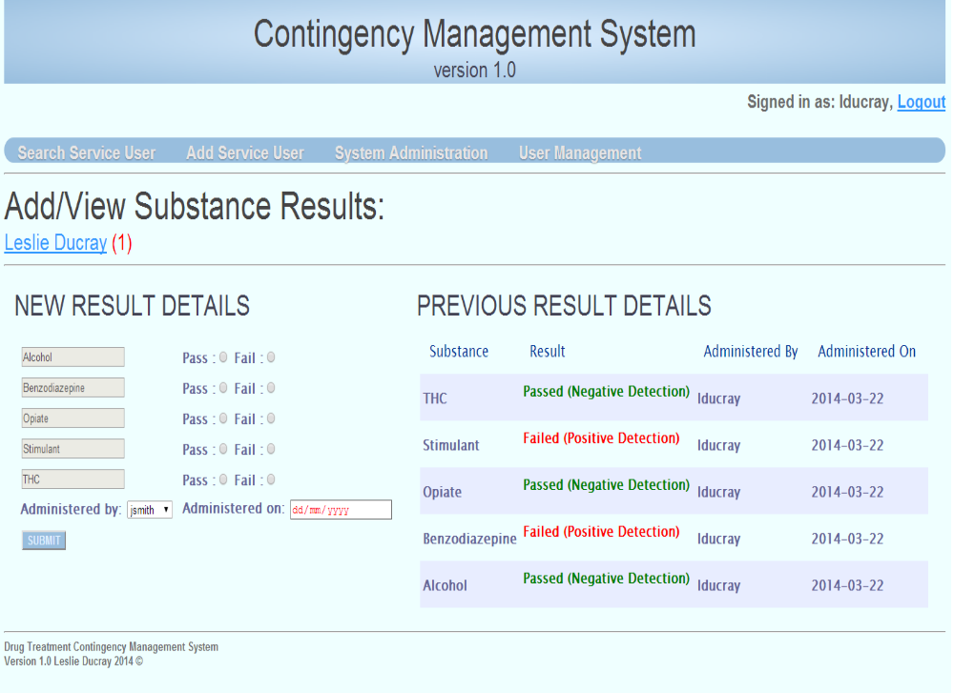
From the service user’s title page, the user can opt to add new toxicology results and view previous results.
Figure 25: Add/View substance results
The “Add/View Substance Results” page is populated with all the previous test results, explicitly stating whether the test was passed or failed. Under the subheading “New Result Details”, a list of all active substances are displayed with the option to select either “pass” or “fail” based on whether the user tested negative or positive for the substance respectively. A selection for each substance is required, as is the staff user who administered the test and the date it was administered on. These values are posted to the “ServiceUserServlet” with the requested action “insertNewSubstanceResult” to be processed. This is one of the core events to the contingency management system, as the substance abuse behaviour is being matched against the rules of the contingency management system. The process undergoes a complex flow of evaluation, firstly each substance and their results are extracted and each populate a new “SubstanceBean” object. Each substance is handled differently depending on whether they affect the service user’s stream progression. The service user has a substance accumulator for each substance in the system. If the user has passed (tested negative for the presence of the substance), their accumulator increments. If they failed the test (positive detection of substance in toxicology screen) for that substance, their accumulator is set to the “reset value” of the substance. The service user’s substance accumulator cannot surpass the maximum accumulation for the substance. A count is kept of all stream progression substances, which have reached their maximum, this is matched against how much stream progression substances there are active on system. If these two counts are equal, the service user is consider to progress to the next stream. If a stream progression substance is tested positive for being present in the service user’s toxicology test results, the service user is to be assigned a target date to test negative by. Target dates to test negative are issued as cards of incrementally severe cautions, progressing from ‘none’ to ‘yellow’, ‘orange’ and finally ‘red’. Once the service user is issued the “red” caution, they digress back to the preliminary stream (assuming they had advanced).
Once the accumulations of each substance has been calculated, they are converted from points to currency based the service user’s stream point conversion. The credit is applied to the service user’s account (this process uses the same functionality implemented and mentioned earlier under Accounts/Transactions).
The system offers two different rule bases, one to cater for substance test results and the other for engagement and attendance. For the rules of the rule base to be applied, an instance of “SubstanceRules” class is instantiated and method “applySubstanceRules” is called which takes the “ServiceUserBean” as a parameter. This method creates the knowledge base for the substance rules based on a .drl (drools) file which stores the rule text. Once the knowledge base is created, a stateless knowledge session is instantiated. A Stateless Knowledge session was chosen over a Stateful Knowledge session as the facts and working memory are inserted into the knowledge base session before firing/executing, once the rules are fired, the fact’s objects can be changed or updated by the executing rules, and the changes are retained and returned. As the session is stateless, there is no need to invoke a clear() or dispose() method to avoid memory leaks. This is the preferred choice as the system requires a new session be created for each request, as each service user would have their own individual and varying attributes to be evaluated.
The “ServiceUserBean” object, storing the service user’s complete data set, is added as a fact to the inference engine. The session executes the rules.
An event listener is attached to session to record each rule which fired (the conditions met). The fired rules are recorded to be returned to the user.
The implementation of establishing a knowledge session, creating the knowledge base object and the rules fired event listener were all adapted from sample code from chapter four of the Drools user manual (15). The entered facts are matched against the knowledge base rules, those that satisfy the rule condition are activated and the “THEN” consequent is executed.

Drools rules allow for the right-hand side (the consequent) to be written in plain old Java, allowing for all the implanted classes and Java APIs to be used. The syntax for the antecedent (the left hand side) is written in the rule expression language, but as mentioned previously, this can be mapped to a more natural language interpretation. A typical Drools rule has the structure:

rule “rule name”
attributes
when
LHS
then
RHS
end

Rule attributes offer a declarative way of controlling the behaviour of the rule. Attributes which were required when implementing the contingency management rule base aided the system significantly, such were ‘no-loop’, ’lock-on-active’ and adding a ‘salience’. ‘no-loop’ ensures no infinite loops would arise when updating the facts. When a fact is modified by the RHS of a rule, it may cause the rule to be activated again. Setting ‘no-loop’ to be true skips the creation of another activation of the same rule, preventing an infinite loop from occurring. The ‘lock-on-active’ attribute will not activate any rules within the same agenda group of the activated rule. This attribute serves as a more forceful approach compared to ‘no-loop’. When the agenda group loses the focus, the rules with ‘lock-on-active’ become eligible for activation again. In any given rule base there is potential to many rules which will fire under given circumstance, often there are rules which match that have conflicting outcomes. The inference engine uses conflict resolution to solve such occurrences. There is an attribute ‘salience’ which provides the rule with a priority in the agenda’s order of firing, this is the rule engine’s conflict resolution strategy.

The service user’s details are used as the facts in the inference engine to be matched against contingency management rule criteria, the implementation of the rules adapted quite significantly during the system implementation. Initially each rule would update the service user fact in some manner, and the return would go through a process of having each change committed to the database. Though this method captured all the correct updates and committed them to the database, the implementation proved quite cluttered and there were many redundant writes to the database. The current implementation initiates an update to only the values changed from the fired rules, each fired rule may prepare a data manipulation call to the database, using implemented classes. This allows potentially multiple smaller more optimized update calls be made to the system. This method was preferred as it also reduced the coupling between the RHS of the rules and the corresponding Java code for the returned facts.
After all the activated rules have fired and completed, the staff user is displayed the service user’s update profile with a set of the rules which fired, all eligibilities, stream, substance accumulation and date to be clean statuses are updated and are present representing the service user’s new status/summary.
Entering new set of substance results covers one aspect of the contingency management systems target behavioural monitoring, the second is the service user’s meeting attendance and engagement.
Staff users can record the service user's attendance or failed attendance through selecting “Add/View Meeting Attendance” from the service user title page. This directs them to a new page for entry and to view previous attendance records (as seen below in Figure 26).A query is performed on the service user’s attendance table (‘cm_client_attendance’) to populate the table of each attendance. To record an attendance entry, the staff user is required to fill in:
    - The time of the meeting.
    - The date of the meeting.
    - Whether or not the service user attended the meeting.
    - Whether or not the service user meaningfully participated.
    - The reason given for missing a meeting (if applicable).
    - Where or not the given reason is valid/excusable (if applicable).
    - Was the meeting a progress review meeting?

This form, provided required fields are populated and validation succeeds, is posted to the “ServiceUserServlet” where it is processed. Similarly to adding the new substance test results, the service user’s most recent attendance is used to populate an “AttendanceBean”, this bean is added as a fact to a new Knowledge Base stateless session. The knowledge base used for applying the contingency management rules specific to attendance is a different file to the substance rules. Two separate knowledge base rule files were created to allow independence between the two monitored behaviours. Allowing this separation would aid dynamic activation/deactivation of these target behaviours in future implementations.

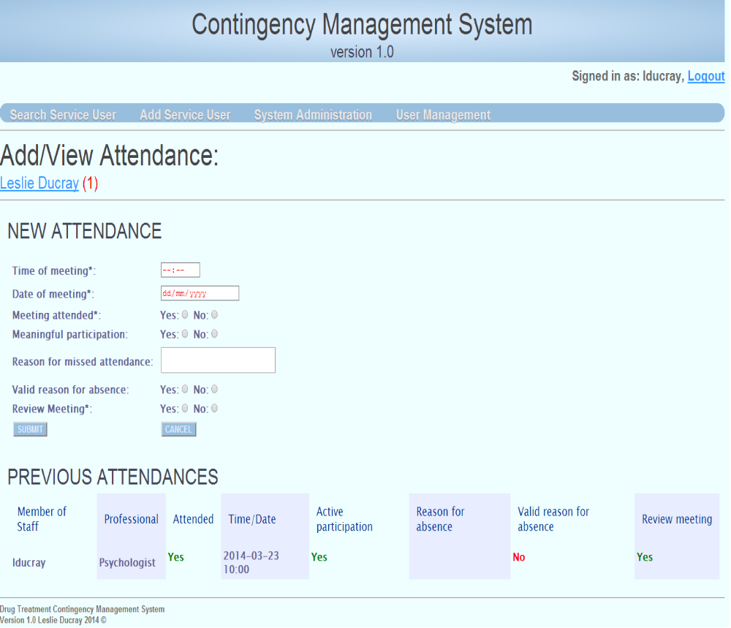
Figure 26: Add/View Attendance.
The attendance rules test on different criteria to the substance rules, as the substance rules apply a more complex evaluation on the service user. The substance rules govern the service user’s progression through the streams, their eligibilities and their ability to withdraw their awarded credits. The attendance rules, while they do award the service user points based on their attendance and engagement, do not affect the service user’s progression/regression in the streams/levels. Attending meetings offers more incentive’s to service users as they are awarded for up to three meetings a week, but also missing certain engagements result in eligibilities and incentives being withheld.

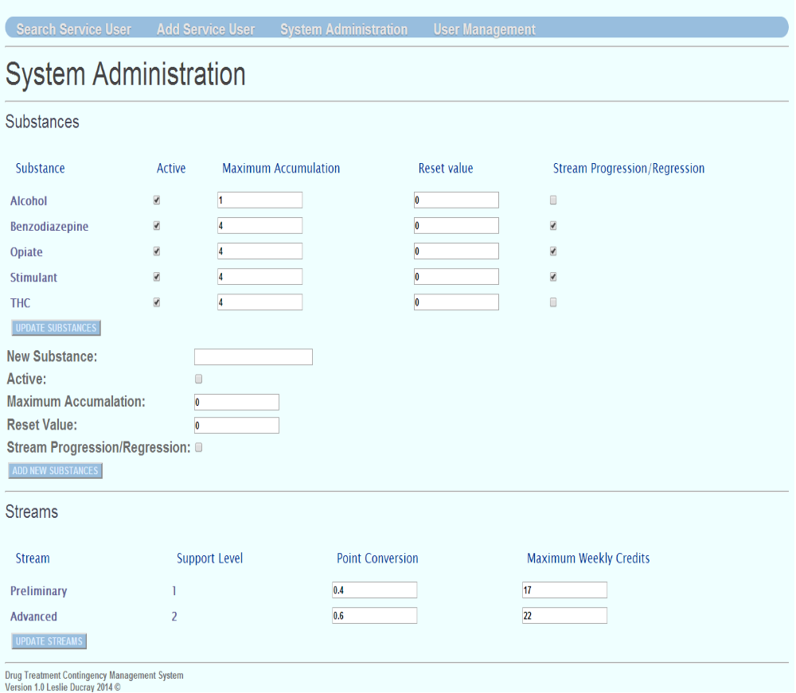
The “System Administration” module is another module which is only accessible to staff users with the admin role. This page allows permitted staff to update and add system features such as substance and stream values. New Substances can be added into the system and existing substances can have their attributes edited.
System administration requests are managed and processed through “SystemServlet”.
The system servlet is required to respond to requests from the System administration page, such as updating an existing substance, adding a new substance or editing stream values.
Figure 27: System Administration page
When the System Administration page is first called, an “init” action request is made, this queries all the information regarding all the substances and the streams. This information is used to populate the fields of the page.
Updating the values of any of the substances requests the action “substanceUpdate”, as it stands, this request action will update every substance regardless of their values being changed or not. This could be optimized to either only request the update of a single substance one at a time (if multiple substances are altered), which could be more time consuming on the user or, having the backend checking between the new and old values before updating. For each existing substance, a new “SubstanceBean” is populated from the submitted form values. Each of these beans are added to a list of “SubstanceBean” objects, each of them are then set as a database update statement and executed.

Adding a new substance to system requests the action “newSubstance” from the SystemServlet. This action populates a single “SubstanceBean” with the inputted form information such as the substance maximum accumulation, the reset value, whether the substance is active or whether the substance affects the service user’s progression through the streams. These values populate an insert statement into ‘cm_substances’ table on the database. This table has an ‘After Insert’ trigger attached to it, whenever a new substance is added each service user existing in the system is associated to the new substance and assigned the ‘rest value’ for the new substance. In doing this, each service user now can be tested for the substance and awarded accordingly.

The final action of the “SystemServlet” is updating the existing streams. The two streams are presented to the user, and they are able to change the streams “Point Conversion” rate, which is how points awarded are converted to currency or the stream’s “Maximum Weekly Credits”, which is the maximum monetary value any service user can be awarded each week. On altering the given values, the user can choose to “update Streams” which submits the forms and requests the “updateStream” action from the servlet. This process takes a similar approach to updating the substances, a new “StreamBean” is initiated and populated with the stream values for each stream. These values are then used in an update statement on the “cm_streams” table.

The changes made to either the substances or the streams will only affect a service user once the service user is evaluated against either them through either a new toxicology result or a new engagement entry.

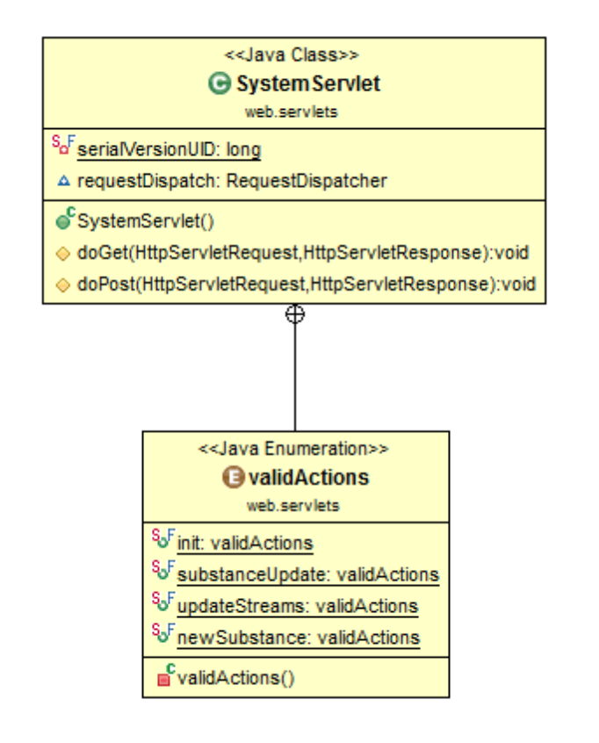
Figure 28: SystemServlet class diagram

Each of the front facing user pages were designed and developed using HTML5 and CSS3 technologies. HTML5 offers and abundance of rich web functionality to improve the user’s experience and the human computer interaction qualities. HTML allows for many new form input types which offer some validation and guidance to the user of what sort of content should be entered in. Placeholder and title attributes can be used to explicitly state the purpose of the input field. For client side validation, HTML5 offers a regex pattern matcher, which detects invalid character entry, which will not allow submission until rectified. Form fields can also be set as ‘required’ to ensure they are populated before submission. Though client side validation certainly improves the user’s experience and takes some weight off the backend, server side validation is still necessary. The web application employed CSS3 for the full styling and appearance, aiding the development of a simplistic, structured, user friendly web application. Throughout every layer of coding, code re-use was always conscious in design, this is evident by many of the Java classes and methods, and also in the JSP. Each page imports a “header.html” page which, if the user is logged in, contains the main application navigation, the logout option and the application header banner. Each page also includes the “footer.html” page which contains the footer text for the bottom of each page.

Implemented Classes and APIs used

Servlets:
- UserServlet.java
- ServiceUserServlet.java
- SystemServlet.java
Services:
- serviceUserServices.java

Java beans:
- AccountBean.java
- AttendanceBean.java
- DateToCleanBean.java
- EligibilityBean.java
- NoteBean.java
- ServiceUserBean.java
- StreamBean.java
- SubstanceAccumBean.java
- SubstanceBean.java
- TransactionBean.java
- UserBean.java
- UserRoleBean.java
Facades and DAO:
- ServiceUserFacade.java
- ServiceUserFacadeImpl.java
- UserFacade.java
- UserFacadeImpl.java
- ServiceUserDao.java
- ServiceUserDaoImpl.java
- UserDao.java
- UserDaoImpl.java

Query Classes:
- cmsQueryAccount.java
- cmsQueryAttendance.java
- cmsQueryDateToClean.java
- cmsQueryEligibility.java
- cmsQueryServiceUser.java
- cmsQuerysubstance.java
- cmsQueryUsers.java
- cms.StreamQuery.java

Rule Engines:
- EngagementRules.java, uses the Drools API and code taken for the Drools user manual to create a stateless knowledge session.
- substancerules.java, uses the Drools API and code taken for the Drools user manual to create a stateless knowledge session.

Rule files:
- EngagementRules.drl
- rules.drl

Utility classes:
- DataSourceManager.java
- KnowledgeBaseManager.java, uses the Drools API and code from the Drools user manual for creating a knowledge base from a .drl file.
- XMLFunctions.java, uses code adapted from a Stackoverflow answer to convert a XML document structure into a string.

Stored Procedures:
- add_attendance
- add_service_user
- add_substance_result
- adjust_balance
- adjust_subsaccum
- newNote
- update_service_user

Trigger:
- AISubstances, After Insert into the substance table. Each service user is associated to the new substance and assigned the ‘rest value’ of the new substance.

Imports
Most classes import a collection of different libraries, the libraries that I have used but had not written, and a description of why they were needed are listed below:
- javax.servlet.http.HttpServletRequest;
- javax.servlet.RequestDispatcher;
- javax.servlet.ServletException;
- javax.servlet.http.HttpServlet;
- javax.servlet.http.HttpServletRequest;
- javax.servlet.http.HttpServletResponse;
- javax.servlet.http.HttpSession;
- org.springframework.context.ApplicationContext;
- org.springframework.web.context.support.WebApplicationContextUtils;
- java.io.IOException;
- java.security.MessageDigest;
- java.security.NoSuchAlgorithmException;
- java.sql.SQLException;
- javax.sql.DataSource; // Used to create an interface for the database connection objects.
- java.math.BigDecimal; // a data type object used to format and manipulate floating point values such as monetary or currency values.
- java.math.RoundingMode;//used by BigDecimal object
- java.util.List; // the list data structure, used to hold a list of objects.
- java.util.Set; // for storing a non-duplicating list.
- java.sql.CallableStatement;// for the creation of callable SQL statements.
- java.sql.Connection; // creating a Database connection.
- java.sql.SQLException; // to catch SQL exception returns from the database after a statement attempts execution.
- java.sql.Statement; // An SQL query or manipulation statement
- javax.xml.parsers.DocumentBuilder; // To create an instance of the document builder, the API required to add node objects to the document.
- javax.xml.parsers.DocumentBuilderFactory;
- org.apache.log4j.Logger;
- org.w3c.dom.Document; //Used to create a XML document object
- org.w3c.dom.Node; // Used to create a tag/node object in an XML document
- org.apache.log4j.Logger; // used to log errors and debug messages to the server
- java.util.ArrayList; //used to create a list of objects
- java.sql.ResultSet; // create the data structure to hold the results returned from the database query.
- org.drools.KnowledgeBase; //To establish and create the knowledge base for the defined rules file.
- org.drools.KnowledgeBaseFactory;
- org.drools.builder.KnowledgeBuilder;
- org.drools.builder.KnowledgeBuilderFactory;
- org.drools.builder.ResourceType;
- org.drools.io.ResourceFactory;
- org.drools.event.rule.AfterActivationFiredEvent;// This captures the rules which were activated/matched
- org.drools.event.rule.DefaultAgendaEventListener;// adds an event listener to the session agenda, this is used to capture the above activation rules.
- org.drools.runtime.StatelessKnowledgeSession; // to create a stateless Knowledge session

Chapter 5 System Validation

Testing

Introduction
In the testing chapter, the various testing stages and processes are discussed.

White Box Testing
White Box testing is an approach to testing which is concerned with the internal mechanisms of the various system components, such as the code structure and processes. When white box testing is performed, the tester is aware of the code structure. Though unit testing code was not used during the implementation, each stage of the development process for each individual piece of system functionality employed the principles of white box testing to verify the correctness of the system function (18). Systematic debugging of code blocks and variable tracking were used to ensure correctness. Primary testing will take place during each sprint iteration as with the process of the Agile design methodology.

Black Box Testing
Black Box testing is not concerned with the internal calculations and mechanisms of the system component. This form of specification testing is used to ensure the developed software meets the specified requirements and the user’s expectations. The Black Box testing approach assumes that the tester has no prior knowledge of the code or the components functional process.
The final full implementation of the ‘Contingency Management’ system was tested using the “Black Box” approach, this functional testing approach tests the possible combinations of the end-user’s actions. (18)

User Acceptance Testing (UAT)

User acceptance testing can be considered a form of Black Box testing. UAT is a phase of application end-user testing which ensures the developed system or system component meets the system specifications, doing what it should. This form of expectancy testing allows ‘real life’ end users to test the product, verifying each functional component meets their expected outcome given a particular test case.

Testing Approach and Results

During the development of each individual system functionality, the White Box testing approach was employed to test the internal functioning mechanics, the parameters and results of each method and optimal performance of code employment. Following the complete implementation of each system sprint, a Black Box UAT test was performed on the system subset. Pre-written test cases for each aspect of the system were thoroughly applied and used to test based on expected outcomes and intended design. The test cases were either pass or fail depending on the systems outputs. Each Implementation underwent a full UAT ensuring the required system requirements were met and correctly implemented. Testing is performed from the front end based on expected flow/redirection of pages, form fields population and data displayed, appearance, validation and client side functionality. The most crucial aspect of the system is the calculation and application of the Contingency Management rule criteria.

UAT Tested Modules

Login
Testing the login involved primarily ensuring valid active users could log into the system given correct details were entered and that invalid attempts were rejected. This approach took the entered details, username and password, encrypted the password and attempted to match these values against all valid users on the system. If the entered credentials did match an active user, a user session was created, and that user was permitted access to the site. If the details did not match, the user is alerted and prompted to try again. The template of test cases used to test user login are presented in Table 2: Login Test Cases.
Table 2: Login Test Cases
Test Id | Test Description | Expected Outcome | Actual outcome | Pass/Fail | Tester/Date
1 | Attempt to login with incorrect details  (Username and/or password) | An incorrect login message is displayed. Inactive users will receive this message too.
2 | Attempt login with correct details | User is permitted access into the application, “search service user” screen.
3 | On successful login, is the correct user login name displayed? | Correct username is displayed on the top right hand corner.
4 | Login with a user who does not have the 'Admin' role/permission. | If the user does not have the admin module, the options 'System Administration' and 'User Management’ should not be displayed in the top navigation.
5 | Login with a user who does have the admin role. | Two additional modules 'System Administration' and 'User Management' are available from the top navigation.
6 | Allow the session to timeout (30 minutes) and try perform any action. | User is directed to the Login screen, they are made aware that their session had timed out.
7 | Once logged in, click 'logout' at the top right. | User is directed to the Login screen, they are made aware that they have logged out.
8 | Entered password is correctly encrypted and matched against stored password. | User is permitted login, encryption is assumed correct.
9 | Attempt to login with either required credential field not populated. | User is prompted that both are required, before attempting to login.
10 | From the login form, click 'Reset'. | User entered fields are cleared of all text.

Add/Edit Service User
Testing to ensure what the user enters into the service user form field is validated and when submitted, retained correctly.
Table 3: Add/Edit Service User- Test cases
Test Id | Test Description | Expected Outcome | Actual outcome | Pass/Fail | Tester/Date
1 | Once Logged in, select “Add New Service User” from the top navigation. | An empty service user form should display.
2 | Attempt to submit without required fields populated or with invalid characters (eg. Numeric/Special characters in name fields, alpha characters in contact number) | Alert messages appear at required fields. Fields with invalid character input will prevent submission
3 | Populate all the required fields and submit. | Populated fields are displayed, service user options are available and service user summary is visible (Stream details, eligibilities, substance accumulators and date to be clean details are populated). Entered details have been retained.
4 | Once a Service user is successfully added, remove from a required field and attempt to save | Alert messages appear at required field. Likewise when invalid character is attempted.
5 | Edit Service user's details and submit | New details successfully committed.
6 | Under "Target Date for Negative Toxicology Screen", there is an option to apply extension (assuming an extension is not already given).Check the check box and apply the extension. | The extension is applied, the Target Date is updated to the new date, correct amount of days have been added. There is no longer an option to apply an extension.

Add/View Toxicology History
Table 4: Add/View Toxicology History - Test cases
Test Id | Test Description | Expected Outcome | Actual outcome | Pass/Fail | Tester/Date
1 | From the service user's title page select "Add/View Toxicology History". | The user is redirected to the "Add/View Substance Results" page.
2 | The selected service user's name appears as a link below the page heading. | As stated
3 | All active substance appear under “New result Details” | As stated
4 | Pass' and 'Fail' radio buttons appear next to each substance title. | As Stated
5 | Fields for 'Administered by' and 'administered on' appear at the bottom of the form with a 'submit' button | As Stated
6 | If the user has no previous results | “no previous results”
7 | if the user has previous results | A list in descending order of 'Administer On' should contain the 'Substance’, 'result’, 'Administer By and 'Administer On' Date
8 | Passed results are green, failed results are red | As stated
9 | A pass or fail radio selection is required for each substance before submission | As stated
10 | Submit the entered test results | After submission, the user is directed to the service user's title page, with a list of rules/events fired displayed. Accumulators have been correctly been increased/reset accordingly, eligibilities are correct, target date to be clean is correct, correct stream is display. Confirm with Rules
11 | Fired rules are recorded on the 'Notes' page – submitted by 'system' | As stated
12 | Ensure service user is not awarded more than weekly maximum (for their current stream) | As stated.

Add/View Meeting Attendance
Table 5: Add/View Meeting Attendance- Test cases
Test Id | Test Description | Expected Outcome | Actual outcome | Pass/Fail | Tester/Date
1 | From service user title page select 'Add/View Meeting Attendance' | The user is redirected to the Add/view attendance page.
2 | The selected service user's name appears as a link below the page heading. | As stated
3 | New attendance form displays fields for  'Time of meeting',  'Date of meeting',  'Meeting attended',  'Meaningful participation',  'Reason for missed attendance',  'Valid reason for absence',  'Review Meeting' | As stated
4 | Attempt to submit form empty | Date, Time, attendance and key worker fields are prompted as required fields.
5 | If the user has no previous attendances | “no previous attendance records”
6 | A list in descending order of 'Time/Date' should contain the 'Member of Staff',  'Professional', 'Attended', 'Time/Date', 'Active participation',  'Reason for absence', 'Valid reason for absence', 'Review meeting' are displayed if the service user has an attendance history. | As stated
7 | Submit a user’s engagement. Time and Date validation are accepted. | User is directed to service user’s title page. A list of fired rules are displayed. Updates to the service user’s eligibilities are visible.
8 | After submission return to engagements page. | The new attendance results are at the top of the list, correct information is displayed yes – green, no – red.
9 | Fired rules are recorded on the 'Notes' page – submitted by 'system' | As stated.
10 | Check back on last attendances (which would have been awarded) or set out to award the service user for 3+ attendances within 7 days of each other. Ensure the service user is only rewarded for three attendances a week | As stated.
11 | Ensure service user is not awarded more than weekly maximum (for their current stream) | As stated.

View Account
Table 6: View Account- Test cases
Test Id | Test Description | Expected Outcome | Actual outcome | Pass/Fail | Tester/Date
1 | From Service user's title page select ' View Account' | User is directed to the Account/Transaction page.
2 | The service users name appears as a link back to their title page | As stated.
3 | Two headings are displayed 'Apply transaction' and 'Account History' | As stated.
4 | Under 'Apply transaction' the user is able to 'Award Account' so many points and set the 'Withdraw Amount'. The 'Account balance' is displayed at the bottom. | The account balance is displayed. If the user has enough credit to be eligible to be withdrawn, the With draw field is present, otherwise I message is displayed explaining. The 'Award Account' field is ever present.
5 | If service user is not eligible to withdraw, a message replaces the withdraw option saying 'service user is NOT eligible to withdraw their credits' | As stated.
6 | awarding an account updates the account balance correctly (converts entered points by stream point conversion) and is recorded under the Account history at the bottom | As stated, the account balance is updated correctly (assuming the weekly max was not exceeded, otherwise the difference is added).The ' Award account' field only accepts full numbers, and the amount enterable is the maximum amount of points that when converted will not exceed the weekly maximum.
7 | withdrawing from an account updates the account balance correctly and is recorded under the Account history at the bottom | With drawing, the field validates the user’s entry to be in correct float/currency format. Balance is correctly updated and displayed.
8 | When withdrawing if the remaining account balance is less than 20, the service user is then ineligible to with draw post transaction. | as stated
9 | A service user cannot with draw more than they have | as stated
10 | A service user cannot be awarded more than their current streams weekly maximum. | as stated
11 | Award Account' only accepts integer/ numeric only (no floating point or any alpha/special characters) value | as stated
12 | Withdraw amount' accepts float value | as stated
13 | Fired rules ( as a result of Awarding/Withdrawing) are recorded on the 'Notes' page – submitted by 'system' | as stated

View Notes
Table 7: View Notes- Test cases
Test Id | Test Description | Expected Outcome | Actual outcome | Pass/Fail | Tester/Date
1 | select 'View Note' from service user title page | User is direct to the notes history page.
2 | Under "Notes History", if no previous notes exist. | “no previous notes”
3 | Under "Notes History", if there are previous notes exist. | Notes that user has entered should appear in editable text boxes, which the user can click to edit and update. Else they appear as read only text if other users have entered them in.
4 | update a note, does the date change to reflect the new date the note was updated on | As stated.
5 | Notes are ordered by date updated | As stated.
6 | Clicking edit on a note, you (the user) have created, allows you to edit the note. Updated data is retained | The note can be edited, and updated. The updated note is now displayed.
7 | Notes entered by the system or other users are displayed as read-only text. | As stated.

System Administration
Table 8: System Administration- Test cases
Test Id | Test Description | Expected Outcome | Actual outcome | Pass/Fail | Tester/Date
1 | Selecting 'System Administration' directs the user to the 'System Administration' page. | The 'System Administration' Page is displayed.
2 | The page displays two administration headings 'Substances' and 'Streams'. | Substances and Streams are displayed, each have editable form fields and populated tables of existing substances/streams.
3 | under 'Substances' a list of existing substance is displayed with editable fields | Multiple rows are displayed representing each existing substance, the admin user is able to check whether the substance is active, alter the maximum accumulation amount, edit the reset value and check where the substance affects stream progression.
4 | Edit the values of the existing substances and attempt to commit changes. Ensure correct validation is applied (only numeric values entered) | The editable values can be changed, checkbox's checked/unchecked, and only numeric values can be submitted.
5 | Once a change has been made and submitted, has the update been retained and displayed. | The new correct result is displayed.
6 | Under 'Substances' the user is presented the option to add a new substance. | The admin user is able to add a new substance into the system.
7 | When adding/editing the 'maximum accumulation' and 'Reset value', validation should only accept integer numbers | Validation is enforced
8 | Under 'Streams', are the current streams displayed, with their correct values shown? | The user is presented with the ‘Stream', it's 'Support level', the 'Point conversion' and the 'Maximum weekly credits'.
9 | Is the user able to edit the Stream Values? | The user is only able to edit the ‘Point conversion' and the 'Maximum weekly credits'.
10 | Edit either or both ‘Point conversion' and the 'Maximum weekly credits'. Is validation enforced, the ‘Point conversion' accepts a float/currency format and 'Maximum weekly credits' accepts full numeric integer. | Both values are editable and validation is enforced. When submitted, the updated values are retained.

User Management
Table 9: User Management- Test cases
Test Id | Test Description | Expected Outcome | Actual outcome | Pass/Fail | Tester/Date
1 | Access the 'User Management' module. (This module is only available to users with the 'admin' role.) | The user is displayed a form which displays the option to add or edit a user. A list of existing users is displayed, they are selectable.
2 | Select an existing user from the list. | The form is populated with that selected user's details. These are editable.
3 | Edit the selected user, attempt to save.  Ensure validation is applied, the name fields should only allow alpha characters, correct email format is inserted. | Validation is applied to each text field, accepting only alpha characters and "-" for name conjunctions. The email field requires correct email format.
4 | Populate the form with legal entries and submit a new service user. | The users details are accepted and the user is displayed the populated form, the user's username is now on the left hand side with the other existing users.
5 | Select an existing user and edit any of their details. Submit. | The new values have been retained and the form displays them.
6 | Select an existing user, change their password. Attempt to login with the new password. | Log in is successful.

Substance Rules

Attendance Rules

All testing was performed on a desktop PC using two different monitor sizes to test the adaptability of the screen entities to adjust two different sizes (18” and 22”), and also on an 10.1” netbook screen. Google Chrome v.33 and Microsoft Internet Explorer v.10 were the two internet browsers used to conduct the testing as these were considered the most opposing and prone to be different.

When testing the rules of the rule engine, initially each rule was tested independently with facts specific to the particular rule ensuring that it fired or didn't fire appropriately. Rules were then tested in combination, to ensure conflict resolutions were correctly managed. Testing the rules in the scope of the system, specific test cases were design to ensure the outcomes were correct.
These test case rely on the initial/current state of a service user, a predefined action (adding set substance or attendance result value) and ensuring the outcome matches the expected outcome.

Evaluation
The evaluation of the Contingency management web application is based on the accuracy, correctness and efficiency of how the Contingency Management rules are applied to the events of the system and how they improve the staff users experience and productivity in helping treat service users of the system. To fully be aware of how this has or has not achieved this goal, will take time for solid feedback and evaluations of this system as is with the nature of the Contingency Management.
Feedback I have received for Doctors and staff in the field of Drug treatment, in particular those that support the contingency management approach have said the system appears to have all the flexibility and functionality they would expect from such a system. If the web application improves the work load, productivity and attitude towards work of the staff of a treatment facility and provides accurate and reliable results, this implementation may be considered a success.

Future work
Apply mapping to all rules, will be more non-technical user friendly.
Edit rules through the system administration page.
Report generation, business analytics.
A second benefit is the potential opportunity to generate reports about patient progress and accumulate outcomes research data, an important consideration in ‘evidence based’ clinical practice

Bibliography
x
1. | Cummins B. ADRU press release story.: Health Research Board; 2013 [cited 2013 December 3. Available from: HYPERLINK "http://www.hrb.ie/health-information-in-house-research/alcohol-drugs/adru-news/adru-press-release-story/release/169/" http://www.hrb.ie/health-information-in-house-research/alcohol-drugs/adru-news/adru-press-release-story/release/169/ .
2. | Drug Treatment Centre Board Annual Report 2011. ; 2011.
3. | Geoghegan T. Merchants Quay Ireland Homeless and Drug Services Annual Report 2012. ; 2012.
4. | Pilling S, Strang J, Gerada C. Psychosocial interventions and opioid detoxification for drug misuse: summary of NICE guidance. [Online].; 2007 [cited 2013 December 3. Available from: HYPERLINK "http://www.ncbi.nlm.nih.gov/pmc/articles/PMC1934496/" http://www.ncbi.nlm.nih.gov/pmc/articles/PMC1934496/ .
5. | Higgins ST, Petry NM. Contingency Management: Incentives for Sobriety. 1999; 23(2): p. 122-127.
6. | Higgins ST, Silverman K, Heil SH. Contingency Management in Substance Abuse Treatment: Guilford Press; 2007.
7. | Petry NM, Martin B, Cooney JL, Kranzler HR. Give them prizes and they will come: Contingency management for treatment of alcohol dependence. Journal of Consulting and Clinical Psychology, Vol 68(2). 2000;: p. 334.
8. | Petry NM. Contingency Management for Substance Abuse Treatment: A Guide to Implementing This Evidence-Based Practice: Routledge; 2013.
9. | Moos RH. Theory-based active ingredients of effective treatments for substance use disorders. Drug and Alcohol Dependence. 2007 May; 88(2-3).
10. | Start Developing iOS Apps Today. [Online].; 2013 [cited 2013 November 29. Available from: HYPERLINK "https://developer.apple.com/library/ios/referencelibrary/GettingStarted/RoadMapiOS/index.html" https://developer.apple.com/library/ios/referencelibrary/GettingStarted/RoadMapiOS/index.html .
11. | The MongoDB 2.4 Manual. [Online]. [cited 2013 December 3. Available from: HYPERLINK "http://docs.mongodb.org/manual/" http://docs.mongodb.org/manual/ .
12. | NET Framework System Requirements. [Online]. [cited 2013 December 3. Available from: HYPERLINK "http://msdn.microsoft.com/en-us/library/8z6watww(v=vs.110).aspx" http://msdn.microsoft.com/en-us/library/8z6watww(v=vs.110).aspx .
13. | Evans I. Your First Cup: An Introduction to the Java EE Platform. [Online]. [cited 2013 October 10. Available from: HYPERLINK "http://docs.oracle.com/javaee/7/firstcup/doc/home.htm" http://docs.oracle.com/javaee/7/firstcup/doc/home.htm .
14. | Johnson R, Hoeller J, Arendsen A, Sampaleanu C, Harrop R, Risberg T, et al. Spring - Java/J2EE Application Framework Reference Document. [Online]. [cited 2013 December 3. Available from: HYPERLINK "http://docs.spring.io/spring-framework/docs/1.2.8/reference/introduction.html" http://docs.spring.io/spring-framework/docs/1.2.8/reference/introduction.html .
15. | team TJD. Drools Expert User Guide. [Online]. [cited 2013 October 10. Available from: HYPERLINK "http://docs.jboss.org/drools/release/5.2.0.Final/drools-expert-docs/html/" http://docs.jboss.org/drools/release/5.2.0.Final/drools-expert-docs/html/ .
16. | Ambler S. Iteration Modeling: An Agile Best Practice. [Online]. [cited 2013 December 3. Available from: HYPERLINK "http://www.agilemodeling.com/essays/iterationModeling.htm" http://www.agilemodeling.com/essays/iterationModeling.htm .
17. | The Deployment Descriptor: web.xml. [Online].; 2013 [cited 2013 November 9. Available from: HYPERLINK "https://developers.google.com/appengine/docs/java/config/webxml" https://developers.google.com/appengine/docs/java/config/webxml .
18. | The Java Tutorials. [Online]. [cited 2014 3 28. Available from: HYPERLINK "http://docs.oracle.com/javase/tutorial/java/javaOO/enum.html" http://docs.oracle.com/javase/tutorial/java/javaOO/enum.html .
19. | Alur D. Core J2EE Patterns: Best Practices and Design Strategies: Prentice Hall Professional; 2003.
20. | Microsoft Corporation. Microsoft Developer Network. [Online].; 2005 [cited 2014 March 30. Available from: HYPERLINK "http://msdn.microsoft.com/en-us/library/ff649503.aspx" http://msdn.microsoft.com/en-us/library/ff649503.aspx .
21. | The Apache Tomcat 5.5 Servlet/JSP Container. [Online]. [cited 2013 November 9. Available from: HYPERLINK "http://tomcat.apache.org/tomcat-5.5-doc/index.html" http://tomcat.apache.org/tomcat-5.5-doc/index.html .
22. | Friedman-Hill E. Jess In Action: Manning; 2003.
23. | Robin. Artificial Intelligence: Articles on Artificial Intelligence. [Online].; 2010 [cited 2014 February 27. Available from: HYPERLINK "http://intelligence.worldofcomputing.net/expert-systems-articles/rule-based-expert-systems.html" \l ".UzJN4fl_t8p" http://intelligence.worldofcomputing.net/expert-systems-articles/rule-based-expert-systems.html#.UzJN4fl_t8p .
24. | Friedman-Hill EJ. Jess Rules. [Online].; 2008 [cited 2014 February 27. Available from: HYPERLINK "http://www.jessrules.com/jess/docs/71/rules.html" http://www.jessrules.com/jess/docs/71/rules.html .
25. | Proctor M, Neale M, Lin P, Frandsen M, Griffith SJ. Drools Documentation. [Online]. [cited 2014 February 27. Available from: HYPERLINK "http://www.jbug.jp/trans/jboss-rules3.0.2/ja/html/ch01.html" http://www.jbug.jp/trans/jboss-rules3.0.2/ja/html/ch01.html .
26. | The Java Tutorials. [Online]. [cited 2014 3 28. Available from: HYPERLINK "http://docs.oracle.com/javase/tutorial/jdbc/basics/" http://docs.oracle.com/javase/tutorial/jdbc/basics/ .

