Not working:

24

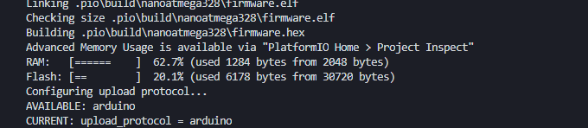

23

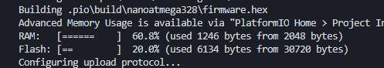

22

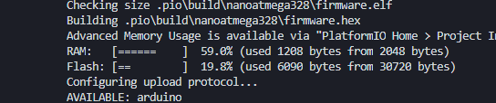

Working:

21

