D&J

Software Architecture Document

Version <1.0>

Revision History

|  |  |  |  |
| --- | --- | --- | --- |
| **Date** | **Version** | **Description** | **Author** |
| <dd/mmm/yy> | <x.x> | <details> | <name> |
|  |  |  |  |
|  |  |  |  |
|  |  |  |  |

Table of Contents

1. Introduction 4

2. Architectural Goals and Constraints 4

3. Use-Case Model 4

4. Logical View 4

4.1 Component: abc 4

5. Deployment 4

6. Implementation View 4

# Introduction

[The introduction of the **Software Architecture Document** provides an overview of the entire **Software Architecture Document**. It includes the purpose, scope, definitions, acronyms, abbreviations, references, and overview of the **Software Architecture Document**.]

# Architectural Goals and Constraints

[This section describes the software requirements and objectives that have some significant impact on the architecture; for example, safety, security, privacy, use of an off-the-shelf product, portability, distribution, and reuse. It also captures the special constraints that may apply: design and implementation strategy, development tools, team structure, schedule, legacy code, and so on.]

# C:\Users\Phy\AppData\Local\Microsoft\Windows\INetCache\Content.Word\UseCaseDiagram1.pngUse-Case Model

# Logical View

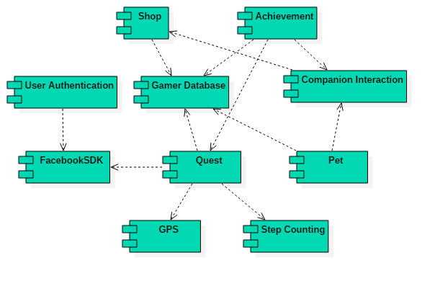

* Shop, Achievement, Pet Information, Quest are all dependent on Gamer Database.
* Users need to use Facebook to login and Facebook sharing is used in some quests as well.
* A quest can be generated by GPS, Step Counting, or FacebookSDK.
* An achievement can be completed by Companion Interaction, Quest.

## Component: using Facebook

# Deployment

[Leave this section blank for PA3.]

# Implementation View

[Leave this section blank for PA3.]