Technical Specification for functions vesselRaise.boot and vesselRaise.an

Document by David Maxwell. Last updated 5 February 2009.

Description
These function implement a traditional 'vessel raising' approach to estimate landed numbers-at-age and at-length from market sampling data. vesselRaise.boot provides variance estimates by bootstrapping the age and length samples, while vesselRaise.an provides analytical variance estimates. In the future, these two functions may be set-up as two options within a single function.

In the notation of 2nd COST meeting 24-26 June 2008 the calculations are for
Sampling strategy: Length + ALK, Commercial categories within Trips
Sampling source: Auction/Market/Harbour Landed fraction

The function requires sample data in a csDataCons object, total landings weights in a clDataCons object and a dbeOutput object (which describes the data) to send the output to.

Stratification
The csDataCons and clDataCons objects need to have the same stratification, which should be described in the strataDesc slot of dbeOutput.

Estimates by length are provided for each combination of the space, time and technical strata specified in the dbeObject supplied to the function. The biological data (ca table) does not include technical stratification so estimates by age are provided for each combination of the space and time strata.

If argument age.plus is a non-negative value then an age ‘plus group’ is formed by setting all ages greater or equal than age.plus to age.plus.

The function does not combine of length groups. We assume that suitable length groups were created when the consolidated object (csDataCons) was formed. [There is no provisions for that in the consolidation phase, should we?]

Stratification Issues
Estimation for mixed species landings is not implemented; the species in the biological data must match the taxon field in the landings data. [Ok, we'll care about this later after the submission of the project]

Similarly, stratification by sex is not implemented. Estimates are not be given by sex if combined sex length data and sexed age data are used. Either use combined sex length and age data or single sex length and age data, by subsetting on sex. {[t's not a big deal, but again we keep that for later]

Methods

Number of samples

The number of age samples is given by the number of unique values in the PSU (primary sampling unit) field of the biological data (ca table).

The number of length samples is given by the number of unique values in the PSU field of the station record (hh table).

Number measured

The number of otoliths is the number of non-missing age observations in the biological data.
The number of length samples is the total number of fish measured (from hl table).

Total landed weight
The total landed weight per stratum is taken directly from the clDataCons input. If adjustments to the landed weight are given in the data these are applied as:

Total Landings = Official Landings * Multiplier + Unallocated Catch + Misallocated Catch

If the multiplier field is NA it is assumed to be one, if unallocated catch and misallocated catch are NA they are assumed to be zero.
[The algorithm above (+ value) should form a generic function for all methods]

The total landings used are output to totalW$estim in dbeObject.

Numbers-at-length
Let n_{ilc} indicate the number of fish sampled of length group l from vessel i and from category c. The estimated total number of fish, per length and category from each vessel is:

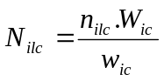 [1]

where W is the total weight and w is the sampled weight.
[Personally, I don't raise to the vessel when I use CC, as the purpose is to get a picture of the CC LC not the Vessel LC; I've never succeeded in having a deep discussion and bias analysis on which is the best! I've put on the CVS the document WDstruc_final.pdf, I presented at the first precision WS]

The total number of fish per length group per vessel is the sum of the categories:

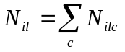 [2]

The sample is then raised to the total landed weight to give the length distribution (LD) per stratum.
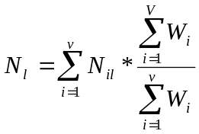 [3]

where V is the total number of landings. So, the numerator is the total landed weight for all vessels and the denominator is the total landed weight relating to the sampled landings, i=1 to v.

Next, estimates by technical strata are summed:
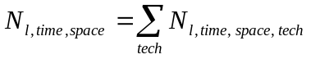 [4]
so that the stratification of the length distribution and the age data will match.

Total numbers landed
Within the code, total numbers landed is estimated following the same approach as numbers-at-length, so equations [2] and [3] become:

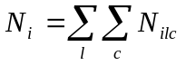 [5]
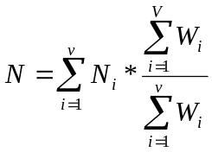 [6]
The result should equal the sum of the N_{l} estimates.

Numbers-at-age
From the biological data r_{al} , the number of fish age a, in length group l and r_{l} , the total number in each length group are calculated. The proportion aged at age a in each length group is:

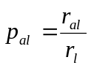 [7]
These values, often referred to as an age-length-key (ALK), are combined with the length distribution to estimate numbers-at-age for each time and space strata.

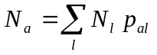 [8]

Gaps in the age-length-key
An estimate of p_{al} is required for each length group in the length distribution otherwise fish of that length will not be assigned to any age. The function alkLgthRec provides a range of options to address this issue in the original data.

However, bootstrapping the age samples can lead to gaps in the ALK even if the original ALK is complete. For example, if all the fish in one length group come from a single age sample and it is not selected within a bootstrap sample. Therefore, the bootstrap process calls the underlying function gapsRm with the following options:

gapsRm(alk,type="fillMiss", value=2, preview=FALSE, postview=FALSE)

This fills all gaps that are 1 or 2 length groups wide with the sum of the surrounding recorded length groups, so that 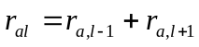 if length group l contains no age data and length groups l-1 and l+1 do contain age data.

If gap-filling is required the function issues a warning and outputs the full details to an object, alkgaps.list. If any gaps still remain then processing continues but the function issues a further warning.

Gaps in the length distribution
If there are length groups with data in the ALK but none in the LD, this does not affect the processing but a warning is given that the length samples may not cover the full length range.

Variance estimates

Bootstrap method

A non-parametric bootstrap is implemented by resampling age and length samples separately within each stratum. The sampling units are defined by unique values in the PSU (primary sampling unit) field. The new set of samples generated is then processed in the same manner as the original data to produce estimates of numbers-at-length and at-age. This process is repeated for a large (e.g. 1000) number of iterations, B.

Estimates from the original data are output to the $rep elements of dbeObject with iter = 0 and estimates from the bootstrap samples are output with iter = 1 to B.

lenStruc$estim, ageStruc$estim and totalN$estim are calculated as the mean of the bootstrap replicates and lenVar, ageVar and totalNvar are the variance of the bootstrap replicates

Issues
If very few samples are present in the original data, few distinct choices of samples are possible when bootstrapping. The function outputs a warning if any stratum contains fewer than 5 length or age samples.

Analytical method
Following the notation above, the variance of the length distribution is estimated by:

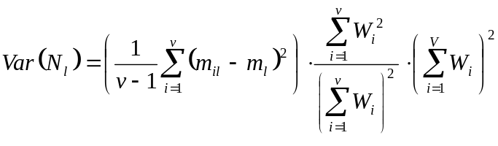 [9]
[Difficult to assess, without an aspirin, if it is the same as in Wdstruc_final.pdf? Looks alike!]

where m_{il} is the estimated number per unit weight

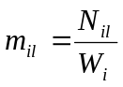 [10]

and m_{l} is the estimated weighted mean number per unit weight
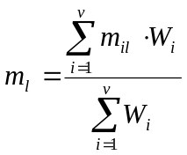 [11]

The variance of the proportion at age for each length group is estimated as
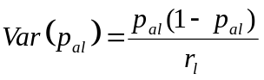 [12]
[Different from Kimura, which applies for proportional allocation. It would be nice to compare!]

and the variance of numbers at age approximated by

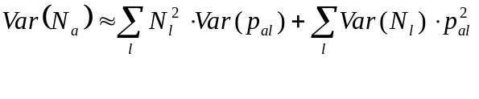 [12]

The variance for total numbers landed follows equations [9] to [11] without the subscript for length class. This estimate will not equal the sum of Var(N_{l}) as the estimates by length class are correlated.

